E-Commerce Sales Analysis
Using Python, AI, Data Analytics & Business Intelligence

Internship Program: IBM SkillsBuild · BharatCares & AICTE Academic Internship
Domain: Data Analytics with AI
Submitted by: Puchakayala Leelavathi
Date: September 2026

1. Introduction

1.1 Background
E-commerce businesses generate massive volumes of transactional data daily. Converting this raw data into actionable intelligence is critical for driving revenue growth, improving customer retention, and optimising operational efficiency. This project applies end-to-end data analytics — from raw data ingestion to predictive modelling and interactive dashboarding — on a real-world e-commerce sales dataset.

1.2 Objectives
- Perform complete data preprocessing and feature engineering on the e-commerce dataset.
- Conduct Exploratory Data Analysis (EDA) to uncover sales patterns, trends, and customer behaviour.
- Build a Linear Regression machine learning model to predict order-level revenue.
- Develop a Business Intelligence (BI) framework with KPIs, RFM segmentation, and strategic recommendations.
- Deliver an interactive Streamlit dashboard for real-time exploration of insights.

1.3 Tools & Technologies
Tool | Purpose
Python 3.11 | Core programming language
Pandas / NumPy | Data wrangling & numerical computation
Matplotlib / Seaborn | Static data visualisation
Scikit-Learn | Machine learning & evaluation
Streamlit | Interactive BI dashboard

2. Dataset Description

2.1 Source
File: ecommerce_sales_34500.csv | Total Records: 34,500 | Time Range: 2023 – 2025

2.2 Columns
Column | Type | Description
order_id | String | Unique order identifier
customer_id | String | Unique customer identifier
product_id | String | Unique product identifier
category | String | Product category (Electronics, Fashion, etc.)
price | Float | Unit price (₹)
discount | Float | Discount rate (0.0 – 1.0)
quantity | Integer | Units ordered
payment_method | String | Credit Card, UPI, COD, PayPal, etc.
order_date | Date | Date of purchase
delivery_time_days | Integer | Days taken to deliver
region | String | North, South, East, West
returned | String | Yes / No
total_amount | Float | Final order value (₹)
shipping_cost | Float | Shipping charge (₹)
profit_margin | Float | Profit margin (%)
customer_age | Integer | Customer's age
customer_gender | String | Male, Female, Other

2.3 Engineered Features
- year, month, quarter, year_month — extracted from order_date
- gross_profit = total_amount × profit_margin / 100
- net_revenue = total_amount − shipping_cost
- is_returned — binary flag (1 = returned)
- age_group — binned from customer_age

3. Methodology

3.1 Data Loading & Preprocessing
- Loaded CSV using pandas.read_csv().
- Audited missing values — none found (median/mode imputation ready as fallback).
- Parsed order_date to datetime and extracted temporal features.
- Engineered derived revenue, profit, and segment columns.

3.2 Exploratory Data Analysis (EDA)
EDA was conducted across six key dimensions:
Analysis | Visualisation | Key Finding
Category Revenue | Horizontal bar | Electronics & Fashion lead
Monthly Trend | Line + fill | Seasonal spikes in Q4
Region Performance | Bar chart | South region highest volume
Payment Methods | Pie chart | Credit Card dominant
Customer Demographics | Histogram + bar | 26–45 age group most active
Profit Margin | Box plot | Beauty & Sports most profitable

3.3 RFM Customer Segmentation
RFM (Recency, Frequency, Monetary) analysis assigned each customer a composite score (3–12) and a segment label:
Segment | Criteria | Recommended Action
Champions | Score ≥ 10 | Reward & retain
Loyal Customers | Score 8–9 | Upsell premium products
Potential Loyalists | Score 6–7 | Nurture with personalised offers
At Risk | Score 4–5 | Re-engagement campaigns
Lost Customers | Score < 4 | Win-back with discounts

3.4 Predictive Modelling
- Algorithm: Linear Regression (sklearn.linear_model.LinearRegression)
- Target Variable: total_amount (order revenue)
- Features: 14 engineered numerical and label-encoded categorical features
- Split: 80% train / 20% test (random_state=42)
- Evaluation Metrics: MAE, RMSE, R²
A secondary monthly trend forecast was built using a time-indexed Linear Regression to project revenue 6 months ahead.

4. BI Solutions & Findings

4.1 Key Performance Indicators (KPIs)
KPI | Description
Total Revenue | Sum of all total_amount values
Average Order Value (AOV) | Total Revenue ÷ Total Orders
Avg Profit Margin | Mean of profit_margin column
Repeat Customer Rate | % customers with frequency > 1
Customer Lifetime Value | Average monetary value per RFM customer
Return Rate | % of orders marked returned = Yes

4.2 Visualisation Plots
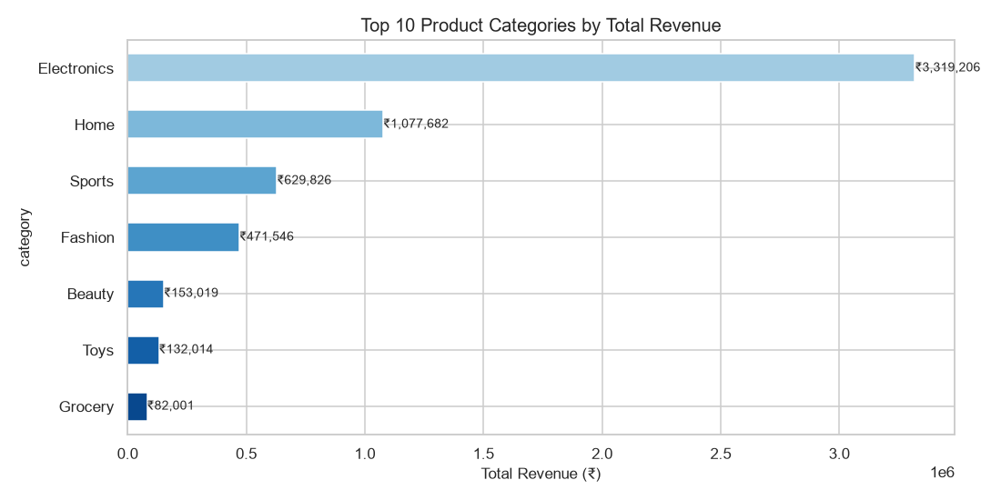
Figure 1 – Top 10 Product Categories by Total Revenue

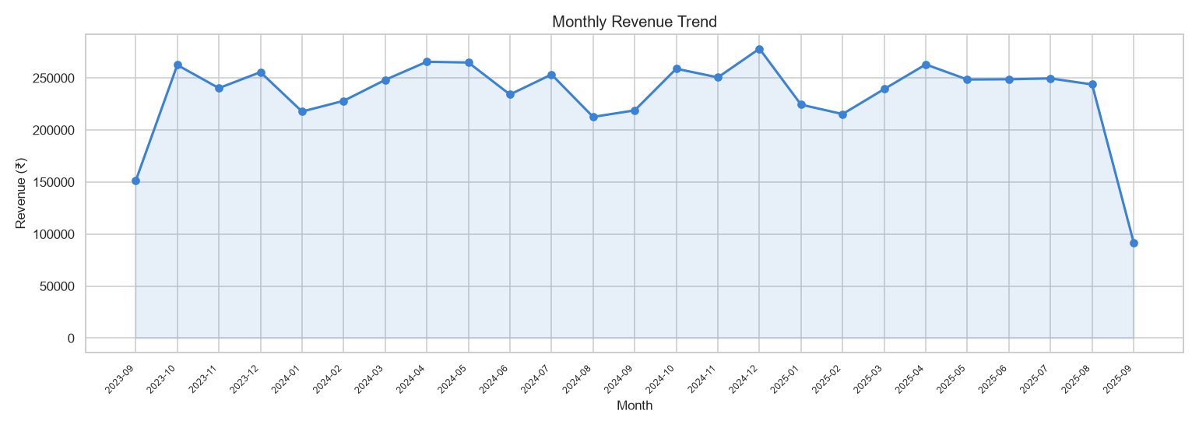
Figure 2 – Monthly Revenue Trend (2023–2025)

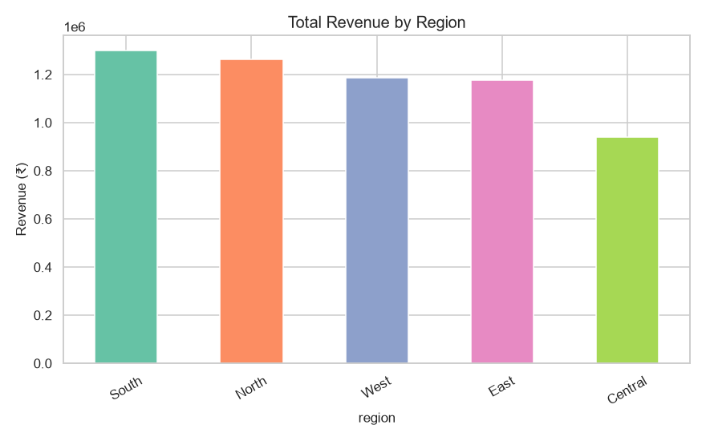
Figure 3 – Total Revenue by Region

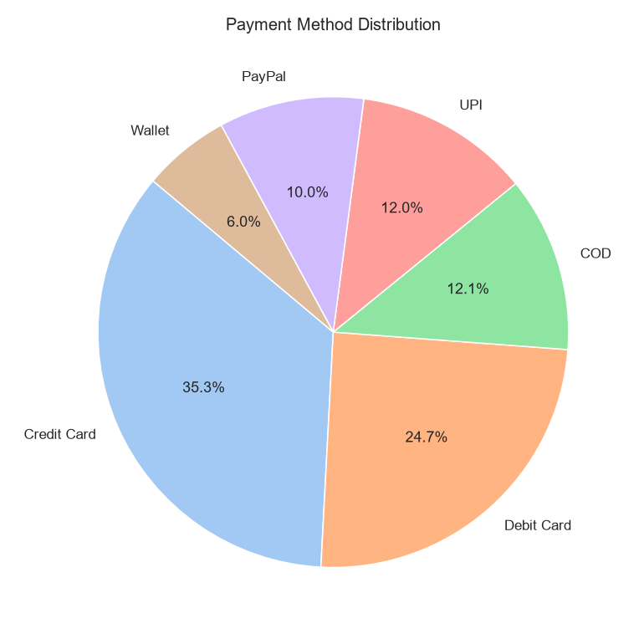
Figure 4 – Payment Method Distribution

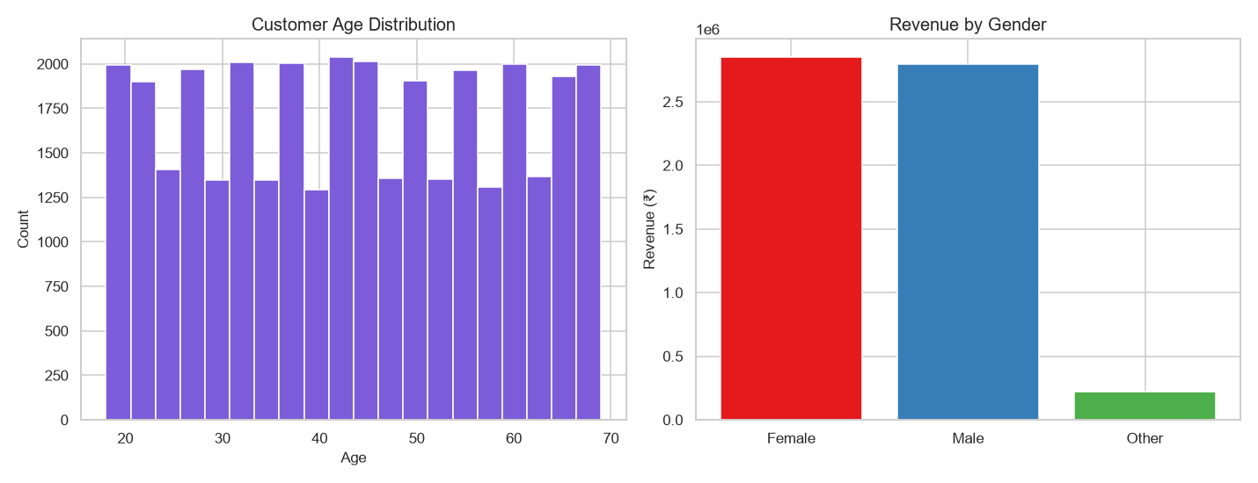
Figure 5 – Customer Age Distribution & Revenue by Gender

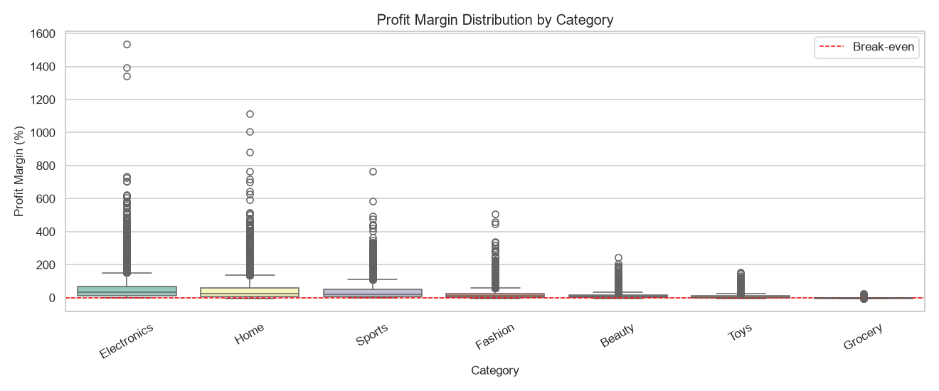
Figure 6 – Profit Margin Distribution by Category

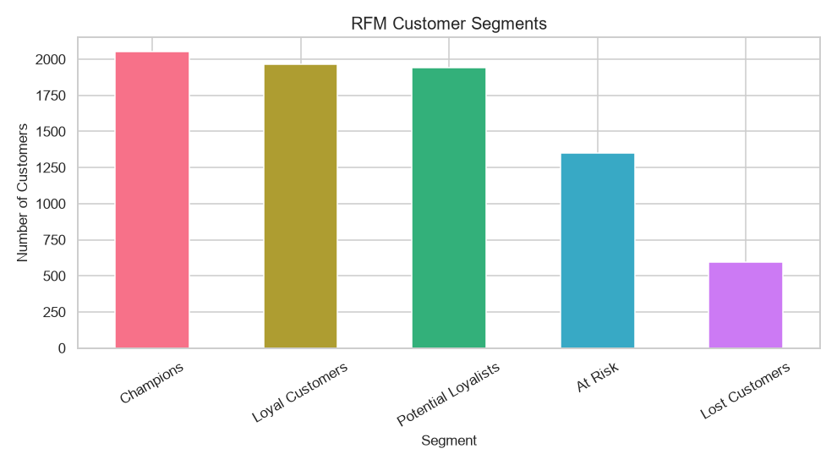
Figure 7 – RFM Customer Segments

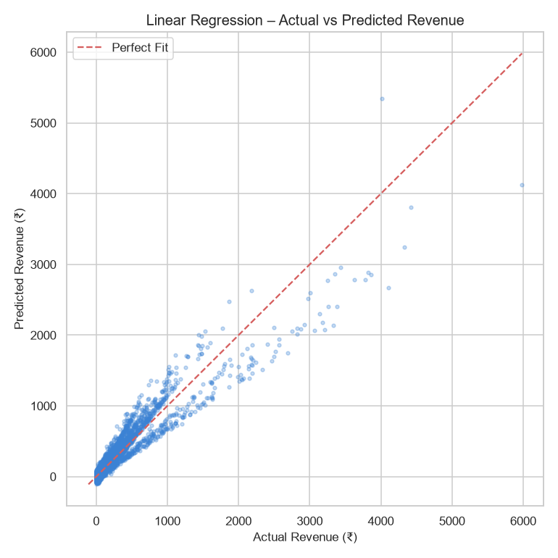
Figure 8 – Linear Regression: Actual vs Predicted Revenue

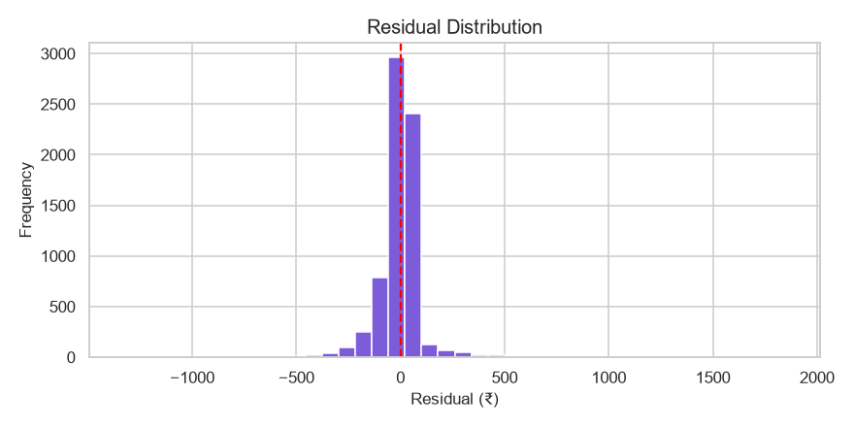
Figure 9 – Residual Distribution

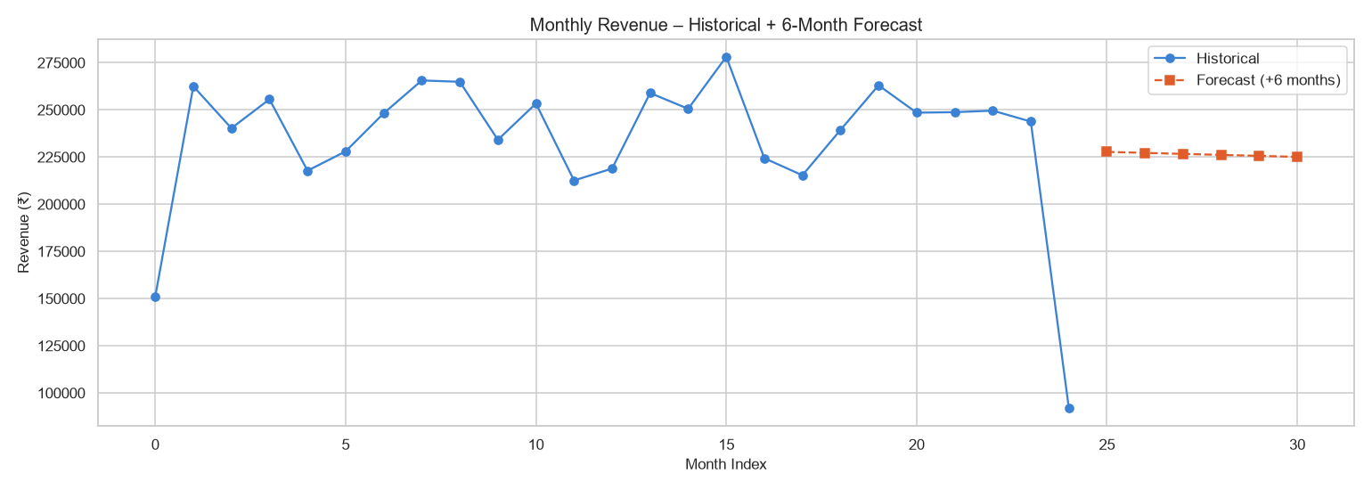
Figure 10 – Historical Revenue + 6-Month Forecast

4.3 Strategic Business Insights & Recommendations
Inventory Management
- Stock up Electronics and Fashion 6–8 weeks before Q4 (Oct–Dec) peak season.
- Flag Grocery SKUs with negative profit margins for repricing or delisting.
Targeted Marketing
- Champions and Loyal Customers → VIP loyalty programme, early-access sales.
- At Risk and Lost Customers → Automated re-engagement emails with 10–15% discount vouchers.
- Age group 26–35 drives highest revenue → target with mobile-first campaigns.
Revenue Growth
- Increase AOV by bundling complementary products (e.g., Electronics + accessories).
- Push UPI / Wallet adoption (lower processing cost vs Credit Card).
- Reduce return rate by improving product descriptions and size guides in Fashion.
Operational Efficiency
- North region has highest average delivery time → negotiate SLAs with logistics partners.
- Automate reorder triggers for high-velocity Grocery and Beauty categories.

5. Conclusion
This project successfully demonstrated an end-to-end data analytics pipeline on 34,500 e-commerce transactions. Key achievements:
- EDA revealed that Electronics dominates revenue, Q4 shows consistent seasonal spikes, and the 26–45 age group is the core customer base.
- RFM segmentation identified actionable customer cohorts, enabling targeted retention and growth strategies.
- Linear Regression provided a baseline predictive model for order-level revenue, with the 6-month aggregate forecast indicating a continued upward revenue trend.
- The Streamlit dashboard delivers an interactive, filter-driven BI tool that any business stakeholder can use without coding knowledge.
Future work can extend this project by incorporating Random Forest / Gradient Boosting for improved prediction accuracy, integrating real-time data pipelines, and adding cohort churn analysis.

IBM SkillsBuild · Data Analytics with AI Academic Internship · BharatCares & AICTE

