

Palestine Technical University (Kadoorie)
Facutly of Engineering and Technology
Computer Systems Engineering

ذات للاستشارات النفسية
By:
Haneen Sawalha – 202112038
Asma’a Dwaikat – 202110467
Maha Abu Zant – 202111934
Roba Shoukri – 202110993

Supervisor:
Eng. Nagham Hamad

This document was submitted in fulfilment of the requirements for the Introduction to Graduation Project course
2025 -2026
ghACKNOWLEDGEMENT
We would like to express our gratitude to Allah for His guidance and support, which gave us the ability to start this project and work on its development. We also want to thank our beloved homeland, Palestine, which always inspires us to work hard and keep learning and improving. We are grateful to Palestine Technical University – Kadoorie for providing a supportive learning environment that helps us gain knowledge and develop our skills, which will guide us in this project. We also want to thank our parents and families for their constant support and encouragement, which gives us the strength to continue working on this project. We hope this project will contribute to serving the community in the field of mental health and psychological counseling, and be a step towards better understanding and providing something useful for our country.

ABSTRACT
Mental health services increasingly rely on digital platforms to improve accessibility and support individuals who cannot attend therapy sessions in person. However, in Palestine, there is a lack of an integrated mental health platform that connects families, clients, therapists, and institutions within a single system. Most existing Arabic platforms provide limited functionality and do not support interactive therapeutic tools, structured progress tracking, or complete case management. This project presents the design and development of a web-based mental health platform built based on real client requirements gathered through direct meetings with “ذات للاستشارات النفسية” in Ramallah. The platform supports appointment booking, online and in-person therapy sessions, secure communication, psychological assessments, therapeutic activities, and progress tracking. Therapists can manage cases, monitor client progress, and record session notes, while administrators manage users and system operations. The proposed solution focuses on usability, security, and interactivity, providing a practical and localized digital mental health platform tailored to the Palestinian context.

Table Of Contents
CHAPTER 1: 1
INTRODACTION 1
1.1 Overview 2
1.2 Problem Statement 3
1.3 Objectives 4
CHAPTER 2: 6
LITERATURE REVIEW 6
2.1 Related Project 7
2.1.1 منصة وعي 7
2.1.2 07Therapy 7
CHAPTER 3: 9
SYSTEM REQIREMENTS 9
3.1 Functional Requirements 10
3.1.1 Client (User – Patients / Parents) Requirements 10
3.1.2 Admin Requirements 12
3.1.3 Therapist Requirements 14
3.2.4 System Requirements 16
3.2 Non-Functional Requirements 16
3.2.1 Usability 17
3.2.2 Performance 17
3.2.3 Security 18
CHAPTER 4: 19
METHODOLOGY 19
& TECHNOLOGIES 19
4.1 Methodology 20
4.1.1 Approach 20
4.1.2 System Analysis 21
4.1.3 Modules 22
4.1.4 System Overview 23
4.2 Technologies 24
4.2.1 Front-End Technologies 25
4.2.1.1 HTML5 25
4.2.1.2 CSS 26
4.2.1.3 Bootstrap 26
4.2.1.4 JavaScript 27
4.2.2 Back-End Technologies 27
4.2.2.1 PHP 28
4.2.2.2 Database 28
4.2.2.3 MySQL (SQL) 29
CHAPTER 5: 30
5.1 Sequence Diagram 31
5.1.1 Book Appointment 31
5.1.2 Activity Diagram – Client Therapy Flow 32
5.1.3 State Machine Diagram – Appointment State 33
5.1.4 Class Diagram 34
5.1.5 Database Schema 36
5.2 Interface Design 38
CHAPTER 6: 53
TIMELINE 53
CHAPTER 7: 59
REFERENCES 59

Table Of Figures
Figure 1 : Use Case (Client) 11
Figure 2 : Use Case (Admin) 13
Figure 3 : Use Case (Therapist) 15
Figure 4 : HTML logo 25
Figure 5 : CSS logo 26
Figure 6 : Bootstrap logo 26
Figure 7 : JavaScript logo 27
Figure 8: PHP logo 28
Figure 9 : Sequence diagram & Book Diagram 31
Figure 10 : Activity diagram - Client therapy flow 32
Figure 11 : State machine - Appointment state 33
Figure 12 : Class Diagram 35
Figure 13 : Database Schema 37
Figure 14 : Login Page 38
Figure 15 : Therapist page 38
Figure 16 : Therapist page 39
Figure 17 : Specialist Selection Page 39
Figure 18 : Specialist Selection full Page 40
Figure 19 : Appointments Page 41
Figure 20 : Appointments Page 41
Figure 21 : Therapist dashboard page 42
Figure 22 : Therapist dashboard page 42
Figure 23 : Therapist dashboard full page 43
Figure 24 : Details Dashboard - Info Case 43
Figure 25 : Details Dashboard – Sessions 44
Figure 26 : Details Dashboard - Assessment 44
Figure 27 : Details Dashboard – Activities Progress 45
Figure 28 : Details Dashboard - Activities 45
Figure 29 : Details Dashboard - Notes 46
Figure 30 : Chat Page 46
Figure 31 : Online Therapy Session 47
Figure 32 : Digital Therapy Activities 47
Figure 33 : Assessment Selection page 48
Figure 34 : Interactive Focus Assessment Selection 49
Figure 35 : Admin Dashboard - System Analytics 49
Figure 36 : Admin Dashboard - User Management 50
Figure 37 : Admin Dashboard - Therapist Management 51
Figure 38 : Admin Dashboard - User Management 52
Figure 39 : Admin Dashboard – Notifications Management 52
Figure 40 : TimeLine 58

Table Of Tables

Table 1 : Comparing the platforms with our project 8
Table 2 : Timeline Work 54

CHAPTER 1:

INTRODACTION

1.1 Overview
In today’s increasingly demanding world, mental health and family well-being have become essential components of a healthy society. Psychological centers and therapy providers play a critical role in supporting children, adolescents, and adults as they navigate emotional, behavioral, and developmental challenges. However, traditional methods of communication between families and therapeutic centers such as phone calls, manual WhatsApp messages, or in-person follow-ups are often inefficient, unstructured, and prone to delays. These limitations can negatively impact the continuity of care, the accuracy of assessments, and the overall therapeutic progress of clients.
To address these challenges, we propose a digital platform for
“ذات للاستشارات النفسية”, designed to enhance clinical workflow, improve parent therapist communication, and provide a secure environment for therapeutic interactions. The platform offers families a structured way to book appointments, access educational materials, complete psychological assessments, submit home activities, measure attention and focus, and communicate directly with specialists. At the same time, it enables therapists to manage cases, document sessions, monitor client progress, and collaborate within the internal professional system.
The proposed system leverages modern web technologies to create a safe, private, and user-friendly therapeutic environment. It supports multiple user roles including clients, therapists, and administrators each with personalized dashboards and tools aligned with their responsibilities. The platform also includes an integrated focus-measurement module that uses progressive cognitive tasks to evaluate attention span and track improvements over time. Additionally, automated alerts highlight critical cases, unusual behavioral indicators, or high-risk assessment outcomes to ensure timely professional intervention.
Digital transformation in mental health services has accelerated in recent years, driven by the need for improved accessibility, structured follow-up, and remote-friendly therapy solutions. By digitizing essential therapeutic processes such as case intake, progress tracking, and home activity monitoring, the system aims to enhance efficiency, accuracy, and long-term treatment outcomes. Ultimately, the objective of this project is to build a comprehensive, secure, and intuitive platform that strengthens communication between families and specialists, supports evidence-based therapeutic practices, and contributes to healthier and more resilient communities.

1.2 Problem Statement
In Palestine, there is a clear lack of an integrated digital platform that connects families, clients, patients, and mental health institutions in one system. Most mental health centers still rely mainly on face-to-face sessions and use manual or scattered methods for appointment booking, communication, and case follow-up. This makes it difficult for families and clients to access services, organize therapy sessions, track progress, or receive proper guidance, especially for issues related to mental health, attention deficit, speech disorders, and behavioral challenges. In addition, social pressure, distance, busy schedules, and privacy concerns prevent many people from seeking help.
To address this gap, we decided to develop a comprehensive mental health platform that provides educational content, psychological support tools, and therapy management features in one secure and easy-to-use system. To ensure that our solution is realistic and practical, we collaborated with a real client, “ذات للاستشارات النفسية” in Ramallah, and held meetings with them to understand their actual needs and challenges. Based on these discussions, the platform was designed to support communication between families, clients, specialists, and the center, enable online and in-person therapy sessions, provide interactive activities and assessments, and help specialists track client progress effectively while maintaining privacy and security.

1.3 Objectives
- Develop an integrated mental health web platform that enables clients to access psychological services easily from anywhere in Palestine.
- Provide a secure and private environment that protects client information and ensures confidentiality in all communications and therapy sessions.
- Enable online appointment booking and scheduling to help clients manage their sessions efficiently and reduce missed or overlapping appointments.
- Create individual profiles for specialists showcasing their qualifications, expertise, schedules, and types of services they provide.
- Support online and in-person therapy sessions by offering tools for real-time communication between clients and specialists.
- Integrate interactive therapeutic tools and games that can be used by psychologists, speech therapists, and language specialists during single or group sessions.
- Improve follow-up and progress tracking by allowing specialists to record session notes and monitor client development over time.
- Enhance accessibility for individuals facing geographic, social, or personal challenges that prevent them from visiting the center physically.
- Provide an easy-to-use interface suitable for all ages, including children who require speech or psychological interventions.
- Strengthen the center’s digital presence and improve service delivery through modern, efficient, and user-friendly technology.

1.4 Procedure
The project development begins with gathering requirements through meetings with a real mental health center to understand the needs of clients, families, specialists, and administrators. The system is then analyzed to define user roles and core functionalities. Next, the user interface and database schema are designed with a focus on usability and security. After completing the design, the frontend and backend are developed and integrated with the database. A dedicated module for therapeutic activities and games is implemented to support psychologists and speech therapists. Finally, the system is tested to ensure correctness and ease of use, and all necessary documentation is prepared.

CHAPTER 2:

LITERATURE REVIEW

2.1 Related Project

2.1.1 منصة وعي
“Wa’I” is an Arabic platform that provides educational content and online therapy services. Users can browse articles, watch videos, and book sessions with licensed psychologists easily. The platform helps people get therapy even if they cannot visit the center in person and keeps their information private. However,” Wa’I” has some limits. It does not have interactive games or exercises for therapy, and it does not fully support group sessions. It also lacks tools for tracking client progress.[1]
Our project improves on these points by offering a simple and clear platform with games and exercises for therapy. It supports both individual and group sessions, helps specialists follow client progress easily, and has a design that is easy to use for everyone. These features make our platform better, more interactive, and more helpful for users and specialists.

2.1.2 07Therapy
07Therapy is an Arabic platform that provides online therapy sessions through video or audio calls. Users can choose a therapist and book sessions easily from anywhere. The platform helps people get therapy even if they live far from centers and keeps their information private. However, 07 Therapy has some limits.
It does not have interactive games or exercises for therapy, and it does not fully support group sessions. It also does not have good tools for tracking client progress.[2]
Our project solves these problems by offering a simple and clear platform with games and exercises for therapy. It supports both individual and group sessions, helps specialists follow client progress easily, and has a design that is easy to use for everyone. These features make our platform better, more interactive.
Table 1 : Comparing the platforms with our project
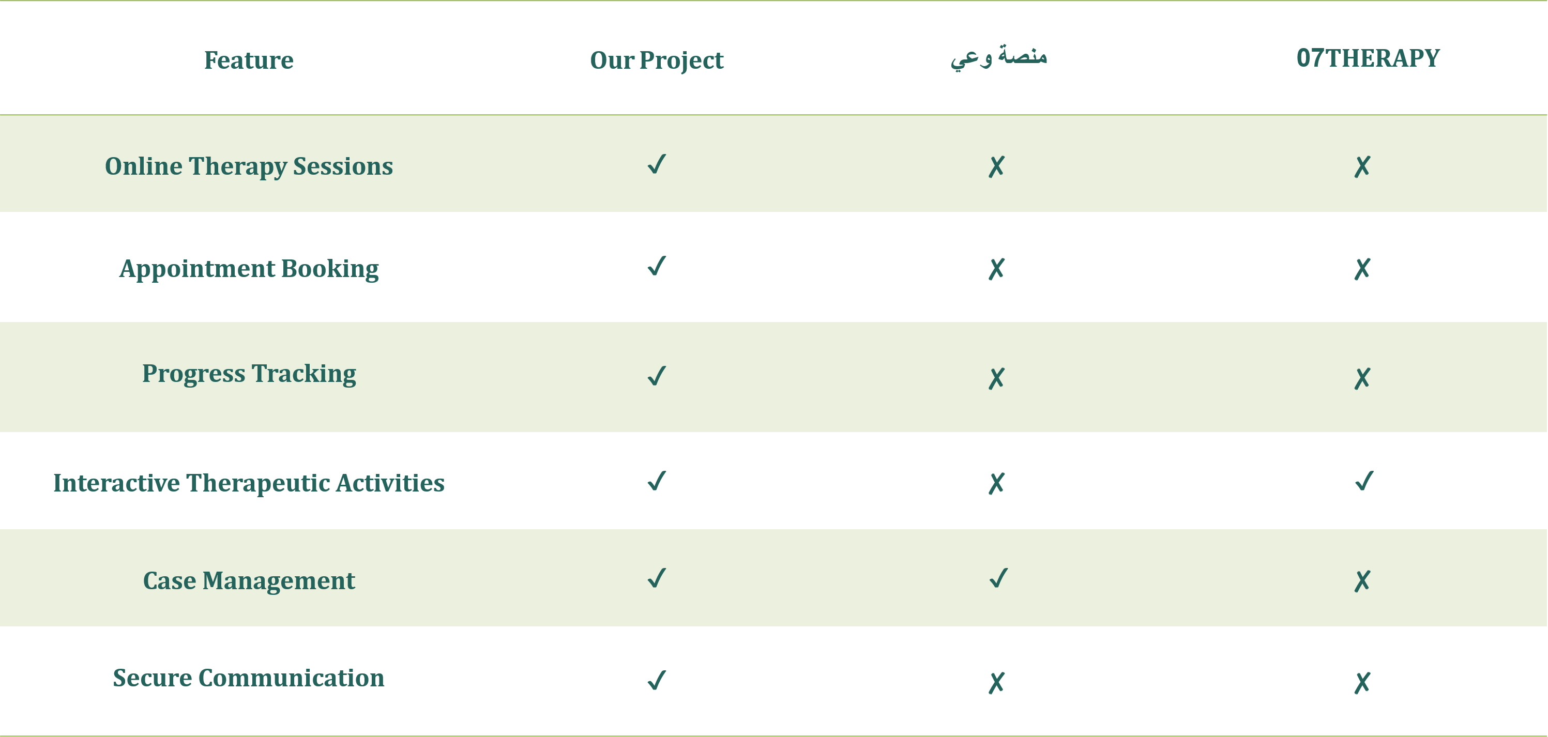

CHAPTER 3:

SYSTEM REQIREMENTS

3.1 Functional Requirements
This section explains what the system does and how it works. It also describes the inputs, outputs, processes, and interfaces, and how they interact with each other and with other systems.

3.1.1 Client (User – Patients / Parents) Requirements
- The client shall be able to create a new account in the system.
- The client shall be able to log in to the system.
- The client shall be able to edit their personal information.
- The client shall be able to update their personal information.
- The client shall be able to book therapy sessions.
- The client shall be able to cancel therapy sessions.
- The client shall be able to reschedule therapy sessions.
- The client should be able to send messages to the therapist.
- The client should be able to send questions to the therapist.
- The client shall be able to view their session history.
- The client shall be able to view their related reports.
- The client shall receive notifications for session confirmations.
- The client shall receive notifications for session reminders.

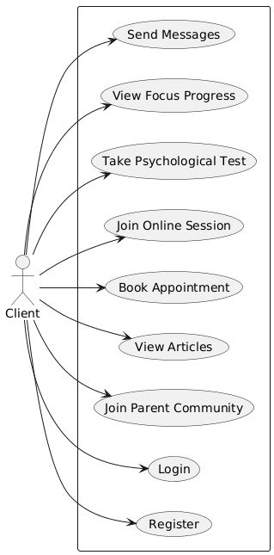
Figure 1 : Use Case (Client)

3.1.2 Admin Requirements
- The admin shall be able to log in to the control panel.
- The admin shall be able to add client accounts.
- The admin shall be able to edit client accounts.
- The admin shall be able to delete client accounts.
- The admin shall be able to add therapist accounts.
- The admin shall be able to edit therapist accounts.
- The admin shall be able to delete therapist accounts.
- The admin shall be able to monitor session schedules.
- The admin shall be able to organize session schedules.
- The admin shall be able to approve session requests.
- The admin shall be able to modify session requests.
- The admin shall be able to view system reports.
- The admin shall be able to view system statistics.
- The admin should be able to send notifications to clients.
- The admin should be able to send notifications to therapists.

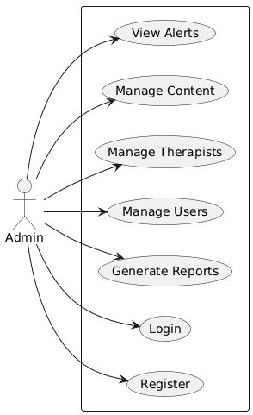
Figure 2 : Use Case (Admin)

3.1.3 Therapist Requirements
- The therapist shall be able to log in to their control panel.
- The therapist shall be able to manage their session schedules.
- The therapist shall be able to accept session requests.
- The therapist shall be able to reject session requests.
- The therapist should be able to receive messages from clients.
- The therapist should be able to reply to messages from clients.
- The therapist should be able to write reports after each session.
- The therapist should be able to check client feedback.
- The therapist should be able to check client ratings.

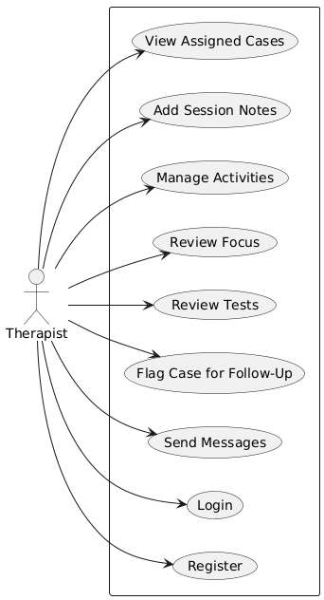
Figure 3 : Use Case (Therapist)

3.2.4 System Requirements
- The system shall provide a user-friendly interface that allows patients, families, and specialists to interact with the platform intuitively.
- The system shall enable users to schedule, manage, and track appointments efficiently.
- The system shall provide secure communication channels for real-time messaging between specialists and families.
- The system shall offer a collection of interactive therapeutic games and activities designed to support treatment for children and adolescents.
- The system shall allow specialists to monitor patient progress continuously through digital activity tracking and session records.
- The system shall generate personalized recommendations based on patient interactions and progress.
- The system shall ensure data privacy and confidentiality in compliance with relevant regulations and standards.
- The system shall be accessible across multiple devices, including desktops, tablets, and smartphones.
- The system shall support scalability to accommodate increasing numbers of users a session.

3.2 Non-Functional Requirements
Non-functional requirements describe how the system should operate.
These characteristics ensure that the platform provides a smooth, safe, and reliable experience for all users, including clients, therapists, and administrators.

3.2.1 Usability
We made the website simple and easy to use for both clients and specialists. The main idea is to help people reach mental health services without any difficulty. All pages are organized in a clear way, so users can find appointments, profiles, games, and tests quickly. Buttons and menus are straightforward and easy to understand, which makes the platform suitable for adults and children.
The website also gives clear and short instructions when users book a session, start an online meeting, or use any feature. The design uses calm colors and readable text to make the experience comfortable and stress-free.
The platform also has interactive games and simple tests that specialists can use during therapy. These tools help make the sessions more engaging and support the goals of the treatment.

3.2.2 Performance
The platform must be fast, responsive, and capable of handling multiple users at the same time without delays.
- Fast Loading: Key pages such as the Home page, Appointments, and Messages should load within 3 seconds under normal network conditions.

- Responsive System: User interactions (sending messages, opening case files, uploading activities) should respond immediately with minimal delay.

- Stable Online Sessions: Audio/video therapy sessions must remain stable, adapting automatically to the user’s internet speed to reduce interruptions.

- Efficient Data Processing: Retrieving client history, therapist notes, or focus-measurement results must take less than 2 seconds, even when the database grows.

3.2.3 Security
Because the system handles sensitive psychological and personal information, strict security and privacy standards are required.
- Secure Login: All users must authenticate using encrypted credentials. Passwords are hashed and stored securely.

- Role-Based Access: Each user can only access information relevant to their role:
- Clients can view their own data only
- Therapists access assigned cases
- Admins manage system-wide data

- Data Protection: Sensitive data such as therapy notes, children’s drawings, voice notes, and psychological test results is encrypted during storage and transmission.

- Privacy: Clients, especially children, appear to therapists using an avatar to protect their identity and ensure confidentiality.

CHAPTER 4:

METHODOLOGY

& TECHNOLOGIES

4.1 Methodology

4.1.1 Approach
The approach of this project is based on collecting real requirements from specialists working in the field of psychological counseling. This ensures that the proposed system addresses real problems and meets the actual needs of mental health centers.
Several Zoom interviews were conducted with representatives from
"ذات للاستشارات النفسية"to understand their services, daily workflow, and challenges when dealing with clients. Additional communication was carried out through WhatsApp, where the team explained their current methods of communication and the difficulties they face.
The collected information showed that WhatsApp is not suitable for professional use due to message clutter, difficulty tracking cases, lack of documentation, and mixing personal and work-related conversations. Based on these findings, the system requirements were defined and the main user roles were identified: users seeking therapy and psychological content, therapists providing counseling and managing cases, and administrators overseeing system operations.
The center also suggested key features such as interactive therapeutic games, a structured appointment booking system, psychological assessments with instant results, strong privacy protection, and case-tracking tools. This practical and research-based approach provided a clear foundation for designing a system that improves the quality and organization of psychological counseling services.

4.1.2 System Analysis
The psychological counseling system developed for ذات That Center aims to provide an organized digital platform that replaces the use of WhatsApp for managing therapy services. The system helps clients access mental health support more easily and enables therapists and administrators to manage appointments, communication, and case follow-up in a structured and professional way. By centralizing booking, assessments, activities, and messaging, the system improves workflow efficiency and reduces confusion.
The system includes three main user roles: client, therapist, and admin. Clients begin by registering or logging into the platform, where they can book therapy sessions, view upcoming appointments, complete assessments, access therapeutic activities, and communicate securely with their therapist. When a client selects a therapist, available time slots are displayed, and a booking request is sent for approval. Once approved, the appointment is added to both schedules and reminders are sent automatically.
Communication is handled through a secure internal messaging system that keeps conversations organized and linked to each client’s case. This allows therapists to review previous messages and follow up efficiently while maintaining privacy and professionalism.
The system also supports psychological assessments and therapeutic activities. Clients can complete assessments and receive immediate results, which are saved for therapist review. Interactive activities are provided to support mental well-being and stress management.
Therapists use a dedicated dashboard to manage appointments, review client information, record session notes, and monitor progress. Administrators use a control panel to manage users, content, assessments, and system operations. Overall, the system is designed to be simple, intuitive, and aligned with the real needs identified through discussions with “ذات للاستشارات النفسية”, providing a strong foundation for system design and development.

4.1.3 Modules
System Modules:
The system is divided into several main modules to keep the platform organized, clear, and easy to use.
- User Module
This module allows users to create accounts, log in, and update their personal information whenever needed.
- Appointment Module
This module makes it easy for clients to book, change, or cancel their appointments with specialists.
- Specialist Module
This module includes the profiles of specialists, their information, working hours, and the services they provide.
- Communication Module
This module allows safe and simple communication between clients and specialists through chat or online sessions.
- Therapeutic Games Module
This module offers simple interactive games and exercises that can be used during individual or group therapy sessions.

- Reports and Records Module
This module helps specialists write notes and follow the progress of each client over time.
- Admin Module
This module allows the admin to manage the system. The admin can approve accounts, organize specialists, check reports, and make sure the platform runs smoothly.
- Specialist Management Module
This module helps specialists manage their daily tasks. They can view their schedule, update appointments, add notes, and upload helpful materials for clients.
- Events and Activities Module
This module allows the creation of events like workshops, group sessions, or awareness activities. Users can join these events and get reminders or updates easily.
- Focus and Progress Module
This module helps track the main goals for each client. Specialists can set focus areas and update progress, and clients can see their improvements in a simple way.

4.1.4 System Overview
The system is designed to provide a simple and clear digital platform for mental health services. It allows clients and specialists to interact easily and safely through different features that support booking, communication, and therapy sessions.
When a client first enters the platform, they can create a new account by filling in basic information. After logging in, the client can browse available specialists, check their working hours, and book an appointment. The client can also edit or cancel the appointment if their plans change. Once the session time arrives, the client can join the online session through a secure video or chat feature inside the platform.
On the other hand, specialists also have their own accounts. After logging in, a specialist can view all upcoming appointments, check client profiles, and prepare for the session. During or after the session, the specialist can add notes, update the client’s progress, and upload helpful exercises or tasks.
The system also includes supportive features like therapeutic games, activity tracking, and event announcements. The admin oversees the whole platform and can manage users, approve specialist accounts, and make sure everything is running smoothly.
Overall, the system brings clients and specialists together in one place, making the process of booking, communicating, and receiving support easier and more organized.

4.2 Technologies
In this section, we present the technologies used in building the website, specifying the programming languages, frameworks, and databases chosen to ensure efficient performance and high-quality results.
The website relies on a combination of front-end technologies to build the user interface, back-end technologies to manage server logic, and a database system to store and organize information securely.
The website is built using a combination of modern and reliable technologies the front-end relies on HTML5, CSS, Bootstrap, and JavaScript to create a responsive and user-friendly interface. The back-end is developed using PHP, which is responsible for handling server-side logic and managing system operations. For data storage, the website uses MySQL (SQL), a structured and dependable relational database system that ensures efficient organization and retrieval of information.

4.2.1 Front-End Technologies
Front-end development focuses on building the part of the website that users interact with directly. This includes designing pages, styling components, and ensuring that content is displayed clearly and is easy to navigate across different devices. Front-end technologies are used to create an engaging user experience, enhance interactivity, and ensure that the interface responds smoothly to user actions. Choosing the right tools contributes to improving website speed, usability, and delivering a consistent and effective interface that supports the system’s goals.

4.2.1.1 HTML5
HTML5 is the essential language used to structure and organize webpage content. It defines headings, paragraphs, sections, multimedia, and layout foundations.
Importance of HTML5

HTML5 forms the structural base of all web pages. It is supported on all modern browsers and devices, is free to use, and supports advanced features without the need for external plugins
Figure 4 : HTML logo

4.2.1.2 CSS
CSS controls the visual appearance of web pages, including layout, colors, fonts, spacing, animations, and responsiveness.
Why is CSS important?

CSS allows developers to modify a website’s design without altering its content, ensuring efficient maintenance and consistent styling across all pages.
Figure 5 : CSS logo

4.2.1.3 Bootstrap

Bootstrap is a free and powerful front-end framework that provides ready-made UI components like buttons, forms, grids, and navigation bars.
Advantages of Using Bootstrap:
Figure 6 : Bootstrap logo
- Saves time and effort.
- Responsive by default.
- Ensures consistent design.
- Cross-browser compatible.
- Highly customizable.
- Large community support.
- Accessibility-friendly.
- Well-documented.

4.2.1.4 JavaScript
JavaScript is a dynamic programming language used to add interactivity, animations, and real-time behavior to web pages.

Advantages of JavaScript
- Easy to learn.
- Enhances user interaction.
- Works on all modern browsers.
- Has a large ecosystem of libraries.
Figure 7 : JavaScript logo
- Supports asynchronous programming.
- Enables live content updates.
- Strong community support.
- Frequently updated.

4.2.2 Back-End Technologies
Back-end development focuses on managing the server-side logic that powers the website behind the scenes. It handles user requests, processes data, secures information, and communicates with the database to deliver dynamic and personalized content. This layer ensures that the system functions efficiently, supports business rules, and maintains secure data flow between the user interface and the server. Selecting the right back-end technology is essential for achieving stability, scalability, and a smooth user experience.

4.2.2.1 PHP

PHP is a widely used server-side language that processes requests, manages data, handles authentication, and connects with databases.
Why Use PHP?
Figure 8: PHP logo
- Integrates easily with HTML.
- Strong database connectivity.
- Popular and well-supported.
- High performance.
- Cross-platform.
- Large community and many libraries.

4.2.2.2 Database
Database technologies are responsible for storing, organizing, and managing the data used by the system. They ensure that information is saved securely, retrieved efficiently, and updated accurately as users interact with the application. A well-designed database supports the system’s performance, maintains data integrity, and enables smooth communication between the back-end and stored information. Choosing a reliable database technology is essential for scalability, security, and ensuring that the application can handle growing amounts of data over time.

4.2.2.3 MySQL (SQL)
MySQL is a relational database system used to store structured data such as user information, records, and operational data.
Why MySQL is a Popular Choice
- Reliable and structured.
- High performance.
- Secure.
- Scalable and efficient.
- Supports complex queries.
- Widely supported.
- Large community.

CHAPTER 5:
DESIGN & SYSTEM INTERFACE

5.1 Sequence Diagram

5.1.1 Book Appointment
This sequence diagram illustrates the process of booking an appointment in the ذات platform.
The client starts by opening the appointment booking page through the web application. The system then requests available therapists and time slots from the backend API, which retrieves the data from the database. After the client selects a therapist and an available slot and confirms the booking, the web application sends the booking request to the backend. The backend stores the appointment in the database and returns a confirmation message, which is displayed to the client.
This diagram clearly shows the interaction between the client, web application, backend API, and database during the booking process.
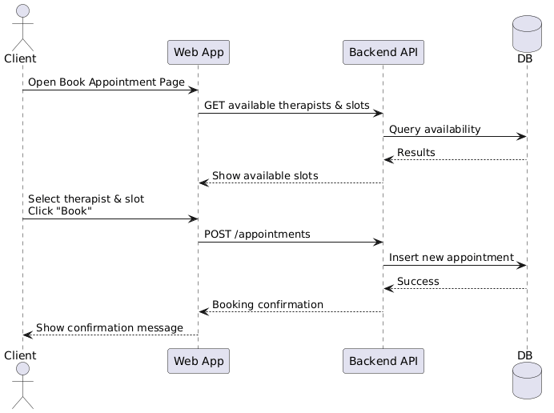
Figure 9 : Sequence diagram & Book Diagram

5.1.2 Activity Diagram – Client Therapy Flow
This activity diagram represents the overall therapy flow for a client in the platform.
The process starts with the client registering or logging into the system, followed by booking an appointment. If the appointment is confirmed, the client joins an online session with the therapist. After the session, the therapist adds session notes and assigns a home activity. The client then submits the activity, which is reviewed by the therapist. Optionally, the client may take psychological or focus tests. The process ends once the therapy activities are completed.
This diagram highlights the main steps and decisions involved in the client’s therapy journey.
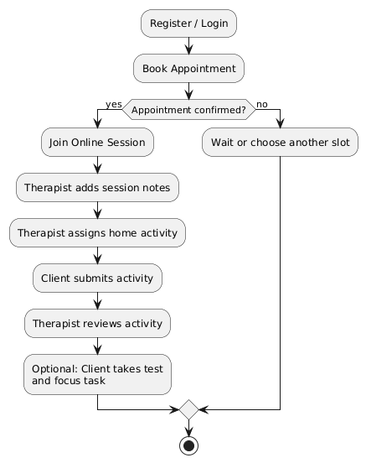
Figure 10 : Activity diagram - Client therapy flow

5.1.3 State Machine Diagram – Appointment State
This state machine diagram describes the different states of an appointment in
the system.
An appointment initially starts in the Requested state. Once the therapist approves it, the appointment moves to the Confirmed state. If the session is completed successfully, it transitions to the Completed state. The appointment may also move to the Cancelled state if either the client or therapist cancels it. The diagram clearly shows all possible transitions between appointment states throughout its lifecycle.
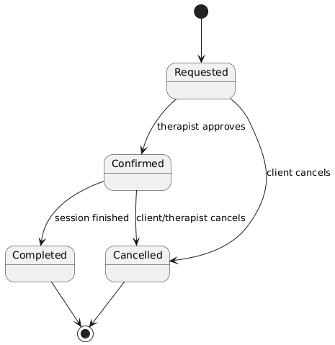
Figure 11 : State machine - Appointment state

5.1.4 Class Diagram
The class diagram represents the static structure of the ذات platform
It defines the main classes such as User, Client, Therapist, Case, Appointment, Session, Message, Activity, Assessment, and Alert, along with their attributes and relationships. The diagram shows inheritance relationships where Client and Therapist extend the User class, as well as associations between cases, appointments, sessions, and other related entities. This diagram provides a clear overview of how data is organized and how different system components are connected.

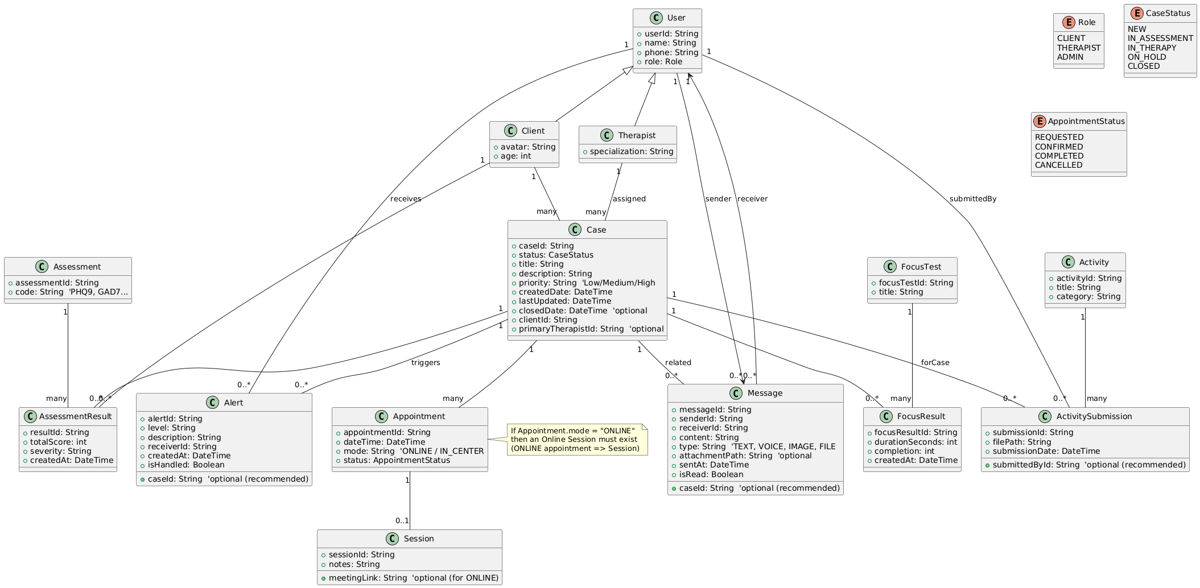
Figure 12 : Class Diagram

5.1.5 Database Schema
The database schema of the ذات platform is designed to efficiently manage users, therapy cases, appointments, sessions, assessments, activities, and communication between users. The schema follows a relational database structure, ensuring data integrity, scalability, and clear relationships between entities.

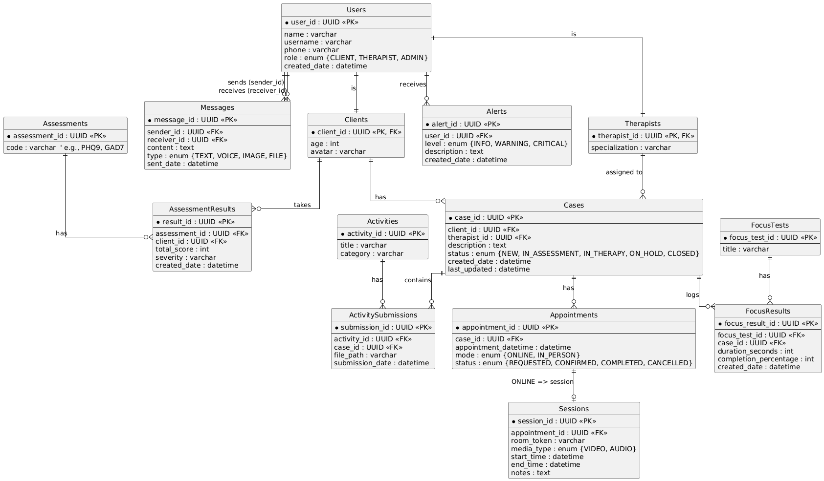
Figure 13 : Database Schema

5.2 Interface Design
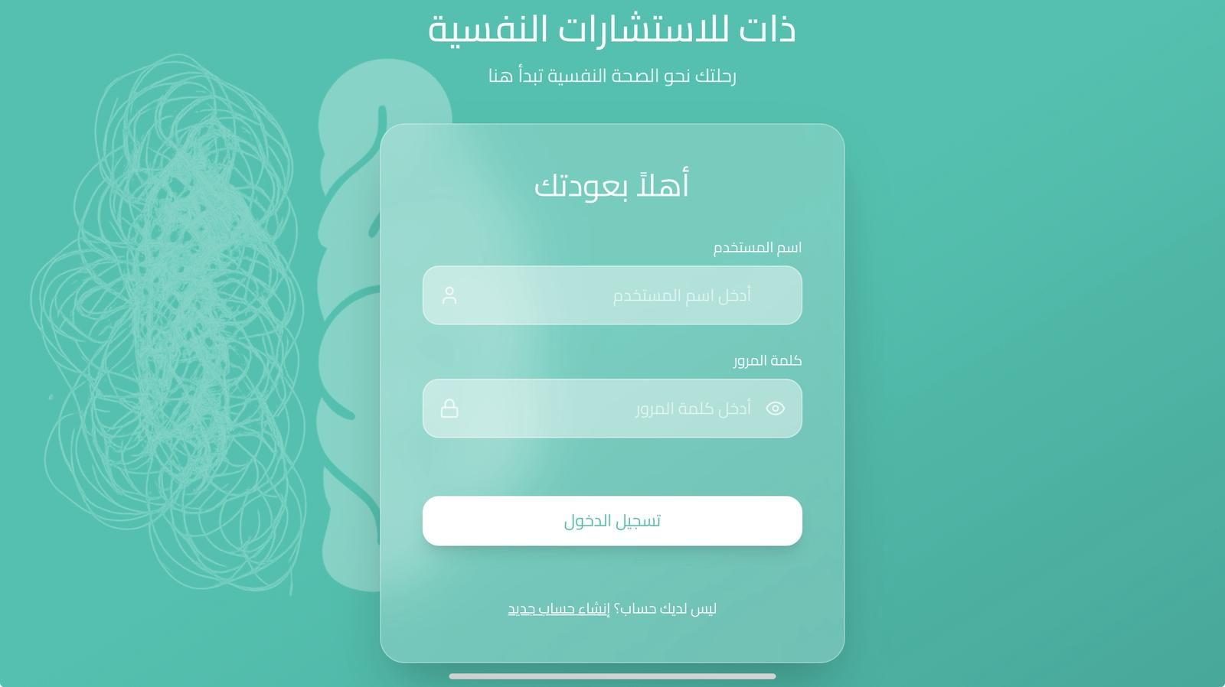
Figure 14 : Login Page
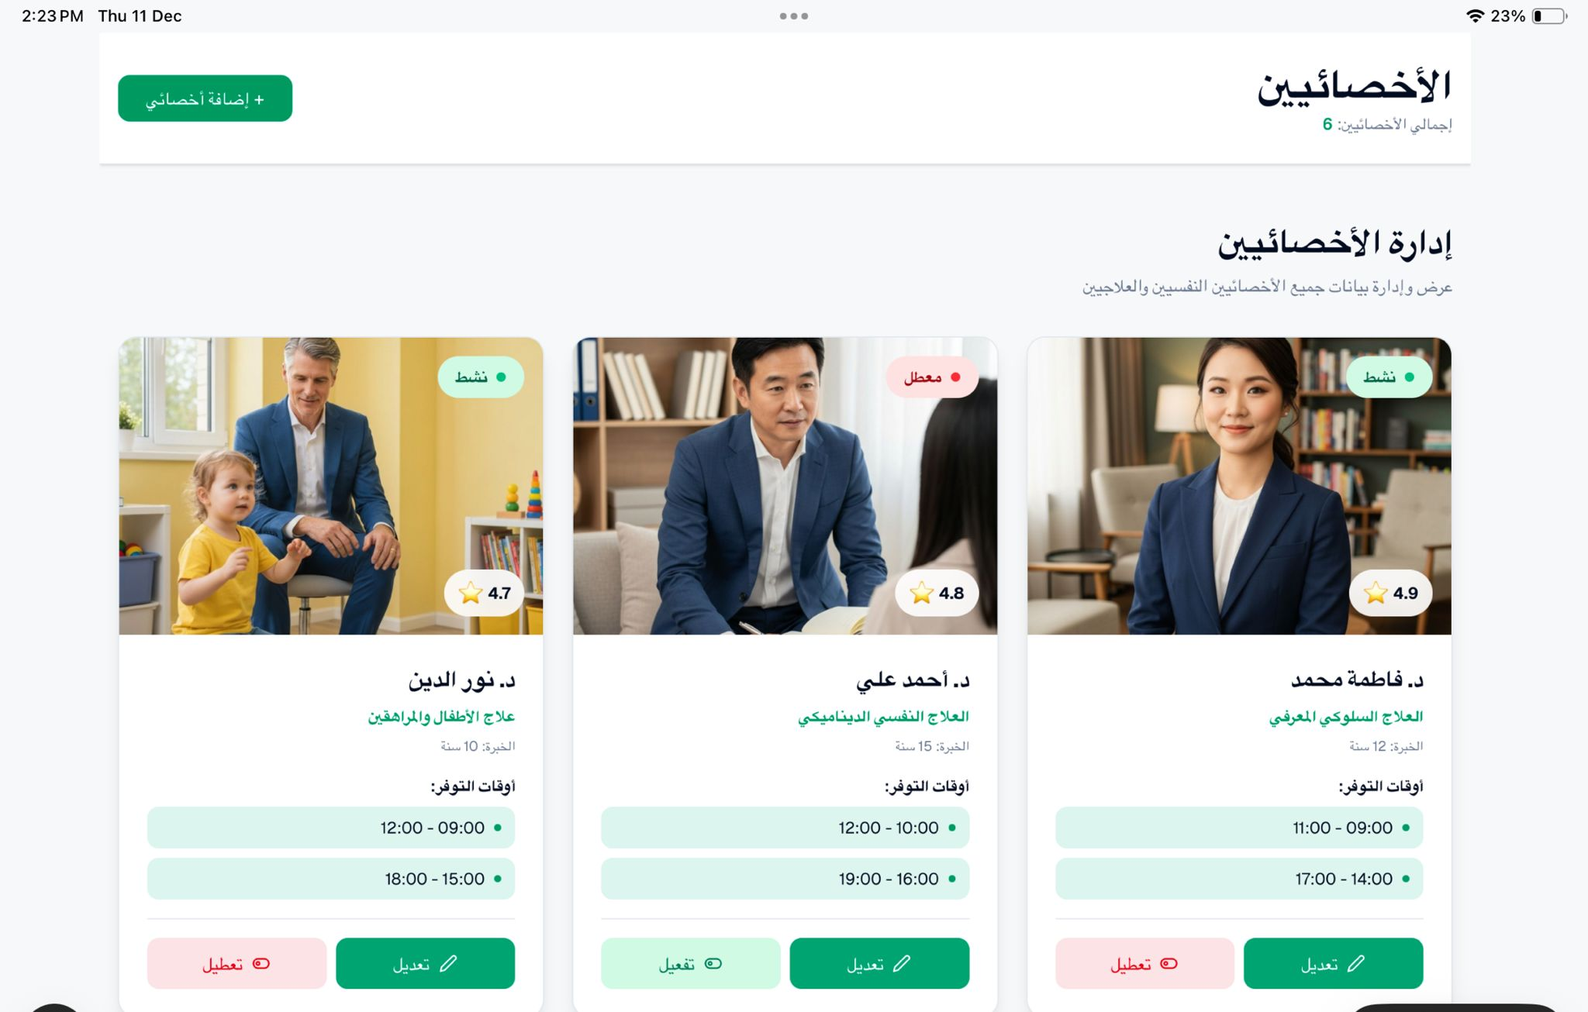
Figure 15 : Therapist page
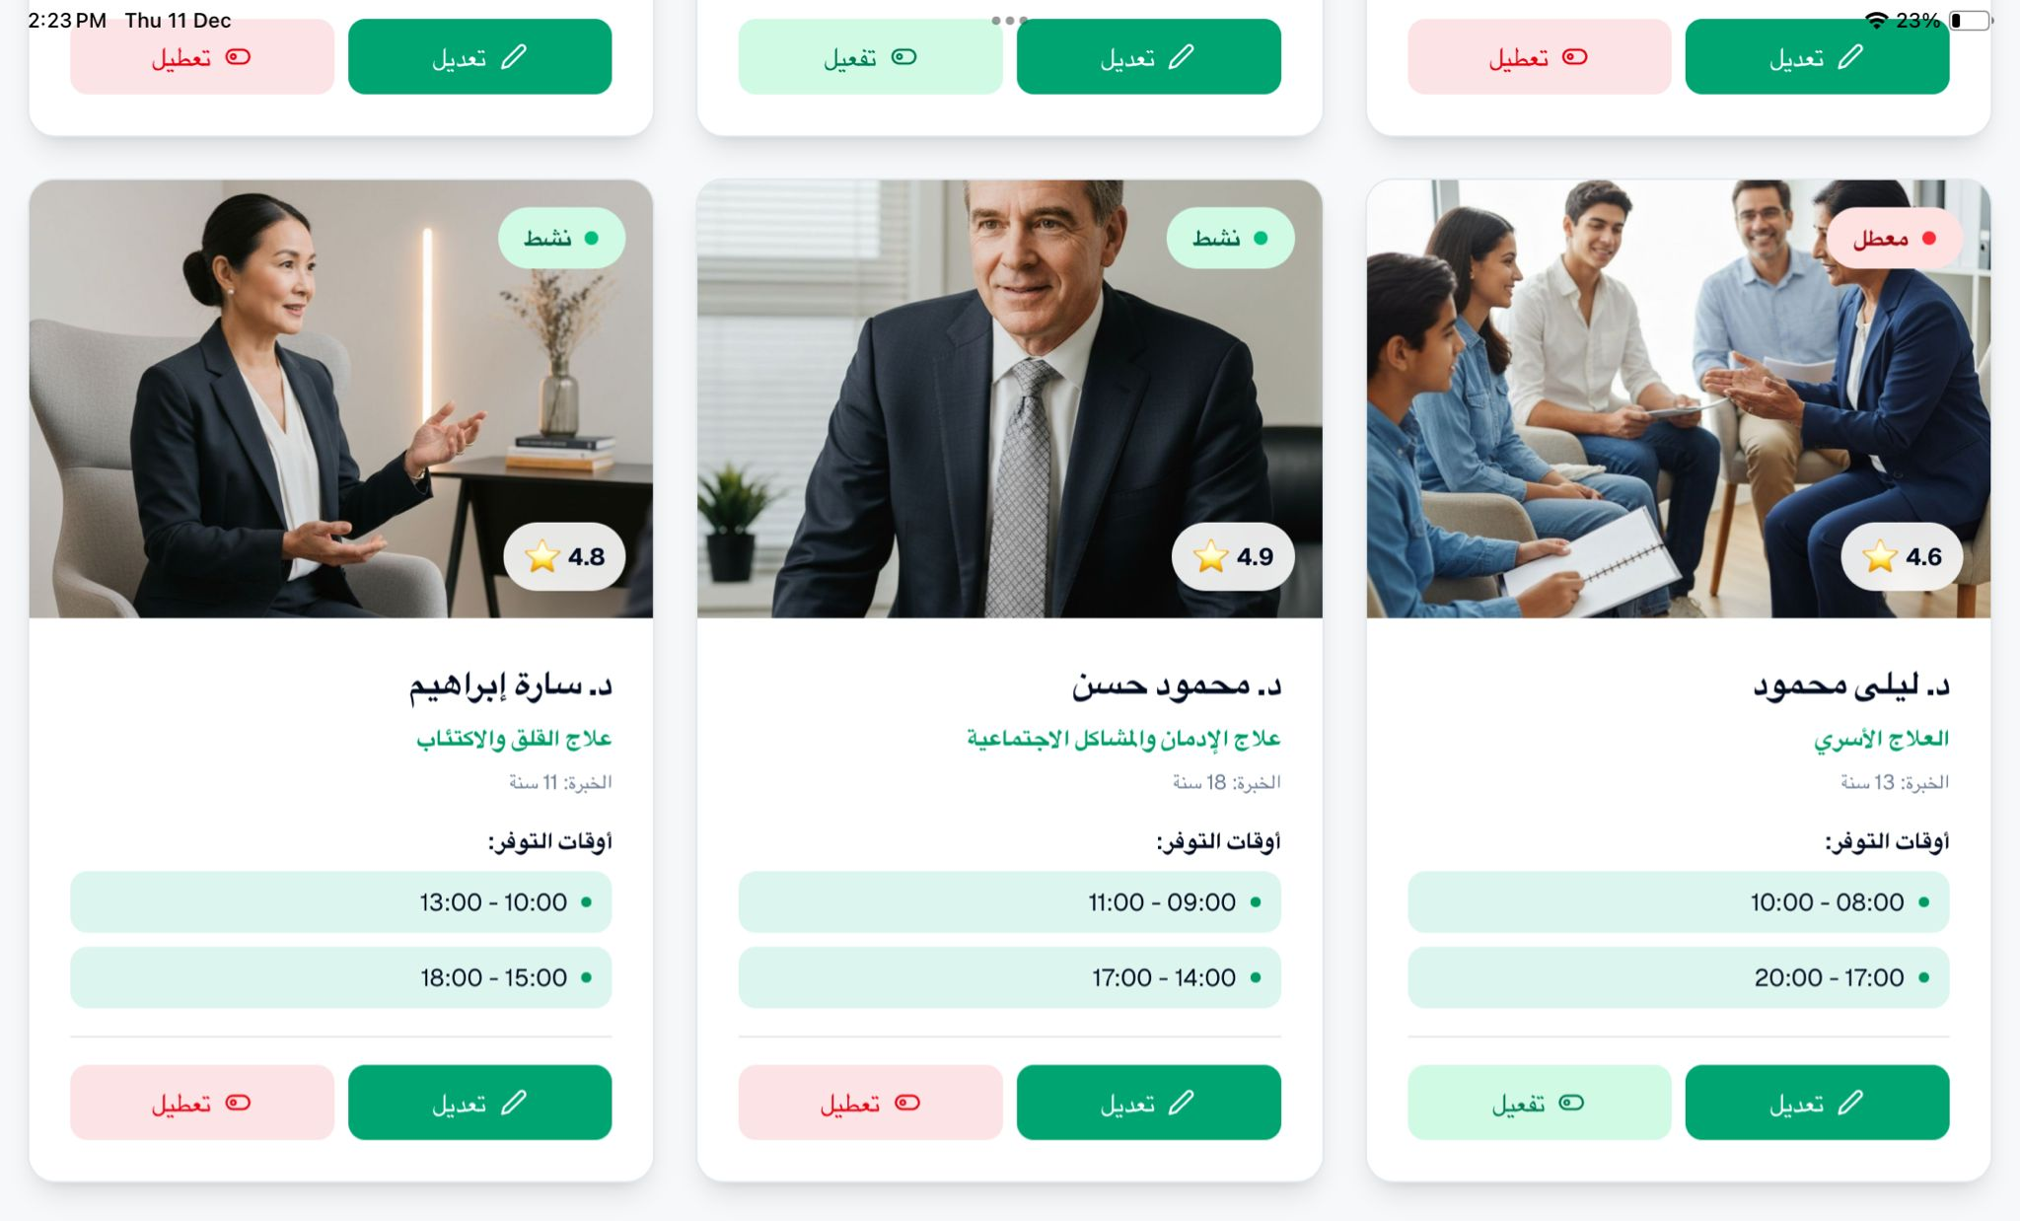
Figure 16 : Therapist page
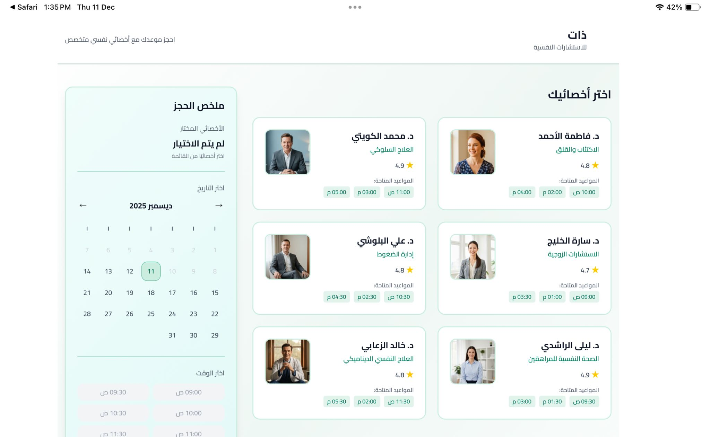
Figure 17 : Specialist Selection Page

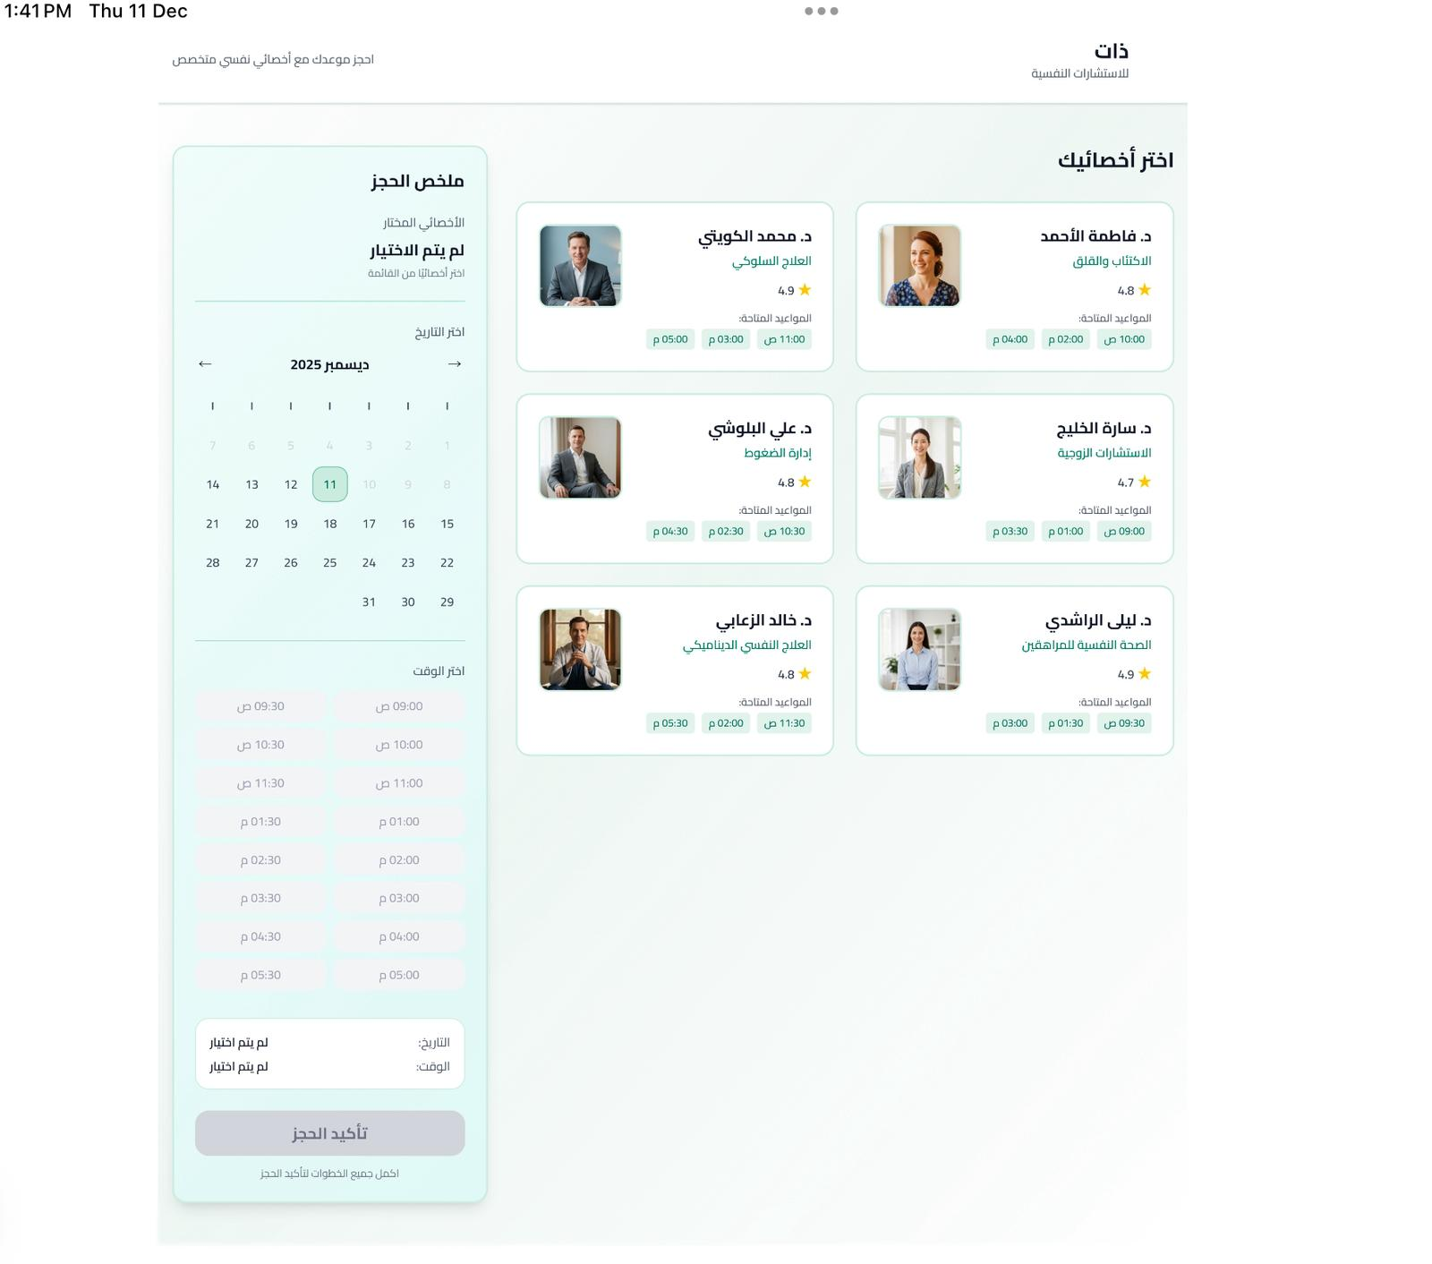
Figure 18 : Specialist Selection full Page
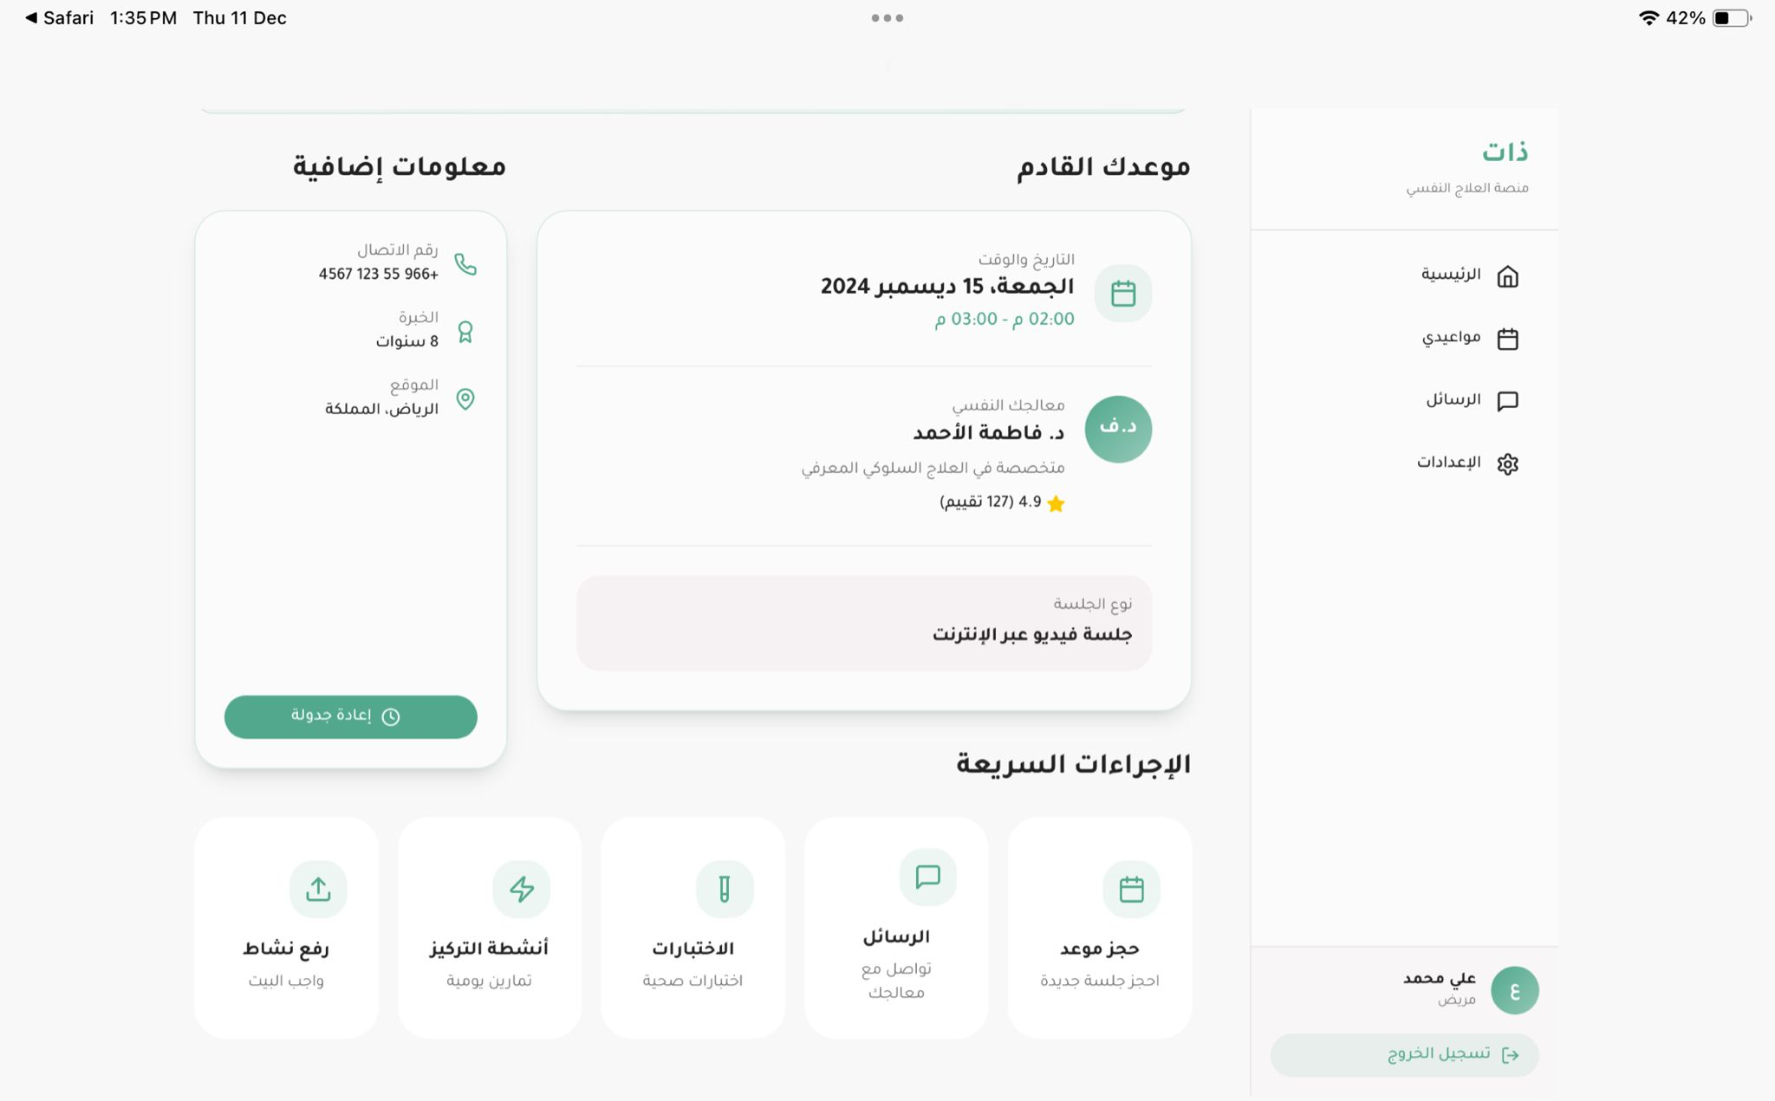
Figure 19 : Appointments Page
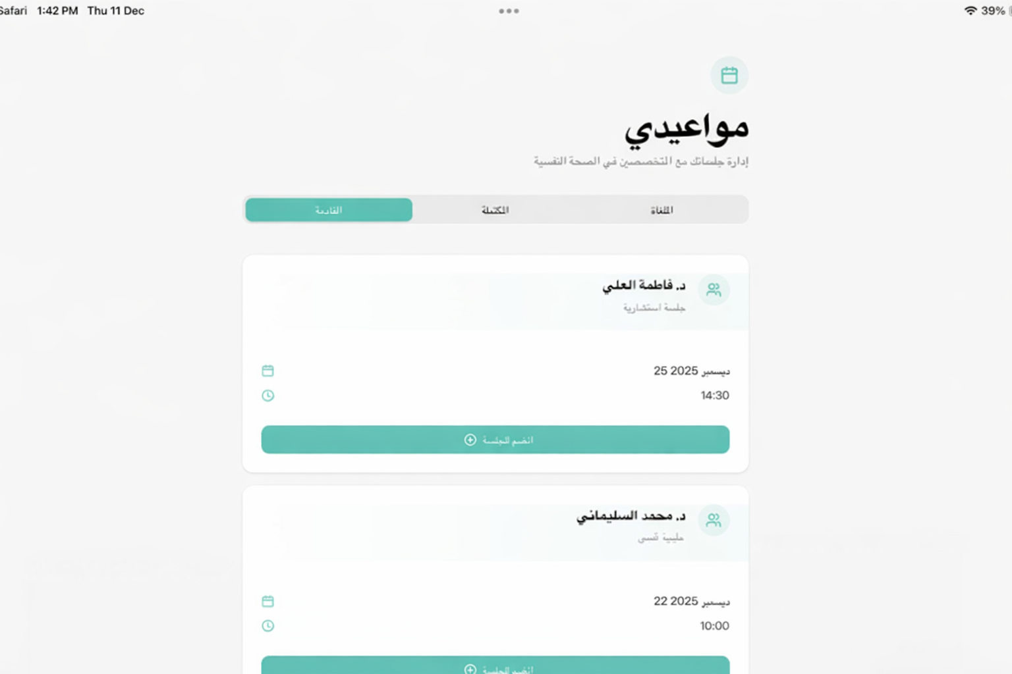
Figure 20 : Appointments Page
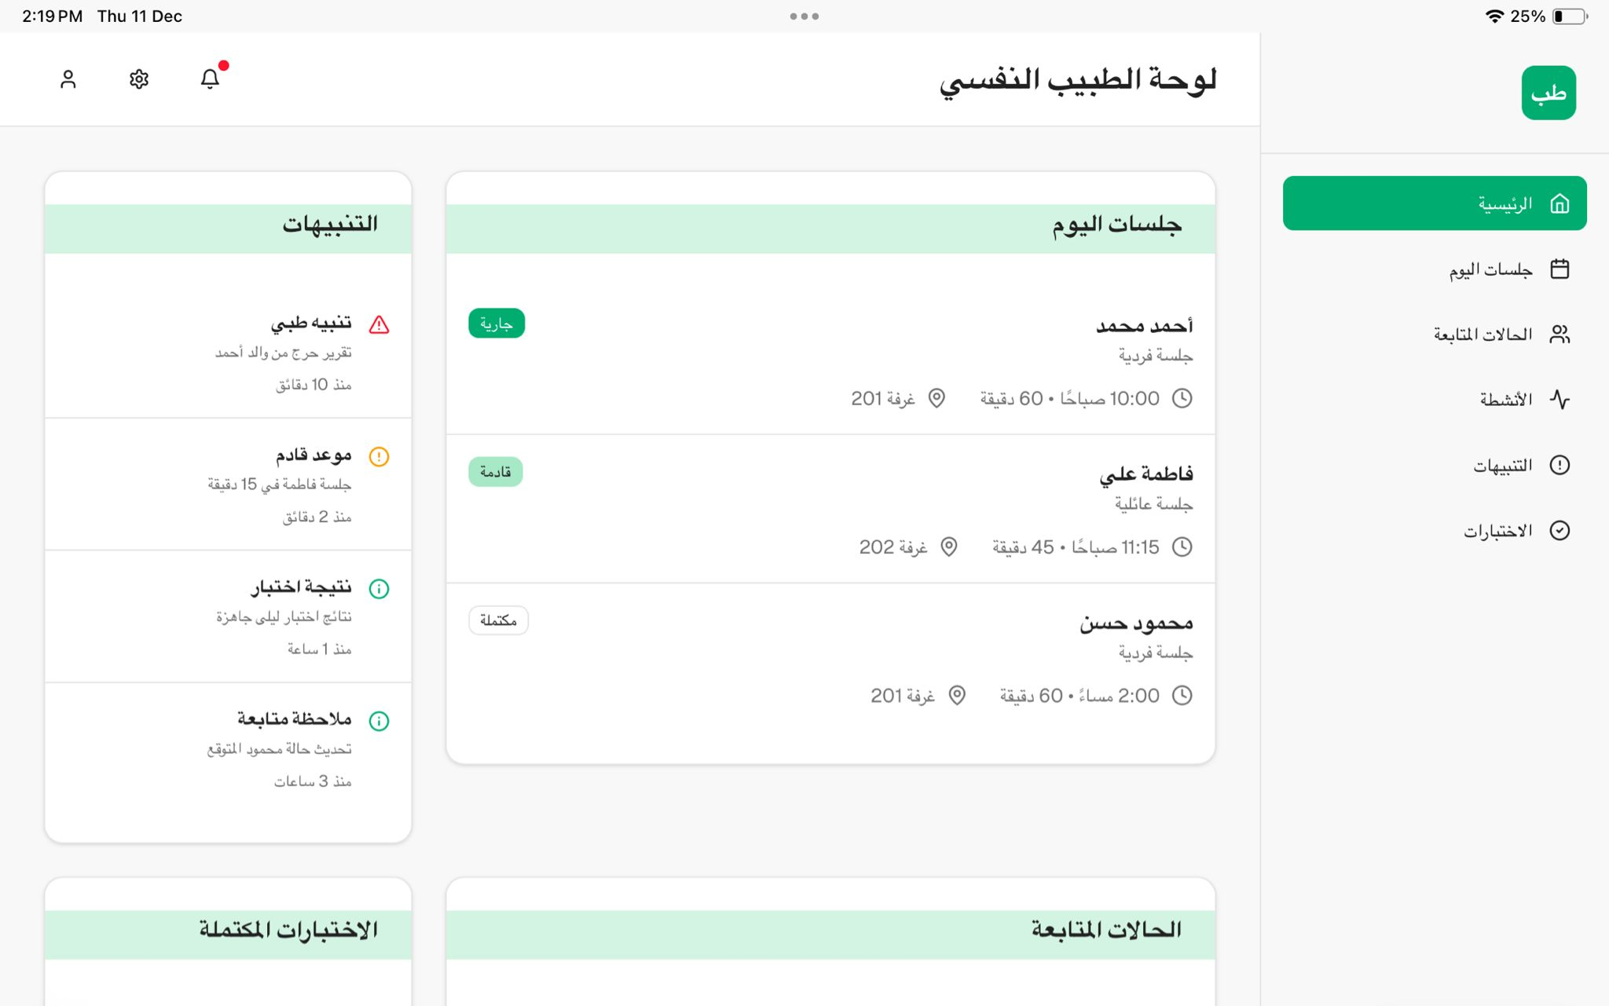
Figure 21 : Therapist dashboard page
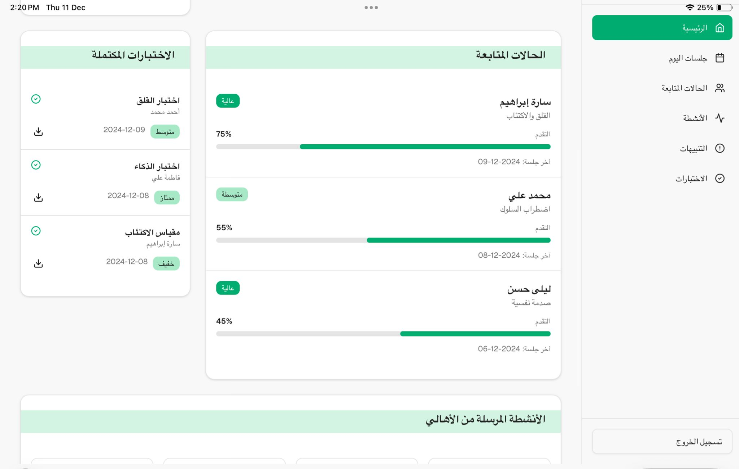
Figure 22 : Therapist dashboard page
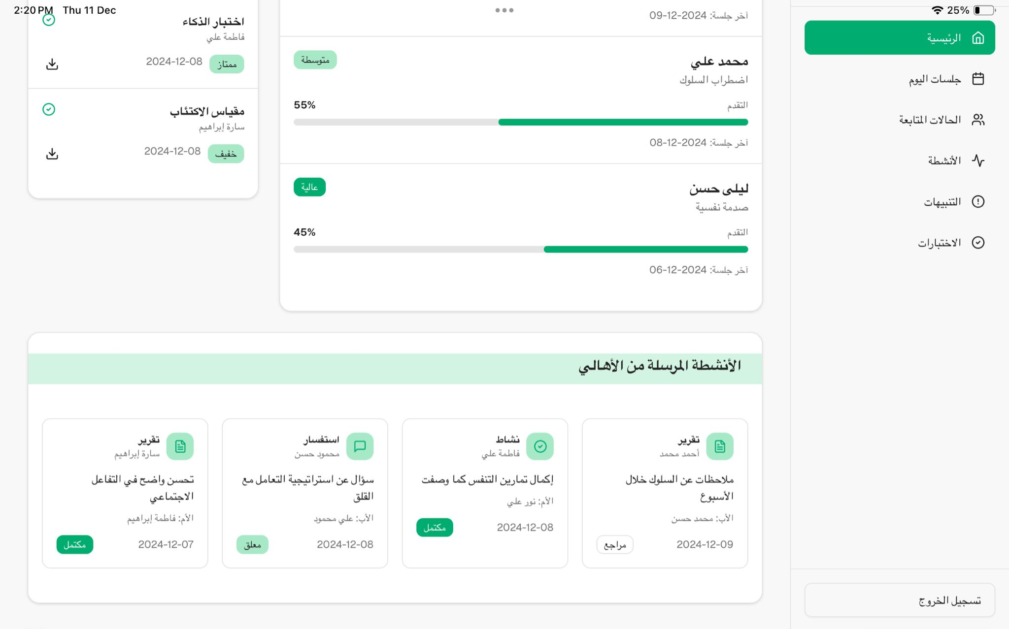
Figure 23 : Therapist dashboard full page
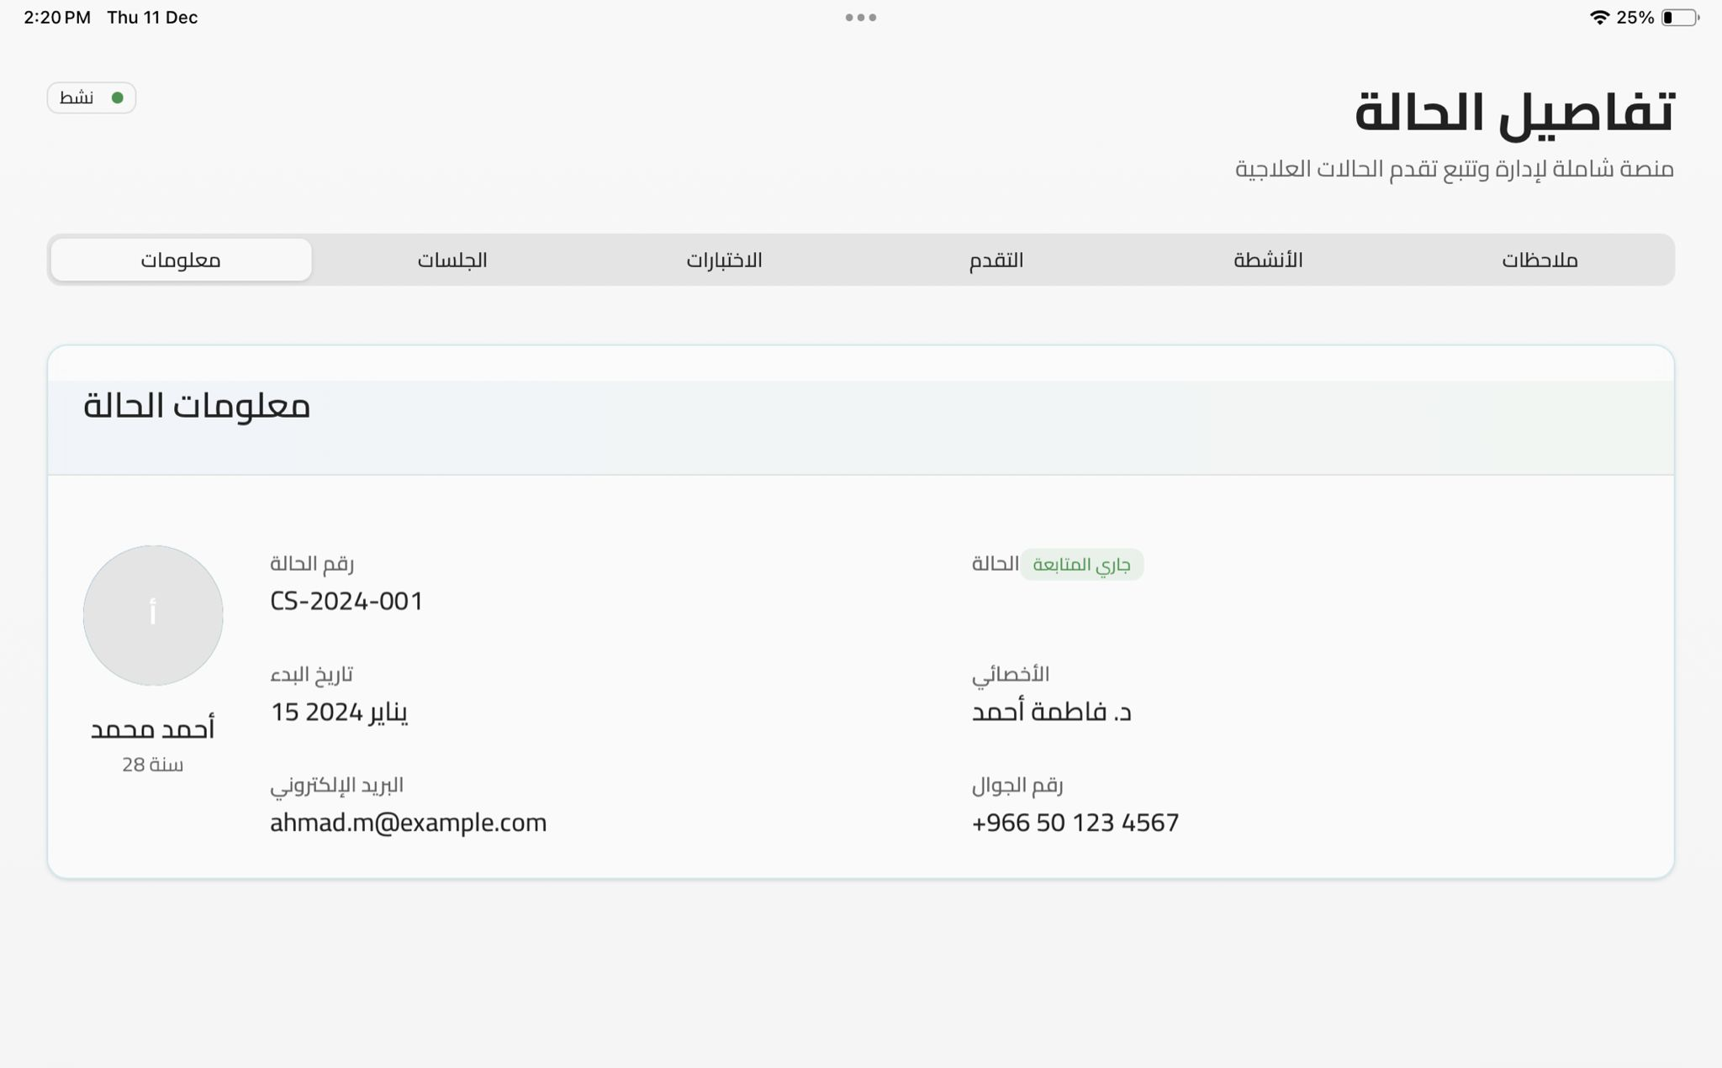
Figure 24 : Details Dashboard - Info Case
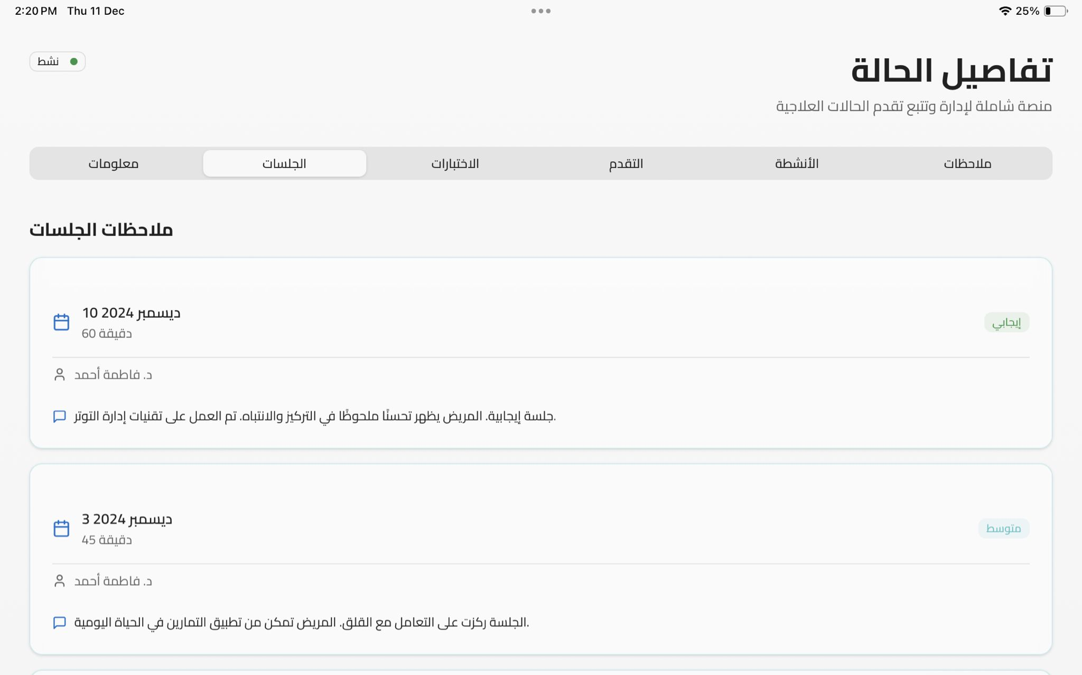
Figure 25 : Details Dashboard – Sessions
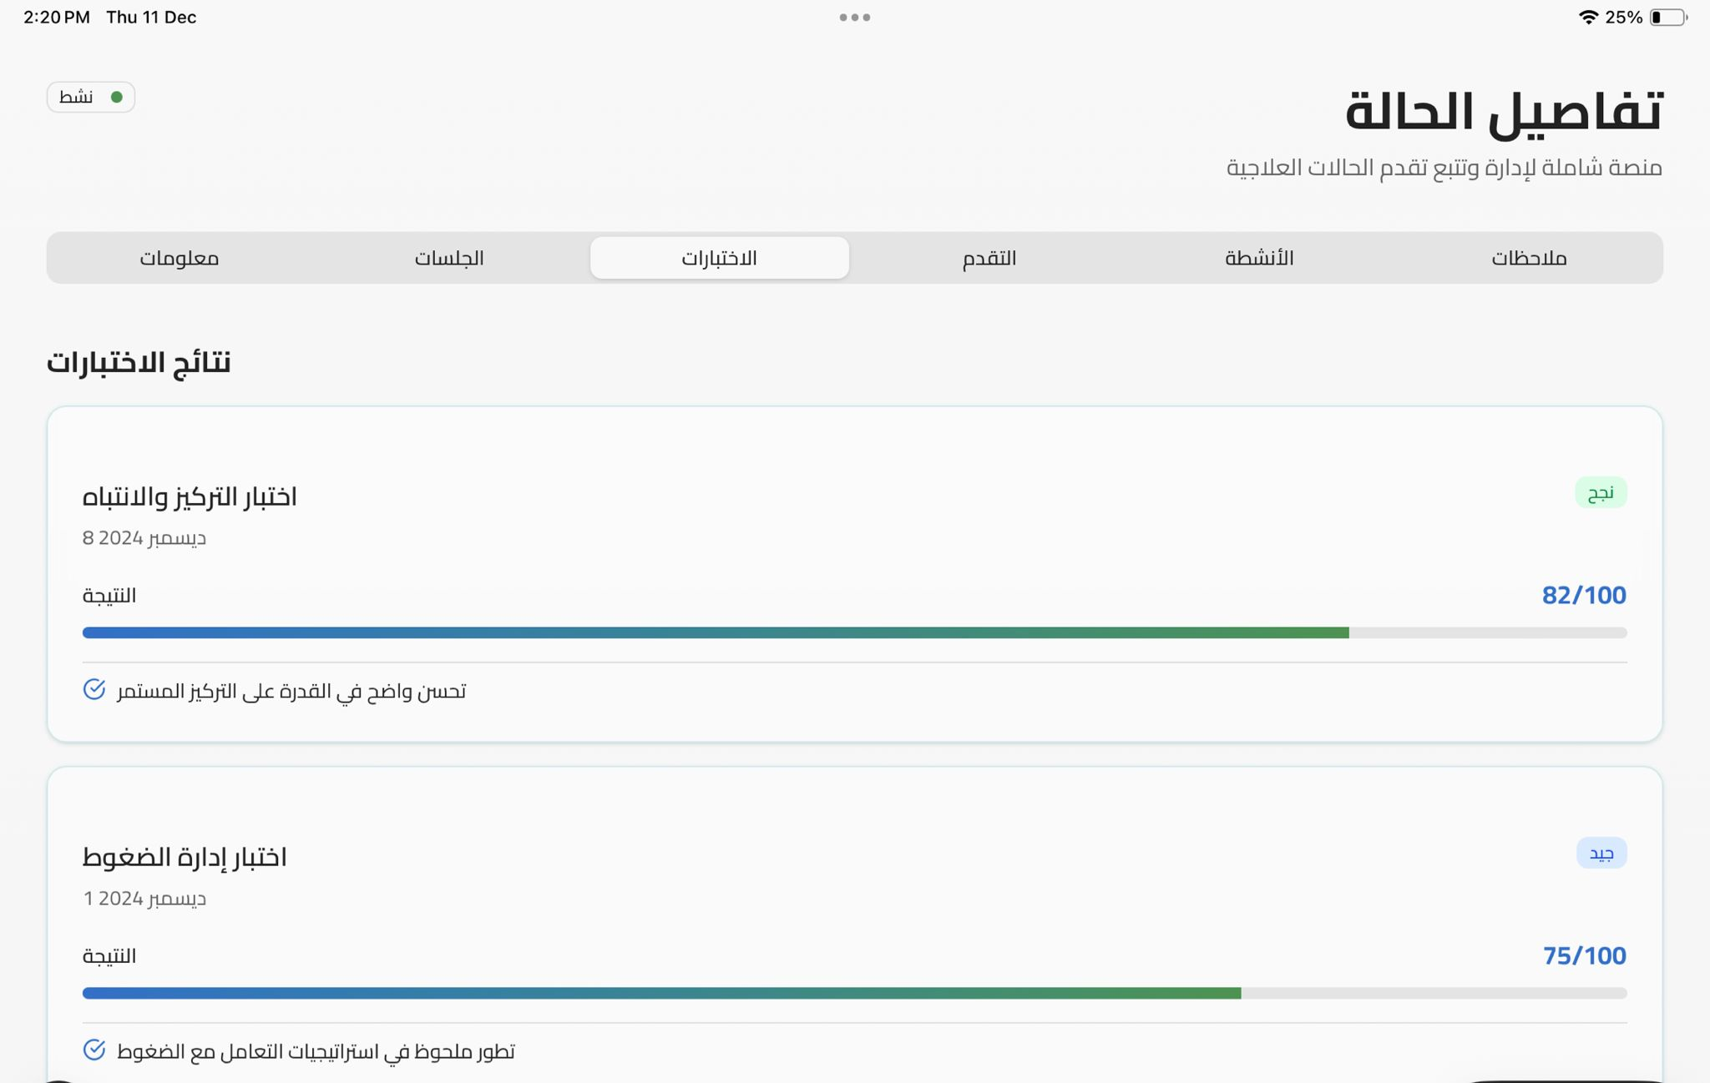
Figure 26 : Details Dashboard - Assessment
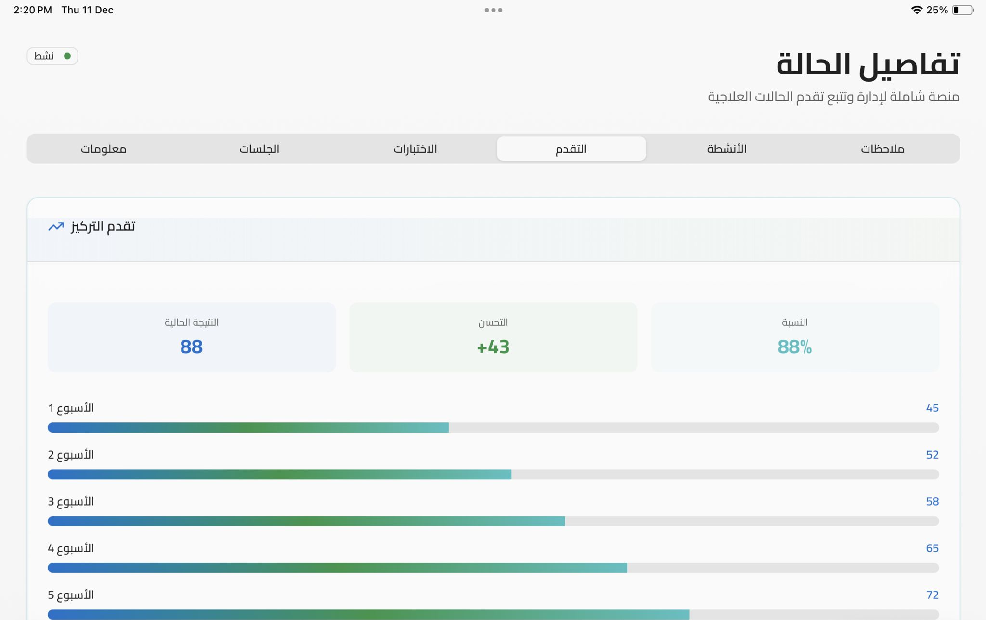
Figure 27 : Details Dashboard – Activities Progress
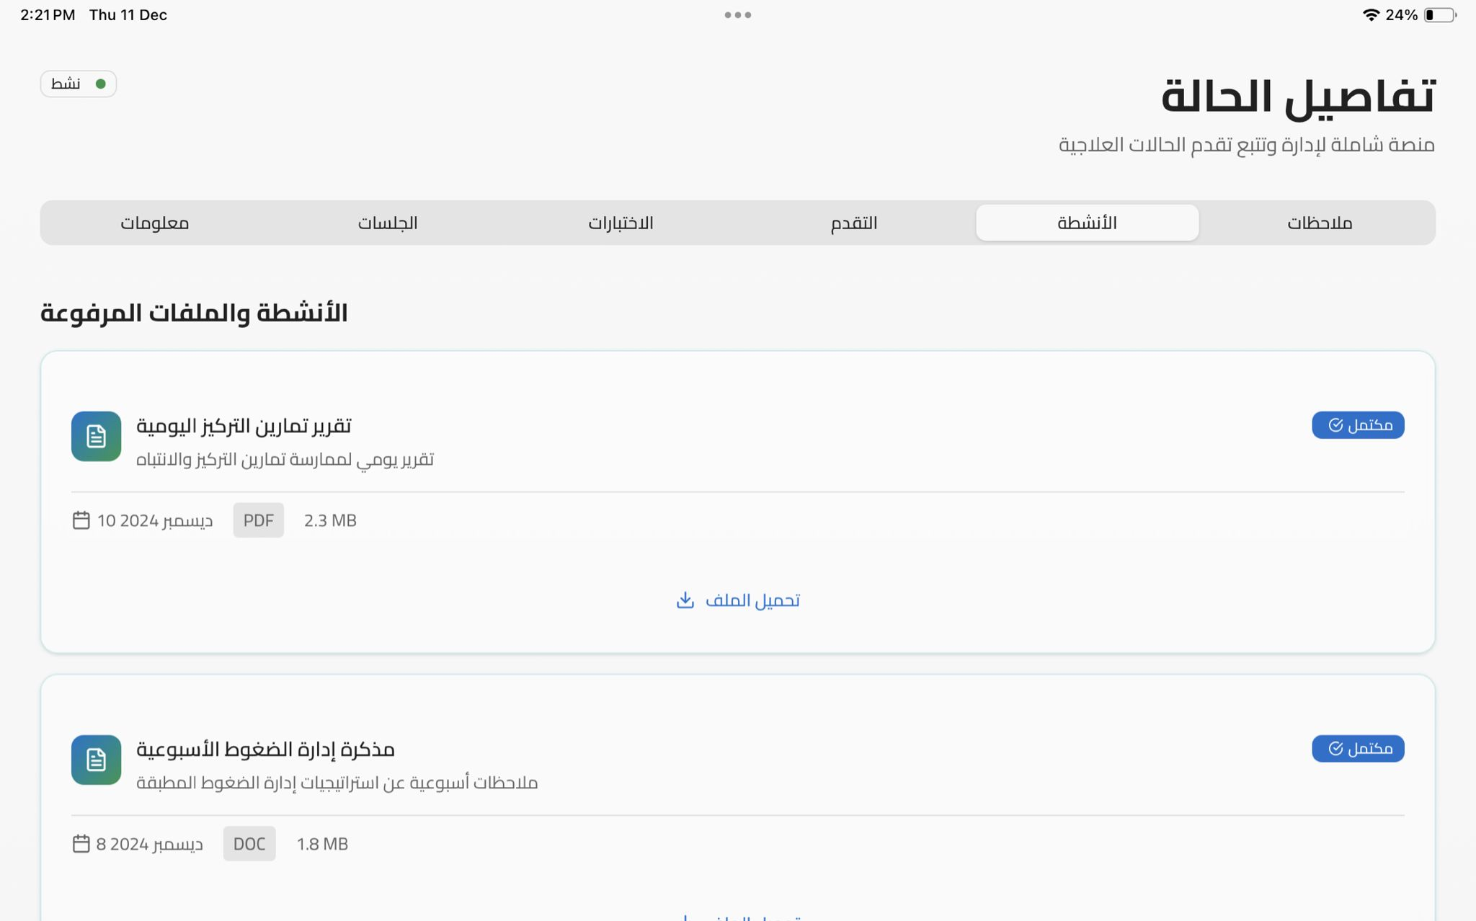
Figure 28 : Details Dashboard - Activities
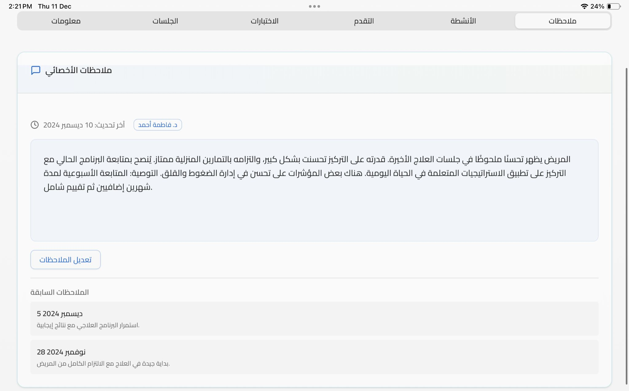
Figure 29 : Details Dashboard - Notes
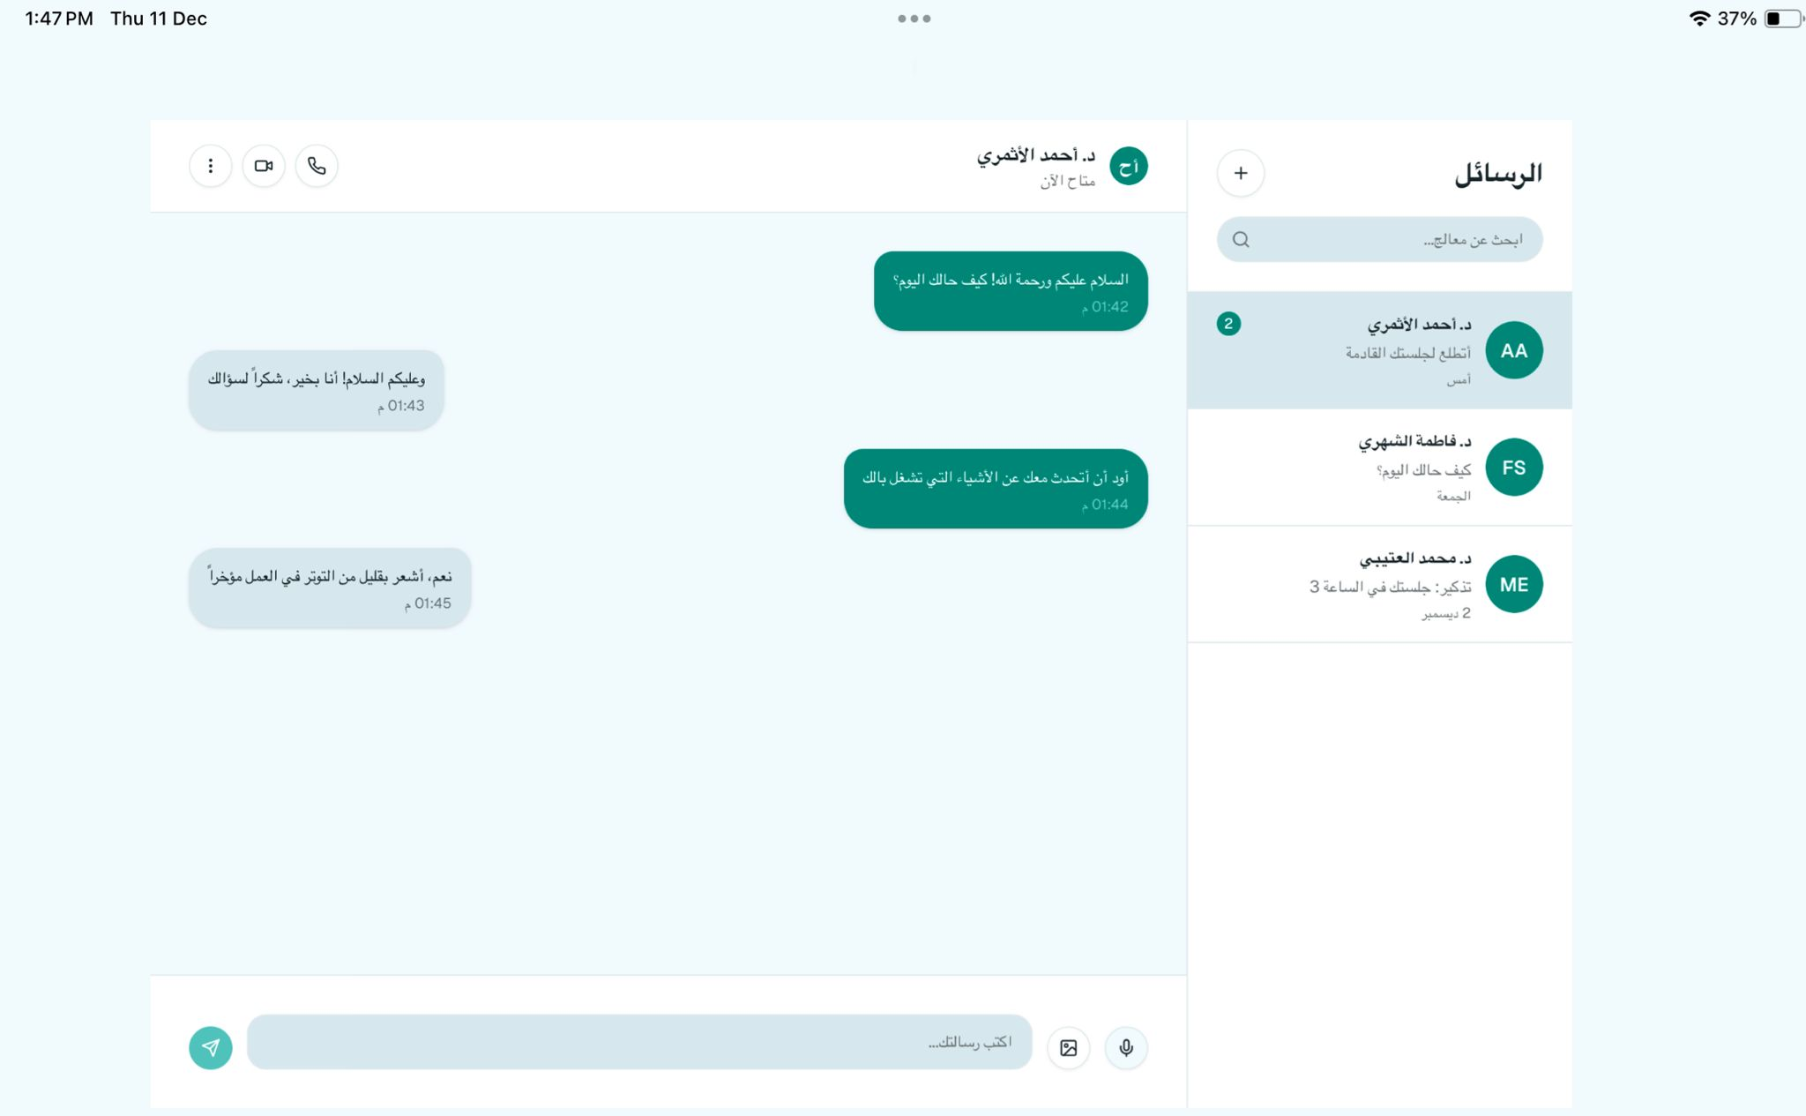
Figure 30 : Chat Page
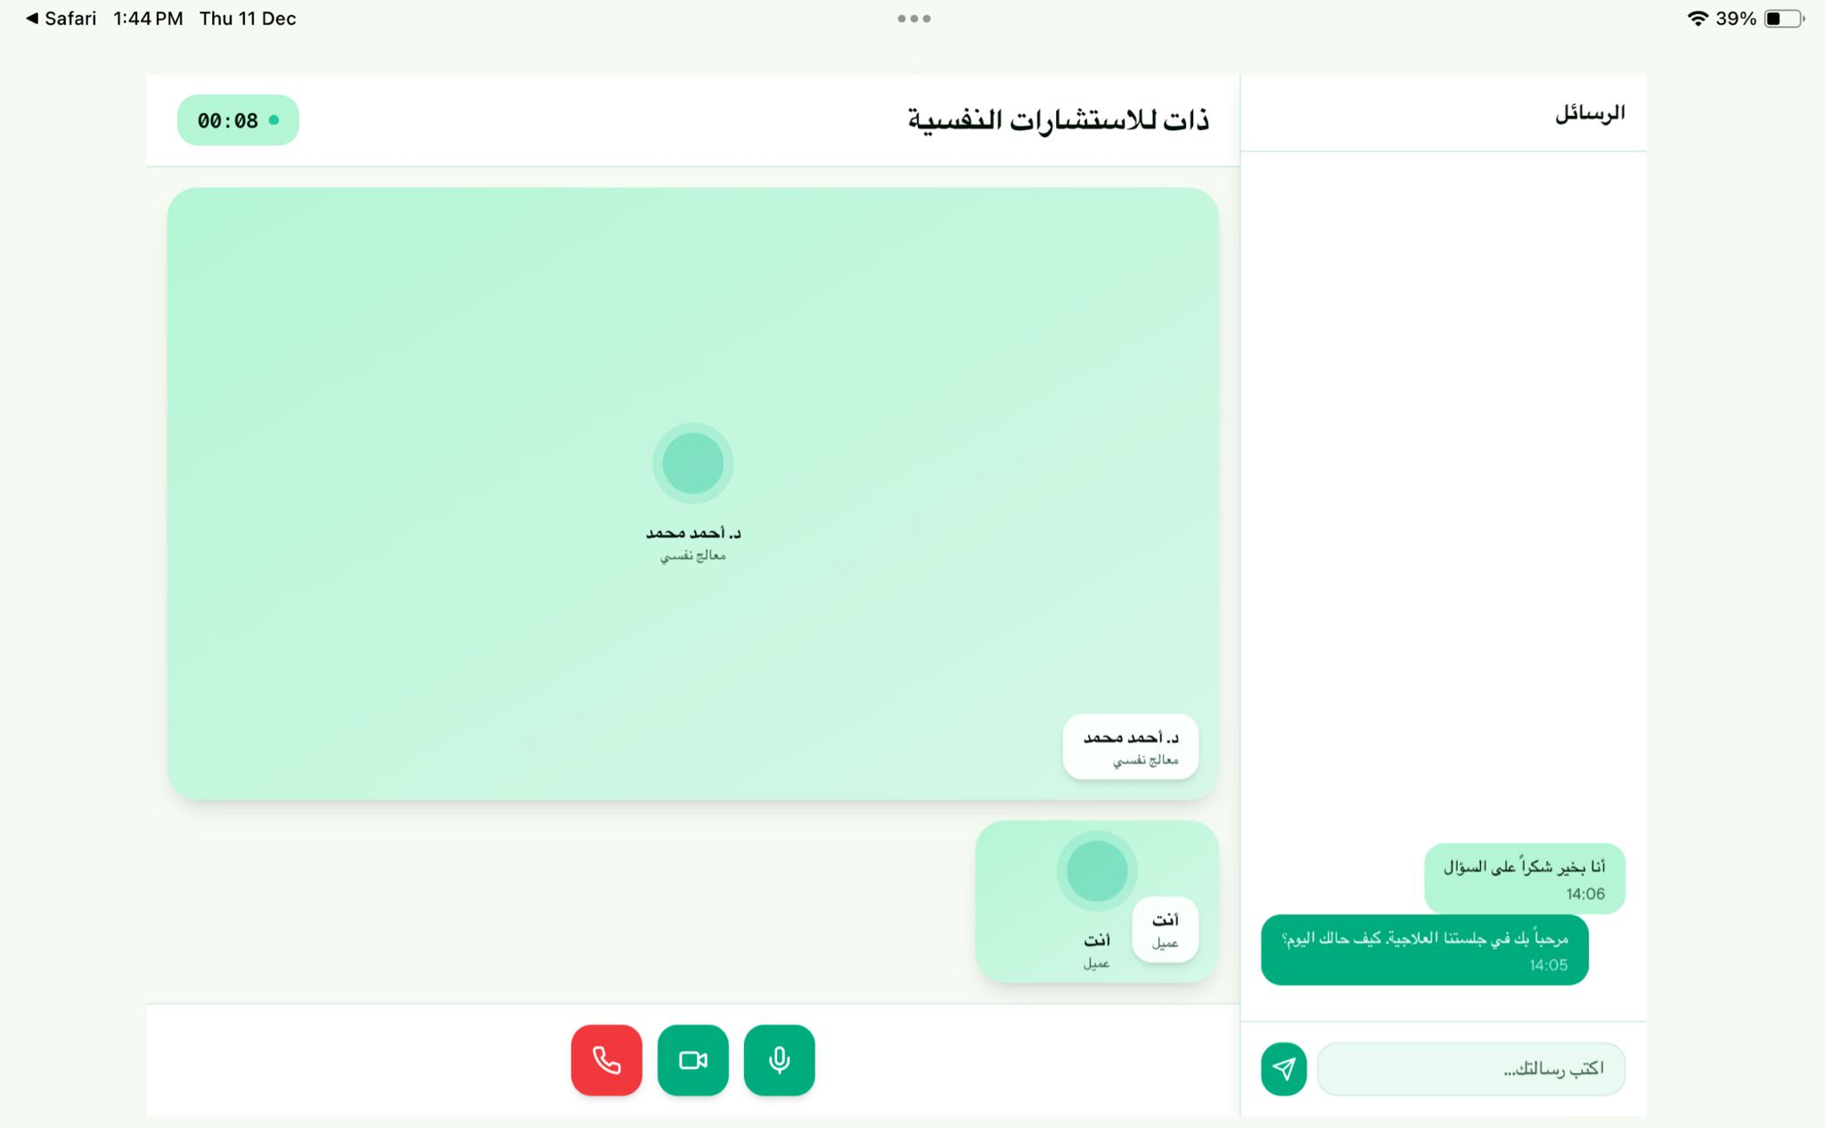
Figure 31 : Online Therapy Session
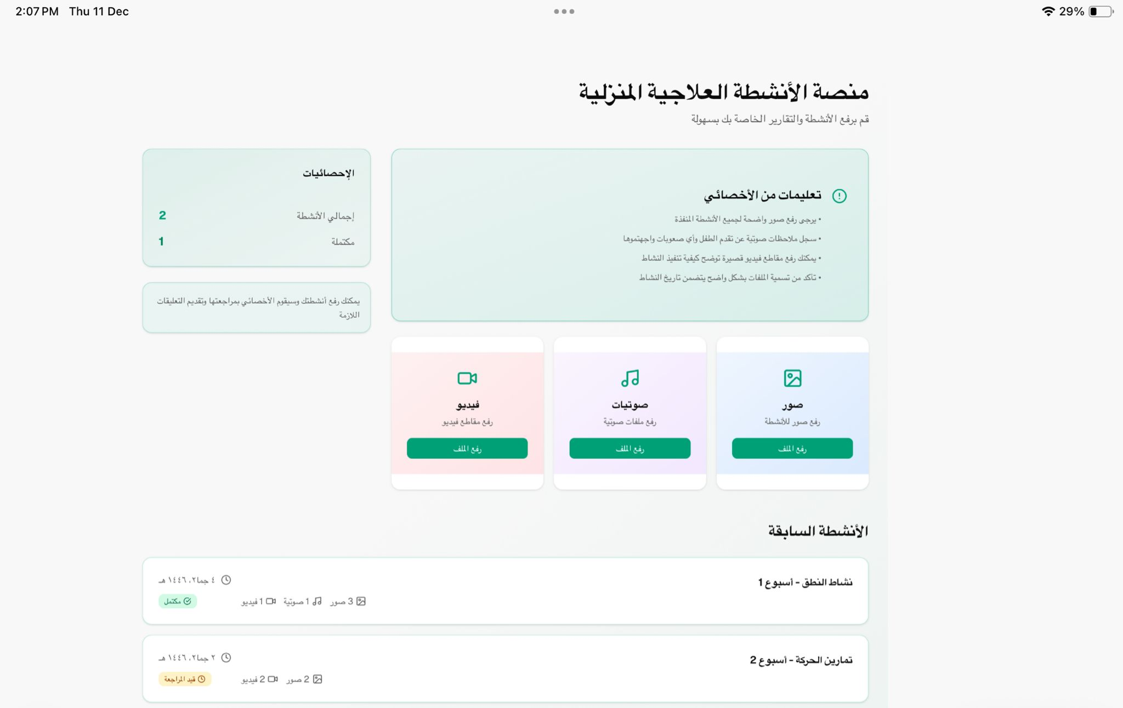
Figure 32 : Digital Therapy Activities
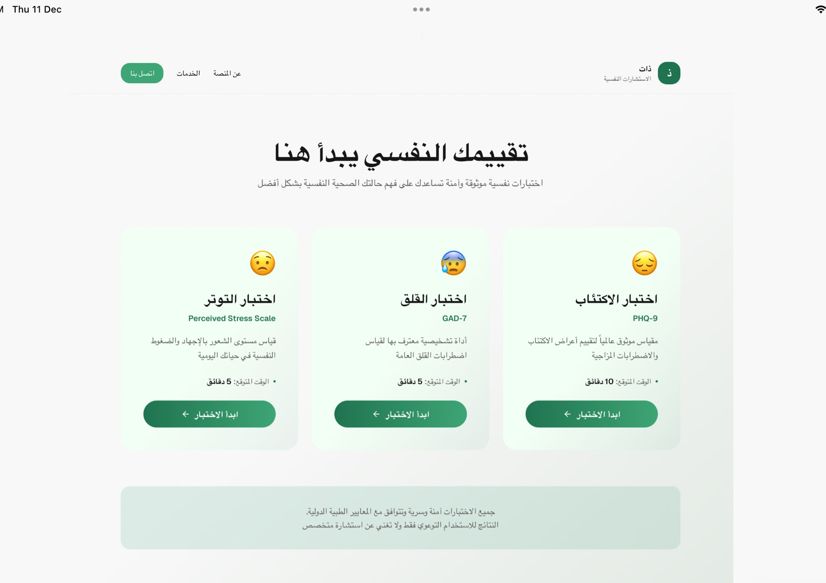
Figure 33 : Assessment Selection page
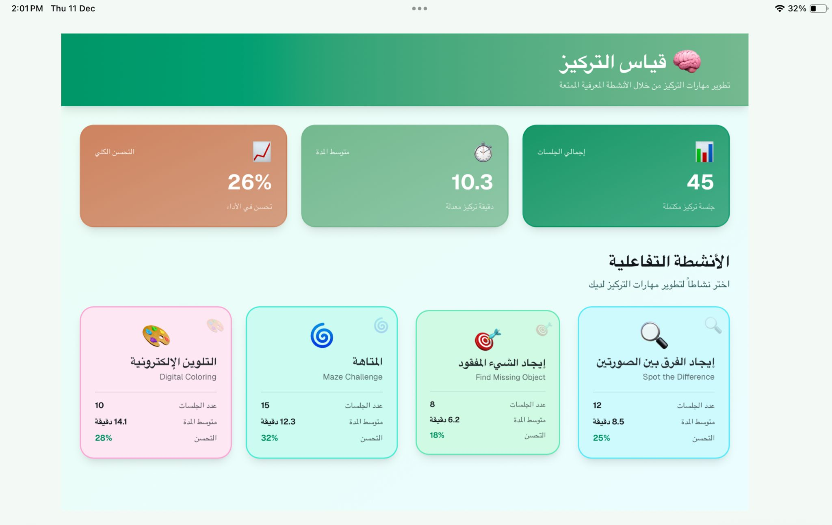
Figure 34 : Interactive Focus Assessment Selection
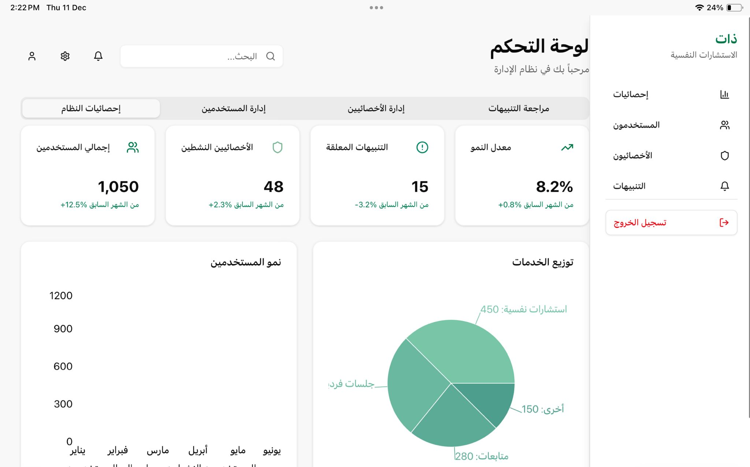
Figure 35 : Admin Dashboard - System Analytics
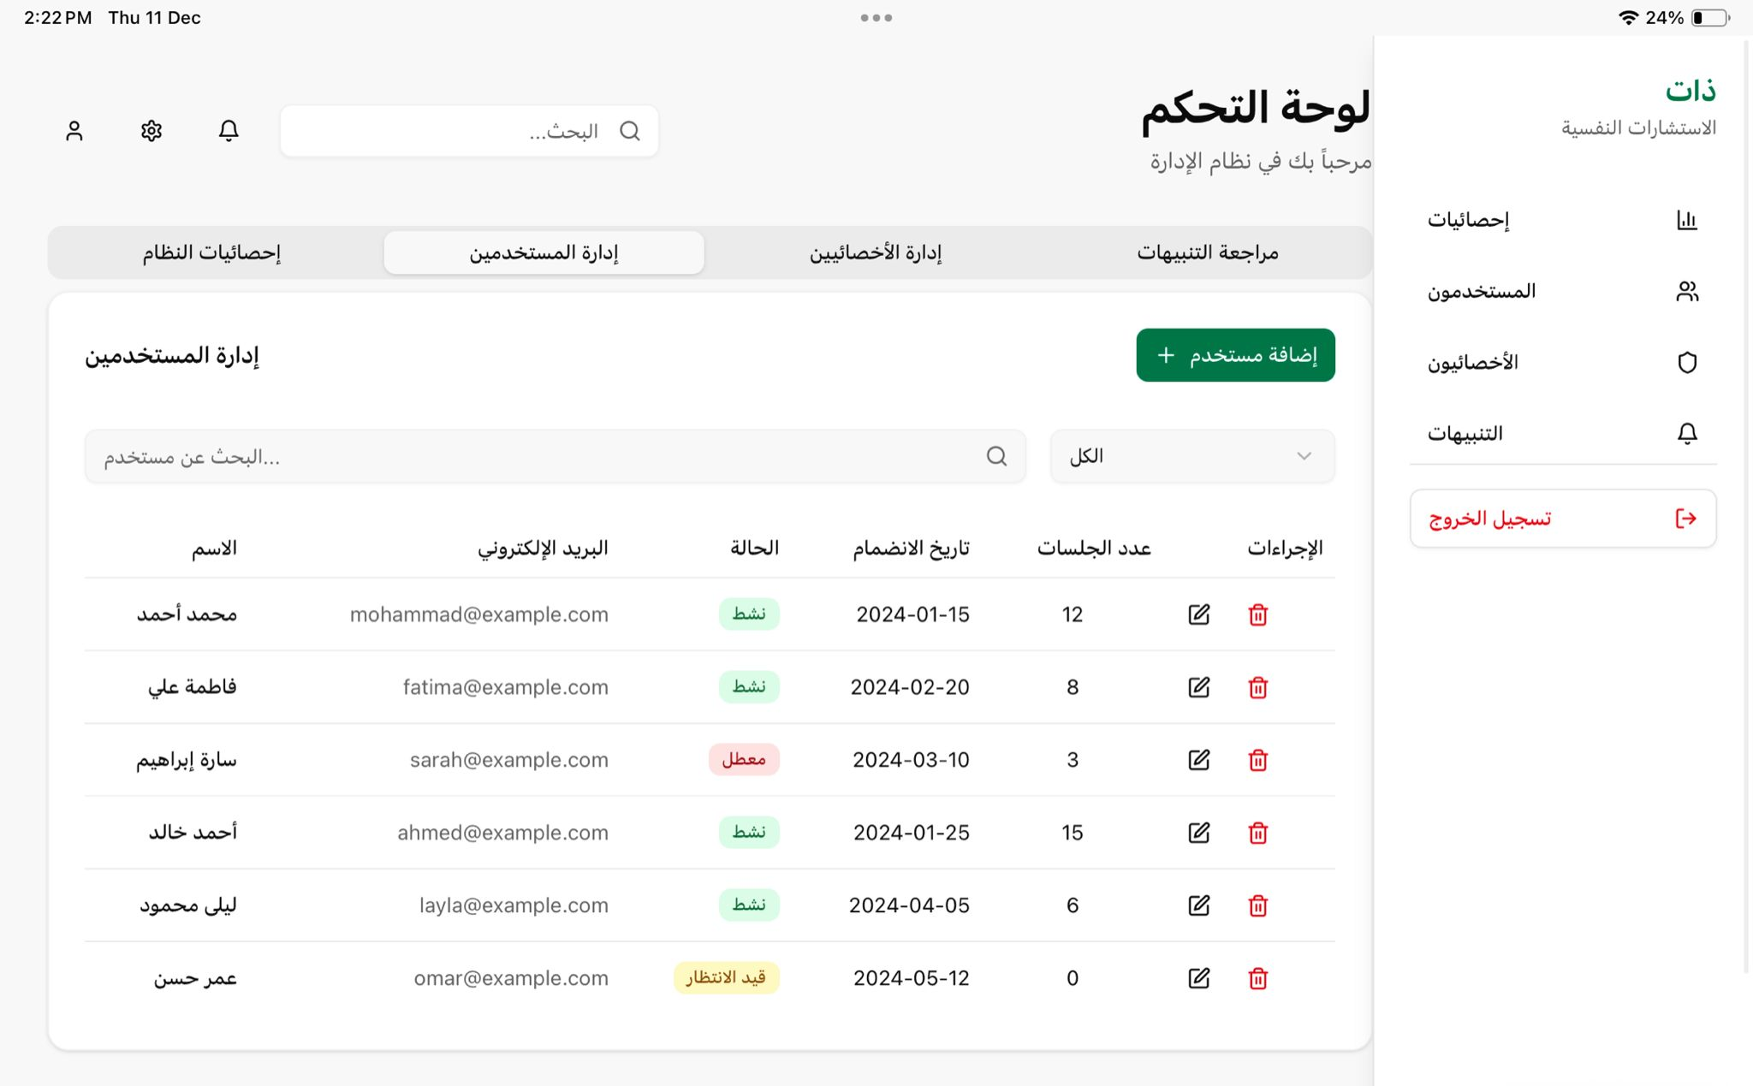
Figure 36 : Admin Dashboard - User Management
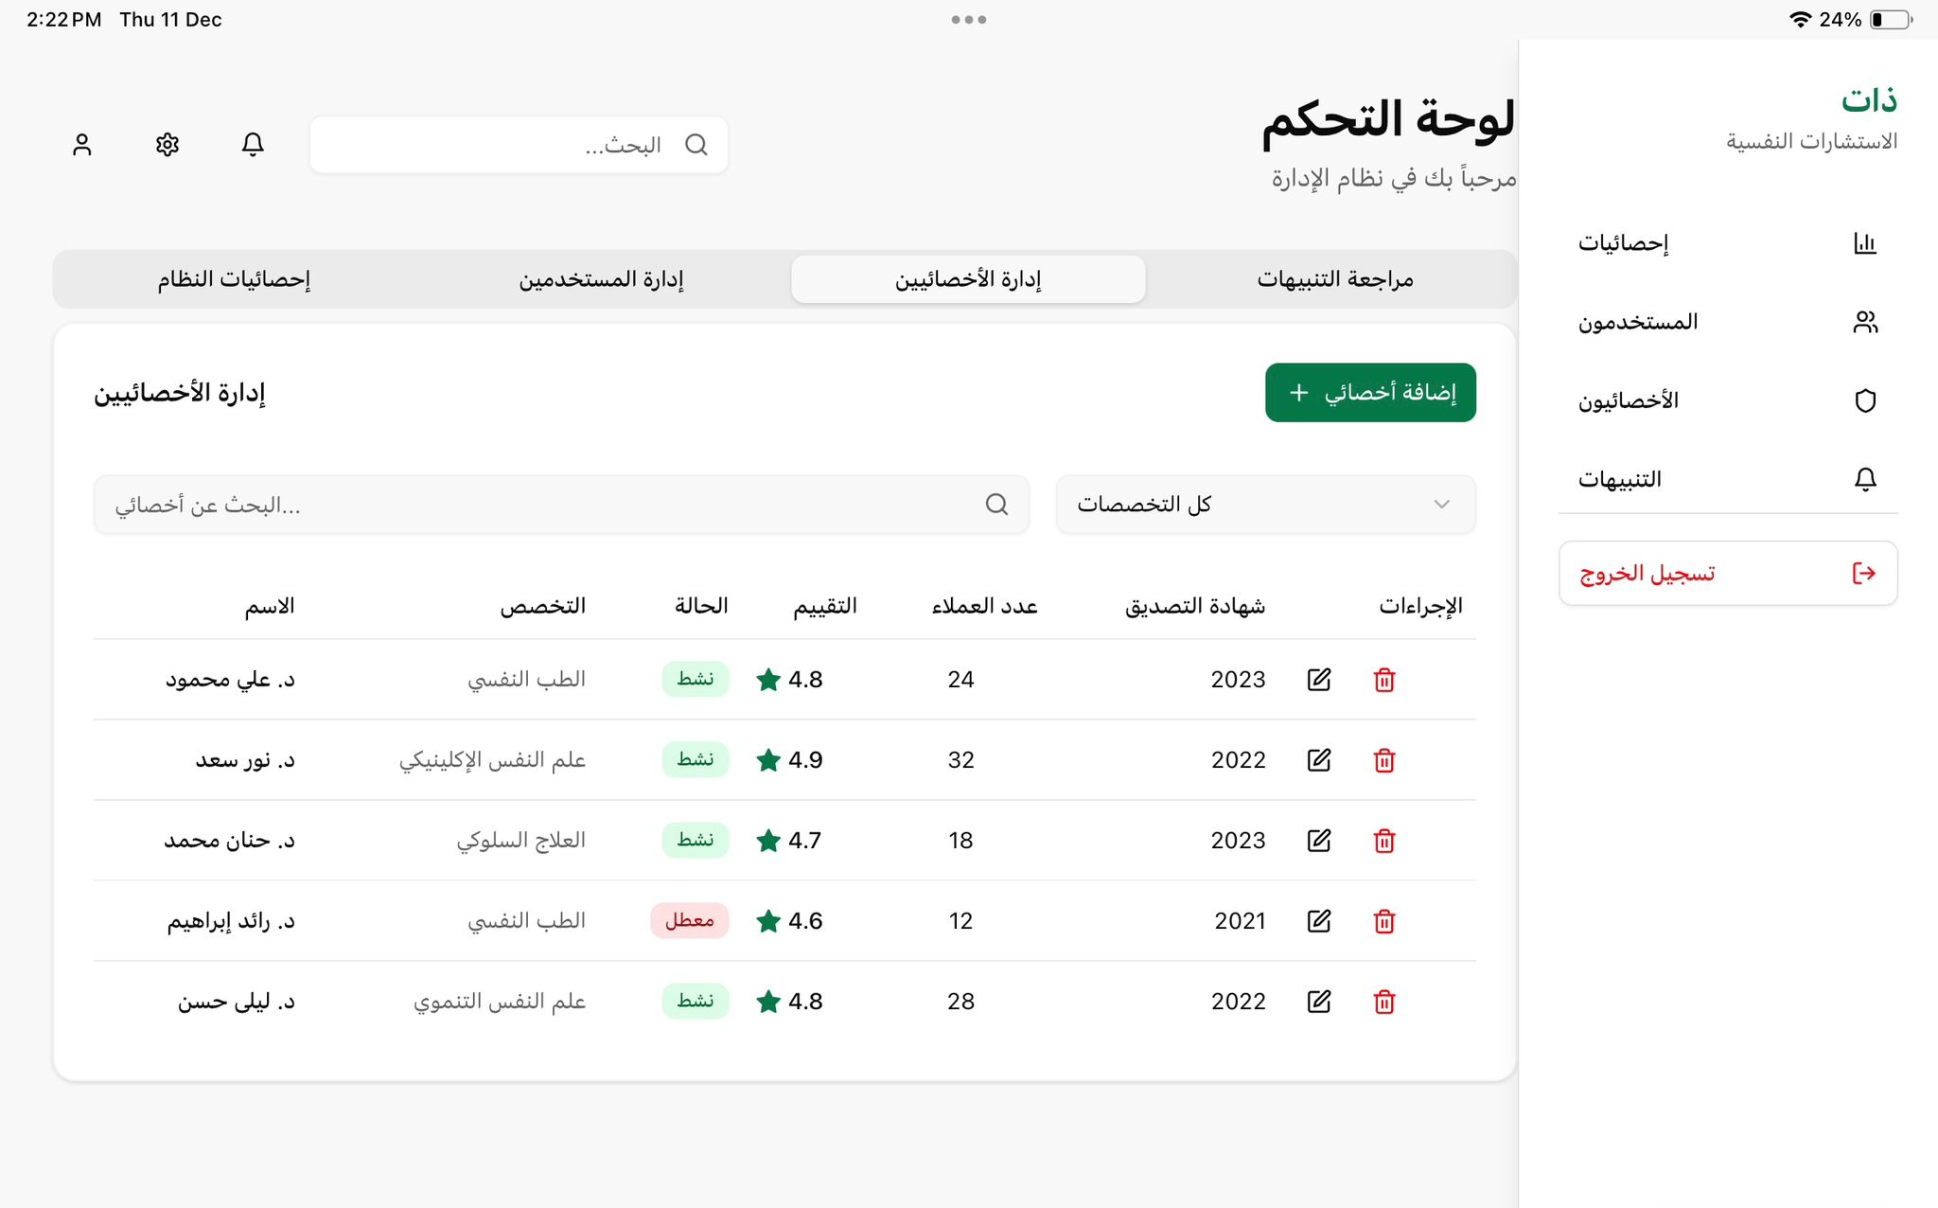
Figure 37 : Admin Dashboard - Therapist Management
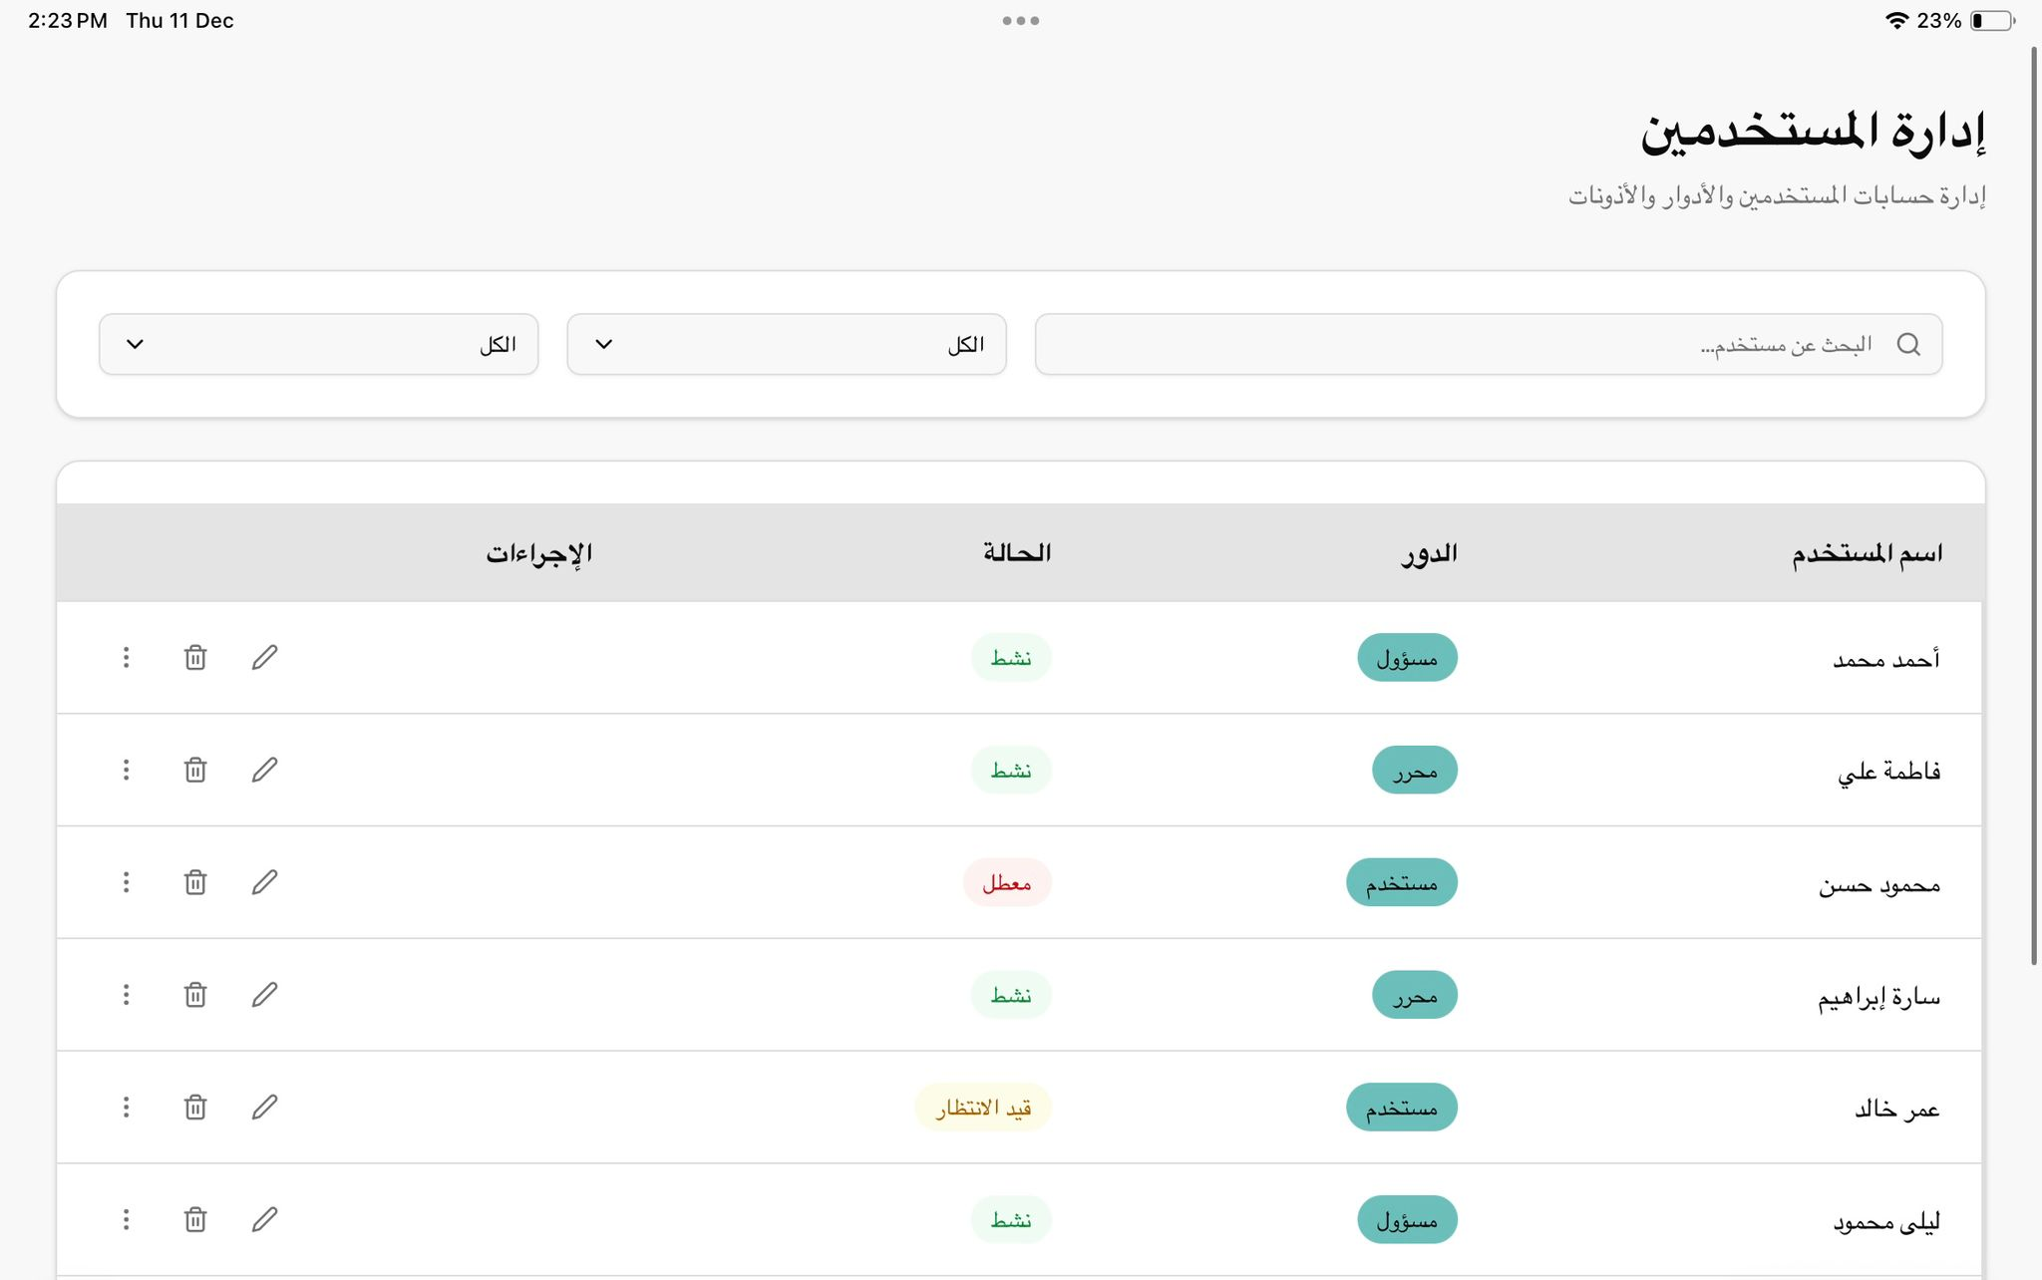
Figure 38 : Admin Dashboard - User Management
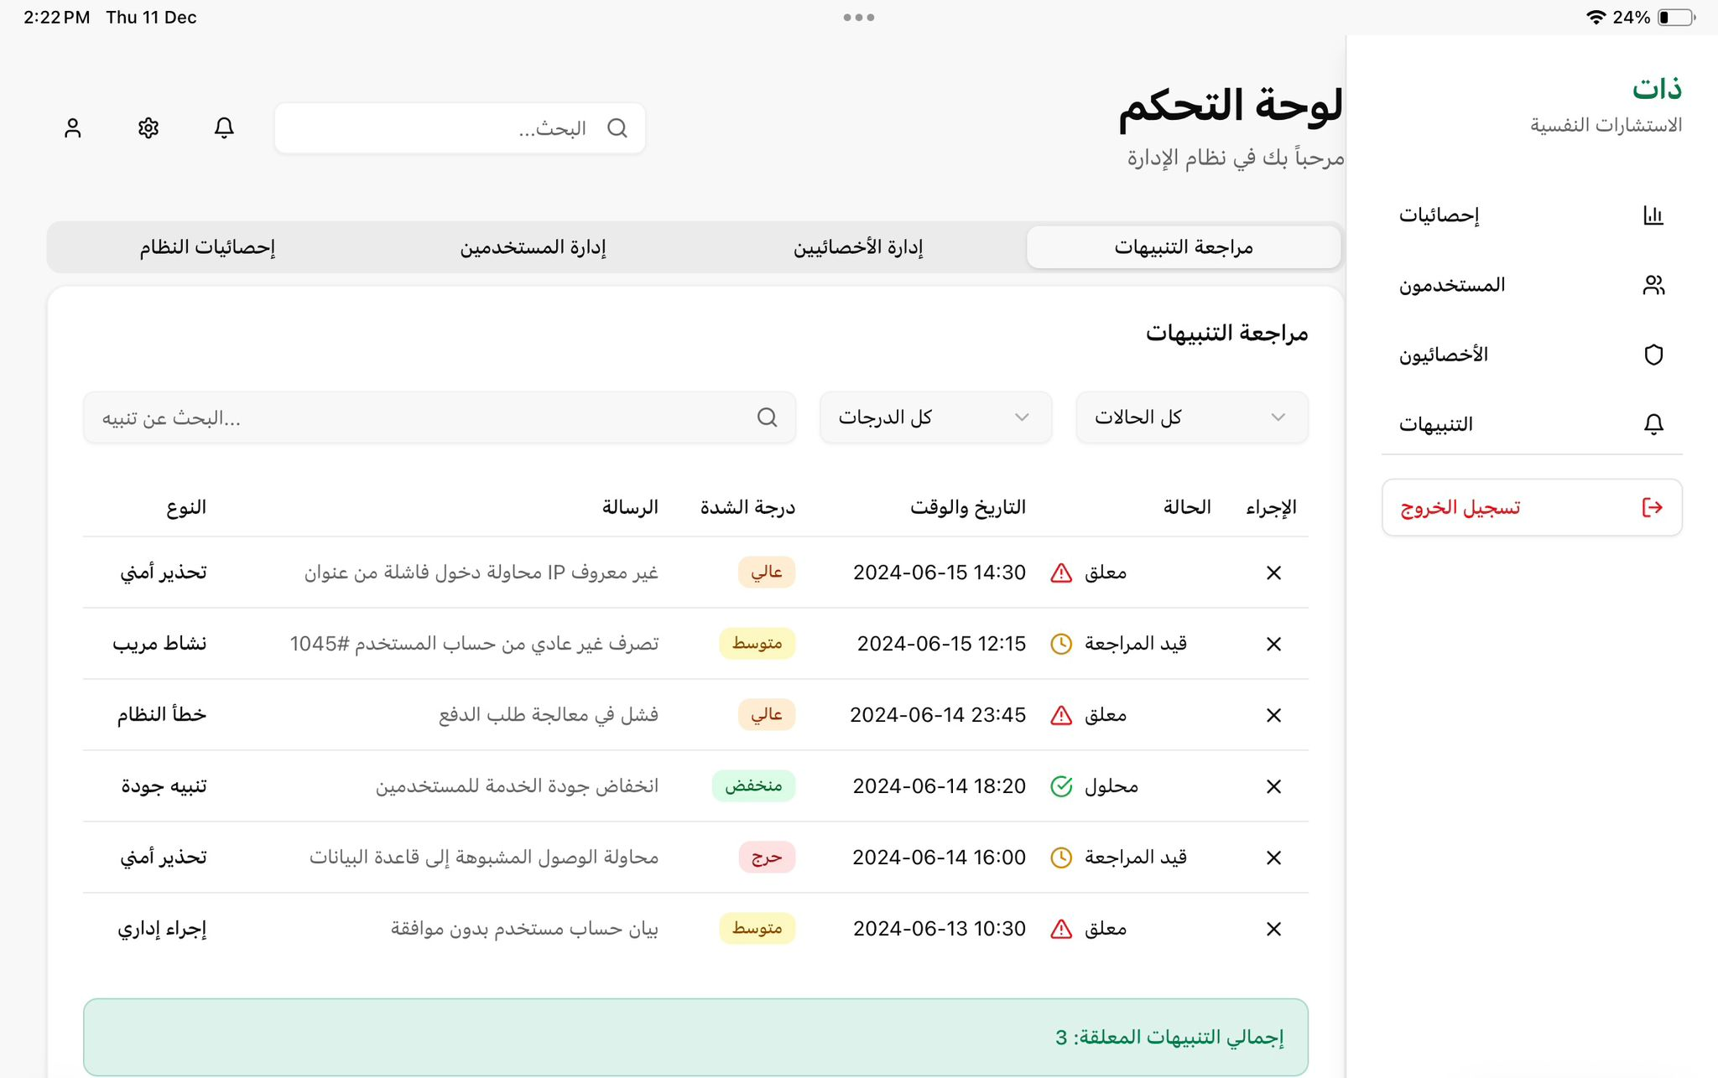
Figure 39 : Admin Dashboard – Notifications Management

CHAPTER 6:

TIMELINE

Table 2 : Timeline Work
Week | Tasks
Week 1 | Project Setup & Basic Pages:  - Set up the project folder and file.  - structure Connect frontend with design files.  - Build main pages (Home, Login, Register,).  - Apply basic styling and layout.
Week 2 | User & Specialist Interfaces:  - Create user dashboard layout.  - Build specialist profile pages.  - Add navigation menus and page links.  - Implement form validation on the frontend.
Week 3 | Appointment & Scheduling Interface:  - Design appointment booking pages.  - Create calendar and time slot views.  - Allow users to edit or cancel appointments.  - Improve user experience and flow.
Week 4 | Communication & UI Improvements:  - Build chat and online session pages (UI only).  - Design session entry and exit flow.  - Improve accessibility and responsiveness.  - Fix UI bugs and layout issues.
Week 5 | Therapeutic Tools Interface:  - Build therapeutic games pages.  - Create focus and activity interfaces.  - Design child-friendly layouts.  - Add interactive elements.
Week 6 | Admin & Events Interface:  - Build admin dashboard UI.  - Create pages for managing users and specialists.  - Build events and activities pages.  - Add notifications UI.
Week 7 | Frontend Integration:  - Connect all frontend pages together.  - Handle error messages and user feedback.  - Improve performance and load times.
Week 8 | Frontend Testing:  - Test all frontend features.  - Fix bugs and design issues.  - Final frontend review.
Week9 | Backend Setup & Authentication:  - Set up server and database.  - Create database tables.  - Implement login and registration logic.  - Define user roles (client, specialist, admin).
Week10 | Appointments & Records:  - Implement appointment booking logic.  - Store and manage user data.  - Implement session records and notes.
Week11 | Sessions & Communication:  - Implement online session management.  - Store reports and progress data.  - Connect backend with frontend features.
Week12 | Admin Backend & Integration:  - Implement admin controls.  - Manage specialists and users.  - Full frontend–backend integration.
Week13 | System Testing:  - Test all system functions.  - Check data accuracy and flow.  - Fix backend and frontend issues.
Week14 | Security & Performance:  - Improve data security.  - Test privacy and access control.  - Optimize system performance.
Week15 | Final Review:  - Final system testing.  - Prepare final version.  - Update documentation.
Week16 | Deployment:  - Deploy the system online  - Final checks  - Project submission

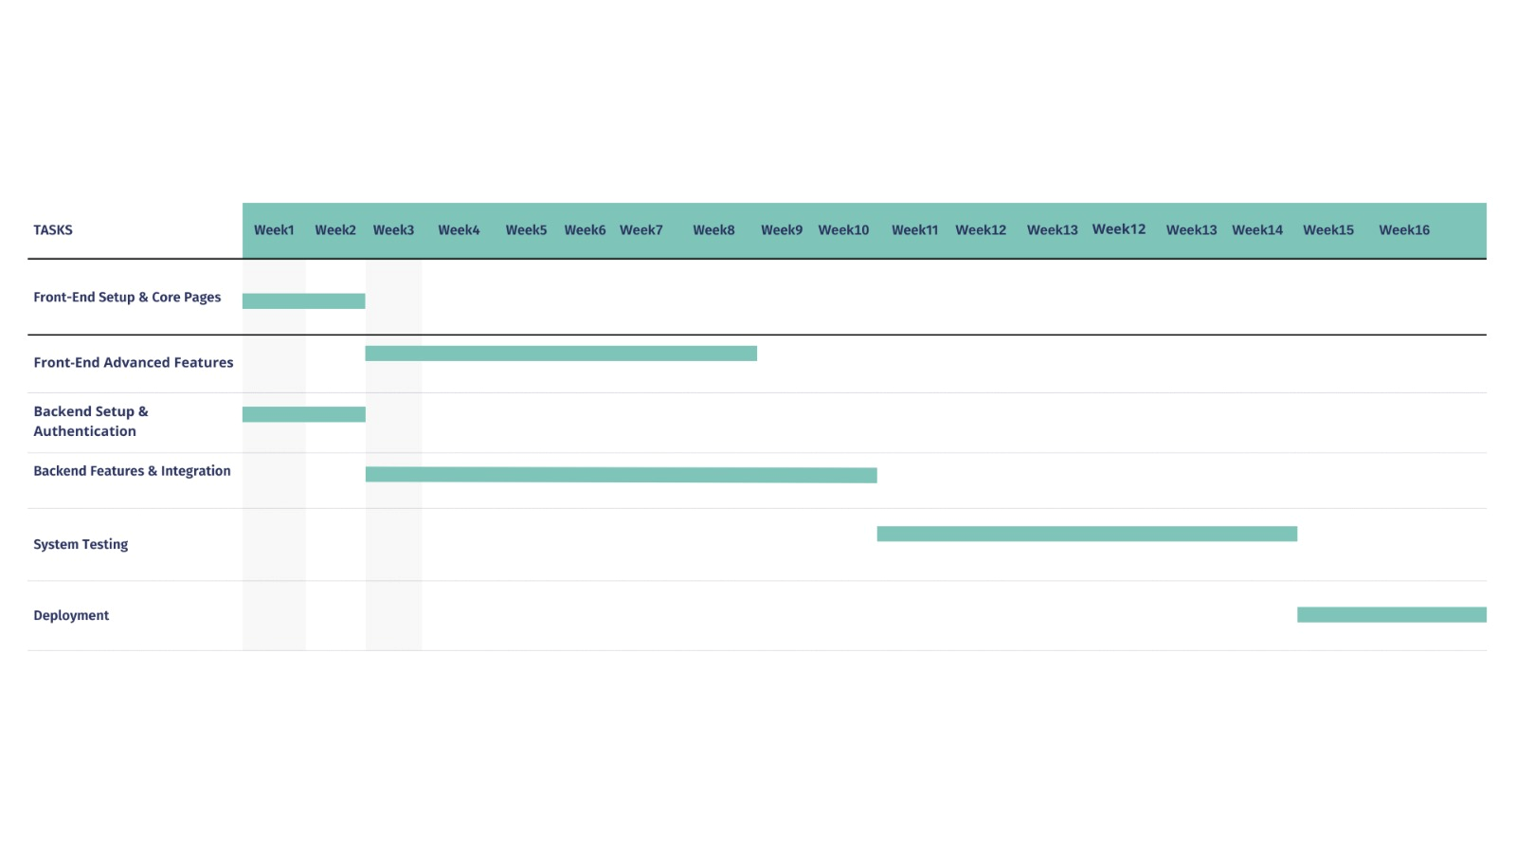
Figure 40 : TimeLine

[1] Zapata, B. C., Fernández-Alemán, J. L., Idri, A., & Toval, A. (2015). Empirical studies on usability of mHealth apps: A systematic literature review. Journal of Medical Systems, 39(2), 1–19.

CHAPTER 7:

REFERENCES

https://doi.org/10.1007/s10916-014-0182-2

[2] Torous, J., Larsen, M. E., Depp, C., Cosco, T. D., Barnett, I., Nock, M. K., & Firth, J. (2020). Smartphone apps for monitoring and supporting mental health: A systematic review. Frontiers in Psychiatry, 11, 104.
https://doi.org/10.3389/fpsyt.2020.00104

https://wa3ytherapy.com/ar
https://o7therapy.com/o7-therapy-global

