Construction project management system
The data requirements is the follows :
1. An EMPLOYEE is working on a project.
- an employee is identified by an employee ID and has attributes such as employee name, employee position, email, telephone number, and address.
- an employee can work on multiple projects.
2. a PROJECT is identified by a project ID.
- It has attributes such as project name, project description, project start date, and project end date.
- The project is worked on by a group of employees. -in project there is group of employee works on it.

3. The DEPARTMENT consists of work individuals.
- The department is defined by a D_number and has a Dname, contact information.
- The department has multiple tasks associated with it.
-department have any number of employee , but the one employee works in one department.
-department control multiple number of project but the project related to one department.
4. The TASKS are performed by the department members.
- The tasks are defined by a Task-ID and have a task description, task start date, task end date, and task status.
- Each member (employee) in the department can handle multiple tasks.
5. The RESOURCES are manufactured by the factory.
- The resource is identified by the resource ID and has the resource name, type, and information related to it
-Resources are tied to only one factory.
-each project need many resources to complete the work.
6. The FACTORY makes the resources that workers need to work in construction. - The factory is identified by the factory number in addition to the factory name, factory location, and factory information.
-Each factory supplies a set of building materials (resources).

7 . TIME LINE is where the time spent by each team member in performing their tasks is recorded.
- a timeline is identified by a Timeline ID and includes a timeline description, timeline start date, and timeline end date.
-Each timeline is associated with a set of reports.
-The timeline is related to one project and the project has one timeline.
8. REPORTS are used to document and evaluate the project progress.
- a report is identified by a Report ID and includes additional attributes such as report description and report creation date.
-Each report includes a single timeline.
-each report related to one project and the project has many report.

9. The CLIENT has contracts with the company.
- A client is identified by client ID and has these attributes: Client telephone-no and customer name.
-The client can be linked to more than one contract.
10. CONTRACTS are an agreement between the client and the company.
- Contracts identify by contract number, and has contract information, contract start date, contract end date.
- Contracts relate to one client but The client can has many contracts.
-contract is belong to one project and the project belong to many contract.
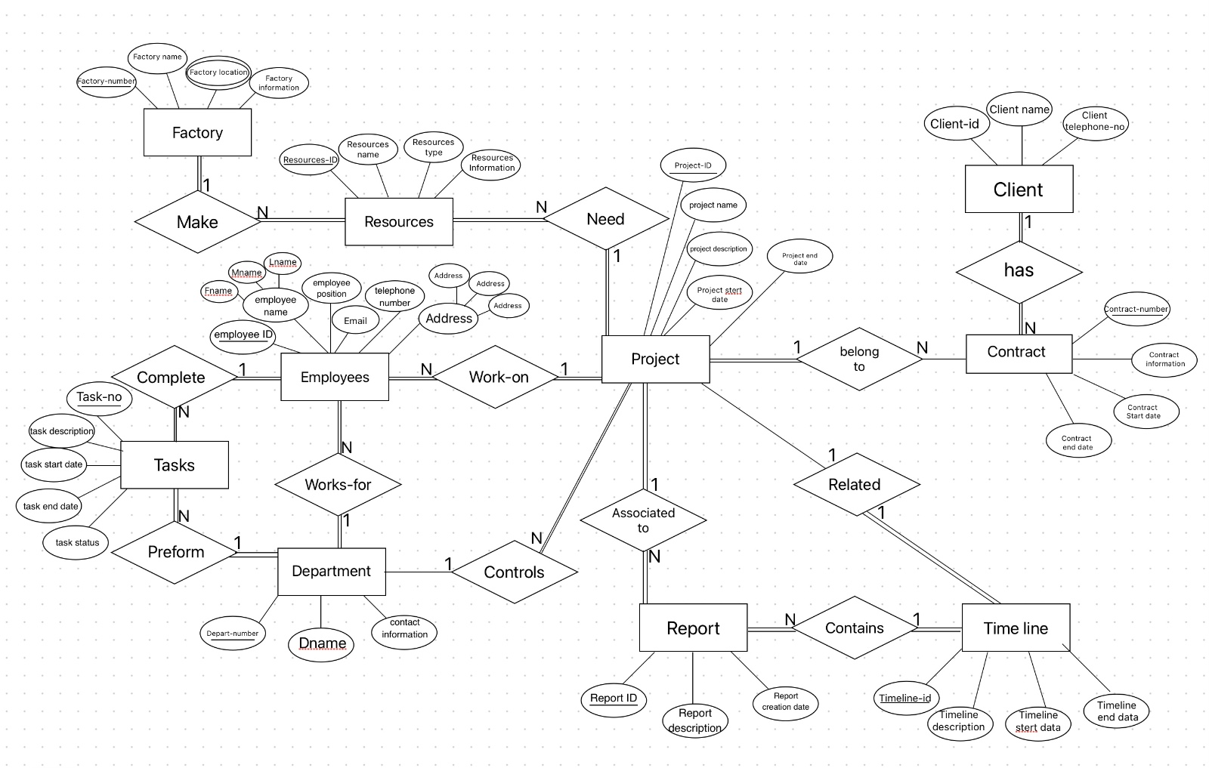
ER Diagram (conceptual data model):

Relational Data Model/ Relational SCHEMA :

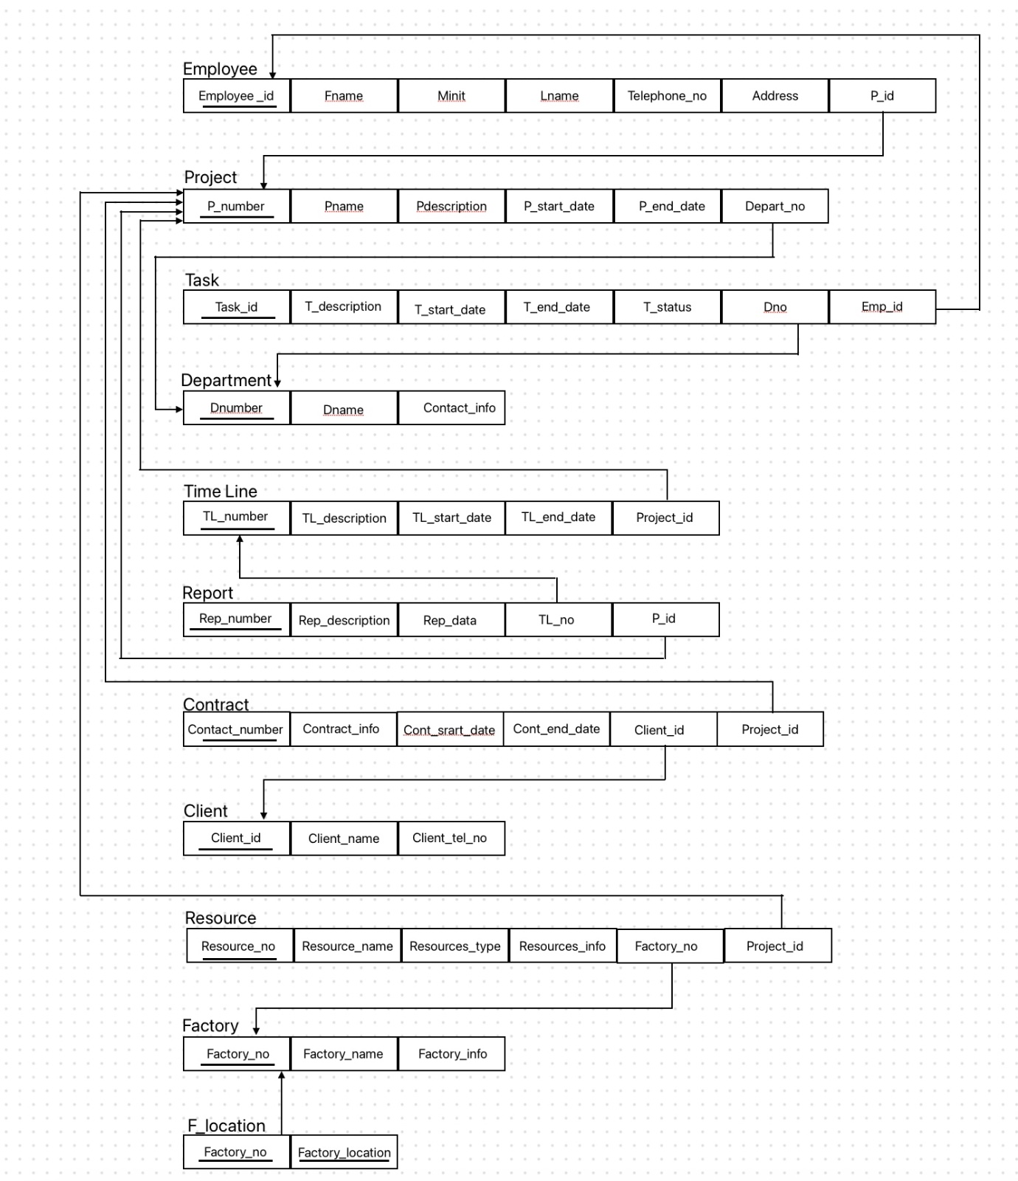

Emp_ID | fname | lname | position | contacts | project_id
123456789 | Gorge | Molten | Anstasia | gorge@gmail.com | 104
276543219 | Jane | Smith | Developer | Jane.smith@gmail.com | 102
345678912 | Sami | Ahmad | Ibrahim | Sam3@gamil.com | 105
987654312 | Davi | Johnson | Analyst | David.johnson@gamil.com | 103
987654321 | John | Doe | Manager | John.doe@gmail.com | 101
RELATIONAL DATABASE:
EMPLOYEE

DEPARTMENT
Dnumber | Dname | Contact_info
10 | HR | hr@gmail.com
20 | Finance | finance@gmail.com
30 | Marketing | marketing@gmail.com
40 | IT | it@gmail.com
50 | Operations | operations@gmail.com

F_LOCATION
Client_ID | Client_name | Client_tel_no
111111111 | Sarah Johnson | 0198567382
222222222 | Daniel Anderson | 0183471384
333333333 | Olivia Brown | 0148254345
444444444 | Willim Taylor | 0144772298
555555555 | Sophia Martinez | 0145322768
Factory_on | Flocation
1005 | Jazan
1010 | Makkah
1015 | Jeddah
1020 | Abha
1025 | Riyadh
CLIENT

FACTORY
Factory_info | Factory_name | Factory_on
This factory produces high-quality cement using ad… | Cement factory | 1005
This factory supplies reliable steel products… | Steel factory | 1010
This factory provides insulated glass for building… | Processed glass factory | 1015
This factory offers high-quality tiles and ceramic… | Tile and ceramic factory | 1020
This factory provides environmentally protected wo | Gin wood factory | 1025

Contracts_NUM | Contracts_info | Cont_start_date | Cont_end_date | client_ID | P_id
135792489 | Contract for interior design | 2022-04-10 | 2022-11-10 | 444444444 | 104
246813792 | Contract for electrical works | 2022-03-30 | 2022-09-30 | 333333333 | 103
789457897 | Contract for construction materials | 2022-01-01 | 2022-12-31 | 111111111 | 101
864297532 | Contract for landscaping | 2022-05-20 | 2022-10-20 | 555555555 | 105
987657216 | Contract for plumbing services | 2022-02-15 | 2022-12-15 | 222222222 | 102
P_number |  | Pname |  | Pdescription |  | Start_date |  | End_date |  | Depart_no
101 | ProjectM |  | Cooperative take management system |  | 2023-01-01 |  | 2023-04-10 |  | 50
102 | ProjectQ |  | Online foreign Language Learning platform |  | 2023-02-15 |  | 2023-07-20 |  | 40
103 | ProjectZ |  | Digital library management system |  | 2023-03-05 |  | 2023-06-15 |  | 30
104 | ProjectX |  | Corporate social networking Application |  | 2023-07-20 |  | 2023-09-19 |  | 20
105 | ProjectK |  | Commercial and entertainment complex |  | 2023-08-12 |  | 2023-11-23 |  | 20
R_no | R_name | R_type | resource_information | factory_no | Project_id
5557 | Wood metal | Metal | a high-quality | 1005 | 101
8766 | iron metal | Metal | Used for specific tasks | 1010 | 102
3255 | Oil | Energy resource | It is used for electricity | 1015 | 103
4499 | Gas | Natural resource | The item is natural | 1020 | 104
8822 | Coal | Natural resource | The item is natural | 1025 | 105
RESOURCES
PROJECT
CONTRACT

TL_number | timeline_date | timeline_description | timeline_end_date | Project_id
20 | 2023-04-10 | Installation of plumbing and electrical systems | 2023-07-20 | 104
21 | 2023-05-20 | Final inspection and handover | 2023-09-20 | 105
23 | 2023-03-30 | Completion of foundation work | 2023-08-15 | 103
24 | 2023-02-15 | Commencement of construction | 2023-04-20 | 102
25 | 2023-01-01 | Preparation of project proposal | 2023-02-20 | 101
TIMELINE

REPORT

Rep_number | Rep_description | report_creation_date | TL_no | P_id
3232 | Construction progress update | 2022-02-20 | 21 | 102
3344 | Initial project assessment | 2022-01-10 | 20 | 101
5432 | Quality inspection report | 2022-03-15 | 23 | 103
6789 | Post-construction evaluation | 2022-05-25 | 25 | 105
7766 | Project completion report | 2022-04-30 | 24 | 104

CONTRACTS

Contracts_NUM | Contracts_info | Cont_start_date | Cont_end_date | client_ID | P_id
135792489 | Contract for interior design | 2022-04-10 | 2022-11-10 | 444444444 | 104
246813792 | Contract for electrical works | 2022-03-30 | 2022-09-30 | 333333333 | 103
789457897 | Contract for construction materials | 2022-01-01 | 2022-12-31 | 111111111 | 101
864297532 | Contract for landscaping | 2022-05-20 | 2022-10-20 | 555555555 | 105
987657216 | Contract for plumbing services | 2022-02-15 | 2022-12-15 | 222222222 | 102

Schema DDL (SQL):
codes for COMS
CREATE TABLE employee (
employee_id INT NOT NULL,
fname VARCHAR(255),
lname VARCHAR(255),
position VARCHAR(255),
contacts VARCHAR(255),
p_id INT NOT NULL,
PRIMARY KEY( employee_id),
FOREIGN KEY (p_id) REFERENCES projects(p_number)
);

CREATE TABLE DEPARTMENT (
Dnumber Int NOT NULL,
Dname Varchar(15) NOT NULL,
Contract_info Varchar(30),
PRIMARY KEY (Dnumber) );

CREATE TABLE projects (
P_number INT NOT NULL ,
Pname varchar(15),
Pdescription varchar(50),
start_date DATE,
end_date DATE,
Depart_no INT NOT NULL ,
PRIMARY KEY (P_number),
FOREIGN KEY (Depart_no)REFERENCES DEPARTMENT(Dnumber)
);

CREATE TABLE TASK (
Task_id Int NOT NULL,
T_description Varchar(60),
T_start_date date NOT NULL,
T_end_date date NOT NULL,
T_status Varchar(20) NOT NULL,
Dno Int NOT NULL,
Emp_id Int NOT NULL,
PRIMARY KEY(Task_id),
FOREIGN KEY(Dno) REFERENCES DEPARTMENT (Dnumber),
FOREIGN KEY (Emp_id) REFERENCES employees (employee_id)
);

CREATE TABLE Timeline (
TL_number INT NOT NULL,
timeline_date DATE,
timeline_description VARCHAR(255),
timeline_end_date DATE,
project_id INT NOT NULL,
PRIMARY KEY(TL_number),
FOREIGN KEY (project_id)REFERENCES PROJECT(P_numper)
);

CREATE TABLE Reports (
Rep_number INT NOT NULL,
Rep_description VARCHAR(255),
Rep_creation_date DATE,
TL_NO INT NOT NULL,
p_id INT NOT NULL,
PRIMARY KEY(Rep_number),
FOREIGN KEY (TL_NO) REFERENCES timeline(TL_number),
FOREIGN KEY (p_id) REFERENCES projects(P_number)
);

CREATE TABLE client (
client_ID INT NOT NULL,
Client_name VARCHAR(15),
Client_tel_no VARCHAR(255),
PRIMARY KEY (client_ID)
);

CREATE TABLE contracts (
contracts_NUM INT NOT NULL,
contracts_info VARCHAR(255),
Cont_start_date DATE,
Cont_end_date DATE,
client_ID INT NOT NULL,
project_id INT NOT NULL,
PRIMARY KEY (contracts_NUM),
FOREIGN KEY (client_ID) REFERENCES client(client_ID),
FOREIGN KEY (project_id) REFERENCES projects(P_number)
);

CREATE TABLE factory (
factory_no INT ,
factory_name VARCHAR(255),
factory_info VARCHAR(255),
PRIMARY KEY(factory_no)
);

CREATE TABLE F_location(
Factory_no INT NOT NULL,
Flocation VARCHAR(100),
PRIMARY KEY (Factory_no,Flocation)
);

CREATE TABLE resources (
Resource_no INT NOT NULL,
Resource_name VARCHAR(20),
Resource_type VARCHAR(20),
Resource_info VARCHAR(150),
factory_number INT NOT NULL,
project_ID INT NOT NULL,
PRIMARY KEY (Resource_no),
FOREIGN KEY (factory_number) REFERENCES factory(factory_no),
FOREIGN KEY (project_ID) REFERENCES projects(P_number)
);

THE INSERTS:

INSERT INTO DEPARTMENT
VALUES
(10, 'HR', 'hr@gmail.com'),
(20, 'Finance', 'finance@gmail.com'),
(30, 'Marketing', 'marketing@gmail.com'),
(40, 'IT', 'it@gmail.com'),
(50, 'Operations', 'operations@gmail.com');

INSERT INTO TASK
VALUES
(324, 'Complete report', '2022-01-10', '2022-01-15', 'In progress',10,987654321),
(334, 'Prepare presentation', '2022-02-05', '2022-02-10', 'Completed',20,2765432198),
(232, 'Research market trends', '2022-03-01', '2022-03-10', 'In progress',30,987654312),
(213, 'Develop new feature', '2022-04-15', '2022-04-30', 'Pending',40,123456789),
(234, 'Review code quality', '2022-05-20', '2022-05-25','Completed',50,345678912);

INSERT INTO employee
VALUES
(987654321, 'John', 'Doe', 'Manager', 'john.doe@gmail.com', 5),
(276543219, 'Jane', 'Smith', 'Developer', 'jane.smith@gmail.com',6 ),
(987654312, 'Davi', 'Johnson', 'Analyst', 'david.johnson@gmail.com', 7),
(123456789, 'Gorge', 'Molten', 'Anstasia','gorge@gmail.com', 8),
(345678912, 'Sami', 'ahmed', 'Ibrahim', 'sam3@gmail.com', 9);

INSERT INTO projects
VALUES
(101,'projectM','Cooperative Task Management System','2023-01-01','2023-04-10',50),
(102,'projectQ','Online Foreign Language Learning Platform','2023-02-15','2023-07-20',40),
(103,'projectZ','Digital Library Management System','2023-03-05','023-06-15',30),
(104,'projectX','Corporate Social Networking Application','2023-07-20','023-09-19',20),
(105,'projectK','ommercial and Entertainment Complex','2023-08-12','2023-11-23',20);

INSERT INTO Timeline
VALUES
(025, '2023-01-01', 'Preparation of project proposal', '2023-02-20',101),
(024, '2023-02-15', 'Commencement of construction work', '2023-04-20',102),
(023, '2023-03-30', 'Completion of foundation work', '2023-08-15',103),
(020, '2023-04-10', 'Installation of plumbing and electrical systems', '2023-07-20',104),
(021, '2023-05-20', 'Final inspection and handover', '2023-09-20',105);

INSERT INTO Reports
VALUES
(3344, 'Initial project assessment', '2022-01-10',20 , 101),
(3232, 'Construction progress update', '2022-02-20',21 , 102),
(5432, 'Quality inspection report', '2022-03-15', 23, 103),
(7766, 'Project completion report', '2022-04-30', 24, 104),
(6789, 'Post-construction evaluation', '2022-05-25',25 , 105);

INSERT INTO client
VALUES
(111111111, 'Sarah Johnson', '0198567382'),
(222222222, 'Daniel Anderson', '0183471384'),
(333333333, 'Olivia Brown', '0148254345'),
(444444444, 'William Taylor', '0144772298'),
(555555555, 'Sophia Martinez', '0145322768');

INSERT INTO contracts
VALUES
(789457897, 'Contract for construction materials', '2022-01-01', '2022-12-31',111111111 , 101),
(987657216, 'Contract for plumbing services', '2022-02-15', '2022-12-15',222222222 , 102),
(246813792, 'Contract for electrical works', '2022-03-30', '2022-09-30',333333333 , 103),
(135792489, 'Contract for interior design', '2022-04-10', '2022-11-10', 444444444, 104),
(864297532, 'Contract for landscaping', '2022-05-20', '2022-10-20', 555555555, 105);

INSERT INTO factory
VALUES
(1005, 'Cement factory', 'This factory produces high-quality cement using advanced techniques.'),
(1010, 'steel factory', 'This factory supplies reliable steel products and components for construction projects.'),
(1015, 'Processed glass factory', 'This factory provides insulated glass for building facades and windows.'),
(1020, 'Tile and ceramic factory', 'This factory offers high-quality tiles and ceramics for building finishes.'),
(1025, 'Gin wood factory', 'This factory provides environmentally protected wood for building structures.
');

INSERT INTO f_location
VALUES
(1005,'JAZAN'),
(1010,'MAKKAH'),
(1015,'JEDDAH'),
(1020,'ABHA'),
(1025,'RIYADH');

INSERT INTO resources
VALUES
(5557,'Wood metal','Metal','a high quality',1005,101),
(8766,'iron metal','Metal','Used for specific tasks',1010,102),
(3255,'Oil','Energy resources','it is used for electricity',1015,103),
(4499,'Gas','Natural resource','the item is natural', 1020,104),
(8822,'Coal','Natural resource','the item is natural',1025,105);

