Survey
*A questionnaire was created to collect information from the target audience of our project, The details of the survey can be found below
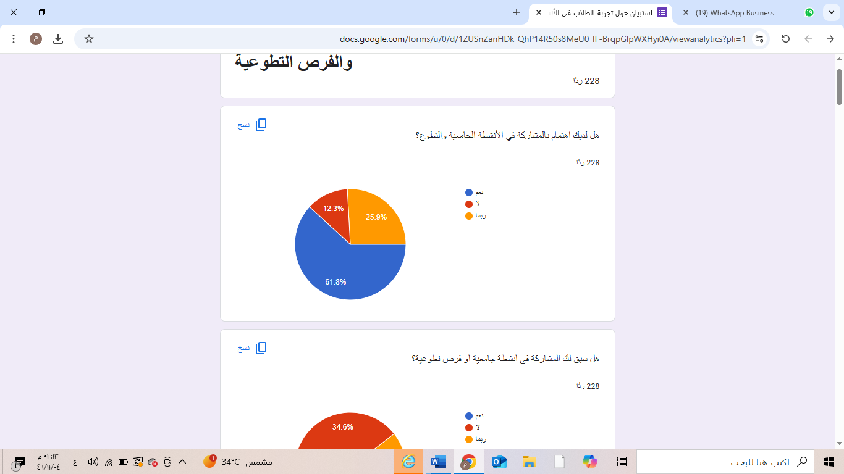

Analysis:
It is evident that the majority (about two-thirds of the sample) have a clear interest in
participating in university activities and volunteering. Meanwhile, around 12.3% are not
interested, and approximately 26% are still undecided. This result indicates a large
student base interested in activities if they are well-organized and accessible.
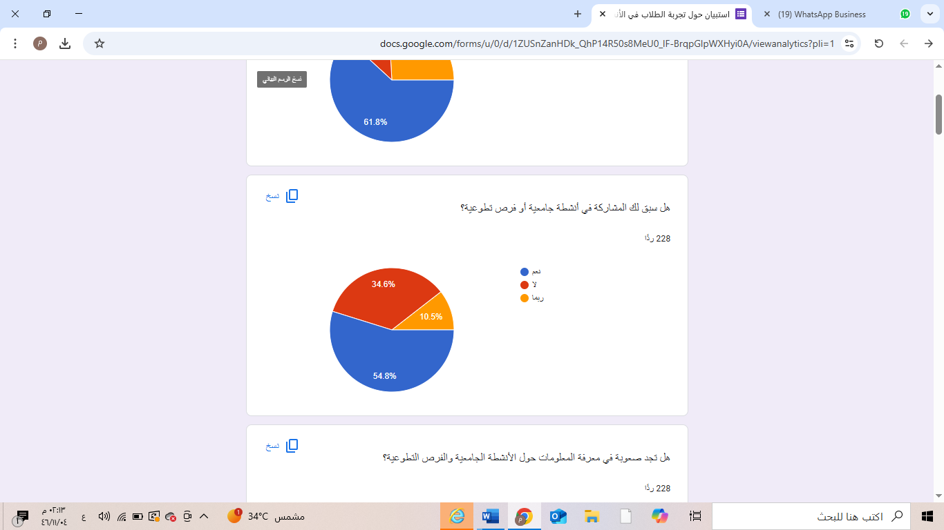

Analysis:
More than half of the respondents have previously participated in university activities or volunteer opportunities, suggesting positive or negative past experiences. On the other hand, about one-third have never participated, possibly due to a lack of awareness or organizational/personal challenges
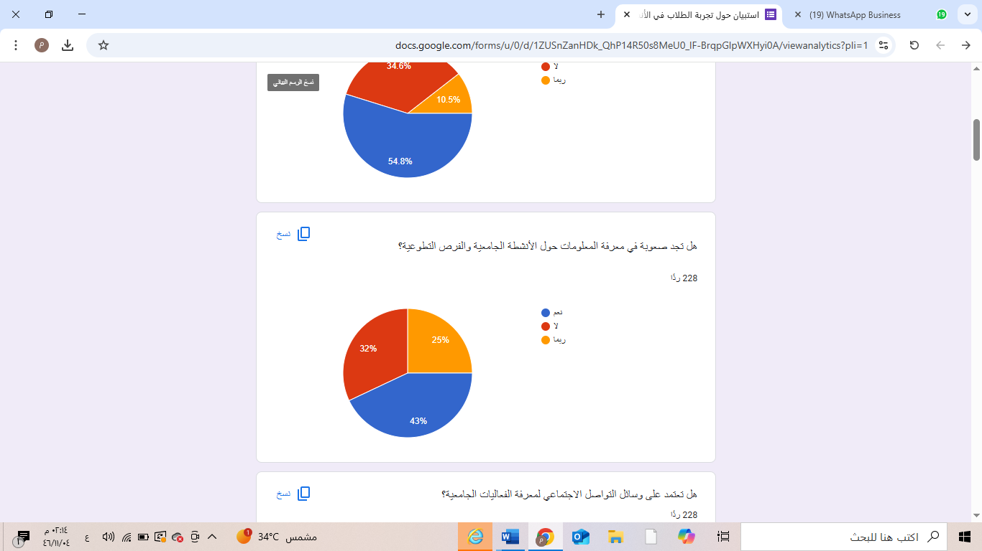

Analysis:
A significant percentage of students (about 43%) struggle to access the necessary
information about activities, while around 32% do not face difficulties, and nearly
25% responded with “Maybe.” This highlights the problem of scattered inform\ation
or weak official communication channels
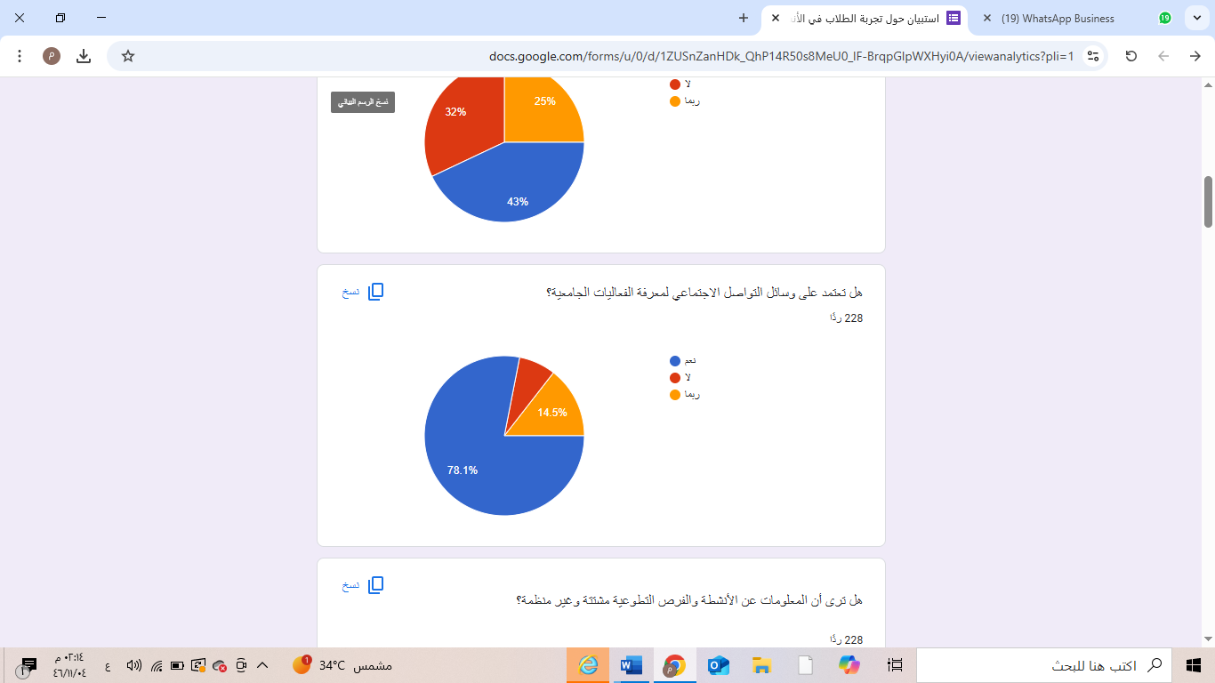

Analysis:
The results show that a large majority (over 75%) rely on social media for information
about university events. This clearly indicates a lack of a unified official platform or
its inefficiency, leading students to depend on platforms like Twitter and WhatsApp.
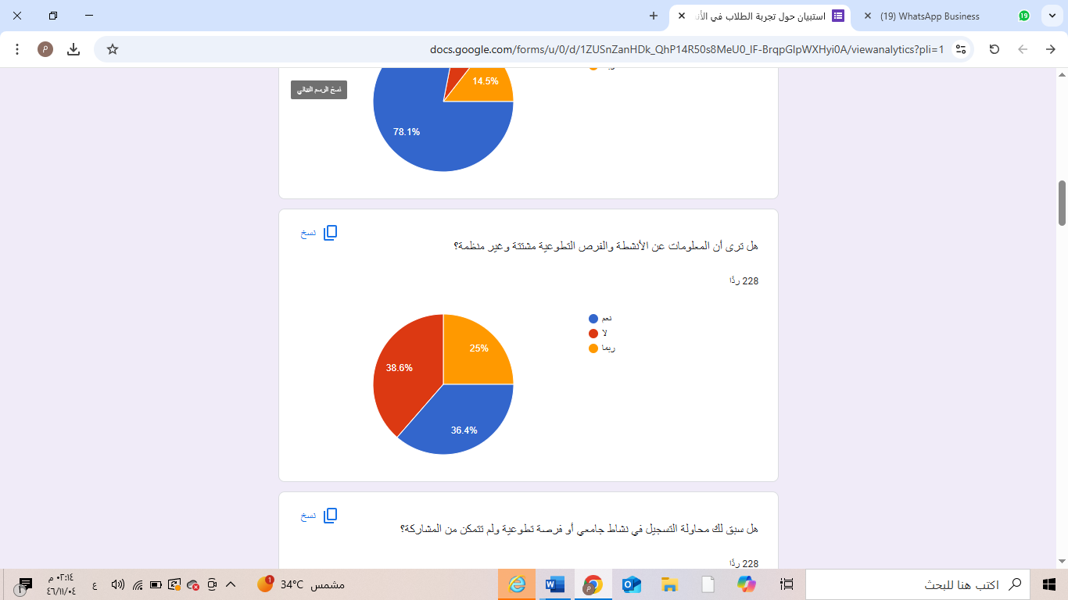

Analysis:
Opinions are divided, with about 36.4% believing that information is scattered, while
around 38.6 % disagree. Additionally, 25% are unsure. This divide may be due to
differences between colleges or departments in how they announce activities; some
may have structured systems, while others experience disorganization.
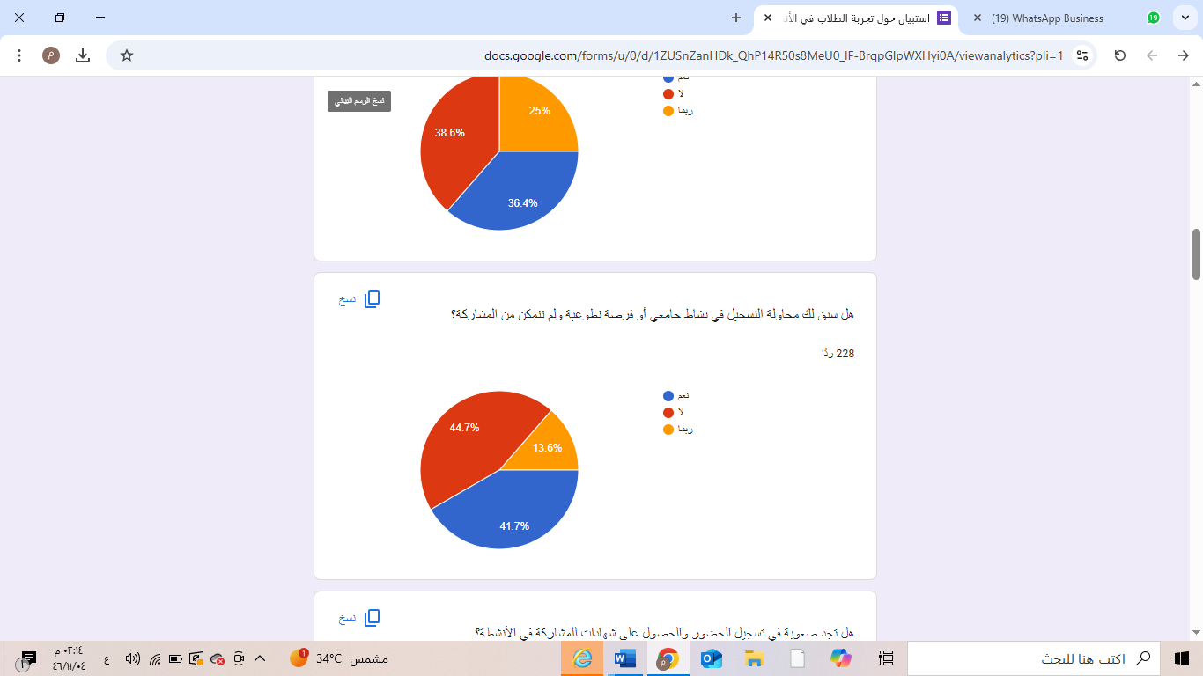

Analysis:
Around half of the respondents faced issues during registration, where they tried to
join activities or opportunities but could not due to procedural problems, lack of clear
registration mechanisms, or limited seats. This confirms the need for a clear and user-
friendly registration system

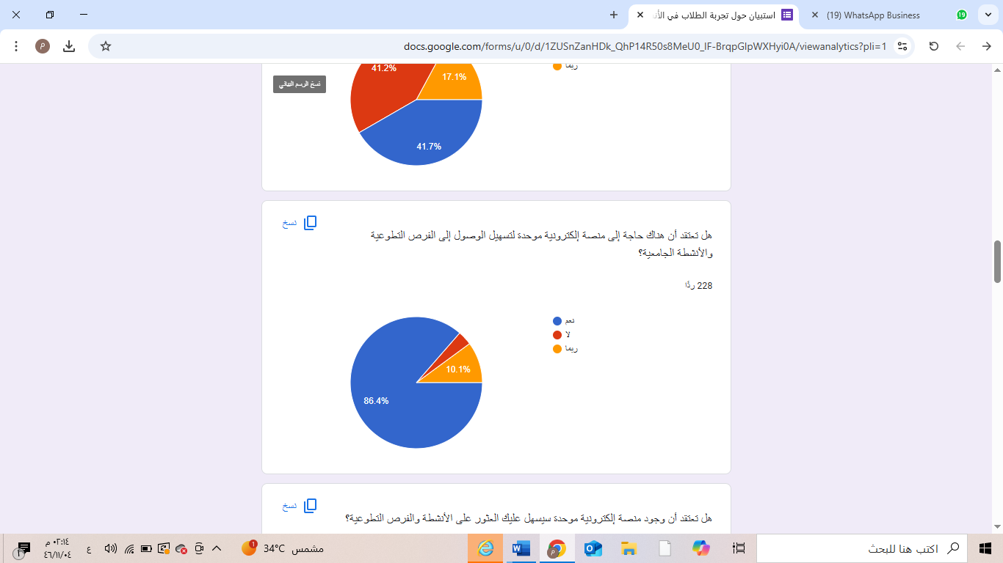

The overwhelming majority (over 85%) support the idea of a unified electronic
platform. This indicates a high level of awareness among students regarding the
necessity of centralizing efforts and communication for efficient participation

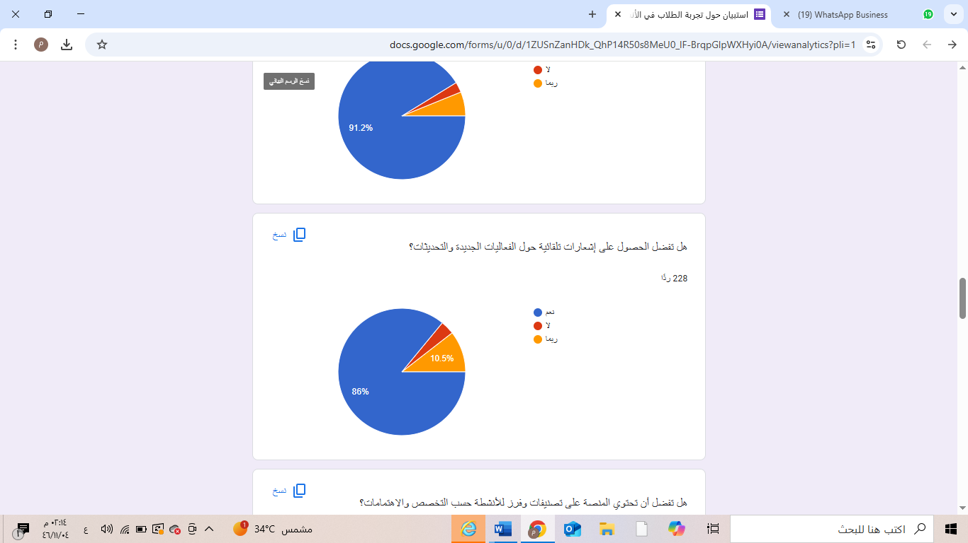
Analysis:
A large majority of students prefer an automatic notification system, reflecting their
need to stay updated on activities and opportunities without constant searching.

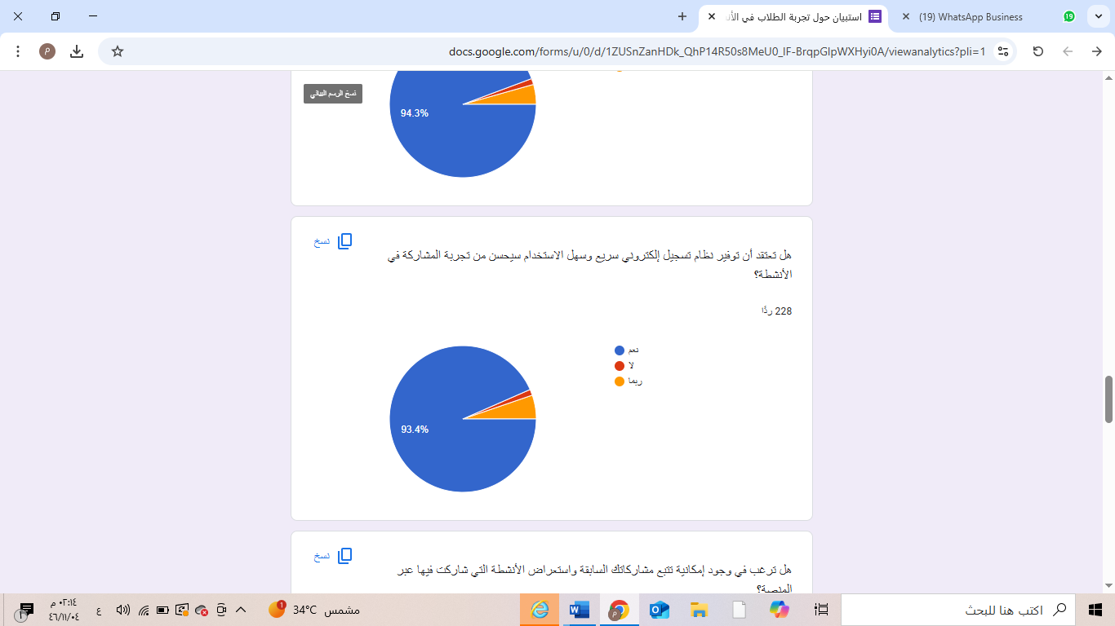

Analysis:
Once again, an overwhelming majority (over 90%) support having a smart and simple
online registration system, which would enhance the user experience and increase
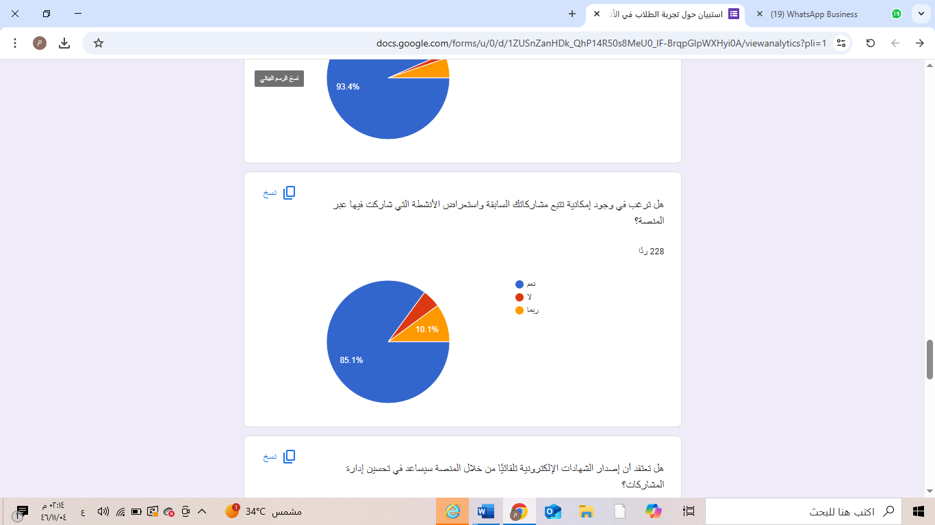
participation rates
Analysis:
Most respondents believe that having a tracking feature for past participations and
volunteer activities would be beneficial for both personal documentation and resume-
building.

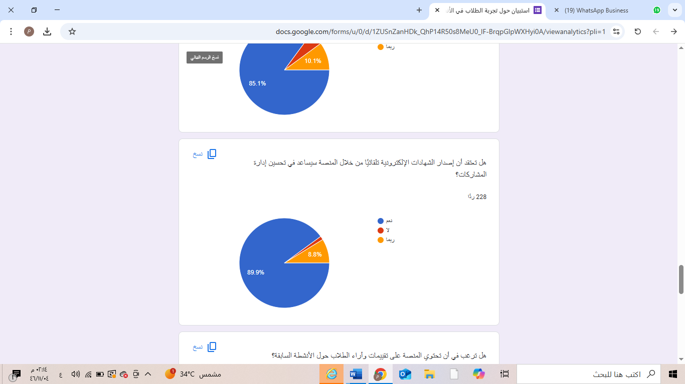

Analysis:
Around 90% of respondents believe that automated certificate issuance would be a
valuable service, eliminating paperwork issues and simplifying participation
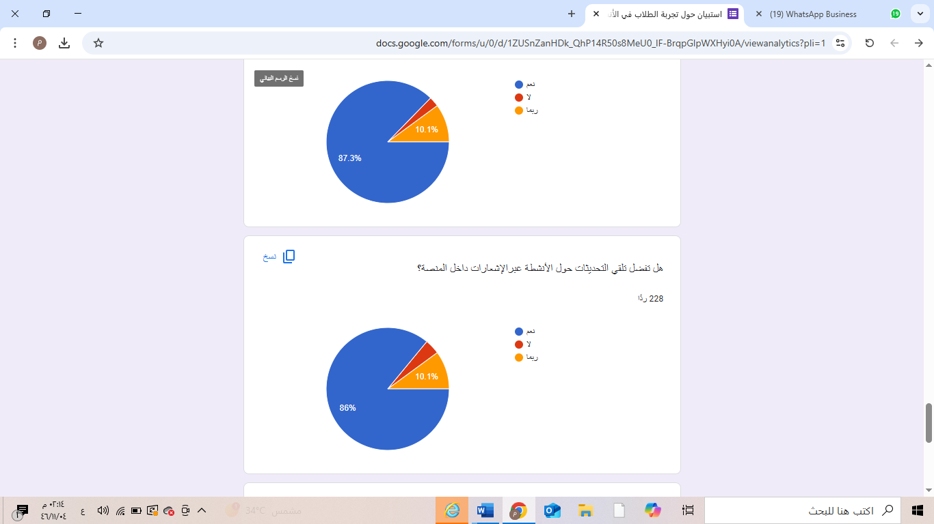
documentation
Analysis:
Students continue to emphasize their preference for integrated notifications within the
platform, reinforcing the need for a unified, distraction-free experience rather than
relying on emails or external platforms.

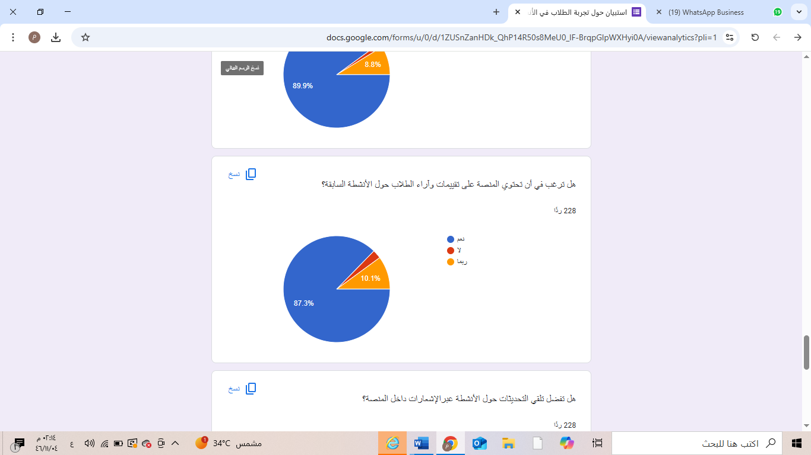
Analysis:
A review and feedback system would encourage student engagement and help
organizers improve future activities. More than 85% of respondents see value in this
feature
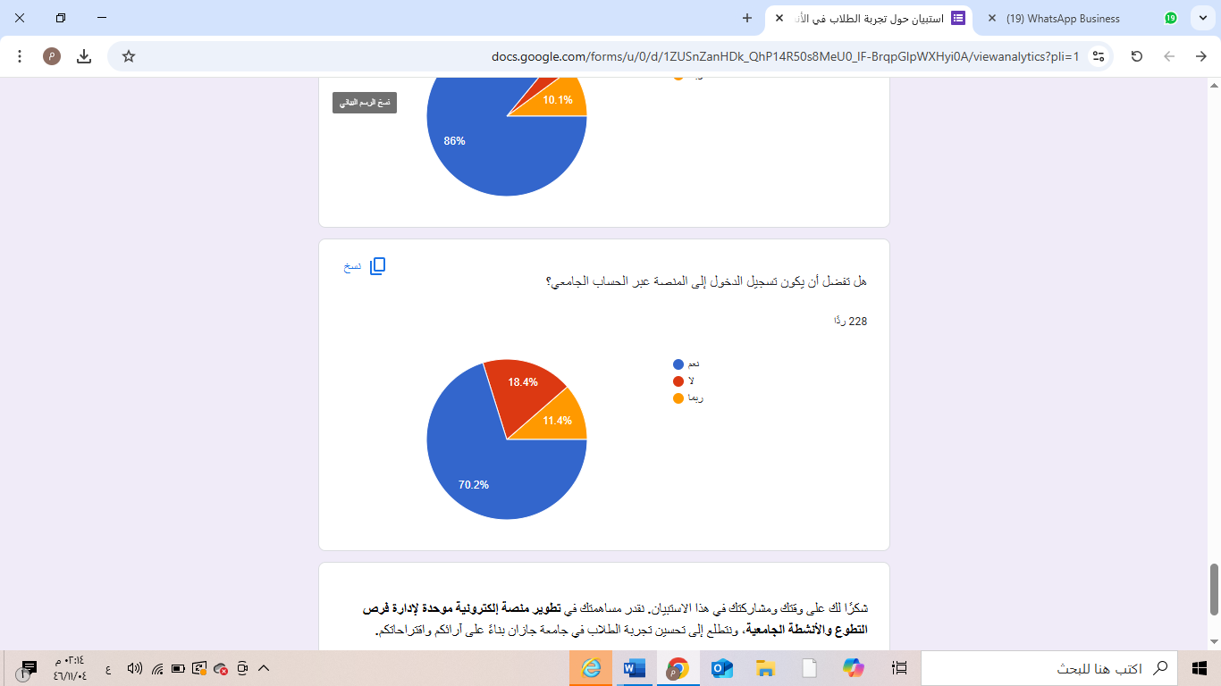

Analysis:
Most participants favor direct integration with university accounts for ease of access
and reliability. However, a small percentage prefers alternative login options or is
hesitant about linking their university accounts to a new platform

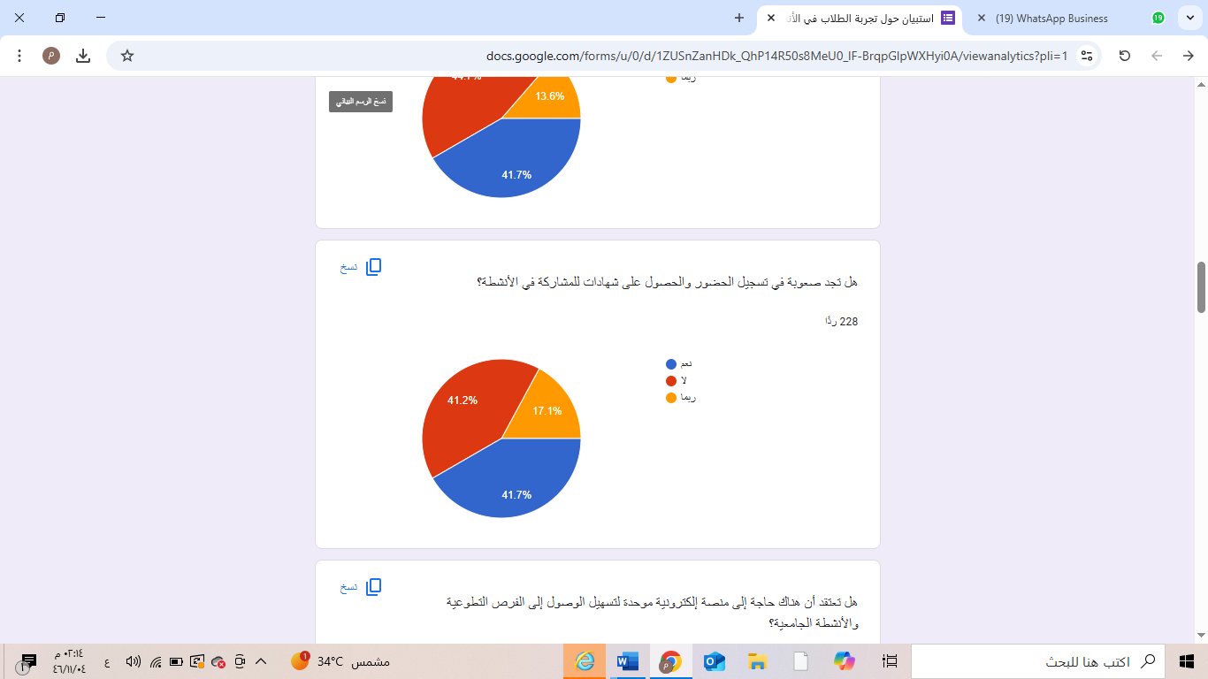
Analysis:
The responses are nearly split; a large number of students experience difficulties in
attendance verification and certificate issuance. This issue could lead to loss of their
volunteer efforts or an inability to prove their participation later.
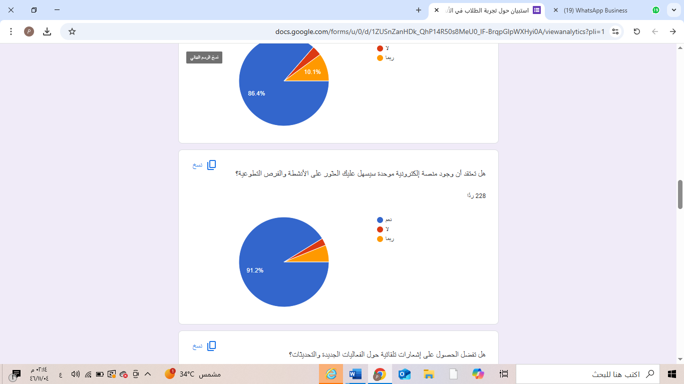

Analysis:
This response further reinforces the urgent need for a centralized platform, with more
than 90% believing it would significantly ease the process of finding opportunity



Analysis:
Students continue to emphasize their preference for integrated notifications within the
platform, reinforcing the need for a unified, distraction-free experience rather than
relying on emails or external platforms.

