TrackUp Database Schema
  - An explained guide for the development team
16 October 2026
TrackUp stores accounts, learning progress, catalog listings, discussions, connections, messages and hackathon teams. This guide explains what each table represents, how its records connect, and which rules prevent incorrect data.
Read each feature overview first, then its field tables. The final appendix contains the database details needed during backend implementation. ASP.NET Core Identity is the proposed account framework; its built-in fields are clearly separated from the information TrackUp asks users to provide.

A: Reading the schema
Term | Plain meaning | Example
Table and row | A table groups one kind of record. A row is one record. | courses is a table; one workshop is a row.
Primary key or PK | The value or combination that identifies one row. | users.id identifies a user.
Foreign key or FK | A stored link to an existing row in another table. | course_answers.question_id links to a question.
Unique | A value or combination cannot be repeated. | The same user cannot save the same course twice.
Optional or NULL | The database may have no value for that field. | An empty avatar_id uses the default avatar.
One to many | One parent can be linked from several child rows. | One question can have many answers.
Link table | Rows connect two lists without copying their records. | user_skills links users and skills.
Transaction | Several related changes either all save or all roll back. | Accepting a request and adding membership succeed together.

How to read a field table
Needed = Required means NOT NULL. Optional means NULL is allowed. Key means it belongs to the primary key, which is always required. See rule means a value is required for an existing account but cleared when the account is deleted. Character limits are shown inside varchar(...).
uuid is a stable identifier, not something a user types. varchar(150) is text up to 150 characters. boolean means true/false. integer is a whole number. numeric(12,2) is an exact decimal, useful for prices. timestamptz stores a point in time; the event timezone is stored separately. jsonb holds a small structured payload for delivery work or message parameters.

B: Where the information lives
Area | Main tables | What you can do with them
Accounts | users, external_logins, sessions | Sign in, edit profiles, verify email and manage access.
Learning | positions, roadmaps, topics, items, completions | Choose a career path and keep each learner’s checked items.
Courses | courses, translations, saves, questions, answers | Discover offerings and discuss them.
Connections and chat | connections, private_conversations, private_messages | Connect mutually and keep private text history.
Hackathons and teams | hackathons, teams, requests, memberships, participation | Find events and coordinate one team per user per event.
Activity and administration | notifications, reports, api_keys, activity_events | Deliver relevant notices, resolve reports and authorize course integrations.
Some labels in this overview are shortened. The following pages show the exact database table names. Reference lists such as skills and IT fields are shared across the features that use them.

What a line in a diagram means
A diagram shows a selected relationship, not every column or every link. “Zero or many” means the child list may be empty. “One to one” means each parent has at most one matching child, with setup supplying required catalog records. “Zero or one” describes an optional single record. Read the nearby explanation for limits that ordinary connector lines cannot express.

Details that are calculated instead of stored twice
Display value | How to get it
Roadmap percentage | Completed published items ÷ all published items × 100; whole-number display; 0% if empty.
Topic state | None checked = incomplete; some = partial; all = complete.
Available team places | capacity minus active membership count, including owner.
Online status | At least one valid live connection with a current heartbeat.
Registration open | Published, not cancelled, and current time is before registration_deadline.
Notification badge | Unexpired, unsuppressed notices with no seen_at value.

What is deliberately not a product table
Toasts and inline feedback are shown immediately and are not bell records. Search result pages and percentages are queries. Online presence and short-lived IP/API rate-limit counters belong in operational state, not a permanent user activity history.

C: Accounts and profiles
A user record is the center of an account. Its Google link proves which Google identity belongs to it; sessions represent device logins; skill links and image metadata support the profile.
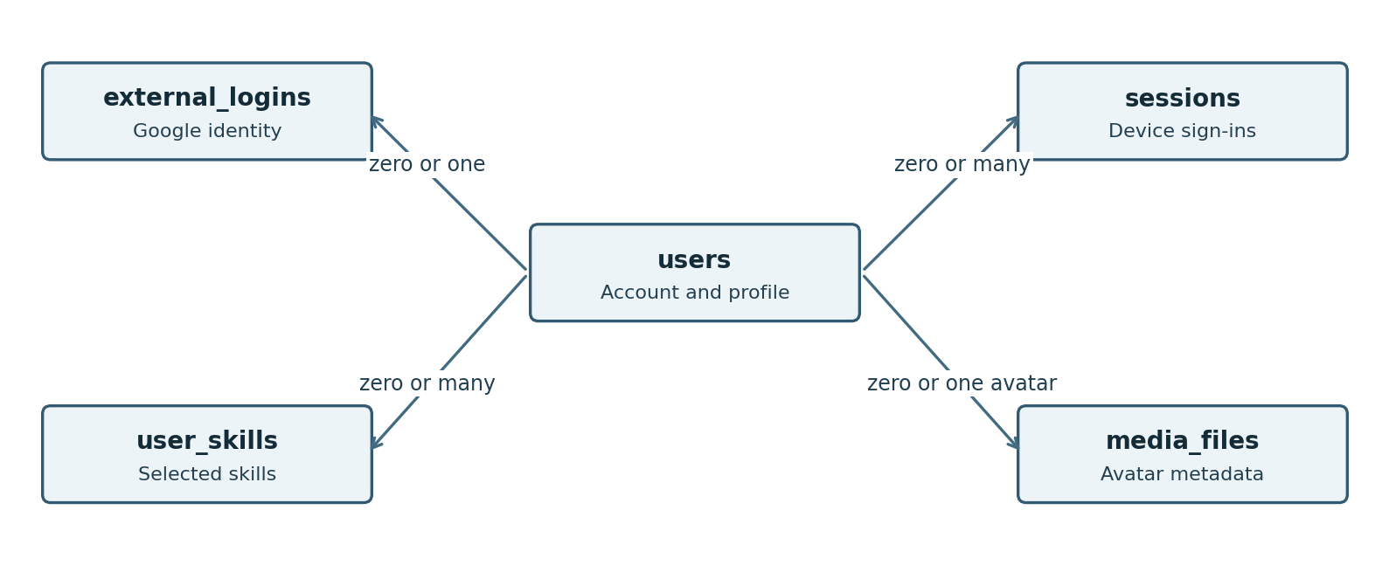
Selected account links. The Google link is optional and limited to one per user in TrackUp. A user can have several device sessions.

TrackUp data and framework data
ASP.NET Core is the web framework. ASP.NET Core Identity is an optional account-management component used in this design. Identity supplies tested account storage and password-hashing support, while our backend configures it and adds TrackUp profile fields.
Identity fields do not imply extra website features. There is no public username or phone-number collection. Normalized email is a comparison value, not a second email address. All Identity-only user fields are explained together in Section K so the product fields are easier to read.
Example: Sara registers, verifies her email, and signs in from a laptop and phone. There is one users row and two sessions rows. If she later links Google safely, one external_logins row points to that same user; it does not create a duplicate profile.

Users
Table name: users
One row is one TrackUp account and its profile. The account stays as an anonymous reference after deletion so old messages and Q&A still have a valid author link.
Field | Type | Needed | What it means
id | uuid | Key | Application-generated stable identifier
email | varchar(256) | See rule | Private email used to sign in; removed when the account is deleted
email_confirmed | boolean | Required | Verified email; default false
password_hash | text | Optional | Identity hash; NULL for Google-only account
first_name | varchar(80) | See rule | First name, 1–80 nonblank characters while account exists; cleared on deletion
last_name | varchar(80) | See rule | Last name, 1–80 nonblank characters while account exists; cleared on deletion
account_status | varchar(12) | Required | active, suspended or deleted; active does not itself mean email verified
suspension_reason | text | Optional | Required while suspended
suspended_at | timestamptz | Optional | When suspended
suspended_by | uuid | Optional | Admin who suspended account; links to users.id
preferred_language | varchar(2) | See rule | en ar fr; default en
professional_position | varchar(150) | Optional | Profile text independent of active roadmap
bio | varchar(500) | Optional | Short profile biography
linkedin_url | text | Optional | Validated http or https URL
github_url | text | Optional | Validated http or https URL
portfolio_url | text | Optional | Validated http or https URL
avatar_id | uuid | Optional | Current avatar; NULL means default; links to media_files.id
active_roadmap_id | uuid | Optional | Link to the one currently selected roadmap; empty before selection; links to roadmaps.id
created_at | timestamptz | Required | Creation instant; default now()
updated_at | timestamptz | Required | Last saved change; application maintains
deleted_at | timestamptz | Optional | When the account was anonymized; empty for other accounts

Rules to protect
- Email and names are required for every nondeleted account. Email comparison is case-insensitive. Deleted accounts have these identifying fields cleared.
- Only the owner sees email and private saved/progress data. Account status is separate from email verification. Suspended and deleted accounts cannot use protected features.
- active_roadmap_id contains at most one selection; it does not replace the professional-position text.
Record identity: id. Unique values: normalized_email, normalized_user_name, avatar_id.

Google sign-in
Table name: external_logins
One row connects a Google identity to a TrackUp user. It is not a second user account and does not store a Google password.
Field | Type | Needed | What it means
login_provider | varchar(128) | Key | Google
provider_key | varchar(256) | Key | Google stable subject identifier
provider_display_name | text | Optional | Provider label
user_id | uuid | Required | Linked account; links to users.id

Rules to protect
- Google only: UNIQUE (user_id, login_provider) gives each user at most one Google link. The provider/subject pair identifies only one TrackUp user.
- Link an existing account automatically only when both emails are verified. Remove the link on account deletion.
Record identity: login_provider + provider_key.

Login sessions
Table name: sessions
One row represents one device login. Removing access to one session logs out that device; revoking every session logs the user out everywhere.
Field | Type | Needed | What it means
id | uuid | Key | Application-generated stable identifier
user_id | uuid | Required | Authenticated account; links to users.id
token_hash | varchar(128) | Required | Hash of random session identifier
created_at | timestamptz | Required | Creation instant; default now()
expires_at | timestamptz | Required | No more than seven days after creation
revoked_at | timestamptz | Optional | NULL while valid
revocation_reason | varchar(100) | Optional | Logout password change or suspension

Rules to protect
- A session lasts no longer than seven days. Logout revokes the current session; password change or suspension revokes all sessions. Deletion removes their credentials.
- The browser receives a protected cookie reference. Every protected request checks revocation, expiry and account status.
Record identity: id. Unique values: token_hash.

Email verification links
Table name: email_verification_tokens
One row holds the current verification-link hash for one user. Replacing this row makes an older emailed link stop working.
Field | Type | Needed | What it means
user_id | uuid | Key | Account awaiting verification; links to users.id
token_hash | varchar(128) | Required | Hash of random single-use link token
issued_at | timestamptz | Required | Also used for 60-second resend cooldown
expires_at | timestamptz | Required | Issued time plus 24 hours
consumed_at | timestamptz | Optional | Single-use consumption time

Rules to protect
- The link expires after 24 hours and can be used once. Resending waits at least 60 seconds, then replaces the old token.
- Store only a token hash. Verify the email and consume the token together.
Record identity: user_id. Unique values: token_hash.

Uploaded images
Table name: media_files
One row describes an uploaded image. The actual image bytes are stored outside the database; storage_key tells the backend where to find them.
Field | Type | Needed | What it means
id | uuid | Key | Application-generated stable identifier
storage_key | text | Required | Internal storage reference, not an arbitrary public URL
media_type | varchar(30) | Required | image/jpeg image/png or image/webp
size_bytes | integer | Required | Positive size
purpose | varchar(20) | Required | avatar course or hackathon
uploaded_by | uuid | Optional | Uploader; NULL for setup or API upload; links to users.id
created_at | timestamptz | Required | Creation instant; default now()

Rules to protect
- Avatars accept JPEG, PNG or WebP, with actual image validation and a maximum of 2 MiB.
- Replacing/removing an avatar removes its old reference and schedules deletion of unused old image bytes after the save succeeds. Default avatars need no uploaded-file record.
Record identity: id. Unique values: storage_key.

Skills on a profile
Table name: user_skills
One row means a user selected one skill. The row links two records instead of copying the skill name into every profile.
Field | Type | Needed | What it means
user_id | uuid | Key | Profile owner; links to users.id
skill_id | uuid | Key | Selected seeded skill; links to skills.id

Rules to protect
- The user/skill combination is the primary key, so a skill cannot appear twice on one profile.
Record identity: user_id + skill_id.

Available skills
Table name: skills
The shared list of selectable skills, such as React or SQL. The same skill can be used on profiles, hackathons, and team requirements.
Field | Type | Needed | What it means
id | uuid | Key | Application-generated stable identifier
code | varchar(80) | Required | Stable seed key
name_en | varchar(150) | Required | English label
name_ar | varchar(150) | Optional | Arabic label
name_fr | varchar(150) | Optional | French label
is_active | boolean | Required | Default true

Rules to protect
- Keep stable seed codes and IDs so setup reruns do not duplicate skills or break user selections.
Record identity: id. Unique values: code.

D: Career paths and progress
A position names a career role. Its roadmap groups topics. Each topic contains small checklist items, and the completion table connects each learner to the items they checked.
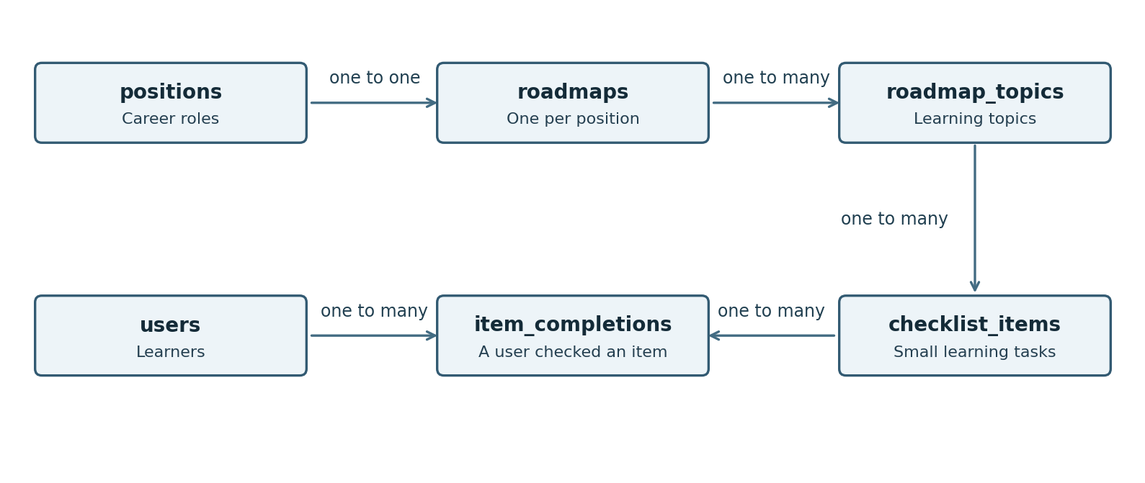
One position has one seeded roadmap; a roadmap has topics; a topic has checklist items. Completion rows belong to both a user and an item.

Example of saved progress
User | Checklist item | Completion row
Sara | HTML headings | Exists: checked
Sara | HTML forms | No row: unchecked
Omar | HTML headings | No row: unchecked
Sara’s checked item does not affect Omar. If Sara has checked 3 of the roadmap’s 12 published items, progress is 25%. Checking an entire topic inserts all of its item links together. Switching the active roadmap changes one pointer on users; existing completions stay saved.

Career positions
Table name: positions
The six seeded career roles, such as Frontend Developer. A role can also be named as a team recruitment need.
Field | Type | Needed | What it means
id | uuid | Key | Application-generated stable identifier
code | varchar(80) | Required | Stable role key
name_en | varchar(150) | Required | English name
summary_en | text | Required | English summary
name_ar | varchar(150) | Optional | Arabic name
summary_ar | text | Optional | Arabic summary
name_fr | varchar(150) | Optional | French name
summary_fr | text | Optional | French summary
is_published | boolean | Required | Seeded true
archived_at | timestamptz | Optional | Optional seed-content retirement marker; no dashboard editor is required

Rules to protect
- Seed the six agreed roles. Keep stable IDs and English names/summaries. This scope does not require a dashboard editor for seeded learning content.
Record identity: id. Unique values: code.

Roadmaps
Table name: roadmaps
One row is the learning path for one position. Its topics and checklist items are stored in the next two tables.
Field | Type | Needed | What it means
id | uuid | Key | Application-generated stable identifier
position_id | uuid | Required | Owning career position; links to positions.id
is_published | boolean | Required | Seeded true
archived_at | timestamptz | Optional | Optional seed-content retirement marker; no dashboard editor is required
updated_at | timestamptz | Required | Last saved change; application maintains

Rules to protect
- A position has at most one roadmap, enforced by unique position_id; the seed setup supplies one for each agreed position.
- Changing the user’s active selection never removes completion records.
Record identity: id. Unique values: position_id.

Topics inside a roadmap
Table name: roadmap_topics
One row is one learning topic, such as HTML basics. Order and optional map coordinates control its presentation.
Field | Type | Needed | What it means
id | uuid | Key | Application-generated stable identifier
roadmap_id | uuid | Required | Containing roadmap; links to roadmaps.id
code | varchar(80) | Required | Stable code within roadmap
title_en | varchar(150) | Required | English title
description_en | text | Required | English explanation
title_ar | varchar(150) | Optional | Arabic title
description_ar | text | Optional | Arabic explanation
title_fr | varchar(150) | Optional | French title
description_fr | text | Optional | French explanation
sort_order | integer | Required | Nonnegative suggested order
map_x | numeric(10,2) | Optional | Optional map coordinate
map_y | numeric(10,2) | Optional | Optional map coordinate
is_published | boolean | Required | Default true
archived_at | timestamptz | Optional | Preserve historical records

Rules to protect
- A topic belongs to one roadmap. Each published topic needs at least one published checklist item.
- The same topic idea in another roadmap has different item IDs, so progress remains independent.
Record identity: id.

Small checklist items
Table name: checklist_items
One row is a small learning item inside a topic. These are the units used to calculate progress.
Field | Type | Needed | What it means
id | uuid | Key | Application-generated stable identifier
topic_id | uuid | Required | Owning topic; links to roadmap_topics.id
code | varchar(80) | Required | Stable item code within topic
title_en | varchar(150) | Required | English text
description_en | text | Optional | English detail
title_ar | varchar(150) | Optional | Arabic text
description_ar | text | Optional | Arabic detail
title_fr | varchar(150) | Optional | French text
description_fr | text | Optional | French detail
sort_order | integer | Required | Nonnegative order
is_published | boolean | Required | Default true
archived_at | timestamptz | Optional | Preserves completion history

Rules to protect
- The topic/code pair is unique and stable across seed reruns. Sort order is nonnegative.
- Only published items under published topics count towards current progress. Retired content keeps its old links.
Record identity: id.

Suggested prerequisites
Table name: topic_prerequisites
One row links a topic to another topic recommended before it. It is learning advice, not a restriction on checking items.
Field | Type | Needed | What it means
topic_id | uuid | Key | Topic being explained; links to roadmap_topics.id
prerequisite_topic_id | uuid | Key | Recommended earlier topic; links to roadmap_topics.id

Rules to protect
- The topic pair is unique. Both topics belong to the same roadmap; self-links and circular chains are rejected when seed data is loaded.
- An unfinished prerequisite never blocks checking an item or opening a topic.
Record identity: topic_id + prerequisite_topic_id.

Checked learning items
Table name: item_completions
One row means a specific user checked a specific item. No row means unchecked. Unchecking removes only this link.
Field | Type | Needed | What it means
user_id | uuid | Key | Learner; links to users.id
item_id | uuid | Key | Completed item; links to checklist_items.id
completed_at | timestamptz | Required | Completion instant

Rules to protect
- The user/item pair is the primary key. Checking twice produces one record; unchecking removes it.
- A topic-wide toggle changes all its published items in one transaction. Do not store an independent percentage or topic-complete flag.
Record identity: user_id + item_id.

E: Courses and discussions
The courses table stores offerings. Translations add optional catalog text. Saved links belong to the saver. Questions belong to a course and answers belong to a question.
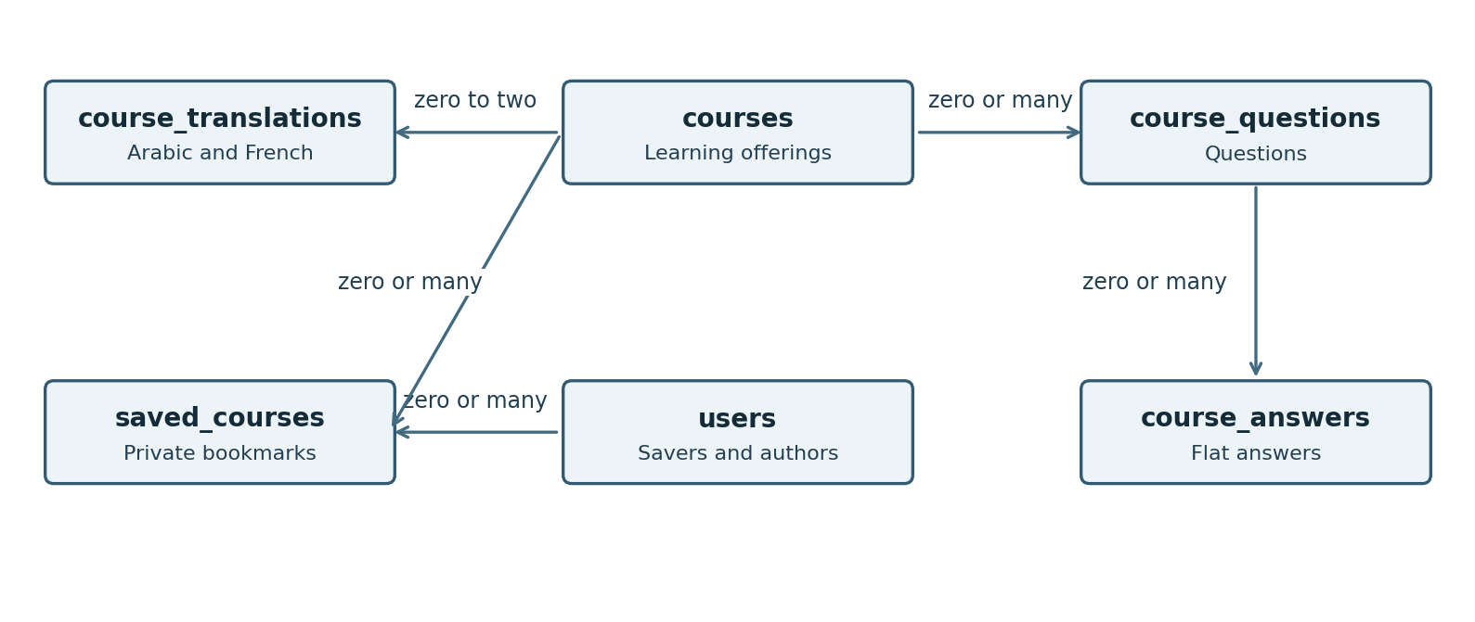
Selected course links. A course can have many questions, each with many direct answers. Each saved_courses row connects one saver to one course.
Example: a workshop has one English catalog row, one Arabic translation row, several private saves, two questions and three answers. Unpublishing hides it from the catalog but leaves these linked records in place.
Catalog English is required. Optional Arabic and French values fall back per field: an Arabic title can be displayed with an English description if only the title was translated. User-written Q&A is displayed in its original language.

IT fields
Table name: it_fields
The shared list of IT categories used to organize and filter course offerings.
Field | Type | Needed | What it means
id | uuid | Key | Application-generated stable identifier
code | varchar(80) | Required | Stable seed key
name_en | varchar(150) | Required | English label
name_ar | varchar(150) | Optional | Arabic label
name_fr | varchar(150) | Optional | French label
is_active | boolean | Required | Default true

Rules to protect
- One primary IT field per course is the proposed interpretation of the required IT-field field. English labels are required; other labels fall back to English.
Record identity: id. Unique values: code.

Course offerings
Table name: courses
One row is a listed course, workshop, or bootcamp. TrackUp stores its information and provider link, not lessons or enrollment records.
Field | Type | Needed | What it means
id | uuid | Key | Application-generated stable identifier
title_en | varchar(150) | Required | English title
description_en | varchar(10000) | Required | English catalog description
provider | varchar(150) | Required | Provider name
course_type | varchar(10) | Required | course workshop bootcamp
it_field_id | uuid | Required | Primary IT field; links to it_fields.id
delivery_method | varchar(6) | Required | online onsite hybrid
level | varchar(20) | Optional | Proposed beginner intermediate advanced all_levels
is_free | boolean | Required | Free or paid
price | numeric(12,2) | Optional | Free requires 0; NULL paid means See provider
currency | varchar(3) | Optional | ISO currency for known paid price
external_url | text | Required | Validated http or https provider link
starts_at | timestamptz | Optional | Optional scheduled start
ends_at | timestamptz | Optional | Optional scheduled end
event_timezone | varchar(100) | Optional | IANA zone; required if dates exist
location | varchar(300) | Optional | Required for onsite or hybrid
duration_text | varchar(150) | Optional | Human-readable duration
prerequisites | text | Optional | Offering prerequisite information
image_id | uuid | Optional | Catalog image; links to media_files.id
is_published | boolean | Required | Create true; DELETE API sets false
created_at | timestamptz | Required | Creation instant; default now()
updated_at | timestamptz | Required | Last saved change; application maintains

Rules to protect
- Titles are nonblank and at most 150 characters; descriptions at most 10,000. Course type is course, workshop or bootcamp; delivery is online, onsite or hybrid.
- Free means price 0. A known paid price is positive and has a currency; an unknown paid price and currency are both empty, displayed as See provider.
- Dates are optional for unscheduled offerings; supplied start/end pairs must be ordered. Scheduled dates need a timezone, and onsite/hybrid needs a location.
- Create complete listings as published. Unpublishing keeps their saves and discussions; republishing restores availability.
Record identity: id.

Translated course information
Table name: course_translations
One row holds optional Arabic or French values for one course. English remains in courses, so a missing translated field can fall back to it.
Field | Type | Needed | What it means
course_id | uuid | Key | Offering; links to courses.id
language_code | varchar(2) | Key | ar or fr
title | varchar(150) | Optional | Translated title
description | varchar(10000) | Optional | Translated description
provider | varchar(150) | Optional | Optional localized provider label
location | varchar(300) | Optional | Optional localized location
duration_text | varchar(150) | Optional | Optional localized duration
prerequisites | text | Optional | Translated prerequisites

Rules to protect
- The course/language pair is unique. Languages are ar and fr only. A field may be empty; use its English field instead. At least one translated field is supplied.
Record identity: course_id + language_code.

Saved courses
Table name: saved_courses
One row means one user bookmarked one offering. It is private to the user and does not mean they enrolled or completed it.
Field | Type | Needed | What it means
user_id | uuid | Key | Saver; links to users.id
course_id | uuid | Key | Saved offering; links to courses.id
saved_at | timestamptz | Required | Time saved

Rules to protect
- The user/course pair is the primary key. Unsave deletes the bookmark, not the course. Unpublished saves show only identifying information and Unavailable.
Record identity: user_id + course_id.

Course questions
Table name: course_questions
One row is a question posted on a course. Its answers are stored separately so one question can have several answers.
Field | Type | Needed | What it means
id | uuid | Key | Application-generated stable identifier
course_id | uuid | Required | Offering; links to courses.id
user_id | uuid | Required | Author; links to users.id
title | varchar(150) | Required | Nonblank question title
body | varchar(2000) | Required | Plain-text question
created_at | timestamptz | Required | Creation instant; default now()
updated_at | timestamptz | Required | Last saved change; application maintains
removed_at | timestamptz | Optional | Soft removal by author or admin
removed_by | uuid | Optional | Actor; links to users.id
removal_reason | text | Optional | Required for moderation

Rules to protect
- Only active verified users write on published offerings. Title: 1–150 characters. Body: 1–2,000 characters, plain text.
- Removal hides the question and all its answers from discussions. Keep a removed record for reports and unavailable notification links.
Record identity: id.

Course answers
Table name: course_answers
One row is one direct answer to a question. There is no parent-answer field because nested replies are not required.
Field | Type | Needed | What it means
id | uuid | Key | Application-generated stable identifier
question_id | uuid | Required | Parent question; links to course_questions.id
user_id | uuid | Required | Author; links to users.id
body | varchar(2000) | Required | Nonblank plain-text answer
created_at | timestamptz | Required | Creation instant; default now()
updated_at | timestamptz | Required | Last saved change; application maintains
removed_at | timestamptz | Optional | Soft removal
removed_by | uuid | Optional | Actor; links to users.id
removal_reason | text | Optional | Moderation explanation

Rules to protect
- An answer belongs to one question; the course is found through that question. Body: 1–2,000 nonblank plain-text characters.
- The author can edit/remove their own answer. Admin removal requires a reason. Display the edited state after an edit.
Record identity: id.

F: Connections and private messages
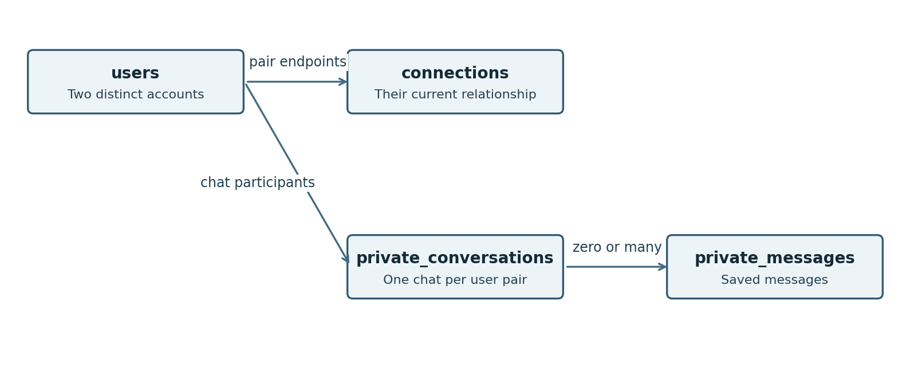
Two users have one relationship record and at most one shared private conversation. The conversation owns its messages. These are different facts with different lifetimes.

Why connection and conversation are separate
Sara and Omar can disconnect while keeping their chat history. The connection stops allowing new messages, but the conversation and existing messages remain. Reconnecting reuses their old conversation.
For a pair of user IDs A and B, always put the smaller UUID in user_low_id and the larger in user_high_id. Then A–B and B–A cannot become separate records. This ordering is only a database technique; it does not give one person more permissions.
A pending connection has a sender and a recipient. An accepted connection is mutual. If opposite requests arrive together, show the existing incoming request for acceptance rather than creating a second request.

Connection requests and connections
Table name: connections
One row holds the current relationship between a pair of users, including pending or accepted status. Acceptance makes it mutual; no second reverse row is needed.
Field | Type | Needed | What it means
id | uuid | Key | Application-generated stable identifier
user_low_id | uuid | Required | Smaller UUID in canonical pair; links to users.id
user_high_id | uuid | Required | Larger UUID in canonical pair; links to users.id
requested_by | uuid | Required | Sender of current or latest request; links to users.id
status | varchar(12) | Required | pending accepted rejected cancelled disconnected
request_cycle_id | uuid | Required | New event identity each time a fresh request is made
requested_at | timestamptz | Required | Current cycle request time
responded_at | timestamptz | Optional | Acceptance rejection cancellation or disconnect time
updated_at | timestamptz | Required | Last saved change; application maintains

Rules to protect
- Always order the two user IDs consistently. The unique pair prevents duplicate relationships and simultaneous opposite requests.
- The sender must be one endpoint. Only the recipient accepts/rejects; the sender can cancel. Reuse the row for a new request after rejection/cancellation/disconnection.
- Disconnect stops new messages and online-status sharing, but keeps chat history. Account deletion cancels requests and ends accepted connections.
Record identity: id.

Private conversations
Table name: private_conversations
One row identifies a private chat between two users. It remains after disconnecting so both participants keep their permitted history.
Field | Type | Needed | What it means
id | uuid | Key | Application-generated stable identifier
user_low_id | uuid | Required | First canonical participant; links to users.id
user_high_id | uuid | Required | Second canonical participant; links to users.id
created_at | timestamptz | Required | Creation instant; default now()

Rules to protect
- The ordered user pair is unique. Reconnect or starting a chat again reuses this conversation.
- Only its two participants can read history. Admin dashboard access does not grant access to private chats.
Record identity: id.

Private messages
Table name: private_messages
One row is one saved text message. Its conversation determines who can read it; current connection status determines whether a new message may be sent.
Field | Type | Needed | What it means
id | uuid | Key | Application-generated stable identifier
conversation_id | uuid | Required | Containing private conversation; links to private_conversations.id
sender_id | uuid | Required | Must be one participant; links to users.id
client_message_id | uuid | Required | Client-generated retry key
body | varchar(2000) | Required | Nonblank plain text
sent_at | timestamptz | Required | Server-assigned timestamp

Rules to protect
- Sender is one participant, with an accepted connection and active verified accounts at send time. Body: 1–2,000 nonblank plain-text characters.
- The sender/client-message pair is unique. Retrying the same send returns its original message; it does not create another one.
- No attachments, edit, delete, typing status or read receipts. Order messages by sent_at then id.
Record identity: id.

G: Hackathons and team finding
Hackathons store public event information. Teams are coordination records inside an event, not official hackathon registration. A team’s needs, requests and memberships are different kinds of records.
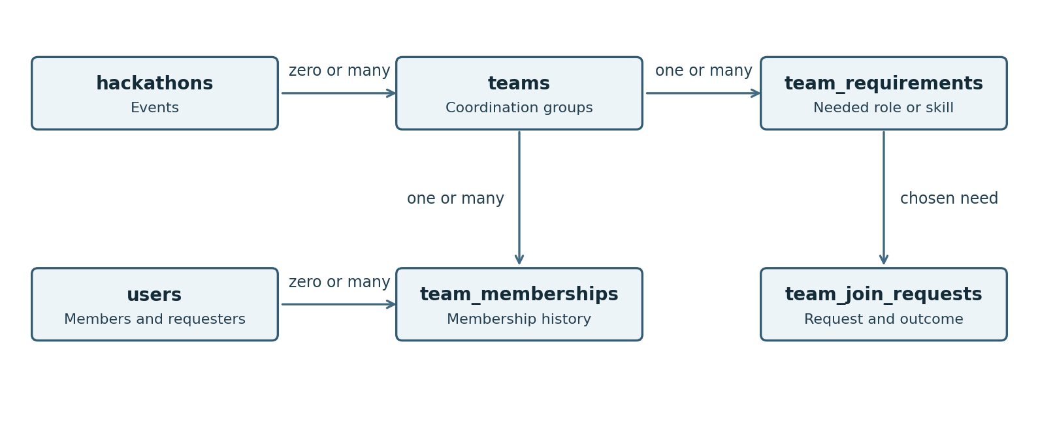
Selected team links. A request chooses a recruitment need. Membership history is separate from the request outcome. The owner is also one of the members.

One example from request to membership
Sara requests to join Team Cedar for a hackathon. The request is pending, so she cannot request another team or create one for that event. If the owner accepts, the request becomes accepted, a membership begins, and her current reservation changes from request to membership in the same save operation.
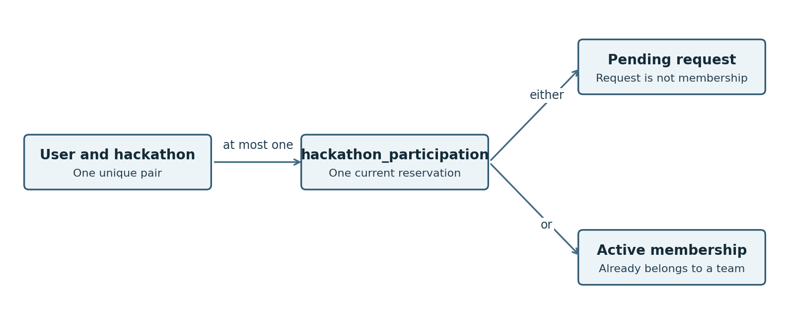
The event/user pair has at most one current reservation. It points to either a pending request or an active membership, never both.
Why keep this reservation table? A unique rule in requests prevents two pending requests. A unique rule in memberships prevents two memberships. Neither alone prevents one pending request plus one membership. hackathon_participation protects the shared rule across both tables.

Hackathons
Table name: hackathons
One row is an event listing and its official registration link. Its deadline also controls whether TrackUp recruitment is allowed.
Field | Type | Needed | What it means
id | uuid | Key | Application-generated stable identifier
name_en | varchar(150) | Required | English name
description_en | varchar(10000) | Required | English description
organizer | varchar(150) | Required | Organizer label
starts_at | timestamptz | Required | Event starts
ends_at | timestamptz | Required | Event ends
registration_deadline | timestamptz | Required | Recruitment closes at this instant
event_timezone | varchar(100) | Required | Validated IANA timezone
delivery_method | varchar(6) | Required | online onsite hybrid
location | varchar(300) | Optional | Required onsite or hybrid
external_url | text | Required | Official registration link
max_team_size | integer | Optional | Positive organizer maximum; must allow valid team capacity
prizes | text | Optional | Prize information
image_id | uuid | Optional | Catalog image; links to media_files.id
is_published | boolean | Required | Default true
cancelled_at | timestamptz | Optional | Cancellation keeps published page readable
closure_reason | text | Optional | Reason for cancellation or unpublishing
created_at | timestamptz | Required | Creation instant; default now()
updated_at | timestamptz | Required | Last saved change; application maintains

Rules to protect
- Start precedes end; registration deadline is no later than event end. Keep an explicit IANA timezone such as Asia/Amman.
- Recruitment stops at the exact deadline, even if the cleanup worker is late. Cancelled details stay readable when published; unpublishing hides the page.
- Onsite/hybrid requires a location. A supplied maximum team size is positive and cannot be reduced below current team membership counts.
Record identity: id.

Translated hackathon information
Table name: hackathon_translations
One row holds Arabic or French event information. Missing fields fall back individually to English.
Field | Type | Needed | What it means
hackathon_id | uuid | Key | Event; links to hackathons.id
language_code | varchar(2) | Key | ar or fr
name | varchar(150) | Optional | Translated title
description | varchar(10000) | Optional | Translated description
organizer | varchar(150) | Optional | Localized organizer
location | varchar(300) | Optional | Localized venue
prizes | text | Optional | Localized prizes

Rules to protect
- The event/language pair is unique, with ar or fr only. Use English for each missing field.
Record identity: hackathon_id + language_code.

Hackathon skill tags
Table name: hackathon_skills
One row tags one hackathon with one seeded skill. These links allow filtering events by skill.
Field | Type | Needed | What it means
hackathon_id | uuid | Key | Tagged event; links to hackathons.id
skill_id | uuid | Key | Skill tag; links to skills.id

Rules to protect
- The event/skill combination is unique. Multiple selected skill filters match any selected skill.
Record identity: hackathon_id + skill_id.

Saved hackathons
Table name: saved_hackathons
One row is a private bookmark from a user to an event. Keep it when the event becomes unavailable.
Field | Type | Needed | What it means
user_id | uuid | Key | Saver; links to users.id
hackathon_id | uuid | Key | Saved event; links to hackathons.id
saved_at | timestamptz | Required | Time saved

Rules to protect
- The user/event pair is the primary key. Unsave removes this bookmark only. Keep saves when an event becomes unavailable.
Record identity: user_id + hackathon_id.

Teams
Table name: teams
One row is an informal coordination team for one hackathon. It has one owner who is also counted as a member.
Field | Type | Needed | What it means
id | uuid | Key | Application-generated stable identifier
hackathon_id | uuid | Required | Parent event; links to hackathons.id
owner_id | uuid | Required | Owner must also have active membership; links to users.id
name | varchar(100) | Required | Nonblank team name
description | varchar(1000) | Required | Nonblank recruitment description
capacity | integer | Required | Maximum member count including owner; checked against event limit
recruitment_status | varchar(6) | Required | open or closed
is_published | boolean | Required | Moderation visibility; default true
unpublished_reason | text | Optional | Moderation reason
archived_at | timestamptz | Optional | Set on disband
closure_reason | text | Optional | Why recruitment closed or team disbanded
created_at | timestamptz | Required | Creation instant; default now()
updated_at | timestamptz | Required | Last saved change; application maintains

Rules to protect
- The owner is an active member and counts towards capacity. Without an event maximum, capacity is 2–20; with one, capacity cannot exceed it or fall below the current membership count.
- At least one active role/skill requirement is needed. Recruitment closes on deadline, cancellation, unpublication, suspension of its owner, or disbanding.
- An owner cannot leave or manually transfer ownership. Deleting the owner’s account invokes the automatic transfer rule. Admins may unpublish, restore or disband with a reason.
- Restoring/republishing never revives cancelled requests or bypasses capacity/deadline rules.
Record identity: id.

Team recruitment needs
Table name: team_requirements
One row describes a needed role, skill, or combination. Applicants choose a need when requesting to join.
Field | Type | Needed | What it means
id | uuid | Key | Application-generated stable identifier
team_id | uuid | Required | Recruiting team; links to teams.id
position_id | uuid | Optional | Seeded needed role; links to positions.id
skill_id | uuid | Optional | Seeded needed skill; links to skills.id
role_description | varchar(1000) | Optional | Additional role explanation
is_active | boolean | Required | Can retire without breaking past requests

Rules to protect
- At least a position or skill is supplied; both may be supplied together. The text is an explanation, not a substitute for the seeded role/skill.
- A selected requirement must belong to the requested team. Retire an old requirement with is_active rather than deleting a referenced row; old requests remain identifiable.
Record identity: id.

Team join requests
Table name: team_join_requests
One row records one request and its eventual outcome. Accepted requests are retained as request history; membership is recorded separately.
Field | Type | Needed | What it means
id | uuid | Key | Application-generated stable identifier
team_id | uuid | Required | Requested team; links to teams.id
hackathon_id | uuid | Required | Copied only to enforce same-event consistency; links to hackathons.id
user_id | uuid | Required | Requester; links to users.id
requirement_id | uuid | Required | Selected need; auto-select if only one; links to team_requirements.id
note | varchar(500) | Optional | Optional request note
status | varchar(9) | Required | pending accepted rejected cancelled expired
requested_at | timestamptz | Required | Submission time
decided_at | timestamptz | Optional | Final state time
decided_by | uuid | Optional | Owner requester or NULL for system; links to users.id
decision_reason | text | Optional | Required for system closure

Rules to protect
- Allowed states: pending, accepted, rejected, cancelled, expired. One pending request per user per event, and none while already a member.
- Selecting a need is required if several exist; choose the only one automatically otherwise. Note: at most 500 characters.
- Only the owner decides a pending request. Recheck current account, team, capacity and deadline before acceptance. Keep the final state and reason.
Record identity: id.

Team memberships
Table name: team_memberships
One row records a period of membership in a team. An empty ended_at means the membership is still active.
Field | Type | Needed | What it means
id | uuid | Key | Application-generated stable identifier
team_id | uuid | Required | Joined team; links to teams.id
hackathon_id | uuid | Required | Same-event consistency; links to hackathons.id
user_id | uuid | Required | Member; links to users.id
joined_at | timestamptz | Required | Membership start
ended_at | timestamptz | Optional | NULL while active
ended_by | uuid | Optional | Actor; NULL for system; links to users.id
end_reason | text | Optional | Leave removal or disband

Rules to protect
- One active membership per user per event. Keep ended rows for history; leaving/removal fills ended_at and frees the current reservation.
- A live team’s owner has exactly one active membership. On disbanding, end all current memberships.
- For automatic ownership transfer, choose the longest-standing remaining active eligible member by joined_at, then membership ID to break ties.
Record identity: id.

Current place in a hackathon
Table name: hackathon_participation
One row says that a user currently has either a pending request or an active membership for an event. This shared reservation prevents having both at once.
Field | Type | Needed | What it means
hackathon_id | uuid | Key | Event; links to hackathons.id
user_id | uuid | Key | Participant; links to users.id
team_id | uuid | Required | Reserved team; links to teams.id
join_request_id | uuid | Optional | Pending reservation; links to team_join_requests.id
membership_id | uuid | Optional | Active membership; links to team_memberships.id
updated_at | timestamptz | Required | Last transition

Rules to protect
- The event/user pair is the primary key. Exactly one pointer is set: pending request OR active membership.
- The referenced request/member must match the same user, team and event. All request/member/reservation changes commit together.
- Unsuccessful final decisions and ended membership remove this current reservation while preserving the separate historical rows.
Record identity: hackathon_id + user_id. Unique values: join_request_id, membership_id.

Request states in plain language
State | Meaning | Can the user seek another team for that event
pending | Waiting for the owner | No
accepted | The request created membership | Only after membership ends
rejected | The owner declined | Yes
cancelled | Requester or system ended it | Yes, if the event is eligible
expired | The event deadline passed | No new recruitment after deadline
A pending request does not reserve an actual member place. When two owners’ decisions compete for the same user or a final available place, the backend serializes the affected changes and the database constraints reject an invalid result.

H: Notifications reports and API access
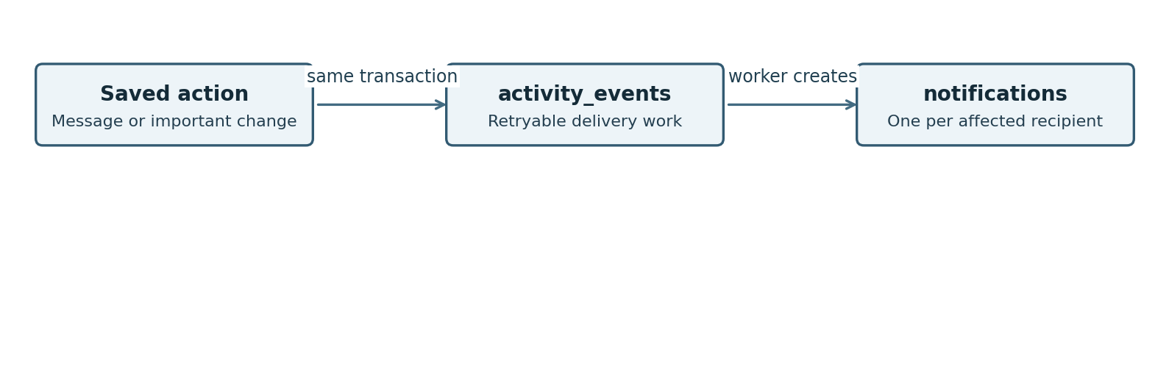
Save the action and its delivery work together. A worker creates each affected recipient’s notice after the action commits. Retrying delivery must not duplicate notices.
Example: a course update affects Sara both as a saver and as an affected discussion participant. Combine the recipient lists so Sara receives one notice for that event. The admin who performed the update sees immediate feedback, not an unnecessary bell notice about their own action.
An activity_events row is a delivery job. A notifications row is what a recipient sees. Separate rows let delivery retry even when the user is offline or the real-time connection fails.

Notification delivery work
Table name: activity_events
One row is work for a background worker after an important action succeeds. It lets delivery retry without requiring the user to repeat the action.
Field | Type | Needed | What it means
id | uuid | Key | Application-generated stable identifier
event_type | varchar(100) | Required | Stable event code
actor_id | uuid | Optional | Person causing action; NULL for system or API; links to users.id
api_key_id | uuid | Optional | API actor when applicable; links to api_keys.id
payload | jsonb | Required | Versioned minimal event data and recipient IDs
created_at | timestamptz | Required | Creation instant; default now()
processed_at | timestamptz | Optional | NULL until fan-out completes
attempt_count | integer | Required | Default 0
next_attempt_at | timestamptz | Required | Retry schedule; default now()
last_error | text | Optional | Sanitized delivery failure

Rules to protect
- Save the work item with the original action, then deliver after commit. Failed delivery retries without undoing the saved action.
- Capture affected recipients before requests/memberships end. Avoid passwords, API secrets and private message bodies in the payload.
- This is delivery work, not an admin audit log. Remove successful jobs under an operational cleanup policy; retain failures until handled.
Record identity: id.

Bell notifications
Table name: notifications
One row is one relevant activity notice for one recipient. It stores seen and read separately, with text in all three interface languages.
Field | Type | Needed | What it means
id | uuid | Key | Application-generated stable identifier
event_id | uuid | Required | Logical event UUID; no FK after queue cleanup
recipient_id | uuid | Required | Only this user may read it; links to users.id
actor_id | uuid | Optional | Actor when applicable; links to users.id
event_type | varchar(100) | Required | Versioned event and translation template key
target_type | varchar(40) | Required | Allowlisted related-resource type
target_id | uuid | Optional | Related resource ID; logical reference
message_parameters | jsonb | Required | Safe template values; no private message body
message_en | text | Required | English message snapshot
message_ar | text | Required | Arabic message snapshot
message_fr | text | Required | French message snapshot
created_at | timestamptz | Required | Notification event time
expires_at | timestamptz | Required | Created time plus 30 days
seen_at | timestamptz | Optional | Dropdown displayed this entry
read_at | timestamptz | Optional | Clicked or opened corresponding item
suppressed_at | timestamptz | Optional | Obsolete request notice hidden

Rules to protect
- Only the recipient may read it. Keep one row per logical event and recipient, even when several rules identify that recipient.
- Opening the dropdown sets seen_at for displayed notices; clicking/opening the relevant item sets both seen_at and read_at. The badge counts unseen notices.
- Expire after 30 days. Self-action toasts do not create rows. Removed targets lead to an unavailable state; deletion cleanup removes identifying snapshots.
Record identity: id.

Reports and outcomes
Table name: reports
One row records a user report, what it targets, and its current outcome. It is not a history of every admin action.
Field | Type | Needed | What it means
id | uuid | Key | Application-generated stable identifier
reporter_id | uuid | Required | Reporting user; links to users.id
profile_user_id | uuid | Optional | Reported profile; links to users.id
question_id | uuid | Optional | Reported question; links to course_questions.id
answer_id | uuid | Optional | Reported answer; links to course_answers.id
team_id | uuid | Optional | Reported team; links to teams.id
reason_category | varchar(50) | Required | Proposed spam harassment misleading inappropriate other
explanation | varchar(1000) | Optional | Reporter detail
status | varchar(8) | Required | open dismissed resolved
resolved_by | uuid | Optional | Reviewing admin; links to users.id
resolved_at | timestamptz | Optional | Decision instant
resolution_reason | text | Optional | Internal current decision reason
public_outcome | text | Optional | Safe outcome shown to reporter
created_at | timestamptz | Required | Creation instant; default now()

Rules to protect
- Set exactly one target: profile, question, answer or team. A reporter cannot have two open reports for the same target.
- States: open, dismissed, resolved. Record who decided, when and why. Give the reporter a safe outcome, not private moderation details.
- No general admin-action history table is included. Reports retain their current resolution information.
Record identity: id.

Course API keys
Table name: api_keys
One row describes an external client credential. TrackUp stores its hash and permissions, not the raw secret.
Field | Type | Needed | What it means
id | uuid | Key | Application-generated stable identifier
label | varchar(150) | Required | Operator-friendly key label
key_prefix | varchar(20) | Required | Nonsecret lookup identifier
key_hash | varchar(128) | Required | Hash of high-entropy secret
access_scope | varchar(10) | Required | read or management
created_at | timestamptz | Required | Creation instant; default now()
revoked_at | timestamptz | Optional | NULL while enabled
created_by | uuid | Optional | Setup actor if known; links to users.id

Rules to protect
- Scope is read or management. Management permits course writes; read permits only published course reads.
- Provision/revoke with a setup command. The raw key is shown only at creation. A revoked key stops working immediately.
- Limit separately per key to 60 requests/minute. Keys never impersonate an ordinary signed-in user.
Record identity: id. Unique values: key_prefix, key_hash.

Seen and read are different
Action | Stored result | Badge effect
Notice arrives | seen_at and read_at empty | Adds one unseen notice
Dropdown displays the notice | Set seen_at only | Removes it from unseen badge
User opens the related item | Set seen_at and read_at | Badge stays cleared
Notice reaches 30 days old | Remove the notice, preserve its target | No longer counted

I: Admin actions and account deletion
Admin pages use the same course, hackathon, team, user and report tables. A separate dashboard does not need copies of those tables. Backend role checks protect every action; being able to see a team does not grant access to its members’ private messages.
Admin action | Stored change
Suspend or restore account | Update users status and current suspension fields; revoke sessions when suspending.
Edit or delete account | Edit ordinary profile fields, or use the same deletion cleanup described below. Do not silently change login identity.
Manage courses | Create, edit or change is_published; API DELETE also unpublishes.
Manage hackathons | Edit fields, change publication, or set cancellation with a reason; close affected recruitment.
Moderate Q&A or resolve report | Set removal fields and report outcome; hide a removed question’s answers.
Oversee teams | Search existing teams; unpublish, restore or disband with a reason; notify affected people.

Deleting an account without breaking history
Delete the person’s identifying account information, but retain an anonymous users.id referenced by existing chat and Q&A. Display Deleted user and remove the profile link. This is anonymization of the account record, not a cascade that erases everyone’s discussions.
- Confirm the action and reauthenticate with the existing login method. Block further use while the cleanup runs.
- Revoke/remove sessions, verification links and external login links. Clear email, internal usernames, password hash, names, bio, professional links, avatar, skills and active roadmap. Remove saved listings and completion records.
- Cancel pending connection and team requests, end accepted connections, and release matching event reservations. End ordinary memberships and notify remaining members.
- For each owned team, choose the longest-standing remaining active verified member. Order by joined_at, then membership ID for a tie. Transfer owner_id and notify everyone. If no eligible member remains, disband/archive the team and cancel its requests.
- Set account_status to deleted and deleted_at. Clear suspension/profile identifying details, remove user-specific roles/claims/tokens, and invalidate security markers. Retain only non-identifying linkage metadata.
- Keep old messages and Q&A linked to the anonymous ID. Remove or anonymize identifying notification snapshots, queued payloads and obsolete avatar bytes. Do not recreate provider links or allow the old account to sign in.
The same cleanup applies when an admin deletes a user. It is not a manual team-ownership-transfer feature. Account removal and all database relationship changes commit as one operation; file cleanup and outbound notices run safely after the commit.

Preserving unavailable records
Record | Treatment
Course or hackathon | Unpublish rather than delete. Keep saves and linked records.
Question or answer | Soft-remove. Hide from users while preserving moderation links.
Team | Unpublish for moderation; archive and end memberships on disband.
Saved item or checklist link | Delete the link on unsave/uncheck; keep its parent.
Chat | Keep history. Remove author identity on account deletion.
Report | Keep current status, moderator, safe outcome and decision reason; no separate action-history log.

J: Rules for the backend developer
This appendix translates the plain rules into implementation checks. A constraint is a database-enforced rule. A transaction keeps related edits together. A row lock makes a competing edit wait until the current transaction finishes.

Keys and uniqueness
Table | Primary key | Additional uniqueness
external_logins | login_provider + provider_key | user_id + login_provider
sessions | id | token_hash
email_verification_tokens | user_id | token_hash
media_files | id | storage_key
skills | id | code
user_skills | user_id + skill_id | Primary key is sufficient for duplicates
it_fields | id | code
positions | id | code
roadmaps | id | position_id
roadmap_topics | id | roadmap_id + code
checklist_items | id | topic_id + code
topic_prerequisites | topic_id + prerequisite_topic_id | Primary key is sufficient for duplicates
item_completions | user_id + item_id | Primary key is sufficient for duplicates
courses | id | Primary key is sufficient for duplicates
course_translations | course_id + language_code | Primary key is sufficient for duplicates
saved_courses | user_id + course_id | Primary key is sufficient for duplicates
course_questions | id | Primary key is sufficient for duplicates
course_answers | id | Primary key is sufficient for duplicates
connections | id | user_low_id + user_high_id
private_conversations | id | user_low_id + user_high_id
private_messages | id | sender_id + client_message_id
hackathons | id | Primary key is sufficient for duplicates
hackathon_translations | hackathon_id + language_code | Primary key is sufficient for duplicates
hackathon_skills | hackathon_id + skill_id | Primary key is sufficient for duplicates
saved_hackathons | user_id + hackathon_id | Primary key is sufficient for duplicates
teams | id | id + hackathon_id
team_requirements | id | id + team_id
team_join_requests | id | id + team_id + hackathon_id + user_id; one pending per event/user
team_memberships | id | id + team_id + hackathon_id + user_id; one active per event/user
hackathon_participation | hackathon_id + user_id | join_request_id, membership_id
reports | id | one open per reporter and selected target
api_keys | id | key_prefix, key_hash
activity_events | id | Primary key is sufficient for duplicates
notifications | id | event_id + recipient_id
users.id and roles.id are primary keys. Nondeleted normalized_email and normalized_user_name are unique; add database uniqueness as well as Identity validation. roles.normalized_name is unique. user_roles uses user_id + role_id. user_claims and role_claims use integer identity IDs. user_tokens uses user_id + login_provider + name.

Foreign keys that compare several fields
Single-column foreign keys are identified in the field tables. These additional composite keys stop a request or membership from being attached to a different event/user/team by mistake:
Child fields | Must match
team_join_requests (team_id, hackathon_id) | teams (id, hackathon_id)
team_memberships (team_id, hackathon_id) | teams (id, hackathon_id)
team_join_requests (requirement_id, team_id) | team_requirements (id, team_id)
hackathon_participation (team_id, hackathon_id) | teams (id, hackathon_id)
hackathon_participation (join_request_id, team_id, hackathon_id, user_id) | team_join_requests (id, team_id, hackathon_id, user_id)
hackathon_participation (membership_id, team_id, hackathon_id, user_id) | team_memberships (id, team_id, hackathon_id, user_id)

Membership and request safety
- Add a partial unique index on (hackathon_id, user_id) for pending requests and another for memberships where ended_at is empty. The participation primary key protects the shared reservation.
- Add a check that exactly one participation pointer is present. At transaction end, deferred constraint triggers must verify every pending request and active membership has its matching participation row, and vice versa. The linked status and all four identifying columns must agree.
- A live team has exactly one active membership for owner_id. Archived teams have no active memberships or pending requests. Validate at commit so creation, ownership transfer and disbanding can update several rows safely.
- To enforce capacity, lock the team row before inserting/ending membership or editing capacity, then compare active membership count. Use a trigger to protect the count for every write path. Ordinary CHECK constraints cannot count rows in another table.
- Use one consistent locking order: affected hackathons, teams, then users; sort IDs within each group. Recheck account eligibility, publication, requirements, capacity and database wall-clock deadline after acquiring locks. Finalize request, membership, reservation and event together.
- When an event maximum is lowered, do not allow it below any current team’s member count. If a configured capacity exceeds the new maximum, reduce that capacity atomically to the new maximum, without dropping below membership count, and notify affected teams. This keeps the stated admin rule without requiring a stricter rejection policy.

Closure and restore rules
Deadline closure expires pending requests. Event cancellation/unpublication, team unpublication/disband, owner suspension, and owner recruitment closure cancel affected pending requests with reasons and release their reservations. Close recruitment on those paths. Restoring a listing does not revive requests or automatically reopen teams. Full teams disappear from recruitment results; existing pending requests are not automatically rejected merely because another request filled the last place.
Every acceptance rechecks requester eligibility. Suspension leaves an ordinary member’s existing membership intact; account deletion ends it. Closing recruitment does not remove existing members. A cleanup worker applies deadline transitions, while backend checks prevent late writes even before the worker runs.

Content validation and defaults
Required text is nonblank after trimming, within its declared maximum. Optional translated fields use NULL rather than empty strings. Account names are mandatory unless deleted. Password confirmation is never stored, and passwords are never silently trimmed.
Allowed values: language en/ar/fr; translation language ar/fr; account active/suspended/deleted; course type course/workshop/bootcamp; delivery online/onsite/hybrid; connection pending/accepted/rejected/cancelled/disconnected; request pending/accepted/rejected/cancelled/expired; report open/dismissed/resolved; API scope read/management; team recruitment open/closed. Enforce these with CHECK constraints.
Defaults: creation timestamps use now(); the backend maintains updated_at. New catalogs publish immediately. New requests/reports are pending/open. Account starts active but unverified; preferred language en; failure count 0; claim-support flags false unless explicitly used. Publication, archival and removal markers determine visibility, not duplicate status flags.
Add timestamp ordering, positive byte sizes, nonnegative counters/order, capacity bounds, price/currency consistency, selected-target count, and read-implies-seen checks. Known paid prices must explicitly be non-NULL and positive. Validate http/https links, actual images, IANA timezone and Unicode passwords in backend code. Source labels without agreed lengths/categories are implementation proposals, not extra product requirements.

Progress and seed loading
Use stable IDs and unique seed codes; upsert only content, never reset user links. Validate topic prerequisites stay in one roadmap and form no cycles. A published topic needs published items. Lock the learner row for individual and bulk toggles; only the active roadmap is editable. Bulk inserts use conflict-safe upserts and commit together. Count only current published, nonarchived topics/items for percentages.

Messages and notification retries
Lock the user-pair connection row for sends and disconnects, and check both account states. The sender must be a participant. A repeated sender/client_message_id returns the existing message only if conversation and body match; otherwise return a conflict. Persist before sending real-time confirmation. Recover missed messages by (sent_at, id).
Insert activity work with the domain change, then fan out after commit. Use a stable logical event ID and UNIQUE(event_id, recipient_id); combine recipients and exclude the actor. event_id on notifications is deliberately not a foreign key to the short-lived queue, so completed queue jobs may be cleaned independently. Target type/id is also a validated soft reference so unavailable targets can still be explained.
For an already open conversation, acknowledge authorized delivery and set the matching notice seen/read. Handle acknowledgment arriving before notification creation by retrying or storing the acknowledgment until insertion. Update only notices belonging to the caller. Expired/suppressed notices are excluded even before cleanup runs.

Authentication and short-lived operational state
Identity handles password hashes and account lockout data. Configure the agreed Unicode policy: 8–64 characters, Latin uppercase/lowercase, a Unicode decimal digit and punctuation/symbol. Five consecutive account password failures cause a 15-minute lockout; success resets that count. The separate IP limit is 30 unsuccessful attempts in 15 minutes.
Use a server-revocable Secure HttpOnly cookie session, at most seven days, with CSRF protection. Check session/account status for HTTP and real-time requests. Verification hashes expire after 24 hours with single-use consumption and a 60-second resend lock. No credential change/reset tables are needed for the specified scope.
For multiple backend processes, use shared expiring state for rate limits and presence. Course API keys have their own 60-per-minute counter. These counters are distinct from account lockout and do not require a permanent IP history table. Do not store Google access tokens merely for sign-in.

Indexes and deletion behavior
Primary/unique keys already create indexes. Add reverse indexes to frequently queried child foreign keys; an FK does not automatically create its child-side index in PostgreSQL. Index conversation history by (conversation_id, sent_at, id), notification inbox by (recipient_id, created_at, id), pending requests by (team_id, status), and active memberships by team_id. Add expiry/retry indexes for workers.
Catalog results use stable ID tie-breakers and 12 rows per page. Search the displayed fallback title/provider/description; combine filters with AND across categories and OR within each category. Event date overlap uses event start <= filter end AND event end >= filter start. Add filter/order indexes as data size warrants; substring-search acceleration is an optional implementation optimization.
Default foreign-key deletion behavior is RESTRICT for retained product data. Do not let Identity deletion cascades erase Q&A or chat. Account deletion uses the controlled anonymization workflow. Explicitly remove disposable links/tokens and obsolete files, and keep retained relations pointing to the anonymous user reference. Never use UserManager.DeleteAsync without the required custom cleanup and preservation strategy.

K: Identity fields and support tables
These are framework implementation details, not additional registration fields. Keep them separate when reviewing product behavior. Use one Identity account model, extended with the TrackUp fields, rather than building a parallel login system.

Why keep normalized email
An email such as Sara@Example.com and sara@example.com must identify the same TrackUp account. Identity keeps a separate normalized comparison form so it can preserve the entered value and perform consistent lookups. A custom schema could store one comparison form instead, but this design follows the selected Identity store. Never remove dots or plus-address suffixes as a normalization shortcut.

Why keep internal usernames
Identity’s default store has UserName and NormalizedUserName. Set its internal username to the email; do not ask users to choose a public handle. These fields are framework storage only. The same distinction applies to unused phone and two-factor columns: their presence does not authorize a phone collection or two-factor feature.
User field | Type | Needed | Why Identity has it
normalized_email | varchar(256) | See rule | Identity comparison form of email; removed on deletion
user_name | varchar(256) | See rule | Internal Identity login value equal to email; no public username
normalized_user_name | varchar(256) | See rule | Identity comparison form of its internal username; removed on deletion
security_stamp | text | Required | Identity credential invalidation marker
concurrency_stamp | text | Required | Identity optimistic concurrency marker
phone_number | text | Optional | Unused Identity compatibility field
phone_number_confirmed | boolean | Required | Unused framework field; false and never requested from users
two_factor_enabled | boolean | Required | Unused framework field; false; no two-factor feature
lockout_end | timestamptz | Optional | Password lockout expiry
lockout_enabled | boolean | Required | Default true
access_failed_count | integer | Required | Consecutive password failures; default 0
Comparison/login fields are required for nondeleted accounts and cleared on deletion. security_stamp invalidates credential state; concurrency_stamp detects conflicting account edits. Use fresh non-identifying values on anonymization. Phone remains NULL, confirmation false, and two-factor false. Lockout fields implement the agreed account-password failure rule.

Framework table mapping
Schema name | Identity default name
users | AspNetUsers
roles | AspNetRoles
user_roles | AspNetUserRoles
external_logins | AspNetUserLogins
user_claims | AspNetUserClaims
role_claims | AspNetRoleClaims
user_tokens | AspNetUserTokens
Our names are proposed EF mappings, not a separate set of duplicate tables. Start with the selected Identity store, add TrackUp fields and relationships, and inspect the generated migration. Actual framework schema details depend on the configured .NET/Identity options; optional unused features are not required by this guide.

Account roles
Table name: roles
The seeded User and Admin roles used by Identity. Team owner is determined from a team record and is not an extra platform role.
Field | Type | Needed | What it means
id | uuid | Key | Application-generated stable identifier
name | varchar(256) | Required | Role display name
normalized_name | varchar(256) | Required | Identity-normalized name
concurrency_stamp | text | Required | Identity concurrency marker

Rules to protect
- Seed User and Admin. The first admin is provisioned by setup; no public admin registration or role assignment feature is assumed.
Record identity: id. Unique values: normalized_name.

Roles assigned to users
Table name: user_roles
One row assigns one role to one account. This is the link between users and roles.
Field | Type | Needed | What it means
user_id | uuid | Key | Role holder; links to users.id
role_id | uuid | Key | Assigned role; links to roles.id

Rules to protect
- The user/role pair is unique. Admins retain ordinary-user capabilities. Remove role links when the account is deleted.
Record identity: user_id + role_id.

Identity user claims
Table name: user_claims
Framework support for additional claims about a user. No custom claims are needed for the agreed features; the table can remain empty.
Field | Type | Needed | What it means
id | integer | Key | GENERATED BY DEFAULT AS IDENTITY
user_id | uuid | Required | Claim owner; links to users.id
claim_type | text | Optional | Identity claim type
claim_value | text | Optional | Identity claim value

Rules to protect
- Framework-managed support table; no product screen depends on filling it. Remove user-specific claims on deletion.
Record identity: id.

Identity role claims
Table name: role_claims
Framework support for claims granted through a role. The table can remain empty.
Field | Type | Needed | What it means
id | integer | Key | GENERATED BY DEFAULT AS IDENTITY
role_id | uuid | Required | Role owner; links to roles.id
claim_type | text | Optional | Identity claim type
claim_value | text | Optional | Identity claim value

Rules to protect
- Framework-managed support table; it may stay empty.
Record identity: id.

Identity token support
Table name: user_tokens
A standard Identity support table. The proposed session and verification-link records below have their own tables; do not confuse them with this one.
Field | Type | Needed | What it means
user_id | uuid | Key | Token owner; links to users.id
login_provider | varchar(128) | Key | Provider namespace
name | varchar(128) | Key | Token purpose
value | text | Optional | Framework-managed protected value

Rules to protect
- Do not store Google access tokens just to support sign-in. Remove account-related token values on deletion.
Record identity: user_id + login_provider + name.

L: Team review checklist and references
Review one feature at a time. For each table, explain in your own words what one row means, which record it links to, and what should happen when its parent becomes unavailable. Use the backend appendix when implementing migrations and concurrent actions.
- Account registration stores no confirmation password or public username; Google links reuse the intended account and prevent duplicate provider identities.
- Switching roadmaps preserves checked items, and topic-wide updates save together.
- Unpublishing a listing preserves required saves and discussion/team history.
- Disconnect preserves chat history but prevents new messages; retry sends do not duplicate it.
- One user cannot have a pending request and membership for the same event; two acceptances cannot overfill a team.
- Account deletion transfers ownership automatically where eligible and leaves anonymous chat/Q&A authors.
- Bell notices deduplicate across recipient roles, separate seen/read, and expire after 30 days.
- Admins can manage users and teams as specified without reading private chats; reports retain their current outcomes.

Implementation choices to confirm
The schema is a proposed implementation of the requirements. Course level labels (suggested: beginner, intermediate, advanced, all_levels), report reason categories, optional text limits not fixed by the requirements, exact seed labels, and operational job-cleanup periods should be confirmed by the team. They do not add product features.

Sources
Product reference: the attached TrackUp_Requirements(1).docx, including account deletion US-05, admin user management US-32, team oversight US-38, and the shared rules. This document replaces the earlier schema reading guide for the current requirements.
Microsoft Learn — Identity model customization in ASP.NET Core: https://learn.microsoft.com/en-us/aspnet/core/security/authentication/customize-identity-model
PostgreSQL documentation — Constraints: https://www.postgresql.org/docs/current/ddl-constraints.html
Technical sources were checked on 16 October 2026. They support the Identity model and database constraint behavior; product decisions come from the attached requirements.

