Date of publication xxxx 00, 0000, date of current version xxxx 00, 0000.
Digital Object Identifier 10.1109/ACCESS.2026.Doi Number
Reliable Cross-Dataset Lymph Node Metastasis Detection Using Quality-Aware Preprocessing and Pathology Foundation Models
Sameer Ahmad Hasan¹, Leen Rayess¹, and Zaineh Hamzeh¹
¹Department of Biomedical Engineering, School of Applied Medical Sciences, German Jordanian University, Amman, Jordan
Corresponding author: Sameer Ahmad Hasan (e-mail: sameer.hasan@gju.edu.jo).
This work received no external funding.
ABSTRACT Reliable computational pathology requires systems that preserve discrimination, sensitivity, and probability quality when image distributions change across datasets and institutions. We developed a data-integrity-audited, quality-aware framework for patch-level lymph-node metastasis detection using PatchCamelyon and CAMELYON17-WILDS in four locked train-test conditions. The workflow combines exact-content integrity screening, tissue-quality control, stain standardization, a conventional convolutional neural network baseline, and two frozen pathology foundation-model classifier configurations, Virchow2 and UNI2-h, with source-fitted temperature calibration and decision-oriented operating-point analysis. On identical quality-passed test patches, preprocessing increased the area under the receiver operating characteristic curve from 0.7232 to 0.9847 and recall from 0.1381 to 0.9094 in the CAMELYON17-WILDS in-domain condition. Both foundation-model configurations transferred strongly from PatchCamelyon to CAMELYON17-WILDS, reaching areas under the receiver operating characteristic curve of 0.9971 and 0.9980. Under reverse transfer, the locked UNI2-h configuration exceeded the locked Virchow2 configuration by 0.0309 in area under the receiver operating characteristic curve, 0.1537 in recall, and 0.1064 in F1 score; all paired 95% slide-cluster bootstrap intervals excluded zero. A stain-benchmark-disjoint sensitivity analysis preserved this separation after removal of all historically overlapping PatchCamelyon benchmark patches. Calibration and high-specificity operating points further exposed model differences that discrimination alone did not capture. The integrated framework demonstrates how disciplined input preparation, directional transfer testing, transferable pathology representations, and cluster-aware probability analysis can strengthen cross-dataset metastasis detection.
INDEX TERMS Calibration, computational pathology, deep learning, domain shift, foundation models, histopathology, medical image analysis, metastasis detection.

I. INTRODUCTION
Histopathological assessment of axillary and sentinel lymph nodes remains an important component of breast cancer staging, with the presence and extent of nodal metastasis contributing to prognostic assessment and treatment planning. Examination of hematoxylin and eosin (H&E)-stained lymph-node sections can be particularly demanding when metastatic deposits are small, sparse, or distributed across large tissue areas. The CAMELYON16 challenge provided compelling early evidence that deep learning could support this task: the best-performing algorithm achieved a whole-slide area under the receiver operating characteristic curve (ROC-AUC) of 0.994 and exceeded the performance of pathologists working under simulated time constraints, while remaining comparable with expert assessment without time restriction [1]. CAMELYON17 subsequently extended automated metastasis assessment to patient-level nodal staging across five medical centers [2]. Together with later weakly supervised whole-slide approaches, these studies established computational pathology as a promising route to scalable decision support [3], [4].
They also highlighted a more difficult translational question: whether performance obtained under a development distribution remains reliable when tissue preparation, staining, scanning, or institutional context changes. This question is particularly important in digital pathology because image appearance reflects both tissue biology and the processes used to prepare and digitize the specimen. Variation in fixation, sectioning, H&E staining, reagent characteristics, scanner optics, illumination, resolution, and image-processing pipelines can introduce systematic differences in color and texture [5]-[8]. Such non-biological variation can become encoded in learned features, allowing models to exploit associations that are predictive within the development environment but unstable elsewhere. Domain shift has consequently been associated with substantial performance degradation when histopathology models are transferred across institutions, scanners, or datasets [8], [9].
Moreover, quality-control studies have demonstrated that tissue folds, blur, background regions, staining abnormalities, and other artifacts are sufficiently prevalent to warrant systematic screening before computational analysis [7]. Robust model assessment therefore requires more than conventional random partitioning within a single image distribution. The CAMELYON resources provide a useful controlled setting in which to study these effects. PatchCamelyon (PCam), derived from CAMELYON16, contains 327,680 labeled 96 × 96-pixel lymph-node patches and has become a widely used benchmark for binary metastasis classification [10]. CAMELYON17 introduced additional institutional heterogeneity through material collected at five centers [2], while its patch-level WILDS formulation explicitly organizes evaluation around hospital-associated distribution shift.
The two resources therefore permit cross-dataset evaluation while maintaining a closely related biological endpoint and patch definition. Their common CAMELYON lineage, however, is an important interpretive constraint. Transfer between PCam and CAMELYON17-WILDS constitutes a rigorous cross-dataset distribution-shift benchmark, but it should not be interpreted as equivalent to prospective validation on an independently collected clinical cohort. This distinction is important when translating strong patch-level performance into claims about clinical generalizability. One long-standing strategy for reducing technical heterogeneity is to control nuisance variation before representation learning.
Classical approaches include statistical color transfer [11], optical-density-based stain decomposition such as the Macenko method [12], and structure-preserving sparse stain separation such as Vahadane normalization [13]. Their objective is to harmonize stain appearance while preserving diagnostically relevant morphology. The benefit of these procedures is nevertheless context dependent. In a systematic evaluation spanning four histopathology tasks and nine laboratories, Tellez et al. showed that stain-aware augmentation and normalization can materially alter cross-laboratory generalization, with the preferred strategy depending on the training configuration and target distribution [14]. Subsequent reviews and multicenter evaluations have emphasized both the potential of stain normalization and its limitations, including reference dependence, structural distortion, and variable effectiveness across tissues and acquisition conditions [15]-[17].
More recently, physical scanner color calibration has also been shown to improve cross-site performance of both supervised and foundation-model-based pathology systems [18]. Preprocessing should therefore be considered an experimentally testable component of a computational pathology pipeline rather than a purely cosmetic operation. In parallel, representation learning in computational pathology has undergone a major transition. Conventional convolutional neural networks (CNNs) learn their full representation from task-specific labeled data and may consequently encode dataset-specific characteristics despite high within-domain performance [5], [6], [8]. Pathology-specific self-supervised learning seeks to reduce this dependence by learning reusable representations from large collections of unlabelled histological images.
CTransPath demonstrated the value of domain-specific contrastive pretraining using a hybrid convolutional-transformer architecture [19]. More recent foundation models have substantially expanded both the scale and diversity of this paradigm. UNI was pretrained on more than 100 million images from over 100,000 diagnostic whole-slide images and demonstrated strong transfer across a broad range of computational pathology tasks [20]. CONCH combined pathology images with biomedical language through large-scale vision-language pretraining [21]. Virchow used approximately 1.5 million whole-slide images from around 100,000 patients to develop representations applicable to common and rare cancers [22].
Virchow2 subsequently extended this family using mixed-magnification self-supervised pretraining on approximately 3.1 million whole-slide images [23], while UNI2-h was released as a larger ViT-H/14 pathology backbone in the UNI model family [24]. Prov-GigaPath extended large-scale pretraining to more than one billion pathology tiles and incorporated long-context whole-slide modelling [25]. These advances have made frozen feature extraction followed by lightweight task-specific learning an increasingly attractive alternative to training all representation layers from task-specific annotations. Large-scale pretraining, however, does not guarantee invariance to technical domain shift. Independent benchmarking has become increasingly important as the number of pathology foundation models has expanded.
Campanella et al. compared publicly available self-supervised pathology encoders on clinically generated datasets and found meaningful differences among models and tasks [26]. Neidlinger et al. subsequently benchmarked 19 foundation models across 13 cohorts and 31 weakly supervised prediction tasks, showing that relative performance depended on the downstream setting and that pretraining diversity could be as important as scale [27]. More directly, Komen et al. evaluated 20 pathology foundation models and demonstrated that medical-center-associated information remained recoverable from their representation spaces; robustness differed substantially among encoders, and post-hoc robustification, including stain normalization, reduced but did not eliminate technical-domain effects [28]. A further 2026 benchmark of 32 vision and pathology foundation models found that model rankings shifted across datasets and task categories and that differences among leading models were often task dependent [29]. Collectively, these studies argue against two simplifying assumptions: that broad pathology pretraining automatically removes stain-or center-associated information, and that contemporary foundation encoders can be regarded as interchangeable.
These findings also broaden the role of preprocessing in the foundation-model era. Input curation and representation learning are complementary components of a robust pathology system: a quality-aware pipeline can reduce avoidable technical variability before inference, while a pretrained pathology encoder can contribute a richer representation learned from large-scale histological data. Evaluating conventional and frozen-pretrained classifiers within the same locked data framework therefore provides a practical way to examine how input quality and representation capacity contribute to cross-dataset reliability. A second challenge concerns how robustness is measured. ROC-AUC and precision-recall AUC characterize ranking across thresholds, but they do not determine whether a particular decision threshold yields an appropriate sensitivity-specificity trade-off.
Likewise, strong discrimination does not imply that predicted probabilities are well calibrated. A model may continue to rank positive and negative patches correctly after distribution shift while its probability scale changes sufficiently to impair sensitivity at a fixed threshold or produce substantial miscalibration. Calibration has therefore become an important consideration in medical image classification [30], and histopathology-specific investigations have shown that uncertainty behavior can deteriorate under both domain shift and label noise [31]. For screening-oriented or decision-support applications, discrimination should consequently be interpreted together with operating-point performance and probability reliability, while recognizing that patch-level benchmarks alone do not establish a clinically deployable operating threshold. Reliable computational pathology is best approached as an end-to-end system in which input quality, representation learning, transfer behavior, and probability reliability reinforce one another.
Quality-aware preprocessing can reduce avoidable technical variability before learning, pathology foundation models can provide reusable representations learned from large-scale histology, and calibration with operating-point analysis can translate strong ranking performance into more informative decision behavior. Integrating these components within one controlled cross-dataset workflow creates an opportunity to move beyond isolated accuracy reporting toward a more complete characterization of robustness and practical model utility. The present study develops and tests a comprehensive cross-dataset framework for patch-level lymph-node metastasis detection using PCam and CAMELYON17-WILDS. Its contribution is built on four coordinated elements. First, the input pipeline combines exact-content and cross-corpus integrity screening, tissue-quality assessment, stain standardization, and standardized intensity processing, with the resulting impact quantified through conventional shallow-CNN baselines.
Second, two contemporary pathology foundation models, Virchow2 and UNI2-h, are deployed as frozen feature extractors with lightweight task-specific heads to examine the transferability of large-scale histology representations. Third, four locked train-test conditions provide bidirectional cross-dataset analysis, allowing the source-target relationship itself to become an informative part of the robustness assessment. Fourth, discrimination is complemented by source-fitted temperature calibration, Brier score, log loss, 15-bin expected calibration error (ECE15), reliability diagrams, clinically relevant high-specificity operating points, paired bootstrap confidence intervals, and paired permutation testing. This integrated design enables the study to identify not only where high cross-dataset performance is achieved, but also which model configuration better preserves sensitivity and probability reliability under the more challenging transfer direction.
II. METHODS
A. STUDY DESIGN
This retrospective computational study developed a controlled framework for patch-level detection of breast cancer lymph-node metastasis across dataset and institutional distribution shift. The framework was designed to combine input quality control, pathology foundation-model representation, bidirectional transfer analysis, threshold behavior, and probability reliability within a single reproducible workflow. Two public histopathology patch datasets were used: PatchCamelyon (PCam) [10] and CAMELYON17-WILDS, derived from the CAMELYON17 challenge [2]. The experimental layout comprised four prespecified train-test conditions (Table I).
C2 was the primary forward distribution-shift experiment. C4 was retained as a mirror analysis to characterize directional asymmetry, threshold drift, and calibration shift; it was not treated as a second symmetric success criterion for C2. The study used a layered comparison. First, a shallow convolutional neural network (CNN) was trained on raw and study-preprocessed inputs to characterize the association of the complete preprocessing pipeline with performance at the pipeline level.
Second, Virchow2 and UNI2-h were evaluated as frozen pathology foundation-model encoders with trainable binary heads on the same curated image tensors. Third, model behavior was assessed using discrimination, fixed-threshold metrics, prespecified sensitivity-specificity operating points, overall probabilistic accuracy, and calibration. The complete locked experimental workflow is summarized in Fig. 1.
The raw-versus-preprocessed ablation was performed with the shallow CNN and quantifies preprocessing effects for that conventional pipeline. Virchow2 and UNI2-h were evaluated only on the locked curated/preprocessed surface; their experiments test representation transfer and decision reliability under a fixed input protocol and are not used to claim a causal preprocessing benefit for foundation models.

TABLE I. PRESPECIFIED TRAIN-TEST CONDITIONS.
Condition | Training dataset | Test dataset | Purpose
C1 | PCam | PCam | In-domain PCam reference
C2 | PCam | CAMELYON17-WILDS | Primary forward cross-dataset stress test
C3 | CAMELYON17-WILDS | CAMELYON17-WILDS | In-domain CAMELYON17 reference
C4 | CAMELYON17-WILDS | PCam | Prespecified mirror transfer to assess asymmetry
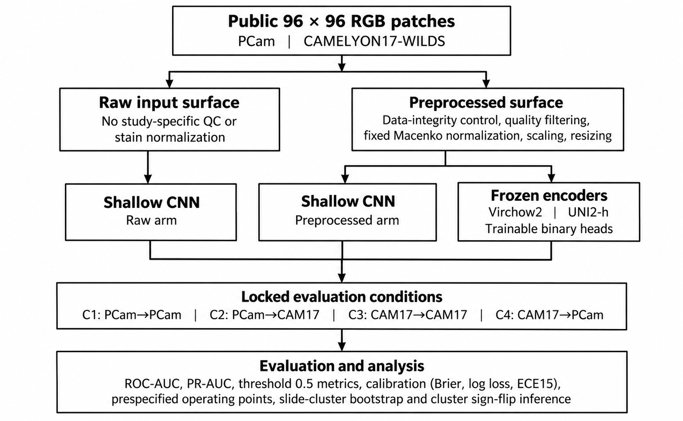
FIGURE 1. Study design and locked experimental workflow. Official split roles are preserved in final model-training and calibration arms. The public datasets branch into a raw input surface and a locked curated/preprocessed surface. The shallow convolutional neural network is evaluated on both surfaces, whereas Virchow2 and UNI2-h are evaluated as frozen encoders on the curated/preprocessed surface. Final test labels are excluded from model-head training, checkpoint selection, and temperature scaling; the earlier stain-handling development benchmark and its PatchCamelyon overlap are documented separately in Section II-E.

B. DATASETS AND ENDPOINT DEFINITION
PCam and CAMELYON17-WILDS were used as fixed 96 × 96 red-green-blue (RGB) patch-level datasets for binary lymph-node metastasis classification. In both datasets, the binary endpoint indicates whether metastatic tumor is present within the central 32 × 32-pixel region of the patch, with the surrounding pixels providing local histologic context. The public PCam catalogue contained 262,144 training patches, 32,768 validation patches, and 32,768 test patches before study-specific curation [10]. In the CAMELYON17-WILDS Hierarchical Data Format version 5 (HDF5) package used in this study, the training split contained 302,436 patches from centers 0, 3, and 4; the validation split contained 34,904 patches from center 1; and the test split contained 85,054 patches from center 2.
The packaged split roles were preserved throughout development and evaluation. Source-domain validation data were used for checkpoint selection and temperature scaling. Neither in-domain nor external test labels were used for model selection, calibration, or training decisions. Final retained patch counts after data-integrity controls and quality filtering are shown in Table II.

TABLE II. FINAL RETAINED PATCH COUNTS AND CLASS PREVALENCE AFTER INTEGRITY AND QUALITY CONTROL.
Dataset | Split | Retained patches | Positive fraction
PCam | Training | 208,355 | 0.426
PCam | Validation | 26,515 | 0.442
PCam | Test | 27,704 | 0.467
CAMELYON17-WILDS | Training | 296,294 | 0.509
CAMELYON17-WILDS | Validation | 34,389 | 0.507
CAMELYON17-WILDS | Test | 83,181 | 0.511

C. DATA-INTEGRITY CONTROLS
Before model training, data-integrity controls were applied to reduce leakage and inflated performance estimates. For PCam, exact-content deduplication was performed by Secure Hash Algorithm 256-bit (SHA-256) hashing of raw patch bytes, retaining the first index from each identical-content group. This reduced the training, validation, and test partitions from 262,144 to 220,025, from 32,768 to 28,108, and from 32,768 to 29,383 patches, respectively, before quality filtering. CAMELYON17-WILDS was not deduplicated within this pipeline.
Exact cross-dataset overlap was subsequently assessed by SHA-256 hashing of the final curated uint8-equivalent RGB tensors across PCam and CAMELYON17-WILDS. One normalized hash was shared across the pooled corpora. The final PCam test split had no exact match to any CAMELYON17-WILDS patch, whereas the CAMELYON17-WILDS test split contained one patch matching the pooled PCam corpus (1/83,181; approximately 1.2 x 10^-5). Because this audit was performed after the curated surfaces had been locked, it was treated as a diagnostic integrity check and no post hoc exclusions were introduced; final comparisons preserved the locked retained indices.
SHA-256 screening detects byte-identical duplicates after the specified image representation but does not constitute a perceptual near-duplicate or tissue-provenance analysis. The overlap results are therefore interpreted as exact-content checks.
D. PREPROCESSING PIPELINE
The study preprocessing sequence was fixed as follows: PCam exact deduplication and split protection, patch-level quality filtering, single-reference Macenko stain normalization, value scaling to [0,1], and model-specific resizing. CAMELYON17-WILDS followed the same sequence except that no within-dataset deduplication was performed. 1) PATCH-LEVEL QUALITY FILTERING Quality filtering was implemented in the locked preprocessing script before stain normalization. Each red-green-blue (RGB) patch was converted to floating-point values in [0,1].
The grayscale image was defined as the channel mean, G = (R + G + B)/3. A patch was rejected as near-uniform when SD(G) < 0.04. High-black burden was defined from the fraction of all RGB channel values less than or equal to 0.10; a patch was rejected when this fraction was at least 0.50. Tissue content combined chromatic saturation and local grayscale variance.
Pixel saturation was calculated as S = [max(R,G,B) - min(R,G,B)]/max(R,G,B), with saturation set to zero when the maximum channel value was effectively zero. Local grayscale variance was estimated with an 11 x 11 uniform window as V = E(G^2) - E(G)^2. The preliminary tissue mask was the union of pixels satisfying S > 0.12 or V > 0.003, and the combined tissue fraction was the proportion of pixels in this union. For borderline combined tissue fractions between 0.12 and 0.45, grayscale values were rescaled using the 5th and 95th percentiles, an Otsu threshold was estimated from a 256-bin histogram, and an Otsu-derived tissue fraction was calculated as the proportion of normalized grayscale values below that threshold.
The final tissue fraction was the larger of the combined and Otsu-derived fractions. Patches with a final tissue fraction < 0.35 were excluded. The same quality rules were applied to both datasets and all splits. Across all splits, quality filtering removed 14,942 of 277,516 deduplicated PCam candidates (5.4%) and 8,530 of 422,394 CAMELYON17-WILDS candidates (2.0%).
Low-tissue patches accounted for most exclusions. 2) VALUE SCALING AND MODEL INPUT After quality filtering and stain normalization, patches were stored as float RGB tensors in [0,1] at the native 96 × 96 resolution. The shallow CNN operated on native-resolution tensors. For Virchow2 and UNI2-h, patches were upsampled at model-input time from 96 × 96 to 224 × 224 using bicubic interpolation implemented with torch.nn.functional.interpolate (align_corners=False), followed by ImageNet normalization with mean (0.485, 0.456, 0.406) and standard deviation (0.229, 0.224, 0.225).
Bicubic interpolation was retained after visual comparison with bilinear interpolation because it produced less apparent smoothing of nuclear boundaries; resizing was not interpreted as recovery of spatial information absent from the original patch.
The QC constants were engineering thresholds fixed in the preprocessing script before the final foundation-model evaluations and were applied identically across datasets and splits. They are not presented as optimized or universally optimal histopathology QC thresholds. Their operational effect is reported through split-and class-specific exclusion counts, and the matched-index analysis separately evaluates model behavior while holding the test population fixed.
E. STAIN NORMALIZATION AND FIXED PREPROCESSING CHOICE
The final curated image surface used single-reference Macenko normalization [12], implemented with staintools 2.1.2. A fixed reference patch from the PCam training set (raw training index 89340) was luminosity-standardized and used to fit StainNormalizer(method="macenko"). The same fitted PCam reference was used for PCam and CAMELYON17-WILDS. For each quality-passed patch, the uint8 representation was luminosity-standardized, transformed with the fitted Macenko normalizer, and rescaled to [0,1].
The implementation permitted luminosity-only fallback if the Macenko transform raised an exception; final preprocessing reports recorded Macenko use for 100% of retained patches in both datasets. Macenko had originally been selected during pipeline development in a matched shallow-CNN comparison of six stain-handling strategies: Macenko, Reinhard, Vahadane, adaptive single-reference routing, adaptive multi-reference routing, and adaptive multi-reference routing with training-time color/intensity augmentation. The original benchmark targeted 40,000 training, 8,000 validation, and 16,000 test patches before quality filtering, with matched retained indices across stain methods. The benchmark test subset was not independent of the final PCam test surface: after quality control, 13,522 of 15,190 benchmark-test patches were also present in the final curated PCam test set used in C1 and C4.
The original stain comparison is therefore treated only as a pipeline-development step and not as independent evidence of stain-method superiority. After the final experimental pipeline had been locked, a validation-only rerun was used as a sensitivity check and did not rank Macenko first (validation ROC-AUC 0.9202 versus 0.9261 for Reinhard and adaptive multi-reference routing with augmentation). Accordingly, no claim is made that Macenko is the optimal stain-normalization method. All preprocessing conclusions refer to the complete locked quality-aware pipeline rather than to Macenko in isolation.
The same PCam-training reference patch was intentionally used as a common color anchor for both corpora. Accordingly, C4 is interpreted as reverse transfer under a fixed common-reference harmonization protocol rather than as a target-unseen or strictly zero-shot normalization setting. Because the identical normalized PCam test surface was used for both foundation-model configurations, the within-C4 model comparison remains paired on the same inputs.
F. SHALLOW CONVOLUTIONAL NEURAL NETWORK BASELINE
A compact end-to-end CNN was used to quantify pipeline-level performance differences associated with preprocessing and to provide a conventional non-foundation reference. The feature extractor comprised four 3 × 3 convolutional stages with padding 1 and channel progression 32, 64, 128, and 256. Each convolution was followed by ReLU activation; 2 × 2 max pooling followed the first three stages. The final convolutional stage was followed by adaptive global average pooling, a 128-unit fully connected layer with ReLU activation, dropout 0.5, and a single binary-logit output.
No batch-normalization layers were used. All CNN parameters were trained from random initialization using BCEWithLogitsLoss and Adam with learning rate 0.001, batch size 320, and weight decay 0 for 10 epochs. The seed was fixed at 42 for Python, NumPy, PyTorch, and CUDA where applicable. The locked training script did not use a learning-rate scheduler, gradient clipping, or training-time augmentation in the four principal raw/preprocessed arms.
The checkpoint with the highest source-validation ROC-AUC on raw sigmoid probabilities was retained. Four CNN training arms were evaluated: PCam raw, PCam preprocessed, CAMELYON17-WILDS raw, and CAMELYON17-WILDS preprocessed. Each trained model was evaluated on its in-domain and external test surface. Because quality filtering changed the eligible sample population, raw-versus-preprocessed comparisons are interpreted as pipeline-level comparisons of the original and curated data surfaces, not as paired patch-level causal effects of preprocessing.
Temperature scaling was fitted separately on the source validation split for each arm; fitted temperatures were 1.3574, 1.4727, 4.4247, and 1.7334 for PCam raw, PCam preprocessed, CAMELYON17 raw, and CAMELYON17 preprocessed, respectively.
Matched-index preprocessing sensitivity analysis. The operational raw-versus-preprocessed comparison includes both input transformation and quality-based patch exclusion. To separate model/input-processing effects from changes in the eligible test population, raw-arm predictions were additionally restricted to the exact raw patch indices retained by the corresponding curated/preprocessed test surface. Raw and preprocessed CNN metrics were then recomputed on identical labels and patch indices in each condition.
G. VIRCHOW2 FROZEN-ENCODER CLASSIFIER
Virchow2 [23] was evaluated as a frozen encoder with a trainable binary head. The encoder was loaded with timm from hf-hub:paige-ai/Virchow2 using Hugging Face revision 3158645804b69e3f3bc4439d4116edddf0840a72. Encoder parameters were frozen throughout supervised training. For each patch, the representation was formed by concatenating the classification (CLS) token with the mean of the patch-token embeddings, yielding a 2560-dimensional feature vector.
A dropout layer (p=0.2) and linear layer mapped this representation to one binary logit. The head was optimized with BCEWithLogitsLoss and Adam (learning rate 0.001, weight decay 0) for 10 epochs. Batch size was 256 for PCam training and 320 for CAMELYON17-WILDS training. Checkpoints were selected by source-validation accuracy.
Source-validation temperature scaling yielded T=1.2783 for the PCam-trained model (applied unchanged to C1 and C2) and T=1.5900 for the CAMELYON17-trained model (applied to C3 and C4).
H. UNI2-H FROZEN-ENCODER CLASSIFIER
UNI2-h [24], a ViT-H/14 pathology backbone in the UNI model family [20], was evaluated using the same curated tensors and C1-C4 layout. The encoder was loaded with timm from hf-hub:MahmoodLab/UNI2-h and remained frozen. The exact Hugging Face commit was not pinned at the time of training; reproducibility is therefore anchored to the locked local trained heads and exported predictions rather than to a bit-exact Hub revision. The 1536-dimensional CLS token from the backbone output was used as the patch representation and mapped to a single binary logit by a trainable head.
Training used BCEWithLogitsLoss and Adam (learning rate 0.001, weight decay 0), batch size 256, and 10 epochs, with checkpoint selection by source-validation accuracy. The PCam-trained head used dropout 0.2, whereas the CAMELYON17-trained head used dropout 0.0; this difference was part of the locked experimental configuration and was not altered post hoc. Separate source-validation temperature fits for the two training origins selected the same grid value, T=1.1461, which was applied to C1-C2 and C3-C4, respectively. Because the locked Virchow2 and UNI2-h configurations were not identical in all downstream-head settings, particularly CAMELYON17 training dropout and batch size, their head-to-head results are interpreted as comparisons of the locked frozen-encoder classifier configurations rather than as perfectly isolated encoder-only effects.
For PCam-origin training (C1-C2), downstream training settings were matched across encoders: batch size 256, head dropout 0.2, Adam learning rate 0.001, 10 epochs, and checkpoint selection by source-validation accuracy. For CAMELYON17-origin training (C3-C4), the retained historical configurations differed in batch size and head dropout (Virchow2: 320 and 0.2; UNI2-h: 256 and 0.0). Consequently, C3-C4 head-to-head results are interpreted as comparisons of the complete locked frozen-encoder classifier configurations rather than as isolated causal effects of encoder identity.
I. CALIBRATION, THRESHOLD POLICY, AND RELIABILITY DIAGRAMS
All main probability-based results used temperature-scaled probabilities. For a binary logit z, the calibrated probability was p = sigmoid(z/T), with T > 0, where T was fitted by minimizing mean binary negative log-likelihood on source-validation logits only. The search used a log-spaced grid over T in [0.2, 5.0], with 60 candidate values for Virchow2 and UNI2-h and 80 for the CNN. The fitted temperature was applied unchanged to the corresponding in-domain and external test surfaces.
No target-domain test labels or logits were used to fit T. Threshold-dependent metrics used a fixed calibrated-probability threshold of 0.5 for accuracy, precision, recall, and F1 score. This cut-off was a standardized reporting reference and was not optimized on test data. Discrimination was summarized using ROC-AUC and precision-recall performance, operationalized as average precision (AP) and reported as PR-AUC/AP in the supplementary metric tables.
Overall probabilistic accuracy was summarized using Brier score and binary log loss, whereas calibration was assessed using expected calibration error with 15 equal-width bins (ECE15) and reliability diagrams. Because temperature scaling is a strictly monotone transformation for T > 0, it does not change ranking metrics; with a binary zero-logit decision boundary, it also preserves the class assignment at an exact probability threshold of 0.5. Reliability diagrams used the same 15 equal-width probability bins. Within each non-empty bin, mean predicted positive-class probability was plotted against the observed positive fraction.
Virchow2 and UNI2-h were overlaid for each C1-C4 condition.
Raw and source-temperature-scaled probability-quality metrics were also retained to determine whether a calibration transformation fitted in the source domain transported beneficially to each external test surface; target-domain improvement was not assumed.
J. OPERATING-POINT ANALYSIS
To complement the fixed 0.5 threshold, three prespecified operating-point summaries were calculated from the calibrated test scores: sensitivity at specificity ≥95%, sensitivity at specificity ≥98%, and specificity at sensitivity ≥90%. Scores were sorted in descending order and performance was evaluated only after all observations sharing an identical score had been accumulated, so tied predictions were treated together. Sensitivity at a target specificity was defined as the maximum sensitivity among thresholds satisfying the specificity constraint; specificity at a target sensitivity was defined analogously. These operating points are descriptive test-set trade-off summaries and were not used to select or claim a prospectively locked clinical deployment threshold.
K. STATISTICAL ANALYSIS
All principal foundation-model test metrics were accompanied by nonparametric cluster-bootstrap 95% confidence intervals to account for within-slide dependence among patches. For PatchCamelyon, the source whole-slide image identifier was recovered from the official test metadata and used as the resampling cluster; 129 whole-slide images contributed retained patches to the final PCam test surface. For CAMELYON17-WILDS, the slide identifier in the official WILDS metadata was used as the cluster; the retained center-2 test surface comprised 10 slides from 9 patients.
For each condition and model, 2,000 bootstrap replicates were generated by sampling slides with replacement and including all retained patches from each sampled slide, preserving multiplicity. Metrics were recomputed from temperature-calibrated probabilities, with threshold-dependent metrics evaluated at 0.5. Percentile intervals were defined by the 2.5th and 97.5th percentiles of the cluster-bootstrap distribution.
For the matched-index shallow-CNN analysis, raw and preprocessed predictions were aligned on identical retained patch indices and paired slide-cluster bootstrap resampling was applied with the same 2,000-replicate scheme. Preprocessed-minus-raw contrasts were calculated for ROC-AUC and recall using the same resampled slides for both surfaces; these intervals quantify whether the principal preprocessing-associated gains persist after holding the evaluation population fixed.
A patient-clustered sensitivity analysis was additionally performed for the CAMELYON17-WILDS test surface. Within each foundation-model configuration, paired probability-quality comparisons were repeated with cluster-aware sign-flip tests. Per-patch Brier-score and negative-log-likelihood differences were grouped by source slide, and all paired differences within a slide were assigned the same random sign.
For PCam, 10,000 Monte Carlo slide-level sign flips were used across 129 whole-slide images. For CAMELYON17-WILDS, all 2^10 possible slide-level sign assignments were enumerated exactly. Benjamini-Hochberg false-discovery-rate control at q=0.05 was applied across the predefined family of eight Brier/log-loss tests.
The principal direct C4 comparison between the locked UNI2-h and Virchow2 configurations used the same 2,000 slide-cluster bootstrap samples for both models so that paired contrasts preserved the common test-surface clustering structure. Contrasts were defined as UNI2-h minus Virchow2 for ROC-AUC, accuracy, recall, F1 score, and ECE15. Operating-point summaries and reliability diagrams were treated as supportive descriptive analyses rather than as an additional confirmatory hypothesis family.
Because the historical stain-handling development benchmark sampled from the official PCam test split, an additional sensitivity analysis excluded every final PCam test patch that had appeared in that benchmark. This left 14,182 completely disjoint patches spanning all 129 source whole-slide images. C1 and C4 metrics were recomputed on this subset, and the principal C4 paired comparison was repeated using slide-cluster bootstrap resampling.
L. PREDICTION EXPORTS, IMPLEMENTATION ENVIRONMENT, AND REPRODUCIBILITY
For all final CNN, Virchow2, and UNI2-h test evaluations, prediction exports were retained with patch or row index, true label, raw logit, sigmoid probability, temperature-scaled probability, predicted label at 0.5, dataset, split, model, training origin, test surface, and fitted temperature where applicable. Locked checkpoints, prediction NumPy compressed (NPZ) and comma-separated-value (CSV) files, metric JavaScript Object Notation (JSON) files, curated split indices, and preprocessing manifests constitute the primary reproducibility anchors for the reported analyses. The principal training and evaluation workflows were executed in Google Colab on CUDA-capable graphics processing unit (GPU) hardware; available notebook evidence records an NVIDIA L4 runtime. Mixed-precision training was not used.
The recorded Colab stack included Python 3.12, PyTorch 2.5.1+cu121, and torchvision 0.20.1+cu121. Local Windows analyses used Python 3.10.7, PyTorch 2.3.0+cu121, timm 1.0.25, h5py 3.14.0, WILDS 2.0.0, and staintools 2.1.2. The CNN seed was recorded as 42. Training seeds for Virchow2 and UNI2-h were not recorded in the locked training configurations; therefore, bit-exact retraining of the foundation-model heads is not claimed.
The study used only publicly available, de-identified benchmark data. Because the analysis was limited to public, de-identified data and involved no interaction with participants, clinical intervention, or access to identifiable private information, no new ethics-review or informed-consent procedure was undertaken for this secondary computational study. Analysis scope. Preprocessing results are interpreted at the level of the complete locked input pipeline, which combined integrity control, quality filtering, stain standardization, and standardized intensity handling. Foundation-model comparisons are reported for the locked Virchow2 and UNI2-h classifier configurations used in each transfer condition.
This preserves the experimental configurations that generated the retained checkpoints and prediction exports and keeps interpretation aligned with the actual computational workflow. PCam and CAMELYON17-WILDS are publicly available benchmark datasets. Study-specific curated indices, trained classification heads, prediction outputs, and analysis artifacts are available from the corresponding author upon reasonable request.
Analysis scope. Preprocessing effects are inferred from the shallow-CNN raw/preprocessed experiments and their matched-index sensitivity analysis. The foundation-model experiments evaluate transfer and decision reliability on the fixed curated/preprocessed surface. Foundation-model head-to-head comparisons are reported for the locked Virchow2 and UNI2-h classifier configurations used in each transfer condition.
III. RESULTS
A. CURATED DATASETS AND LOCKED EVALUATION SURFACES
After preservation of public split roles, PCam exact-content deduplication, cross-corpus exact-content screening, and patch-quality filtering, the locked PCam tensors contained 208,355 training, 26,515 validation, and 27,704 test patches. The corresponding CAMELYON17-WILDS tensors contained 296,294 training, 34,389 validation, and 83,181 test patches. Quality filtering removed 14,942 of 277,516 deduplicated PCam candidates (5.4%) and 8,530 of 422,394 CAMELYON17-WILDS candidates (2.0%), with low-tissue patches accounting for most exclusions.
Class-specific QC reporting showed that exclusions were concentrated among negative/background patches: on the PCam test split, 0.42% of positive and 9.92% of negative candidates were removed; on the CAMELYON17-WILDS test split, the corresponding values were 0.14% and 4.27% (Supplementary Table S6). The matched-index analysis described below therefore provides the principal test of whether preprocessing-associated gains persist when evaluation population is held fixed. Exact-hash screening showed negligible byte-identical overlap between the final corpora.
The four locked evaluation conditions were C1 (PCam to PCam), C2 (PCam to CAMELYON17-WILDS; primary forward transfer), C3 (CAMELYON17-WILDS to CAMELYON17-WILDS), and C4 (CAMELYON17-WILDS to PCam; prespecified mirror transfer). A validation-only stain-handling rerun performed after the preprocessing surface had been locked did not rank Macenko first (Supplementary Table S1 and Supplementary Fig. S1); no result is interpreted as an isolated Macenko effect.
B. QUALITY-AWARE PREPROCESSING RETAINED LARGE GAINS ON MATCHED TEST PATCHES
The preprocessing-associated improvements persisted when raw and preprocessed CNNs were evaluated on exactly the same quality-passed test indices. In C3, ROC-AUC increased from 0.7232 to 0.9847 and recall at threshold 0.5 from 0.1381 to 0.9094; accuracy increased from 0.5445 to 0.9424, while Brier score decreased from 0.2728 to 0.0446 and ECE15 from 0.2392 to 0.0268. Paired slide-cluster bootstrap contrasts confirmed the size of the C3 changes: delta ROC-AUC was +0.2615 (95% CI 0.1896 to 0.4961) and delta recall was +0.7713 (0.7375 to 0.8799). In C4, ROC-AUC increased from 0.6956 to 0.8560 and recall from 0.0740 to 0.3621 on the same 27,704 PCam patches; the corresponding paired contrasts were +0.1604 (0.1021 to 0.2211) for ROC-AUC and +0.2881 (0.2001 to 0.3744) for recall.
C1 also showed improved ROC-AUC (+0.0687; 95% slide-cluster CI 0.0210 to 0.1328) and recall (+0.1575; 0.0803 to 0.2437). C2 remained near ceiling for discrimination: the ROC-AUC contrast was +0.0012 with a cluster interval spanning zero (-0.0017 to 0.0181), whereas recall increased by +0.0349 (0.0128 to 0.1420). Accuracy and probability-quality metrics in C2 were less favorable after preprocessing. These matched-index results show that the large C3 and C4 gains are not explained solely by exclusion of patches from the test population. The complete operational-surface and matched-index metrics, together with paired cluster-bootstrap contrasts, are reported in Supplementary Tables S2-S3 and immediately below Supplementary Table S3.

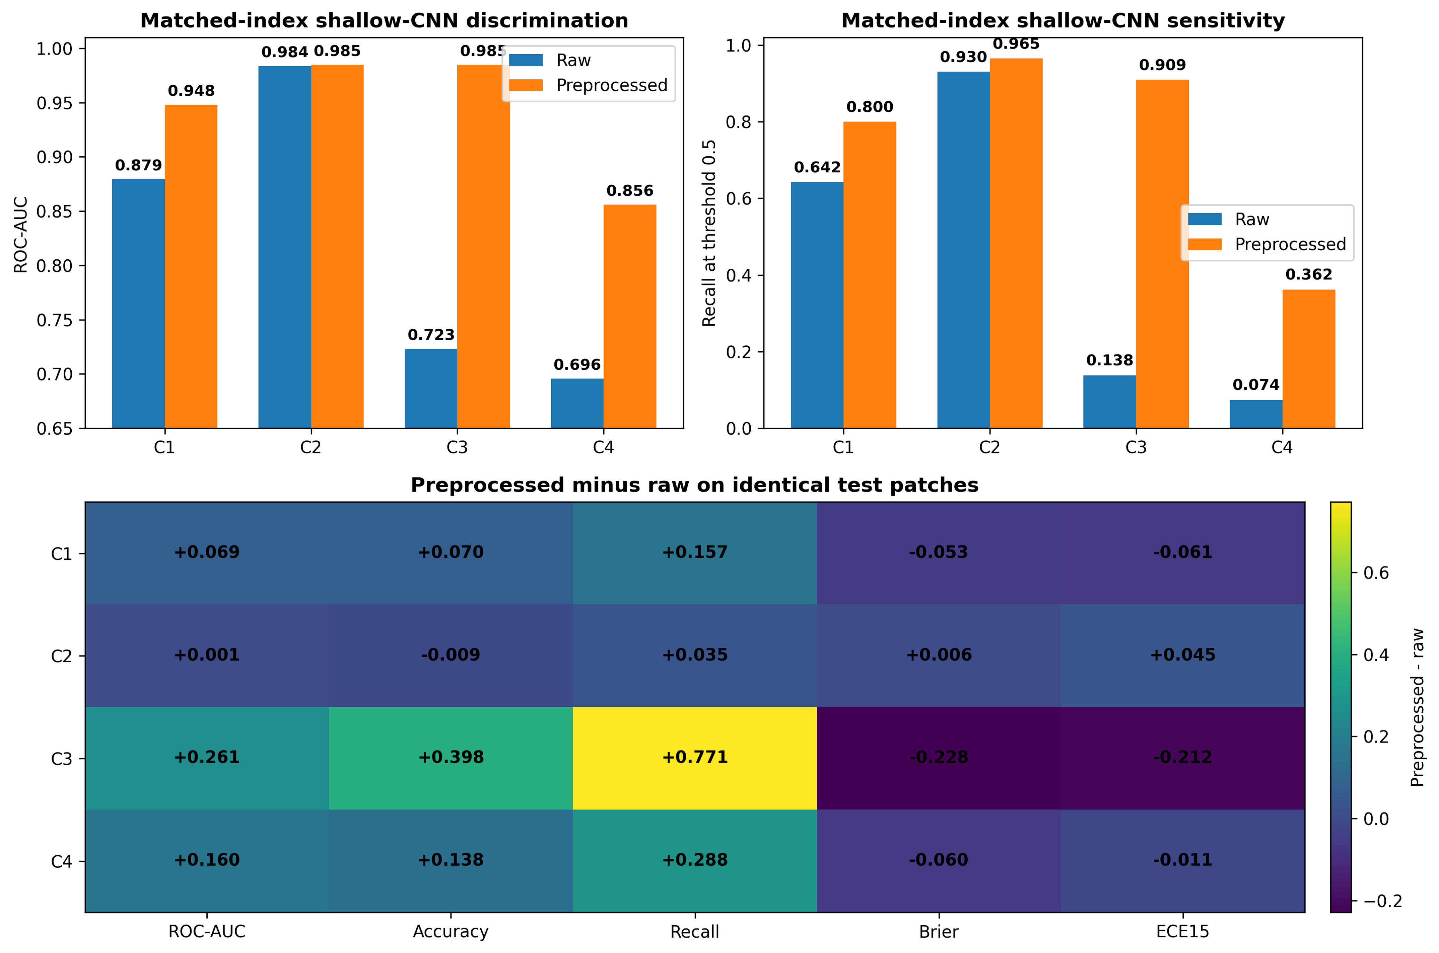
FIGURE 2. Matched-index effect of the locked preprocessing protocol on the shallow CNN. Raw and preprocessed predictions are evaluated on identical quality-passed test indices. Positive changes are favorable for ROC-AUC, accuracy, and recall; negative changes are favorable for Brier score and ECE15.

C. BOTH FOUNDATION-MODEL CONFIGURATIONS TRANSFERRED STRONGLY FROM PCAM TO CAMELYON17-WILDS
Both frozen foundation-model configurations achieved high discrimination on the curated tensors. In C1, Virchow2 achieved ROC-AUC 0.9813 (95% slide-cluster CI 0.9747-0.9875) and UNI2-h 0.9855 (0.9798-0.9907). In the primary forward-transfer condition C2, Virchow2 achieved ROC-AUC 0.9971 (0.9948-0.9977), recall 0.9820, and F1 score 0.9843, while UNI2-h achieved ROC-AUC 0.9980 (0.9975-0.9986), recall 0.9899, and F1 score 0.9857.
Thus, both locked configurations maintained near-saturated discrimination when transferred from PCam to the held-out CAMELYON17-WILDS center-2 test surface. C3 was similarly strong. Virchow2 achieved ROC-AUC 0.9966 and UNI2-h 0.9974.
At threshold 0.5, UNI2-h had higher precision (0.9951 versus 0.9795) but slightly lower recall (0.9729 versus 0.9810), showing that ranking and a single thresholded operating point did not move identically. The CAMELYON17 test surface comprised 10 slides from 9 patients; cluster-aware intervals are therefore wider than patch-level intervals and are reported in Table III. Figure 3 summarizes discrimination, recall, and calibration across C1-C4.

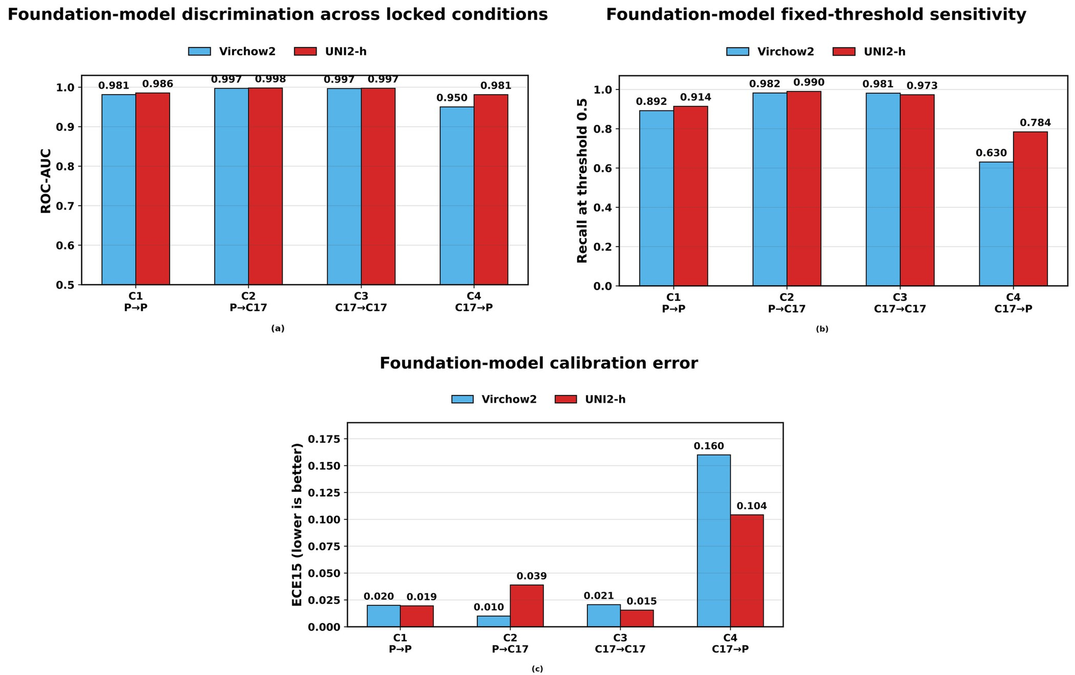
FIGURE 3. Performance of the locked Virchow2 and UNI2-h classifier configurations across the four conditions. (a) ROC-AUC. (b) Recall at threshold 0.5. (c) ECE15; lower values indicate better calibration.
TABLE III. KEY FOUNDATION-MODEL METRICS WITH 95% SLIDE-CLUSTER BOOTSTRAP CONFIDENCE INTERVALS (B = 2,000).
Condition | Model | ROC-AUC [95% CI] | Recall [95% CI] | F1 [95% CI] | ECE15 [95% CI]
C1 PCam to PCam | Virchow2 | 0.9813 [0.9747, 0.9875] | 0.8919 [0.8533, 0.9277] | 0.9294 [0.9071, 0.9480] | 0.0200 [0.0120, 0.0420]
C1 PCam to PCam | UNI2-h | 0.9855 [0.9798, 0.9907] | 0.9141 [0.8807, 0.9447] | 0.9449 [0.9263, 0.9604] | 0.0195 [0.0142, 0.0362]
C2 PCam to CAMELYON17-WILDS | Virchow2 | 0.9971 [0.9948, 0.9977] | 0.9820 [0.9467, 0.9899] | 0.9843 [0.9394, 0.9915] | 0.0100 [0.0060, 0.0266]
C2 PCam to CAMELYON17-WILDS | UNI2-h | 0.9980 [0.9975, 0.9986] | 0.9899 [0.9761, 0.9940] | 0.9857 [0.9436, 0.9923] | 0.0389 [0.0239, 0.0698]
C3 CAMELYON17-WILDS to CAMELYON17-WILDS | Virchow2 | 0.9966 [0.9918, 0.9986] | 0.9810 [0.9410, 0.9930] | 0.9803 [0.9225, 0.9900] | 0.0206 [0.0122, 0.0472]
C3 CAMELYON17-WILDS to CAMELYON17-WILDS | UNI2-h | 0.9974 [0.9925, 0.9990] | 0.9729 [0.9169, 0.9907] | 0.9839 [0.9511, 0.9935] | 0.0155 [0.0068, 0.0381]
C4 CAMELYON17-WILDS to PCam | Virchow2 | 0.9502 [0.9340, 0.9650] | 0.6304 [0.5458, 0.7135] | 0.7696 [0.7022, 0.8290] | 0.1600 [0.1128, 0.2035]
C4 CAMELYON17-WILDS to PCam | UNI2-h | 0.9811 [0.9739, 0.9875] | 0.7841 [0.7222, 0.8478] | 0.8760 [0.8360, 0.9144] | 0.1042 [0.0705, 0.1363]

D. REVERSE TRANSFER EXPOSED A LARGE CONFIGURATION-LEVEL SEPARATION
The largest separation occurred in C4, the reverse-transfer test conducted under the fixed common-reference harmonization protocol, where CAMELYON17-WILDS-trained classifiers were evaluated on PCam. Virchow2 retained ROC-AUC 0.9502 but recall declined to 0.6304, F1 score to 0.7696, and ECE15 increased to 0.1600. The locked UNI2-h configuration achieved ROC-AUC 0.9811, recall 0.7841, F1 score 0.8760, and ECE15 0.1042 on the same 27,704 PCam test patches.
Slide-clustered paired bootstrap analysis confirmed that the C4 separation was not explained by within-slide patch dependence. UNI2-h improved ROC-AUC by 0.0309 (95% cluster-bootstrap CI 0.0201-0.0427), accuracy by 0.0727 (0.0531-0.0937), recall by 0.1537 (0.1147-0.1948), and F1 score by 0.1064 (0.0760-0.1432). ECE15 decreased by 0.0558, corresponding to a paired difference of -0.0558 (95% CI -0.0745 to -0.0372).
Every paired cluster-bootstrap interval excluded zero. The configuration-level contrasts are shown in Fig. 4.

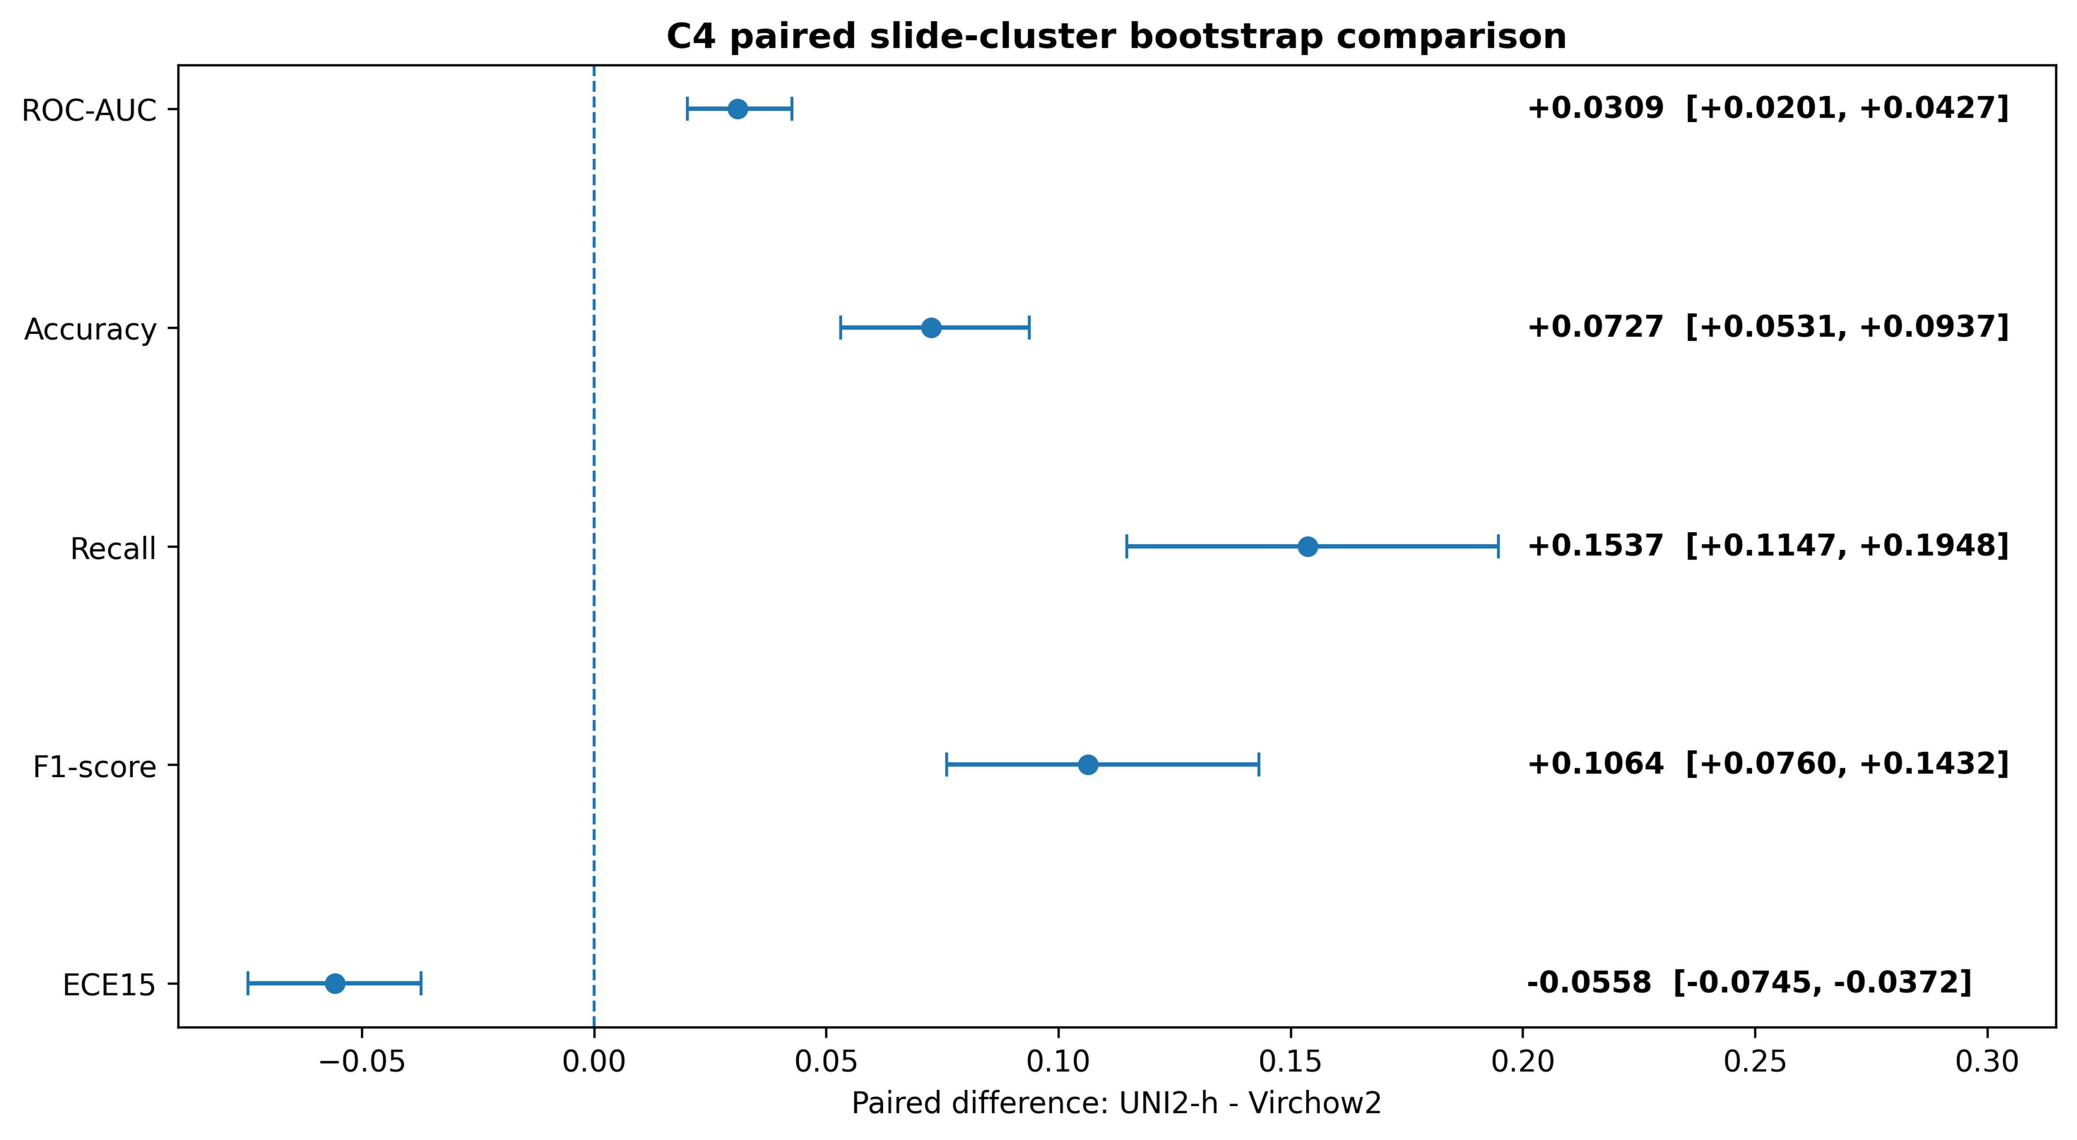
FIGURE 4. Paired C4 comparison on shared PCam test indices using slide-cluster bootstrap resampling. Points show UNI2-h-minus-Virchow2 configuration differences; horizontal bars show 95% cluster-bootstrap intervals.

E. OPERATING-POINT ANALYSIS CONFIRMED THAT THE C4 SEPARATION WAS NOT SPECIFIC TO THRESHOLD 0.5
Threshold-swept operating-point summaries were close to saturation in C2 and C3 but separated clearly in C4. At specificity of at least 95%, C4 sensitivity was 0.8065 for Virchow2 and 0.9329 for UNI2-h. At specificity of at least 98%, sensitivity was 0.7243 and 0.8963, respectively.
When sensitivity was constrained to at least 90%, specificity was 0.8362 for Virchow2 versus 0.9787 for UNI2-h. Thus, the reverse-transfer separation persisted across decision-relevant high-specificity regions and was not an artifact of the default probability cut-off. The complete prespecified operating-point results are given in Table IV.

TABLE IV. OPERATING-POINT CHARACTERISTICS FROM TEMPERATURE-SCALED TEST PROBABILITIES. VALUES ARE DESCRIPTIVE TEST-SET TRADE-OFFS RATHER THAN PROSPECTIVELY SELECTED DEPLOYMENT THRESHOLDS.
Condition | Model | Sensitivity at >=95% specificity | Sensitivity at >=98% specificity | Specificity at >=90% sensitivity
C1 PCam to PCam | Virchow2 | 0.9238 | 0.8807 | 0.9707
C1 PCam to PCam | UNI2-h | 0.9454 | 0.9185 | 0.9873
C2 PCam to CAMELYON17-WILDS | Virchow2 | 0.9910 | 0.9850 | 0.9990
C2 PCam to CAMELYON17-WILDS | UNI2-h | 0.9937 | 0.9900 | 0.9990
C3 CAMELYON17-WILDS to CAMELYON17-WILDS | Virchow2 | 0.9887 | 0.9803 | 0.9977
C3 CAMELYON17-WILDS to CAMELYON17-WILDS | UNI2-h | 0.9922 | 0.9874 | 0.9987
C4 CAMELYON17-WILDS to PCam | Virchow2 | 0.8065 | 0.7243 | 0.8362
C4 CAMELYON17-WILDS to PCam | UNI2-h | 0.9329 | 0.8963 | 0.9787

F. CALIBRATION REVEALED BEHAVIOR THAT DISCRIMINATION ALONE DID NOT CAPTURE
Calibration differed by condition and configuration despite uniformly high ranking performance in C2 and C3. In C2, UNI2-h had slightly higher ROC-AUC and recall than Virchow2, but Virchow2 had lower ECE15 (0.0100 versus 0.0389), Brier score (0.0134 versus 0.0146), and log loss (0.0559 versus 0.0698). This provides a direct example in which a small discrimination advantage did not translate into better probability reliability.
The cross-dataset reliability diagrams are shown in Fig. 5. In C4, calibration shift was substantially larger.
Virchow2 had ECE15 0.1600, Brier score 0.1363, and log loss 0.4716; UNI2-h reduced these to 0.1042, 0.0797, and 0.2839, respectively, but did not eliminate the external-domain calibration shift. Raw-versus-source-temperature-scaled metrics further showed that source-fitted temperature scaling did not uniformly improve external probability quality (Supplementary Table S7), reinforcing the interpretation of calibration transport as an empirical property rather than an assumption. Cluster-aware probability-quality testing refined the earlier patch-level findings.
On PCam, both Brier-score and log-loss contrasts between C1 and C4 remained significant for Virchow2 and UNI2-h after Benjamini-Hochberg correction (adjusted p=0.0002 for each). On CAMELYON17-WILDS, the C3-versus-C2 contrasts remained significant for Virchow2 (adjusted p=0.0365 for both metrics) but were not significant for UNI2-h (adjusted p=0.8594 for Brier score and 0.5871 for log loss). Thus, training-origin effects on probability quality were strongly supported on PCam for both locked configurations and on CAMELYON17-WILDS for Virchow2, whereas no slide-cluster-level evidence of a probability-quality difference was detected for UNI2-h on the CAMELYON17-WILDS test surface.

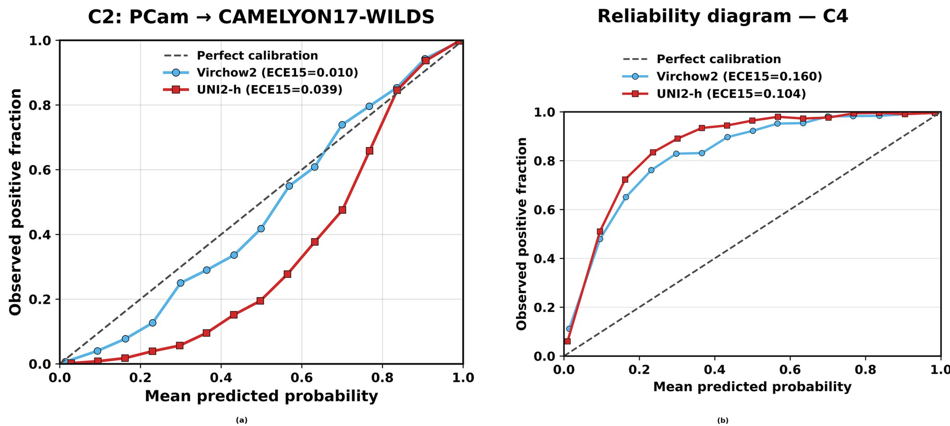
FIGURE 5. Reliability diagrams for the cross-dataset transfer conditions. (a) C2, PCam to CAMELYON17-WILDS. (b) C4, CAMELYON17-WILDS to PCam. Fifteen equal-width bins were computed from source-temperature-scaled probabilities; the diagonal denotes perfect calibration.

G. C4 CONFUSION MATRICES LOCALIZED THE REVERSE-TRANSFER ERROR PATTERN TO FALSE NEGATIVES
At threshold 0.5, the C4 confusion matrices showed that the between-configuration difference was driven primarily by false negatives. Virchow2 correctly classified 63.0% of positive PCam patches while preserving 99.3% specificity; UNI2-h correctly classified 78.4% of positive patches while preserving 99.5% specificity. The row-normalized heatmaps retain raw counts so that class-specific error rates and sample sizes remain visible simultaneously.

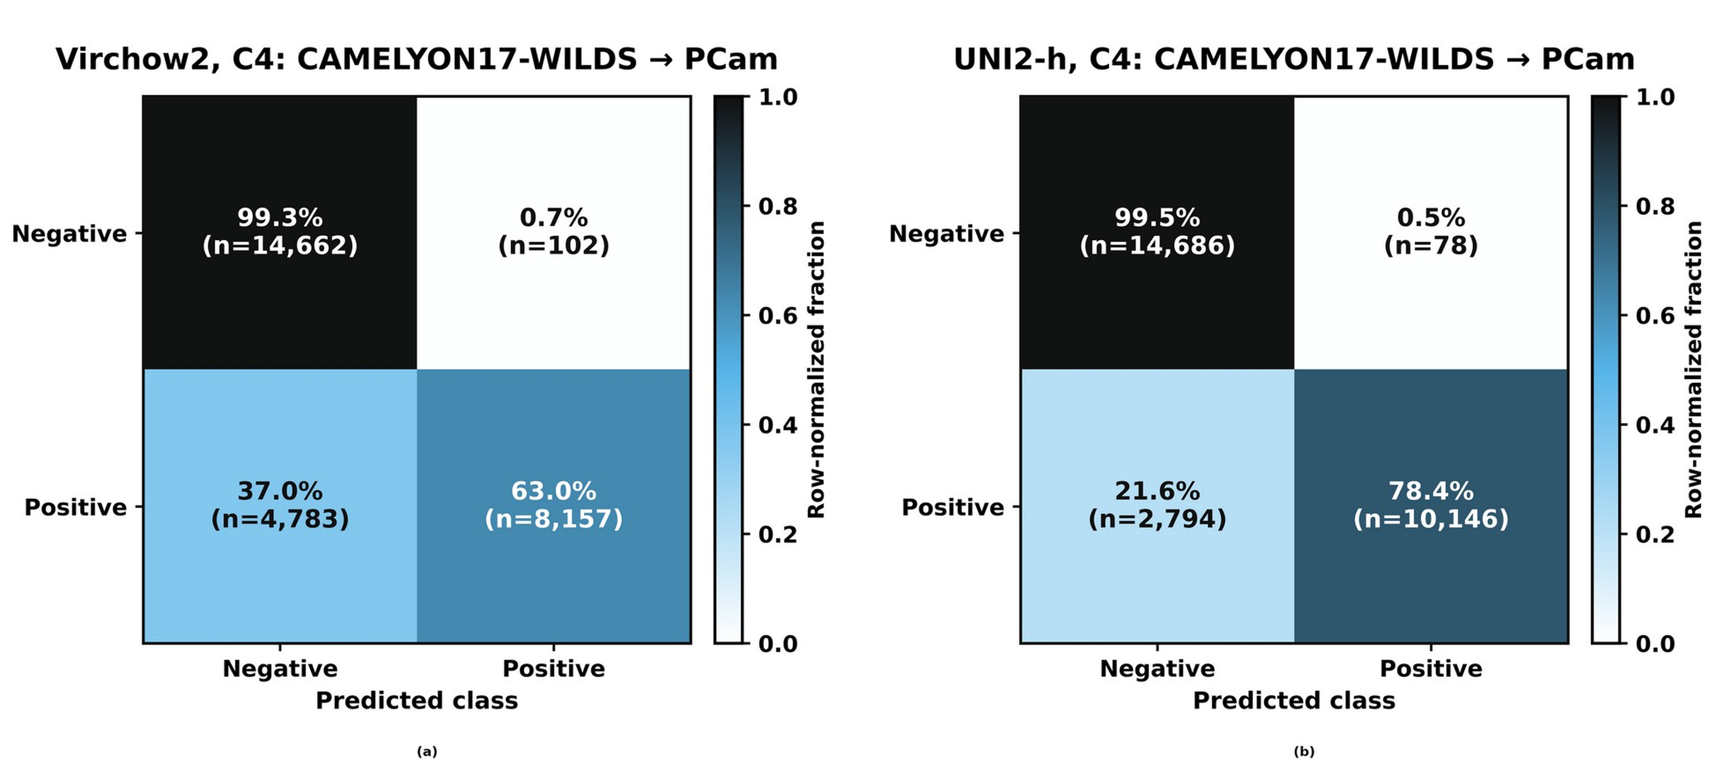
FIGURE 6. C4 confusion matrices at threshold 0.5. (a) Virchow2. (b) UNI2-h. Color encodes the row-normalized fraction, and each cell reports the corresponding percentage and raw number of patches.

H. STAIN-BENCHMARK-DISJOINT SENSITIVITY ANALYSIS PRESERVED THE C4 SEPARATION
To assess whether the historical stain-development overlap could account for the principal PCam findings, all 13,522 retained PCam test patches that had appeared in the earlier stain-benchmark test subset were excluded. The remaining 14,182 patches were completely disjoint from that development test subset while spanning all 129 source whole-slide images. C1 discrimination remained high for Virchow2 (ROC-AUC 0.9809) and UNI2-h (0.9850).
On the disjoint C4 surface, Virchow2 achieved ROC-AUC 0.9508, recall 0.6279, F1 score 0.7676, and ECE15 0.1603, whereas UNI2-h achieved ROC-AUC 0.9803, recall 0.7849, F1 score 0.8763, and ECE15 0.1043. The paired configuration differences remained 0.0295 for ROC-AUC (95% slide-cluster CI 0.0187-0.0413), 0.0742 for accuracy (0.0529-0.0968), 0.1570 for recall (0.1165-0.2032), and 0.1087 for F1 score (0.0763-0.1465); ECE15 remained lower for UNI2-h by 0.0560 (difference -0.0560, 95% CI -0.0762 to -0.0366). These results show that the principal reverse-transfer separation persists on a PCam test subset that was not used in the historical stain-method benchmark (Supplementary Table S8 and Supplementary Fig.
S4).
IV. DISCUSSION
A. PRINCIPAL FINDINGS AND CONTRIBUTIONS
This study demonstrates the value of engineering robustness across the full computational pathology pipeline rather than optimizing a single performance metric in isolation. Four findings define the contribution. First, the quality-aware input protocol produced large shallow-CNN gains that remained after raw and preprocessed models were evaluated on identical test patches, establishing that the strongest C3 and C4 improvements were not artifacts of quality-based test exclusion.
Second, both frozen pathology foundation-model configurations delivered exceptionally strong PCam-to-CAMELYON17-WILDS transfer with lightweight downstream heads. Third, reverse transfer exposed a large configuration-level separation that remained after slide-cluster inference and after exclusion of every PCam test patch used in the historical stain-method benchmark. Fourth, calibration and decision-threshold analyses revealed behavior that discrimination alone could not capture.
Together, these results establish a coherent pathway from data integrity and input preparation to transferable representation and decision-level reliability.
B. QUALITY-AWARE PREPROCESSING STRENGTHENED THE SHALLOW-CNN PIPELINE
The matched-index shallow-CNN experiments provide the clearest evidence for the practical value of disciplined input preparation. In C3, ROC-AUC increased from 0.7232 to 0.9847 and recall from 0.1381 to 0.9094 on the same 83,181 test patches; the corresponding C4 increases were 0.6956 to 0.8560 and 0.0740 to 0.3621. Because evaluation composition is fixed in these contrasts, the major improvements cannot be attributed simply to removal of difficult patches.
The operational pipeline results remain useful for describing the effect of the complete QC-and-preprocessing system, while the matched analysis isolates model/input-processing behavior more directly. This pattern is consistent with prior work showing that stain variation, scanner characteristics, and other non-biological acquisition factors can alter histopathology generalization [8], [14], [17]. Multicenter evidence indicates that physical color calibration can improve external performance [18], while PathoROB showed that image-space stain normalization can improve robustness to center-associated variation [28].
The present results extend this evidence by showing that a complete quality-aware input protocol can substantially alter the behavior of a conventional metastasis classifier under both in-domain and reverse-transfer testing. The preprocessing arm should be interpreted as a system-level input strategy rather than evidence that Macenko itself is optimal. The post-lock validation-only stain comparison ranked Reinhard and adaptive multi-reference normalization with augmentation slightly above Macenko, while the common PCam-training reference used here defines a fixed harmonization protocol rather than a zero-shot target-unseen normalization setting.
The stain-benchmark-disjoint sensitivity analysis further shows that the principal foundation-model C4 finding does not depend on the PCam patches that were historically observed during stain-method development.
C. PATHOLOGY FOUNDATION MODELS ENABLED STRONG CROSS-DATASET TRANSFER
The foundation-model results show strong transfer potential from large-scale pathology pretraining. In the primary forward-transfer condition C2, Virchow2 and UNI2-h reached ROC-AUC values of 0.9971 and 0.9980, respectively, despite evaluation on the held-out CAMELYON17-WILDS center-2 test surface. This level of transfer with frozen encoders and lightweight task-specific heads is attractive for practical adaptation because the pretrained representation can be retained while the downstream classifier remains compact.
The reverse-transfer condition, evaluated under the same fixed common-reference harmonization protocol, provided a more discriminating stress test. In C4, the locked UNI2-h configuration exceeded the locked Virchow2 configuration by 0.0309 ROC-AUC, 0.1537 recall, and 0.1064 F1 score, with all paired slide-cluster intervals excluding zero. The same separation persisted at high-specificity operating points.
Independent benchmarks likewise show that pathology foundation-model rankings depend on downstream task, cohort, and technical domain [26]-[29], supporting the broader conclusion that high average benchmark performance does not make contemporary encoders interchangeable. The C4 comparison is deliberately interpreted at the configuration level because the CAMELYON17-origin heads differed in batch size and dropout. Importantly, the directional pattern is also evident within each configuration: from C3 to C4, ROC-AUC decreased by 0.0463 for Virchow2 versus 0.0163 for UNI2-h, recall decreased by 0.3507 versus 0.1888, and F1 score decreased by 0.2107 versus 0.1079.
These within-configuration gaps strengthen the conclusion that the two locked systems respond differently to the reverse dataset transition without requiring an encoder-only causal claim.
D. TRANSFER DIRECTION REVEALED DISTINCT ROBUSTNESS PROFILES
Cross-dataset behavior was strongly asymmetric. PCam-trained configurations transferred to CAMELYON17-WILDS with no loss of ranking performance, whereas CAMELYON17-WILDS-trained configurations transferred less reliably to PCam, particularly the locked Virchow2 configuration. Successful transfer in one direction therefore did not predict equivalent behavior in the opposite direction, even though the datasets share a related biological endpoint and a 96 x 96 patch formulation.
Directional behavior can arise from staining and scanner characteristics, source-domain heterogeneity, patch selection, class-conditional appearance, and how fully the training distribution covers the target distribution. The explicit transfer-gap analysis makes the asymmetry quantitative rather than inferential from absolute scores alone. The very high C2 performance remains important: exact-content overlap screening and held-out center-2 evaluation provide strong evidence that both locked configurations preserved metastasis-discriminative information across this benchmark transition.
The cluster-aware probability-quality analyses further show that training-origin effects are not uniform across models and surfaces. On PCam, both configurations showed clear Brier-score and log-loss differences between in-domain and reverse-transfer origins. On CAMELYON17-WILDS, corresponding differences remained significant for Virchow2 but were not detected for UNI2-h after slide-level clustering and multiplicity correction.
This refinement strengthens the directional interpretation while avoiding patch-count-driven pseudo-replication.
E. CALIBRATION AND OPERATING POINTS ADDED DECISION-LEVEL RELIABILITY
The calibration analyses provide a second reason to avoid ranking models by ROC-AUC alone. In C2, UNI2-h had slightly higher ROC-AUC and recall than Virchow2, yet Virchow2 had lower ECE15, Brier score, and log loss. In C4, both configurations showed substantial calibration shift, although UNI2-h retained lower probability-quality errors.
Because temperature scaling was fitted only on source-domain validation data and transported unchanged, these analyses test whether a source-calibrated probability scale remained reliable after transfer. The raw-versus-scaled sensitivity analysis shows that this transport can improve some external settings while slightly worsen others. This distinction has practical importance.
ROC-AUC is invariant to monotonic score transformations and can remain high when probability levels no longer correspond well to observed event frequencies; likewise, a fixed threshold can lose sensitivity after transfer despite preserved ranking. Virchow2 illustrates this in C4, retaining ROC-AUC 0.9502 while recall fell to 0.6304 and ECE15 rose to 0.1600. Threshold-swept operating points confirmed that the C4 separation was not limited to the default 0.5 threshold: at specificity >=95%, sensitivity was 0.8065 for Virchow2 and 0.9329 for UNI2-h; at specificity >=98%, values were 0.7243 and 0.8963.
These decision-relevant benchmark regions complement discrimination without being presented as prospectively validated clinical thresholds.
F. STRENGTHS, PRACTICAL VALUE, AND STUDY SCOPE
The study has several strengths that increase the value of its findings. Public split roles were retained for final model-head training and calibration; exact-content duplicates and cross-corpus overlap were screened explicitly; preprocessing rules and evaluation surfaces were auditable from retained indices and manifests; raw-versus-preprocessed effects were tested again on identical test patches; and the principal C4 comparison was repeated with slide-cluster resampling. The stain-benchmark development history is disclosed rather than obscured, and a patch-disjoint PCam sensitivity analysis demonstrates that the central C4 separation persists after exclusion of every final-test patch that had appeared in the historical stain-method benchmark. This direct patch-reuse sensitivity analysis does not retrospectively alter the historical development procedure used to select the fixed stain-normalization component.
The inferential framework now respects the clustered structure of histopathology patches. PCam analyses use 129 source whole-slide images, while CAMELYON17-WILDS analyses use 10 center-2 slides from 9 patients, with a patient-cluster sensitivity analysis providing a complementary check. The relatively small number of independent CAMELYON17-WILDS test slides limits the precision of cluster-level uncertainty estimates for C2 and C3 despite the large number of constituent patches; those intervals should therefore be interpreted with appropriate caution. This cluster-aware treatment remains preferable to patch-level resampling, which would yield artificially narrow uncertainty intervals in the presence of within-slide dependence.
The scope of inference remains defined by the benchmark design. PCam and CAMELYON17-WILDS share CAMELYON lineage and establish cross-dataset patch-level robustness for this metastasis task rather than whole-slide or patient-level clinical performance. The complete preprocessing protocol should be interpreted as a system-level input strategy, not as evidence for universal superiority of a specific stain-normalization method.
The foundation-model results represent the locked classifier configurations evaluated here; CAMELYON17-origin head settings were not harmonized across encoders, and training seeds for the foundation-model heads were not recorded. The slide-cluster bootstrap intervals quantify uncertainty associated with the sampled test-surface structure and do not incorporate between-training-run variability. These boundaries define the next level of validation without diminishing the observed transfer results.
G. POTENTIAL FOR ROBUST COMPUTATIONAL PATHOLOGY
The results support a practical strategy for developing more reliable pathology AI systems. Exact-content integrity checks, tissue-quality control, and stain handling can stabilize the data surface before learning; pathology foundation models can provide highly transferable representations with lightweight downstream adaptation; bidirectional cross-dataset testing can reveal behavior that one-way transfer may conceal; and calibration with decision-relevant high-specificity operating points can connect model scores to operational requirements. The strength of the framework lies in combining these components while auditing the dependence structure of the evaluation data.
The strong forward-transfer performance of both locked configurations, the substantial reverse-transfer separation, the persistence of that separation after stain-benchmark-disjoint and slide-cluster sensitivity analyses, and the large matched-index shallow-CNN gains together demonstrate considerable potential for robust lymph-node metastasis detection across changing data environments. These findings motivate broader validation in independent multi-institutional whole-slide cohorts, where the same workflow can support site-aware quality control, lightweight foundation-model adaptation, calibration, and prospectively specified decision thresholds.
V. CONCLUSION
This study presents a reproducibly audited framework for cross-dataset lymph-node metastasis detection that integrates quality-aware preprocessing, frozen pathology foundation-model configurations, bidirectional transfer testing, calibration, decision-oriented operating points, and cluster-aware statistical inference. On matched test patches, the input protocol produced large gains in the shallow-CNN baseline, while both frozen foundation-model configurations achieved near-saturated discrimination in the primary PCam-to-CAMELYON17-WILDS transfer. Under the more demanding reverse transfer, the locked UNI2-h configuration preserved substantially higher sensitivity, F1 score, discrimination, and probability reliability than the locked Virchow2 configuration, and slide-cluster paired inference confirmed that the separation exceeded within-slide resampling uncertainty.
The principal C4 finding also persisted after exclusion of every PCam test patch used in the historical stain-method benchmark, providing a direct patch-reuse sensitivity check on the development-history concern. Calibration and high-specificity operating-point analyses identified behavior that ranking metrics alone did not reveal, while cluster-aware probability testing showed that training-origin effects on probability quality were model-and surface-dependent. Together, these findings provide a strong basis for broader multi-institutional and whole-slide validation and a practical strategy for engineering reliability from input quality through representation transfer to decision behavior.
VI. SUPPLEMENTARY MATERIAL
Supporting information includes the post-lock validation-only stain-handling sensitivity benchmark, authoritative shallow-CNN operational and matched-index metrics, paired slide-cluster contrasts for the matched preprocessing analysis, full slide-cluster foundation-model intervals including PR-AUC/AP, cluster-aware probability-quality tests, QC exclusion analyses, raw-versus-temperature-scaled probability-quality metrics, stain-benchmark-disjoint sensitivity analyses, and additional reliability diagrams.
ACKNOWLEDGMENT
OpenAI ChatGPT (GPT-5.6 Sol) [32] was used to assist with language restructuring and journal-format adaptation in the Abstract and Sections I-V, figure-formatting support, and generation of analysis code used for the matched-index and cluster-aware statistical analyses described in Sections II-III and the Supplementary Material. All computational analyses were executed on retained prediction files and official dataset metadata using deterministic scripts, and all outputs were reviewed and verified by the authors. The authors take full responsibility for the analyses and article content. No generative artificial intelligence system generated experimental data.
REFERENCES
[1] B. Ehteshami Bejnordi et al., “Diagnostic assessment of deep learning algorithms for detection of lymph node metastases in women with breast cancer,” JAMA, vol. 318, no. 22, pp. 2199-2210, 2017, doi: 10.1001/jama.2017.14585.
[2] P. Bándi et al., “From detection of individual metastases to classification of lymph node status at the patient level: The CAMELYON17 challenge,” IEEE Trans. Med. Imaging, vol. 38, no. 2, pp. 550-560, 2019, doi: 10.1109/TMI.2018.2867350.
[3] G. Campanella et al., “Clinical-grade computational pathology using weakly supervised deep learning on whole slide images,” Nat. Med., vol. 25, pp. 1301-1309, 2019, doi: 10.1038/s41591-019-0508-1.
[4] M. Y. Lu, D. F. K. Williamson, T. Y. Chen, R. J. Chen, M. Barbieri, and F. Mahmood, “Data-efficient and weakly supervised computational pathology on whole-slide images,” Nat. Biomed. Eng., vol. 5, pp. 555-570, 2021, doi: 10.1038/s41551-020-00682-w.
[5] C. L. Srinidhi, O. Ciga, and A. L. Martel, “Deep neural network models for computational histopathology: A survey,” Med. Image Anal., vol. 67, Art. no. 101813, 2021, doi: 10.1016/j.media.2020.101813.
[6] A. H. Song et al., “Artificial intelligence for digital and computational pathology,” Nat. Rev. Bioeng., vol. 1, pp. 930-949, 2023, doi: 10.1038/s44222-023-00096-8.
[7] A. Janowczyk, R. Zuo, H. Gilmore, M. Feldman, and A. Madabhushi, “HistoQC: An open-source quality control tool for digital pathology slides,” JCO Clin. Cancer Inform., vol. 3, pp. 1-7, 2019, doi: 10.1200/CCI.18.00157.
[8] K. Stacke, G. Eilertsen, J. Unger, and C. Lundström, “Measuring domain shift for deep learning in histopathology,” IEEE J. Biomed. Health Inform., vol. 25, no. 2, pp. 325-336, 2021, doi: 10.1109/JBHI.2020.3032060.
[9] S. Otálora, M. Atzori, V. Andrearczyk, A. Khan, and H. Müller, “Staining invariant features for improving generalization of deep convolutional neural networks in computational pathology,” Front. Bioeng. Biotechnol., vol. 7, Art. no. 198, 2019, doi: 10.3389/fbioe.2019.00198.
[10] B. S. Veeling, J. Linmans, J. Winkens, T. S. Cohen, and M. Welling, “Rotation equivariant CNNs for digital pathology,” in Medical Image Computing and Computer Assisted Intervention - MICCAI 2018, 2018, pp. 210-218, doi: 10.1007/978-3-030-00934-2_24.
[11] E. Reinhard, M. Ashikhmin, B. Gooch, and P. Shirley, “Color transfer between images,” IEEE Comput. Graph. Appl., vol. 21, no. 5, pp. 34-41, 2001, doi: 10.1109/38.946629.
[12] M. Macenko et al., “A method for normalizing histology slides for quantitative analysis,” in Proc. IEEE Int. Symp. Biomed. Imaging, 2009, pp. 1107-1110, doi: 10.1109/ISBI.2009.5193250.
[13] A. Vahadane et al., “Structure-preserving color normalization and sparse stain separation for histological images,” IEEE Trans. Med. Imaging, vol. 35, no. 8, pp. 1962-1971, 2016, doi: 10.1109/TMI.2016.2529665.
[14] D. Tellez et al., “Quantifying the effects of data augmentation and stain color normalization in convolutional neural networks for computational pathology,” Med. Image Anal., vol. 58, Art. no. 101544, 2019, doi: 10.1016/j.media.2019.101544.
[15] T. A. A. Tosta, P. R. de Faria, L. A. Neves, and M. Z. do Nascimento, “Computational normalization of H&E-stained histological images: Progress, challenges and future potential,” Artif. Intell. Med., vol. 95, pp. 118-132, 2019, doi: 10.1016/j.artmed.2018.10.004.
[16] N. Michielli et al., “Stain normalization in digital pathology: Clinical multi-center evaluation of image quality,” J. Pathol. Inform., vol. 13, Art. no. 100145, 2022, doi: 10.1016/j.jpi.2022.100145.
[17] M. Z. Hoque, A. Keskinarkaus, P. Nyberg, and T. Seppänen, “Stain normalization methods for histopathology image analysis: A comprehensive review and experimental comparison,” Inf. Fusion, vol. 102, Art. no. 101997, 2024, doi: 10.1016/j.inffus.2023.101997.
[18] X. Ji et al., “Physical color calibration of digital pathology scanners for robust artificial intelligence-assisted cancer diagnosis,” Mod. Pathol., vol. 38, no. 5, Art. no. 100715, 2025, doi: 10.1016/j.modpat.2025.100715.
[19] X. Wang et al., “Transformer-based unsupervised contrastive learning for histopathological image classification,” Med. Image Anal., vol. 81, Art. no. 102559, 2022, doi: 10.1016/j.media.2022.102559.
[20] R. J. Chen et al., “Towards a general-purpose foundation model for computational pathology,” Nat. Med., vol. 30, pp. 850-862, 2024, doi: 10.1038/s41591-024-02857-3.
[21] M. Y. Lu et al., “A visual-language foundation model for computational pathology,” Nat. Med., vol. 30, pp. 863-874, 2024, doi: 10.1038/s41591-024-02856-4.
[22] E. Vorontsov et al., “A foundation model for clinical-grade computational pathology and rare cancers detection,” Nat. Med., vol. 30, pp. 2924-2935, 2024, doi: 10.1038/s41591-024-03141-0.
[23] E. Zimmermann et al., “Virchow2: Scaling self-supervised mixed magnification models in pathology,” arXiv:2408.00738, 2024. [Online]. Available: https://arxiv.org/abs/2408.00738
[24] MahmoodLab, “UNI2-h,” Hugging Face, 2025. [Online]. Available: https://huggingface.co/MahmoodLab/UNI2-h. Accessed: Sep. 6, 2026.
[25] H. Xu et al., “A whole-slide foundation model for digital pathology from real-world data,” Nature, vol. 630, pp. 181-188, 2024, doi: 10.1038/s41586-024-07441-w.
[26] G. Campanella et al., “A clinical benchmark of public self-supervised pathology foundation models,” Nat. Commun., vol. 16, Art. no. 3640, 2025, doi: 10.1038/s41467-025-58796-1.
[27] P. Neidlinger et al., “Benchmarking foundation models as feature extractors for weakly supervised computational pathology,” Nat. Biomed. Eng., vol. 10, pp. 1113-1123, 2026, doi: 10.1038/s41551-025-01516-3.
[28] J. Kömen et al., “Towards robust foundation models for digital pathology,” Nat. Commun., vol. 17, Art. no. 5218, 2026, doi: 10.1038/s41467-026-73923-2.
[29] R. Bareja et al., “A benchmark study of vision and pathology foundation models for computational pathology,” Nat. Commun., vol. 17, Art. no. 9012, 2026, doi: 10.1038/s41467-026-76004-6.
[30] S. Rajaraman, P. Ganesan, and S. Antani, “Deep learning model calibration for improving performance in class-imbalanced medical image classification tasks,” PLoS ONE, vol. 17, no. 1, Art. no. e0262838, 2022, doi: 10.1371/journal.pone.0262838.
[31] H. A. Mehrtens, A. Kurz, T.-C. Bucher, and T. J. Brinker, “Benchmarking common uncertainty estimation methods with histopathological images under domain shift and label noise,” Med. Image Anal., vol. 89, Art. no. 102914, 2023, doi: 10.1016/j.media.2023.102914.
[32] OpenAI, “ChatGPT (GPT-5.6 Sol),” 2026. [Online]. Available: https://chatgpt.com/. Accessed: Sep. 6, 2026.
.

