Leen Samman

Note: First 3 tasks are in the first 2 screen shots

1.Modify the query to analyze data for the last month instead of the last two weeks.

2.Change the query to include search term ranked in the top 3 instead of just rank 1.

3.Modify the query to filter search terms specific to the UK region (if regional data is

available).

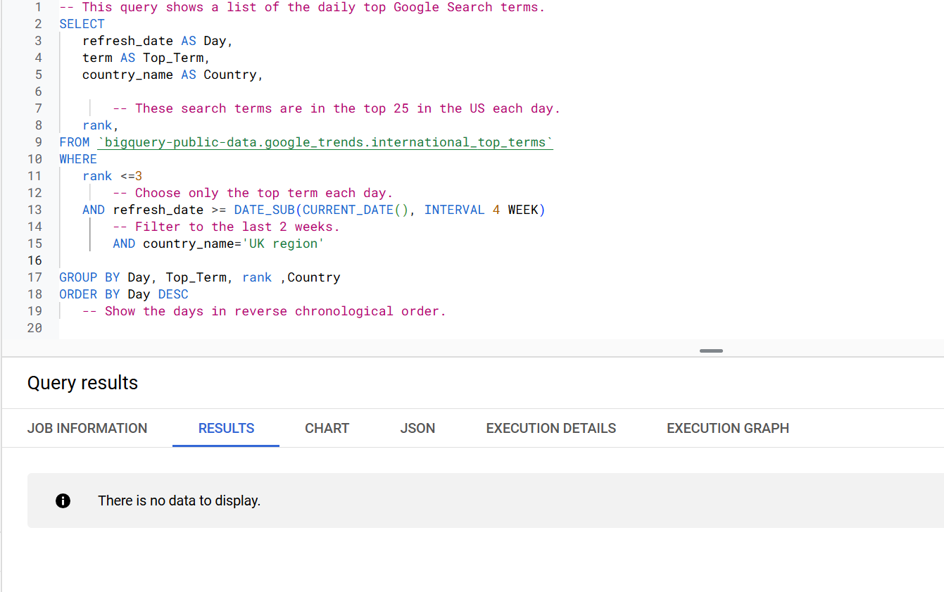

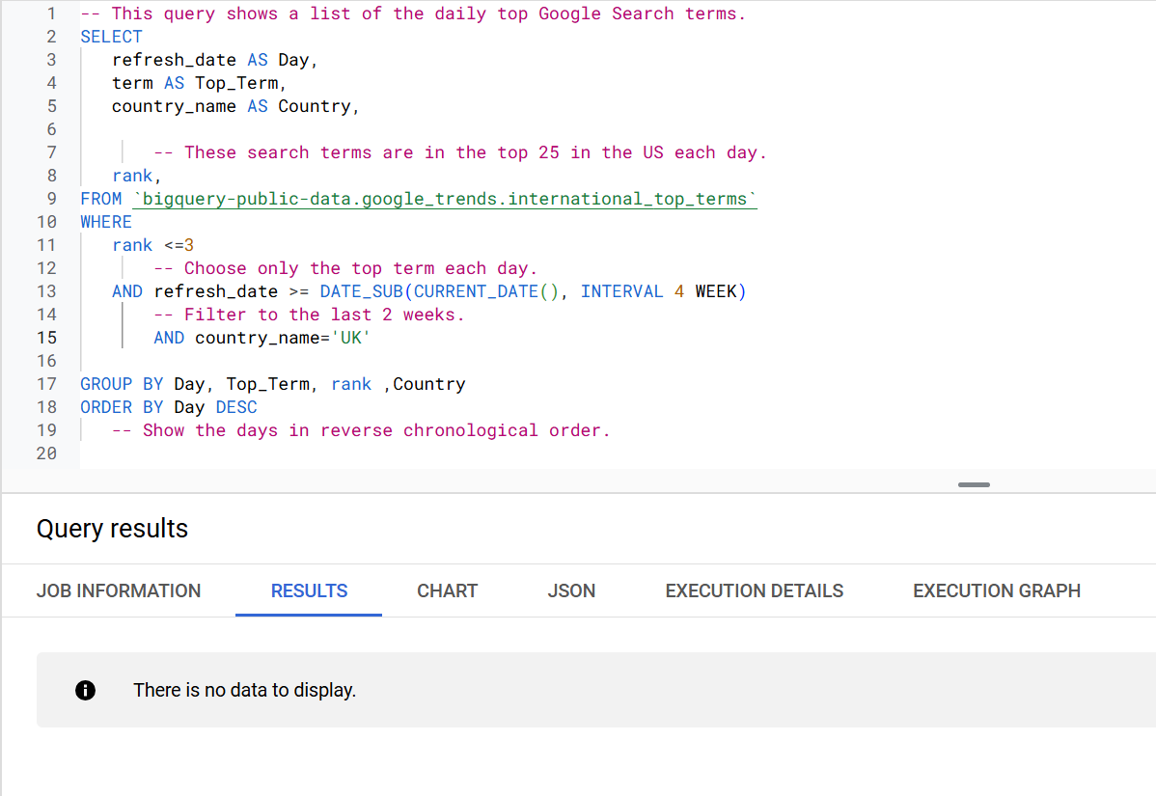

Additional Step to ensure the code correct if there is another region specified.

I tried UK , UK region , The United Kingdom and none return any data.

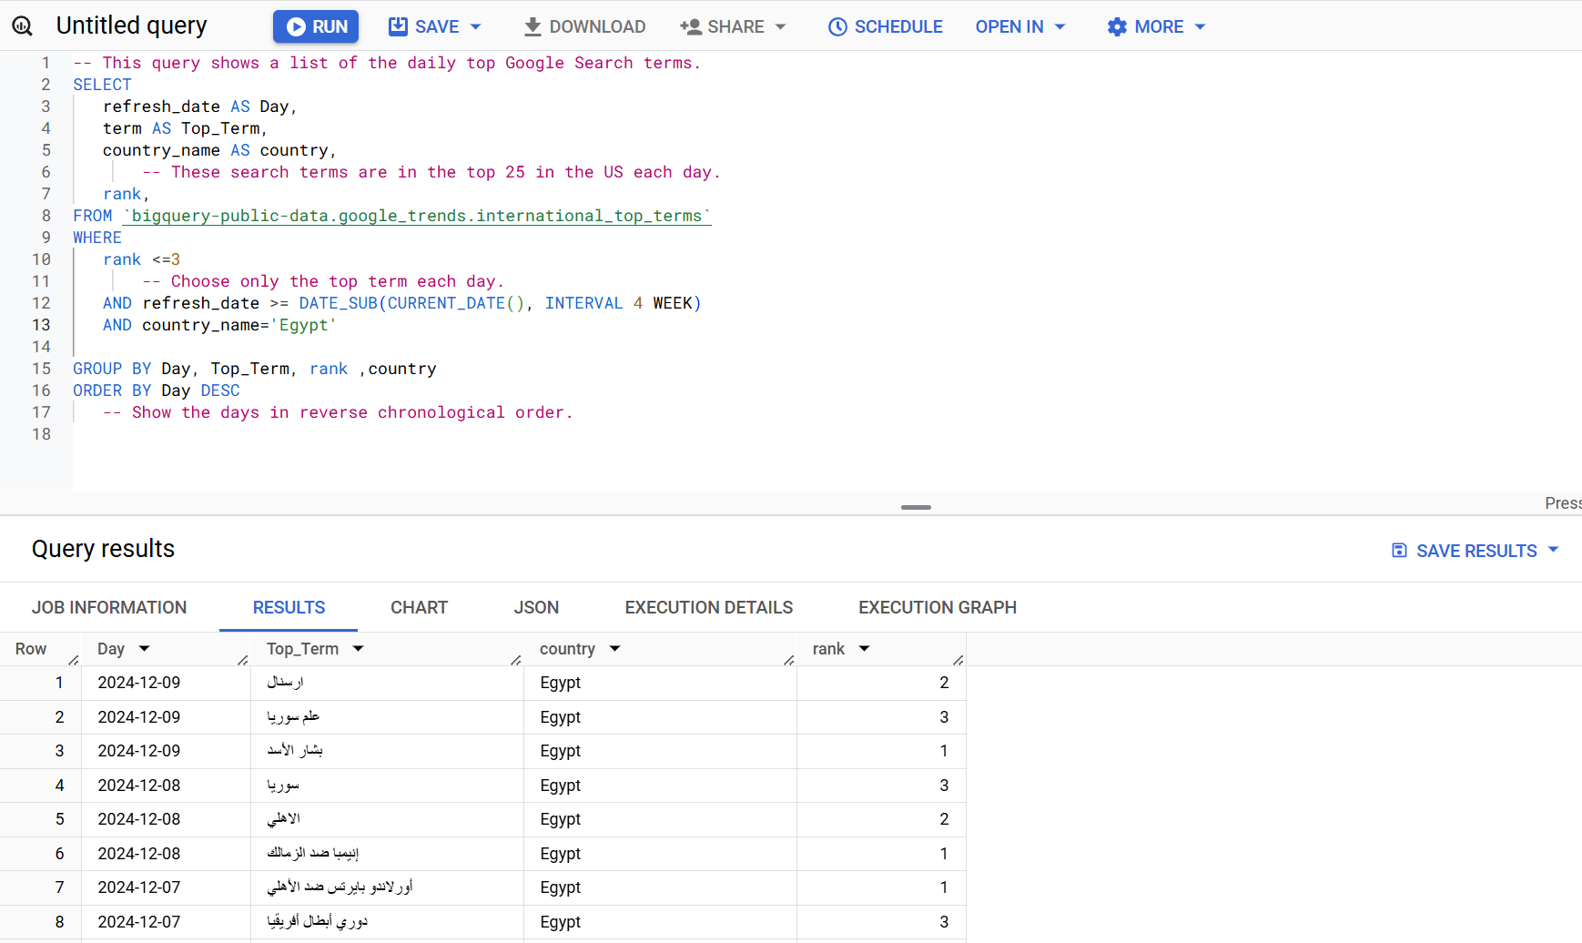

5. Add Weekly Aggregation

Task:

• Modify the query to group terms by the week they appeared as top terms.

