TOPIC: Electric Vehicle Market Performance And Insights.
Submitted By: Leena Vishwakarma.
Platform: MySkillWallet / Data Analytics with Tableau.
1. INTRODUCTION
1.1 Project Overview:
This project focuses on analyzing the Electric Vehicle (EV) market trends, sales performance, manufacturer distributions, battery technologies, and regional demands using data analytics.
1.2 Purpose:
The main objective is to provide actionable insights for decision-makers, manufacturers, and market analysts to understand consumer preferences and sales trajectories across model years.
2. IDEATION PHASE
2.1 Problem Statement:
Understanding complex market dynamics in the EV industry, such as identifying dominant manufacturers, tracking sales over time, evaluating battery preferences (LFP, NCA, NMC, Sodium-Ion, Solid-State), and assessing regional adoption.
2.2 Empathy Map Canvas:
User Needs: Clear visual summary of EV adoption trends, battery reliability, and growth hotspots.
Pain Points: Raw data is disorganized and difficult to interpret without interactive dashboard visualizations.
2.3 Brainstorming:
Categorized metrics into 8 distinct visualization sheets to cover Manufacturers, Annual Sales, Model Years, Battery Types, Market Regions, Categories, and Capacity.
3. REQUIREMENT ANALYSIS
3.1 Customer Journey Map:
Stakeholders explore high-level sales trends first, filter by region and vehicle category, and then dive deep into battery specs and manufacturer performance.
3.2 Solution Requirement:
An interactive Tableau Public Dashboard containing 8 customized sheets and key filter actions.
3.3 Data Flow Diagram & Technology Stack:
*Data Source: EV Market Dataset (CSV/Excel).
*Analytics Tool: Tableau Desktop & Tableau Public.
*Version Control: GitHub Repository.
4. PROJECT DESIGN
4.1 Problem Solution Fit:
Translating raw EV dataset rows into clean, interactive charts directly solves the problem of manual data evaluation.
4.2 Proposed Solution:
Built a consolidated multi-sheet Tableau Dashboard containing:
Sheet 1: Annual Sales Units by Manufacturer
Sheet 2: Sales Trend by Model Year
Sheet 3: Battery Type Distribution
Sheet 4: Market Region Wise Breakdown
Sheet 5: Category Analysis
Sheet 6: Battery Capacity (KWh) Insights
Sheet 7 & 8: Performance & Regional Metrics
4.3 Solution Architecture:
Data Ingestion -> Data Cleaning -> Worksheet Creation in Tableau ->Dashboard Layouting -> Tableau Public Publishing.
5. PROJECT PLANNING & SCHEDULING
Phase 1: Course Completions (Vibe Coding & ServiceNow)
Phase 2: Dataset Selection & Data Preparation
Phase 3: Visual Analysis & Tableau Worksheet Building
Phase 4: Dashboard Integration & Tableau Public Publishing
Phase 5: Video Explanation Recording & GitHub Documentation
6. FUNCTIONAL AND PERFORMANCE TESTING
Verified that all interactive filters respond accurately across all 8 sheets.
Validated data aggregations for total sales units, year-wise trends, and battery capacity calculations.
7. RESULTS
7.1 Output Screenshots:
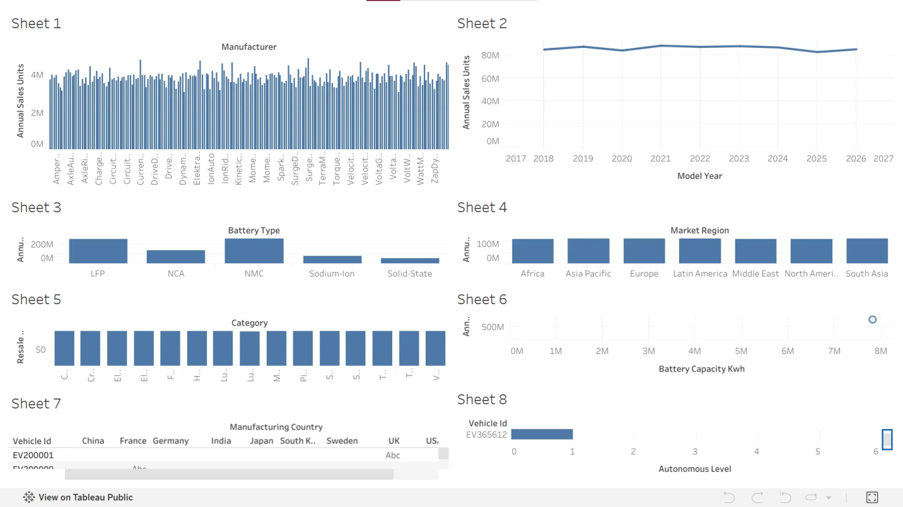
8. ADVANTAGES & DISADVANTAGES
*Advantages:
Clear data visualization making EV market trends easy to comprehend.
Multi-dimensional filtering across regions, manufacturers, and battery types.
*Disadvantages:
Analysis depends strictly on the scope of the provided static dataset.
9. CONCLUSION
The "Electric Vehicle Market Performance and Insights" project was successfully designed and published on Tableau Public. All 8 visual sheets function properly to deliver comprehensive market insights.
10. FUTURE SCOPE
Integrating live data streams to track daily EV registration data.
Adding predictive machine learning models for future sales forecasting.
11. APPENDIX
*GitHub Repository Link:
[https://github.com/Leena-Vishwakarma12/EV-Market-Performance-and-Insights].
*Tableau Public Dashboard Link:
[https://public.tableau.com/app/profile/leena.vishwakarma/viz/LeenaVishwakarma/Dashboard1].

