ElectroMap - DYNAMIC NETWORK DISCOVERY AND ASSET COORDINATION ENGINE
CSE 211: FULL STACK DEVELOPMENT

Submitted By:
Name | Roll No
Leena Chowdary | AP24110010584
Kanagala Sahithi | AP24110010570
Dhruti R Talati | AP24110010663
Yaaseen Shaik | AP24110010806
Ch Skanda Pranith | AP24110010607

Submitted To:
Mr. Pravanshu Samadhiya



SRM University-AP, Neerukonda, Andhra Pradesh

Introduction

In today's rapidly evolving energy landscape, the transition to sustainable infrastructure is a critical function within modern urban planning. Electrical grid managers and EV infrastructure providers are regularly tasked with monitoring hundreds of geographically dispersed assets, a process that is often time-consuming and prone to data inconsistency. The sheer volume of nodes makes manual tracking nearly impossible, resulting in range anxiety for consumers and maintenance delays for providers.

The ElectroMap platform is a full-stack web application designed to solve this fundamental challenge. By leveraging automated mapping and algorithmic monitoring, the system transforms labor-intensive tracking into a streamlined, data-driven workflow that empowers users to make faster, smarter decisions regarding infrastructure health.
Built on the PERN stack (PostgreSQL, Express.js, React.js, and Node.js), the application provides a modern architecture for geospatial management. The frontend offers an intuitive, responsive interface with interactive mapping and visual status indicators, while the backend exposes a secure REST API protected by JWT-based authentication.

- Scenario-Based Introduction

Meet Leo, an EV owner and consultant who needs to ensure his vehicle is charged for a multi-city travel schedule. Leo finds it difficult to track compatible and available charging points across different networks manually.

Leo discovers ElectroMap, a purpose-built web application designed specifically for infrastructure workflows. He decides to explore how the platform can streamline his travel planning and find the best charging slots quickly.

- User Registration & Authentication: Leo creates a secure account and logs in using JWT-secured credentials, ensuring his trip data remains private.
- Station Discovery: Leo uses the drag-and-drop map interface to find stations. The system immediately retrieves coordinates and status from the PostgreSQL database.
- Automated Status Updates: The platform automatically extracts real-time information—voltage, connector type, and current load—eliminating hours of manual searching.
- Route Management: Leo creates a trip plan, specifying his power requirements. The system stores this as a structured deployment document.
- Ranking & Selection: Leo views a ranked leaderboard of stations sorted by proximity and price. Color-coded badges allow him to instantly identify the best matches.

System Requirements

To ensure smooth development, deployment, and usage of the Resume Parser & Matching Engine, the following system prerequisites must be met. These requirements are categorized into software, setup, and hardware specifications.
  - Software Requirements

Component | Purpose / Description
Operating System | Windows 10/11, macOS, or Linux — supports cross-platform development and testing
Node.js (v18+) | Runtime environment for backend API server and build tooling
npm (v8+) | Package manager for installing React, Express, and all project dependencies
React.js 18+ | JavaScript library for building dynamic and responsive user interfaces
Express.js | Lightweight web framework for building RESTful APIs
Mongodb | Relational database for storing users, assets, and logs
PostGIS | Spatial extension for geographic data handling
VS Code | Preferred code editor with built-in Git integration and terminal support
Browser | Google Chrome / Firefox (latest) — for rendering and testing the UI
  - Hardware Requirements

Hardware | Specification
Processor | Intel Core i5 (8th Gen+) / AMD Ryzen 5 or better for fast compilation and multitasking
RAM | Minimum 8 GB (16 GB recommended) for dev servers, IDEs, and browser testing
Storage | At least 2 GB free space for dependencies, MongoDB, and project files
Display | 1366×768 or higher for optimal coding experience and application layout

Architecture

PROJECT ARCHITECTURE

The ElectroMap application follows a client-server architecture where the React.js frontend communicates with the Express.js backend via RESTful API calls. The backend processes requests and interacts with MongoDB for persistent storage of user profiles and electric vehicle charging station data.

TECHNICAL ARCHITECTURE

In this architecture, the flow begins with a User interacting with the ElectroMap Frontend (React.js SPA built with Vite). The user performs actions such as browsing the interactive geographic map, searching for nearby charging stations, and logging into their account through the frontend interface.

The frontend sends HTTP requests to the ElectroMap Backend (Node.js + Express.js), which acts as the API server. The backend processes requests, validates authentication tokens (JWT), and routes them to the appropriate service handlers.

The backend communicates with MongoDB via Mongoose ODM to store and retrieve all application data including registered users and EV charging stations.
For the core mapping functionality, the frontend utilizes the Leaflet library (via React-Leaflet) to render interactive maps. When station data (including latitude, longitude, and status) is retrieved from the backend, the frontend dynamically plots these locations as graphical pins on the map interface.
Once the backend responds to any user action or data query, the frontend updates the UI to reflect the latest state for the user.

Architecture Flow Summary
- User interacts with the React.js Frontend (SPA)
- Frontend sends REST API requests to the Express.js Backend
- Backend validates JWT (if authentication is required) and routes to the appropriate controller
- Controller queries MongoDB (via Mongoose) for user data or EV charging station records
- Backend returns the JSON response containing the requested data to the Frontend
- For map rendering: Frontend utilizes Leaflet to process geographic coordinates and plot charging stations on the interactive map
- Frontend renders the updated UI to the user

ER DIAGRAM

The Entity-Relationship (ER) diagram for ElectroMap represents the various entities and their
relationships within the exam preparation management system. Here is a description of the key
components of the ER diagram:

  - Entities
    - User: Represents individuals registered in the system, including both regular users and administrators. It contains attributes such as user ID, name, email (unique), password (secured and excluded from output), admin status (isAdmin), and automatically maintained timestamps for creation and updates.

    - Station: Represents electric vehicle (EV) charging stations available in the system. It includes attributes such as station ID, name, distance, number of available connectors, total connectors, pricing details, fast charging availability (isFast), operational status (available, in-use, or offline), image URL, geographical coordinates (latitude and longitude), and timestamps for creation and updates.

  - Relationships
User - Station: There is no direct relationship between the User and Station entities. The schema does not define any foreign keys or references linking users to stations (e.g., bookings, or usage history). Both entities function independently.

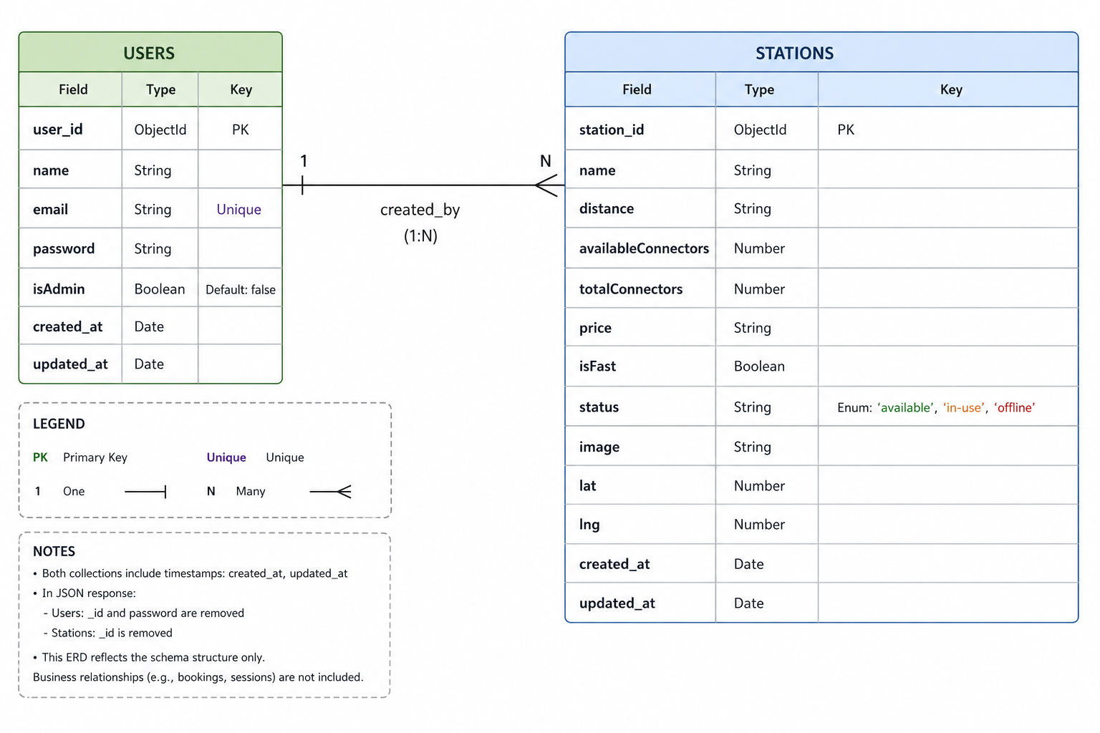

Key Features
The key features of the ElectroMap platform are designed to provide a seamless, efficient, and interactive experience for electric vehicle (EV) drivers seeking charging solutions.
• User Registration and Profiles: Allow standard users and administrators to create accounts, securely log in, and manage their personal information. The system utilizes JSON Web Tokens (JWT) and bcrypt for secure authentication and session management.
• Interactive Geographic Map: ElectroMap integrates with Leaflet (via React-Leaflet) to provide a rich, interactive map interface. This core feature allows users to visually navigate and locate nearby EV charging stations across geographic regions.
• Charging Station Discovery: Users can browse an extensive catalog of EV charging stations. The platform provides comprehensive station details, including distance from the user, charging pricing, and visual images of the location.
• Real-Time Availability Tracking: Stations display their current operational status (e.g., Available, In-Use, or Offline). The system also tracks and displays the exact number of currently available connectors versus the total physical capacity, helping drivers avoid occupied stations.
• Fast Charging Indicators: The platform clearly identifies whether a station supports fast-charging capabilities, allowing users to make informed decisions based on their vehicle's compatibility and their time constraints.
• Geospatial Data Integration: Every charging station record includes precise latitude and longitude coordinates, ensuring accurate map placement and paving the way for future navigation integrations.
• Admin Capabilities: A dedicated administrative role allows authorized personnel to manage user accounts and oversee the platform’s operations, ensuring the station catalog remains accurate and up-to-date.

Roles and Responsibilities
EV Driver (User)
• Registration and Account Management: Drivers are responsible for creating an account, providing an accurate email address, and managing their account details including profile updates and password security.
• Map Navigation & Station Discovery: Users are responsible for utilizing the interactive geographic map to locate EV charging stations in their vicinity or along their planned routes.
• Information Verification: Before traveling to a station, users should check the provided real-time data, such as available connectors, total capacity, and current operational status (available/in-use/offline) to ensure a successful charging session.
• Service Selection: Drivers utilize the provided details on fast-charging capabilities and pricing to select the most appropriate charging station for their vehicle and budget.
• Communication: Users may utilize standard platform channels (if available) to report incorrect station data or reach out for account support.

ADMIN
• System Management: The admin is responsible for the overall management and administration of the ElectroMap platform. This includes monitoring system performance, ensuring data security and privacy via JWT authentication, and managing platform API configurations.
• User Management: The admin oversees all user accounts. This involves handling user registration oversight, account moderation, and addressing any necessary suspensions or permissions management (such as granting administrative access).
• Station Data Management: The admin manages the core catalog of EV charging stations on the platform. They are responsible for ensuring that station names, geospatial coordinates (latitude/longitude), pricing, and connector capacities are accurate and up-to-date.
• Analytics and Reporting: The admin can monitor platform health by viewing the database to track the number of registered drivers, active charging stations, and overall system usage

USER FLOW

EV Driver (User) Flow
• Registration & Account
Create and manage account details securely with JWT authentication and password hashing.

• Map Navigation
Access the interactive geographic map (powered by Leaflet) to visually explore and locate nearby EV charging stations.

• Station Discovery
Select specific map pins to view comprehensive station details, including images, distance, and charging prices.

• Status Monitoring — Check the real-time operational status of a station (Available/In-Use/Offline) and view the exact number of open connectors prior to traveling.

• Feature Verification — Quickly identify whether a selected station supports fast-charging capabilities to suit immediate travel and vehicle requirements.

Admin Flow
• System Management — Oversee platform performance, database connections, and overall system security.

• User Management — Verify, moderate, suspend, or manage driver accounts and assign administrative privileges.

• Station Management — Monitor, add, or update the platform's catalog of EV charging stations, ensuring that geospatial coordinates, pricing data, and connector capacities remain accurate

MVC PATTERN

The ElectroMap application follows the Model-View-Controller (MVC) architectural pattern, a software design approach that separates an application into three interconnected layers. This separation allows for modularity, easier maintenance, and scalability.

Model Layer (Data Layer)
The Model layer is responsible for handling all data-related logic. This includes the definition of data schemas and the operations performed on the database using those schemas. The models are implemented using Mongoose, which provides a schema-based solution to model application data for MongoDB. ElectroMap has models primarily for Users and Stations.

Controller Layer
The Controller layer acts as an intermediary between the routing layer (View) and the models. It receives incoming requests, processes the input (validation, authentication verification), calls the appropriate methods from the model, and returns a JSON response to the client. Controllers are organized by domain, typically covering authentication (auth), station management, and user profiles.

View Layer (Routing Layer)
In the context of this backend REST API, the View is implemented as the routing layer, where various API endpoints are defined. These endpoints determine how the backend responds to different HTTP requests (GET, POST, PUT, DELETE) and are responsible for invoking the appropriate controller functions. The actual visual presentation is handed off to the decoupled React.js frontend.

Advantages of Using MVC in This Project
• Separation of Concerns: By isolating data logic (Model), request handling (Controller), and routing (View), the codebase remains clean, organized, and prevents spaghetti code.

• Modularity and Scalability: Different parts of the application can be developed and updated independently. For example, the database schema (Model) can be modified without breaking the routing structure (View).

• Easier Debugging and Maintenance: When an issue arises, the MVC structure makes it easier to pinpoint whether it is a data-related bug, a logic error in the controller, or a routing mistake.

• Parallel Development: The backend team can work on API controllers and models while the frontend team simultaneously builds the React UI based on the defined API endpoints.

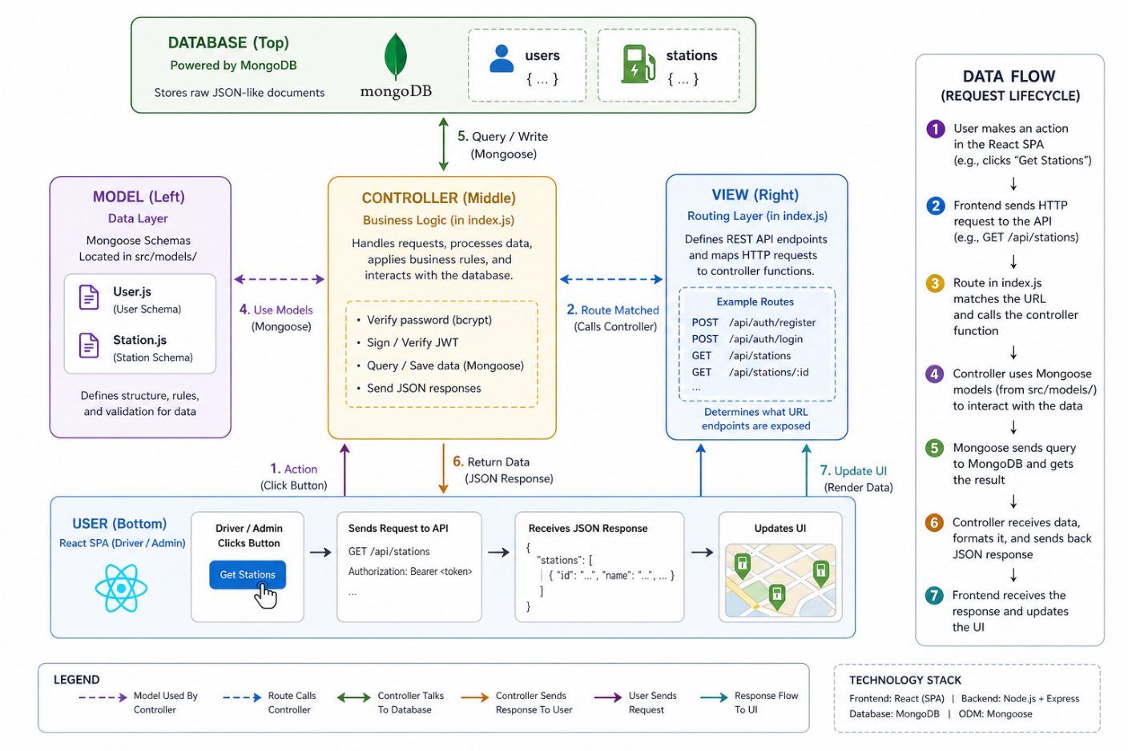

Project Setup
Follow the steps below to set up and run the project locally.

Creating project folder
◦ Create a new folder with your project name (e.g., `electromap`).
◦ Inside that folder, create a new sub-folder for the backend: `backend`. (The root folder will act as the client/frontend).
◦ Open the project folder in Visual Studio Code.

Client setup (React + Vite)
◦ Open the root project folder in the VSCode terminal.
`npm create vite@latest . -- --template react`
◦ Select React as the framework.
◦ Select JavaScript as the variant.
◦ Install all default packages:
`npm install`

◦ Install additional frontend dependencies (Tailwind, Map Libraries, Icons, Routing, etc.):
`npm install react-router-dom leaflet react-leaflet lucide-react clsx tailwind-merge @tailwindcss/vite tailwindcss`
◦ Start the React development server:
`npm run dev`

Server setup
◦ Open the `backend` folder in the terminal.
`cd backend`
`npm init -y`
◦ Install backend dependencies:
`npm install express mongoose dotenv cors jsonwebtoken bcryptjs`
◦ Install development dependencies (optional, for auto-reloading):
`npm install -D nodemon`
◦ Create the main entry file inside `src/`: `index.js`
◦ Create architecture folders: `src/models/` (Note: Routing and Controller logic are currently consolidated within `index.js`).

Environment Configuration
◦ Create a `.env` file inside the `/backend` directory:
```env
PORT=3000
MONGODB_URI=your_mongodb_connection_string
JWT_SECRET=your_secure_jwt_secret_key
```

BACKEND DEVELOPMENT

Backend Structure
In the ElectroMap project, the routing, configuration, and middleware logic are consolidated within the primary `index.js` entry file for simplicity. However, they are logically separated into the following domains:

Routes (API Endpoints)
• Auth Routes → Defines API routes for user registration, user login, and secure token validation to fetch the current user profile (`/api/auth`).
• Station Routes → Defines public API routes for retrieving the complete catalog of EV charging stations and fetching specific station details by ID (`/api/stations`).
• Admin Routes → Defines protected API routes for admin-specific actions, including viewing platform statistics, managing user accounts (fetching lists and deleting), and performing full CRUD operations on charging stations (`/api/admin`).

Config
• Database Connection → Contains the MongoDB database connection setup using Mongoose directly within `index.js`. It connects to the database utilizing the `MONGODB_URI` specified in the `.env` file and handles the initial database seeding (populating the database with Indian EV stations if empty).

Middleware
• Auth Middleware → JWT validation middleware that protects private API routes (such as `/api/auth/me`). It verifies that the incoming request contains a valid, unexpired authentication token and extracts the user's identity.
• Admin Middleware → Role-based authorization middleware that operates after the Auth Middleware. It checks the `isAdmin` boolean flag on the authenticated user to ensure that only authorized administrators can access sensitive routes (like deleting users or modifying station data).

DATABASE DEVELOPMENT

1. Configure MongoDB
• Install Mongoose. In your Node.js backend directory, run:
`npm install mongoose`
• Ensure your Schemas and Models are created inside the `src/models/` folder.

Create Database Connection
Make sure the database is connected before performing backend operations. The connection code establishes a Mongoose connection to MongoDB using the `MONGODB_URI` environment variable, with error handling. In this project, this logic is handled in `src/index.js`:

Create Schemas
Configure the Mongoose schemas for the MongoDB database. Each schema defines the shape and data types for each collection. The schemas for this application are as follows:

1. User Schema (`User.js`)

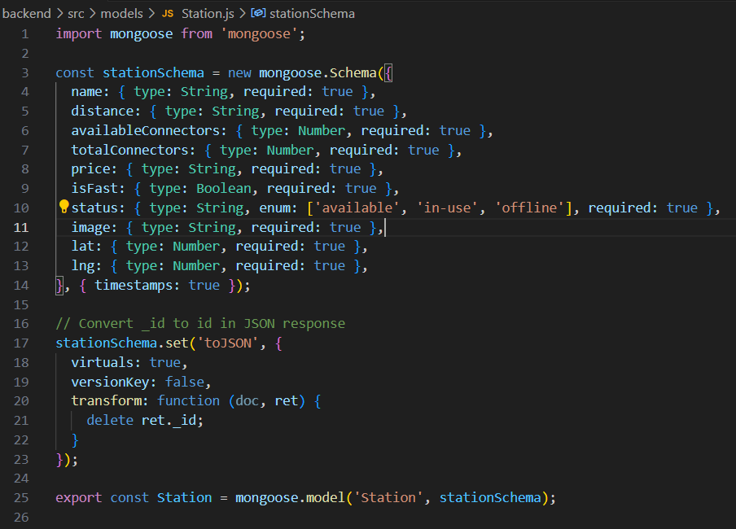

2. Station Schema (`Station.js`)
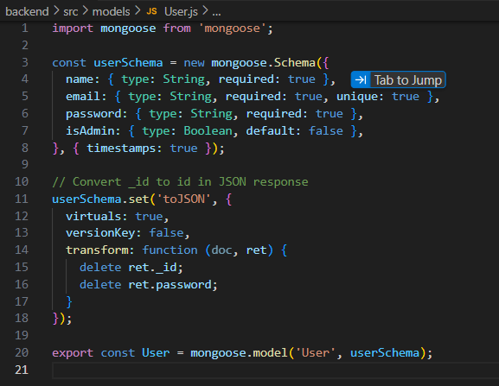

Front-End Development

Pages (`src/pages`)
• AuthPage.jsx → Combined login and registration page for standard users and admins. Handles the JWT-based authentication flow and form validation.

• MapPage.jsx → The core interactive map interface. Utilizes Leaflet to plot EV charging stations geographically, allowing users to discover nearby chargers, view real-time availability, and filter by fast charging capabilities.

• ProfilePage.jsx → User profile dashboard displaying account information, secure credentials, and personalized settings.

• RoutePage.jsx → A dedicated interface for route planning, allowing users to map out journeys and locate charging stations along specific paths.

• AdminPage.jsx → A comprehensive administrative dashboard providing platform analytics and full CRUD (Create, Read, Update, Delete) management capabilities for user accounts and the charging station catalog.

Components (`src/components`)

• Layout.jsx → The main structural wrapper component. It contains the primary navigation bar (Navbar) with contextual links based on authentication status (e.g., hiding login links if the user is already signed in) and provides consistent structural formatting across all pages.

• StationCard.jsx → A highly reusable UI component that renders a visually appealing card for an individual EV charging station. It displays concise information such as the station's image, distance, connector availability, pricing, and operational status.

Context (`src/context`)
• AuthContext.jsx → A React Context provider that manages the global authentication state. It stores the currently authenticated user's profile and JWT token, providing `login` and `logout` functions that can be accessed by any component throughout the application tree.

API END POINTS
Auth Routes - /api/auth

Method | Endpoint | Description | Auth
POST | /api/auth/register | Register a new recruiter account | No
POST | /api/auth/login | Login and receive JWT token | No
GET | /api/auth/profile | Get authenticated user profile | Yes
Station Routes - /api/stations

Method | Endpoint | Description | Auth
GET | /api/stations | List all charging stations | No
GET | /api/stations/:id | Get single charging station detail | No
Admin Routes - /api/admin

Method | Endpoint | Description | Auth
POST | /api/admin/users | List all registered users | Yes (Admin)
GET | /api/admin/stats | Get platform overall statistics | Yes (Admin)
GET | /api/jobs/:id | Get single job detail | Yes (Admin)
PUT | /api/admin/stations/:id | Update an existing charging station | Yes (Admin)
DELETE | /api/admin/stations/:id | Delete a charging station | Yes (Admin)
DELETE | /api/admin/users/:id | Delete a specific user account | Yes (Admin)

11.Technology Used

Frontend Technologies
Technology | Purpose
React.js 19+ | Primary UI framework for building dynamic, component-based interfaces
React Router v7 | Client-side routing and navigation between pages
Fetch API | Native HTTP client for sending API requests to the backend
React Context API | Global State Management for authentication context

Tailwind CSS | Interactive mapping service for rendering EV station locations
Leaflet & React-Leaflet | Global state management for authentication context
Vite | Frontend build tool and highly optimized development server

Backend Technologies

Technology | Purpose
Node.js | JavaScript runtime environment for the backend server
Express.js | Lightweight framework for building RESTful API endpoints
MongoDB and Mongoose | NoSQL Database and Object Data Modelling for storing users and stations
JWT (jsonwebtoken) | Stateless authentication via signed JSON Web Tokens
Bcrypt.js | Secure password hashing with configurable salt rounds
CORS | Node.js middleware for handling multipart file uploads
dotenv | Loads environment variables from .env files

Development Tools

Technology | Purpose
VS Code | Primary code editor with Git integration and extensions
Git + GitHub | Version control and remote code repository
Node Watch Mode | Automatic backend server restart on file changes (native node --watch)
ESLint | Static code analysis and linting to maintain code quality

11.OUTPUT Screen Shots

Landing Page:
The public-facing homepage with a call-to-action for recruiters to sign up or log in.

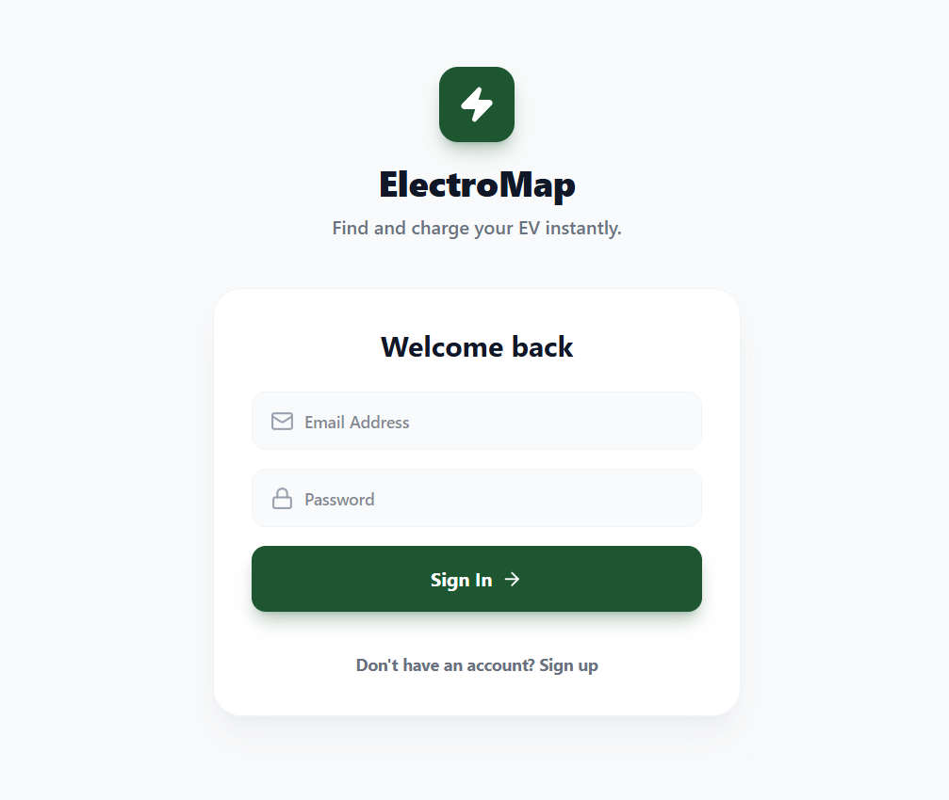

UserRegistration:
The signup form where a new recruiter creates an account with name, email, and password.
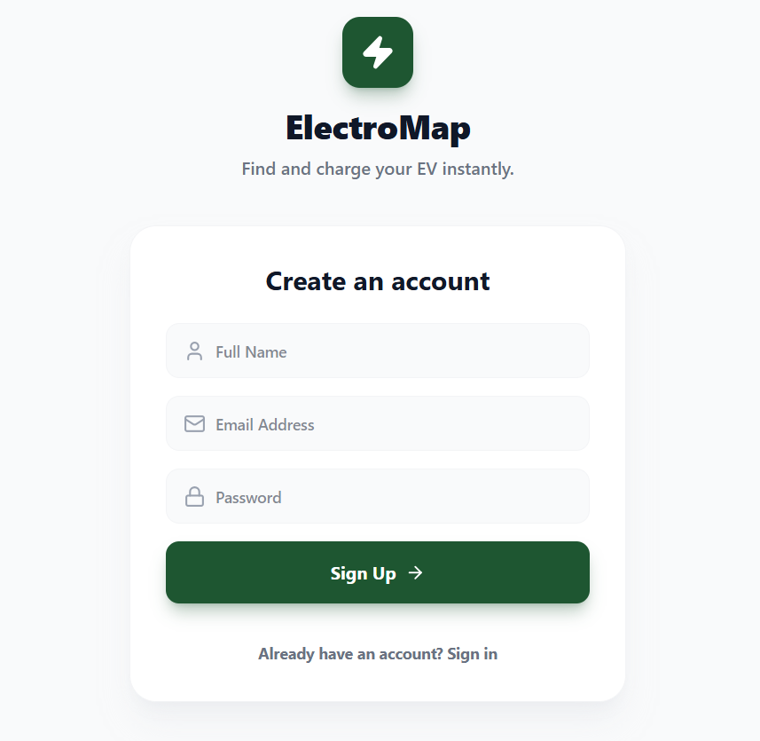

Dashboard / Main Page
The dashboard is the main working area of the ElectroMap application. It provides options for users to enter route details and interact with the system. It acts as the central hub where all functionalities are accessible after login.

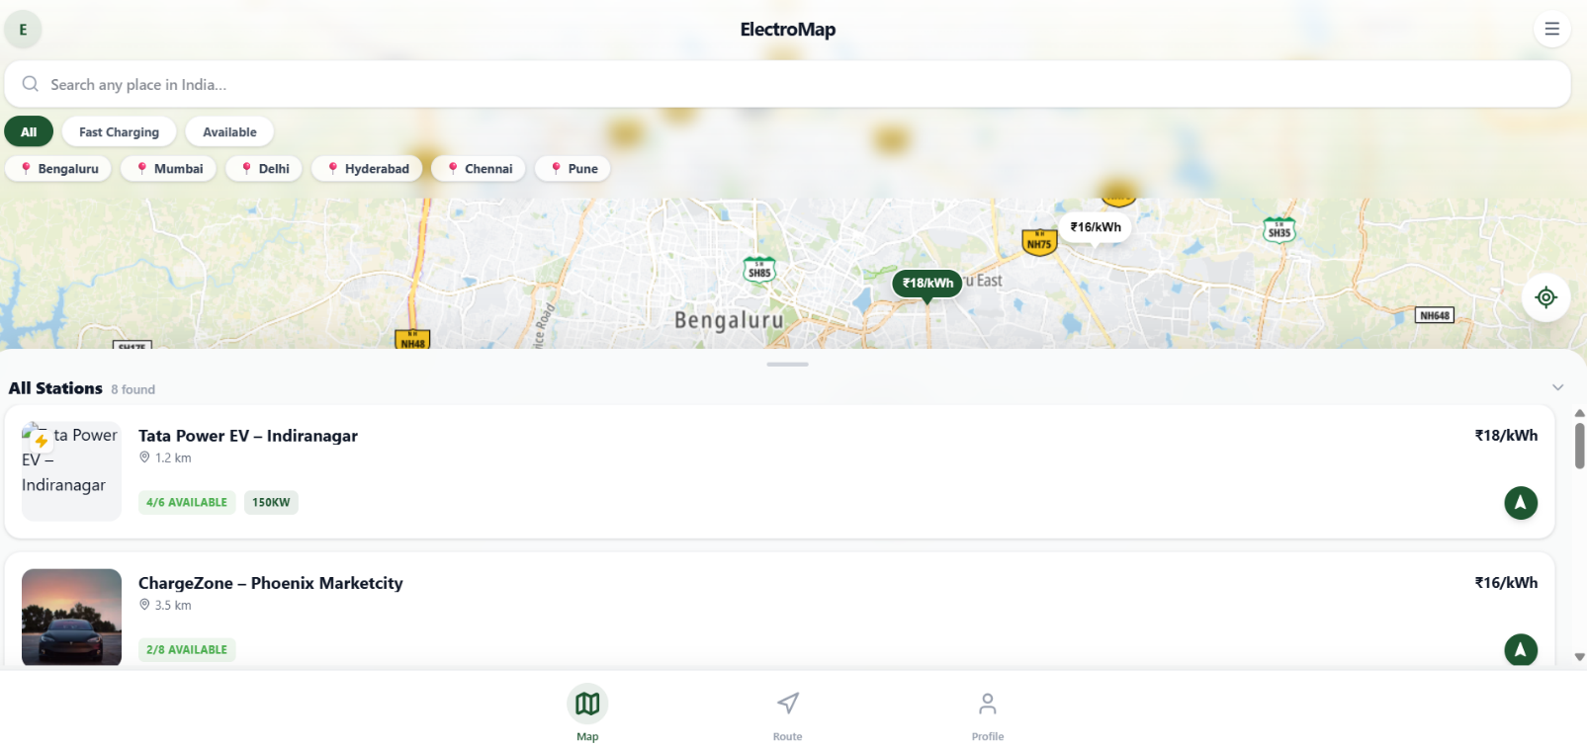

Route Input Section and charging stations display:

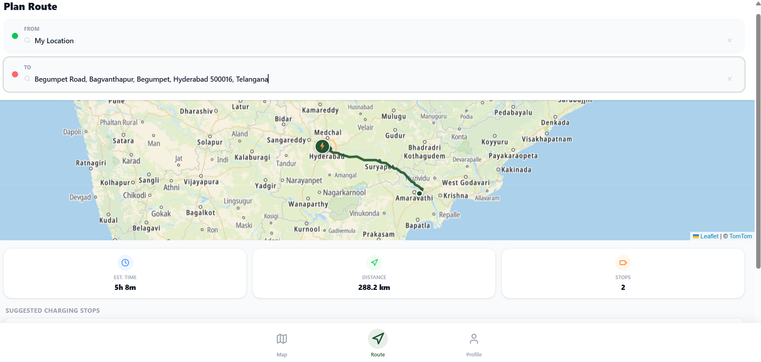

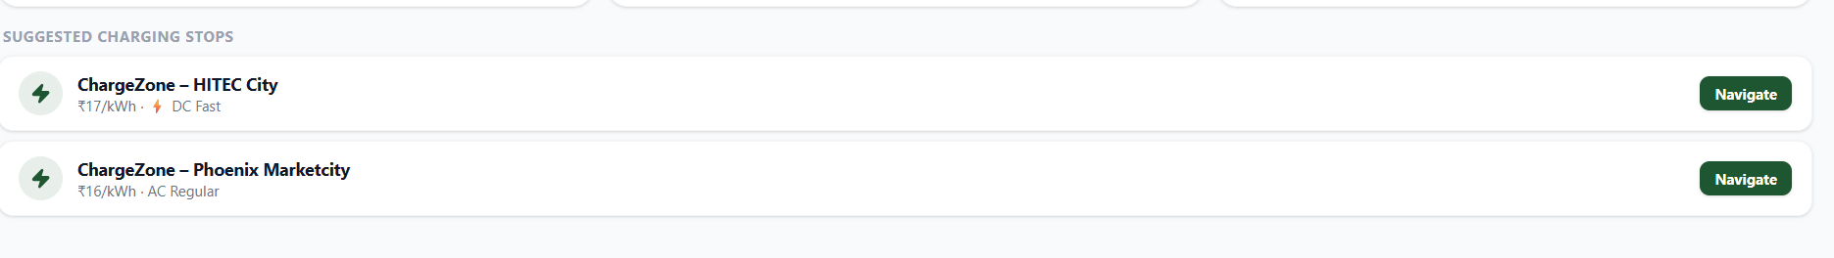

Logout:

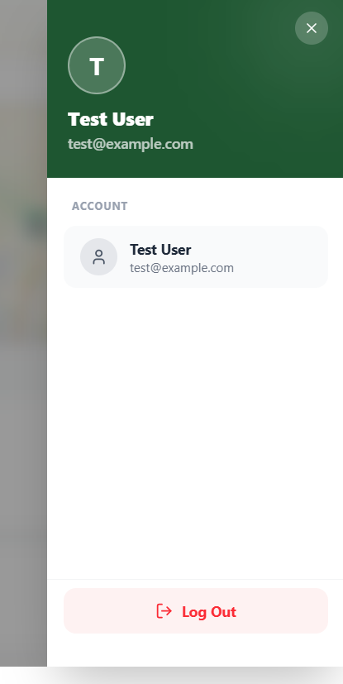

11.Learning Outcomes

By completing this project, the development team will acquire hands-on experience in the following areas:

● Full-Stack MERN Development: End-to-end application development utilizing MongoDB, Express.js, React.js, and Node.js.

● Geospatial Mapping & Visualization: Integrating and configuring interactive maps using Leaflet and React-Leaflet to plot and manage geographic coordinates (latitude and longitude).

● Real-Time Data Handling: Managing and displaying dynamic data states, such as live charging station availability, pricing, and connector capacities.

● REST API Design: Designing and building a well-structured RESTful API with proper HTTP methods, modular routing, and distinct public vs. admin access control.

● MongoDB Schema Design: Designing robust MongoDB schemas with Mongoose to efficiently model user profiles and extensive geographic station catalogs.

● JWT Authentication & Security: Implementing stateless authentication with JSON Web Token (JWT) generation, verification, password hashing (bcrypt), and role-based route protection (Admin vs. User).

● React Architecture: Building a scalable React Single Page Application (SPA) utilizing component composition, custom hooks, context API for global state, and React Router for client-side navigation.

● Responsive UI Design: Creating mobile-friendly, modern user interfaces using Tailwind CSS utility classes and conditional styling (clsx/tailwind-merge).

● Software Engineering Practices: Managing development environments with Vite, implementing environment variable security (`.env`), robust error handling, and separation of concerns via the MVC architecture.

Future Enhancement

1. Live Hardware Integration (OCPP) :Integrate with industry-standard Open Charge Point Protocol (OCPP) APIs to pull true, real-time availability and status updates directly from the physical charging hardware, replacing static database statuses.

2. Intelligent Route Planning: Implement advanced routing engines (like Mapbox or Google Directions API) to allow users to plan long road trips, with the system automatically suggesting optimal charging stops based on their specific EV's battery range.

3. In-App Payment Gateway: Integrate payment processors like Stripe or Razorpay to allow users to securely reserve charging slots and pay for their charging sessions directly within the ElectroMap application.

4. User Reviews & Ratings: Allow drivers to leave star ratings, written reviews, and upload photos for charging stations. This crowdsourced feedback helps the community identify broken, blocked, or highly reliable chargers.

5. Vehicle Profile Filtering: Enable users to save their specific EV make and model in their profile. The application can then automatically filter the map to only show stations with compatible connector types (e.g., CCS2, CHAdeMO) and optimal charging speeds.

6. Push Notifications & Alerts: Implement browser or mobile push notifications to alert users when a highly contested nearby station becomes available, or when their ongoing charging session reaches 100%.

7. Advanced Admin Analytics Dashboard: Upgrade the admin panel with visual data representations (using Chart.js or Recharts) showing peak charging hours, the most utilized geographic zones, and user growth trends.

8. Favorite & Saved Stations: Introduce a feature allowing users to bookmark or "favorite" their most frequently visited charging stations for quick access directly from their profile dashboard.

9. Crowdsourced Station Reporting: Allow active users to submit new, undocumented charging stations or flag inaccurate data (e.g., incorrect pricing or closed stations), creating a moderation queue for admins to review and approve.

10. Native Navigation Hand-off: Add a "Get Directions" feature that seamlessly exports the selected charging station's precise geospatial coordinates into the user's native Google Maps, Apple Maps, or Waze application for turn-by-turn navigation.

Conclusion
The ElectroMap - EV Charging Station Locator successfully demonstrates how modern full-stack technologies can be leveraged to solve a critical, real-world challenge in green transportation and electric vehicle infrastructure accessibility. By consolidating scattered charging station data into a unified, interactive platform, the system significantly reduces range anxiety and improves trip-planning efficiency for EV drivers.
The project integrates key components such as interactive geospatial mapping, structured geographic data modeling, and dynamic filtering to transform raw location data into a meaningful and user-friendly navigation tool. The core platform, which provides essential details such as real-time connector availability, pricing, and fast-charging capabilities, offers a clear and highly accessible method for drivers to locate optimal charging solutions on the go.
From a technical perspective, the implementation of the MERN stack architecture, along with JWT-based secure authentication, RESTful APIs, and robust MongoDB schema design, reflects a well-structured and highly scalable system. The integration of modern frontend mapping libraries like Leaflet and React-Leaflet, combined with a modular MVC backend architecture, ensures both the maintainability and future extensibility of the application.
Moreover, the project highlights important software engineering principles such as separation of concerns, secure data handling, and state management, while also prioritizing a responsive, mobile-first interface designed for real-world usability in transit.
In conclusion, this project not only achieves its primary objective of simplifying EV charging station discovery but also lays a strong technological foundation for ambitious future enhancements such as live OCPP hardware integration, intelligent route planning, and in-app payment gateways. It serves as a practical demonstration of how web technologies can actively support and accelerate the global transition toward sustainable electric mobility.

LINK TO PROJECT: https://github.com/Leena1657/ElectroMap

