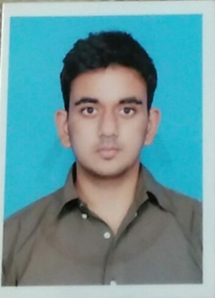

PERSONAL DETAILS

**Name**: Kartik Arora

**DOB**: 15th April 1997

**Contact No**: +91 9036888728

**E-mail ID**: [kartikaries97@gmail.com](mailto:kartikaries97@gmail.com)

**Current Address**: 29/202, Mantri Residency,

Near Meenakshi Mall, Bannerghatta Road,

Bangalore-560076

**Languages Spoken**: English, Hindi



PERSONAL SKILLS

Enthusiastic

Sound interpersonal skills

Sound temperament

Team Management and Leadership

Time management

Goal orientated

Ability to grasp concepts quickly/multi-task

Adept at adapting quickly

Kartik Arora

PERSONAL SUMMARY

A highly resourceful, responsible and competent worker. Passionate about tackling real life problems and a drive to see things through completion using both analytical and technical skills. I have successfully combined work with studies and other commitments proving myself to be self-motivated, organised and capable of working under pressure, I enjoy working with a team as well as on my own initiative. I am looking for an opportunity to learn new skills and strengthen the ones I already possess.

WORK EXPERIENCE

* Worked as Research Intern with Healthsignz for a period of 4 months.
* Worked with Dream Merchants for 2 events (Sheraton Hotel and Clarks Exotica).
* Worked with CDS (Chasse Dance Studio) for a corporate event.
* Worked with E-cure NGO for social work project.

ACADEMIC QUALIFICATION

|  |
| --- |
| ***Christ University Bangalore - 2015-2018***  Bachelors of Busines Adminstraon CGPA – 3.25 |

**Christ Junior College – 2013-2015**

(Arts) – 85.3%

**Army Public School – 2013**

CBSE – 10TH - CGPA – 8.2

Live Projects & Extra Curricular

* Ranked First for HR in ‘Adhiveshana’ a state level MBA fest organized by NMIT College, Bangalore.
* Ranked first for HR in ‘Elixir’ a management fest organized by Garden City University, Bangalore.
* Top 4 for HR event (Human Resource) in Vistas 2016 (Department Level Management Fest)
* Ranked First in Group Task in Vistas 2016.
* Ranked first in Indian Group Non theme dance in Alaap (Intra department fest) Christ University
* Secured Third position in Group Non – Theme dance as part of “Blossoms” (inter department fest), Christ University
* Ranked Second in Group Dance in CMRIT College’s annual cultural fest
* Participated in Street play and finished 4th as part of “Blossoms”
* Member of the College Mime Team, Christ Junior College
* Ranked 2nd in the inter college Mime competition, Jain College