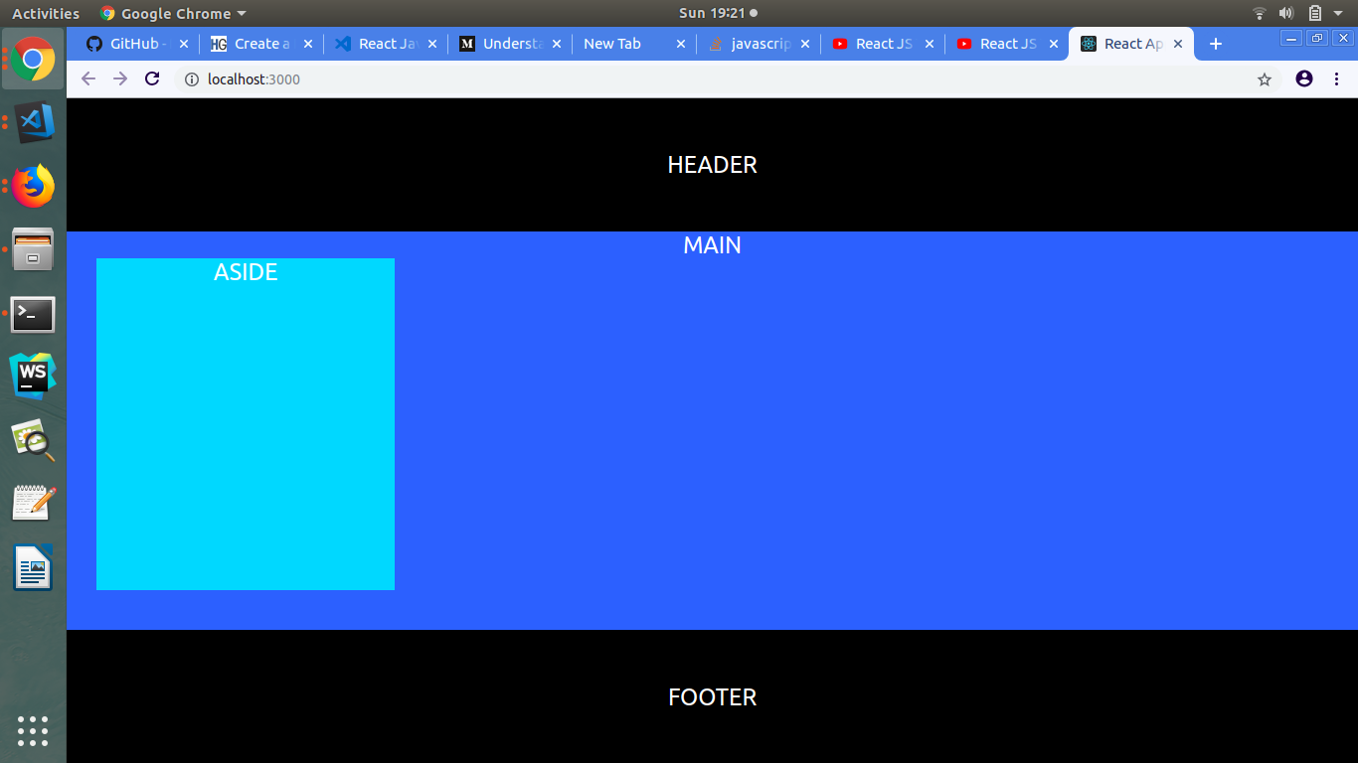
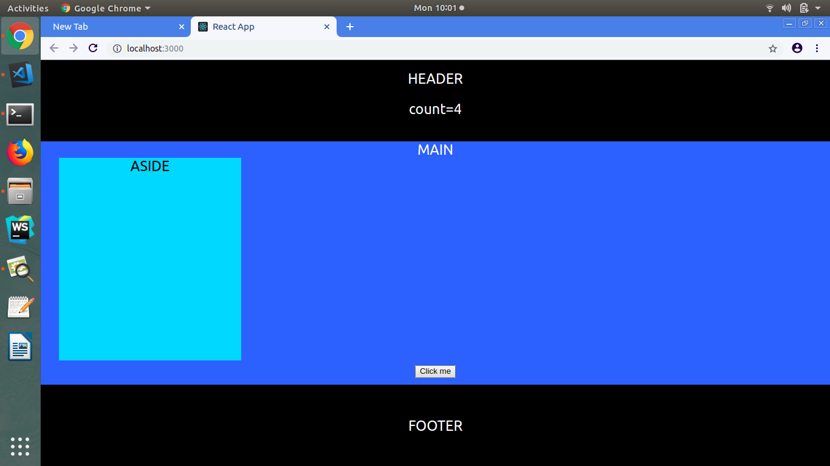
i) Create a layout containing Header,Main,Aside and Footer Component.
ii) Create a Button in Main Component.

iii) On Click of the button in Main Component every time, change the counter in the Header Component.

