Q1. Create a hierarchy of person, employee and developers.
ANS:

<!DOCTYPE html>
<html lang="en">
<head>
<meta charset="UTF-8">
<title>Title</title>
</head>
<body>
<script>
function Person(name, age){ //function person
this.name = name,
this.age = age
}

function Employee(id, salary, designation){ //function employee
this.id = id,
this.salary = salary,
this.designation = designation
}

function Developers (competancy, certificates) { //function developer
this.competancy = competancy,
this.certificates = certificates
}

Employee.prototype = new Person("John", "20"); //person properties inside employee prototype

Developers.prototype = new Employee(1010, 35000, "Trainee");

//employee properties inside developers prototype and person properties inside employee proto

var Employee1 = new Developers("FEEN", "Frontend");

console.log(Employee1.name);
console.log(Employee1.age);
console.log(Employee1.id);
console.log(Employee1.salary);
console.log(Employee1.designation);
console.log(Employee1.competancy);
console.log(Employee1.certificates);

</script>
</body>
</html>

OUTPUT

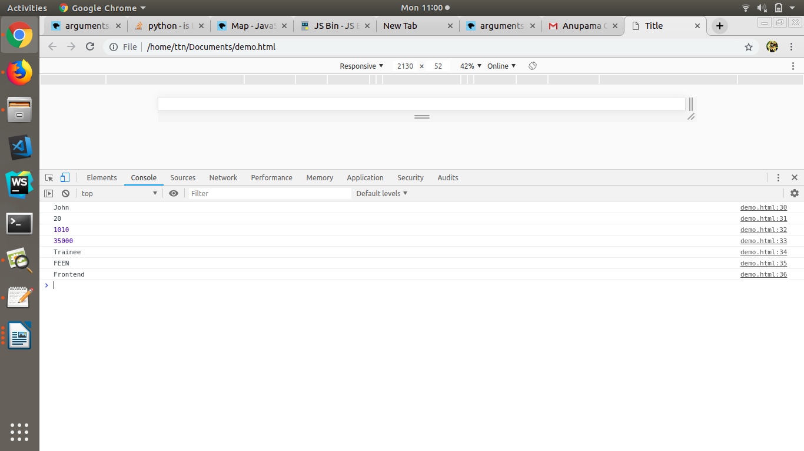

Q2. Given an array, say [1,2,3,4,5]. Print each element of an array after 3 secs.
ANS:
<!DOCTYPE html>
<html lang="en">
<head>
<meta charset="UTF-8">
<title>Title</title>
</head>
<body>
<script>
var arr=[1,2,3,4,5];
var i=0;

var set=setInterval(function(){
if(i<=4)
{
console.log(arr[i]);
i++;
}
else{
clearInterval(set);
}
},3000);

</script>
</body>
</html>

OUTPUT

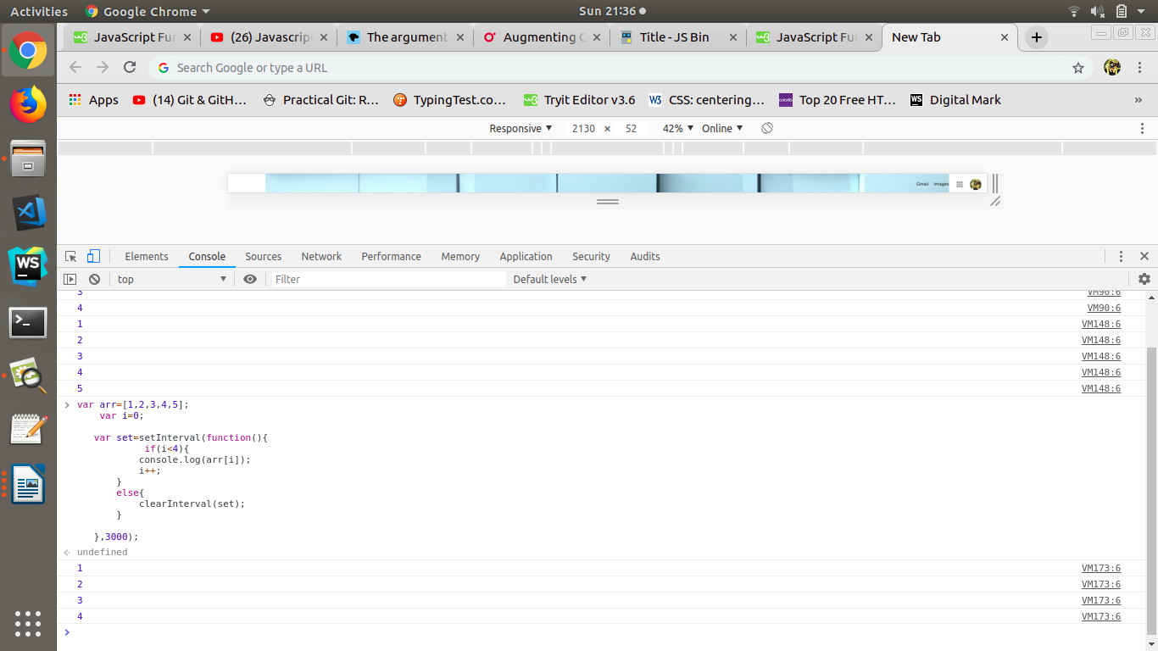

Q3. Explain difference between Bind and Call (example).
ANS:
1). call( )
The call( ) method is a predefined JavaScript method.
It can be used to invoke (call) a method with an owner object as an argument (parameter).
We can write a method that can be used on different objects.

OUTPUT

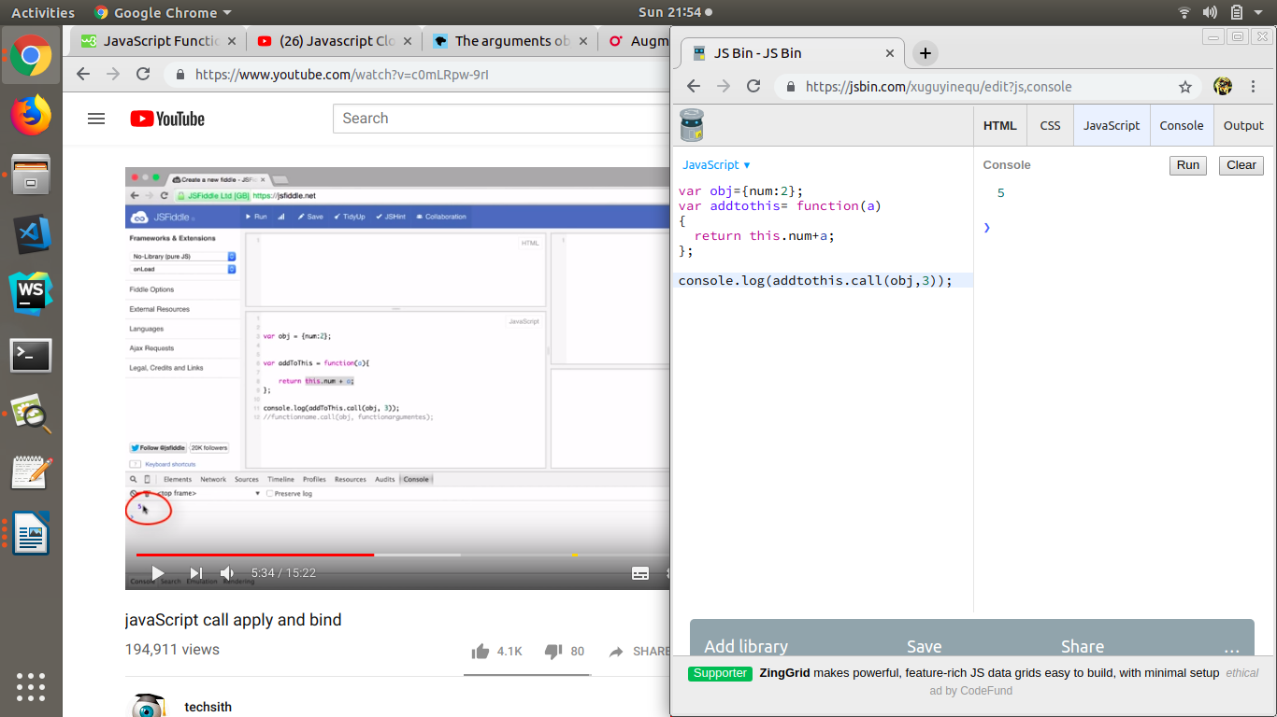

2). bind( )
The bind( ) function creates a new bound function.
A bound function is an exotic function object that wraps the original function object.
Calling a bound function generally results in the execution of its wrapped function.

OUTPUT
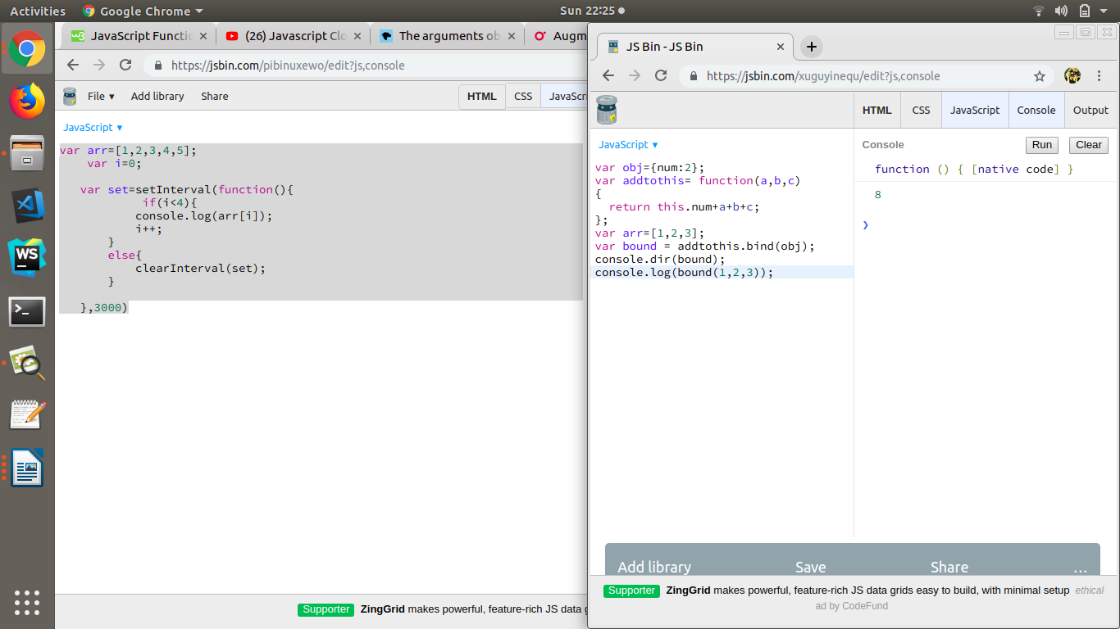

Q4. Explain 3 properties of argument object.

Argument object: an Array-like object accessible inside function that contains the values of the arguments passed to that function.
1). arguments.callee
It can be used to refer to the currently executing function inside the function body of that function.
2). arguments.caller

Reference to the function that invoked the currently executing function.

3). arguments.length

The number of arguments that were passed to the function.

Q5. Create a function which returns number of invocations and number of instances of a function.
ANS:
var instantiate=0;
var invoke=0;
function Person(){
if(this===window){
invoke++;
}
else{
instantiate++;
}
}
//Testing Function
new Person();
Person();
new Person();
Person();
new Person();
new Person();
console.log("invoked"+invoke);
console.log("instantiated"+instantiate);

OUTPUT

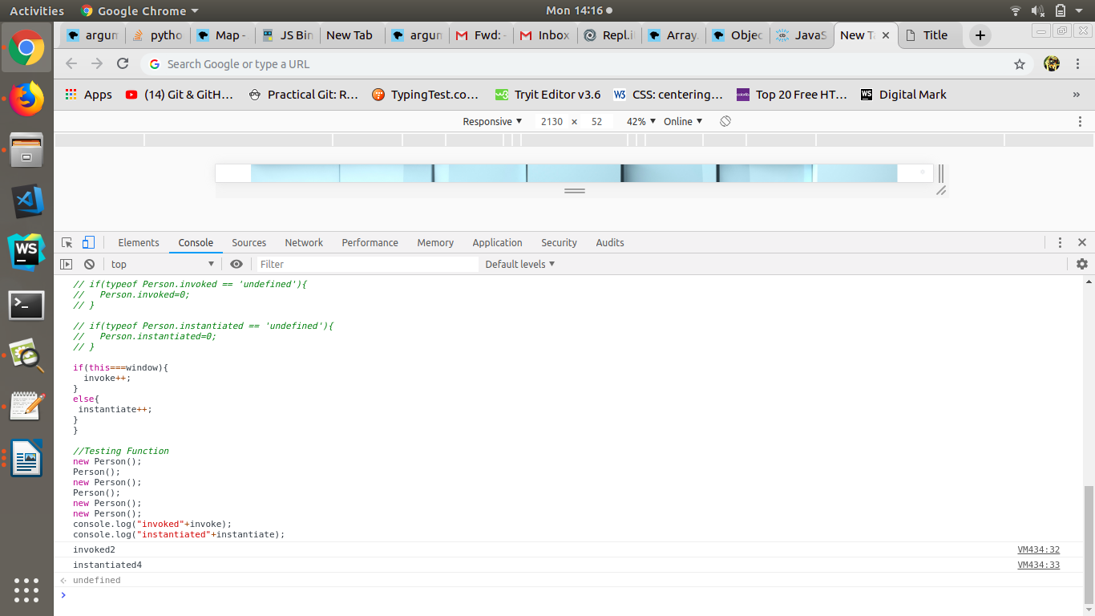

Q6. Create a counter using closures.

<html>
<body>
<h2>Counter using Closures</h2>
<button onclick="myFunction()">Counter</button>
<p id="demo"></p>

<script>
function myFunction()
{
let num = prompt("Please enter number"); //user enter number
if (num != null)
{
let counter = 0; //initial counter=0
function add()
{
counter += 1;
}

for(let i=1;i<=num;i++) //add() call acc. to user input
{
add();
}

document.write("The counter is: " + counter);

}
}
</script>
</body>
</html>

OUTPUT

