Assignment 3 : intoduction to database
1. Create Database
CREATE database activity;
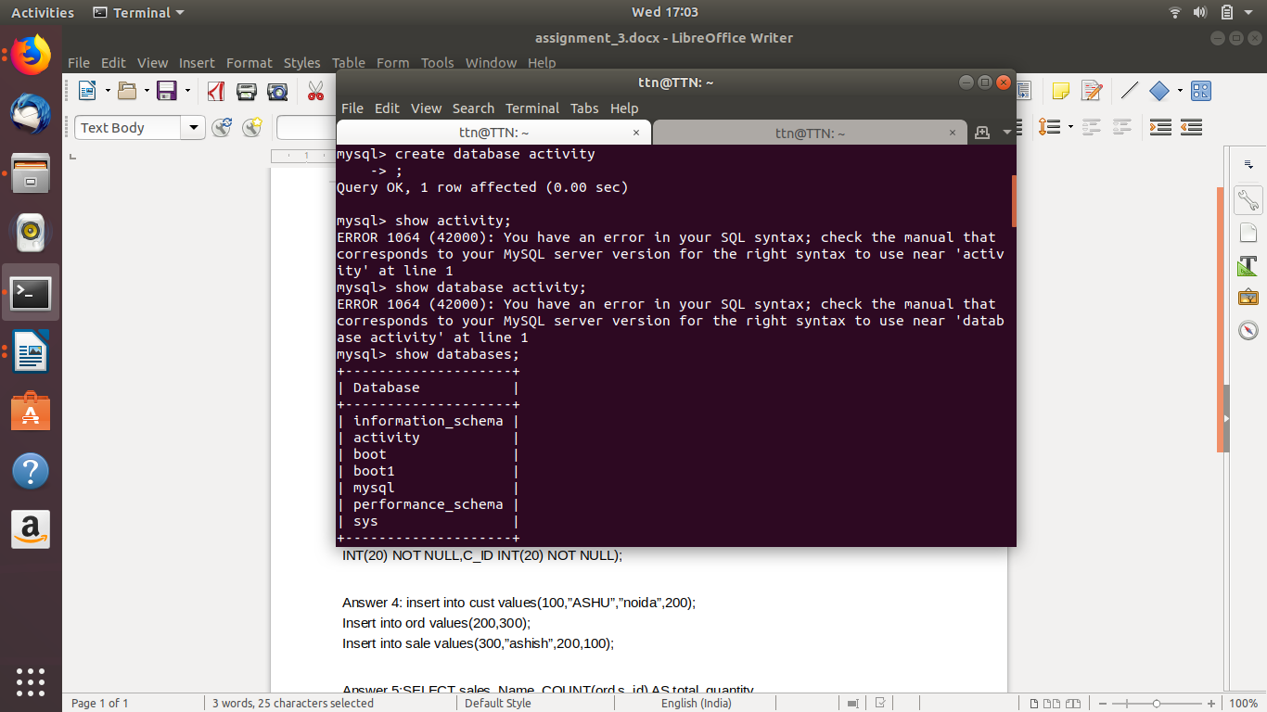
2.Design Schema
for database: show Create database activity;
for tables:
show create table ord;
show create table sale;
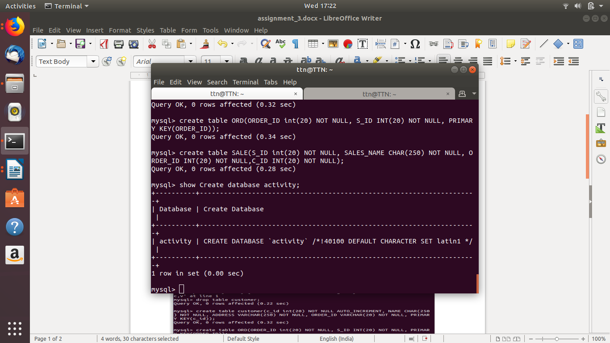
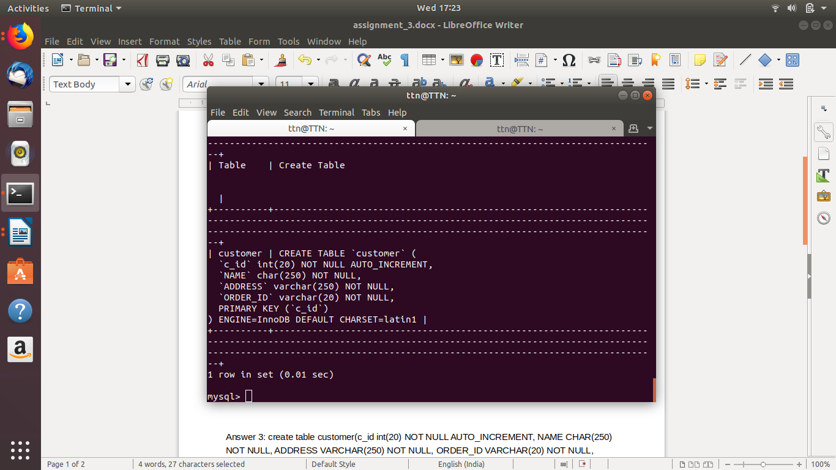
3. Create tables
create table customer(c_id int(20) NOT NULL AUTO_INCREMENT, NAME CHAR(250) NOT NULL, ADDRESS VARCHAR(250) NOT NULL, ORDER_ID VARCHAR(20) NOT NULL, PRIMARY KEY(c_id));
create table ORD(ORDER_ID int(20) NOT NULL, S_ID INT(20) NOT NULL, PRIMARY KEY(ORDER_ID));
create table SALE(S_ID int(20) NOT NULL, SALES_NAME CHAR(250) NOT NULL, ORDER_ID INT(20) NOT NULL,C_ID INT(20) NOT NULL);
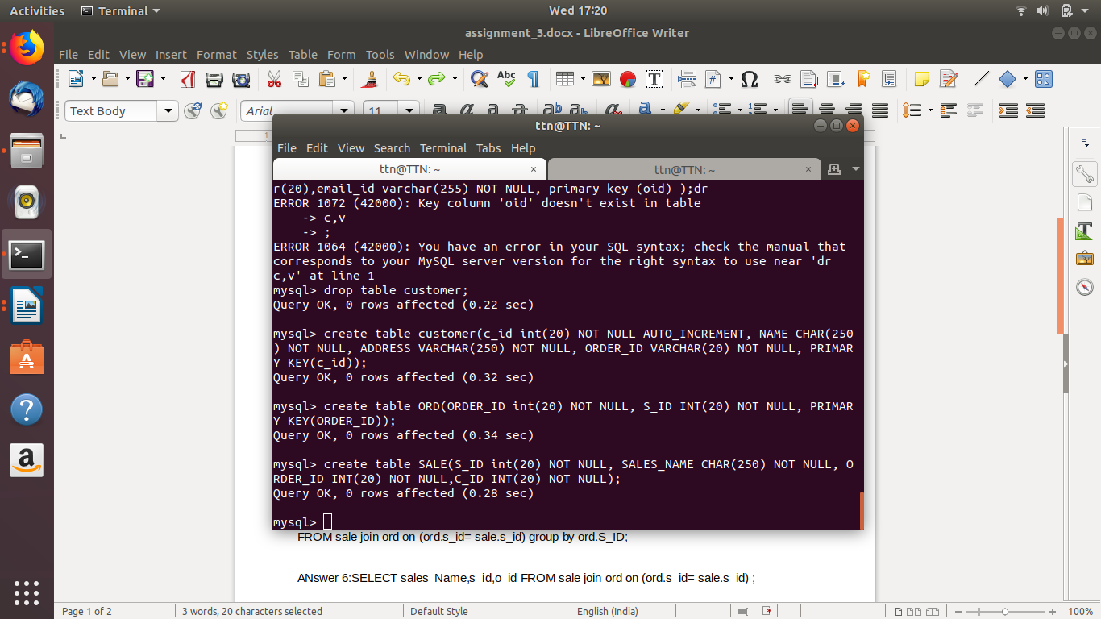
4. insert values
insert into customer values(100,’lee’,’delhi’,200);
Insert into ORD values(200,300);
Insert into SALE values(300,’rish’,200,100);
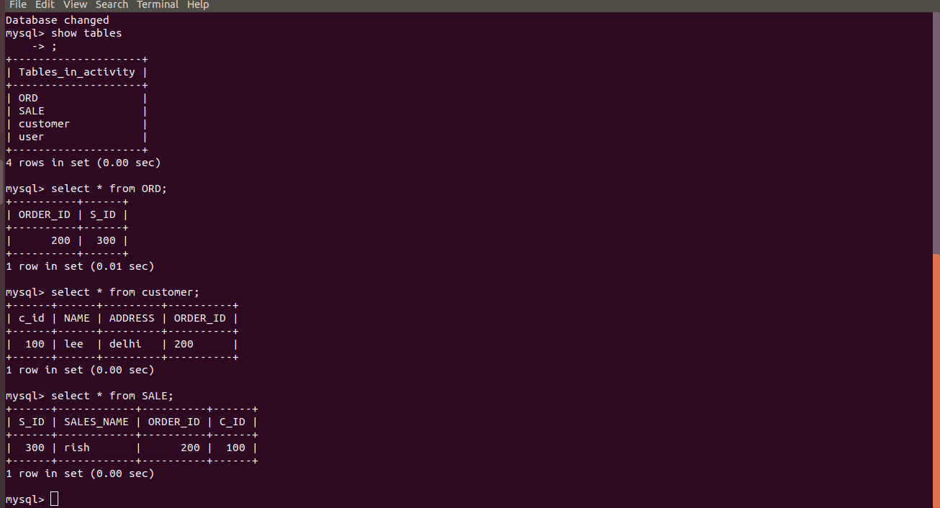

5. Find the sales person have multiple orders.
SELECT SALES_NAME, COUNT(SALE.O_ID) AS total_quantity
FROM SALE join ORD on (ORD.S_ID= SALE.S_ID) group by ORD.S_ID;

6. Find the all sales person details along with order details
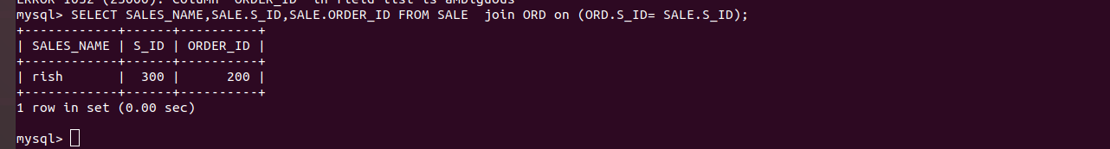

7. create index
Create index cust_id
On customer (c_id);

8. how to showindex on tables.
Show index from customer;
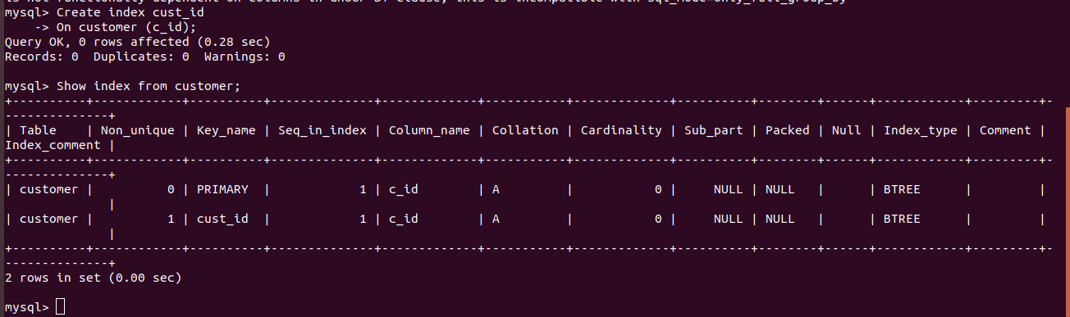
Answer 9:
select ORD.O_ID, SALE.SALES_NAME, customer.NAME, customer.ADDRESS from customer join (SALE join ORD);
