Q1.How are inline and block elements different from each other?
Ans:
There are two types of elements in HTML page – INLINE and BLOCK.

- A block-level element always starts on a new line and takes up the full width available (stretches out to the left and right as far as it can).

The <div> element is a block-level element.

- An inline element does not start on a new line and only takes up as much width as necessary.

This <span> element is an inline-level element

Q2.Explain the difference between visibility:hidden and display:none.
Ans:
- visibility: hidden
Ith hides an element from the browser. However, that hidden element still takes up space in the layout. It's like you have basically made the element invisible, but it still remains in place and takes up the space it would have taken up had it been left alone.
- Display: none
It removes the element completely from the document. It does not take up any space, even though the HTML for it is still in the source code.

Q3. Explain the clear and float properties.
Ans:

The float Property
The float property is used for positioning and formatting content e.g. let an image float left to the text in a container.
The float property can have one of the following values:
- left - The element floats to the left of its container
- right- The element floats to the right of its container
- none - The element does not float (will be displayed just where it occurs in the text). This is default
- inherit - The element inherits the float value of its parent
In its simplest use, the float property can be used to wrap text around images

- The clear property
It specifies what elements can float beside the cleared element and on which side.
The clear property can have one of the following values:
- none - Allows floating elements on both sides. This is default
- left - No floating elements allowed on the left side
- right- No floating elements allowed on the right side
- both - No floating elements allowed on either the left or the right side
- inherit - The element inherits the clear value of its parent

Q4. Explain difference between absolute, relative,fixed and static.
Ans:
The position property specifies the type of positioning method used for an element (static, relative, fixed, absolute )

position: static
- HTML elements are positioned static by default.
- Static positioned elements are not affected by the top, bottom, left, and right properties.
- An element with position: static; is not positioned in any special way; it is always positioned according to the normal flow of the page:

position: relative
- An element with position: relative; is positioned relative to its normal position.
- Setting the top, right, bottom, and left properties of a relatively-positioned element will cause it to be adjusted away from its normal position. Other content will not be adjusted to fit into any gap left by the element

position: fixed
- An element with position: fixed; is positioned relative to the viewport, which means it always stays in the same place even if the page is scrolled. The top, right, bottom, and left properties are used to position the element.
- A fixed element does not leave a gap in the page where it would normally have been located

position: absolute
- An element with position: absolute; is positioned relative to the nearest positioned ancestor (instead of positioned relative to the viewport, like fixed).
- However; if an absolute positioned element has no positioned ancestors, it uses the document body, and moves along with page scrolling.

Q5. Write the HTML code to create a table in which there are 4 columns( ID , Employee Name, Designation, Department) and at least 6 rows. Also do some styling to it.
Ans:

<!DOCTYPE html>
<html>
<head>
<style>
#customers {
font-family: "Trebuchet MS", Arial, Helvetica, sans-serif;
border-collapse: collapse;
width: 100%;
}

#customers td, #customers th {
border: 1px solid rgb(130, 248, 169);
padding: 8px;
}

#customers tr:nth-child(even){background-color: #8deffc;}

#customers tr:hover {background-color: #ddd;}

#customers th {
padding-top: 12px;
padding-bottom: 12px;
text-align: left;
background-color: rgb(40, 245, 235);
color: white;
}
</style>
</head>
<body>

<table id="customers">
<tr>
<th>ID</th>
<th>EMPLOYEE NAME</th>
<th>DESIGNATION</th>
<th>DEPARTMENT</th>
</tr>

<tr>
<td>101</td>
<td>Maria </td>
<td>Administrative Assistant</td>
<td>IT</td>
</tr>
<tr>
<td>102</td>
<td>Piku </td>
<td>Senior Manager</td>
<td>Finance</td>
</tr>
<tr>
<td>103</td>
<td>Lee</td>
<td>Administrative Assistant</td>
<td>IT</td>
</tr>
<tr>
<td>104</td>
<td>Jay</td>
<td> Medical Receptionist</td>
<td>HR</td>
</tr>
<tr>
<td>105</td>
<td>Aman</td>
<td> Data Entry Clerk</td>
<td>IT</td>
</tr>
<tr>
<td>106</td>
<td>Jack </td>
<td> Receptionist</td>
<td>HR</td>
</tr>

</table>

</body>
</html>

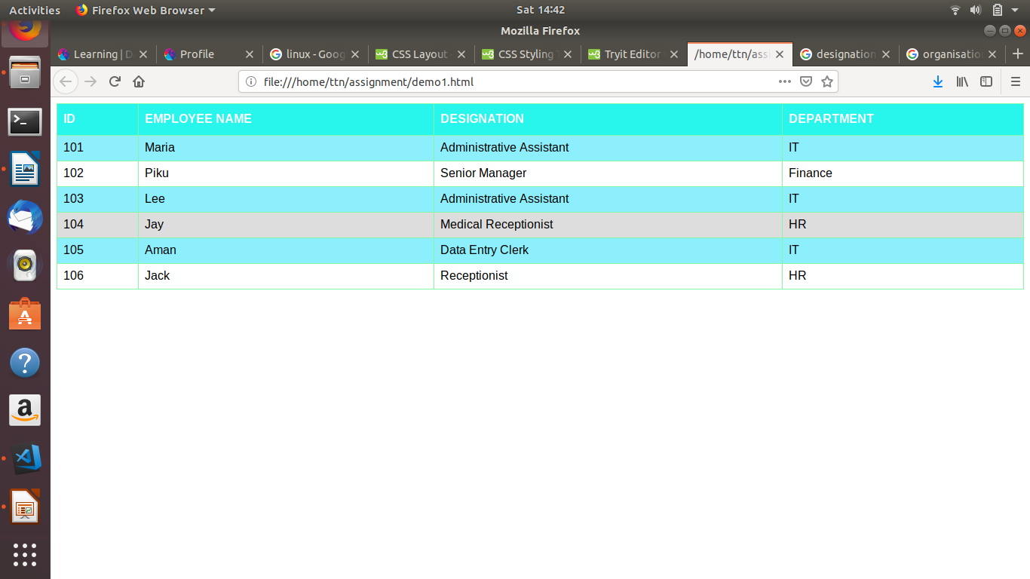

Q6. Why do we use meta tags?
Ans:
Meta elements are typically used to specify page description, keywords, author of the document, last modified, and other metadata. Also, it helps to improve the SEO( Search Engine Optimization) of a web page by using certain keywords related to the web page.
<meta> tags always go inside the <head> element.

Following are few examples of <meta> tag with different attributes :

<meta name="keywords" content="HTML, CSS, XML, XHTML, JavaScript"> (For Search engines)
<meta name="description" content="Free Web tutorials on HTML and CSS"> ( Description of web page)
<meta name="author" content="John Doe"> (Author of web page)
<meta name="viewport" content="width=device-width, initial-scale=1.0"> (Responsiveness)
The <meta> tag provides metadata about the HTML document. Metadata will not be displayed on the page, but will be machine parsable.

Q7. Explain box model.
Ans:
The CSS box model is essentially a box that wraps around every HTML element. It consists of: margins, borders, padding, and the actual content.
- Content - The content of the box, where text and images appear
- Padding - Clears an area around the content. The padding is transparent
- Border - A border that goes around the padding and content
- Margin - Clears an area outside the border. The margin is transparent

Q8. What are the different types of CSS Selectors?
Ans:
In CSS, selectors are patterns used to select the element(s) you want to style.
- selector { property: value }
- body {background: #eeeeee; font-family: Georgia, sans-serif;}
- h1 {font-family: Georgia, sans-serif;}
- h1, h2 {color: #009900;font-family: Georgia, sans-serif;}

Q9. Define Doctype.
Ans:
The <!DOCTYPE> declaration is not an HTML tag; it is an instruction to the web browser about what version of HTML the page is written in.
HTML5 is not based on SGML, and therefore does not require a reference to a DTD.
Q10. Explain 5 HTML5 semantic tags.
Ans:

<header> : specifies a header for a document or section
<footer> : specifies a footer for a document or section
<section> : defines a section in a document
<article> : specifies independent, self-contained content
<nav> : defines a set of navigation links

Q11. Create HTML for web-page.jpg (check resources, highest weightage for answers)
Ans:
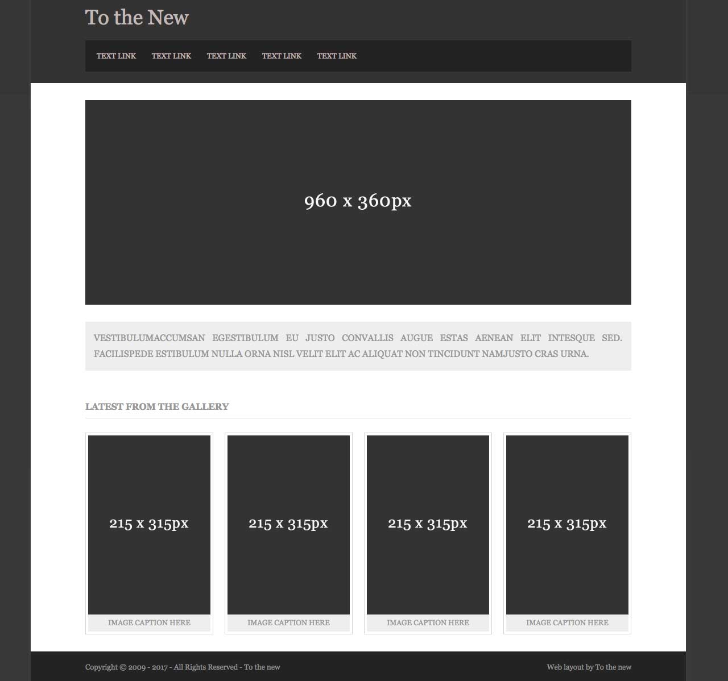

<!DOCTYPE html>
<html>
<head>
<link rel="stylesheet" type="text/css" href="main.css">
<title>sample</title>
</head>
<body>
<div class="main">
<div class="head">
<header>
<div><a href="#"><h1>TO THE NEW</h1></a></div>
<div class="nav">
<nav >
<ul class="nav-bar">
<a href="#"><li>Test Link</li></a>
<a href="#"><li>Test Link</li></a>
<a href="#"><li>Test Link</li></a>
<a href="#"><li>Test Link</li></a>
<a href="#"><li>Test Link</li></a>
</ul>
</nav> </div><br>
</header>
</div>

<div class="middle">
<center>
<div class="box-model">
<p id=two>960*360 px</p>
</div>
<br>

<div class="content">
<p id=three>
We are a digital technology company providing end-to-end product development services.<br> We leverage the power of experience design, cutting-edge engineering, and cloud to build disruptive web and mobile apps enabling digital transformation for businesses.
</p>
</div>
<br>

<h2>
LATEST FROM THE GALLERY
</h2>
<hr>

<div>
<div class="box-model1">
<p id=two>315*215 px</p>
</div>

<div class="box-model1">
<p id=two>315*215 px</p>
</div>

<div class="box-model1">
<p id=two>315*215</p>
</div>

<div class="box-model1">
<p id=two>315*215</p>
</div>
</div>
</center>

</div>
<div class="foot">
<footer>
<p id=six>Copyright @2009-2017- All right reserved- To the new</p>
<p align="right" id=seven>Web layout by to the new</p>
</footer>
</div>
</div>

</body>

</html>

css file:

.box-model
{

background-color: rgb(37, 37, 37);
height: 360px;
width: 960px;
box-sizing: border-box;

}

.nav
{
background-color: rgb(19, 18, 18);
margin-left: 25px;
margin-right: 25px;
padding-bottom: 5px;
}

.qwe
{
background-color: white;
}
#two
{

font-size: 20px;
text-align: center;
color: white;
padding-top: 150px;
}
#three
{

text-align: justify;
padding-left: 10px;
font-size: 20px;
background-color: #cdccc3;
margin-left: 55px;
margin-right: 55px;
}
#five{

font-size: 15px;
margin-top: -1px;
color: white;
}
#six{

margin-left: 50px;
font-size: 15px;
}
#seven{
margin-top:-32px;
font-size: 15px;

}
h2{
margin-left: -600px;
color: #424141
}
hr{

margin-top: -10px;
margin-right: 55px;
margin-left: 55px;

}
.middle
{
background-color: white;
}
.box-model1
{

background-color: rgb(71,71,71);
height: 315px;
width: 215px;
box-sizing: border-box;
float: left;
margin-left:45px;
}
.box-model2{

background-color: #c9c7c0;
height: 20px;
width: 215px;
float: left;
margin-left: 45px;
}
.middle2{
background-color: white;
margin-right: 5px;
}

ul {
list-style-type: none;
margin: 0;
padding: 0;

}

li{
display: block;
width: 60px;
display: inline;
}
.head
{
background-color: rgb(41, 39, 39);
}
a{
text-decoration: none;
color: white;
padding-left:px;

}
h1{
padding-left: 20px;
}
body{
background-color: grey;
}
.main
{
background-color: white;
margin-left: 100px;
margin-right: 100px;
margin-top: -20px;
}
.foot
{
margin-top: 375px;
background-color: rgb(71,71,71);
}

Q12. Create HTML for form.png (check resources, highest weightage for answers)
Ans:
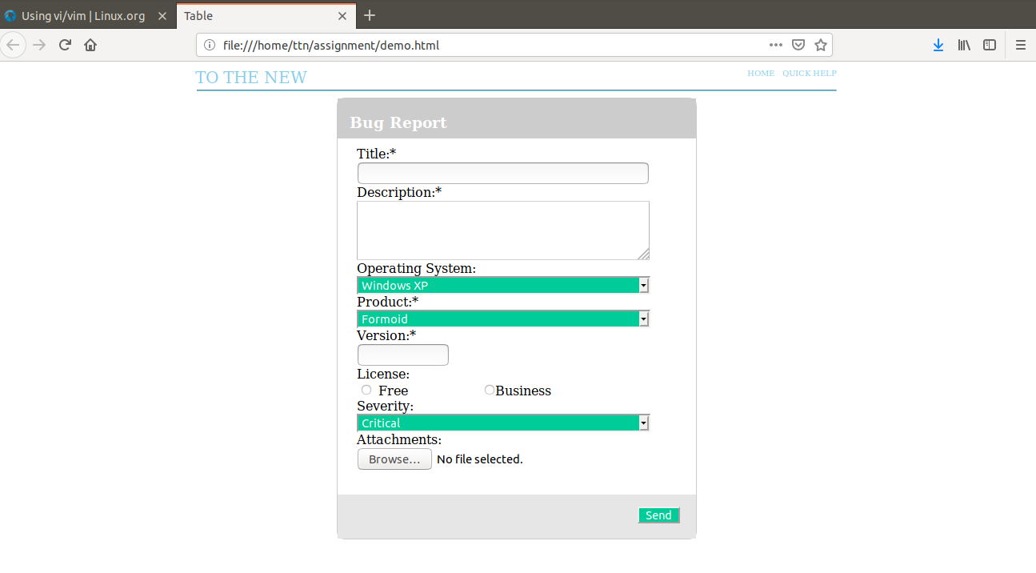

<!DOCTYPE html>
<head>
<meta charset="utf-8" >
<meta name="viewport" content="width=device-width,initial-scale=1.0">
<title>Table</title>
<style>

#main
{
width: 450px;
height: 550px;
margin: 0 auto;

}
#inside
{
width:100%;
height: 50px;
top:-10;
background-color: #cccccc;
display:inline-block;

}
#form1
{
border-style: solid;
border-radius: 10px;
height: 550px;
margin: 0 auto;
border-width: 1px;
border-color: #cccccc;
}
h3
{
color: white;
position: relative;
left: 15px;

}
#abc{
width: 800px;
margin: 0 auto;
}
#inside1
{
width: 400px;
margin: 0 auto;
height: 400px;
position: relative;
top:10px;
}
#len
{
width:350px;
}
#a
{
width: 367px;
background-color: #00cc99;
color: white;

}
#text2
{
width: 100px;
}
.select-selected:after {
position: absolute;
content: "";
top: 14px;
right: 10px;
width: 0;
height: 0;
border: 6px solid transparent;
border-color: #fff transparent transparent transparent;
}
#foot
{
width: 100%;
height: 55px;
position: relative;
top:45px;
background-color: #e6e6e6;
display:inline-block;
}
#snd
{
float:right;
margin: 15px 20px 0 0;
background-color:#00cc99;
color: white;
}
.button
{
color: white;
}

</style>
</head>
<body>
<div id="xyz" style="width: 1000px; padding-left: 240px;">
<div><span style="color: skyblue;float: left; padding-right:550px; font-size: 20px">TO THE NEW </span></div>
<div><span style="color: skyblue; float: left; padding-right:10px; font-size: 10px">HOME</a></span></div>
<div><span style="color: skyblue;float:left;font-size: 10px">QUICK HELP</span></div><br>
</div>
<div id="abc">
<hr style="color: skyblue; padding-right: 550px;">
<div id="main">
<form id="form1">
<div id="inside">
<h3>Bug Report</h3>
</div>
<div id="inside1">
Title:*<br>
<input type="text" name="title" id="len">
<br>
Description:*<br>
<textarea rows="4" cols="50" name="Description"></textarea>
<br>
Operating System:<br>
<select name="Operating System" id="a">
<option value="Windows XP">Windows XP</option>
<option value="saab">Saab</option>
<option value="fiat">Fiat</option>
<option value="audi">Audi</option>
</select><br>
Product:*<br>
<select name="Product" id="a">
<option value="Formoid">Formoid</option>
<option value="saab">Saab</option>
<option value="fiat">Fiat</option>
<option value="audi">Audi</option>
</select><br>
Version:*<br>
<input type="text" name="Version" id="text2">
<br>
License:<br>
<input type="radio" name="Free" > Free
<input type="radio" name="Business" style="margin: 0 0 0 90px;">Business<br>

Severity:<br>
<select name="Severity" id="a">
<option value="Critical">Critical</option>
<option value="saab">Saab</option>
<option value="fiat">Fiat</option>
<option value="audi">Audi</option>
</select><br>
Attachments:<br>
<input type="file" name="pic" accept="image/*">
<br>
</div>

<div id="foot">
<footer>
<input type="submit" value="Send" id="snd">
</footer>

</div>

</div>
</form>
</div>
</body>
</html>

________________________________________________________________________

