LINUX ASSIGNMENT

- Create a directory "exercise" inside your home directory and create nested(dir1/dir2/dir3) directory structure inside "excerise" with single command.

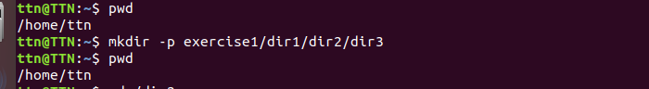
- Create two empty files inside dir2 directory: emptyFile1,emptyFile2 in single command
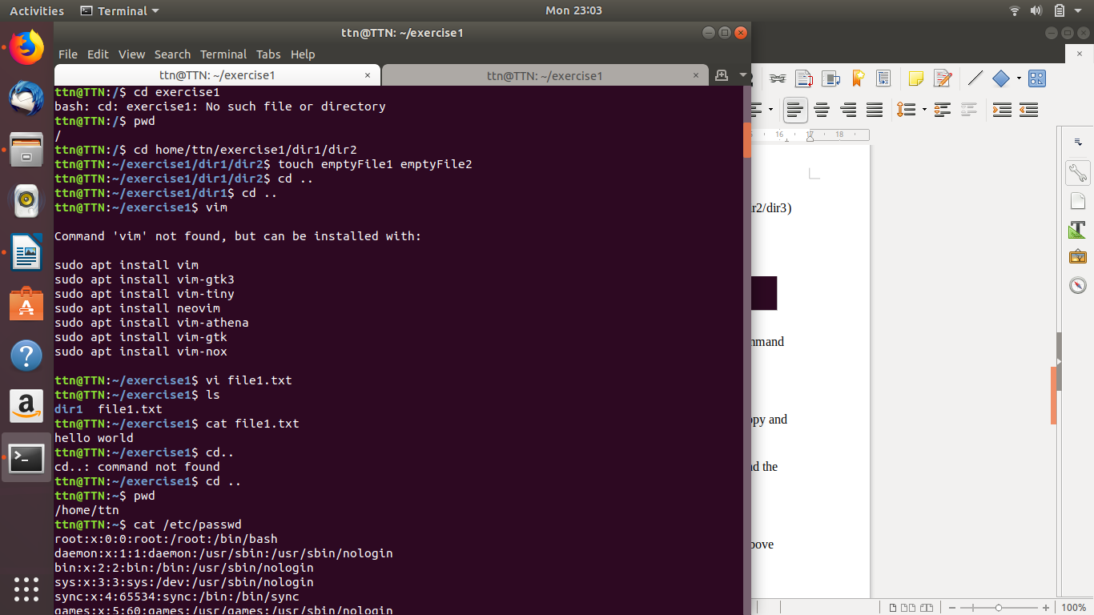

- Create one file file1.txt containing text "hello world" and save it.
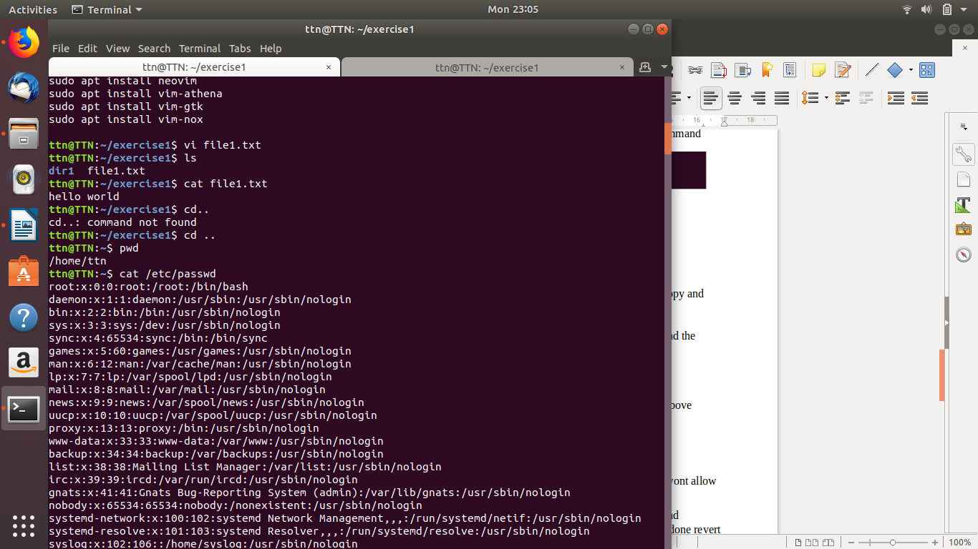
- Find a "passwd" file using find command inside /etc. copy this files as passwd_copy and then rename this file as passwd_backup.
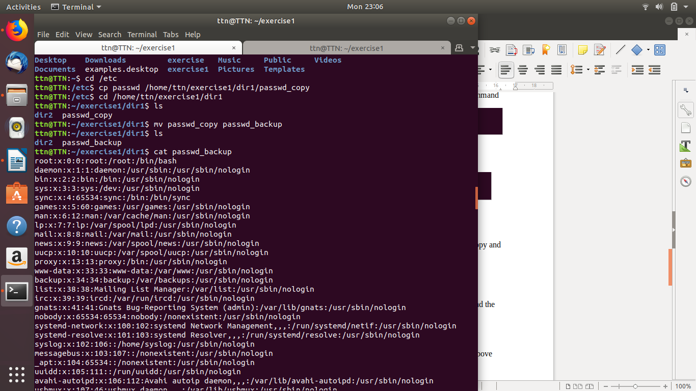

- Try reading passwd_backup file in multiple tools: less,more,cat,strings etc and find the difference in their usage.

- More command:
As 'cat' command displays the file content. Same way 'more' command also displays the content of a file. Only difference is that, in case of larger files, 'cat' command output will scroll off your screen while 'more' command displays output one screenful at a time.
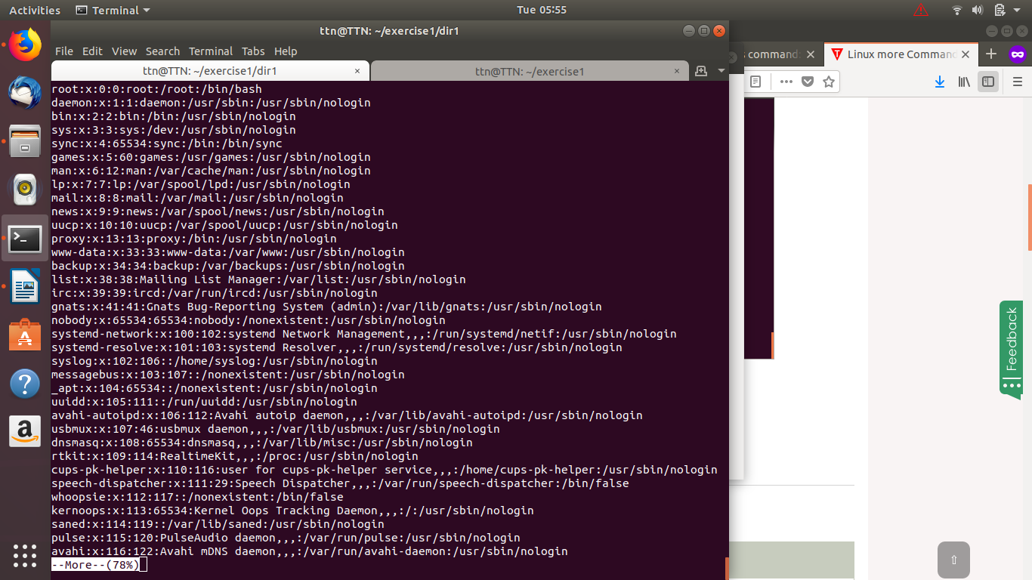

- Less command
It automatically adjust with the width and height of the teminal window, while 'more' command cuts the content as the width of the terminal window get shorter.

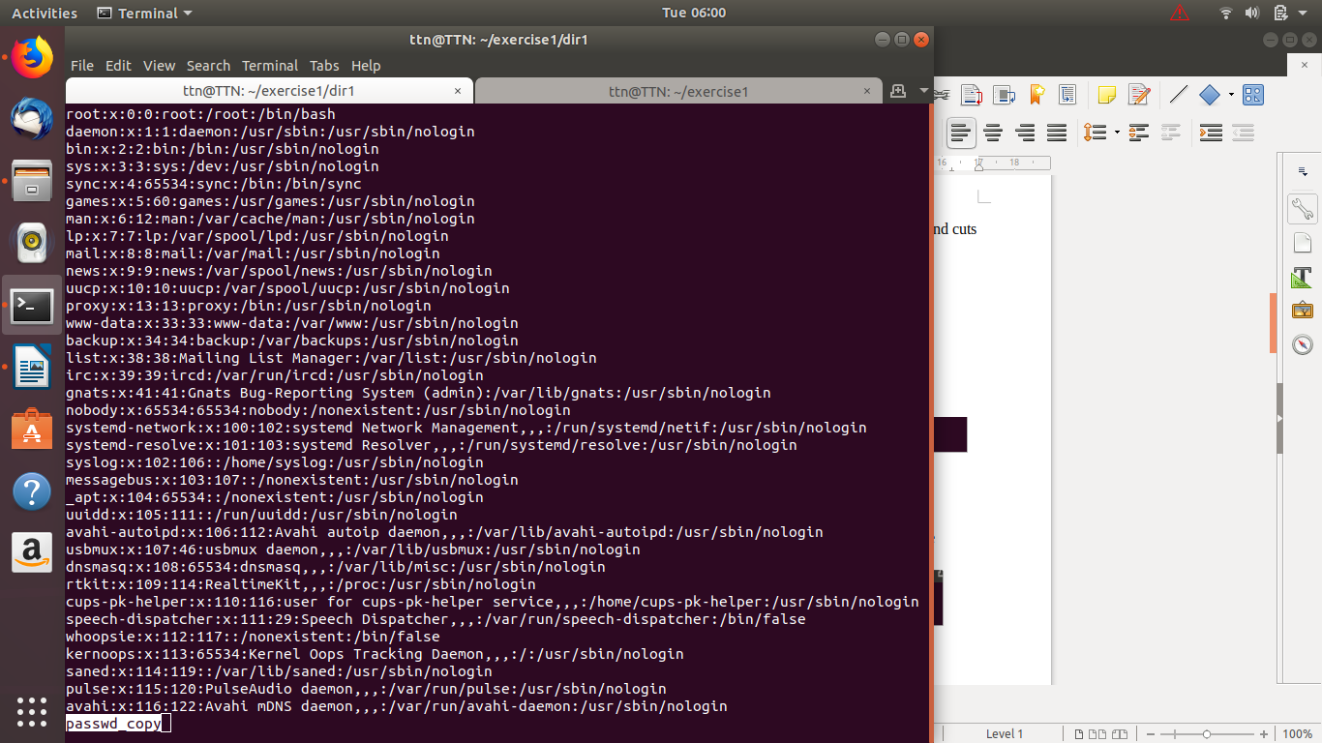

- Cat command:
This command allows us to create single or multiple files, view contain of file, concatenate files and redirect output in terminal or files.
$ cat passwd_copy

- Find out the number of line in password_backup containing "/bin/false".
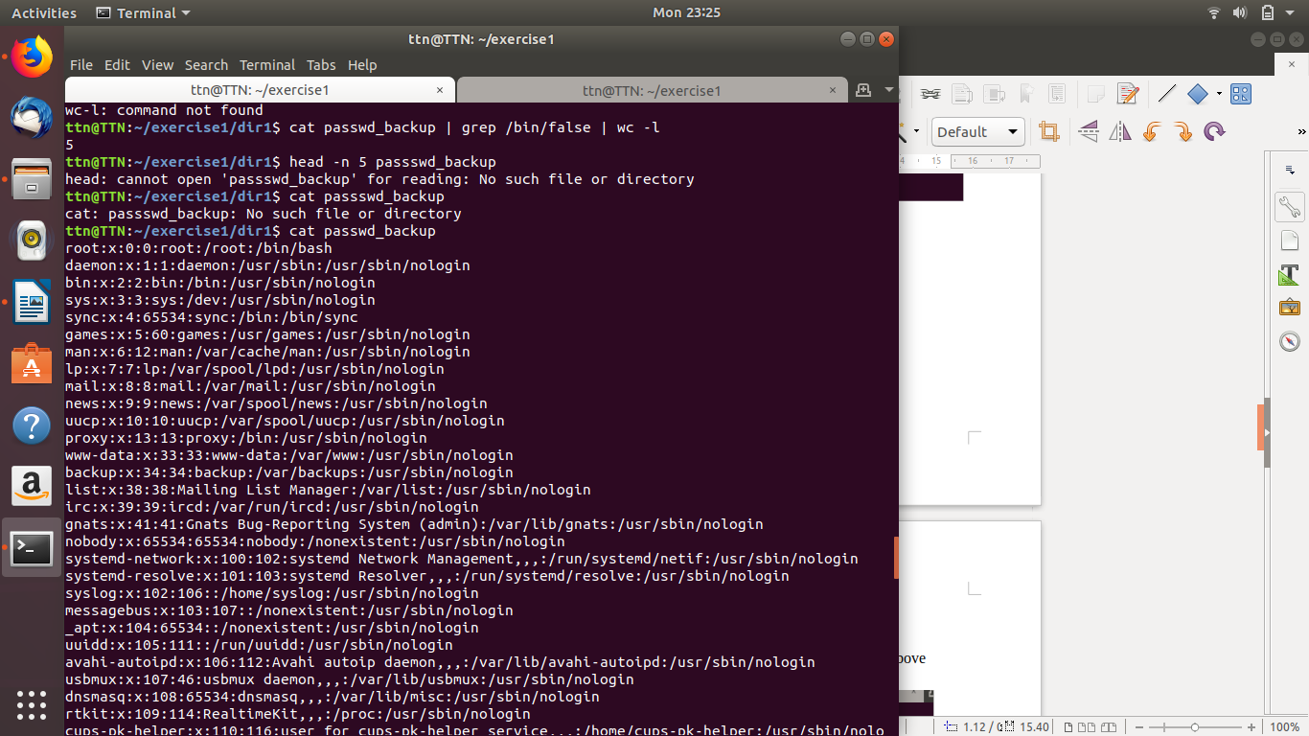

- Get the first 5 lines of a file “password_backup” and Redirect the output of the above commands into file "output".

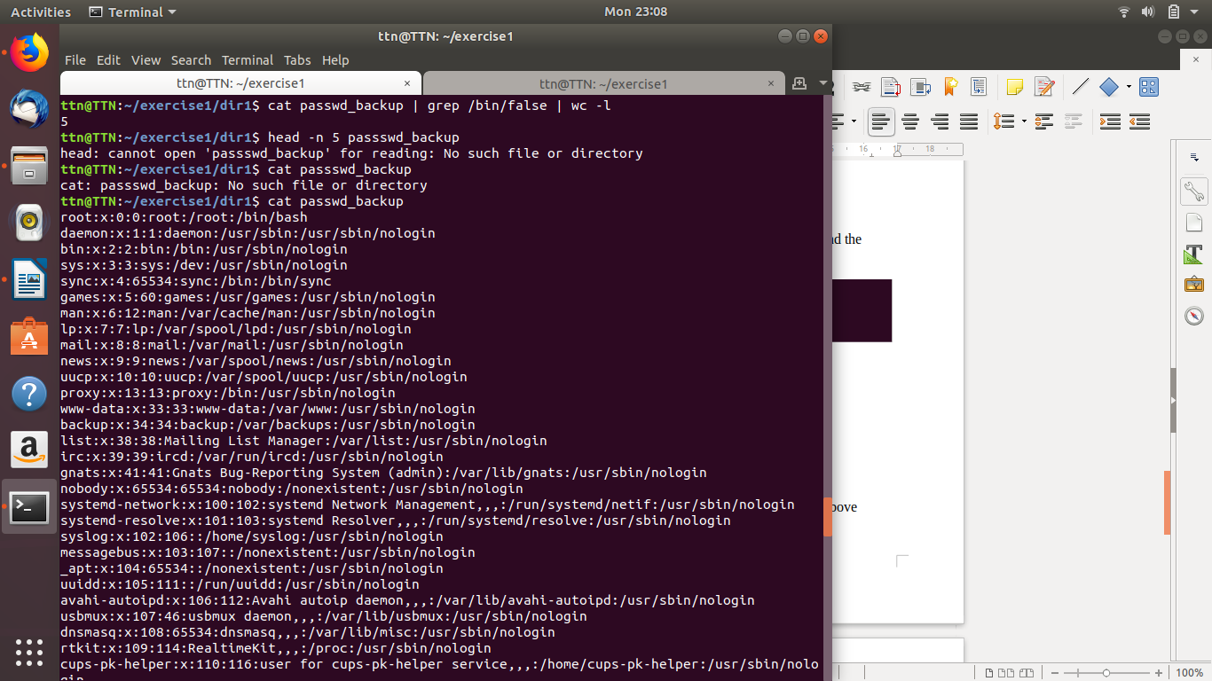
- Create a "test" user,create its password and find out its uid and gid.
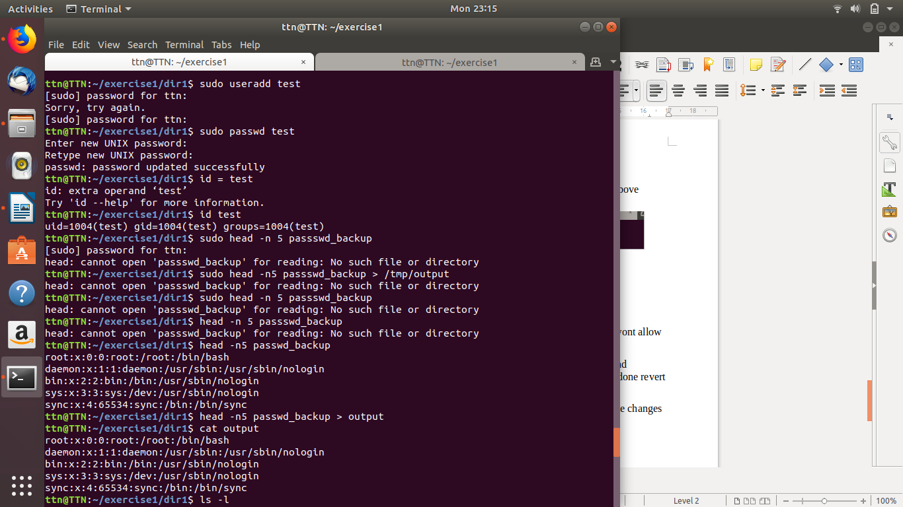

- Change the timestamp of emptyFile1,emptyFile2 which are exist in dir2

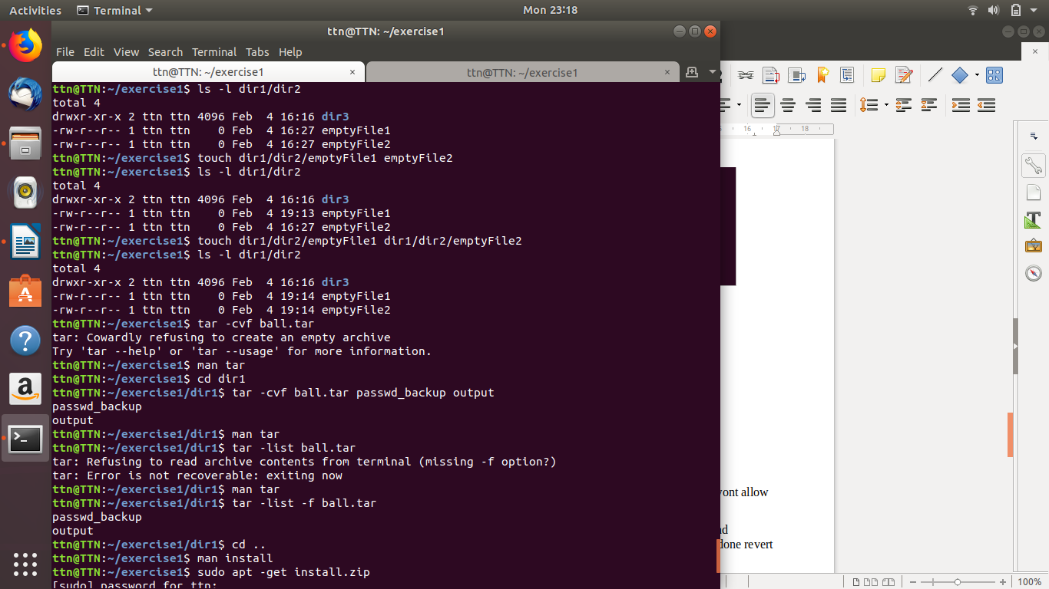

- Login as test user and edit the "output" file created above. Since the permission wont allow you to save the changes. Configure such that test user can edit it.
  - Add group owner of the "output" file as the secondary group of testuser and check/change the "output" file permission if it is editable by group. Once done revert the changes
  - Make the file editable to the world so that test user can access it. Revert the changes after verification
  - Change the ownership to edit the file.

- Create alias with your name so that it creates a file as "/tmp/aliastesting".
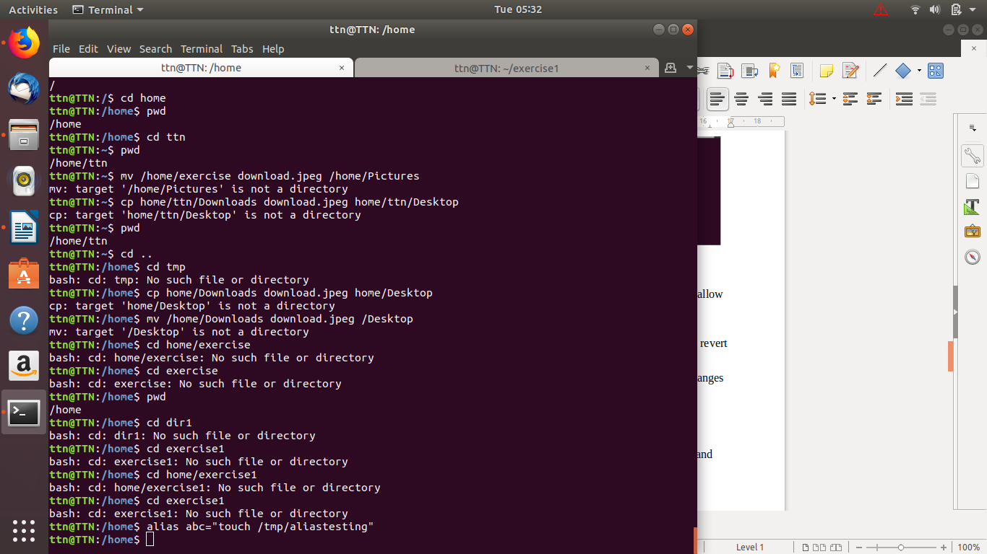
- Edit ~/.bashrc file such that when you change to "test" user it should clear the screen and print "Welcome".
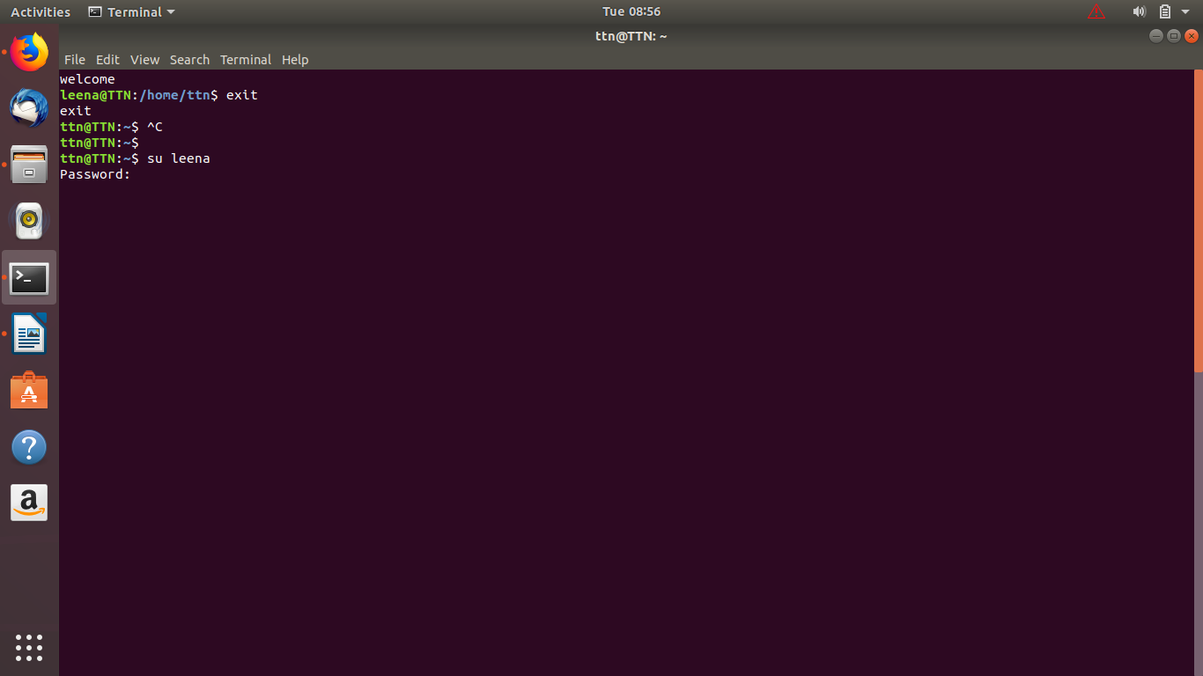

- Install “zip” package.
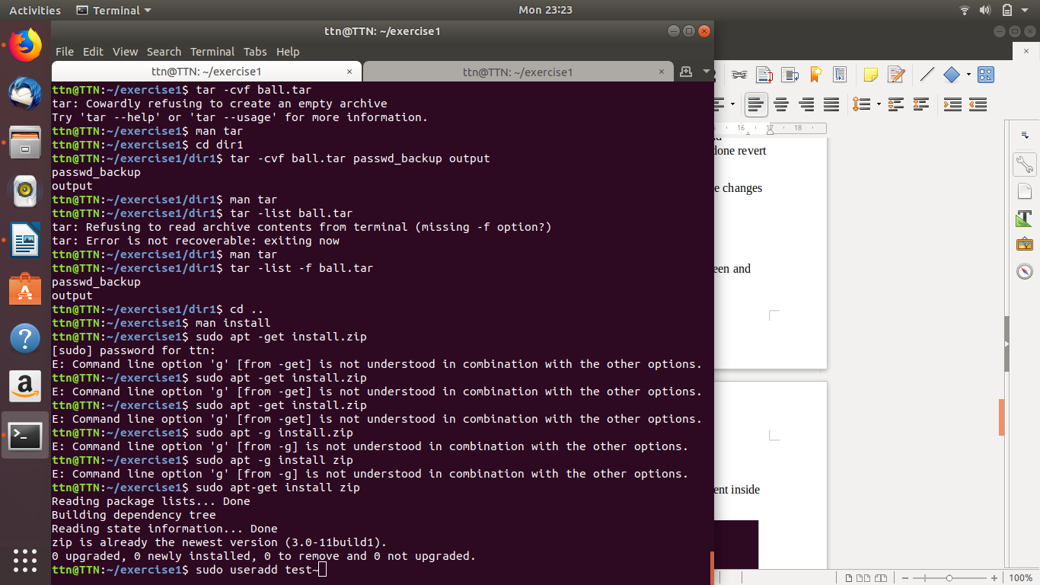

- "output" and "password_backup" files into a tar ball. List the files present inside the tar created.
- scp this file to test user
- Unzip this tar bar by logging into the remote server

- Download any image from web and move to desktop

- How to get help of commands usages.
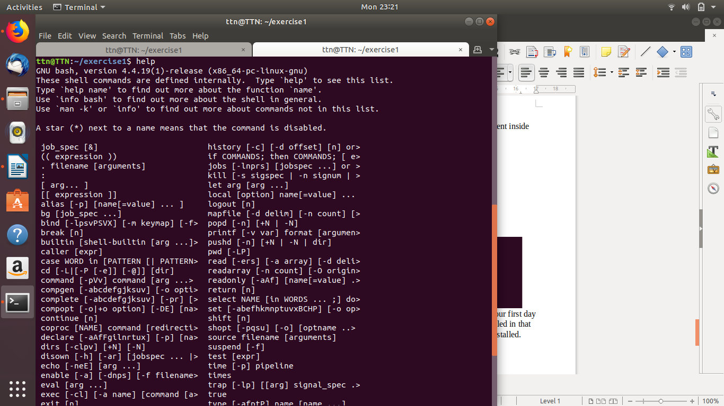

- Create a symlink of /etc/services into /tmp/ports-info
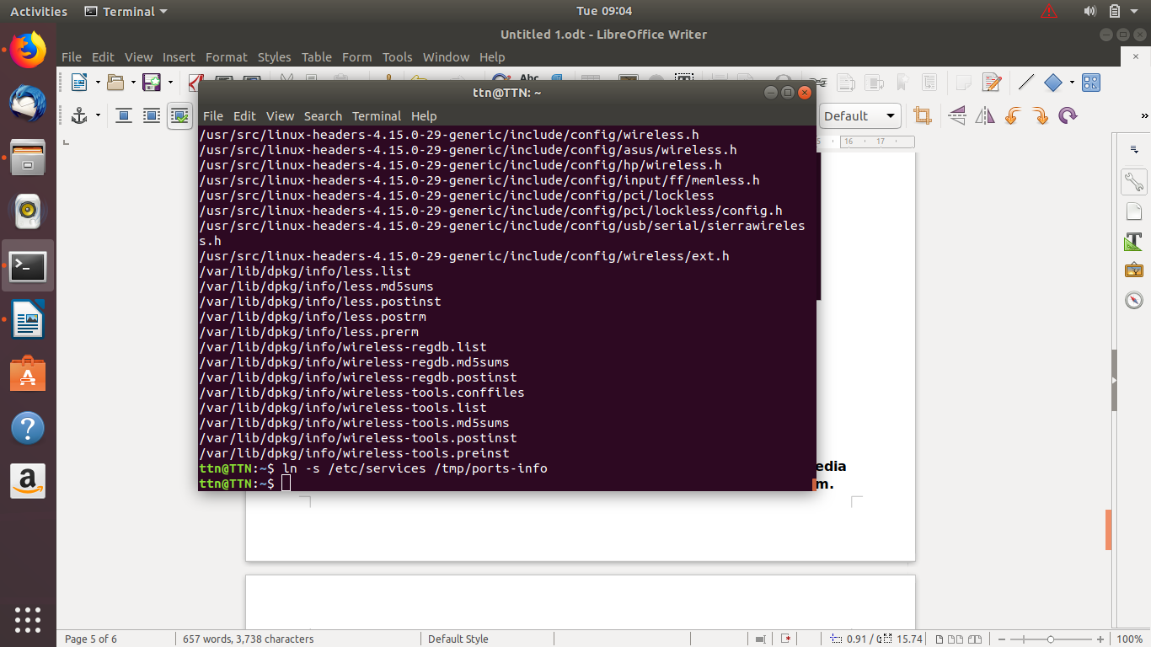

- You are appointed as a Software/DevOps Engineer in ABC media services. On your first day you need to troubleshoot a problem. There is a command “xyz” somewhere installed in that linux system. But as a new joinee you do not have any idea about where is that Installed. How can you check that
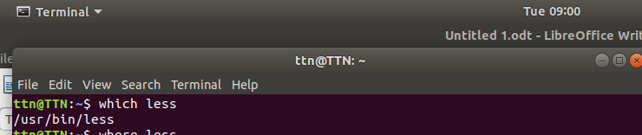

- Difference between # and $ in linux.
If the screen shows a dollar sign ($) or hash (#) on the left of the blinking cursor, you are in the command line environment.
$, #, % symbols indicate the user account type you are logged in to.
- Dollar sign ($) means you are a normal user.
- hash (#) means you are the system administrator (root).
- Difference in sudo-i and sudo -s.
- sudo -i It is nearly the same as sudo su - The -i (simulate initial login) option runs the shell specified by the password database entry of the target user as a login shell. This means that login-specific resource files such as .profile, .bashrc or .login will be read and executed by the shell.

- sudo -s reads the $SHELL variable and executes the content. If $SHELL contains /bin/bash it invokes sudo /bin/bash

- Make two directories dir1 dir2. In dir1 make four files and move these files into dir2.
