R Notebook

This is an [R Markdown](http://rmarkdown.rstudio.com) Notebook. When you execute code within the notebook, the results appear beneath the code.

Try executing this chunk by clicking the *Run* button within the chunk or by placing your cursor inside it and pressing *Ctrl+Shift+Enter*.

## Building Multiple Linear Regression Model for Predicting Medical Expenses ----  
## Step 2: Exploring and preparing the data ----  
insurance <- read.csv("insurance.csv", stringsAsFactors = TRUE)  
str(insurance)

## 'data.frame': 1338 obs. of 7 variables:  
## $ age : int 19 18 28 33 32 31 46 37 37 60 ...  
## $ sex : Factor w/ 2 levels "female","male": 1 2 2 2 2 1 1 1 2 1 ...  
## $ bmi : num 27.9 33.8 33 22.7 28.9 25.7 33.4 27.7 29.8 25.8 ...  
## $ children: int 0 1 3 0 0 0 1 3 2 0 ...  
## $ smoker : Factor w/ 2 levels "no","yes": 2 1 1 1 1 1 1 1 1 1 ...  
## $ region : Factor w/ 4 levels "northeast","northwest",..: 4 3 3 2 2 3 3 2 1 2 ...  
## $ expenses: num 16885 1726 4449 21984 3867 ...

# summarize the charges variable  
summary(insurance$expenses)

## Min. 1st Qu. Median Mean 3rd Qu. Max.   
## 1122 4740 9382 13270 16640 63770

## ‘expenses’ is our dependent variable. Using linear regression, we will try to predict expenses using all other independent variables.

# histogram of insurance charges  
hist(insurance$expenses)

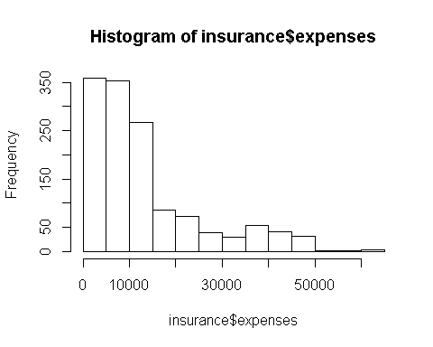

## From the histogram, we see that the distribution of insurance expenses is right-skewed.

# table of region  
table(insurance$region)

##   
## northeast northwest southeast southwest   
## 324 325 364 325

## The data is almost evenly distributed among the four regions.

## We now try to find the linear association between the features by calculating their correlation coefficients with each other in a correlation matrix:

# exploring relationships among features: correlation matrix  
cor(insurance[c("age", "bmi", "children", "expenses")])

## age bmi children expenses  
## age 1.0000000 0.10934101 0.04246900 0.29900819  
## bmi 0.1093410 1.00000000 0.01264471 0.19857626  
## children 0.0424690 0.01264471 1.00000000 0.06799823  
## expenses 0.2990082 0.19857626 0.06799823 1.00000000

# visualing relationships among features: scatterplot matrix  
pairs(insurance[c("age", "bmi", "children", "expenses")])

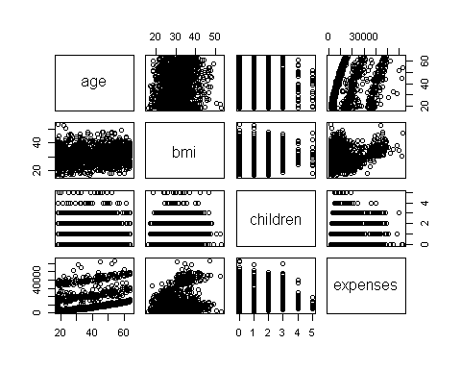

## There appears to be a somewhat linear relationship between ‘age’ and ‘expenses’

# more informative scatterplot matrix  
library(psych)  
pairs.panels(insurance[c("age", "bmi", "children", "expenses")])

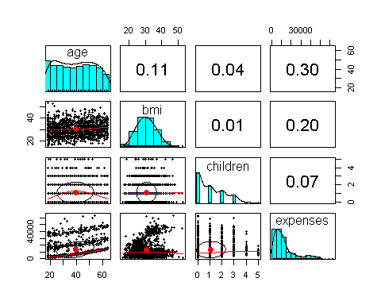

## The correlation ellipse between bmi and children is almost a perfectly round oval. This indicates very weak correlation between them.

## The loess curve for age and children is an upside-down U, peaking around middle age. This is a non-linear relationship indicating that middle-aged people have the most number of children on the insuarance plan.

## Step 3: Training a model on the data ----  
ins_model <- lm(expenses ~ age + children + bmi + sex + smoker + region,  
 data = insurance)  
ins_model <- lm(expenses ~ ., data = insurance) # this is equivalent to above  
  
# see the estimated beta coefficients  
ins_model

##   
## Call:  
## lm(formula = expenses ~ ., data = insurance)  
##   
## Coefficients:  
## (Intercept) age sexmale bmi   
## -11941.6 256.8 -131.4 339.3   
## children smokeryes regionnorthwest regionsoutheast   
## 475.7 23847.5 -352.8 -1035.6   
## regionsouthwest   
## -959.3

## The beta coefficients for each feature indicate the estimated increase in expenses for an increase of one unit in the feature. eg. For every addition of a smoking individual, expenses increase by $23847.5

## Step 4: Evaluating model performance ----  
# see more detail about the estimated beta coefficients  
summary(ins_model)

##   
## Call:  
## lm(formula = expenses ~ ., data = insurance)  
##   
## Residuals:  
## Min 1Q Median 3Q Max   
## -11302.7 -2850.9 -979.6 1383.9 29981.7   
##   
## Coefficients:  
## Estimate Std. Error t value Pr(>|t|)   
## (Intercept) -11941.6 987.8 -12.089 < 2e-16 ***  
## age 256.8 11.9 21.586 < 2e-16 ***  
## sexmale -131.3 332.9 -0.395 0.693255   
## bmi 339.3 28.6 11.864 < 2e-16 ***  
## children 475.7 137.8 3.452 0.000574 ***  
## smokeryes 23847.5 413.1 57.723 < 2e-16 ***  
## regionnorthwest -352.8 476.3 -0.741 0.458976   
## regionsoutheast -1035.6 478.7 -2.163 0.030685 *   
## regionsouthwest -959.3 477.9 -2.007 0.044921 *   
## ---  
## Signif. codes: 0 '***' 0.001 '**' 0.01 '*' 0.05 '.' 0.1 ' ' 1  
##   
## Residual standard error: 6062 on 1329 degrees of freedom  
## Multiple R-squared: 0.7509, Adjusted R-squared: 0.7494   
## F-statistic: 500.9 on 8 and 1329 DF, p-value: < 2.2e-16

## Small and statistically significant p-values for age, bmi and smokeryes indicate that these features are extremely likely to have a relationship with the dependent variable.

## The multiple R-squared value of 0.7509 indicates that the model explains nearly 75 percent of the variation in the dependent variable.

## Step 5: Improving model performance ----  
  
#The relationship between age and expenses is not truely linear  
# add a higher-order "age" term  
insurance$age2 <- insurance$age^2  
  
#BMI has an effect on the expenses only after a threshold value is reached. Hence we convert it to a binary indicator variable  
# add an indicator for BMI >= 30  
insurance$bmi30 <- ifelse(insurance$bmi >= 30, 1, 0)  
  
#as high BMI and the presence of smoking combined together have a greater impact on expenses, we include them as an interaction BMI30*smoker  
# create final model  
ins_model2 <- lm(expenses ~ age + age2 + children + bmi + sex +  
 bmi30*smoker + region, data = insurance)  
  
summary(ins_model2)

##   
## Call:  
## lm(formula = expenses ~ age + age2 + children + bmi + sex + bmi30 *   
## smoker + region, data = insurance)  
##   
## Residuals:  
## Min 1Q Median 3Q Max   
## -17297.1 -1656.0 -1262.7 -727.8 24161.6   
##   
## Coefficients:  
## Estimate Std. Error t value Pr(>|t|)   
## (Intercept) 139.0053 1363.1359 0.102 0.918792   
## age -32.6181 59.8250 -0.545 0.585690   
## age2 3.7307 0.7463 4.999 6.54e-07 ***  
## children 678.6017 105.8855 6.409 2.03e-10 ***  
## bmi 119.7715 34.2796 3.494 0.000492 ***  
## sexmale -496.7690 244.3713 -2.033 0.042267 *   
## bmi30 -997.9355 422.9607 -2.359 0.018449 *   
## smokeryes 13404.5952 439.9591 30.468 < 2e-16 ***  
## regionnorthwest -279.1661 349.2826 -0.799 0.424285   
## regionsoutheast -828.0345 351.6484 -2.355 0.018682 *   
## regionsouthwest -1222.1619 350.5314 -3.487 0.000505 ***  
## bmi30:smokeryes 19810.1534 604.6769 32.762 < 2e-16 ***  
## ---  
## Signif. codes: 0 '***' 0.001 '**' 0.01 '*' 0.05 '.' 0.1 ' ' 1  
##   
## Residual standard error: 4445 on 1326 degrees of freedom  
## Multiple R-squared: 0.8664, Adjusted R-squared: 0.8653   
## F-statistic: 781.7 on 11 and 1326 DF, p-value: < 2.2e-16

## The improved model has a multiple R-squared value of 0.8664 and adjusted R-squared value of 0.8653. It can now explain almost 86.6% of variations in the medical expenses.