LockBox Project Report: Secure File Encryption & Management
Project Goal
Build a Python-based system to securely encrypt sensitive company documents using AES encryption (Fernet) and demonstrate secure key handling. The project also includes safe GitHub practices for working with secret keys.
Step-by-Step Procedure
Step 1: Setting Up Python Environment
- Installed Python on your system.
- Installed the cryptography library via pip for encryption functionality.
- Ensured Python and pip commands worked correctly by fixing PATH issues.
Step 2: Project Structure
- Created a project folder named LockBox.
- Inside, created these files and folders in VS Code
LockBox/
- encrypt.py
- decrypt.py
- README.md
- Demo_Files/
- The Demo_Files folder stores files to encrypt and decrypt.
Step 3: Key Generation & Encryption Script (encrypt.py)
- Used the cryptography.fernet module to generate a secure symmetric encryption key.
- Saved the generated key safely in a file encrypt.key to use later for decryption.
- Read the file to be encrypted (secret.txt from Demo_Files).
- Encrypted the file contents with the generated key.
- Saved the encrypted data as secret.enc in the Demo_Files folder.
Step 4: Decryption Script (decrypt.py)
- Loaded the saved encryption key from encrypt.key.
- Read the encrypted file secret.enc.
- Decrypted the data back to its original form.
- Saved decrypted content in a new file to verify encryption/decryption correctness.
Step 5: Key Management Best Practices
- Learned to never share or commit your key file (encrypt.key) to GitHub or public repositories.
- Created a .gitignore file in your repo root to exclude sensitive files like encryption keys and compiled Python files.
- This step ensures your encryption keys remain private and secure, essential for real-world security.
- 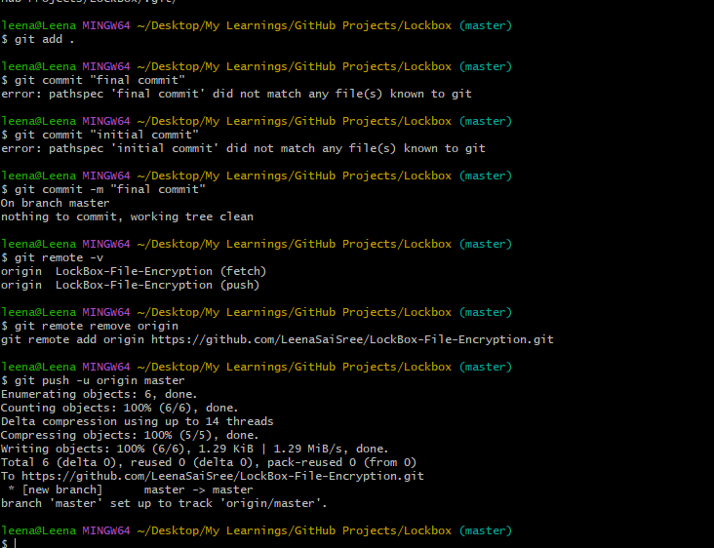
Step 6: Documentation and GitHub Setup
- Composed a README.md explaining project purpose, usage steps, and security concepts.
- Choose a clear GitHub repository name and description highlighting data protection, encryption, and secure key handling.
- Initialized Git repo with .gitignore and pushed project code excluding sensitive keys.
- 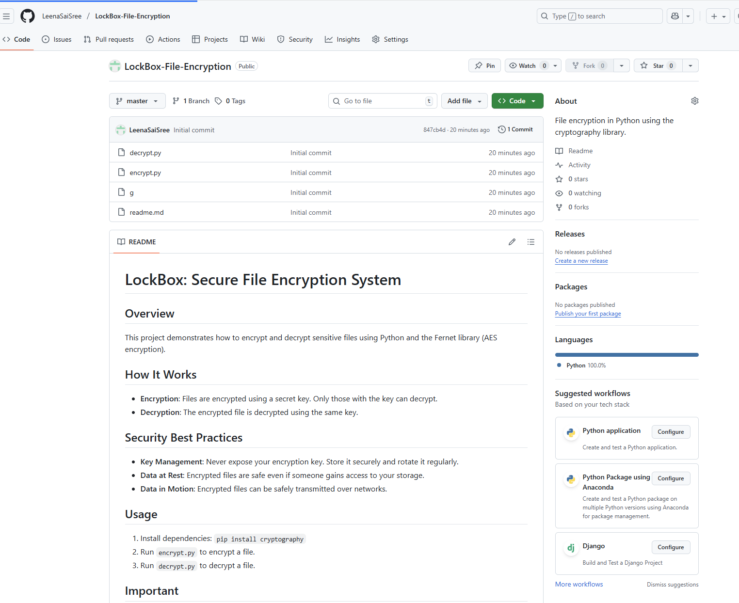

Concepts Used
- Symmetric Encryption: Used AES-based Fernet for encrypting and decrypting files with the same secret key.
- Key Generation and Storage: Generated secure random keys and managed them carefully to prevent exposure.
- File Handling in Python: Opened, read, wrote files in binary mode for safe handling of encrypted data.
- Security Best Practices: Key secrecy, .gitignore usage, and careful GitHub repo management.
- Tool and Environment Setup: Installed Python and required libraries, handled environment PATH issues.
- Basic Git Usage: Created repository, committed files safely, and used secret management techniques.

