Project - High Level Design
on

Deploy Education App to Kubernetes

Course Name: DevOps Foundation

Institution Name: Medicaps University – Datagami Skill Based Course

Student Name(s) & Enrolment Number(s):
Sr no | Student Name | Enrolment Number
1 | Leeni Patidar | EN22CS301554
2 | Mahak Agrawal | EN22CS301563
3 | Kunal Singh Chouhan | EN22CS301540
4 | Krishna Patidar | EN22CS301523

Group Name: 04D5
Project Number: DO-04
Industry Mentor Name:
University Mentor Name:: Prof. Ritesh Joshi
Academic Year: 2025-2026

Table of Contents
1. Introduction
1.1. Scope of the Document
1.2. Intended Audience
1.3. System Overview
2. System Design
2.1. Application Design
2.2. Process Flow
2.3. Information Flow
2.4. Components Design
2.5. Key Design Considerations
2.6. API Catalogue
3. Data Design
3.1. Data Model
3.2. Data Access Mechanism
3.3. Data Retention Policies
3.4. Data Migration
4. Interfaces
5. State and Session Management
6. Caching
7. Non-Functional Requirements
7.1. Security Aspects
7.2. Performance Aspects
8. References

1. Introduction
1.1 Scope of the Document
This document provides a comprehensive High-Level Design (HLD) of the EduLearn Platform, an interactive web-based education system developed using the MERN stack (MongoDB, Express.js, React.js, Node.js). The purpose of this document is to clearly describe the overall system architecture, major components, and the design approach used in building the platform. It explains how different parts of the system interact and how data flows across the application.
The scope of this document includes:
- Description of system architecture and layered design
- Overview of frontend, backend, and database components
- API structure and communication between client and server
- Authentication and authorization mechanisms
- Key design considerations such as scalability, performance, and security
- High-level understanding of system workflows and modules
This document serves as a technical blueprint for developers, architects, testers, and stakeholders. It helps in guiding development, ensuring consistency, and supporting system maintenance. It focuses only on high-level design and does not include detailed code-level implementation.

1.2 Intended Audience
This document is intended for all stakeholders involved in the EduLearn Platform and is designed to be understandable by both technical and non-technical users.
- Software Developers: To understand system architecture, modules, and development flow for implementation
- System Architects: To evaluate design decisions, technology stack, and scalability of the system
- Project Managers: To understand project scope, system components, and dependencies for planning and tracking
- QA Engineers/Testers: To understand workflows, integration points, and expected system behavior for testing
- Stakeholders/Clients: To gain a high-level understanding of the platform and ensure alignment with business requirements

1.3 System Overview
EduLearn Platform is a full-stack, responsive web application designed to provide an interactive and efficient online learning experience. The platform allows students to access educational content, participate in quizzes, and track their progress, while administrators manage courses, users, and system data.
The system supports user registration and secure login using JWT-based authentication. After logging in, users can browse available courses, enroll in courses, and access structured learning materials such as notes, videos, and modules. The platform includes an interactive quiz system where users can attempt quizzes and receive instant evaluation. Based on user activity, the system tracks progress and displays performance analytics through dashboards.
The platform also includes an admin panel that allows administrators to manage users, create and update courses, upload content, and monitor platform activity.
Main functionalities of the system include:
- User registration and secure login using JWT authentication
- Course browsing, selection, and enrollment
- Access to structured course content (notes, videos, modules)
- Quiz participation with automatic evaluation and scoring
- Progress tracking with dashboards and analytics
- Admin panel for managing users, courses, and content
Key features of the system include:
- Secure authentication and role-based access control (Student and Admin roles)
- Responsive and user-friendly interface using Tailwind CSS
- RESTful API communication between frontend and backend
- Scalable backend using Node.js and Express.js
- Efficient data management using MongoDB and Mongoose
Architecture overview of the system:
- Presentation Layer: Built using React.js, responsible for UI rendering, routing, and user interaction
- Business Logic Layer: Built using Node.js and Express.js, responsible for handling requests, authentication, and core logic
- Data Layer: Uses MongoDB with Mongoose for storing and managing application data
The EduLearn Platform is designed to be scalable, secure, and maintainable, ensuring smooth performance and a seamless user experience for both students and administrators.
2.System Design

2.1 Application Design
The EduLearn Platform follows a scalable and modular three-tier architecture that separates the system into independent layers to ensure maintainability, flexibility, and performance optimization. The application is implemented as a Single Page Application (SPA), where the frontend dynamically interacts with backend services through RESTful APIs without reloading the entire page.
The system is divided into the following layers:
- Presentation Layer: Built using React.js, Vite, and Tailwind CSS; responsible for rendering UI, handling user interaction, routing, and state management
- API Layer: Built using Node.js and Express.js; responsible for handling HTTP requests, routing, middleware execution, and request validation
- Business Logic Layer: Contains core services such as course management, quiz evaluation, enrollment handling, and progress tracking
- Data Layer: Uses MongoDB with Mongoose ODM for schema design, querying, indexing, and data persistence
- Authentication Layer: Implements JWT-based authentication and bcrypt for secure password hashing and verification
Additional design aspects:
- The system follows a modular structure where each feature is divided into controllers, services, and models
- The backend is stateless, meaning no session data is stored on the server, improving scalability
- Environment variables are used for configuration management (e.g., database URI, JWT secret)
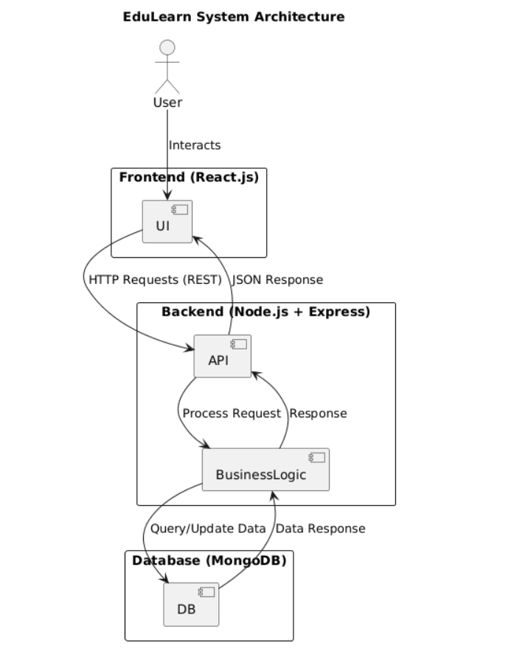
SYSTEM ARCHITECHURE

2.2 Process Flow
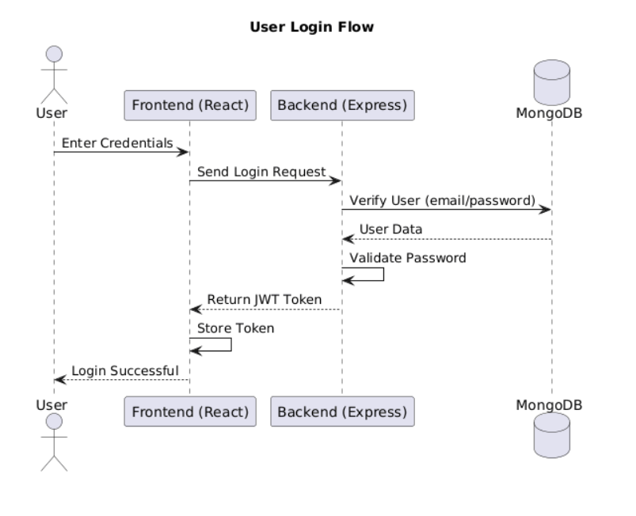
The platform follows structured workflows to ensure smooth communication between components and efficient handling of user actions.
Authentication Flow:
- User enters credentials on the frontend login page
- Request is sent to backend via REST API
- Backend validates credentials using hashed passwords stored in MongoDB
- On success, a JWT token is generated and returned
- Token is stored securely (HTTP-only cookies or localStorage)
- Each subsequent request includes the token for authorization
- Middleware verifies the token and grants or denies access
Course Enrollment Flow:
- User browses courses using the dashboard interface
- User selects a course and initiates enrollment
- Frontend sends enrollment request to backend
- Backend validates user identity and checks course availability
- Enrollment record is created in the database
- User is granted access to course content
Quiz Submission Flow:
- User attempts quiz within a course module
- Answers are submitted to backend via API
- Backend evaluates answers using predefined logic
- Score is calculated instantly without heavy database operations
- Results are stored and linked to user progress
- Feedback is displayed on the dashboard
2.3 Information Flow
The system uses a client-server architecture with secure communication over HTTPS. All data exchange occurs through RESTful APIs in JSON format.
Flow of data:
- React frontend sends API requests to Express backend
- Backend processes requests and applies business logic
- Mongoose is used to interact with MongoDB database
- Database returns data to backend
- Backend sends structured JSON response to frontend
- Frontend updates UI dynamically based on response
Additional points:
- Communication is stateless due to JWT usage
- API responses follow a consistent structure (status, message, data)
- Error responses are standardized across the system
- Data validation is performed both on client-side and server-side

2.4 Components Design
The system is designed using modular and reusable components to improve maintainability and scalability.
Frontend components include authentication modules, dashboard, course browsing interface, course detail pages, quiz interface, progress tracking views, and an admin panel. Shared components such as navigation bar, sidebar, loaders, and notification elements are reused across the application to maintain consistency.
Backend components are organized into services such as authentication service, user service, course service, quiz service, progress service, and admin service. Each service is responsible for handling specific business logic and interacts with the data layer through defined models.
The system maintains a clear separation between controllers and services, and uses middleware for authentication, validation, and error handling. This modular design ensures that the system can be easily extended and maintained.
2.5 Key Design Considerations
The system is designed keeping important non-functional requirements in mind:
- Scalability: Stateless backend allows horizontal scaling using load balancers
- Performance: Use of indexing, optimized queries, and pagination
- Security: JWT authentication, password hashing, input validation, and protected APIs
- Maintainability: Modular architecture and clean code practices
- Reusability: Component-based frontend and reusable backend services
- Reliability: Error handling and fallback mechanisms
- Responsiveness: Mobile-first design approach using Tailwind CSS
- Flexibility: Easy integration of new features or modules
Additional considerations:
- Logging and monitoring can be integrated for debugging and performance tracking
- Future support for microservices architecture if system scales
- API versioning to handle future updates without breaking existing clients
2.6 API Catalogue
The backend exposes RESTful APIs categorized based on functionality:
Authentication APIs:
- POST /api/auth/register: Register a new user
- POST /api/auth/login: Authenticate user and return JWT token
User APIs:
- GET /api/users/profile: Retrieve logged-in user details
Course APIs:
- GET /api/courses: Fetch all available courses
- GET /api/courses/:id: Fetch specific course details
- POST /api/courses: Create course (Admin only)
- PUT /api/courses/:id: Update course (Admin only)
- DELETE /api/courses/:id: Delete course (Admin only)
Enrollment APIs:
- POST /api/enrollments: Enroll user in course
- GET /api/enrollments/my: Get user’s enrolled courses
Quiz APIs:
- GET /api/quizzes/:courseId: Get quizzes for a course
- POST /api/quizzes/:id/submit: Submit quiz answers
Progress APIs:
- GET /api/progress/:courseId: Get progress for a course
Admin APIs:
- GET /api/admin/users: Retrieve all users (Admin only)
Additional API design practices:
- RESTful conventions are followed for all endpoints
- Proper HTTP methods are used (GET, POST, PUT, DELETE)
- Status codes are standardized (200, 201, 400, 401, 404, 500)
- Authentication middleware protects sensitive routes
3. Data Design
3.1 Data Model
The EduLearn Platform uses MongoDB, a NoSQL document-based database, to provide flexible, scalable, and high-performance data storage. Mongoose ODM is used to define schemas, enforce validation rules, and manage relationships between different data entities. The data model is designed to support core functionalities such as user management, course delivery, quiz evaluation, and progress tracking while ensuring efficient data retrieval and scalability.
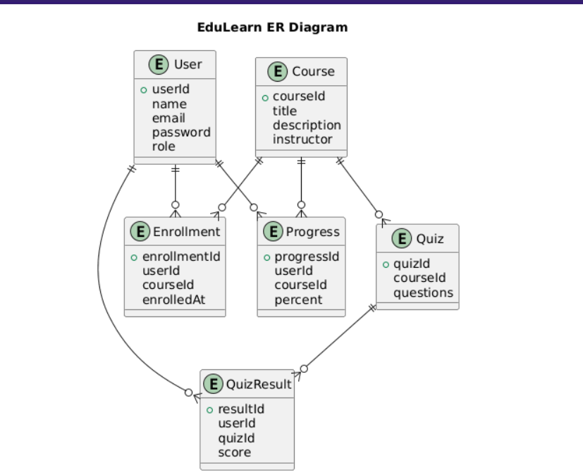
The system consists of the following primary collections:
- Users Collection: Stores user details including unique identifier, name, email, encrypted password, role (student/admin), and account metadata; email is indexed for fast lookup and uniqueness
- Courses Collection: Stores course-related data such as title, description, instructor details, modules, and metadata; modules may include embedded arrays for structured content delivery
- Enrollments Collection: Maintains mapping between users and courses, including enrollment date and status; acts as a linking collection for many-to-many relationships
- Quizzes Collection: Stores quiz definitions including course reference, questions array, options, correct answers, and passing criteria; questions may be embedded for faster access
- Quiz Results Collection: Stores user quiz attempts, scores, timestamps, and performance data; supports analytics and reporting
- Progress Collection: Tracks user progress per course including completed modules, percentage completion, and last activity timestamp
- Notes Collection: Stores additional study materials such as text notes, file URLs, and attachments linked to courses
Key design characteristics:
- Use of schema validation through Mongoose to ensure data consistency and integrity
- Use of ObjectId references to establish relationships between collections (e.g., userId, courseId)
- Combination of embedding and referencing to balance performance and flexibility
- Denormalized structure where necessary to reduce join operations and improve read performance
- Designed for horizontal scalability and efficient handling of large datasets
3.2 Data Access Mechanism
Data access is managed through Mongoose ODM, which provides a structured and efficient way to interact with MongoDB. The system follows best practices to ensure optimized performance and maintainability.
Key mechanisms used:
- Repository/Service Pattern: Each module (User, Course, Quiz, Progress) has a dedicated service layer that handles database interactions, keeping controllers clean
- CRUD Operations: Standard database operations (Create, Read, Update, Delete) are implemented using Mongoose methods such as save(), find(), updateOne(), and deleteOne()
- Query Optimization: Efficient queries are written using filters, projections, and indexing to minimize response time
- Indexing: Indexes are applied on frequently accessed fields such as email, userId, courseId, and quizId to improve query performance
- Population: Mongoose populate() is used to fetch related data across collections (e.g., course details in enrollment records)
- Pagination: Implemented using skip and limit to efficiently handle large datasets in APIs
- Aggregation: MongoDB aggregation pipelines may be used for analytics such as calculating average scores or progress summaries
Additional practices:
- Use of .lean() for faster read-only queries to reduce memory overhead
- Schema-level validation and middleware (pre/post hooks) for data consistency
- Centralized error handling for database operations
- Use of async/await for non-blocking database interactions
3.3 Data Retention Policies
The system defines clear data retention policies to manage storage efficiently, ensure compliance, and maintain system performance.
- User Data: Stored for the lifetime of the account and retained for a limited period after deletion request for recovery or auditing
- Course Content: Stored while active; archived or soft-deleted when no longer needed
- Quiz Results: Retained for a defined period (e.g., 3 years) for performance analysis and reporting
- Progress Data: Maintained to provide historical learning insights and analytics
- Logs and Audit Trails: Stored temporarily (e.g., 1 year) for debugging, monitoring, and security tracking
- JWT Tokens: Short-lived tokens with expiration (e.g., 24 hours); no long-term storage on server
- Backups: Periodic backups retained for disaster recovery
Additional considerations:
- Data anonymization can be applied for analytics if required
- Soft delete approach (flag-based deletion) can be used instead of permanent deletion
- Compliance with data protection best practices
3.4 Data Migration
Data migration strategies are implemented to handle schema updates, feature enhancements, and data transformations without affecting system availability.
- Schema Versioning: Each schema change is version-controlled and managed using migration scripts
- Migration Tools: Tools like migrate-mongo can be used to automate schema updates
- Data Seeding: Initial datasets are inserted into development and staging environments for testing
- Backup Strategy: Automated backups (e.g., MongoDB Atlas backups) are scheduled regularly to prevent data loss
- Data Export: Data can be exported in formats such as CSV or JSON for reporting and external use
- Zero-Downtime Migration: Rolling updates and backward-compatible changes ensure no service interruption
Additional practices:
- Testing migrations in staging environment before production deployment
- Rollback mechanisms in case of migration failure
- Monitoring system performance during migration

4. Interfaces
The EduLearn Platform defines multiple interfaces to enable communication between system components and external services. These interfaces ensure smooth data exchange between the frontend, backend, database, and third-party services while maintaining consistency, security, and performance. Each interface is designed following standard protocols and best practices to ensure reliability and scalability of the system.

4.1 User Interface
The user interface is implemented as a responsive Single Page Application using React.js, providing a seamless and dynamic user experience without full page reloads. It is designed to support both students and administrators with role-based access and functionality.
The student interface allows users to perform actions such as registration, login, course browsing, enrollment, accessing learning materials, attempting quizzes, and tracking progress through dashboards and visual analytics. The admin interface provides tools for managing users, creating and updating courses, uploading content, and monitoring overall system activity.
The UI follows a component-based architecture, ensuring reusability and modularity of elements such as forms, cards, navigation bars, and dashboards. State management is handled using React features such as hooks or context API to maintain application state efficiently. Tailwind CSS is used to ensure consistent styling, responsiveness, and mobile-first design across all devices.

4.2 API Interface
The platform uses RESTful APIs as the core interface for communication between the frontend and backend systems. All API requests are made over secure HTTPS connections to ensure data confidentiality and integrity. Data is exchanged in JSON format, which is lightweight and widely supported.
Each API request includes necessary components such as headers, request body, query parameters, and authentication tokens when required. The backend processes the request, applies business logic, and returns a structured response containing status codes, messages, and data.
Authentication and authorization are implemented using JWT tokens, which are passed in the Authorization header for protected routes. The API design follows REST principles, ensuring clear resource-based endpoints and proper use of HTTP methods such as GET, POST, PUT, and DELETE. Error handling is standardized, and consistent response formats are maintained across all endpoints.

4.3 Database Interface
The database interface is implemented using Mongoose ODM, which provides a structured and efficient way to interact with MongoDB. It allows the definition of schemas, validation rules, and relationships between different data entities.
All database operations, including create, read, update, and delete, are performed using Mongoose methods, ensuring consistency and abstraction from raw database queries. Relationships between collections are maintained using ObjectId references and resolved using population when required.
The database interface is optimized for performance through indexing on frequently accessed fields and efficient query design. Schema validation ensures data integrity, while middleware functions can be used for pre-save and post-save operations. This interface ensures reliable and scalable data handling within the system.

4.4 File Storage Interface
The system includes a file storage interface to manage uploading, storing, and retrieving course-related files such as notes, documents, and media content. File uploads are handled using middleware such as Multer, which processes multipart/form-data requests.
Files can be stored either on the local server or on external cloud storage services depending on deployment requirements. The system stores file metadata or URLs in the database, allowing easy retrieval and access from the frontend.
Security measures are implemented to restrict file access based on user roles and permissions. The interface is designed to handle large files efficiently and can be extended to support content delivery networks (CDNs) for faster access and scalability.

4.5 Email Interface
The platform integrates an email interface to enable communication with users for system notifications and alerts. This interface is implemented using SMTP-based services or libraries such as Nodemailer.
Emails are triggered for events such as user registration, password reset, course enrollment confirmation, and important system notifications. The system uses predefined templates to ensure consistency and professionalism in communication.
The email interface is designed to be reliable and can be extended to support advanced features such as scheduled emails, bulk messaging, and integration with third-party email services. Proper error handling and retry mechanisms can be implemented to ensure successful delivery of emails.
5. State and Session Management
The EduLearn Platform implements state and session management to maintain a consistent user experience, ensure secure authentication, and support efficient data handling across the application. State management is primarily handled on the client side to control UI behavior and data flow, while session management is implemented using token-based authentication to maintain user identity across requests. The overall design follows a stateless architecture to improve scalability and performance.
5.1 Client-Side State Management
Client-side state management is implemented using React to manage application data and UI updates efficiently. The system distinguishes between global state and local component state to ensure optimal performance and maintainability.
Global state is managed using React Context API, which stores shared data such as authenticated user details, user roles, and application-level settings. This allows different components to access and update common data without prop drilling. Component-level state is managed using hooks such as useState and useReducer to handle UI interactions, form inputs, and temporary states.
To improve performance and reduce unnecessary API calls, data fetching strategies such as caching and memoization can be applied. Libraries like React Query or similar approaches can be used to cache server responses and synchronize data efficiently. This ensures that frequently accessed data such as course lists, user profiles, and progress data is reused instead of being fetched repeatedly.
The state management approach ensures consistency between UI and backend data, supports real-time updates, and improves overall responsiveness of the application.
5.2 Session Management
Session management is implemented using JSON Web Tokens (JWT), which provide a secure and stateless mechanism for user authentication. In this approach, session information is not stored on the server, which allows the system to scale easily across multiple instances.
When a user successfully logs in, the backend generates a JWT containing user identification and role information. This token is signed and sent to the client, where it is stored securely, either in HTTP-only cookies or localStorage depending on the security requirements.
For every subsequent request to protected endpoints, the client includes the JWT token in the Authorization header. The backend verifies the token using middleware before allowing access to the requested resource. If the token is valid, the request is processed; otherwise, access is denied.
This approach eliminates the need for server-side session storage and reduces overhead, making the system more efficient and scalable.
5.3 Session Lifecycle and Security
The session lifecycle is controlled using token validation, expiration policies, and secure handling mechanisms to ensure that user sessions remain safe and properly managed.
- Tokens are issued with a predefined expiration time to limit session duration and reduce security risks
- Once a token expires, the user must re-authenticate or use a refresh mechanism if implemented
- Each request is validated through middleware to ensure the authenticity and integrity of the token
- Sensitive user data is not stored directly within the token payload
Additional security practices include storing tokens securely to prevent unauthorized access, using HTTPS for all communications, and protecting against common vulnerabilities such as cross-site scripting (XSS) and cross-site request forgery (CSRF).
The system can be extended with advanced features such as refresh tokens for session renewal, token blacklisting for logout handling, and role-based access control to restrict access to specific resources. These mechanisms enhance the overall security and reliability of session management.
6. Caching
The EduLearn Platform implements caching mechanisms to improve system performance, reduce server load, and enhance user experience. Caching helps minimize repeated data fetching by storing frequently accessed data temporarily at different layers of the system. The caching strategy is designed to balance performance, data freshness, and consistency across the application.
6.1 Caching Layers
Caching is implemented at multiple levels to optimize different parts of the system.
Client-side caching is used to store static assets such as JavaScript files, stylesheets, and images in the browser cache. This reduces page load time and improves responsiveness for returning users.
API-level caching is implemented using frontend data fetching strategies where responses from the backend are temporarily stored. Frequently accessed data such as course listings and user profiles can be reused without making repeated API calls.
Server-side caching can be implemented using in-memory stores such as Redis to cache frequently requested data, reducing database load and improving response time.
Content Delivery Networks (CDNs) can be used to cache and serve static assets from geographically distributed servers, improving access speed for users in different locations.

6.2 Cache Usage Strategy
The caching strategy is designed to store data that is frequently accessed but does not change frequently. This ensures that performance is improved without compromising data accuracy.
- Static resources such as images, stylesheets, and scripts are cached for longer durations
- Frequently accessed data such as course lists and user profiles are cached for short durations
- Dynamic or sensitive data such as authentication responses are not cached
- Cache duration (TTL) is configured based on data type and usage pattern
The system ensures that cached data is refreshed periodically to maintain consistency with the latest data in the database.
6.3 Cache Invalidation
Cache invalidation is an important aspect of caching to ensure that outdated data is not served to users. The system uses strategies to clear or update cache when underlying data changes.
- When course data is updated or deleted, related cache entries are invalidated
- When a user enrolls in a course, dashboard-related cache is refreshed
- When quiz results or progress data changes, corresponding cache is updated
Cache invalidation can be triggered either manually within the application logic or automatically based on time-to-live (TTL) expiration. This ensures that users always receive accurate and up-to-date information.
6.4 Performance Considerations
Caching significantly improves system performance by reducing response time and database load. It allows the system to handle a larger number of concurrent users efficiently.
Proper cache design ensures that frequently accessed data is quickly available while minimizing memory usage. Over-caching is avoided to prevent stale data and excessive memory consumption.
The system is designed to scale caching mechanisms as needed, allowing integration with advanced tools such as Redis or distributed caching systems. Monitoring tools can be used to track cache performance and optimize caching strategies over time.

7. Non-Functional Requirements
The EduLearn Platform is designed to meet various non-functional requirements that ensure the system is secure, reliable, scalable, and efficient. These requirements define how the system performs under different conditions and how it maintains quality attributes such as performance, security, and usability.
7.1 Security Aspects
Security is a critical aspect of the system to protect user data and prevent unauthorized access. The platform implements multiple layers of security across authentication, authorization, data handling, and communication.
- Authentication is implemented using JWT tokens with expiration to ensure secure access
- Passwords are stored using strong hashing algorithms such as bcrypt with salting
- Role-based access control is enforced to restrict access to sensitive operations
- Input validation is performed on both client-side and server-side to prevent invalid data
- Protection against injection attacks is ensured through schema validation and controlled queries
- Cross-site scripting (XSS) is mitigated through frontend sanitization and secure rendering
- Cross-site request forgery (CSRF) protection is implemented using secure cookies and tokens
- All communication is secured using HTTPS to encrypt data in transit
- Rate limiting is applied to prevent brute-force attacks on authentication endpoints
- Sensitive configuration data is stored securely using environment variables
The system is designed following best security practices to ensure confidentiality, integrity, and availability of data.
7.2 Performance Aspects
Performance requirements define how efficiently the system responds to user actions and handles workload. The platform is optimized to provide fast response times and smooth user experience.
- Page load time is optimized using efficient frontend bundling and lazy loading techniques
- API response time is minimized through optimized queries, indexing, and caching
- The system supports concurrent users through asynchronous processing in Node.js
- Database performance is improved using indexing and efficient schema design
- Static assets are optimized and served through caching or CDN mechanisms
- Quiz evaluation is designed to be fast and does not rely heavily on database operations
- Pagination is implemented to handle large datasets efficiently
The system is designed to maintain consistent performance under normal and peak load conditions.
7.3 Scalability and Availability
The system is designed to scale efficiently as the number of users and data increases. It ensures high availability and minimal downtime.
- Stateless backend architecture allows horizontal scaling using multiple server instances
- Load balancing can be used to distribute traffic across servers
- Cloud-based deployment ensures high availability and fault tolerance
- Database scaling can be achieved using replication and sharding techniques
- Health checks and monitoring ensure system reliability
- Auto-restart mechanisms can be used to recover from failures
These features ensure that the system can grow and handle increasing demand without performance degradation.
7.4 Usability and Reliability
The platform is designed to provide a user-friendly experience while ensuring system reliability and stability.
- The user interface is intuitive and easy to navigate
- Responsive design ensures usability across different devices and screen sizes
- Error messages are clear and informative for better user understanding
- System handles unexpected errors gracefully without crashing
- Logging mechanisms can be implemented for debugging and monitoring
- Regular testing ensures reliability and correctness of the system
The system ensures consistent behavior and dependable performance for all users.
8. References
This section lists the key resources, documentation, and standards referred to during the design and development of the EduLearn Platform. These references provide guidance on technologies, frameworks, and best practices used in the system.
The following resources were used:
- React.js Documentation: https://react.dev
- Node.js Documentation: https://nodejs.org/en/docs
- Express.js Guide: https://expressjs.com/en/guide
- MongoDB Documentation: https://www.mongodb.com/docs
- Mongoose ODM Documentation: https://mongoosejs.com/docs
- JSON Web Token (JWT) Standard (RFC 7519): https://datatracker.ietf.org/doc/html/rfc7519
- Tailwind CSS Documentation: https://tailwindcss.com/docs
- Vite Documentation: https://vitejs.dev/guide
- OWASP Security Guidelines: https://owasp.org/www-project-top-ten
- REST API Best Practices: https://restfulapi.net
These references were used to ensure that the system design follows industry standards, security practices, and modern development approaches.

