Deploy Education App to Kubernetes Report

  - Course Name: DevOps

Institution Name: Medicaps University – Datagami Skill Based Course

Student Name(s) & Enrolment Number(s):
Sr no | Student Name | Enrolment Number
1 | Leeni Patidar | EN22CS301554
2 | Mahak Agrawal | EN22CS301563
3 | Kunal Singh Chouhan | EN22CS301540
4 | Krishna Patidar | EN22CS301523
Group Name: 04D5
Project Number: DO-04
Industry Mentor Name:
University Mentor Name: Prof. Ritesh Joshi
Academic Year: 2025-2026

SNO | Title | Page
 | Table of contents | 2
 | List of Figures | 3
1 | Problem Statement & Objectives | 4
1.1 | Problem Statement | 4
1.2 | Project Objectives | 5
1.3 | Scope of the Project | 5
2 | Proposed Solution | 7
2.1 | Key Features | 7
2.2 | Overall Architecture / Workflow | 10
2.3 | Tools & Technologies Used | 12
3 | Results & Output | 14
3.1 | Outputs
3.2 | Reports and Dashboards
3.3 | Key Outcomes
4 | Conclusion | 17
5 | Future Scope | 19

List of Figures

Figure No. | Title | Page No.
Figure 2.1 | System Architecture
Figure 2.2 | ER Diagram | 10
Figure 2.3 |  | 10
Figure 2.4 |  | 11
Figure 2.5 |  | 11
Figure 2.6 |  | 12
Figure 3.1 |  | 14
Figure 3.2 |  | 15

1.Problem Statement & Objectives
1.1 Problem Statement
In the rapidly growing digital era, online education has emerged as a primary medium for learning and skill development. However, despite the availability of numerous e-learning platforms, many systems still face critical challenges that limit their effectiveness and user engagement. These challenges include unstructured content delivery, lack of personalization, poor user interface design, and insufficient mechanisms for tracking student progress.
Many existing platforms provide learning materials without a well-organized structure, making it difficult for students to follow a clear learning path. As a result, learners often struggle to manage their studies efficiently, leading to reduced productivity and lack of motivation. Furthermore, the absence of integrated assessment systems means that students are unable to evaluate their understanding in real time, which negatively impacts their learning outcomes.
Another major issue is the lack of a unified system that combines course management, assessment, and performance tracking. In most cases, these functionalities are either missing or exist as separate modules that are not well integrated. This creates a fragmented user experience where students must rely on multiple tools to complete their learning process. Additionally, limited feedback mechanisms prevent students from identifying their strengths and weaknesses effectively.
From an administrative perspective, managing users, maintaining course content, and monitoring student performance becomes increasingly complex as the number of users grows. Many systems lack proper role-based access control and efficient content management tools, making it difficult for administrators to handle operations smoothly. This results in inefficiencies, data inconsistency, and increased maintenance effort.
Moreover, traditional systems often fail to address important non-functional requirements such as scalability, security, and performance. As user traffic increases, these systems may experience slow response times, data handling issues, and security vulnerabilities. The absence of a well-defined architecture further complicates system expansion and future enhancements.
Therefore, there is a strong need for a centralized, scalable, and user-friendly web-based platform that integrates learning content, assessment mechanisms, and progress tracking into a single system. The solution should provide a seamless experience for both students and administrators, ensuring structured learning, real-time performance evaluation, secure data handling, and efficient system management. Such a platform will not only improve the learning experience but also enhance system reliability, scalability, and overall effectiveness.

1.2 Project Objectives
The primary objective of the EduLearn Platform is to design and develop a comprehensive, scalable, and user-centric web-based learning system that enhances the overall educational experience while simplifying administrative operations. The platform aims to provide a unified solution that integrates course delivery, assessment, and performance tracking into a single system, thereby improving learning efficiency and system usability.
The project focuses on developing an intuitive and responsive user interface that ensures seamless interaction across different devices. It also aims to implement secure authentication and role-based access control to maintain data security and ensure that different types of users, such as students and administrators, have appropriate access to system functionalities.
Another key objective is to enable efficient course management by allowing users to browse, select, and enroll in courses while accessing structured learning materials. The system also includes the development of an interactive quiz module that supports automatic evaluation and provides immediate feedback to enhance the learning process.
In addition, the platform aims to implement a comprehensive progress tracking mechanism that provides real-time insights into user performance through dashboards and analytics. This helps users monitor their learning progress and identify areas for improvement.
The project also emphasizes building an administrative interface that allows efficient management of users, courses, and content, ensuring smooth operation and maintenance of the system. Furthermore, the system is designed to ensure high performance, scalability, and reliability through optimized architecture and efficient data handling.
Overall, the objective of the project is to develop a robust, secure, and maintainable platform that demonstrates the effective application of modern web technologies and system design principles while delivering a seamless and engaging learning experience.

1.3 Scope of the Project
The scope of the EduLearn Platform encompasses the design and development of a full-stack web-based application that provides an integrated environment for online learning and content management. The system is intended to support both student and administrator functionalities, ensuring a seamless interaction between users and the platform.
The project includes the implementation of core features such as user registration and authentication, course browsing and enrollment, and access to structured learning materials including notes and modules. It also covers the development of an interactive quiz system that enables users to attempt assessments and receive instant evaluation of their performance.
In addition, the platform provides a progress tracking mechanism that allows users to monitor their learning journey through dashboards and analytics. This helps in improving learning

outcomes by offering insights into performance and completion status. The system also includes an administrative interface that enables efficient management of users, courses, and content, ensuring proper control and smooth functioning of the platform.
From a technical perspective, the project focuses on building a scalable and maintainable architecture using modern web technologies. It includes frontend development for user interaction, backend development for handling business logic and APIs, and database design for efficient data storage and retrieval. The system is designed to ensure secure communication, proper data handling, and optimized performance.
However, the scope of the project is limited to a web-based implementation and does not include advanced features such as mobile applications, artificial intelligence-based recommendations, or real-time collaborative tools at this stage. These features can be considered as part of future enhancements.
Overall, the scope of the project is to deliver a functional, efficient, and user-friendly online learning platform that demonstrates the practical application of full-stack development and system design principles.

2.Proposed Solution
2.1 Key Features
The EduLearn Platform provides a set of core features designed to deliver a comprehensive and efficient online learning experience while ensuring ease of use and system scalability. The key features of the system are as follows:
- User Authentication and Authorization: Secure login and registration system using JWT-based authentication, along with role-based access control to differentiate between student and administrator functionalities
- Course Management System: Enables users to browse, search, and enroll in available courses, while allowing administrators to create, update, and manage course content efficiently
- Structured Content Delivery: Provides organized learning materials such as notes and modules, ensuring a clear and systematic learning path for users
- Interactive Quiz Module: Supports quiz creation and participation with automatic evaluation, enabling users to assess their understanding and receive instant feedback
- Progress Tracking and Analytics: Tracks user performance and course completion status, presenting insights through dashboards to help users monitor their learning progress
- Administrative Panel: Provides centralized control for administrators to manage users, courses, and system data, ensuring smooth platform operation
- Responsive User Interface: Ensures a consistent and user-friendly experience across different devices using a mobile-first design approach
- Secure Data Handling: Implements proper validation, encryption, and secure communication protocols to protect user data and maintain system integrity
- Scalable System Architecture: Designed to handle increasing user load and support future enhancements without major structural changes

2.2 Overall Architecture / Workflow
The EduLearn Platform follows a structured three-tier architecture that ensures clear separation of concerns, scalability, and efficient system operation. The architecture is divided into presentation, application, and data layers, each responsible for specific functionalities within the system.
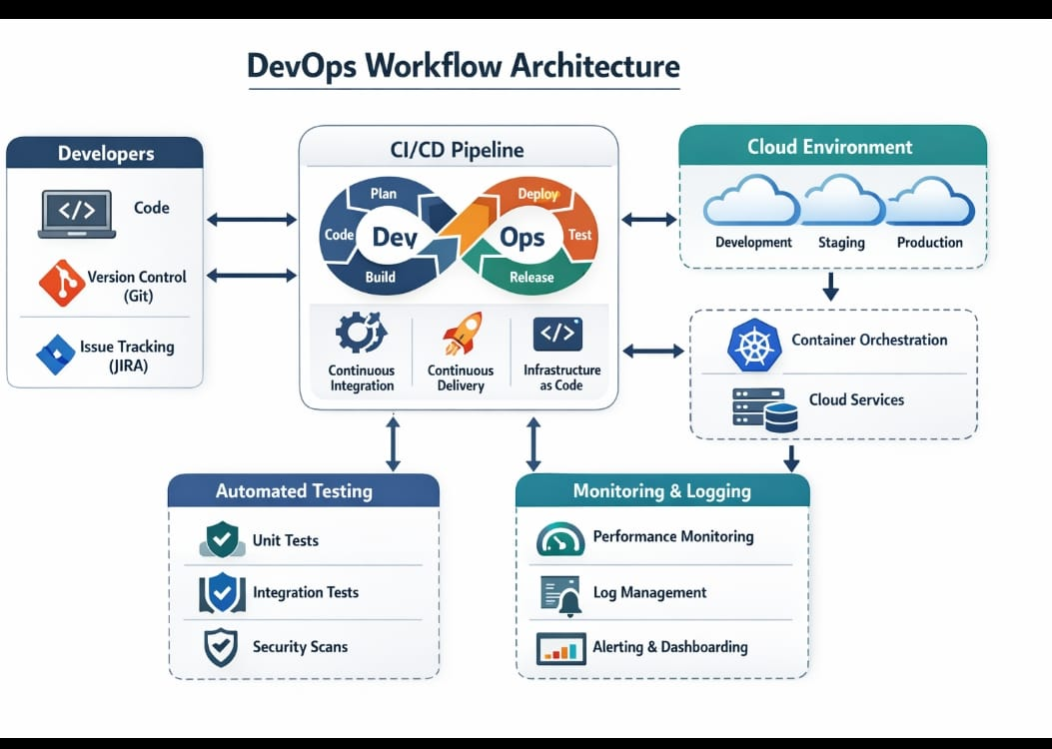
The presentation layer is implemented using React.js and is responsible for handling user interactions, rendering the user interface, and managing client-side state. It provides a dynamic and responsive experience, allowing users to perform actions such as logging in, browsing courses, enrolling in courses, and attempting quizzes.
The application layer is developed using Node.js and Express.js, which acts as the core processing unit of the system. It handles API requests from the frontend, performs business logic operations, manages authentication and authorization, and ensures proper communication between the frontend and the database.
The data layer is implemented using MongoDB with Mongoose ODM, which stores and manages all application data including users, courses, enrollments, quizzes, and progress records. It ensures efficient data retrieval, storage, and integrity through schema design and indexing.
The overall workflow of the system begins when a user interacts with the frontend interface. The frontend sends requests to the backend through RESTful APIs. The backend processes these requests, performs necessary validations, and interacts with the database to fetch or

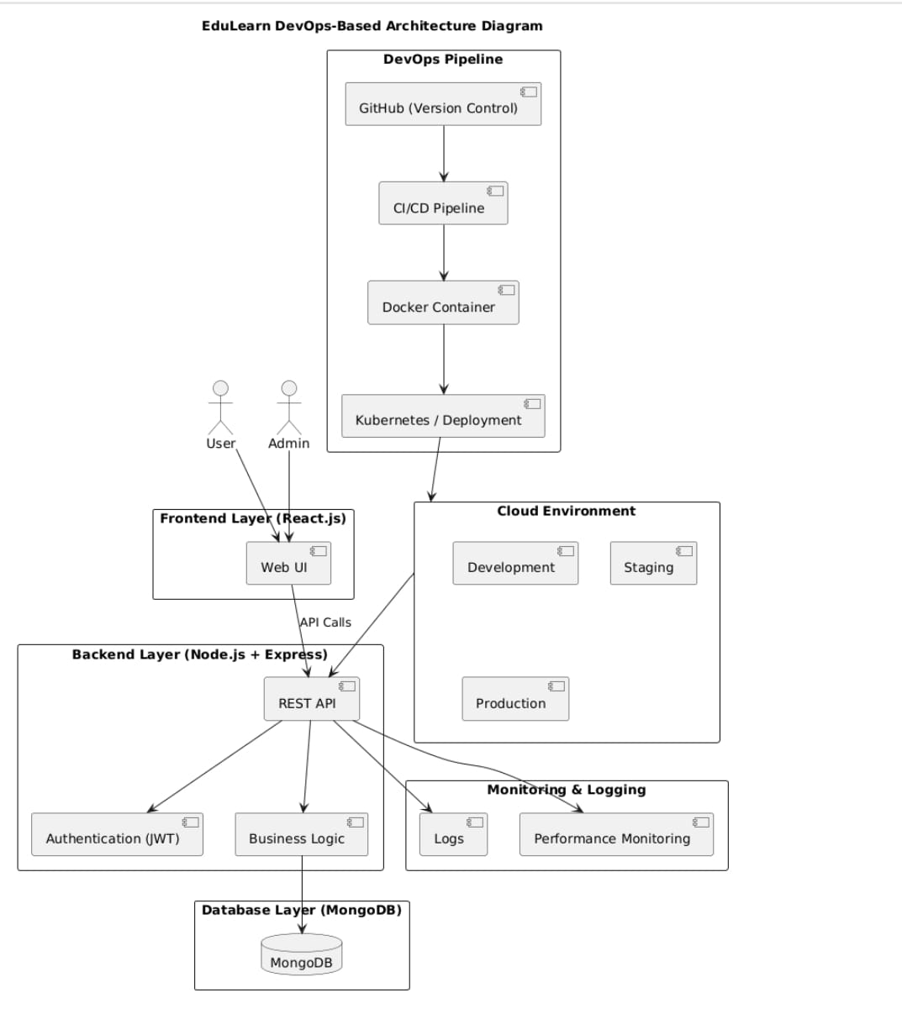
Key workflow steps include:
- User performs an action through the frontend interface
- Request is sent to the backend API
- Backend validates the request and processes business logic
- Database is queried or updated accordingly
- Response is sent back to the frontend
- Frontend updates the UI based on the response

This architecture ensures modularity, maintainability, and scalability, allowing the system to handle increasing user load and support future enhancements efficiently.

2.3 Tools & Technologies Used
The EduLearn Platform is developed using a modern full-stack technology stack, carefully selected to ensure scalability, performance, maintainability, and efficient development. Each technology plays a specific role in building different layers of the system.

React.js (Frontend Library)
React.js is used to build the user interface of the application. It follows a component-based architecture, which allows the UI to be divided into reusable and independent components. This improves code maintainability and scalability. React also provides efficient rendering

through its virtual DOM, ensuring fast updates and a smooth user experience. It is used to implement features such as dashboards, course views, and interactive forms.

Tailwind CSS (Styling Framework)
Tailwind CSS is a utility-first CSS framework used to design the user interface. It enables rapid UI development by providing pre-defined classes for styling elements such as layout, spacing, colors, and typography. This ensures consistency in design and supports a mobile-first approach, making the application responsive across different devices.

Vite (Build Tool)
Vite is used as the frontend build tool to improve development speed and performance. It provides fast server startup and hot module replacement, allowing developers to see changes instantly during development. It also optimizes the final build for production, ensuring better performance and smaller bundle sizes.

Node.js (Runtime Environment)
Node.js is used as the runtime environment for executing backend JavaScript code. It enables server-side development using JavaScript and supports asynchronous programming, which allows the system to handle multiple requests efficiently. This makes it suitable for building scalable and high-performance applications.

Express.js (Backend Framework)
Express.js is used to build the backend server and handle API requests. It provides a lightweight and flexible framework for creating RESTful APIs, routing requests, and managing

middleware. It is responsible for processing user requests, implementing business logic, and handling communication between the frontend and database.

MongoDB (Database)
MongoDB is a NoSQL database used for storing application data. It stores data in a flexible, document-based format (JSON-like), which allows easy handling of dynamic and unstructured data. It is well-suited for applications that require scalability and fast data access, such as managing users, courses, quizzes, and progress records.

Mongoose (ODM - Object Data Modeling)
Mongoose is used as an Object Data Modeling (ODM) library for MongoDB. It provides a structured way to define schemas, enforce validation rules, and interact with the database. It

simplifies database operations such as creating, reading, updating, and deleting data, while ensuring consistency and data integrity.

JSON Web Tokens (JWT) (Authentication)
JWT is used for implementing secure and stateless authentication. When a user logs in, a token is generated and sent to the client. This token is included in subsequent requests to verify user identity. JWT eliminates the need for server-side session storage, making the system more scalable and efficient.

bcrypt (Password Security)
bcrypt is used for securely hashing user passwords before storing them in the database. It adds a layer of security by converting plain text passwords into encrypted hashes, preventing unauthorized access even if the database is compromised. It also uses salting to enhance security further.

Git and GitHub (Version Control)
Git is used for version control to track changes in the codebase, while GitHub is used as a remote repository for storing and managing the project. These tools enable collaboration among team members, maintain code history, and support efficient project management.

Visual Studio Code (Development Environment)
Visual Studio Code is used as the primary code editor for development. It provides features such as syntax highlighting, debugging tools, extensions, and integrated terminal support, which improve developer productivity and ease of coding.

Postman (API Testing Tool)
Postman is used for testing and debugging backend APIs. It allows developers to send HTTP requests, inspect responses, and verify the correctness of API endpoints. This ensures that the backend services function properly before integration with the frontend.

Docker ( Deployment Tool)
Docker can be used for containerizing the application, ensuring consistency across development and production environments. It packages the application along with its dependencies, making deployment easier and more reliable.

3. Results & Output
3.1 Outputs
The EduLearn Platform has been successfully implemented with multiple functional modules that demonstrate the working of the system. The following screenshots represent key interfaces of the application and highlight user interaction across different components.
The login and registration interface provides secure access to the system, allowing users to create accounts and authenticate using valid credentials. This module ensures proper validation and secure handling of user data.
The user dashboard displays an overview of enrolled courses, progress status, and quick access to different features of the platform. It acts as the central interface for user interaction and navigation.
The course listing page allows users to browse available courses with relevant details, while the course detail page provides structured content such as modules, notes, and learning materials. These interfaces ensure a clear and organized learning experience.
The quiz interface enables users to attempt assessments, submit answers, and receive instant evaluation. It demonstrates the system’s ability to handle real-time interaction and automated result generation.
The progress tracking dashboard visually represents user performance, including course completion percentage and quiz scores. This helps users monitor their learning progress effectively.
The admin panel provides functionalities for managing users, courses, and content. It demonstrates the system’s administrative capabilities and centralized control over platform operations.
Key screenshots included:
- Login and Registration Page
- User Dashboard
- Course Listing and Course Detail Page
- Quiz Interface and Result Output
- Progress Tracking Dashboard
- Admin Panel
These outputs confirm that the system is functional, user-friendly, and capable of handling the core requirements of an online learning platform.

3.2 Reports and Dashboards
The EduLearn Platform incorporates reporting and dashboard mechanisms to transform system data into meaningful insights, thereby enhancing user experience and supporting informed decision-making. These components are designed to provide clear visibility into user performance, course engagement, and overall system activity.
The user dashboard acts as the primary interface for accessing personalized information. It displays details such as enrolled courses, progress status, and recent activities, enabling users to easily track their learning journey. The dashboard is designed to provide a structured and intuitive overview, ensuring that users can quickly access relevant information without complexity.
The progress tracking dashboard provides a detailed representation of user performance through measurable indicators such as course completion percentage, quiz scores, and activity status. This allows users to evaluate their learning progress in real time and identify areas that require improvement. By presenting data in a clear and organized manner, the system encourages continuous learning and self-assessment.
The quiz result model plays a significant role in performance evaluation by displaying scores, correct and incorrect responses, and overall performance metrics after each assessment. This immediate feedback mechanism helps users understand their level of understanding and reinforces learning outcomes.
From an administrative perspective, the system supports monitoring and reporting functionalities that provide insights into user activity, course engagement, and system usage patterns. Administrators can track the number of active users, course enrollments, and overall platform performance, which helps in managing resources and improving content delivery.
The system is designed with extensibility in mind, allowing future integration of advanced reporting features such as graphical data visualization, trend analysis, and detailed performance reports. Tools such as charts and analytics dashboards can be incorporated to provide deeper insights into user behavior and learning effectiveness.
Key outputs included:
- User dashboard displaying enrolled courses and activity summary
- Progress dashboard showing completion percentage and performance metrics
- Quiz result output with evaluation details and scoring
- Administrative view for monitoring users, courses, and engagement data
Overall, these reporting and dashboard components enhance the usability of the platform by converting raw data into actionable insights, thereby improving both learning efficiency for users and management effectiveness for administrators

3.3 Key Outcomes
The development of the EduLearn Platform resulted in the successful implementation of a comprehensive and scalable web-based learning system that effectively integrates course management, assessment, and progress tracking. The project demonstrates the practical

application of modern web technologies and system design principles to solve real-world problems in the domain of online education.
The platform successfully provides a structured and user-friendly environment for students to access learning materials, enroll in courses, and evaluate their performance through interactive quizzes. The integration of these features ensures a seamless learning experience and improves user engagement.
The implementation of secure authentication and role-based access control ensures that user data is protected and system functionalities are accessed appropriately. This enhances both security and system reliability.
The project also achieves efficient data management through the use of MongoDB and Mongoose, enabling flexible storage and retrieval of data related to users, courses, quizzes, and progress. The modular system architecture ensures maintainability and scalability, allowing the platform to handle increasing user load and future enhancements.
From a functional perspective, the system successfully demonstrates:
- Integration of frontend and backend using RESTful APIs
- Automated quiz evaluation and instant result generation
- Real-time progress tracking and performance monitoring
- Administrative control for managing users and course content
In addition to technical outcomes, the project contributed significantly to the development of practical skills such as full-stack development, API design, database modeling, and system architecture design. It also enhanced problem-solving abilities and understanding of real-world application development.
Overall, the project achieved its intended objectives by delivering a reliable, efficient, and user-centric learning platform, while also providing valuable technical and practical learning outcomes.

4. Conclusion
The EduLearn Platform successfully demonstrates the design and development of a comprehensive, scalable, and user-centric web-based learning system that integrates course management, assessment, and progress tracking into a single unified platform. The project effectively addresses the key limitations of traditional e-learning systems by providing a structured, interactive, and efficient learning environment that enhances both user experience and administrative efficiency.
The implementation of the MERN stack enabled the development of a dynamic and responsive frontend, robust backend services, and flexible data management through a NoSQL database. The system ensures secure authentication using JWT, efficient handling of user requests through RESTful APIs, and real-time interaction between different components of the application. The modular architecture adopted in the project ensures maintainability, scalability, and ease of future enhancements.
The platform successfully delivers core functionalities such as course browsing and enrollment, structured content delivery, interactive quiz evaluation, and real-time progress tracking. These features work together to provide a seamless and engaging learning experience for users, while the administrative panel ensures effective management of users, courses, and system data.
From a technical perspective, the project demonstrates strong integration of frontend and backend technologies, efficient database design, and proper implementation of security and performance considerations. It highlights the importance of designing systems that are not only functional but also scalable, secure, and user-friendly.
In addition to technical outcomes, the project significantly contributed to the development of practical skills such as full-stack development, API design, database modeling, and system architecture planning. It also enhanced problem-solving abilities, critical thinking, and the understanding of real-world software development practices.
Overall, the EduLearn Platform achieves its intended objectives by delivering a reliable and efficient solution for online learning while providing valuable hands-on experience in modern web development. The project serves as a strong foundation for future enhancements and demonstrates the effective application of theoretical concepts in a practical environment.

5. Future Scope & Enhancements
The EduLearn Platform is designed with scalability and flexibility, allowing it to be enhanced with additional features and improved capabilities in the future. While the current system successfully delivers core functionalities such as course management, quizzes, and progress tracking, there is significant scope for further development.
One potential enhancement is the integration of personalized recommendation systems using machine learning, which can suggest relevant courses based on user preferences, learning history, and performance. This would improve user engagement and provide a more customized learning experience.
The platform can also be extended by developing a mobile application, enabling users to access learning resources anytime and anywhere. This would increase accessibility and improve overall user convenience.
Another area of improvement is the addition of real-time features such as notifications, messaging systems, and discussion forums. These features would promote better communication and collaborative learning among users.
The reporting and analytics module can be enhanced by incorporating advanced data visualization techniques such as charts and graphs, providing deeper insights into user performance and system usage.
From a technical perspective, adopting cloud-based deployment and microservices architecture can improve system scalability, reliability, and performance. Security can also be strengthened by implementing advanced mechanisms such as multi-factor authentication and enhanced data protection techniques.
Overall, these enhancements will make the EduLearn Platform more advanced, efficient, and aligned with modern e-learning standards, while providing a better learning experience and supporting future growth.

