Estate Agents 4

Query 1 –

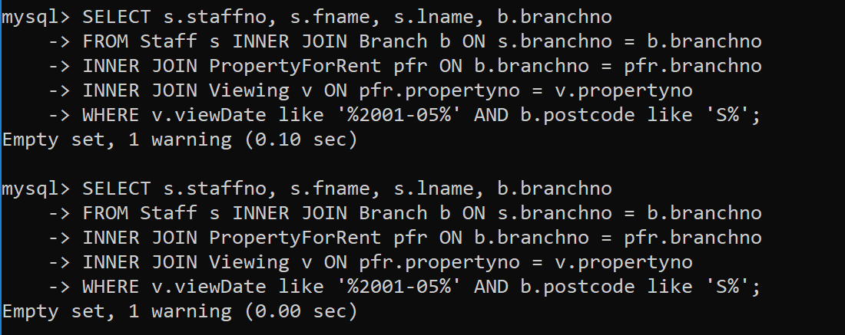

Query 2 –

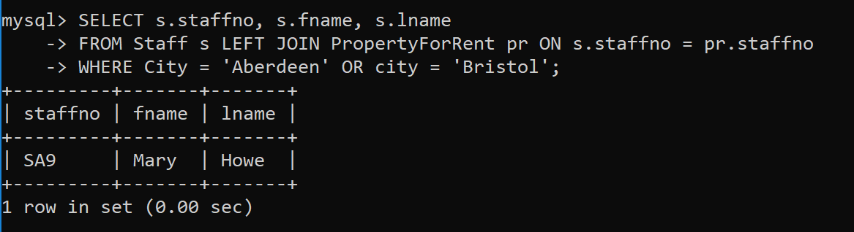

Query 3 –

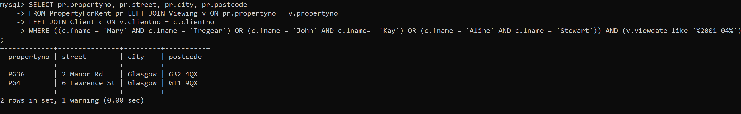

Query 4 –

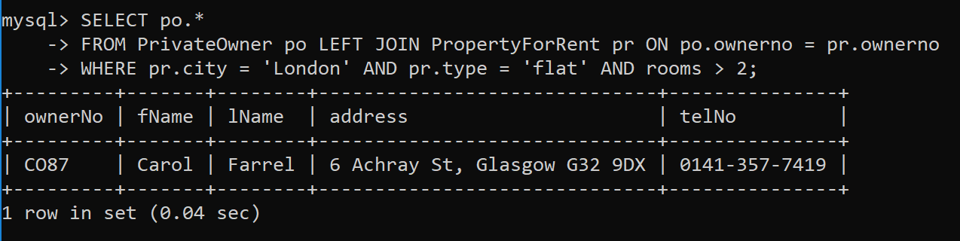

Query 5 –

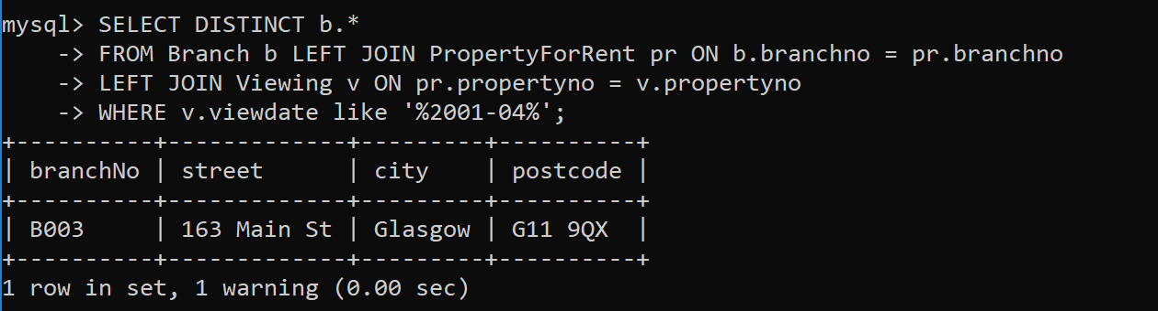

Query 6 –

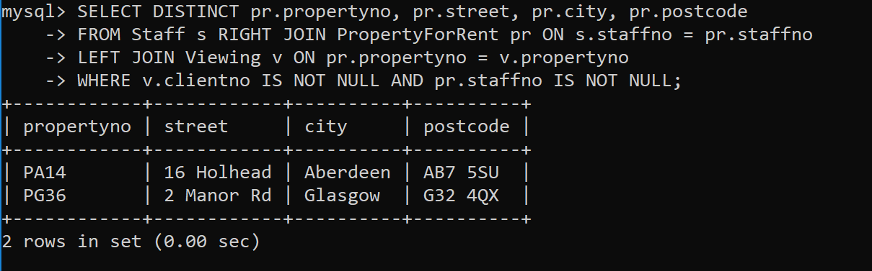

Query 7 –

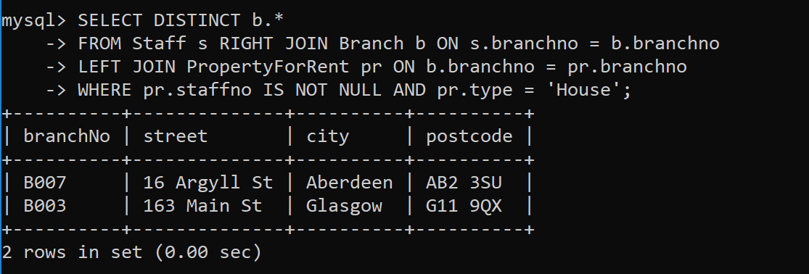

Query 8 –

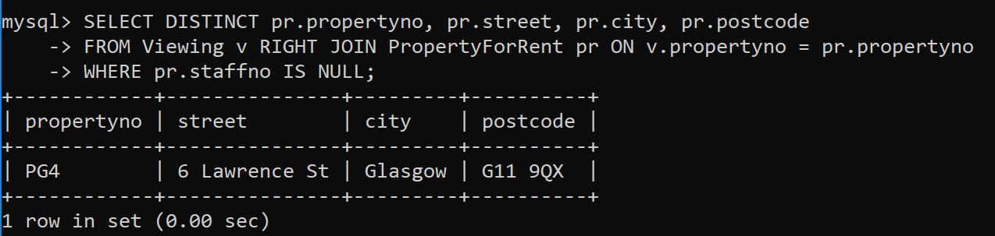

Query 9 –

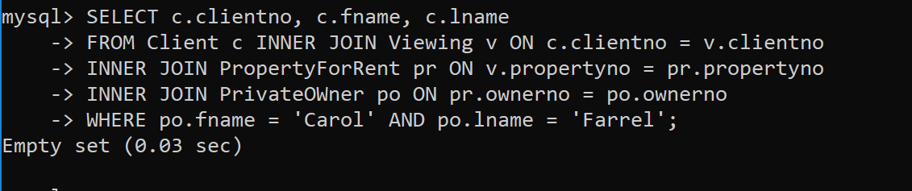

Query 10 –

