Lee O’Sullivan – 2992902 – Relational Databases

Midterm Assignment

Part 1 –

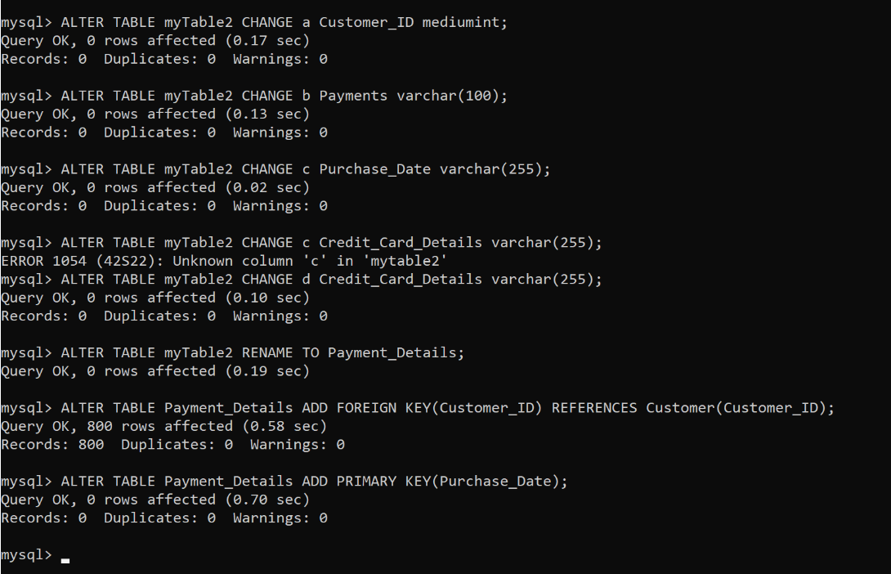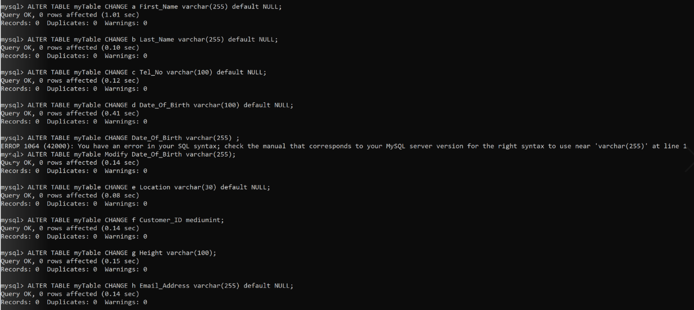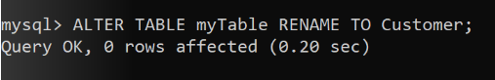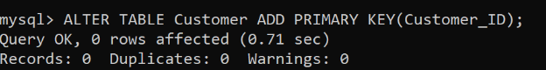

Part 2 -

1. ‘e’ could represent Longitute and Latitude values, as none of the first value are below -90 or greater than 90 and none of the second values are under -180 or above 180, thus the column should be named with something appropriate to longitude and latitude values such as Location.

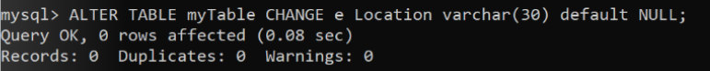

1. In myTable(Renamed to Customer) there is 100 rows

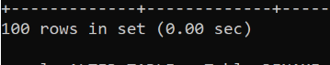

In myTable2(Renamed to Payment_Details) there is 800 Rows



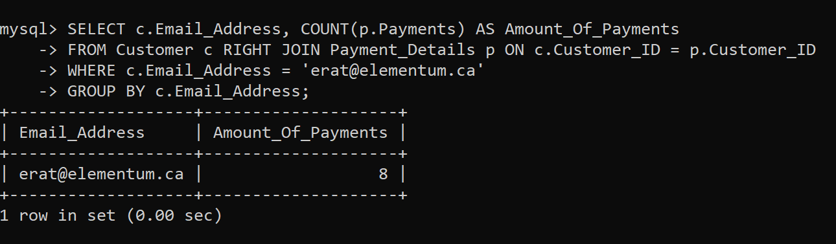

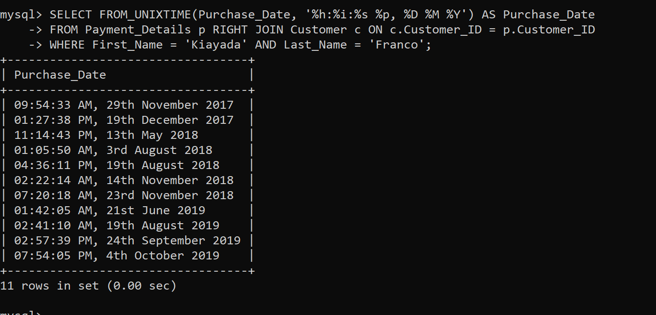

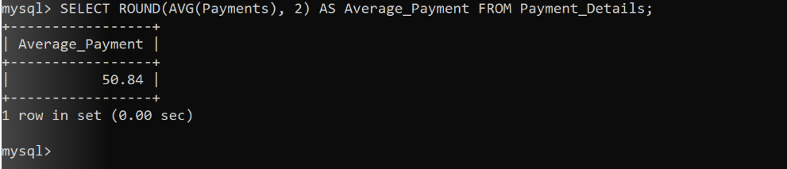

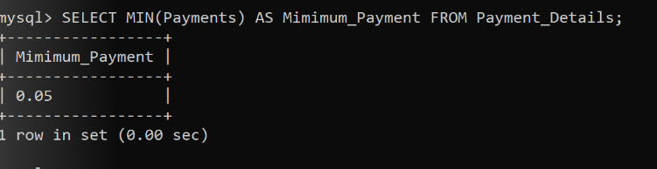

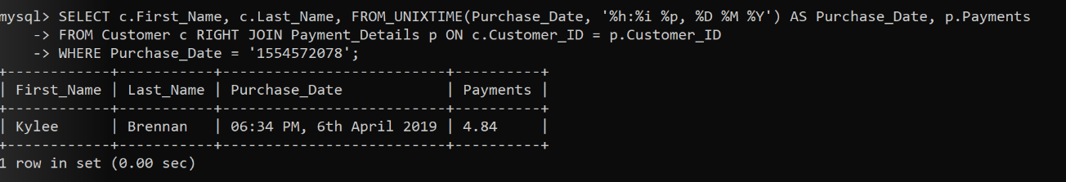

8.

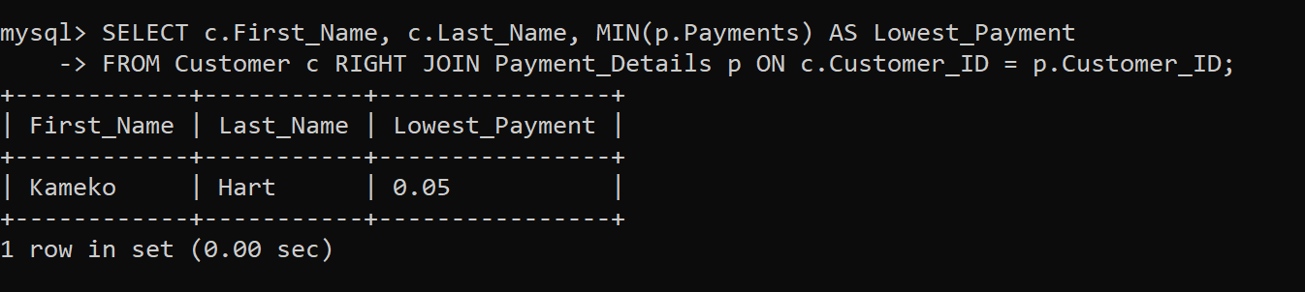

^ This sql query provided the wrong results, no matter what join I used, unless I used a WHERE clause.

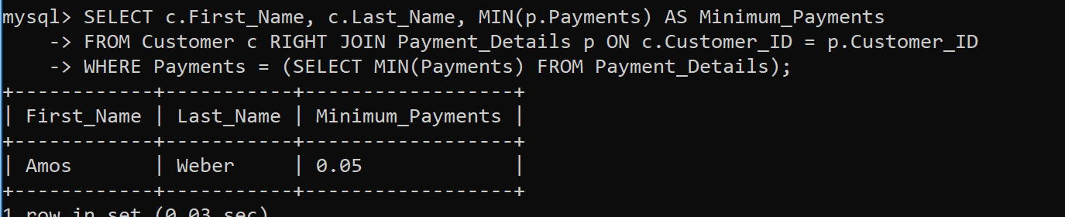

9. Every Customer has made at least one payment.

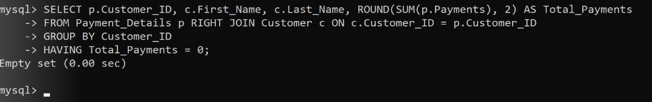

10.

