Assignment 2- Griffith College Cork

- Find how many staff hold each Job Position.
SELECT position, COUNT(position) FROM Staff
-> GROUP BY Position;
+------------+-----------------+
| position | COUNT(position) |
+------------+-----------------+
| Assistant | 3 |
| Manager | 2 |
| Supervisor | 1 |
+------------+-----------------+
3 rows in set (0.00 sec)

- Find how many Flats are available to rent in each City.
SELECT city, COUNT(type) FROM PropertyforRent
-> WHERE type = 'flat'
-> GROUP BY city;
+---------+-------------+
| city | COUNT(type) |
+---------+-------------+
| Glasgow | 3 |
| London | 1 |
+---------+-------------+
2 rows in set (0.00 sec)

- Find how many properties are assigned to each Branch.
SELECT branchNo, COUNT(propertyNo) FROM PropertyforRent
-> GROUP BY branchNo;
+----------+-------------------+
| branchNo | COUNT(propertyNo) |
+----------+-------------------+
| B003 | 4 |
| B005 | 1 |
| B007 | 1 |
+----------+-------------------+
3 rows in set (0.00 sec)

- For each city find those cities that have more than 2 properties to rent.
SELECT city, COUNT(city) FROM PropertyforRent
-> GROUP BY city
-> HAVING COUNT(city) >= 2;
+---------+-------------+
| city | COUNT(city) |
+---------+-------------+
| Glasgow | 4 |
+---------+-------------+
1 row in set (0.00 sec)

- For each branch , find the branch that has more than 1 Assistant working there.
SELECT branchNo, COUNT(position) FROM Staff
-> WHERE position = 'Assistant'
-> GROUP BY branchno
-> HAVING COUNT(position) > 1;
Empty set (0.00 sec)

Screenshot for Question 1 & 3
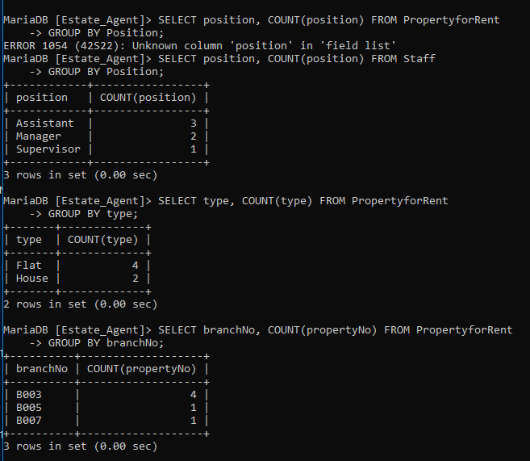

Screenshot for Question 4 & 5
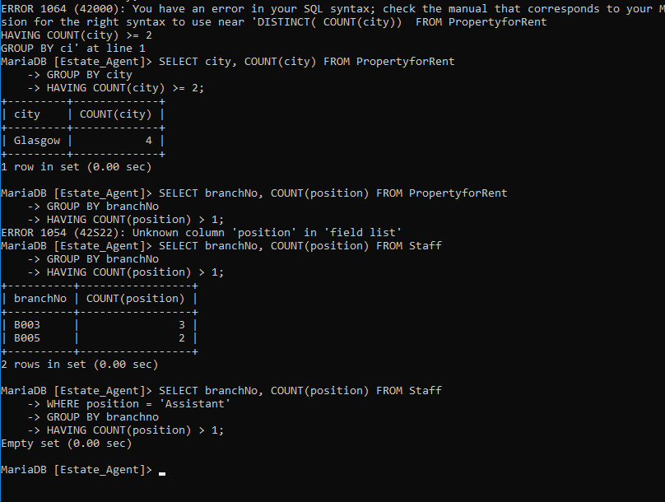

Screenshot for Question 2
