**Library System – UML Class Diagram**

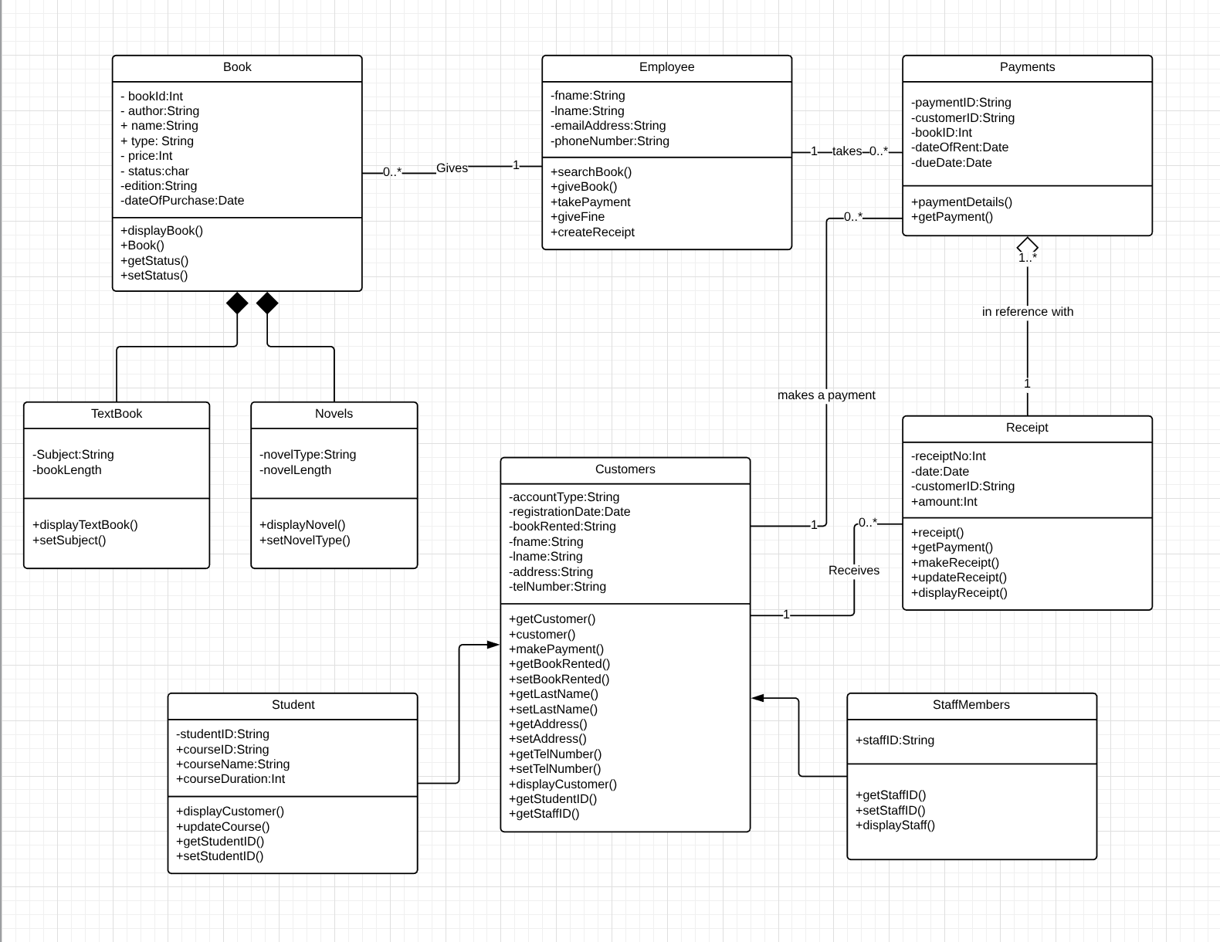

UML Class Diagram for a Library System with multiple classes such as Book, Employee, Payments, Receipt, Customers. The Student and StaffMembers classes are children of Customers class but these differ from the TextBook and Novel classes which are children of the Book class as a Student exists without being a customer of the library as does a StaffMembers. These students and staffmembers exist outside of the customer class whereas the novels and textbooks do not exist without the book class. The receipt class to payment class is an example of aggregation in which there isn’t parent-child relationship but the two classes are linked. Information hiding is seen with the use of private and public methods/variables. Association can be seen between the classes using lines which link classes to each other which also contain multiplicity.

**Inheritance –**

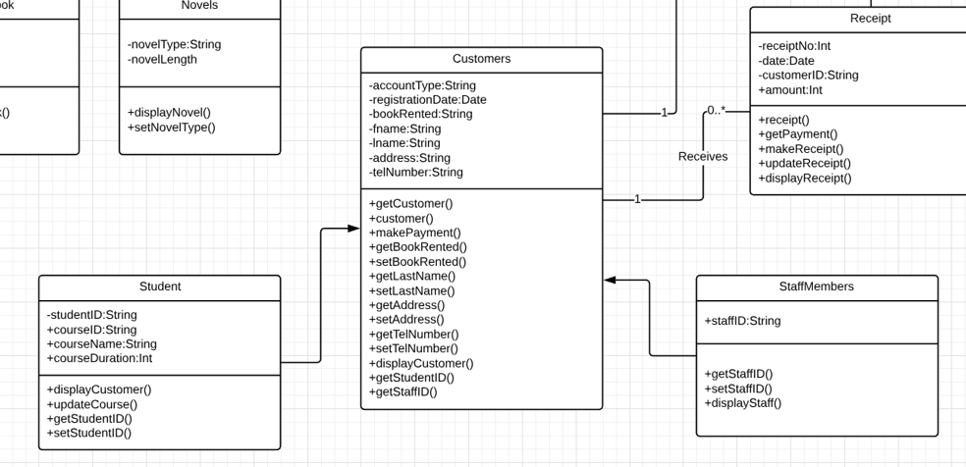

**Aggregation –**

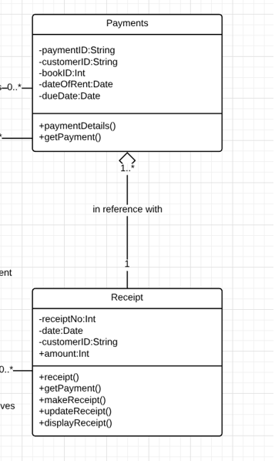

**Association –**

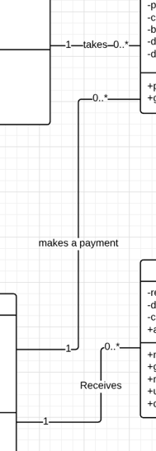

**Composition –**

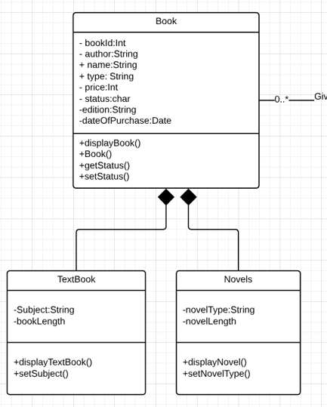

**Information Hiding –**

