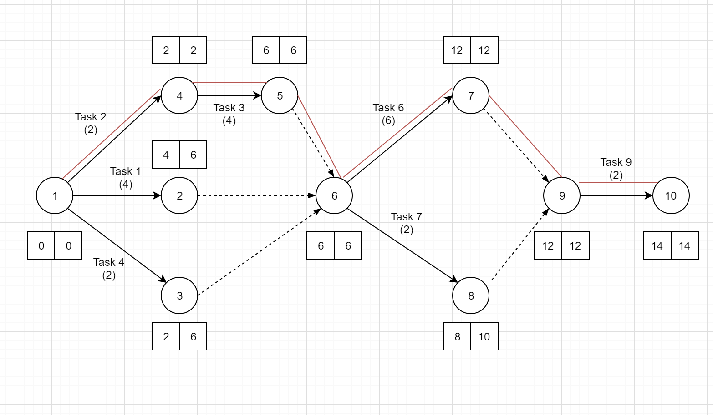

|  |  |
| --- | --- |
| Activity | Total Float |
| Task 1 | 6 – 0 – 4 = 2 |
| Task 2 | 2 – 0 – 2 = 0 |
| Task 3 | 6 – 2 – 4 = 0 |
| Task 4 | 6 – 0 – 2 = 4 |
| Deliverable A | 6 – 2 – 0 = 4 |
| Task 6 | 12 – 6 – 6 = 0 |
| Task 7 | 10 – 6 – 2 = 2 |
| Deliverable B | 12 – 8 – 0 = 4 |
| Task 9 | 14 – 12 – 2 = 0 |

|  |  |
| --- | --- |
| Activity | Free Float |
| Task 1 | 6 – 4 = 2 |
| Task 2 | 6 – 2 = 4 |
| Task 3 | 6 – 6 = 0 |
| Task 4 | 6 – 2 = 4 |
| Deliverable A | 8 – 6 = 2 |
| Task 6 | 12 – 12 = 0 |
| Task 7 | 12 – 10 = 2 |
| Deliverable B | 14 – 12 = 2 |
| Task 9 | Cannot calculate as there is no activity after task 9 thus no early start for the next activity can be gotten |

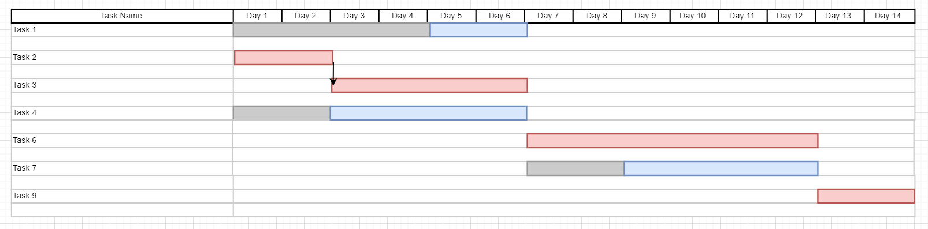

Red – Represents the Critical Path

Blue – Represents the Float Time