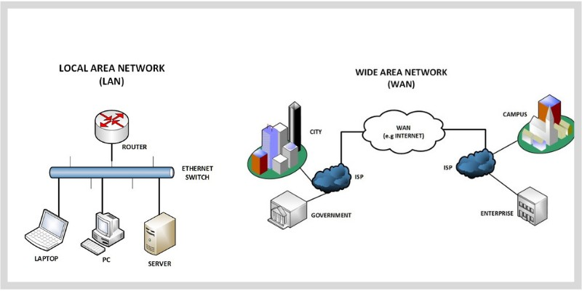**Local Area Network (LAN)**

### 

A **LAN** is a small network that connects devices **within a limited area**, like your **home, school, or office**.

### **In the Diagram (Left Side):**

* Devices like **laptop, PC, and server** are all connected to a **router and Ethernet switch**.
* These devices can **share files**, **printers**, or **internet** with each other quickly.

### **Example:**

In your school computer lab, all the computers are connected and can share the printer. That’s a **LAN**!

## **Wide Area Network (WAN)**

### 

A **WAN** is a network that connects devices over **large distances**, like **cities, states, or countries**.

### **In the Diagram (Right Side):**

* Cities, campuses, and offices are all connected to each other through the **internet (WAN)** using **ISPs (Internet Service Providers)**.
* This lets them **share data, emails, and resources** across long distances.

**Example:**

Your school in one city can connect and share data with the head office in another city using the **internet (WAN)**.