**Continuous Time and Communication in a Public-goods Experiment**

Gary Charness, Dan Friedman, and Ryan Oprea[1]*

December 11, 2011

**Abstract:** We investigate the effects of continuous time and communication on contributions in a public-goods experiment with a set of parameters that make cooperation difficult. We vary whether communication amongst the four people in a group is feasible, as well as whether decisions are made in continuous time during a 10-minute interval or only at 10 discrete points of time during this interval. The data show that continuous time leads to an increase in cooperation relative to a standard protocol and a very substantial increase when subjects are allowed to communicate in an unrestricted manner.

**Keywords:** public goods, voluntary contribution mechanism, continuous time games

**JEL codes:** C72, C92, D70, H41

Acknowledgments: We would like to thank Jordi Brandts, David Cooper, Martin Kocher, Matthias Sutter, Lise Vesterlund, James Walker, Rachel Croson, Martin Dufwenberg and participants at the EWEBE meeting in Munich in October, 2011 and North American ESA meeting in Tucson in November, 2011 for valuable comments.

1. **Introduction**

The provision of public goods is critical in every society, yet always problematic. Since by definition nobody can be excluded from enjoying public goods once they are provided, there is the incentive to free ride --- to simply allow others to provide the good (whether it is a park, volunteerism, clean air, public health services, or national defense) and make use of it without contributing to it.

Often governments provide public goods that otherwise might not be provided at all. Experimental economists have focused on the opposite case, where public goods provision relies entirely on voluntary contribution. In typical experimental games, voluntary contributions to the “group account” (the public good) are socially valuable, but not individually rational, given the assumption of pure self-interest. The typical result is that there is some intermediate level of contribution to the group account in the beginning, but dwindling over time to very little or nothing. Thus there is an initial impulse towards cooperation, but this is quashed, perhaps because one sees others not contributing and becomes annoyed. A typical interpretation is that many laboratory participants are conditional cooperators, who contribute as long as others do.

Our study speaks to the issue of how to coordinate groups. Our innovation is to combine communication with real-time (continuous) play. Experimentalists have traditionally compared strategic behavior in one-shot situations to situations repeated in discrete time. Only recently have they begun to consider strategic interaction in continuous time, although such interactions are quite common outside the lab. One example of this involves real-time team-production with monitoring, where all team members will get the benefits of joint production but choose to incur differential flow costs of effort. In fact, a large variety of group activities have this flavor. In the business domain, think of collusion in multi-lateral online markets, work on the factory floor, or telephone fund-raising drives. In the social realm, this is common to most team sports (continuous adjustments in football, sailing, rowing crew, tennis, etc.) and even Amish barn raisings.

The literature survey will note two recent continuous-time laboratory studies, one in which there was a great deal of cooperation in two-player groups with good opportunities for a form of communication, and another in which no cooperation was seen in 12-person groups with few communication opportunities. These findings raise two questions for public-goods games. Compared to the usual discrete-time strategic interactions, do outcomes change when contributions are made asynchronously, in continuous time? In groups of a common size in the public-goods game (four members), does communication encourage cooperation in continuous time?

Non-binding pre-play communication (cheap talk) has been shown to have strong effects in some experimental games and little effect in others; it seems that the technology matters. While our primary interest regarding the effectiveness of communication here involves an unrestricted message space, we also test whether a simpler form of communication, limited to a small number of pre-programmed messages, is effective in enhancing the contribution rate. The results of a number of previous experiments have suggested that only certain forms of communication are effective in improving pro-social behavior when there is a unique equilibrium that is socially unattractive.

Our results are instructive. Free-form communication is extremely effective in achieving a high rate of contribution when participants make decisions in continuous time, but is only somewhat effective with discrete time. However, we find that making decisions in continuous time is not enough by itself to achieve much in the way of higher contributions, although the rates with continuous choice are higher in every case than with discrete choice. Pre-programmed messages lead to results that are not significantly different than the no-communication environment.

We choose a version of the game in which there is only a small social benefit from contributing, so it is a very difficult environment in which to achieve a high level of cooperation. For example, in the same game in the seminal study by Isaac and Walker (1988), the contribution rate begins at around 35 percent and decreases to about 5 percent by the last three periods of 10 (see their Figure 2). In our comparable treatment without communication, our overall contribution rate was under 17 percent, in the middle of this range. In this case, the median contribution was tiny; by comparison, the median contribution in the continuous treatment with free-form communication is a full 100%. Finally, as we had conjectured, limited communication is much less effective than full communication and, in fact, does not significantly induce more contributions than when no communication at all is feasible.

In our continuous time sessions, players can freely change allocations and the resulting flow payoffs. Other players’ behavior can be seen instantly, and each player can react right away at low cost --- the payoff impact of a temporary move lasting one second, for example, is only 1/600 of the total aggregated payoff, compared to 1/10 for each period in discrete time. So why does continuous time encourage much greater public-good provision only when there is full communication?

The answer appears to be that full communication makes promises, cajoling, and brow-beating more credible. It is true that communication helps even in discrete time, but the benefit is considerably smaller: the contribution rate in this case is a bit less than 48 percent, with a median contribution of 43 percent. While people can still make promises and other relevant comments, the mechanism of social enforcement is considerably weaker, perhaps due to the lack of immediacy in response.

Permitting instant changes in behavior and allowing full communication thus seems to strongly ameliorate the free-riding problem in the public-goods game. The greatest impact comes from combining these two forces. Thus, we suspect that, given the right tools, a high level of cooperation is usually sustainable at least in small groups. Being able to make credible promises and to admonish in real time leads to very good social outcomes, even when are presumably a substantial number of subjects who are neither pure cooperators nor conditional cooperators. This comes with no efficiency loss from costly punishment and does not involve intervention by an exogenous agency or strong informational requirements.

In the mixed treatments --- communication in discrete time, and no communication in continuous time --- we see considerable variability both across cohorts and over time. Using a new measure of time variability, we find that communication destabilizes contributions in discrete time but stabilizes contributions in continuous time. That finding helps to explain the differences in behavioral equilibration across treatments.

The remainder of the paper is structured as follows. We provide a review of the related literature in Section 2, and describe the experimental procedures and implementation in Section 3. The results are presented in Section 4, and we offer some discussion in Section 5. Section 6 concludes. Appendices collect instructions to subjects and supplementary data analysis.

1. **Related Literature**

Three decades of laboratory experiments have identified several distinct devices that enhance contribution rates in public-goods games. One mechanism is to permit individuals to engage in costly punishment of other individuals in the group. To the best of our knowledge, Yamagishi (1986, 1988) and Ostrom, Walker, and Gardner (1992) were the first to consider the role of punishments in sustaining cooperation in social dilemmas. More recently, the well-known study by Fehr and Gächter (2000) examines the efficacy of costly punishments; this study has been widely replicated. People play two sets of 10 rounds; the first set is a standard linear public goods game, while in the second set players, having seen the contributions of others can punish other people in the group.[2] The average contribution to the public good is 19% without punishment and 58% with punishment. The extent to which an individual contributes less than the group average is highly correlated with the amount of punishment received.

Gürerk, Irlenbusch, and Rockenbach (2006) investigate what happens when people can voluntarily choose an institution with feasible punishment or one without it. People play a linear public-goods game and people in a “sanctioning” environment can punish (or reward) other individuals in the group. In the first of 30 periods (with random re-matching), the “sanction-free” environment is chosen 63% of the time; however, the sanctioning institution becomes the norm, being chosen by nearly everyone. The overall contribution rate averages 91% with feasible punishment, and increases over time. In contrast, contributions in the no-punishment case decrease to almost nothing.

And yet, there can be a downside to punishment. If there is a consensus to contribute at a high rate, there will be little or no punishment, and we would observe a high degree of efficiency. However, in practice (the nice Gürerk, Irlenbusch, and Rockenbach, 2006 institutional-choice design aside, as it may not always be feasible to implement) in there is typically some segment of the population that tries to free-ride, so that punishment erodes efficiency. Nikiforakis and Normann (2008) find that the more cost-effective it is to punish, the more people contribute. Whether there is an efficiency gain or loss is dependent on the specific experimental parameters chosen. Punishment only leads to higher efficiency (profits) in one of the four experimental treatments, the one where it is most cost-effective.[3]

Another approach involves forming groups of cooperators and conditional cooperators either endogenously or exogenously. A third mechanism is to permit communication between the members of the group, in order to enhance pro-social behavior. All of these mechanisms have some degree of effectiveness, yet none of them is completely satisfactory. Chaudhuri (2011) provides an excellent survey on developments in laboratory public-goods experiments since the early Ledyard (1995) survey on this topic.[4]

Some devices restrict group membership to those who demonstrate a willingness to cooperate. The premise is that many people are conditional cooperators, who like to improve social welfare but dislike cooperating when they see that others are not; for a review and a discussion of policy implications, see Gächter (2007). Excluding non-cooperators, then, can enable conditional cooperators to sustain a high contribution rate; see Sonnemans, Schram, and Offerman (1999), Keser and van Winden (2000), Fischbacher, Gächter, and Fehr (2001), Brandts and Schram (2001), and Fischbacher and Gächter (2009, 2010).

In other studies the experimenter forms non-random subgroups from the population. For instance, Gunnthorsdöttir, Houser, McCabe, (2007) sort people into high, medium and low contributing groups of fixed-size of four, while Croson, Fatás, and Neugebauer (2006) exclude the lowest contributor from receiving the group’s payoffs; both treatments considerably enhance contribution rates in the public-goods game. Ehrhart and Keser (1999) and especially Cinyabuguma, Page, and Putterman (2005) find that groups that can expel individuals achieve higher contribution levels. See also Charness and Yang (2008), Page, Putterman, and Unel (2005), and Ahn, Isaac, and Salmon (2009).

Another sort of device involves communication.  Studies such as Cooper, DeJong, Forsythe, and Ross (1989, 1992) and Charness (2000) show that access to even simple and pre-fabricated pre-play messages (cheap talk) suffices to select among a multiplicity of equilibria, in the direction of payoff dominance. On the other hand, such weak forms of communication seem insufficient to shift play away from a unique equilibrium in dominant strategies (in terms of material payoffs) that is socially inefficient (Charness, 2000). In these environments it may be the case that messages must either somehow be more meaningful and/or more personalized; see Charness and Dufwenberg (2006, 2010). The issue of how different forms of messages affect behavior is far from settled.

In terms of why a sense of group membership might affect behavior in our experimental environment,[5] it could be argued that this makes it more costly to violate promises or agreements. One may well feel worse when one has acted selfishly towards group members or close friends or kin than when the victim is a stranger (or even an adversary). For example, there may be some sense of guilt or shame.[6] If one expects one’s fellow group members to behave in a more pro-social (or more pro-group) manner, then there would be a correspondingly higher sense of guilt from disappointing these expectations. There may well be other emotions that come into play and the level of tolerance may vary across continuous and discrete time.

To the best of our knowledge, the first paper to employ continuous time with public goods is Dorsey (1992) who allows subjects to make cheap talk decisions throughout the period and pays subjects based only on their final decisions. This generates a dramatically different strategic environment from our continuous flow-payoff setting. Results in Dorsey’s institution are mixed – while real-time adjustments are beneficial with provision points, these are largely ineffective in the standard linear set-up. More recently, Friedman and Oprea (2011) explore a two-person social dilemma and find remarkably high rates of mutual cooperation in continuous time, ranging from 81 percent to 93 depending on the parameters. Control sessions with repeated matching over 8 sub-periods achieve less than half as much cooperation, and cooperation rates approach zero in one-shot control sessions. On the other hand, Oprea, Henwood and Friedman (2011) find no tendency for continuous time to encourage cooperation in 12 member groups playing a multilateral Hawk-Dove game.

1. **Experimental Design and Implementation**

We conducted the experiment at the University of California, Santa Cruz. Participants in all sessions were randomly selected (using online recruiting software) from our pool of volunteers, which included undergraduates from all major disciplines. None of them had previously participated in a public-goods game experiment. On arrival, subjects received written instructions (Appendix I) that also were read aloud.

In all treatments, participants played the same public-goods game. Each person received an endowment of 25 tokens and could allocate these between their private account and the group account. Every token retained in the private account was worth one point to that player. Each token put into the group account became worth 1.2 points shared equally across all four people in the group, so the marginal per capita return (MPCR) is 0.3. Relative to no contribution, the societal gain from full contribution is only 20%, while the private risk is substantial --- absent reciprocation, one loses 70% of any contribution. These parameters are the least conducive to cooperation of any we saw in the published empirical literature and were selected to create a challenging environment for cooperation.

The experiment used a software package called ConG, for Continuous Games. Figure 1 shows the user interface. Each participant can adjust her strategy using the slider (seen as a small open rectangle) at the bottom. A position all the way to the left indicates zero contribution; a position all the way to the right indicates full (25) contribution. Contributions of other participants are shown according to an assigned color, and colored bubbles float above strategies to show current payoff rates.

In our continuous time treatments, strategies can be moved at any time and as frequently as desired – the computer response time is less than 100 milliseconds, giving the experience of continuous action. In the chat treatments a second window showing the history of conversation (with participants shown by color) floats next to the screen.

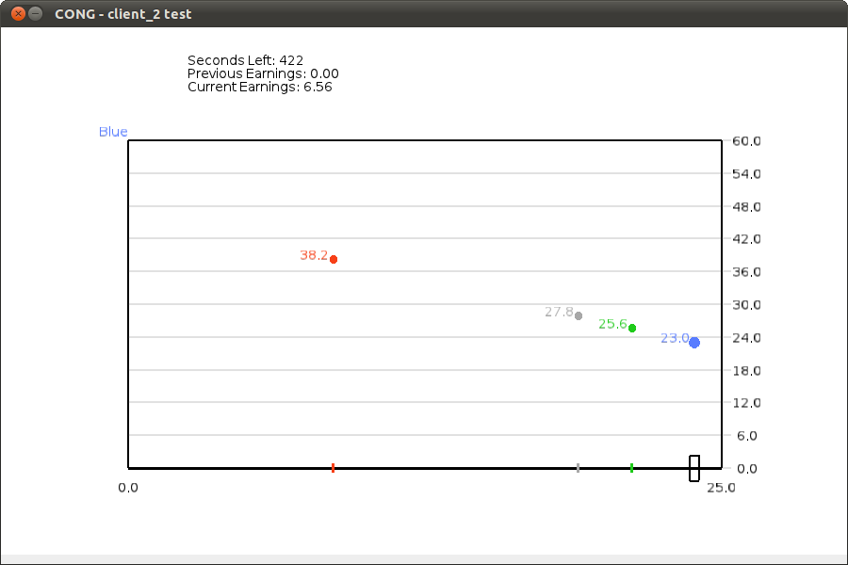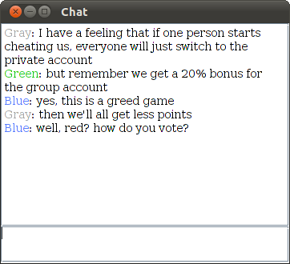

**Figure 1: Player screen and chat box.** The player screen approximates that of player Blue midway through session CC4, and the chat box contents are excerpted from that session.

We study two time treatments, Continuous and Discrete. In each case, the total decision-making time (including communication where applicable) was 10 minutes. In Continuous time subjects could freely change allocations at any time and continuously earned flow payoffs according to the parameterized public goods function described earlier. Allocations of the other three group members were color-coded, and could be seen with an imperceptible lag of less than 100 milliseconds. In Discrete time subjects made their allocation choices during 10 one-minute sub-periods during which they could not see others’ choices. At the end of each minute, the computer took a snapshot of choices and these applied to the entire sub-period. (People were made aware that decisions at the end of the sub-period were the only ones with payoff relevance.) Participants were then shown the sub-period allocations and received 60 seconds of the corresponding flow payouts (i.e. 1/10 of the nominal amount).

Our other treatment variable was the communication protocol. The baseline was No Communication. In Full Communication alternative treatments, the four group members shared a chat room in a separate window. Entries were color-coded (to allow subjects to correlate messages to actions) and unrestricted, although participants were asked to avoid using inappropriate language. We also ran a diagnostic treatment with Limited Communication in which group members again shared a chat window, but could only click buttons, not type out messages. The button menu included only the colors of all other players, “go left”, “go right”, “stay still” and “ok”. There were no limits on the frequency of communication.

The treatments are summarized below. We had 20 participants in four of the treatments and 24 in the other two, for a total of 128 people. Average earnings for a 30–minute session were $14.00, including a $5 show-up fee.

**Table 1: Treatments**

|  |  |  |  |
| --- | --- | --- | --- |
|  | No Communication | Limited Communication | Full Communication |
| Discrete | **DN**: 5 groups | DL: 6 groups | **DC**: 6 groups |
| Continuous | **CN**: 5 groups | CL: 5 groups | **CC**: 5 groups |

1. **Experimental results**

We first focus on the four main treatments, shown in bold font in Table 1. The intermediate treatments involving Limited communication will be discussed later in section 4.3. Session-level data for all treatments can be found in Appendix II.

**4.1 Main Treatment Effects**

Table 2 gives summary statistics for the median and mean contributions in both discrete and continuous time treatments for either no communication or full communication. We see that contributions are higher in the continuous-time treatment than in the corresponding discrete-time treatment in all of the main treatments, by any of three measures. Also, within each time treatment, contributions are higher with full communication than with no communication.

**Table 2: Summary statistics on contributions**

|  |  |  |  |  |
| --- | --- | --- | --- | --- |
| Treatment | DN | DC | CN | CC |
| Median Contribution | 0.71 | 10.75 | 3.89 | 25.00 |
| Mean Contribution | 4.21 | 11.94 | 7.35 | 18.87 |
| Standard Deviation | 6.28 | 9.70 | 8.61 | 10.01 |
| Rate of Maximum Contribution | 0.02 | 0.24 | 0.10 | 0.67 |

The most dramatic contrast in Table 2 is between the extremes, DN (Discrete, No communication) and CC (Continuous, Communication). Players in DN contribute all 25 tokens only two percent of the time, compared to 67 percent of the time in CC. The median contribution in DN is three percent while it is 100 percent in CC.

These statistics collapse behavior over time and across players and groups. Panel (a) of Figure 2 disaggregates by individual player and decision, and shows the cumulative distribution of contributions in each main treatment. The red line shows that behavior is bimodal in CC, with about 15% of decisions being to contribute nothing and nearly 70% to contribute all 25 tokens. The mode at full contribution is considerably smaller in the other treatments, while the mode at 0 contribution is somewhat larger in the No Communication treatments. Thus the majority of players in these other treatments exhibit intermediate behavior, usually contributing a positive fraction but also keeping a positive fraction of tokens.

**Figure 2: Main Results**

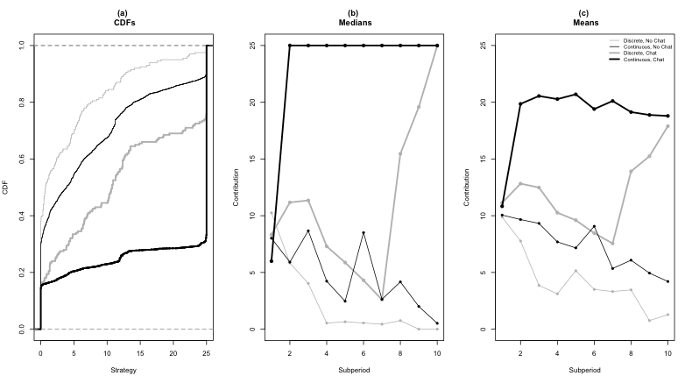

Panel (b) of Figure 2 disaggregates over time, focusing on the median choice.[7] That choice is to contribute everything from the second minute onward in CC, and it increases in the last few minutes of DC to hit almost the same level. Contribution rates decay in the other treatments (even in DC at first) and approach zero by the last minute. Panel (c) shows that the more conventional measure, mean contribution, exhibits the same general patterns, though of course pushed away from the extremes of 0 and 25.

Table 3 shows the non-parametric significance of the treatment differences in contribution rates. Since there is full interaction between the members of each 4-person group, we conservatively take each session mean to be a single independent observation, and apply the Wilcoxon-Mann-Whitney ranksum test.[8] The Table confirms that, at the conventional 5% level, the mean contribution rate for CC is significantly higher than the corresponding rate for every other category. The mean contribution rate for DC is also significantly higher than the corresponding rate for DN. There are also some modest (but not quite statistically significant) differences in mean contributions for CN versus DC and for CN vs. DN. The patterns suggest a major influence for full communication, but the beneficial effect for continuous time occurs only with full communication, a marked contrast to Friedman and Oprea (2011).

**Table 3: Pairwise Tests of Contribution Rates**

|  |  |  |  |
| --- | --- | --- | --- |
|  | CC | CN | DC |
| CN | 0.017 |  |  |
| DC | 0.030 | 0.095 |  |
| DN | 0.004 | 0.151 | 0.008 |

Entries are two-tailed *p*-values for Wilcoxon test applied to session means.

We also see considerable heterogeneity across groups in the communication treatments; the mean contribution rates over time, by group, are shown in Appendix II. In continuous time, four of the six groups have converged on full contribution while one other group seems to be drifting down to the zero-contribution level. The contribution rate in the sixth group appears to be increasing slowly but steadily. The panel for the DC treatment indicates even more of a split, with three groups making full contributions at the end (with two of these groups ramping up these contributions in the final three periods) and two other groups having positive but small contributions at the end.

Thus, it is not that many people in the communication treatments make intermediate contributions; instead, the overall average contribution rates are the result of most groups converging on full contribution with others converging on zero contribution. We suspect that full contribution is indeed stable with communication, since we observe no case in which the full contribution rate collapses after everyone contributes her entire endowment to the public fund.

The main treatment effects are summarized below.[9]

**Observation 1:** Contribution rates are greater with continuous than with discrete time, particularly when there is full communication.

**Observation 2:** Full communication has a very strong effect relative to no communication in both time protocols, with a significantly and substantially larger effect in continuous time.

**Observation 3:** We have the usual cooperative decay with no communication, but it seems to disappear with full communication.

**4.2 Total variation**

So far we have focused on overall tendencies. However, one gets the impression from Figure 2 (and even more from individual and group level time series) that behavior is much more variable in some treatments than in others. Such variability is of great interest to the extent that it reflects the speed and reliability of convergence (or non-convergence) in contributions.

In discrete time, one intuitive measure of variability is the sum of absolute changes in a player’s choices. That is, if player *i* chooses contribution level in subperiod *t*, then the measure is



,



which is known to mathematicians as Total Variation (TV). The first two columns of Table 4 show that communication more than doubles TV in our discrete-time treatments.

Mathematicians extend the definition of TV to continuous time by taking the supremum (least upper bound) of expressions like the last one over all discrete time grids:



where *G* is a finite grid of time points of the 10 minute time interval. The last two columns of the Table show that communication greatly *decreases* TV in continuous time, the opposite of its impact in discrete time.



**Table 4: Total Variation in Contribution Rates**

|  |  |  |  |  |
| --- | --- | --- | --- | --- |
|  | DN | DC | CN | CC |
| Mean | 31.0 | 70.1 | 796 | 206.7 |
| Median | 22.8 | 51.0 | 609 | 105 |

Figure 3 confirms both effects by looking at the CDFs of individual players’ total variation. Further confirmation comes from a conservative group-level Wilcoxon test, which rejects the null hypothesis of equal TV for the two communication treatments with two-tailed p-values of 0.018 in the Continuous data and 0.008 in the Discrete data.

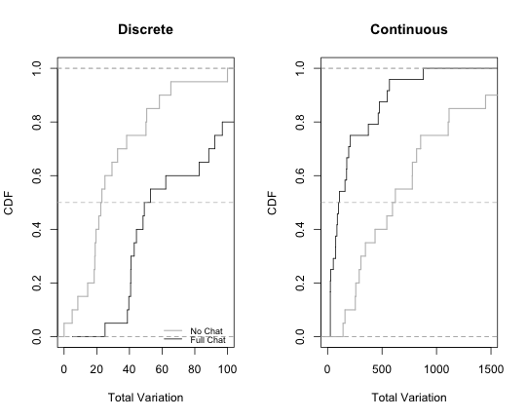

**Figure 3: Total variation by treatment**

**Observation 4:** Communication leads to less variability in the Continuous treatments but to more variability in Discrete treatments.

Together with the content analysis of chat data in Appendix III (which is of some interest in its own right), this result suggests that communication disrupts the smooth decay to the inefficient Nash equilibrium in discrete time, while it encourages convergence towards efficient (but non-Nash) full contributions in continuous time. That is, while communication is efficiency-enhancing in both cases, it appears to enhance efficiency by stabilizing “good” behavior in continuous time and by destabilizing “bad” behavior in discrete time.

**4.3 Limited communication**

We also explore the impact of restricted communication. Recall that several previous studies suggested that a richer message space (or the possibility of endogenous messages, which may include promises and bring guilt into the picture) is needed to effectively change behavior when there is a unique (but socially inefficient) equilibrium.

In fact, we find support for this notion. Table 5 shows the median rate, the mean rate, and the rate of maximum contribution with limited communication.

**Table 5: Summary statistics on contributions with limited communication**

|  |  |  |
| --- | --- | --- |
| **Treatment** | **CL** | **DL** |
| Median Contribution | 7.26 | 5.77 |
| Mean Contribution | 10.13 | 8.35 |
| (Standard Deviation) | 9.73 | 8.27 |
| Rate of Maximum Contribution | 0.15 | 0.04 |

Comparing to the figures in Table 2, we see that these are all intermediate between the rates with no communication and with free-form communication, and always closer to the no-communication results. In the case of discrete time, the mean contribution rate for limited communication is not significantly different than that for free-form communication or no communication (Wilcoxon-Mann-Whitney rank sum tests give *p* = 0.310 and *p* = 0.421, respectively, two-tailed tests). In the case of continuous time, there is no difference in the mean contribution rates with no communication and limited communication (*p* = 0.662, two-tailed test), while there is a marginally-significant difference in the rates with free-form and limited communication (*p* = 0.065, two-tailed test). The mean total variation is also intermediate, but again much closer to the level observed with no communication, in both continuous and discrete time. Overall, there is no instance in which limited communication leads to significantly different results than with no communication, and this result also holds for patterns over time.

**Observation 5:** Limited communication has no significant effect on contributions, relative to no communication.

1. **Discussion**

In our control treatment (DN), we see consistent convergence towards the inefficient Nash equilibrium of zero contribution, minimal variation, and an overall contribution rate of 17 percent. This is no surprise since we use very tough parameters: each token contributed ‘risks’ a loss of up to 0.7 units (if no one else contributes), with a maximum gain of 0.2 units (if everyone one else contributes). This is not *per se* a very attractive proposition.

Nevertheless, the combination of continuous time and communication in the CC treatment leads to an impressive overall contribution rate, over 75 percent. As can be seen in the detailed analysis in Appendix III, even the groups that fail to achieve full contribution and that exhibit considerable variability often do so because they try to institute a complicated rotation scheme in which one member and then another reaps the maximum individual payoff while the others contribute. The point is that, despite the very tough parameters, we see remarkably high degrees of cooperation in CC, and very little evidence of unraveling at the end of the period.

The mixed treatment DC produces more heterogeneous results, with some groups achieving high contribution levels by the end and other groups decaying almost to zero contribution. The remaining mixed and intermediate treatments likewise produce considerable variability and heterogeneity, but seldom converge to full contribution.

We have documented these patterns in the data, but have yet to explain *why* they are there. In the rest of this section, we discuss some possible reasons for what we have observed. Our focus is on when players persistently try for high contribution levels, and when they succeed.

A useful point of departure is the continuous time Prisoner’s Dilemma (CPD) experiments mentioned earlier (Friedman and Oprea, 2011). Despite very tough parameters, player pairs managed to achieve very high levels of cooperation via “pulsing” behavior. From mutual defection, often one player would pulse to cooperation and return after a second or two if the other did not follow; and if one player defected from mutual cooperation, the other typically followed within a second. This nonverbal form of communication was very effective in conveying threats and promises in continuous time, and the vast majority of the players soon adopted it. By contrast, players in the one-population continuous time Hawk-Dove (CHD) experiment mentioned earlier (Oprea et al. 2011) had no effective way to communicate --- the actions of any one player were hardly visible to the 11 others in the group. Despite facing much easier parameters, the Hawk-Dove players failed to achieve any degree of cooperation.

Our continuous public goods (CPG) game falls somewhere in between these CPD and CHD games. Each player’s action can be seen clearly by the three other CPG players, but its meaning is not nearly as obvious as to the one other player in CPD. If a player in our CPG game pulses from a very low contribution rate to a high rate and returns after a few seconds, the other players might interpret that as a request to increase their own contributions. Or they might all think that it is someone else’s turn, or just wait to see whether someone else responds. Another complication is that the action space is not binary but rather is the entire interval [0, 25].[10] Absent full communication, the intent of pulses (and other allocation adjustments) remains quite ambiguous.

Free-form chat evidently resolves the ambiguity. Players know that there will be nowhere to hide if they misbehave and, in continuous time, that retribution can come quickly. Being able to respond immediately and in an unambiguous manner seems sufficient to achieve a high level of cooperation. In discrete time, free-form chat still reduces ambiguity, but perhaps the inability to respond immediately reduces the effectiveness of promises and threats.

To delve more deeply into how free-form communication affected behavior we need to look at the micro-details of the chat in each session in relation to the observed behavior. This means that we have a quite limited set of data points (five in each treatment, except for six in CC), so it is difficult to draw strong conclusions. Nevertheless, we present detailed summaries of the chat logs of each of the 11 full communication groups listed in Appendix III.

We can make several observations from these micro-results. Three groups in continuous time made four-person agreements that were kept for the duration. One other group made no full agreements, while another group made an initial agreement to rotate that worked, but a new partial agreement to contribute half appeared to de-stabilize matters. Finally, one group was able to cooperate without any explicit agreement, but with references to being a team and having team players. The latter would appear to be a direct influence of a sense of group membership and a reluctance to disappoint others by not being sufficiently pro-social with respect to the group.

It seems clear that agreements amongst all of the group members are the most effective, as three-person agreements usually collapse. It may also be that a sense of solidarity can substitute for explicit agreements, leading to “the dog that didn’t bark” in the case of group 2 (which achieved nearly 100 percent cooperation). The groups with four-person agreements had high contribution rates: 79.85 percent, 92.24 percent, and 93.47 percent; the group that had a four-person agreement in force until people tried to change it had a contribution rate of 74.57 percent during the three periods in question. With the exception of the group 2 case of strong group identity, the lack of a four-person agreement leads to lower contribution rates (48.05 percent for group 5 and about 25.9 percent for group 1 during the time there was no four-person agreement). Four-person agreements were essentially never broken, with only brief deviations that were remedied by quick and successful peer pressure.

Matters are rather different with discrete time. There were only three four-person agreements before the late stages, and two of these were violated. Group 5 was the only one to sustain an agreement largely throughout the session, with the highest mean contribution rate of any group. There were also two agreements made in late stages (in groups 2 and 4), and these were kept, leading to high contributions at the end. Also, in contrast to the results with continuous time, there was relatively little discussion on this point, with an average of less than two mentions per session. It seems that in discrete time it is both more difficult to reach four-person agreements and more difficult to sustain them. Perhaps there is less of a sense of camaraderie, as we never observe any discussion of team play; instead we see outbursts of emotion and harsh language.

To some extent, the higher emotional content with discrete time may stem from the fact that there is a build-up to a specific moment and all attention is focused on it; in comparison, with continuous time there is no deadline effect and people seem to be more relaxed.[11] In this respect, there is a sense of immediacy in continuous time, as one can make instant responses to deviations in continuous time and can quickly see the response to a response; in contrast, one must wait to take action in discrete time and must wait another substantial duration to see whether the offender makes a suitable response. This difference clearly makes the possibility of peer pressure more salient. Nevertheless, we do see some trend towards effective agreements at the end of more than one session; perhaps communication in discrete time might also be effective, but just requires more time.

Finally, why is the impact of limited communication so similar to that of no communication? One possibility is that the simple choices from the restricted menu were just not sufficient. However, our sense is that it is impossible with limited communication to actually have the clear agreements that seem so helpful in achieving the high contribution rates that we observe with full communication. In the absence of clear and convincing evidence that others will cooperate, it seems quite difficult to reach efficient non-equilibrium play. We suspect that such simple messages would be quite effective in a coordination game such as the Battle of the Sexes, perhaps with explicit alternation between the two pure-strategy equilibria.

1. **Conclusion**

We find that permitting decisions to be made in continuous time makes a difference in a four-person public goods game with a challenging set of parameters that offer a poor reward-to-risk ratio. The major beneficial effect, however, occurs in our data only when free-form communication is permitted. Unlike the two-person Prisoner’s Dilemma, where strategy changes in real time are easy to interpret, in our public goods game something more is needed to resolve ambiguities and to get everyone on the same page. Explicit free-form communication does the job.

It appears that agreements are crucial, and that there must be a consensus agreement to avoid deterioration in the contribution rate. Agreements are more common when there is the sense of immediacy in continuous time, and they are also violated with considerably less frequency. It seems that agreements are more likely to be upheld when there is this sense of immediacy, perhaps because the expectations of the expectations of others are higher (guilt aversion) or there is more of a sense of all working together (group membership). The fact that there is essentially no decay over time (and in fact, some positive time trends) suggests that the social motivations play a more important role than repeated game strategic considerations, particularly since the no-communication treatments show the decay over time that is typical in public-goods experiments.

Our results suggest that communication is important because it can facilitate agreements and help to instill a sense of group identity. These factors have been shown to be quite relevant in affecting behavior in individual decisions in games, as discussed earlier. The extent to which each of these factors is in play is difficult to ascertain from the data. Yet the fact that we see absolutely no decay of the contribution rate with communication seems to be clear evidence that non-strategic motivations apply in our game. In a group setting, it seems to be vital that all group members agree on a course of action, as matters otherwise tend to devolve.

Overall, it appears that allowing decisions in continuous time is not a panacea *per se*, but still facilitates better social outcomes here when there is rich communication. Our public-goods game is a difficult one in which to achieve high contribution rate, but we see that most such sessions feature nearly full cooperation. We feel that this promising result can be extended further to other environments, and that continuous time is a very useful device to have in one’s toolbox.

**References**

Ahn, T.K, R. Mark Isaac and Timothy C. Salmon. “Coming and Going: Experiments on

Endogenous Group Sizes for Excludable Public Goods,” *Journal of Public Economics*, Vol. 93, No. 1-2 (2009), pp. 336-351

Brandts, Jordi and Arthur Schram. “Cooperation and Noise in Public Goods Experiments:

Applying the Contribution Function Approach,” *Journal of Public Economics*, Vol. 79, No. 2 (2001), pp. 399-427

Carpenter, Jeffrey. “Punishing Free-Riders: How Group Size Affects Mutual Monitoring

and the Provision of Public Goods,” *Games and Economic Behavior*, Vol. 60, No. 1 (2007), pp. 31-51

Charness, Gary. “Self-Serving Cheap Talk: A Test Of Aumann's Conjecture,” *Games and*

*Economic Behavior*, Vol. 33, No. 2 (2000), pp. 177-194

Charness, Gary and Martin Dufwenberg. “Promises and Partnership,” *Econometrica*, Vol. 74 (2006), pp. 1579–1601.

Charness , Gary and Martin Dufwenberg. “Bare Promises: An Experiment,” *Economics*

*Letters*, Vol. 107, No. 2 (2010), pp. 281-283

Charness, Gary B and Yang, Chun-Lei. “Endogenous Group Formation and Public Goods

Provision: Exclusion, Exit, Mergers, and Redemption,” UCSB Working Paper (2008)

Charness, Gary, Luca Rigotti and Aldo Rustichini. “Individual Behavior and Group

Membership,” *The American Economic Review*, Vol. 97, No. 4 (2007), pp. 1340-1352

Chaudhuri, Ananish. “Sustaining Cooperation in Laboratory Public goods Experiments: a

Selective Survey of the Literature,” *Experimental Economics*, Vol. 14, No. 1 (2011), pp. 47-83

Cinyabuguma, Matthias, Talbot Page and Louis Putterman. “Cooperation Under the

Threat of Expulsion in a Public Goods Experiment,” *Journal of Public Economics*, 89 (2005), pp. 1421–1435

Cooper, Russell, DeJong, Doug, Forsythe, Robert, and Ross. Thomas. “Cooperation

without Reputation: Experimental Evidence from Prisoner’s Dilemma Games,” *Games and Economic Behavior*, 12 (1996), pp. 187-318

Croson, Rachel, Fatás, Enrique and Neugebauer, Tibor. “Excludability and Contribution:

A Laboratory Study in Team Production,” Working Paper (2006), Wharton School of Economics.

Dorsey, R.E. “The voluntary contributions mechanism with real time revisions,” *Public Choice*, 73 (1992), 261-82.

.

Egas, Martijn, and Riedl, Arno. “The Economics of Altruistic Punishment and the

Maintenance of Cooperation,” Proceedings of the Royal Society B - Biological Sciences, 275 (2008), pp. 871-78

Ehrhart, Karl-Martin and Keser, Claudia. “Mobility and Cooperation: on the Run,”

Working Paper 99s-24, CIRANO, Montreal (1999)

Fehr, Ernst and Simon Gächter. “Cooperation and Punishment in Public Goods

Experiments,” *The American Economic Review*, Vol. 90, No. 4 (2000), pp. 980-994

Fischbacher, Urs and Simon Gächter. “The Behavioral Validity of the Strategy Method

in Public Good Experiments,” Discussion Papers (2009) The Centre for Decision Research and Experimental Economics, School of Economics, University of Nottingham

Fischbacher, Urs and Simon Gächter. “Social Preferences, Beliefs, and the Dynamics of

Free Riding in Public Goods Experiments,” *The American Economic Review*, Vol. 100, No. 1 (2010), pp. 541-556(16)

Fischbacher, Urs, Simon Gächter, Ernst Fehr. “Are People Conditionally Cooperative?

Evidence from a Public Goods Experiment,” *Economics Letters*, Vol. 71, No. 3 (2001), pp. 397-404

Gächter, Simon and Christian Thöni. "Rationality and Commitment in Voluntary

Cooperation: Insights from Experimental Economics," pp. 175-208 in Peter, F. (Ed.), *Rationality and Commitment*. Oxford: Oxford University Press, (2007)

Gächter, Simon, Elke Renner, and Martin Sefton. “The Long-Run Benefits of

Punishment,” *Science*, (2008), Vol. 322 (5907), 1510.

Gunnthorsdottir, Anna, Houser, Daniel , and McCabe, Kevin. “Disposition, History and

Contributions in Public Goods Experiments,” *Journal of Behavior and Organization*, 62 (2007), pp. 304-15

Gurek, Özgur, Bernd Irlenbusch and Bettina Rockenbach. “The Competitive Advantage

of Sanctioning Institutions,” *Science*, 312 (2006), pp. 108-111

Hoggatt, Austin C. James W. Friedman and Shlomo Gill. “Price Signaling in

Experimental Oligopoly,” *The American Economic Review*, Vol. 66, No. 2, (1976), pp. 261-266

Isaac, R. M. and J.M. Walker. “Communication and Free-Riding Behavior: the Voluntary

Contribution Mechanism,” *Economic Inquiry*, 26 (1988), pp. 585–608.

Keser, Claudia and Frans van Winden. “Conditional Cooperation and Voluntary

Contributions to Public Goods,” *The Scandinavian Journal of Economics*,Vol. 102, No. 1 (2000), pp. 23-39

Ledyard, John O. *Public Goods: A Survey of Experimental Research. Handbook of*

*Experimental Economics*, Princeton: Princeton University Press, (1995)

Masclet David, Charles Noussair, Steven Tucker and Marie-Claire Villeval. “Monetary

and Nonmonetary Punishment in the Voluntary Contributions Mechanism,” *The American Economic Review*, Vol. 93, No. 1 (2003), pp. 366-380

Nikiforakis, Nikos and Hans-Theo Normann. “A Comparative Statics Analysis of

Punishment in Public-Good Experiments,” *Experimental Economics*, Vol. 11 Issue, 4 (2008) pp. 358-369

Oprea, Ryan and Daniel Friedman. “A Continuous Dilemma,” Forthcoming, *American*

*Economic Review* (2011)

Oprea, Ryan, Keith Henwood and Daniel Friedman. “Separating the Hawks from the

Doves: Evidence from Continuous Time Laboratory Games,” Forthcoming in *Journal of Economic Theory*, (2011)

Ostrom Elinor, James Walker and Roy Gardner. “Covenants With and Without a Sword:

Self-Governance is Possible,” *The American Political Science Review*, Vol. 86, No. 2 (1992), pp. 404-417

Page, Talbot, Louis Putterman and Bulent Unel. “Voluntary Association in Public Goods

Experiments: Reciprocity, Mimicry and Efficiency,” *The Economic Journal*, 115 (2005), pp. 1032–1053

Sefton, Martin, Shupp, Robert, and Walker, James M. “The Effect of Rewards and

Sanctions in Provision of Public Goods,” *Economic Inquiry*, Vol. 45, No. 4 (2007), pp. 671–90

Sonnemans, Joep, Arthur Schram, Theo Offerman. “Strategic Behavior in Public Good

Games: When Partners Drift Apart,” *Economics Letters*, Vol. 62, No. 1 (1999), pp. 35-41

Walker, James M. and Matthew A. Halloran. “Rewards and Sanctions and the Provision

of Public Goods in One-Shot Settings,” *Experimental Economics*, Vol. 7, No. 3 (2004), pp. 235-247

Yamagishi, Toshio. “The Provision of a Sanctioning System as a Public Good,” *Journal*

*of Personality and Social Psychology*, Vol 51, No. 1, (1986), pp. 110-116

Yamagishi, Toshio. “The Provision of a Sanctioning System as a Public Good,” *Social*

*Psychology Quarterly*, Vol. 51, No. 3 (1988), pp. 265-271

**Appendix I**

A separate instruction set was distributed in each treatment but great pains were taken to maintain the same language across treatments wherever possible. Below we provide instructions sets from two of our treatments as examples. Section I.A. reproduces the Discrete, Full Communication (DC) instructions while section I.B. reproduces the Continuous, Full Communication (CC) instructions.

**I.A Discrete, Full Communication (DC) Instructions**

**Instructions (DC-PG)**

Welcome! This is an economics experiment. If you pay close attention to these instructions, you can earn a significant sum of money, which will be paid to you in cash at the end.

Please remain silent and do not look at other participants’ screens. If you have any questions, or need assistance of any kind, please raise your hand and we will come to you. If you disrupt the experiment by talking, laughing, etc., you may be asked to leave and may not be paid. We expect and appreciate your cooperation today.

**The basic idea**

At the beginning of the experiment, you will be anonymously matched with three other participants. You will each choose an allocation, which can be adjusted during the experiment. Your earnings accumulate at a rate that depends on the allocation you choose and the allocations chosen by the other participants you are matched with. The details are explained below.

The earnings you accumulate will be added up at the end of the experiment, and converted to US dollars at a rate written on the white board. Before you leave the lab, you will sign a receipt and will be paid in cash.

**How earnings are computed**

You have 25 tokens, and you choose how many tokens to allocate to the group account and how many to allocate to your private account. Each token in your private account always pays a rate of 1.0 point. Each token allocated to the group account yields a rate of 1.2 points, divided equally among all members of your group.

You can choose any allocation of the 25 tokens; fractional tokens are OK. You will be able to adjust your allocation choice during the experiment.

For example, suppose that you always allocate 20 tokens to your private account and 5 to the group account, and that the combined allocation of the other 3 members of your group is always 20 tokens. Then the group account would total 25 tokens and it would yield 1.2* 25 = 30 points distributed equally to the 4 members. You then would receive 7.5 points from the group account and 20 from your private account, a total of 27.5 points.

On the other hand, suppose that you always contributed 15 tokens to the group account and kept 10 for your private account, and that the combined group allocation of the other 3 members was 40 tokens. Then the group account has 55 tokens and you would receive 10 + 1.2 * 55/4 = 10 + 16.5 = 26.5 points. If you spent half the session in a situation that paid 27.5 points and the other half in a situation that paid 26.5 points, then you would earn (27.5+ 26.5)/2 = 53/2 = 27 points.

To give a few more examples, if everyone places all of their tokens in their private account, each player will earn at a rate of 25 points. In this situation, were you to instead unilaterally put all of your tokens in the group account you would earn 7.5 points while the other people in the group would earn 32.5.

If everyone places all of their tokens into the group account, each player will earn at a rate of 30 points. In this situation, were you to instead unilaterally put all of your tokens in the private account, you would earn 47.5 points while the other people in the group would earn 22.5.

**Screen display**

It’s hard to keep track of your earnings when you and the other members of your group are adjusting allocations during the experiment. The computer does the calculations for you, as in Figure 1. You drag the rectangular slider at the bottom of the screen to adjust your allocation to the group account between 0 and 25; the rest stays in your private account.

The experiment will be divided into ten consecutive one-minute sub-periods. The rectangular bar at the top of the screen will show how much time has elapsed so far in the current sub-period; when the bar is completely filled, the sub-period is over. During each sub-period you will secretly choose an allocation and other participants will do the same. The computer will use only the allocations selected at the moment the sub-period ends and will pay no attention to slider positions earlier in the sub-period.

At the beginning of the experiment, a message on the screen will tell you the color assigned to you. Colored dots will appear each sub-period to show the allocation choices and earnings for you and the other members of your group from the previous sub-period. Dots further to the right indicate larger allocations to the group account, and higher dots indicate larger earnings that sub-period; exact earnings in the previous sub-period are shown in the numbers floating next to each dot.

Above the box you will see how many sub-periods are left in the experiment, and your “Current Earnings” shows your points accumulated so far.

**Chat window**

During the experiment you will have access to a Chat window, as in Figure 2. You simply type in any permissible message, hit Return, and your message will be shown to all of the people in your group. You can adjust your allocation choice and chat at the same time, if you wish. Messages will be color-coded using the same color assignments used for dots.

In chat, you are permitted to discuss anything related to today’s experiment, but not to reveal your true identity or to discuss what might happen outside the lab. All chat messages will be recorded permanently, so please avoid trash talk.

**Frequently asked questions**

**Q1. Is this some kind of psychological experiment with an agenda you haven't told us?**

Answer. No. It is an economics experiment. If we do anything deceptive or don't pay you cash as described then you can complain to the campus Human Subjects Committee and we will be in serious trouble. These instructions are meant to clarify the game and to explain you how you earn money; our interest is simply in seeing how people make decisions.

**Q2. Will the formula for calculating earnings ever change? Is there any random element?**

Answer. The earnings calculation never changes, and there is no random element. Your earnings depend entirely on your allocation decisions and those of the other members of your group.

**Figure 1**

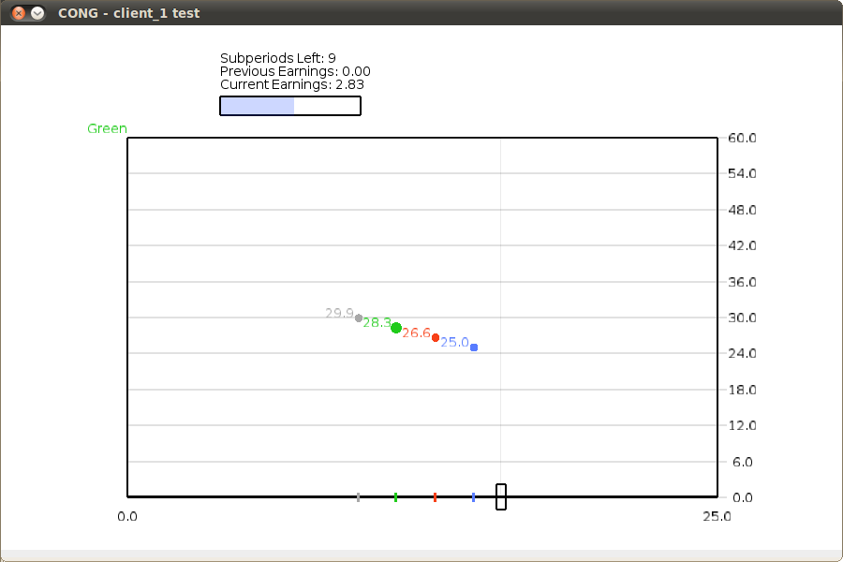

**Figure 2**

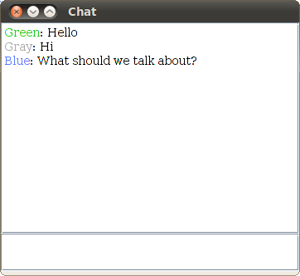

**I.B Continuous, Full Communication (CC) Instructions**

**Instructions (CC-PG)**

Welcome! This is an economics experiment. If you pay close attention to these instructions, you can earn a significant sum of money, which will be paid to you in cash at the end.

Please remain silent and do not look at other participants’ screens. If you have any questions, or need assistance of any kind, please raise your hand and we will come to you. If you disrupt the experiment by talking, laughing, etc., you may be asked to leave and may not be paid. We expect and appreciate your cooperation today.

**The basic idea**

At the beginning of the experiment, you will be anonymously matched with three other participants. You will each choose an allocation, which can be adjusted during the experiment. Your earnings accumulate at a rate that depends on the allocation you choose and the allocations chosen by the other participants you are matched with. The details are explained below.

The earnings you accumulate will be added up at the end of the experiment, and converted to US dollars at a rate written on the white board. Before you leave the lab, you will sign a receipt and will be paid in cash.

**How earnings are computed**

You have 25 tokens, and you choose how many tokens to allocate to the group account and how many to allocate to your private account. Each token in your private account always pays a rate of 1.0 point. Each token allocated to the group account yields a rate of 1.2 points, divided equally among all members of your group.

You can choose any allocation of the 25 tokens; fractional tokens are OK. You will be able to adjust your allocation choice during the experiment.

For example, suppose that you always allocate 20 tokens to your private account and 5 to the group account, and that the combined allocation of the other 3 members of your group is always 20 tokens. Then the group account would total 25 tokens and it would yield 1.2* 25 = 30 points distributed equally to the 4 members. You then would receive 7.5 points from the group account and 20 from your private account, a total of 27.5 points.

On the other hand, suppose that you always contributed 15 tokens to the group account and kept 10 for your private account, and that the combined group allocation of the other 3 members was 40 tokens. Then the group account has 55 tokens and you would receive 10 + 1.2 * 55/4 = 10 + 16.5 = 26.5 points. If you spent half the session in a situation that paid 27.5 points and the other half in a situation that paid 26.5 points, then you would earn (27.5+ 26.5)/2 = 53/2 = 27 points.

To give a few more examples, if everyone places all of their tokens in their private account, each player will earn at a rate of 25 points. In this situation, were you to instead unilaterally put all of your tokens in the group account you would earn 7.5 points while the other people in the group would earn 32.5.

If everyone places all of their tokens into the group account, each player will earn at a rate of 30 points. In this situation, were you to instead unilaterally put all of your tokens in the private account, you would earn 47.5 points while the other people in the group would earn 22.5.

**Screen display**

It’s hard to keep track of your earnings when you and the other members of your group are adjusting allocations during the experiment. The computer does the calculations for you, as in Figure 1. You drag the rectangular slider at the bottom of the screen to adjust your allocation to the group account between 0 and 25; the rest stays in your private account.

The experiment will last for ten minutes. Each participant will be randomly assigned an initial allocation and will be allowed to freely adjust his or her own allocation choice throughout the experiment. At each moment, your earnings will accumulate at a rate determined by your current choice and the current choices of other members of your group.

At the beginning of the experiment, a message on the screen will tell you the color assigned to you. Colored dots will always show the current allocation choices and earnings rate for you and the other members of your group. Dots further to the right indicate larger allocations to the group account, and higher dots indicate larger earnings that sub-period; exact earnings rate are shown in the numbers floating next to each dot.

Above the box you will see how many seconds are left in the experiment, and your “Current Earnings” shows your points accumulated so far.

**Chat window**

During the experiment you will have access to a Chat window, as in Figure 2. You simply type in any permissible message, hit Return, and your message will be shown to all of the people in your group. You can adjust your allocation choice and chat at the same time, if you wish. Messages will be color-coded using the same color assignments used for dots.

In chat, you are permitted to discuss anything related to today’s experiment, but not to reveal your true identity or to discuss what might happen outside the lab. All chat messages will be recorded permanently, so please avoid trash talk.

**Frequently asked questions**

**Q1. Is this some kind of psychological experiment with an agenda you haven't told us?**

Answer. No. It is an economics experiment. If we do anything deceptive or don't pay you cash as described then you can complain to the campus Human Subjects Committee and we will be in serious trouble. These instructions are meant to clarify the game and to explain you how you earn money; our interest is simply in seeing how people make decisions.

**Q2. Will the formula for calculating earnings ever change? Is there any random element?**

Answer. The earnings calculation never changes, and there is no random element. Your earnings depend entirely on your allocation decisions and those of the other members of your group.

**Figure 1**

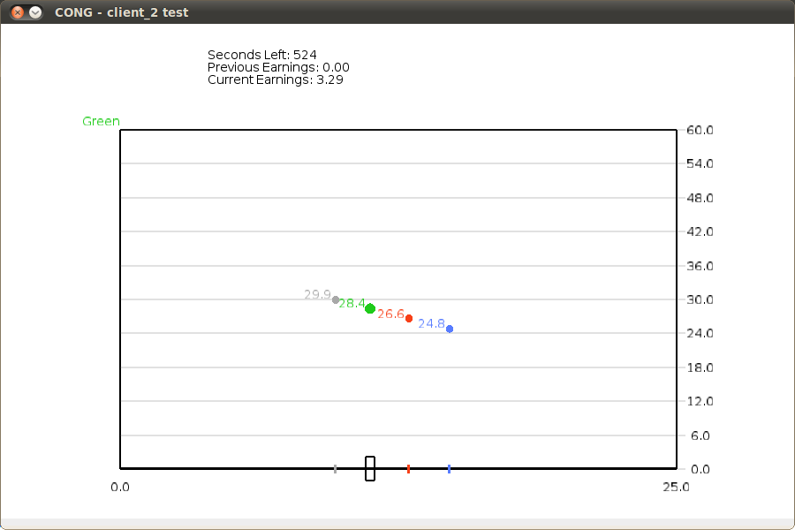

**Figure 2**



**Appendix II: Supplementary Analysis of Choice Data**

**Table II.1: Summary Statistics By Treatment and Group**

|  |  |  |  |  |  |
| --- | --- | --- | --- | --- | --- |
| **Treatment** | **Group** | **Median** | **Mean** | **Rate of Max Play** | **Total Variation** |
| CN | 1 | 6.468 | 9.110 | 0.022 | 4451 |
| CN | 2 | 11.270 | 13.182 | 0.293 | 2088 |
| CN | 3 | 0.357 | 5.254 | 0.098 | 2341 |
| CN | 4 | 0.000 | 1.393 | 0.015 | 851 |
| CN | 5 | 5.536 | 7.830 | 0.085 | 6190 |
| CL | 1 | 1.587 | 6.954 | 0.059 | 1647 |
| CL | 2 | 0.000 | 2.648 | 0.001 | 622 |
| CL | 3 | 13.413 | 13.049 | 0.148 | 2700 |
| CL | 4 | 11.587 | 12.179 | 0.152 | 5477 |
| CL | 5 | 3.690 | 6.876 | 0.038 | 3826 |
| CL | 6 | 24.960 | 19.066 | 0.485 | 4118 |
| CC | 1 | 8.016 | 10.496 | 0.160 | 1953 |
| CC | 2 | 25.000 | 24.292 | 0.968 | 100 |
| CC | 3 | 25.000 | 19.963 | 0.728 | 498 |
| CC | 4 | 25.000 | 23.061 | 0.902 | 679 |
| CC | 5 | 11.865 | 12.013 | 0.323 | 1516 |
| CC | 6 | 25.000 | 23.368 | 0.927 | 214 |
| DN | 1 | 1.379 | 3.452 | 0.000 | 75 |
| DN | 2 | 6.111 | 7.023 | 0.000 | 152 |
| DN | 3 | 0.000 | 1.250 | 0.000 | 46 |
| DN | 4 | 0.397 | 4.198 | 0.050 | 162 |
| DN | 5 | 2.599 | 5.125 | 0.050 | 186 |
| DL | 1 | 0.000 | 2.796 | 0.025 | 102 |
| DL | 2 | 5.179 | 6.744 | 0.000 | 234 |
| DL | 3 | 0.000 | 4.048 | 0.100 | 215 |
| DL | 4 | 11.091 | 10.749 | 0.050 | 254 |
| DL | 5 | 18.294 | 17.401 | 0.000 | 109 |
| DC | 1 | 6.806 | 10.301 | 0.100 | 307 |
| DC | 2 | 6.587 | 10.092 | 0.225 | 223 |
| DC | 3 | 11.270 | 10.088 | 0.025 | 228 |
| DC | 4 | 10.218 | 11.704 | 0.150 | 219 |
| DC | 5 | 25.000 | 17.502 | 0.700 | 425 |

Strategy Mean

**Figure II.1: Mean contribution over time, by group**

Note: In panel CC, one group -- plotted in gray -- nearly perfect overlaps other groups

and is therefore difficult to distinguish. This group achieves 100% cooperation by the

second bin and experiences a slight reduction in cooperation at the very end.

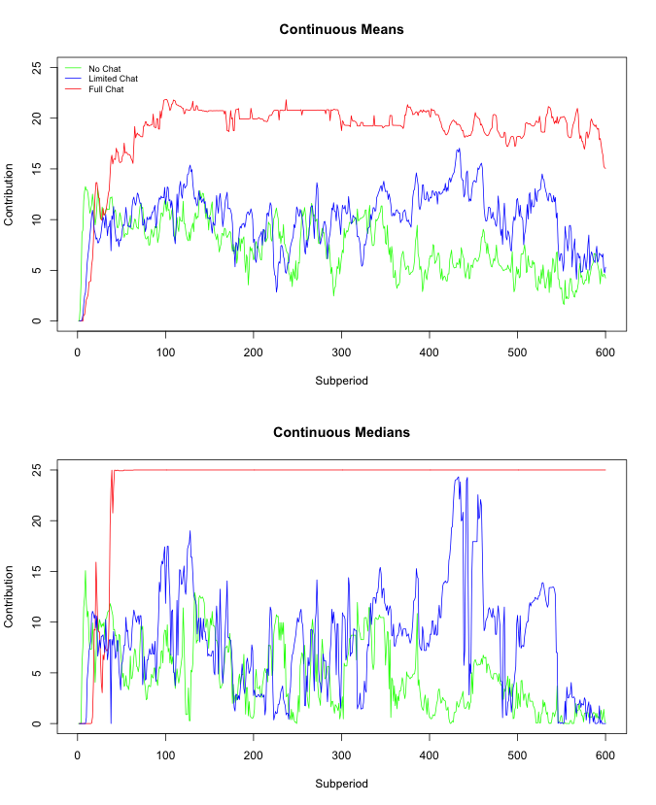

**Figure II.2: Mean and Median contributions for continuous treatments aggregated by second.**

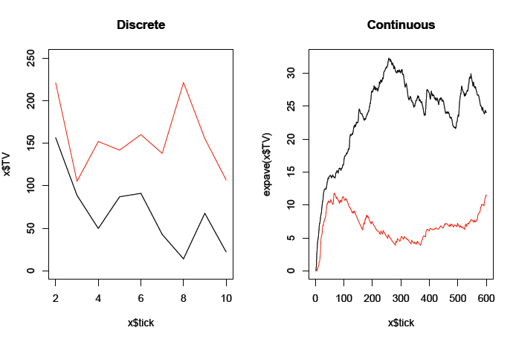

**Figure II.3: Total variation by treatment over time**

**Appendix III: Discussion and Analysis of Chat Data**

**Groups in the continuous-time treatment**

We first examine the six CC groups, cross-referencing the summary statistics from Appendix I and the time series graphed in Figure 4 of Appendix I. Below, we provide summaries of the behavior and the communication for each group.

* CC Group 1 had the lowest mean contribution rate (10.496/25 = 41.98 percent) and the highest total variation. Here there was an agreement at about minute 2.5 to allow one person at a time to not contribute. This worked for a while and another agreement was proposed (to contribute half); however, this one was only kept by three people and lasted only briefly. This then broke down almost completely.
* Group 2 had an extremely high mean contribution rate (97.17 percent) and the lowest total variation. People started contributing 25 from the beginning, with no agreements made. Communication consisted of words of encouragement, such as “Good job team”, “Team players”, and “Haha yeah glad we got a good team tho”.
* Group 3 had a moderately high contribution rate (79.85 percent) and an intermediate level of total variation. There was an initial agreement to all contribute 25, which was kept for about 2.5 minutes. A new agreement was then made to alternate one person out from contributing; this was kept until near the end, when everyone contributed 25.
* Group 4 had a high mean contribution rate (92.24 percent) and an intermediate level of total variation. There was an early agreement to contribute 25, which was kept by all except for a brief deviation at the end of the third minute (from which the deviating party was cajoled) and a small deviation at the very end. One of the players wanted to deviate in the middle of the session, but was talked out of it.
* Group 5 had a relatively low mean contribution rate (48.05 percent) and considerable total variation. There was a three-party agreement early on, but it was only kept briefly (probably because two people made no contributions). After minute 1.5, only two players communicated (and frequently), keeping an agreement to contribute 25 for the rest of the session, despite the others’ behavior.
* Group 6 had a very high contribution rate (93.47 percent) and a low level of total variation. Here there was an early agreement to contribute 25, which was maintained until the end, except for some brief deviations by two of the players near the end. Severe admonishments by the others stopped these deviations.

**Groups in the discrete-time treatment**

* Group 1 had an intermediate mean contribution rate (41.20 percent) and a moderate level of total variation. There were no full agreements, but there was an early 3-person one. When the other didn’t cooperate at t= 60 seconds (and was excoriated), cooperation broke down. Two people tried to get it going later, but failed.
* Group 2 had an intermediate mean contribution rate (40.37 percent) and a moderate level of total variation. There was an early agreement on contributing half, but only three people did so; people complied with a new agreement for one period, then it decayed. New agreement for 25 at t=480; an excuse at 480, a defection (followed by chastisement) at 540, and full contribution at the end.
* Group 3 had an intermediate mean contribution rate (40.35 percent) and a low or moderate level of total variation. There were no real agreements, just some partial ones that weren’t honored. Strong words and complaints in the middle, with some people displaying considerable annoyance until the end. Some people doing half and some people did very little; these were not always the same people.
* Group 4 had an intermediate mean contribution rate (46.82 percent) and a low level of total variation. An early agreement to contribute half was violated, with an apology. It was then kept once and slipped away, with more violations. They agreed to be selfish at 360, and then were able to agree to contribute 25 at the end.
* Group 5 had a relatively high mean contribution rate (70.01 percent), as well as a high level of total variation. There was an early agreement to rotate one person out, but there was some confusion. But the alternation was successful from period 3 to the end, except that everyone contributed 25 at the very end.

**Continuous-time sessions (CC)**

Group 1 *(Red line)*

* Agreement at 110 by all to alternate one person to the left every 30 seconds. Kept until around 255, when another agreement was proposed
* Agreement to go halfway at around 255. Worked for 3 people, but only briefly. It broke down into intermittent behavior after that. No later agreements made.

Group 2 *(Blue line)*

* No agreements at all. All started contributing from the beginning.

Group 3 *(Green line)*

* Agreement to all contribute 25 at 21.
* At around 167, then there was an agreement for one person at a time to contribute 0, with red going first. Red then went for about the agreed time. Then Green did so, and then Blue did so. And then Gray did so briefly, and then all contributed 25 for the last 100 seconds or so.

Group 4 *(Orange line)*

* Agreement at around 70 to all contribute 25. Three people deviated briefly at around 170 and then went back after some cajoling at around 180-190. Then people all contributed 25 until the end. Red wanted to deviate throughout the 200’s, but was talked out of it.

Group 5 (*Purple line)*

* Agreement by 3 people at around 84, but not Gray. Then not much happened until around 300, when both Red and Green started contributing 25 (until the end), apparently not minding that Blue and Gray weren’t helping. And only Red and Green communicated after 98.

Group 6 (*Gray)*

* Agreement at about 30 to contribute 25. Maintained until the end, except for some brief deviations by Gray and Blue near the end. These deviations were stopped by severe admonishments by Red and Green at 562-565.

**Discrete-time sessions (DC)**

Group 1 *(Red line)*

* Three people agreed at 45 to put all in, but Green didn’t communicate. Green then contributed a little at 60, while everyone else contributed 25.
* Green was excoriated at 67-68 and 88. At 120, Red and Blue contributed little, while Green and Gray contributed a lot.
* Blue promised to go to the right at 143, and did so. But Green did not and Red lost faith. Green resisted public and got harangued throughout the 200’s and did cooperate at 180 and 240. But by then none of the other 3 were contributing much.
* Intermittent attempts at cooperation later, but without much success. No agreements.

Group 2 (*Blue line*)

* Agreement on halfway before 60. Complaint about Green at 80.
* New agreement at 99. Everyone complied at half.
* Decay at 180. Stayed low until new agreement at 471.
* 3 people went right at 480, but not Red, who made an excuse.
* Agreed again, but this time Green defected. Complaint. New agreement, and this time they all did 25 at 600.

Group 3 *(Green line)*

* Discussion early on about efficiency vs. greed, but no agreement. An attempt at agreement to go half at 180, but not everyone agreed, and Green defected.
* Some partial agreement to go half at 240, but not honored by 2 people. Lots of complaints/strong words between 240 and 300. And they stayed aggravated until the end, with some people doing half and some doing very little.

Group 4 *(Orange line)*

* Agreed early on middle, but Blue defected at 60. Blue “apologized” and agreed on middle for 120. Kept agreement, some slippage at 180.
* Some discussion about doing 25 at 240, but no agreement. Green was selfish again.
* Agreed on left at 360 and followed through.
* Agreed to go more to the right for 480 and they did. Then agreed on all the way right at around 500 and did so at 540 and 600.

Group 5 *(Purple line)*

* No solid agreement before 60; Green was the only one to contribute. Agreement at 90 for 3 people to contribute at 120, with rotation to private for one. But it didn’t get implemented for 120 (Green defected), but there was some confusion. Worked at 180, rotated successfully at 240. Agreement for Blue to go left at 300, all followed it. Successful alternation all the way until the end, when everyone contributed 25. There was a lot of discussion about how to choreograph this.

1. * *Charness*: Economics Department, University of California, Santa Barbara, 2127 North Hall, Santa Barbara, CA 93106, charness@econ.ucsb.edu; *Friedman*: Economics Department, University of California, 1156 High Street, Santa Cruz, CA 95064, dan@ucsc.edu; *Oprea*: Economics Department, University of British Columbia, #928 – 1873 East Mall, Vancouver, BC V6T1Z1, roprea@gmail.com.
2. Every punishment point reduces the punished individual’s payoff by 10% (up to a maximum of 100%), and the punishment is also costly to the punisher.
3. In fact, even non-monetary punishments can improve the contribution rate; however, this may only be in the short run (Masclet, Noussair, Villeval, and Tucker, 2003).
4. This article provides detailed description on a number of other studies that me omit due to space constraints. These include (but are not limited to) Gächter, Renner, and Sefton (2008), Walker and Halloran (2004), Sefton, Shupp, and Walker (2007), Egas and Riedl (2008), and Carpenter (2007).
5. For previous experimental evidence of this phenomenon see, for example, Charness, Rigotti, and Rustichini (2007).
6. Charness and Dufwenberg (2006) discuss this in terms of guilt aversion, where an individual feels guilt in proportion to her expectations about the expectations of another person who has trusted her.
7. To maintain comparability with the Discrete treatments, the Continuous data are aggregated over 60-second intervals in this Figure. The full detail for the Continuous treatments can be seen in Appendix II.
8. *t*-tests with clustering at the session level generate very similar results.
9. An alternative, parametric approach to assessing the main treatment effects is to run a simple dummy variable regression. We did so, with the following results:

   Contributionsit = 4.21 + 3.14*Cont*i*+ 7.72*Comm*i*+ 3.78*Cont*i*\*Commi

   (6.58) (2.49) (7.45) (1.86)

   where Contributions is the amount contributed by subject *i* making decision *t* (decisions are by sub-period in discrete time and are sampled once per second in continuous time). Cont is an indicator taking a value of 1 if the subject is choosing in continuous time and Comm is an indicator taking a value of 1 if the subject is allowed to use the full chat interface to communicate. Standard errors are clustered at the subject level, and *t*-values are shown in parentheses below the coefficient estimates. The effect of communication is highly significant (*t* = 7.45) in this regression, while the effect of continuous time is significant at the five percent level. The interaction effect is fairly large (3.78 units) but is only marginally significant on a two-tailed test (*p* = 0.062). Because of substantial departures from normality in contributions, evident in Figure 2, most of our analysis uses instead non-parametric analysis.
10. Hoggatt, Friedman and Gill (1976) document pulsing behavior in an early near-continuous time oligopoly game with a similar action space. As in the DC treatment of our public goods game, they observed considerable heterogeneity and variability.
11. Another possible factor involves the frequency of mention of how to make the most money, and the relative benefits of the private and group accounts. On average, this was mentioned more than twice as often in the continuous-time sessions as in the discrete-time sessions.