**Risky Curves:**

**On the Empirical Failure of Expected Utility**

**Daniel Friedman**

**R. Mark Isaac**

**Duncan James**

**Shyam Sunder**

**TABLE OF CONTENTS**

**Acknowledgments and Permissions**

**Commonly Used Abbreviations**

**Chapter 1: The Challenge of Understanding Choice Under Risk**

**Chapter 2: Historical Review of Research Through 1960**

**Chapter 3: Measuring Individual Risk Preferences**

**Chapter 4: Aggregate Level Evidence From the Field**

**Chapter 5: What are Risk Preferences?**

**Chapter 6: Risky Opportunities**

**Chapter 7: Possible Ways Forward**

**Bibliography**

**Index**

**CHAPTER 1**

**THE CHALLENGE OF UNDERSTANDING CHOICE UNDER RISK**

Life is uncertain. We hardly know what will happen tomorrow; our best-laid plans go awry with unsettling frequency. Even the recent past is often a matter of conjecture and controversy. Everyday decisions, small and large, are made without certainty as to what will happen next.

It would therefore be comforting to have a well-grounded theory that organizes our observations, guides our decisions, and predicts what others might do in this uncertain world. Since the 1940s most economists have believed they have had such a theory in hand, or nearly so with only a few more tweaks needed to tie up loose ends. That is, most economists have come to accept that Expected Utility Theory (EUT), or one of its many younger cousins such as Cumulative Prospect Theory (CPT), is a useful guide to behavior in a world in which we must often act without being certain of the consequences.

The purpose of this book is to raise doubt, and to create some unease with the current state of knowledge. We do not dispute that the conclusions of EUT follow logically from its premises. Nor do we dispute that, in a sufficiently simple world, EUT would offer good prescriptions on how to make choices in risky situations. Our doubts concern descriptive validity and predictive power. We will argue that EUT (and its cousins) fail to offer useful predictions as to what actual people end up doing.

Under the received theory, it is considered scientifically useful to model choices under risk (or uncertainty) as maximizing the expectation of some curved function of wealth, income, or other outcomes. Indeed, many social scientists have the impression that by applying some elicitation instrument to collect data, a researcher can estimate some permanent aspect of an individual’s attitudes or personality (e.g., a coefficient of risk aversion) that governs the individual’s choice behavior. This belief is not supported by evidence accumulated over many decades of observations. A careful examination of empirical and theoretical foundations of the theory of choice under uncertainty is therefore overdue.

To begin with the basics: what do we mean by “uncertainty” and “risk”? Economists, starting with, and sometimes following, Frank Knight (1921), have redefined both words away from their original meaning.[1]

In the standard dictionary definition, risk simply refers to the possibility of harm, injury, or loss. This popular concept of risk applies to many specialized domains including medicine, engineering, sports, credit, and insurance. However, in the second half of the twentieth century, a very different definition of risk took hold among economists. This new technical definition refers not to the possibility of harm but rather to the *dispersion* of outcomes inherent in a probability distribution. It is typically measured as variance or a similar statistic. Throughout this book we will be careful to distinguish the possibility-of-harm meaning of risk from the dispersion meaning.

Although the notion of risk as dispersion seems peculiar to laymen, economists acclimated to it easily because it dovetails nicely with EUT. For centuries, economists have used utility theory to represent how individuals construct value. In the 1700s Daniel Bernoulli (1738) first applied the notion to an intriguing gamble, and since the 1940s the uses of expected utility have expanded to applications in a variety of fields, seemingly filling a void.

At the heart of Expected Utility Theory is the proposition that we each, individually or as members of a defined class, have some particular knowable attitudes towards uncertain prospects, and that those attitudes can be captured, at least approximately, in a mathematical function. In various contexts, it has been referred to as a value function (in Prospect Theory), or a utility of income function, or a utility of wealth function. Following the standard textbook (Mas-Colell, Whinston, and Green **[**1995]**)** we shall often refer to it as a Bernoulli function. Such a function maps all possible outcomes into a single-dimensional cardinal scale representing their desirability, or “utility.” Different individuals may make different choices when facing the same risky prospects (often referred to as “lotteries”), and such differences are attributed to differences in their Bernoulli functions.

In particular, the curvature of an individual’s Bernoulli function determines how an individual reacts to the dispersion of outcomes, the second definition of risk. Because the curvature of the Bernoulli function helps govern how much an individual would pay to avoid a given degree of dispersion, economists routinely refer to curvature measures as measures of “risk aversion.”

Chapter 2 explains the evolution and current form of EUT, and the Appendix to Chapter 2 lays out the mathematical definitions for the interested reader. Presently, we simply point out that in its first and original meaning, aversion to risk follows logically from the definition. How can one not be averse to the possibility of a loss? If a person somehow prefers the prospect of a loss over that of a gain, or of a greater loss over a smaller loss, in what sense can the worse outcome be labeled a “loss” in the first place? By contrast, under the second definition of risk as dispersion of outcomes, aversion to risk is not inevitable; aversion to, indifference to, and affinity for risk remain open possibilities.

It is a truism that to deserve attention, a scientific theory must be able to predict and explain better than known alternatives. True predictions must, of course, be out-of-sample, because it is always possible to fit a model with enough free parameters to a given finite sample. That exercise is called “over-fitting,” and it has no scientific value unless the fitted model can predict outside the given sample. Any additional parameters in a theory must pay their way in commensurate extra explanatory power, in order to protect against needless complexity.

We shall see in Chapter 3 that the Expected Utility Theory and its many generalizations have not yet passed this simple test in either controlled laboratory or field settings. These theories arrive endowed with a surfeit of free parameters, and sometimes provide close ex post fits to some specific sample of choice data. The problem is that the estimated parameters, e.g., risk-aversion coefficients, exhibit remarkably little stability outside the context in which they are fitted. Their power to predict out-of-sample is in the poor-to-nonexistent range, and we have seen no convincing victories over naïve alternatives.

Other ways of judging a scientific model include whether it provides new insights or consilience across domains. Chapter 4 presents extensive failures and disappointments on this score. Outside the laboratory, EUT and its generalizations have provided surprisingly little insight into economic phenomena such as securities markets, insurance, gambling, or business cycles.

After almost seven decades of intensive attempts to generate and validate estimates of parameters for standard decision theories, it is perhaps time to ask whether the failure to find stable results *is* the result. Chapter 5 pursues this thought while reconsidering the meaning and measures of risk and of risk aversion.

But does it really matter? What is at stake when empirical support for a theory is much weaker than its users routinely assume? We write this book because the widespread belief in the explanatory usefulness of curved Bernoulli functions has harmful consequences.

1. It can mislead economists, especially graduate students. Excessively literal belief in EUT, or CPT, or some other such model as a robust characterization of decision making can lead to a failed first research program, which could easily end a research career before it gets off the ground. We hope that our book will help current and future graduate students be better informed and avoid this pitfall.
2. It encourages applied researchers to accept a facile explanation for deviations, positive or negative, that they might observe from the default prediction, e.g., of equilibrium with risk-neutral agents. Because preferences are not observable, explaining deviations as arising from risk aversion (or risk seeking) tends to cut off further inquiry that may yield more useful explanations. For example, we will see in Chapter 3 that, besides risk aversion, there are several intriguing explanations for overbidding in first-price sealed-bid auctions.
3. It impedes decision theorists’ search for a better descriptive theory of choice. Given the unwarranted belief that there are only a few remaining gaps in the empirical support for curved Bernoulli functions, many decision theorists invest their time and talent into tweaking them further, e.g., by including a probability weighting function or making the weighting function cumulative. As we shall argue, these variants add complexity without removing or reducing the defects of the basic EUT, and the new free parameters buy us little additional out-of-sample predictive power.

The question remains, what is to be done? Science shouldn’t jettison a bad theory until a better one is at hand. Bernoulli functions and their cousins have dominated the field for decades, but unfortunately we know of no full-fledged alternative theory to replace them.

The best we can do is to offer an interim approach. In Chapter 6 we show how orthodox economics offers some explanatory power that has not yet been exploited. Instead of explaining choice by unobservable preferences (represented, e.g., by estimated Bernoulli functions), we recommend looking for explanatory power in the potentially observable opportunity sets that decision makers face. These often involve indirect consequences (e.g., of frictions, bankruptcy, or higher marginal taxes), and some of them can be analyzed using the theory of real options. Beyond that, we recommend taking a broader view of risk, more sensitive to its first meaning as the possibility of loss or harm.

The interim approach in Chapter 6 has its uses, but we do not believe that it is the final answer. In Chapter 7 we discuss process-based understanding of choice. We speculate on where, eventually, a satisfactory theory might arise. Will neurological data supply an answer? What about heuristics / rule-of-thumb decision-making? Can insights from these latter approaches be integrated with the modeling structure outlined in Chapter 6? We are cautiously optimistic that patient work along these lines ultimately will yield genuine advances.

Chapter 1 Bibliography

Bernoulli, D. (1738) . “Exposition of a New Theory on the Measurement of Risk,” trans. Louise Sommer (1964) *Econometrica* 22: 23–26.

Knight, F. H. (1921) *Risk, Uncertainty and Profit*.Boston: Hart, Schaffner and Marx.

Mas-Colell, A., Whinston, M. D., and Green, J. R. (1995) *Microeconomic Theory*. Oxford University Press.

**….**

**Chapter 5**

**WHAT ARE RISK PREFERENCES?**

*It is a veritable Proteus that changes its form every instant.*

Antoine Lavoisier (speaking of phlogiston, quoted in McKenzie [1960] 91)

The negative empirical results recounted in previous chapters raise fundamental questions. If measured Bernoulli functions are so mutable, so “Protean,” then how can they help us better understand or predict the choices people make? How can we reliably measure peoples’ intrinsic risk preferences?

But what if there is no reliable measure? Might risk preferences be a figment of theorists’ imagination? Might they be an economic analog of phlogiston, a fluid that chemists once conjured up to explain combustion? Although it took almost a century, chemists ultimately abandoned the concept, as it failed to explain the data.

There is a prior question: what is risk? For those not trained in economic theory, risk refers to the possibility of harm. The same is true in important applications in engineering, medicine, insurance, credit and regulation. Only in certain parts of economic theory does risk refer to the variability or dispersion of outcomes. Is that a step forward?

This chapter explores these deeper questions. We begin at the shallow end, with an episode from the history of chemistry.

5.1 Phlogiston

Although first suggested centuries earlier by an obscure Greek philosopher, phlogiston entered the scientific mainstream with the work of Johann Joachim Becher (1635–1682) and Georg Ernst Stahl (1660–1734). It was postulated that phlogiston was an invisible compressible fluid that carried heat from one object to another. The concept of phlogiston appealed to intuition and, at first, seemed able to organize disparate physical phenomena such as combustion of charcoal (it released phlogiston into the air, leaving ashes) and smelting of certain metal ores (the ore absorbed phlogiston to become metal). It appeared to be a scientific advance, offering a sounder explanation of heat and combustion than prevailing explanations based on alchemists’ traditional four elements of earth, air, fire and water.

Despite its initial intuitive appeal, over time the concept generated some vexing puzzles of its own. For example, mass seemed to depend on context. Phlogiston apparently had positive mass in charcoal and some metals such as magnesium, but negative mass in other metals such as mercury. Proponents of the theory still could account for the data if they included enough free parameters, e.g., for context-dependent mass, possibly negative.

Phlogiston theory did not disappear when it created puzzles instead of explanations, nor when its supporters failed, decade after decade, to isolate phlogiston in the laboratory. The theory survived even without proffering any novel but correct predictions. Phlogiston vanished from respectable science only after a better theory came along. Indeed, when Lavoisier’s powerful oxidation/reduction theory emerged in the late 1780s, its acolytes were mostly the younger scientists. McKenzie (1960) remarks, “Priestley and Cavendish, on whose work much of the new theory was based, clung to the phlogiston theory to the end of their lives.” The theory faded away only when its loyal supporters retired from the scene.[2]

Are Bernoulli functions a latter day analog of phlogiston? As noted in Chapter 2, Bernoulli functions are the centerpiece of the theory of risky choice that entered the economic mainstream in the 1940s. Although students often find the theory unintuitive at first, it grows on them with repeated exposure. Their instinctive skepticism gradually fades until “dispersion aversion” seems a self-evident truth.

The problem is that Bernoulli functions have not yet delivered the empirical goods. As we saw in Chapter 3, they have not been isolated (or reliably measured) in the lab or field, and puzzles proliferate. Controversies continue on the appropriate way to measure attitudes to risk. Decades of intensive search by theorists and empiricists in economics, game theory, psychology, sociology, anthropology, and other disciplines have not yet produced evidence that assuming that peoples’ attitudes toward risk can be modeled by Bernoulli functions can help predict their risky choices. Nor, as we find in Chapter 4, has that assumption helped us gain a better understanding of aggregate phenomena in stock, bond, and insurance markets, or about medicine, engineering or gambling.

The lesson we draw from the phlogiston story is that Expected Utility Theory and its variants, despite their serious and perhaps fatal empirical shortcomings, will survive until young economists are convinced that they have a better theory to replace it.

5.2 Current Alternatives to EUT

What might that better theory be? Some regard Kahneman and Tversky’s (1979) prospect theory as a leading candidate. We do not share that view. It seems to us that prospect theory is only another variant of Expected Utility Theory with a curved Bernoulli function and plenty of free parameters. Those parameters allow it to fit many data sets ex post, but have little value for ex ante prediction.

The centerpiece of prospect theory is an S-shaped value function *u* similar to the Bernoulli function proposed by Fishburn and Kochenberger (1979). The value function *u* is convex below a point *z* (the *reference point* from which gains and losses are distinguished) and concave above. After specifying the reference point *z* and allowing for a kink there (“loss aversion”), the value function has at least three additional free parameters. One can normalize the right derivative *u’(z+)* = 1, but then must specify the left derivative *u’(z-)* > 1 and at least two curvature parameters. For example, we might impose constant absolute risk aversion on each piece, with *a(x) = a1* > 0 for *x > z* (“risk aversion for gains”) and *a(x) = a2* < 0 for *x < z* (“risk seeking for losses”).

By itself, the value function predicts that people are risk seeking in the loss domain, e.g., would not purchase insurance even at moderately subsidized prices. To explain unsubsidized insurance purchase and other observed behavior, prospect theory supplements the Bernoulli function *u* with a probability curve *w* similar to that postulated in Edwards (1955) and earlier work. This curve typically requires two free parameters, bringing the total to at least six: two for *w*, one for the reference point *z*, and at least three for the rest of *u*.[3]

This flexibility (together with an unmodeled phase of editing and adjustment) allows prospect theory to rationalize a wide range of risky-choice data. But prediction out-of-sample is the real test of a scientific theory, and we have seen no evidence that prospect theory can predict individual behavior in new risky tasks better than simpler alternatives. Even in-sample, after including a standard penalty (such as Akaike or Schwartz-Bayes) for the number of free parameters, the best predictor is often a one-parameter version of expected utility, or even (parameter free) expected value maximization: see, among many other papers, Hey and Orme (1994), Harless and Camerer (1994), and Gloekner and Pachur (2012, Figure 2, 29).

New proposals and new theoretical variants appear regularly. A prominent recent example is the source-dependent choice model of Chew and Sagi (2008), intended to capture the empirical regularity that people are more willing to bet on familiar events than unfamiliar (or ambiguous) events. For example, some people will pay more for a lottery that pays $10 if the daily high temperature three months hence is *above* x degrees in a nearby city than for a similar bet regarding a distant foreign city, and at the same time they are willing to pay more for the local than the distant complementary lottery which pays when the temperature is *below* x degrees. The famous Ellsberg paradox is similar: many people will be more willing to bet on red *and also more willing to bet on black* when they know that there are exactly 50 black and 50 red balls in an urn than when they only know that the total number of colored balls in an urn is 100 and that the only colors are red and black.

Chew and Sagi try to capture these and other forms of context dependence in a model that allows probability (or, by extension, cumulative-probability) weighting functions to vary across individuals and also to vary across “sources of uncertainty” such as local vs. foreign temperatures. As in prospect theory, they also postulate a value function (or Bernoulli function defined over monetary gains and losses) that varies across individuals. Abdellaoui et al. (2011) test the theory on about 130 subjects. They make heroic assumptions for tractability, e.g., dropping from the analysis subjects whose elicited probabilities departed systematically from the objective probabilities, and they even impose linear Bernoulli functions. This reduces the number of free parameters to four per source per individual. The parameter estimates vary dramatically across individuals and sources (hence the title of the paper, “The Rich Domain of Uncertainty”), and they find more ambiguity seeking than ambiguity aversion over some ranges of probability. In the less noisy treatments (e.g., when lottery prizes are actually paid with positive probability), they are able to reject the null hypothesis that the mean source functions are the same at the 25 percent confidence level at least. In the concluding discussion, they note that an important advantage of the source-dependent model is that it has fewer free parameters than general context-dependent models.

It would take a book far longer than this one — indeed, several shelves of books — to review all the other published variations on Expected Utility Theory, and we can’t claim to have studied them all. In the fairly large sample that we are familiar with, there is a recurrent pattern. A new theoretical model that relaxes one or more of the axioms in the Expected Utility Theorem is proposed in order to accommodate some particular set of empirical results inconsistent with EUT. Relaxing axioms usually introduces free parameters that enable better fits to data for which the new theory was designed. If the model gains traction in the literature, then other researchers design experiments whose results make the new theory look bad, but make a newer theory suggested by the author look good. Authors proposing new theories seldom see the need to show that they can predict individual choice out-of-sample across a range of contexts (beyond those for which it was designed) more accurately than simple extrapolation.

One notable exception is Koszegi and Rabin (2007), which reduces rather than increases the number of free parameters in prospect theory by endogenizing the reference point *z*. Evidence consistent with the more intuitive predictions of the Koszegi-Rabin model is reported in Abeler et al. (2011). However, Goette (2012) reports negative results for several tougher tests of the model, and Heffetz and List (2011) also report contrary evidence. Wenner (2013) shows that the Koszegi-Rabin model implies a surprising result, that a consumer who sees a price at the lower end of her anticipated range is *less* likely to buy a given item than if that same price were at the upper end of her anticipated range. It would be an impressive vindication of the Koszegi-Rabin model if this counterintuitive prediction were true, but Wenner’s experiment finds that the opposite (“good deal”) reaction is far more common.

5.3 Diminishing Marginal Utility

Venturing into slightly deeper waters, consider the meaning of diminishing marginal utility (DMU), the assertion that an extra dollar spent brings less utility at higher levels of consumption.

As noted in Chapter 2, economists from Bentham through Marshall invoked diminishing marginal utility to explain downward sloping demand curves for ordinary (non-risky) goods. They usually took DMU to be self-evident. On occasions when they took the trouble to explain DMU, however, they did not always regard it as a primitive property of preferences. The most persuasive explanation was that DMU is an emergent property that originates in the opportunity set.

In today’s language, the explanation runs as follows. Assume that consumption alternatives are approximately separable, that is, each consumption choice brings some particular utility gain independently of other choices. (This assumption is for simplicity, and can be justified by redefining choices to occur over bundles of complementary composite goods, where the composites take into account substitutability.) Assume also that some opportunities yield more utility per dollar spent than others, and that the consumer is rational in the sense of not systematically choosing a less desirable opportunity when a better one is available. It follows immediately that realized marginal utility will diminish as consumption increases because the more valuable opportunities will be taken before the lesser ones. This argument works even if intrinsic marginal utility is constant. DMU therefore does not have to be innate, and can arise simply from the tendency to pick better opportunities first from any available set.

Downward sloping demand curves are a direct consequence; individual (or aggregate) willingness to pay is higher for the most valuable opportunities chosen first, and declines as additional expenditures go to the less valuable opportunities. For example, a child might buy his favorite action hero first and then, until his allowance is exhausted, buy lesser heroes or villains.

DMU continues to play an important role in riskless choice theory. Quasi-linear utility functions and the single-crossing property are key ingredients of modern models in industrial organization. Friedman and Sakovics (2011) show how declining marginal utility of money can bring consumer choice theory closer to real life experiences.

Hundreds of years ago, Bernoulli first made the long logical leap to use DMU to explain risky choice. It was not until the mid-twentieth century that the leap became routine. By that point, some of the best theorists of the era had built a sturdy safety net: the Expected Utility Theorem. In recent decades few economists seem to have thought twice about taking the leap, or even to have noticed the deep waters underneath.

Milton Friedman and Leonard Savage are interesting exceptions. They had no quarrel with diminishing marginal utility in ordinary consumption, and championed the new theory of risky choice. But they wanted to allow for risk-seeking behavior over some ranges of income, which requires a change in sign so that sometimes marginal utility is *increasing*. To reconcile the apparent contradiction, they took pains to deny connections between the old and the newer notions of cardinal utility, and asserted that Bernoulli functions are “not derivable from riskless choices” (e.g. [1952], 464). As noted in Chapter 2, modern economics textbooks somehow allow diminishing marginal utility to cohabit peacefully with Bernoulli functions that may have convex segments.

5.4 Are Risk Preferences Intrinsic?

Experimental economists in recent decades have devoted considerable attention to eliciting human subjects’ personal preferences over monetary lotteries. As we have seen in Chapter 3, the results typically are quite muddy, and remarkably sensitive to the elicitation method.

This raises a more radical question: do personal risk preferences actually exist? To get started on this question, it is helpful to distinguish between intrinsic or innate preferences (coming entirely from within) and induced preferences (arising from external circumstances). Preferences over income, as represented by Bernoulli curves, surely are induced — because we care about money mainly for the goods and services it can buy, and our utility for money is sensitive to inflation and access to cash machines. But even preferences over goods and services apparently are also induced — we care about specific goods and services mainly because they may satisfy generalized desires for comfort and status. Indeed, Friedman and Savage (1948, 298–299) explain the convex portion of their Bernoulli function in terms of reaching an income level that would allow a person to join the upper class.

There is no natural end to this chain of induction. Preferences for status and comfort presumably are grounded in biological and psychological imperatives, and so on. It thus seems silly to look for truly intrinsic Bernoulli functions. But how else might we think about how people choose among risky opportunities?

We are now in the deep end of the conceptual pool. To stay afloat and get our bearings, we turn to revealed preference theory. It bypasses psychological (or biological or metaphysical) questions about the true nature of preferences and points us to the relevant scientific question: at what level can one demonstrate regularity in risky choice?

To find that level, we need to know how people perceive risk, and how perceived risk can be measured. The evidence, much of it summarized in Chapter 3, suggests that people, except for the most cognitively challenged, consistently avoid first-order, stochastically dominated, choices when dominance is transparent and non-negligible. Evidence on second moments is much more equivocal.

It is time to go beyond these simple empirical points, and to try to develop clearer ideas of how people perceive risk and how those perceptions might be quantified. To those tasks we devote the rest of the chapter.

5.5. How Do People Perceive Risk?

As noted earlier, many economists since Markowitz (1952a) have come to regard risk as the dispersion or variance of monetary outcomes. But this is neither the original meaning of the word, nor its current use in common parlance. The Oxford English Dictionary, for example, defines risk as “a situation involving exposure to danger” or harm, and gives examples from several contexts including flouting law, engaging in outdoor activities, and concerns with security, fire, insurance, banking, and finance (see Chapter 4).

Even financial economists often give the word its original meaning. In a recent search (6 June 2012) of SSRN.com, a finance-dominated database of 345,529 research papers, the word “risk” appears in the titles of 11,144 papers. Of the ten most frequently downloaded of these finance papers, six use the exposure-to-harm meaning of risk, three use the dispersion meaning, and one uses both.

As the dictionary definition suggests, risk is multifaceted. For example, bankers distinguish operational risk (harm resulting from computer failure, embezzlement, robbery, etc.) from political risk (harm stemming from possible changes in national policy, e.g., tax rates or even expropriation) and do not lump them together with credit risk (failure of borrowers to repay), counterparty risk (failure of other financial institutions to honor repayment agreements, possibly due to their own counterparty risk), market risk (changes in financial market prices or yields that decrease asset values or increase liabilities) or currency risk (arising from exchange rate fluctuations).

Of necessity, bankers deal separately with different sorts of risk. Indeed, an important proximate cause of the 2008 financial meltdown was rating agencies’ conflation of credit risk and market risk.[4] Likewise, as we saw in Chapter 4, insurance companies distinguish between risks arising from acts of God and those originating in human nature.

The general point is that different levels and different kinds of risk change the opportunity sets available to decision makers in different ways. We will explore the implications in Chapter 6.

For the remainder of the present chapter, however, we will focus on risk that can legitimately be described by monetary lotteries with given probabilities. Even here, opinions may differ on which aspects of the probability distribution are perceived as salient. Since Markowitz (1952a), economists have taken dispersion (measured as the second moment of the distribution, as noted below) as the salient aspect. But if risk refers to the possibility of harm, then dispersion matters only on the downside. The upside is not perceived as risky except by some economists.

To sharpen the point, consider how you would react if the stock market went up by 2 percent one day and 3 percent the next day. These happy events do not seem automatically to increase the possibility of harm, and your first reaction probably would be that there must be some attractive opportunities. But an economist trained in the Markowitz line of thinking would perceive greater-than-usual dispersion, and therefore greater risk.

5.6. Measuring Risk

In the present context, any numerical risk measure is a functional with non-negative values on the space of lotteries. Of course, there are many such functionals that might capture some aspect of risk. Following is a short list of some that have received attention from academic economists.

* The standard risk measure is *variance* *Var[L] = σ2L = E(m – EL)2*, the mean squared deviation from the mean of the distribution. Closely related measures include *standard deviation* (the square root of variance = *σL = √(Var[L]*) ), and *volatility* (the standard deviation per unit time of a dynamic stochastic process). As noted in the Appendix to Chapter 2, conventional measures of risk aversion (such as the coefficient *A(x)* of absolute risk aversion) are essentially indexes of variance aversion.
* It may surprise some that Markowitz (e.g., [1959] chapter 9, 193–194) argued that there is a better (albeit less convenient) way to capture an intuitive notion of risk: *negative semi-variance*, defined as the mean squared negative deviation from the mean. In the notation of the Appendix to Chapter 2, it is *Nsv[L] = E([m – EL]–)2*, where *y– = min{0, y}*. This risk measure ignores outcomes in excess of the mean (it sets them to zero) and computes the variance of the shortfalls (outcomes *m < EL*) that remain.
* Skewness *Sk[L] = σL-3E(m – EL)3* and kurtosis *Kur[L] = σL-4E(m – EL)4* , the standardized third and fourth moments of the distribution, are considered by some economists as risk measurements that interact with higher derivatives of the Bernoulli function; see below.

A different set of risk measures have gained increasing attention by industry practitioners and some applied economists. Three of the most popular are:

1. *Loss probability* (*Lp*), the probability of a negative (or zero) outcome. Also referred to as “tail risk,” this measure assigns a zero monetary value to a reference outcome, and simply reports the probability mass *Lp[L] ∈ [0, 1]* that the lottery *L* assigns to worse outcomes. For example, short-term-bond ratings are mainly based on the probability of loss relative to the promised payments. See, for example, Buffett (2012) and Gerstein (2012).
2. *Value at Risk* (*VaR*)[5] is the magnitude of maximum loss whose probability is no more than a given level *q*. For *F* denoting the cumulative probability distribution associated with *L*, it can be written *VaR[L,q] = max {0, -F-1(q)}*. For example, let *q* = 0.02 and let *L* closely approximate the standard (mean 0, variance 1) Normal distribution. Then *VaR[L,q]* = 2.05, i.e., the probability of a loss of 2.05 or more is 2 percent. The 2 percent level is favored by some financial practitioners because it closely approximates the worst calendar week of the year. See, for example Jorion (2006).
3. *Expected loss* takes into account the magnitude of losses as well as their probability. It can be written as *Xl[L] = -E ([m]–) = -Σpi min{0, mi}*, which is equal to the loss probability *Lp[L]* times the average size of the loss when there is one. Long-term-bond ratings and new systemic risk measures (e.g., Hansen [2013]) seem to be mainly based on *Xl*.

Compared to those in the previous list, these loss-related measures of risk more directly reflect the degree of harm associated with a lottery. For example, negative semi-variance captures the dispersion of outcomes below the mean, but harm (or loss) may occur only at lower (or perhaps higher) values than the mean. In such cases, dispersion doesn’t really capture the degree or likelihood of harm.

Some recent work with higher moments and higher derivatives (see Eeckhoudt [2012] for a recent summary) can be regarded as an indirect attempt to capture downside risk or loss. An individual facing an unavoidable zero-mean lottery is called *prudent* if she is less averse to it in a higher income initial state, i.e., if she has convex marginal utility, i.e., if the third derivative of her Bernoulli function is positive. The interpretation of *u''' > 0* as prudence remains a bit problematic, however, since an increase in *u'''* induces a lower investment in prevention (Eeckhoudt and Gollier [2005]).

=====

Equation 2A.5, from Appendix to Ch 2

*Eu(m) = u(EL) + (1/2)u’’(EL)VarL + (1/6)u’’’(EL)SkL + (1/24)u’’’’(EL) KurL + ER5*.

======

As seen in equation (2A.5) of the Appendix to Chapter 2, greater prudence indicates a greater affinity for positive skewness in the lottery. That is, holding constant the mean and variance of the lottery, a prudent person prefers (a) a longer positive tail and (b) a shorter negative tail. We suspect that effect (b) is the main driver of empirical findings of prudence (e.g., Noussair, Trautmann, and van de Kuilen [2012]). Of course, effect (b) can be captured more directly by expected loss or value at risk.

A similar analysis applies to kurtosis. A negative fourth derivative of a Bernoulli function corresponds to concavity of the second derivative, and implies that an individual would prefer to disaggregate two independent zero-mean risks across different states, rather than aggregating them in a single state. The literature refers to such individuals as *temperate*, but Eeckhoudt (2012) cautions that this interpretation works for some comparative exercises but not for others.

Temperance is usually measured as –*u''''* normalized either by *u'* or by *u'''*, and by the same equation (2A.5) it can be seen as measuring aversion to kurtosis. More concretely, again holding constant the mean and variance, a temperate person prefers a lottery with (a*'*) a *shorter* positive tail and (b) a shorter negative tail. Again we believe that effect (b) is the main driver, and that it is best captured directly.

Yet higher moments of probability distributions appear in Taylor expansion terms beyond those written out in equation (2A.5) of the Appendix to Chapter 2. Theoretical literature speculates that most people have Bernoulli functions whose *n*th derivatives are negative for *n* even and positive for *n* odd. Although we haven’t seen it spelled out in the literature, the logic is essentially the same as for the second and third derivatives. Higher odd moments capture asymmetries between the more extreme upper and lower tails (beyond the asymmetries already captured in lesser odd moments), and so positive odd *n*th derivatives capture effects (a) and (b) with respect to the more extreme tails. Likewise, higher even moments reflect the mass in either of the more extreme tails, and negative even *n*th derivatives capture effects (a') and (b) with respect to the more extreme tails. We maintain that effect (b) is what counts and that direct measures are preferable.

Although the mathematics may charm some readers, we believe that the theory of prudence, temperance, and beyond is scientifically vacuous. Bernoulli functions can’t be observed directly, and inferring their shape from observed choices is fragile at best. Even under the maintained assumption of Constant Relative Risk Aversion, researchers have been unable to reach consensus on the order of magnitude of the normalized second derivative, as we have seen in Chapters 3 and 4. Estimating higher derivatives seems like a hopeless empirical task even if they (or their ratios) were constant, which seems implausible. The exercise appears essentially metaphysical and, of course, if our interpretation is correct, it is completely unnecessary. All these derivatives are telling us the same thing, over and over — that people typically don’t like the lower tail because it represents loss or harm. And that we know already, from the original loss-based definition of risk.

*Expected Loss versus Standard Deviation*

Standard deviation *σ* *L*is probably the most widely used measure of dispersion risk in a well-defined lottery. The centered second moment *Var[L] = σ* *L2 = E[m-EM]2* has a scale that is unintuitive, but taking its square root makes it easy to interpret as the magnitude of a typical deviation from the mean. Expected loss *Xl[L]* is easier to compute and has a very direct interpretation in terms of monetary lotteries that may have losses as well as gains.

Are these measures really so different in practice? That is, if we stopped using standard deviation and instead used expected loss to compare the risk inherent in alternative choices, would we ever make different decisions? If not — if these and other risk measures typically rate lotteries more or less similarly — then there wouldn’t be much at stake in the present discussion.

To address this practical question we performed the following exercise. Systematically vary the lotteries and for each lottery compute both measures of risk. Next, graph the pair of measures as a point on a scatter plot. If the points bunch tightly around a positively sloped line, then the two risk measures are roughly linear transformations of each other, and in that case for practical purposes are pretty much the same.

Each of the 121 diamond markers in Figure 5.1 plots the expected loss versus standard deviation associated with different lotteries. The outcomes of each lottery are distributed uniformly over [*a, b*], where *a* takes all integer values from –10 to 0 and *b* takes all integer values from 0 to +10. For example, the round marker in the northeast corner of the scatter denotes a lottery uniformly distributed on [–10, 10]; its standard deviation is 5.77, and the expected loss is 5.0.

The regression line in the figure clearly shows a positive but imperfect relation (Spearman correlation 0.71) between the two risk measures.

---Figure 5.1 About Here---

Of course, the uniform distribution is rather special. The beta distribution is a two-parameter family of distributions on a fixed interval, usually normalized to [0, 1], that is reduced to the uniform distribution when the two parameters, *α* and *β*, are both 1.0. To include possible losses, we shifted the support interval to [–0.5, 0.5] and computed the two risk measures for the 121 lattice points *α* ∈ {0.05, 1, 2, 3, . . , 10} and , *β* ∈ {0.15, 1, 2, 3, . . , 10}(the lower limits of *α* and *β* were shifted away from zero to avoid undefined values).

Figure 5.2 shows the resulting scatterplot of expected loss versus standard deviation in diamond markers (with lottery for beta distribution with *α* = 5 and *β* = 5 shown by a circular marker; expected loss = 0.12. standard deviation = 0.15). Given the nature of the scatter, no linear regression line can capture the main regularities of the relationship between standard deviation and expected loss across the 121 lotteries. Their Pearson correlation is 0.1, and Spearman correlation is –0.12.

These figures suggest that, as a practical matter, standard deviation and related dispersion measures are not closely related to the more direct measures of harm. That conclusion is reinforced by similar analyses of the Normal distribution and various skewed combinations of uniform distributions (Sunder [2012]).

---Figure 5.2 About Here---

Does the practical difference between the two sorts of measures extend beyond simple lotteries? Adapting an idea developed in a theoretical paper by Friedman and Abraham (2009), an empirical paper by Feldman (2010) examines financial market behavior. Feldman defines perceived loss (*PL*) as an exponential average of historical losses experienced in a financial asset. Thus *PL* is an empirical counterpart of *Xl* that gives greater weight to more recent events. Feldman found that *PL* predicts subsequent medium- and long-run returns in a large set of mutual funds better than existing popular sentiment indexes, including the *VIX* index and other indexes based on dispersion.

This finding suggests that *Xl* better captures investors’ perceptions of risk than does variance or similar dispersion measures. But it is only a suggestion, because there is a large gap between theoretical lotteries with well-defined distribution functions, and typical risky choices in financial markets (or elsewhere in the world) for which the distribution can only be guessed from historical or other evidence. We leave it to others to suggest how best to bridge that gap.

5.7 Discussion

Our explorations in this chapter have settled little, but they do provide at least three key perspectives for the remaining chapters. First, it is now clear that intrinsic risk preferences, whatever they may be, are not directly observable, and are quite difficult to access even indirectly.

Second, a person’s revealed risk preferences may be driven more by her circumstances than by her intrinsic preferences. For example, classic diminishing marginal utility is an emergent property of getting the “most bang for the buck,” and even the three-segment (concave, convex, concave) Bernoulli function suggested by M. Friedman and L. Savage may arise more from class structure than from intrinsic risk preferences.

Third, for most people, perceived risk may actually have little to do with second moments (variance) or higher moments (skewness, kurtosis, and beyond). Harm in simple lotteries may be captured better by direct (first moment) measures of the lower tail. By Occam’s Razor, anything more complicated requires careful justification.

=====

Equation 2 from Appendix to Ch 2

*Eu(m) = u(EL) + (1/2)u’’(EL)VarL + (1/6)u’’’(EL)SkL + (1/24)u’’’’(EL) KurL + ER5*.

======

Chapter 5 Bibliography

Abdellaoui, M., Baillon, A., Placido, L., and Wakker, P. P. (2011) “The Rich Domain of Uncertainty: Source Functions and Their Experimental Implementation,” *American Economic Review* 101(2): 695–723.

Abeler, J., Falk, A., Goette, L., and Huffman, D. (2011) “Reference Points and Effort Provision,” *American Economic Review* 101(2): 470–492.

Buffett, W. (2012) “Why Stocks Beat Gold and Bonds,” *Fortune* 165(3)(27 February 2012): 40–45. An electronic version appears here: http://finance.fortune.cnn.com/2012/02/09/warren-buffett-berkshire-shareholder-letter/

Chew, S. H., and Sagi, J. S. (2008) “Small Worlds: Modeling Attitudes Toward Sources of Uncertainty,” *Journal of Economic Theory* 139(1): 1–24.

Edwards, W. (1955) “The Prediction of Decisions among Bets,” *Journal of Experimental Psychology*, 50(3): 201–214.

Eeckhoudt, L. (2012) “Beyond Risk Aversion: Why, How and What’s Next?” *The Geneva Risk and Insurance Review* 37:141–155.

Eeckhoudt, L., and Gollier, C. (2005) “The Impact of Prudence on Optimal Prevention,” *Economic Theory* 26(4): 989–994.

Feldman, T. (2010) “A More Predictive Index of Market Sentiment,” J*ournal of Behavioral Finance* (11): 211–223.

Fishburn, P. C., and Kochenberger, G. A. (1979) “Two Piece Von Neumann Morgenstern Utility Functions,” *Decision Sciences* 10(4): 503–518.

Friedman, D., and Abraham, R. (2009) “Bubbles and Crashes: Gradient Dynamics in Financial Markets,” *Journal of Economic Dynamics and Control* 33(4)(April): 922–937.

Friedman, D., and Sákovics, J. (2011) “The Marginal Utility Of Money: A Modern Marshallian Approach to Consumer Choice,” UC Santa Cruz Economics Department Working Paper 684.

Friedman, M., and Savage, L. J. (1948) “The Utility Analysis of Choices Involving Risk,” *Journal of Political Economy* 56: 279–304.

Friedman, M., and Savage, L. J. (1952) “The Expected-Utility Hypothesis and the Measurability of Utility,” *The Journal of Political Economy* 60(6): 463–474.

Gerstein, A. (2012) “The Challenges in Hedging Tail Risk,” *New York Times*, 20 May.

Gloeckner, A., and Pachur, T. (2012) “Cognitive Models of Risky Choice: Parameter Stability and Predictive Accuracy of Prospect Theory,” *Cognition* 123: 21–32.

Goette, L. (2012) “Expectations as Reference Points: A New Empirical Test,” manuscript.

Hansen, L. P. (2013) “Challenges in Identifying and Measuring Systematic Risk,” NBER manuscript c12507, 11 February 2013.

Harless, D. W., and Camerer, C. F. (1994) “The Predictive Utility of Generalized Expected Utility Theories,” *Econometrica* 62(6): 1251–1289.

Heffetz, O., and List, J. A. (2011) “Is the Endowment Effect an Expectations Effect?” NBER Working Paper 16715.

Hey, J. D., and Orme, C. (1994) “Investigating Generalizations of Expected Utility Theory Using Experimental Data,” *Econometrica* 62(6): 1291–1326.

Jorion, P. (2006). *Value at Risk: The New Benchmark for Managing Financial Risk* (3rd edn). McGraw-Hill.

Kahneman, D., and Tversky, A. (1979) “Prospect Theory: An Analysis of Decision under Risk,” *Econometrica* 47: 263–291.

Koszegi, B., and Rabin, M. (2007) “Reference-Dependent Risk Attitudes,” *American Economic Review* 97(4): 1047–1073.

Lo, A. W. (2012) “Reading About the Financial Crisis: A Twenty-One-Book Review,” *Journal of Economic Literature* 50(1): 151–178. Online. Available HTTP:<http://www.aeaweb.org/articles.php?doi= 10.1257/jel.50.1.151> (Accessed 19 June 2013).

Markowitz, H. (1952a) “Portfolio Selection,” *Journal of Finance* 7: 77–91.

Markowitz, H. (1959) *Portfolio Selection: Efficient Diversification of Investments.* New York: John Wiley and Sons, Inc.

McKenzie, A. E. E. (1960) *The Major Achievements of Science*, Vol. I. Cambridge University Press.

Noussair, C. N., Trautmann, S. T., and van de Kuilen, G. (2012) “Higher Order Risk Attitudes, Demographics, and Saving.” Center at Tilburg University Working Paper. http://ssrn. com/abstract 2023584.

Planck, M. (1948) Wissenschaftliche Selbstbiographie. Mit einem Bildnis und der von Max von Laue gehaltenen Traueransprache., Johann Ambrosius Barth Verlag, (Leipzig). trans. F. Gaynor (1949) *Scientific Autobiography and Other Papers*, (New York), 33–34. cited in Kuhn, Thomas S. (1970) *The Structure of Scientific Revolutions*. Chicago and London: University of Chicago Press.

Sunder, S. (2012) “Tail and Dispersion Risk Measures For Five Probability Institutions,” Yale School of Management Working Paper.

Tversky, A., and Kahneman, D. (1992) “Advances in Prospect Theory: Cumulative Representation of Uncertainty,” *Journal of Risk and Uncertainty* 5(4): 297–323.

Wenner, L. M. (2013) “Expected Prices as Reference Points: Theory and Experiments,” Department of Economics Manuscript, University College London.

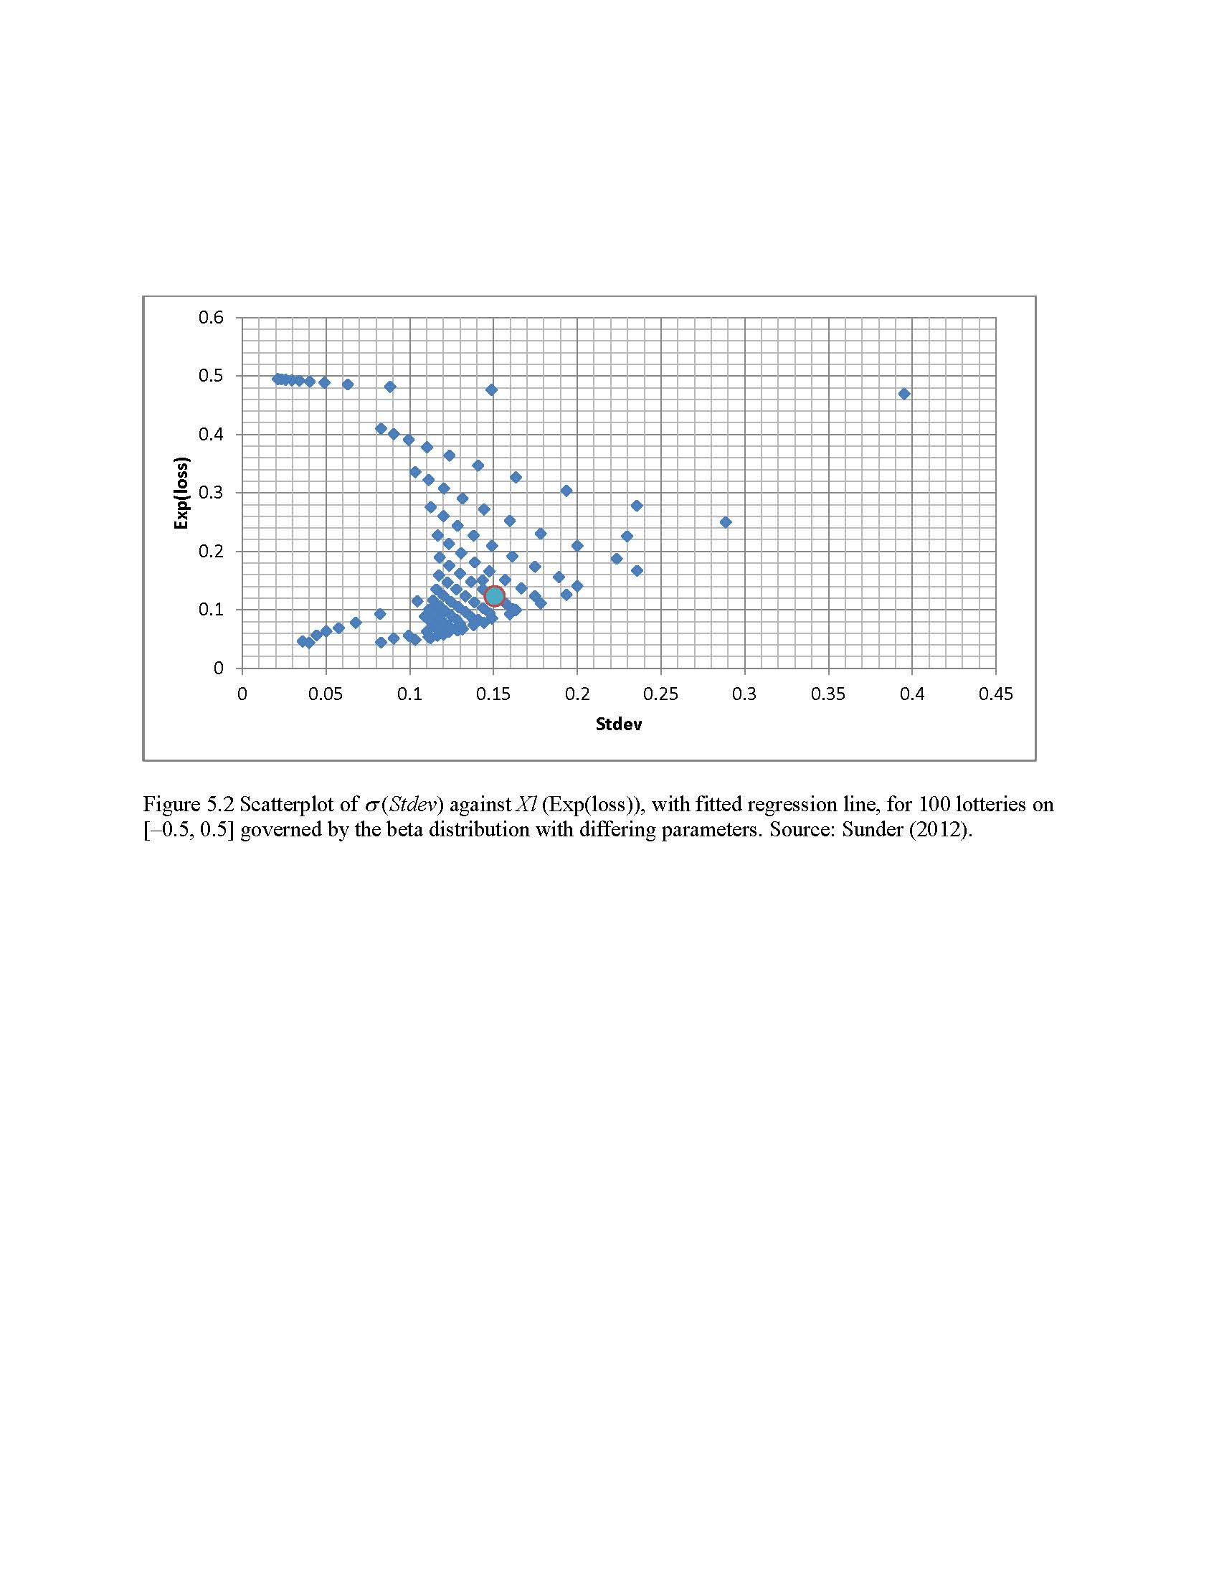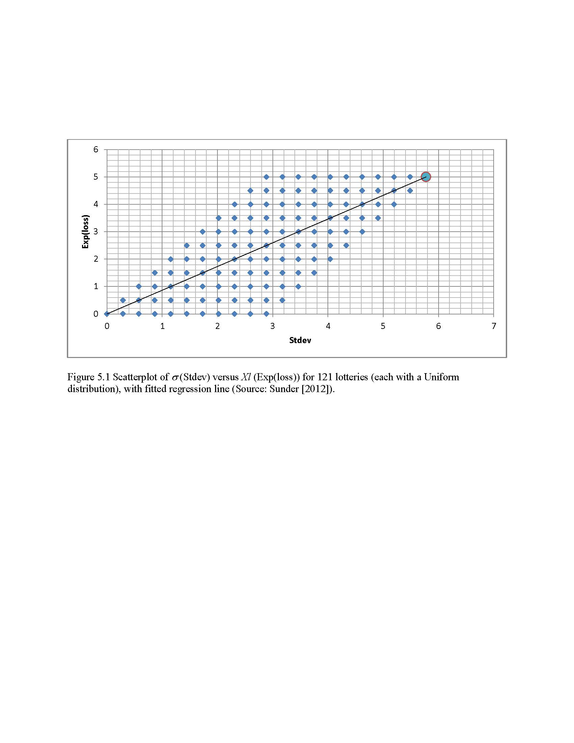

1. Knight said that a decision maker faced risk when probabilities over all possible future states were truly “known” or “measurable,” and faced uncertainty when these probabilities (or some of the possible outcomes) were not known. Knight himself noted that this distinction is different than that of popular discourse.
2. Physicist Max Planck ([1948] 22) expressed a similar thought: “Eine neue wissenschaftliche Wahrheit pflegt sich nicht in der Weise durchzusetzen, daß ihre Gegner überzeugt werden und sich als belehrt erklären, sondern vielmehr dadurch, daß ihre Gegner allmählich aussterben und daß die heranwachsende Generation von vornherein mit der Wahrheit vertraut gemacht ist.” Laue gehaltenen Traueransprache. The translation (as cited in Kuhn, 1970) “A new scientific truth does not triumph by convincing its opponents and making them see the light, but rather because its opponents eventually die, and a new generation grows up that is familiar with it.”
3. A problem with the probability weighting function is that it over weights not just gains and losses that are rare and extreme, but also (contrary to most data) over weights moderate size events if they are rare. This empirical glitch is repaired in cumulative prospect theory (Tversky and Kahneman [1992]) by applying weights to the cumulative probability function instead of directly to the probabilities.
4. Lo (2012), among others, shows how the problem was exacerbated by ambiguous liability for covering higher-than-advertised default rates on products engineered from home mortgages.
5. Not to be confused with variance, Var. Note that VaR has a very similar flavor to risk measures favored by engineers, such as a “100 year flood.”