Answer Key Homework 6

1. a. Common knowledge means all players mutually know the structure of payouts and of the game. Player C knows that players A and B are uncertain about the true nature of C’s own preferences about Paris.

b. To solve this game, first note that whether or not player C has a payout of 4 or 6 for Paris, it has no effect on player C’s preference ordering (that is, player C prefers Paris to Madrid to London in all cases). So, players’ ordered preferences are

A: M > L > P

B: L > P > M

C: P > M > L

Player A gets to propose a city and (common knowledge!) he knows what other players’ preferences are. So player A prefers Madrid most of all but he knows that if he proposes Madrid, both B and C prefer Paris so Madrid will not win the vote and they will stay in Paris, his least preferred option. But if he chooses London, player B will vote in favor and so the group will move to London over Paris which is an improvement for player A. Since order preferences are the same in both cases, the BI solution is player A chooses London and then votes in favor, then player B votes in favor, then player C votes either way because player C is indifferent if there are already two votes against Paris.

c and d. This makes Player C the least happy, so player C gets to propose a new one. Player C knows that Paris won’t beat London (it DID just lose the vote, after all), but knows that he can pick Madrid and be guaranteed player 1’s vote in doing so and Madrid is an improvement over London to C. But then player B gets to choose one and player B can choose Paris knowing that player C will vote in favor. And once that happens, we are in precisely the situation described in part b. If this game is infinitely repeated, there will be an infinite cycle.

e. If x=4, the efficient outcome is either London or Madrid (total payouts of 10 compared to 9 in Paris) but if x=6, the efficient outcome is Paris (total payout of 11 compared to 10). A possible signal would be for them to stage an incentivized practice vote between a city which everybody knows player C values at 5 and Paris; if C votes for Paris, it could send a signal that Paris is valued at more than 5.

2. a.

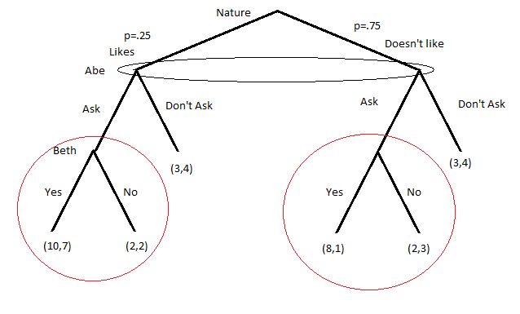

b. Subgames circled in red

c. Subgame perfection requires Beth choosing Yes if she likes Abe and he asks her out and No if she doesnt like Abe and he asks, reducing EFG to

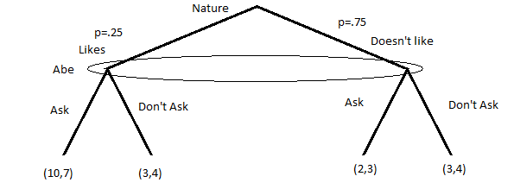

So with p=.25, Abe’s expected payout from Ask is

.25(10) + .75(2) = 4

While expected payout from DA is

.25(3) + .75(3) = 3

So the SPBNE for this game is Abe **Ask**s her out and Beth says **Yes** if she is asked out and likes him and says **No** if she is asked out and she doesn’t like him

d. The borderline probability occurs at the point where payouts become equal (note that Abe is guaranteed a payoff of 3 in all cases if he doesn’t ask):

p(10) + (1-p)(2) = 3

8p + 2 = 3

p=⅛

So if p<⅛ Abe should not ask her and if p> ⅛ he should always ask her and at p=⅛, both are equilibrium strategies.

3. a.

Equilibrium occurs where both strategies have equal fitness: W(H) = W(D)

=

Multiply both sides by 2

For ESS: is this equilibrium stable? If it is stable, any time that the population is off equilibrium, evolutionary pressures should push the population towards the equilibrium. If it is not an ESS, whenever the population is off equilibrium, evolutionary pressures should push the population further away from the equilibrium.

In this case, consider when the population is at equilibrium so p=p*=(v/c). What if there was a freak accident that disproporationately killed off Hawks relative to Doves, such that the population proportion became p’<p*. What happens to fitnesses?

So W(H) > W(D) if

Since we already know that p’<v/c, we know that v-cp’>0. So at any population mix where there are fewer hawks than in equilibrium, hawks have higher fitness than doves. Thus at any p<p* hawks are more fit and so p increase each generation until p=p*. Do the same thing for doves if p>p* and you will see that doves have a higher fitness than hawks if p is too large, so doves will me more reproductively successful. Since if there are too few hawks, hawks grow and if there are too few doves, doves grow, p=v/c must be asymptotically stable equilibrium.

The method for finding ESS as presented in Harrington is more technically correct (ESS are subsets of asymptotically stable equilibria as presented above) and if you checked for ESS this way, it is correct.

9.3.

Solving the subgames reduces the gametree to

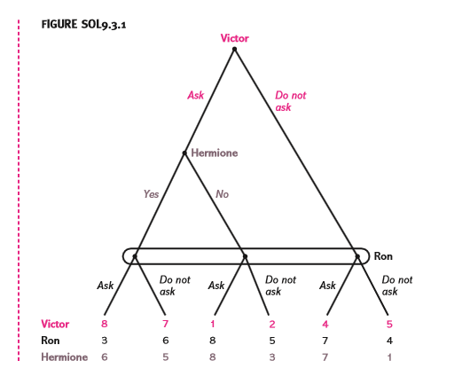

Which can be put into two strategic forms and solved (with * denoting best response)

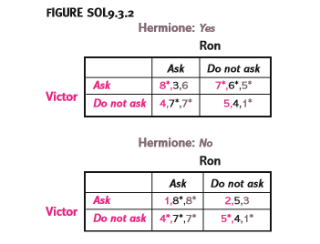

So there are 2 SPNE (strategies in the form of Victor,Hermione,Ron)

(Ask, Yes/Yes/Yes, Do not ask)

and

(Do not ask, No/Yes/Yes, Ask)

10.1

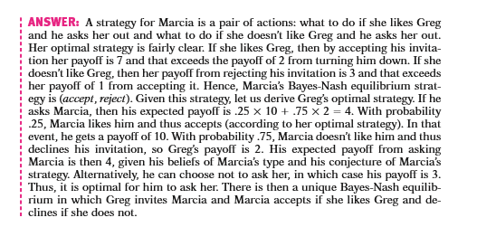

10.3

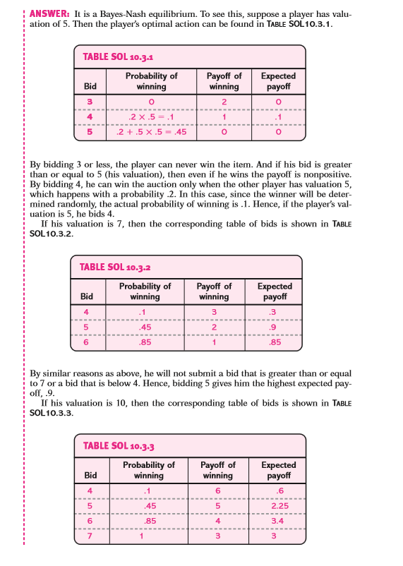

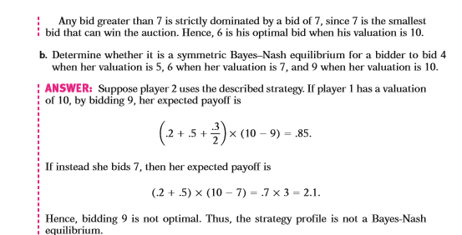

11.5

