ANSWER KEY HOMEWORK 1

1.

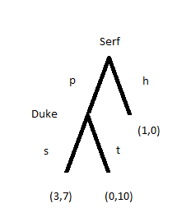

2.

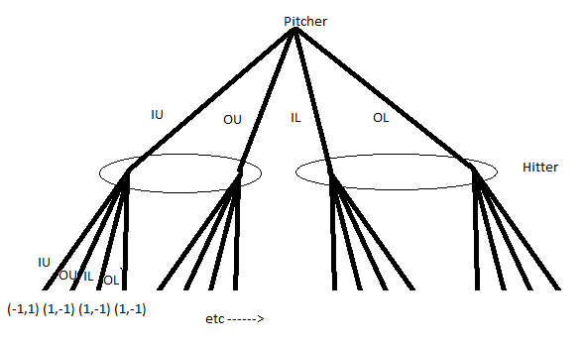

Strategy sets:

Pitcher (4 total): {IU, OU, IL, OL}

Hitter (16 total): {IU/IU, IU/OU, IU/IL, IU/OL, … , OL/OL}

3.

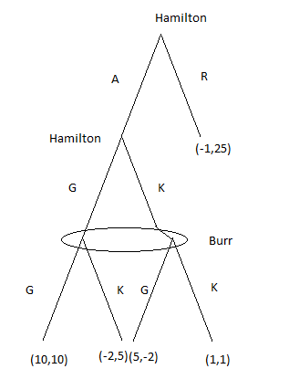

Strategy Sets:

Hamilton: {AK, AG, RK, RG}

Burr: {G, K}

4.

Example Iraq strategy: No WMD/Allow/Allow

Must include instructions at all three places Iraq can move. There are 2 places with two choices and 1 place with three choices, so Iraq has 22(31) = 12 Strategies

UN Strategy set: {Inspect, Do not inspect}

Example US strategy: (No War/War/War/No War)

Must include instructions at all four places US can move. There are 4 places that each have two choices, so the US has 24 = 16 different strategies

5.

|  |  |  |  |  |  |
| --- | --- | --- | --- | --- | --- |
|  |  | P2 |  |  |  |
|  |  | xx | xy | yx | yy |
|  | a | 4,2 | 4,2 | 1,3 | 1,3 |
| P1 | b | 2,2 | 2,2 | 0,6 | 0,6 |
|  | c | 3,1 | 4,2 | 3,1 | 4,2 |
|  | d | 1,5 | 0,0 | 1,5 | 0,0 |

6. Three players ---> Need an extra dimension for the 3rd player to move on

P2 P2

|  |  |  |  |  |  |  |  |
| --- | --- | --- | --- | --- | --- | --- | --- |
|  |  | x | y |  |  | x | y |
|  | a | 4,1,2 | 2,3,0 |  | a | 4,1,2 | 2,3,0 |
| P1 | b | 1,1,1 | 6,0,3 | P1 | b | 1,1,1 | 6,0,3 |
|  | c | 2,3,5 | 2,3,5 |  | c | 1,0,6 | 1,0,6 |
|  |  |  |  |  |  |  |  |
|  | P3 | r |  |  | P3 | s |  |