Continuous Time and Communication in a Public-goods Experiment

Ryan Oprea, Gary Charness and Dan Friedman*

September 4, 2014

Abstract: We investigate the nature of continuous time strategic interaction in public-goods games. In one set of treatments, four subjects make contribution decisions in continuous time during a 10-minute interval while in another they make them only at 10 discrete points of time during this interval. The effect of continuous time is muted in public-goods games compared to simpler social dilemmas and the data suggests that widespread coordination problems are to blame. When we add a rich communication protocol, these coordination problems largely disappear and the median subject contributes completely to the public good with no sign of decay over time. At the median, the same communication protocol is less than half as effective in discrete time.

Keywords: public goods, voluntary contribution mechanism, continuous time games

JEL codes: C72, C92, D70, H41

Acknowledgments: For valuable comments we would like to thank two referees and an Associate Editor of this Journal, as well as Jordi Brandts, David Cooper, Rachel Croson, Martin Dufwenberg, Norman Frohlich, Martin Kocher, Matthias Sutter, Fangfang Tan, Lise Vesterlund, James Walker, and participants at the EWEBE meeting in Munich in October 2011, the North American ESA meeting in Tucson in November 2011, the American Economic Association meeting in January 2012, and the Social Dilemmas conference at Caltech in February 2013.

* Oprea: Economics Department, University of California, Santa Barbara, 2127 North Hall, Santa Barbara, CA 93106, roprea@gmail.com; Charness: Economics Department, University of California, Santa Barbara, 2127 North Hall, Santa Barbara, CA 93106, charness@econ.ucsb.edu; Friedman: Economics Department, University of California, Santa Cruz, 401 Engineering 2 Building, 1156 High Street, Santa Cruz, CA 95064, dan@cats.ucsc.edu

- Introduction

The provision of public goods is critical in every society, yet is typically problematic. Since by definition nobody can be excluded from enjoying public goods once they have been provided, there is the incentive to free ride – to simply allow others to provide the good and make use of it without contributing to it. Formal models of public good provision, one shot or finitely repeated in discrete time, and corresponding laboratory experiments, confirm this free-rider problem.
Our point of departure is the observation that most public goods have a real-time aspect. For example, voluntary contributions of time to neighborhood organizations (like PTA) and of money to charitable organizations (like the Red Cross) are largely asynchronous, and pledge drives for colleges and public radio proceed (all too slowly!) in real time. Team sports, such as soccer and basketball, are another example: provision of individual costly effort takes place over the course of the contest. Co-authors of research papers and co-workers in other types of team production also contribute effort in real time. Efforts to avoid over-using common pool resources (e.g., pollution abatement or using restraint in fishing in common waters) generate flow costs in real time. On the consumption side, we see a continuous flow of utility from many important public goods – national security, the internet, clean air, roads, education, sanitation, to name a few.
Nevertheless, the vast experimental and theoretical literatures (reviewed below) have, almost without exception, assumed that both provision and consumption of public goods is either one-shot or occurs in strict discrete time. That assumption is so pervasive as to escape notice, but it may not be innocuous, because continuous time has the potential to alter the nature of strategic interaction in fundamental ways (e.g., Simon and Stinchombe, 1988). Indeed, a recent experiment (Friedman and Oprea, 2012) shows that continuous time choices and utility flows can generate extremely high rates of cooperation in very simple (2 action) and small (2 player) prisoner's dilemma games. The logic for the result is simple. In their setup, attempts to initiate cooperation are virtually costless as unrequited attempts can be reversed nearly instantly. Likewise, once cooperation is achieved, the temptation to defect drops to nearly zero since experience shows that the other player will match a defection almost instantly. People thus establish and maintain cooperation quite consistently in a two person continuous-time prisoner's dilemma.
There is no compelling theory or evidence to suggest that such cooperative behavior will extend to more complex settings. Multi-player public-goods games, unlike two-player games, pose a difficult coordination problem. To initiate cooperation profitably in our experiment, a player must be confident that every other player will reciprocate fully and promptly; and to deter defection, the non-defectors must coordinate both the timing and severity of punishment. Absent a coordination device, cooperative strategies would seem difficult to implement in continuous-time public-goods games, and therefore continuous time alone may have less impact than in simpler settings. We therefore conjectured that without a coordination device, continuous-time public-goods games will be not much more efficient than discrete-time public-goods games.
Perhaps the most natural coordination device is to allow subjects to communicate. Non-binding free-form communication, after all, has a proven track record at encouraging Pareto-efficient outcomes in many games, as discussed in our literature review below. Of course communication may aid cooperation even in standard discrete-time public goods via moral suasion and promise-keeping. However, communication in continuous time has the added potential to coordinate the near-instant responses that support high rates of cooperation in simpler games. Ours is a very tough environment in which to generate contributions, and the possibility of immediate responses (not present with discrete time) seemed unlikely to deter low or zero contributions. This led us to a second conjecture: with communication, outcomes in continuous time will be much more efficient than in discrete time.
In this paper we report the results of an experiment designed to test these two conjectures. Our 2x2 design varies the timing protocol (discrete time vs. continuous time) and the communication protocol (no communication vs. unrestricted communication). We find support for both of our motivating conjectures. Continuous time per se has only a modest effect on cooperation rates: we observe low initial contributions that decline over time in both discrete and continuous time. However, when we introduce a rich communication protocol, continuous time generates impressively high and sustained cooperation rates: the median subject quickly contributes 100% to the public good and this lasts to the end of the game.
The results also support our second conjecture: at the median, communication leads to less than half as much cooperation in discrete time as in continuous time, and substantially fewer people make high levels of contributions. Moreover, communication works much more slowly and less reliably across the groups (which show evidence of considerable heterogeneity) than with continuous time.
Several other points are worth mentioning. First, we use a very challenging set of parameters: our MPCR is only 0.3 with 4 players, so the payoff difference between zero contributions and full contributions is a mere 20% of earnings. This makes the high cooperation rates achieved in continuous time all the more striking. Second, as reported in section 4.4 below, we ran a robustness communication treatment in which subjects had access to a small set of pre-programmed messages rather than free-form chat. We found that this treatment had little impact on cooperation (relative to no communication) in either continuous or discrete time. As in several previous experiments discussed below, the richness of the message space seems to be an important consideration with respect to the effectiveness of cheap talk.
We see our results primarily as a contribution to the empirical literature on public goods provision. Yet they may have additional interest to theorists, since they illustrate emerging theoretical issues regarding coordination and cooperation, and real-time strategic interaction.
The remainder of the paper is structured as follows. We review related literature in Section 2, and describe our experimental procedures and implementation in Section 3. The results are presented in Section 4, and we offer a discussion in Section 5. Section 6 concludes. Appendices collect instructions to subjects and supplementary data analysis.

- Related Literature
A well-known stylized fact is that there is an intermediate level of contributions in the beginning of standard linear public-goods experiments, but that this declines steadily to a very low contribution rate by the end of 10 periods. Many people are initially attracted to the efficiency of making public contributions, but this proves unsustainable. This is particularly true when the marginal per-capita return (MPCR) is low, as in our design. This pattern is often attributed to the presence of conditional cooperators; these people make contributions until they see that others are not doing so, so the heterogeneity of the participants drives contribution rates down over time. See the surveys by Ledyard (1995) and Chaudhuri (2011) for considerably more background detail.
Three decades of laboratory experiments have identified several different mechanisms for enhancing contribution rates in public-goods games. Each mechanism has some degree of effectiveness. One mechanism, first investigated by Yamagishi (1986, 1988) and Ostrom, Walker, and Gardner (1992), permits players to punish other members of the group at some personal cost. A second mechanism involves sorting players into groups of cooperators and conditional cooperators either endogenously or exogenously. The premise is that many people are conditional cooperators. Excluding non-cooperators, then, can enable conditional cooperators to sustain a high contribution rate.
We employ a third mechanism, communication. Communication does not lead to the inefficiencies (destruction of resources) inherent with punishment, nor does it require the intervention or enforcement of a regulatory institution. Previous experimental work suggests that the impact varies with the game type and the message technology, but the specifics are far from settled. In many situations involving equilibrium selection, such as coordination games, simple forms of anonymous communication are highly effective. For example, Cooper, DeJong, Forsythe, and Ross (1992) shows that access to even simple and pre-fabricated pre-play messages (cheap talk) suffices to implement the payoff-dominant (and therefore the efficient) equilibrium. Charness (2000) finds that communication induces people to play the strategy consistent with payoff dominance 89 percent of the time, compared to 35 percent of the time without communication. In a minimum-effort game, Brandts and Cooper (2007) show that a strategy of specifically requesting high effort and pointing out the mutual benefits of high effort is very effective, even more than increasing the marginal incentive for providing higher effort.
A handful of experimental papers consider various forms of communication in the public-goods game. Early studies by Ostrom, Walker, and Gardner (1992) and Ostrom and Walker (1997) find that face-to-face communication in a public-good game - as well as in other types of social dilemmas- leads to large increases in cooperation throughout a session. Masclet, Noussair, and Villeval (forthcoming) introduce pre-play threats to punish. Participants then chose actual punishment levels after observing the contributions of others. While the possibility of issuing threats is beneficial in the long run, this positive effect is eliminated if people can sanction those who do not carry out their threats, as threats are deterred, and fewer threats are used. This in turn decreases contributions and welfare to levels below those when threats are not feasible. Denant-Beaumont, Masclet, and Noussair (2011) study the effects of announcement and observation on contributions. When announcements of intended contributions are required and contribution decisions are made public, the average level of contributions increases significantly; however, neither of these factors in isolation is sufficient to have a beneficial effect.
There are also a few papers that examine leadership in public-goods games. Potters, Sefton, and Vesterlund (2005) consider an environment with sequential donations; this results in more contributions than with simultaneous donations, because the follower mimics the action of the leader (who is informed about the value of the contribution, while some others are not), who chooses to contribute when this is efficient. Güth, Levati, Sutter, and van der Heijden (2007) find that leadership (with sequential choices) increases contributions, but that only a minority of groups is successful in (endogenously) selecting a leader. Levy, Padgitt, Peart, Houser, and Xiao (2011) have treatments involving suggestions from an elected human leader, a randomly-selected human leader, and from a computer (these matched the suggestions in the elected-human treatment), finding that the decisions of groups are influenced by non-binding contribution suggestions from human leaders, but not by suggestions that do not originate with human leaders.
To the best of our knowledge, Dorsey (1992) is the first paper to employ continuous time in a public-goods setting: throughout the period subjects can make “cheap talk” decisions seen by the other players, but only final decisions count for payment. (As explained below, our continuous flow-payoff setting is strategically very different.) The results are mixed – while Dorsey’s continuous-time treatment increases contributions in provision point (i.e., threshold public goods) games, it is largely ineffective in the standard linear set-up. Kurzban, McCabe, Smith and Wilson (2001) add commitment value to decisions made in Dorsey’s environment and find that this increases terminal contribution rates.
More recently, as noted earlier, Friedman and Oprea (2012) explore a two-person social dilemma in continuous time with a flow payout structure resembling our own. They find remarkably high rates of mutual cooperation, ranging from 81 percent to 93 percent depending on the parameters. Control sessions with repeated matching over 8 discrete time sub-periods achieve less than half as much cooperation, and cooperation rates approach zero in one-shot control sessions. On the other hand, Oprea, Henwood and Friedman (2011) find no tendency for continuous time to encourage cooperation in 12-member groups playing a multilateral Hawk-Dove game.
Evidently continuous time by itself does not automatically boost cooperation. It may well be that communication is also required for effective enforcement mechanisms in multi-player settings. Free-form anonymous communication has been found to lead to a substantial and significant increase in Pareto-improving outcomes even when there is a unique and inefficient equilibrium. Charness and Dufwenberg (2006, 2011) show that free-form communication is quite effective in hidden-action and hidden-information environments. Verbal (chat) communication substantially enhances trusting and trustworthy behavior in Ben-Ner, Putterman, and Ren (forthcoming). Finally, Brandts, Charness, and Ellman (2011) find that free-form communication (but not limited communication) increases both price and quality in a sequential buyer-seller contracting game, leading to higher earnings for both parties.

- Experimental Design and Implementation
We conducted the experiment at the University of California, Santa Cruz. Participants in all sessions were randomly selected (using online recruiting software) from our pool of volunteers, which included undergraduates from all major disciplines. None of them had previously participated in a public-goods experiment. On arrival, people received written instructions (Appendix I) that also were read aloud before beginning the session.
In all treatments, participants played the same public-goods game. Each person received an endowment of 25 tokens and could allocate these between their private account and the group account. Every token retained in the private account was worth one point to that player. Each token put into the group account became worth 1.2 points shared equally across all four people in the group, so the marginal per capita return (MPCR) is 0.3. Relative to no contribution, the societal gain from full contribution is only 20%, while the private risk when other group members free-ride is substantial – one loses 70% of one’s own contribution. These parameters are the least conducive to cooperation of any in the published experimental literature and were selected to create a challenging environment.
The experiment used a software package called ConG, for Continuous Games (see Pettit et al. 2012). Figure 1 shows the user interface. Each participant could adjust her strategy using the slider (seen as a small open rectangle) at the bottom. A position all the way to the left indicates zero contribution; a position all the way to the right indicates full (25) contribution. Contributions of other participants are shown according to an assigned color, and colored bubbles floated above strategies to show current payoff rates.
In our continuous-time treatments, strategies can be moved at any time and as frequently as desired – the computer response time is less than 100 milliseconds, and gives users the experience of continuous action. In the chat treatments a second window showing the history of conversation (with participants shown by color) floats next to the screen.
This screen layout was designed to make the game easy to understand and to enable quick absorption of feedback. Post-experiment questionnaires and discussions with subjects indicate that they found the interface intuitive, and fully understood the rules of the game after the first few seconds.
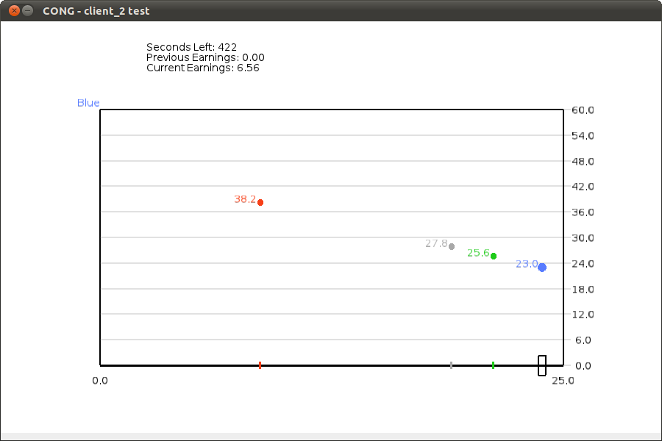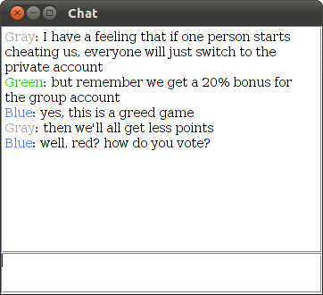

Figure 1: Player screen and chat box. The player screen approximates that of player Blue midway through session CC4, and the chat box contents are excerpted from that session.

The experiment used a software package called ConG, for Continuous Games. Figure 1 shows the user interface. Each participant can adjust her strategy using the slider (seen as a small open rectangle) at the bottom. A position all the way to the left indicates zero contribution; a position all the way to the right indicates full (25) contribution. Contributions of other participants are shown according to an assigned color, and colored bubbles float above strategies to show current payoff rates.

We study two time treatments, Continuous and Discrete. In each case, the total decision-making time (including communication where applicable) was 10 minutes. In Continuous time subjects could freely change allocations at any time and continuously earned flow payoffs according to the parameterized public-goods function described earlier. Allocations of the other three group members were color-coded, and could be seen almost immediately. In Discrete time subjects made their allocation choices during 10 one-minute sub-periods during which they could not see others’ choices. At the end of each minute, the computer took a snapshot of choices and these applied to the entire sub-period. (Participants were aware that decisions at the end of the sub-period were the only ones with payoff relevance.) Participants were then shown the sub-period allocations and received 60 seconds of the corresponding flow payouts (i.e. 1/10 of the nominal sub-period earnings).
Table 1: Treatments
 | No Communication | Full Communication
Discrete | DN: 5 groups | DC: 6 groups
Continuous | CN: 5 groups | CC: 5 groups

The treatments are summarized in Table 1. The exchange rate from lab units to dollars paid was 2.5 to 1. Average earnings for a 30–minute session were $14, including a $5 show-up fee. In both the discrete and continuous treatments, we calculated payoffs based on the average over time each period. In the discrete case, we averaged the ten observations, while in the continuous case we sampled at 100 millisecond intervals and averaged the 60,000 observed outcomes.

- Experimental results
The analysis focuses on the main four treatments, listed in bold in Table 1. Section 4.1 evaluates the two motivating conjectures; the evidence is largely favorable. Section 4.2 examines the underlying dynamics. To better understand the behavioral foundations, section 4.3 examines the variability of strategies within and across groups. Finally, section 4.4 examines the Limited Chat treatment to better understand the robustness of the results.

4.1 Main Results
Figure 2 plots empirical cumulative distribution functions (CDFs) of contribution rates for the four main treatments. Table 2 summarizes the same data in numerical form. Several patterns are worth pointing out.
First, our replication of the standard protocol – the DN treatment – generates a familiar pattern seen repeatedly in previous work: contribution rates on average are small by any metric.
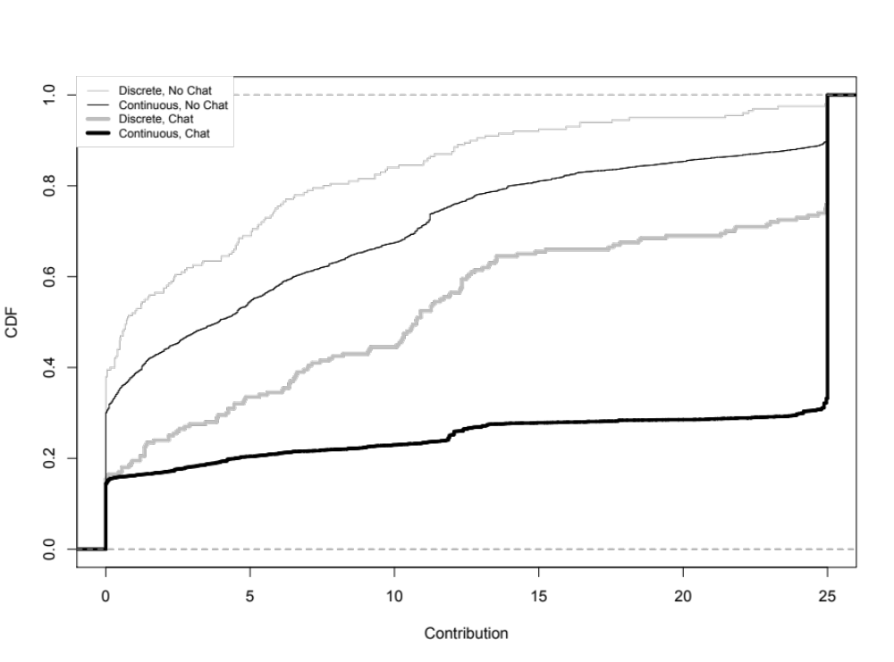
Figure 2: CDFs of contributions by treatment.
Second, while continuous time has a positive impact on contribution rates with or without communication, the size of the effect is modest in the latter case. Participants only contribute fully about 10 percent of the time in the CN treatment and median contributions are about 16 percent of the socially-optimal level. Thus, the data seem to support our first conjecture: continuous time per se has a much smaller impact on cooperation in our public-goods game than in simpler games studied previously.
Third, when communication is added to continuous time, cooperation rates rise to impressive levels. A full 2/3 of the time, subjects contribute everything to the public good, so that the median rate across subjects is 100%. The DC treatment helps to put data from this treatment in perspective. Communication generates a median contribution rate almost half of that observed in continuous time, and the rate of full contribution is less than half of the continuous rate. The data thus qualitatively supports our second conjecture: with communication (and only with communication), the median and mean contributions are substantially higher in continuous-time than in discrete time. Both the mean and median contributions increase by three points from DN to CN, while these increase by seven and 14 points, respectively, from DC to CC.

Table 2: Summary statistics on contributions
Treatment | DN | DC | CN | CC
Median Contribution | 0.71 | 10.75 | 3.89 | 25.00
Mean Contribution | 4.21 | 11.94 | 7.35 | 18.87
Standard Deviation | 6.28 | 9.70 | 8.61 | 10.01
Rate of Maximum Contribution | 0.02 | 0.24 | 0.10 | 0.67

To formally test our first motivating conjecture, we calculate for each group (i) mean contributions and (ii) the rate of maximum contributions. We then compare the distributions of these measures across the DN and CN treatments using Mann-Whitney tests. The differences between these two treatments are small and for neither of the comparisons can we decisively reject the null hypothesis that the distributions are the same (two-tailed p-values are 0.15 and 0.09 respectively). This result, combined with the low increases (three points) in average contributions, leads to our first result:
Result 1: Without communication, continuous time induces only a small and statistically marginal improvement in cooperation relative to discrete time.

To formally test our second conjecture, we calculate the same two measures for each group in the DC and CC treatments. In both cases a two-tailed Mann-Whitney test allows us to reject the hypothesis that distributions are equal (p = 0.03 in both cases). Thus, while continuous time does not increase the level of contributions by very much without communication, it does raise contributions substantially and significantly in combination with communication. This is our second result:
Result 2: With free-form communication, continuous time leads to a strong improvement in cooperation relative to discrete time.

4.2 Dynamics
We have reported aggregate results so far. Figure 3 disaggregates the data over time, plotting the evolution of median and mean contributions over the course of the game. In the DN treatment we replicate the standard finding in the literature: Cooperation begins at moderate levels and drops to nearly zero over time. Continuous time itself does nothing to break this pattern: in the CN treatment there is again clear evidence of cooperative decay.
More interesting patterns emerge with communication. Median rates of cooperation in the CC treatment rise almost immediately to 100% and stay there for the remainder of the game. In the DC treatment, cooperation follows the classical pattern over the first 70 percent of the game, dropping towards zero. However, in the final three periods median contributions rates reverse course, reaching 100% by the end in an interesting inversion of the end-game effect that is often observed in experiments., Means show similar but less extreme dynamics.

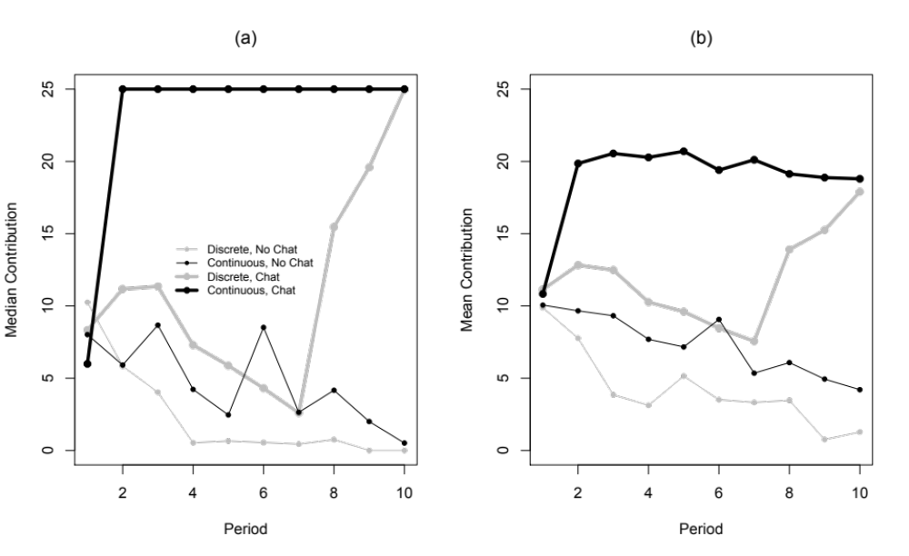
Figure 3: (a) Median and (b) mean contributions by period and treatment.

4.3 Variability and Coordination
Our working hypothesis in designing this experiment was that continuous-time strategies would be difficult to coordinate in settings as rich as public goods games and that communication might mitigate coordination failures. The analysis so far shows that communication indeed unleashes the cooperative potential of continuous time.
But do the data suggest that communication accomplishes this by easing coordination problems? A key indicator is the stability of contribution rates over time. Excessive variability from second to second (or from one discrete period to the next) suggests that players are failing to coordinate their behavior.
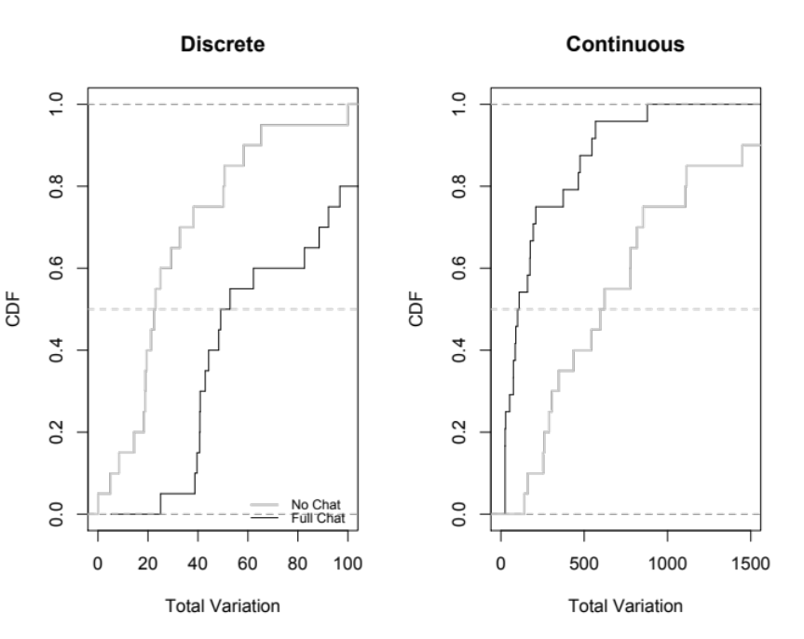
Figure 4: Total variation by treatment

In discrete time, an intuitive way to measure variability is the sum of absolute changes in a player’s choices. That is, if player i chooses contribution level 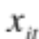 in subperiod t, then the measure is
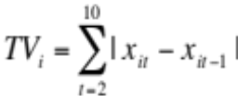,
which is known as Total Variation (TV). The first two columns of Table 3 show that
communication more than doubles TV in our discrete-time treatments.
Table 3: Total Variation in Contribution Rates
 | DN | DC | CN | CC
Mean | 31.0 | 70.1 | 796 | 207
Median | 22.8 | 51.0 | 609 | 105

Mathematicians extend the definition of TV to continuous time by taking the supremum (least upper bound) of expressions like the last one over all discrete time grids:
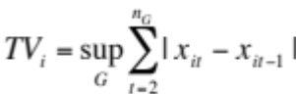
where G is a finite grid of time points 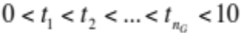 of the 10-minute time interval. The two rightmost columns of Table 3 show that communication greatly decreases TV in continuous time, the opposite of its impact in discrete time.
Figure 4 confirms both effects by looking at the CDFs of individual players’ total variation. Further confirmation comes from conservative, two-tailed group-level Wilcoxon tests, which reject the null hypothesis of equal TV for the two communication treatments with p-values of 0.017 in the Continuous data and 0.008 in the Discrete data.
Together, this analysis gives us a third result:
Result 3: Free-form communication tends to increase the stability of strategies in continuous time. By contrast, free-form communication significantly decreases stability in discrete time.

This result conforms to our intuition on the differential impact of communication in combination with continuous and discrete time. While communication seems to enhance coordination and stabilize behavior in continuous time it has only a rather small impact on total contributions in discrete time. To the contrary, in discrete time, communication actually disrupts coordination on the inefficient Nash equilibrium! While communication is efficiency-enhancing in both cases, it appears to enhance efficiency by stabilizing “good” behavior in continuous time and by destabilizing “bad” behavior in discrete time (but without consistently achieving a higher contribution rate).
It is interesting to note, finally, that these measures likely understate the degree of coordination achieved in the CC treatment. As analysis of the chat data in Appendix III shows, even CC groups that fail to achieve full contribution and that exhibit considerable variability often do so because they (for reasons obscure to us) try to institute a complicated rotation scheme in which one member and then another reaps the maximum individual payoff while the others contribute.

4.4 Robustness: The LC Treatments
We also conduct treatments (six groups with discrete time and five groups with continuous time) to investigate whether high contributions can also be achieved with a rather restricted message space. Here participants could only click buttons with pre-programmed messages (i.e. they could not type out unique messages). The button menu included only the id colors of all other players, “go left”, “go right”, “stay still” and “ok” (for example, the message “Green, go left” is a suggestion for the green player to reduce her contribution). There were no limits on the frequency of communication.
While simple and minimal communication (often with only binary options) has been shown to be very effective in achieving coordination on the Pareto-dominant equilibrium (e.g., Cooper et al., 1992; Charness 2000), it appears to be quite ineffective when there is a unique (and inefficient) equilibrium. For example, Charness (2000) finds that minimalist communication is completely ineffective in escaping a Prisoner’s Dilemma, in sharp contrast to the results in a coordination game, and Charness and Dufwenberg (2010) find that bare promises have only a slight effect in a trust game. In Ben-Ner, Putterman, and Ren (forthcoming), simple numerical messages are rather ineffective in increasing trusting and/or trustworthiness in a trust-game setting. Our LC treatments allow us to examine whether this holds true for our data.
In fact, we do find support for this notion. Table 4 shows the median rate, the mean rate, and the rate of maximum contribution with limited communication. In comparison with the figures in Table 2, we see that these are all intermediate between the rates with no communication and with free-form communication, and generally closer to the no-communication results. In the case of discrete time, the mean contribution rate for limited communication is not significantly different than that for free-form communication or no communication (Wilcoxon-Mann-Whitney rank sum tests give p = 0.421 and p = 0.310, respectively, two-tailed tests). In the case of continuous time, there is no difference in the mean contribution rates with no communication and limited communication (p = 0.66, two-tailed test), while there is a marginally significant difference in the rates with free-form and limited communication (p = 0.065, two-tailed test). The mean total variation is also intermediate, but again much closer to the level observed with no communication, in both continuous and discrete time. Overall, there is no instance in which limited communication leads to significantly different results than with no communication, and this result also holds for patterns over time.

Table 4: Summary statistics on contributions with limited communication

Treatment | CL | DL
Median Contribution | 7.26 | 5.77
Mean Contribution | 10.13 | 8.35
(Standard Deviation) | 9.73 | 8.27
Rate of Maximum Contribution | 0.15 | 0.04

This gives us a fourth result:

Result 4: Limited communication has no significant effect on contributions, relative to having no feasible communication.

- Discussion

We find that public-goods games have substantially more efficient outcomes in continuous than in discrete time, but only if there is a rich communication medium to coordinate strategies. We observe only a small and statistically weak difference between discrete and continuous time in total contributions when communication is not permitted. However, when a suitable communications medium is available, continuous time generates remarkably high contributions – 100 percent at the median -- and no evidence whatsoever of unraveling over time, despite very tough parameters. This is more than twice as large as the rate observed in discrete time with the same communication technology. Moreover contributions in the DC treatment are far slower to increase, noisier and more heterogeneous than in the treatment’s continuous time counterpart, with some groups achieving high contribution levels by the end and other groups decaying almost to zero contribution. The remaining mixed and intermediate treatments likewise produce considerable variability and heterogeneity, but seldom converge to full contribution.

5.1 Underpinnings of our results
Given these striking patterns in the data, it is natural to explore further why they occur. In the rest of this section, we offer some possible reasons, focusing on when players persistently try for high contribution levels, and when they succeed.
A useful point of departure is the continuous time Prisoner’s Dilemma (CPD) experiments mentioned earlier (Friedman and Oprea, 2012). Despite very tough parameters, player pairs managed to achieve very high levels of cooperation via “pulsing” behavior (very brief changes in the level of contributions). This non-verbal form of communication was very effective in conveying threats and promises in continuous time, and the vast majority of the players soon adopted it. By contrast, players in the continuous-time Hawk-Dove (CHD) experiment mentioned earlier (Oprea et al. 2011) had no effective way to communicate – the actions of any one player were hardly visible to the 11 others in the group. Despite facing much easier parameters, the Hawk-Dove players failed to achieve any degree of cooperation.
Our continuous public-goods (CPG) game falls somewhere in between these CPD and CHD games. Each player’s action can be seen clearly by the three other CPG players, but its meaning is not nearly as obvious as to the one other player in CPD. If a player in our CPG game pulses from a very low contribution rate to a high rate and returns after a few seconds, the other players might interpret that as a request to increase their own contributions. Or they might all think that it is someone else’s turn, or just wait to see whether someone else responds. As in the CHD, larger group sizes in the CPG make it difficult to use continuous time strategies CPD subjects use to establish cooperation. A further complication is that the action space is not binary but rather is the entire interval [0, 25]. Absent full communication, the intent of pulses (and other allocation adjustments) remains quite ambiguous.
Free-form chat evidently resolves the ambiguity. Players know that there will be nowhere to hide if they misbehave and, in continuous time, that retribution can come quickly. Being able to respond immediately and in an unambiguous manner seems sufficient to achieve a high level of cooperation. In discrete time, free-form chat still reduces ambiguity and does enhance cooperation rates to some degree, but it seems that the inability to respond immediately reduces the effectiveness of promises and threats.
One question that arises is the extent to which having a large number of multiple periods with small payoffs in each period would give the same results as in our experiment, since one could also signal quite inexpensively in that case. Yet, our sense is that this would not lead to the same outcome. In our view, the experience of continuous action is critical, and this is provided by intervals of less than 100 milliseconds, allowing asynchronous and virtually costless forays into cooperation. Of course the relationship between long lived and continuous time public goods games is an empirical matter, and evidence from Gächter, Renner, and Sefton (2008) seems to support our view. They conduct one non-punishment treatment with 10 periods and another with 50 periods. There is little difference in the contribution rates across these treatments (except for a drop in the last period of the 10-period treatment), as evidenced by their Figure 1.

5.2 Chat content and behavior
To delve more deeply into how free-form communication affected behavior we need to look at the micro-details of the chat in each group in relation to the observed behavior. This means that we have a quite limited set of data points (five in each treatment, except for six in CC), so it is difficult to draw strong conclusions. Nevertheless, we present detailed summaries of the chat logs of each of the 11 full-communication groups listed in Appendix III.
We can make several observations from these micro-results. Three groups in continuous time made four-person agreements that were kept for the duration. One other group made no full agreements, while another group made an initial agreement to rotate that worked, but a new partial agreement to contribute half appeared to de-stabilize matters. Finally, one group was able to cooperate without any explicit agreement, but with references to being a team and having team players. The latter would appear to be a direct influence of a sense of group membership and a reluctance to disappoint others by not being sufficiently pro-social with respect to the group.
It seems clear that agreements amongst all of the group members are the most effective, as three-person agreements usually collapse. It may also be that a sense of solidarity can substitute for explicit agreements, leading to “the dog that didn’t bark” in the case of group 2 (which achieved nearly 100 percent cooperation). The groups with four-person agreements had high contribution rates: 79.85 percent, 92.24 percent, and 93.47 percent; the group that had a four-person agreement in force until people tried to change it had a contribution rate of 74.57 percent during the three periods in question. With the exception of the group 2 case of strong group identity, the lack of a four-person agreement leads to lower contribution rates (48.05 percent for group 5 and about 25.9 percent for group 1 during the time there was no four-person agreement). Four-person agreements were essentially never broken, with only brief deviations that were remedied by quick and successful peer pressure.
Matters are rather different with discrete time. There were only three four-person agreements before the late stages, and two of these were violated. Group 5 was the only one to sustain an agreement throughout the game, and had the highest mean contribution rate of any group. There were also two agreements made in late stages (in groups 2 and 4), and these were kept, leading to high contributions at the end. Also, in contrast to the results with continuous time, there was relatively little discussion on this point, with an average of less than two mentions per group. It seems that in discrete time it is both more difficult to reach four-person agreements and more difficult to sustain them. Perhaps there is less of a sense of camaraderie, as we never observe any discussion of team play; instead we see outbursts of emotion and harsh language.
To some extent, the higher emotional content with discrete time may stem from the fact that there is a build-up to a specific moment and all attention is focused on it; in comparison, with continuous time there is no deadline effect and people seem to be more relaxed. In this respect, there is a sense of immediacy in continuous time, as one can make instant responses to deviations in continuous time and can quickly see the response to a response; in contrast, one must wait to take action in discrete time and must wait another minute or more to see whether the offender makes a suitable response. The possibility of peer pressure is therefore more salient in continuous time. Nevertheless, we do see some trend towards effective agreements at the end of more than one group; perhaps communication in discrete time might also be effective, but just requires more time.
Finally, why is the impact of limited communication so similar to that of no communication? One possibility is that the simple choices from the restricted menu were just not sufficient. However, our sense is that it is impossible with limited communication to actually have the clear agreements that seem so helpful in achieving the high contribution rates that we observe with full communication. In the absence of clear and convincing evidence that others will cooperate, it seems quite difficult to reach efficient non-equilibrium play. On the other hand, we suspect that such simple messages would be quite effective in a coordination game like the Battle of the Sexes, and perhaps lead to explicit alternation between the two pure-strategy equilibria.

- Conclusion

Can subjects in public-goods games generate high levels of cooperation in continuous time settings? The efficacy of continuous time in simple two-player, two-action social dilemmas suggests that possibility, but our findings are more nuanced in our multi-player public-goods game.
Free form cheap-talk communication definitely solves the continuous-time coordination problem. When we allow subjects to communicate using a chat interface in continuous time, median cooperation rates quickly rise to 100% and stay there without diminishing (and volatility overall drops to a very low level). In discrete time, where immediate responses are not possible, cooperation rates are less than half as large under the same communication protocol. The data also suggest that this large effect of continuous time relies on a rich message space: A more limited form of pre-programmed communication, studied in a robustness treatment, has a much smaller effect.
However, continuous time per se has only a small positive impact on total contributions in our four-player, public-goods game relative to the discrete-time treatment. By itself, the continuous-time treatment generates highly volatile contributions, indicating widespread failure of subjects to coordinate their strategies and expectations. We suspect that these two patterns are related: coordination difficulties make it difficult to implement the rapid-fire responses necessary for achieving and sustaining cooperation in simpler continuous time games. As a result contributions start low in continuous time without communication and fall steadily over time, mirroring the typical pattern in discrete-time public-goods games.
Many directions seem promising for future work – research on continuous-time strategic behavior is, after all, still in its infancy. One open question is whether a continuous action space impedes or boosts cooperation relative to a coarse discrete action space in a continuous-time setting, with or without communication. Another open question, with perhaps deeper implications, is whether the difference in the effectiveness of communication between continuous and discrete time will remain in the very long run. The data give conflicting but tantalizing clues. On the one hand a few groups in our DC treatment reverse cooperative decay late in the game and establish full cooperation by the end. On the other hand, some chat content suggests that such late rallies may be an endgame effect, and that more discrete time periods would simply delay their appearance. The answer awaits new experiments that include dozens of additional periods in discrete time.
Although our contribution is empirical, we believe that it offers intriguing hints to theorists. The boundary between coordination games and social dilemma games is not entirely clear in continuous time. We hope that our empirical results encourage more theoretical exploration of that boundary.

References

Ahn, T.K, R. Mark Isaac and Timothy C. Salmon. “Coming and Going: Experiments on
Endogenous Group Sizes for Excludable Public Goods,” Journal of Public Economics, Vol. 93, No. 1-2 (2009), pp. 336-351
Ben-Ner, A., L. Putterman, and T. Ren (forthcoming), “Lavish Returns on Cheap Talk: Non-binding Communication in a Trust Experiment,” Journal of Socio-Economics.
Bigoni, M., M. Casari, A. Skrzypacz, G. Spagnolo (2013). Time Horizon and Cooperation in Continuous Time. Stanford Research Paper n. 2088R.
Brandts, Jordi, Gary Charness, and Matthew Ellman (2011), “Let’s Talk: How Communication Affects Contract Design,” mimeo.
Brandts, Jordi and David Cooper (2007), “It’s Not What You Pay, It’s What You Say: An Experimental Study of Manager-Employee Relationships in Overcoming Coordination Failure,” Journal of the European Economic Association, 5(6), 1223-1268.
Brandts, Jordi and Arthur Schram. “Cooperation and Noise in Public Goods Experiments: Applying the Contribution Function Approach,” Journal of Public Economics, Vol. 79, No. 2 (2001), pp. 399-427
Charness, Gary. “Self-Serving Cheap Talk: A Test Of Aumann's Conjecture,” Games and
Economic Behavior, Vol. 33, No. 2 (2000), pp. 177-194
Charness, Gary and Martin Dufwenberg. “Promises and Partnership,” Econometrica, Vol. 74 (2006), pp. 1579–1601.
Charness , Gary and Martin Dufwenberg. “Bare Promises: An Experiment,” Economics
Letters, Vol. 107, No. 2 (2010), pp. 281-283
Charness, Gary and Martin Dufwenberg. “Participation,” American Economic Review, 101 (2011), 1213-1239.
Charness, Gary, Luca Rigotti and Aldo Rustichini. “Individual Behavior and Group
Membership,” The American Economic Review, Vol. 97, No. 4 (2007), pp. 1340-1352
Charness, Gary and Chun-Lei Yang. “Starting small toward voluntary formation of efficient large groups in public-goods provision,” Journal of Economic Behavior, 102, pp. 119-132.
Chaudhuri, Ananish. “Sustaining Cooperation in Laboratory Public goods Experiments: a
Selective Survey of the Literature,” Experimental Economics, 14(1), (2011), pp. 47-83
Cinyabuguma, Matthias, Talbot Page and Louis Putterman. “Cooperation Under the
Threat of Expulsion in a Public Goods Experiment,” Journal of Public Economics, 89 (2005), pp. 1421–1435
Cooper, Russell, DeJong, Doug, Forsythe, Robert, and Thomas Ross. “Cooperation
without Reputation: Experimental Evidence from Prisoner’s Dilemma Games,” Games and Economic Behavior, 12 (1996), pp. 187-318
Denant-Beaumont, Laurent, David Masclet, and Charles Noussair (2011), “Announcement, Observation, and Honesty in the Voluntary Contributions Game,” Pacific Economic Review, 16(2), 207-228.
Dorsey, R.E. “The voluntary contributions mechanism with real time revisions,” Public Choice, 73 (1992), 261-82.
Duffy, John, Jack Ochs, and Lise Vesterlund (2007), “Giving Little by Little: Dynamic Voluntary Contribution Games,” Journal of Public Economics, 91(9), 1708-1730
Fischbacher, Urs, Simon Gächter, Ernst Fehr. “Are People Conditionally Cooperative?
Evidence from a Public Goods Experiment,” Economics Letters, Vol. 71, No. 3 (2001), pp. 397-404
Friedman, Daniel and Ryan Oprea. “A Continuous Dilemma,” American Economic Review, 102(1), 337-363
Gächter, Simon (2007), “Condiitonal Cooperation: Behavoral Regularities from the Lab and the Field and Their Policy Implications,” Psychology and economics: a promising new cross-disciplinary field (CESifo Seminar Series), pp. 19-50
Gächter, Simon, Elke Renner, and Martin Sefton. “The Long-Run Benefits of
Punishment,” Science, (2008), Vol. 322 (5907), 1510.
Guth, Werner, Vittoria Levati, Matthias Sutter, and Eline van der Heijden (2007), “Leading by example with and without exclusion power in voluntary contribution experiments,” Journal of Public Economics, 91(5-6), 1023-1042
Hoggatt, Austin C. James W. Friedman and Shlomo Gill. “Price Signaling in
Experimental Oligopoly,” The American Economic Review, Vol. 66, No. 2, (1976), pp. 261-266
Isaac, R. M. and J.M. Walker. “Group size and the voluntary provision of public goods,” Journal of Public Economics, 54 (1994), pp. 1-36.
Keser, Claudia and Frans van Winden. “Conditional Cooperation and Voluntary
Contributions to Public Goods,” The Scandinavian Journal of Economics,Vol. 102, No. 1 (2000), pp. 23-39
Kurzban, Robert, Kevin McCabe, Vernon Smith, and Bart Wilson (2001), “Incremental commitment and reciprocity in a real-time public good s game,” Personality and Social Psychology Bulletin, 27(12), 1662-1673
Ledyard, John O. Public Goods: A Survey of Experimental Research. Handbook of
Experimental Economics, Princeton: Princeton University Press, (1995)
Levy, David, Kail Padgitt, Sandy Peart, Daniel Houser and Erte Xiao, 2011, “Leadership: cheap talk, real cheap talk,” Journal of Economic Behavior and Organization.77, 40–52
Masclet David, Charles Noussair, and Marie-Claire Villeval. “Threat and Punishment in Public Goods Experiments,” Economic Inquiry, forthcoming
Oprea, Ryan, Keith Henwood and Daniel Friedman. “Separating the Hawks from the
Doves: Evidence from Continuous Time Laboratory Games,” Journal of Economic Theory, Vo 146, Issue, 6 (2011) pp. 2206-2225.
Ostrom, Elinor, James Walker and Roy Gardner. “Covenants With and Without a Sword:
Self-Governance is Possible,” The American Political Science Review, Vol. 86, No. 2 (1992), pp. 404-417
Page, Talbot, Louis Putterman and Bulent Unel. “Voluntary Association in Public Goods
Experiments: Reciprocity, Mimicry and Efficiency,” The Economic Journal, 115 (2005), pp. 1032–1053
Pettit, James, Daniel Friedman, Curtis Kephart and Ryan Oprea. “Continuous Game Experiments.”
Potters, Jan, Martin Sefton, and Lise Vesterlund (2005), “After you – Endogenous Sequencing in Voluntary Contribution Games,” Journal of Public Economics, 89(8), pp. 1399-1419
Simon, Leo and Maxwell Stinchcombe. “Extensive Form Games in Continuous Time: Pure Strategies,” Econometrica, Vol 57, No. 5 (1989), pp. 1171-1214.
Sonnemans, Joep, Arthur Schram, Theo Offerman. “Strategic Behavior in Public Good
Games: When Partners Drift Apart,” Economics Letters, Vol. 62, No. 1 (1999), pp. 35-41
Yamagishi, Toshio. “The Provision of a Sanctioning System as a Public Good,” Journal
of Personality and Social Psychology, Vol 51, No. 1, (1986), pp. 110-116
Yamagishi, Toshio. “The Provision of a Sanctioning System as a Public Good,” Social
Psychology Quarterly, Vol. 51, No. 3 (1988), pp. 265-271
Appendix I
A separate instruction set was distributed in each treatment but great pains were taken to maintain the same language across treatments wherever possible. Below we provide instructions sets from two of our treatments as examples. Section I.A. reproduces the Discrete, Full Communication (DC) instructions while section I.B. reproduces the Continuous, Full Communication (CC) instructions.

I.A Discrete, Full Communication (DC) Instructions

Instructions (DC-PG)
Welcome! This is an economics experiment. If you pay close attention to these instructions, you can earn a significant sum of money, which will be paid to you in cash at the end.
Please remain silent and do not look at other participants’ screens. If you have any questions, or need assistance of any kind, please raise your hand and we will come to you. If you disrupt the experiment by talking, laughing, etc., you may be asked to leave and may not be paid. We expect and appreciate your cooperation today.

The basic idea
At the beginning of the experiment, you will be anonymously matched with three other participants. You will each choose an allocation, which can be adjusted during the experiment. Your earnings accumulate at a rate that depends on the allocation you choose and the allocations chosen by the other participants you are matched with. The details are explained below.
The earnings you accumulate will be added up at the end of the experiment, and converted to US dollars at a rate written on the white board. Before you leave the lab, you will sign a receipt and will be paid in cash.

How earnings are computed
You have 25 tokens, and you choose how many tokens to allocate to the group account and how many to allocate to your private account. Each token in your private account always pays a rate of 1.0 point. Each token allocated to the group account yields a rate of 1.2 points, divided equally among all members of your group.
You can choose any allocation of the 25 tokens; fractional tokens are OK. You will be able to adjust your allocation choice during the experiment.

For example, suppose that you always allocate 20 tokens to your private account and 5 to the group account, and that the combined allocation of the other 3 members of your group is always 20 tokens. Then the group account would total 25 tokens and it would yield 1.2* 25 = 30 points distributed equally to the 4 members. You then would receive 7.5 points from the group account and 20 from your private account, a total of 27.5 points.
On the other hand, suppose that you always contributed 15 tokens to the group account and kept 10 for your private account, and that the combined group allocation of the other 3 members was 40 tokens. Then the group account has 55 tokens and you would receive 10 + 1.2 * 55/4 = 10 + 16.5 = 26.5 points. If you spent half the session in a situation that paid 27.5 points and the other half in a situation that paid 26.5 points, then you would earn (27.5+ 26.5)/2 = 53/2 = 27 points.

To give a few more examples, if everyone places all of their tokens in their private account, each player will earn at a rate of 25 points. In this situation, were you to instead unilaterally put all of your tokens in the group account you would earn 7.5 points while the other people in the group would earn 32.5.

If everyone places all of their tokens into the group account, each player will earn at a rate of 30 points. In this situation, were you to instead unilaterally put all of your tokens in the private account, you would earn 47.5 points while the other people in the group would earn 22.5.

Screen display
It’s hard to keep track of your earnings when you and the other members of your group are adjusting allocations during the experiment. The computer does the calculations for you, as in Figure 1. You drag the rectangular slider at the bottom of the screen to adjust your allocation to the group account between 0 and 25; the rest stays in your private account.
The experiment will be divided into ten consecutive one-minute sub-periods. The rectangular bar at the top of the screen will show how much time has elapsed so far in the current sub-period; when the bar is completely filled, the sub-period is over. During each sub-period you will secretly choose an allocation and other participants will do the same. The computer will use only the allocations selected at the moment the sub-period ends and will pay no attention to slider positions earlier in the sub-period.

At the beginning of the experiment, a message on the screen will tell you the color assigned to you. Colored dots will appear each sub-period to show the allocation choices and earnings for you and the other members of your group from the previous sub-period. Dots further to the right indicate larger allocations to the group account, and higher dots indicate larger earnings that sub-period; exact earnings in the previous sub-period are shown in the numbers floating next to each dot.

Above the box you will see how many sub-periods are left in the experiment, and your “Current Earnings” shows your points accumulated so far.

Chat window
During the experiment you will have access to a Chat window, as in Figure 2. You simply type in any permissible message, hit Return, and your message will be shown to all of the people in your group. You can adjust your allocation choice and chat at the same time, if you wish. Messages will be color-coded using the same color assignments used for dots.
In chat, you are permitted to discuss anything related to today’s experiment, but not to reveal your true identity or to discuss what might happen outside the lab. All chat messages will be recorded permanently, so please avoid trash talk.

Frequently asked questions

Q1. Is this some kind of psychological experiment with an agenda you haven't told us?
Answer. No. It is an economics experiment. If we do anything deceptive or don't pay you cash as described then you can complain to the campus Human Subjects Committee and we will be in serious trouble. These instructions are meant to clarify the game and to explain you how you earn money; our interest is simply in seeing how people make decisions.

Q2. Will the formula for calculating earnings ever change? Is there any random element?
Answer. The earnings calculation never changes, and there is no random element. Your earnings depend entirely on your allocation decisions and those of the other members of your group.

Figure 1

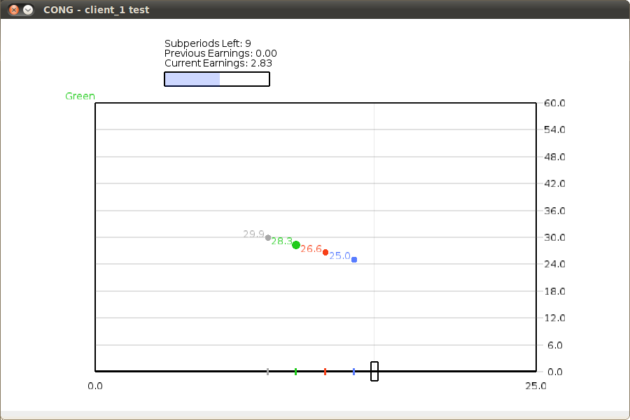

Figure 2

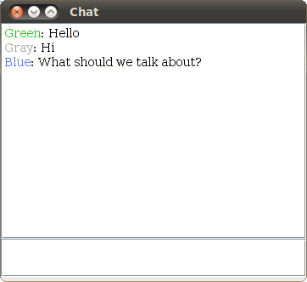
I.B Continuous, Full Communication (CC) Instructions

Instructions (CC-PG)

Welcome! This is an economics experiment. If you pay close attention to these instructions, you can earn a significant sum of money, which will be paid to you in cash at the end.
Please remain silent and do not look at other participants’ screens. If you have any questions, or need assistance of any kind, please raise your hand and we will come to you. If you disrupt the experiment by talking, laughing, etc., you may be asked to leave and may not be paid. We expect and appreciate your cooperation today.

The basic idea
At the beginning of the experiment, you will be anonymously matched with three other participants. You will each choose an allocation, which can be adjusted during the experiment. Your earnings accumulate at a rate that depends on the allocation you choose and the allocations chosen by the other participants you are matched with. The details are explained below.
The earnings you accumulate will be added up at the end of the experiment, and converted to US dollars at a rate written on the white board. Before you leave the lab, you will sign a receipt and will be paid in cash.

How earnings are computed
You have 25 tokens, and you choose how many tokens to allocate to the group account and how many to allocate to your private account. Each token in your private account always pays a rate of 1.0 point. Each token allocated to the group account yields a rate of 1.2 points, divided equally among all members of your group.

You can choose any allocation of the 25 tokens; fractional tokens are OK. You will be able to adjust your allocation choice during the experiment.

For example, suppose that you always allocate 20 tokens to your private account and 5 to the group account, and that the combined allocation of the other 3 members of your group is always 20 tokens. Then the group account would total 25 tokens and it would yield 1.2* 25 = 30 points distributed equally to the 4 members. You then would receive 7.5 points from the group account and 20 from your private account, a total of 27.5 points.
On the other hand, suppose that you always contributed 15 tokens to the group account and kept 10 for your private account, and that the combined group allocation of the other 3 members was 40 tokens. Then the group account has 55 tokens and you would receive 10 + 1.2 * 55/4 = 10 + 16.5 = 26.5 points. If you spent half the session in a situation that paid 27.5 points and the other half in a situation that paid 26.5 points, then you would earn (27.5+ 26.5)/2 = 53/2 = 27 points.

To give a few more examples, if everyone places all of their tokens in their private account, each player will earn at a rate of 25 points. In this situation, were you to instead unilaterally put all of your tokens in the group account you would earn 7.5 points while the other people in the group would earn 32.5.

If everyone places all of their tokens into the group account, each player will earn at a rate of 30 points. In this situation, were you to instead unilaterally put all of your tokens in the private account, you would earn 47.5 points while the other people in the group would earn 22.5.

Screen display
It’s hard to keep track of your earnings when you and the other members of your group are adjusting allocations during the experiment. The computer does the calculations for you, as in Figure 1. You drag the rectangular slider at the bottom of the screen to adjust your allocation to the group account between 0 and 25; the rest stays in your private account.
The experiment will last for ten minutes. Each participant will be randomly assigned an initial allocation and will be allowed to freely adjust his or her own allocation choice throughout the experiment. At each moment, your earnings will accumulate at a rate determined by your current choice and the current choices of other members of your group.

At the beginning of the experiment, a message on the screen will tell you the color assigned to you. Colored dots will always show the current allocation choices and earnings rate for you and the other members of your group. Dots further to the right indicate larger allocations to the group account, and higher dots indicate larger earnings that sub-period; exact earnings rate are shown in the numbers floating next to each dot.
Above the box you will see how many seconds are left in the experiment, and your “Current Earnings” shows your points accumulated so far.

Chat window
During the experiment you will have access to a Chat window, as in Figure 2. You simply type in any permissible message, hit Return, and your message will be shown to all of the people in your group. You can adjust your allocation choice and chat at the same time, if you wish. Messages will be color-coded using the same color assignments used for dots.
In chat, you are permitted to discuss anything related to today’s experiment, but not to reveal your true identity or to discuss what might happen outside the lab. All chat messages will be recorded permanently, so please avoid trash talk.

Frequently asked questions

Q1. Is this some kind of psychological experiment with an agenda you haven't told us?
Answer. No. It is an economics experiment. If we do anything deceptive or don't pay you cash as described then you can complain to the campus Human Subjects Committee and we will be in serious trouble. These instructions are meant to clarify the game and to explain you how you earn money; our interest is simply in seeing how people make decisions.
Q2. Will the formula for calculating earnings ever change? Is there any random element?
Answer. The earnings calculation never changes, and there is no random element. Your earnings depend entirely on your allocation decisions and those of the other members of your group.

Figure 1

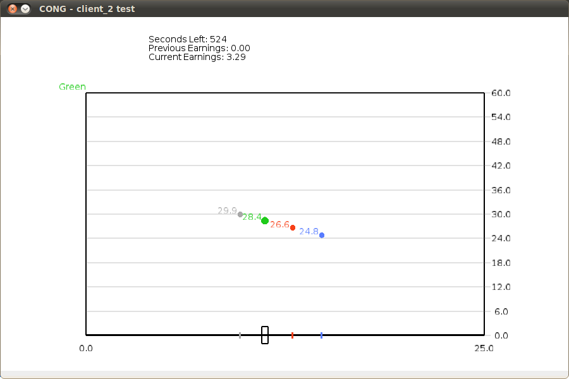

Figure 2

Appendix II: Supplementary Analysis of Choice Data

Table II.1: Summary Statistics By Treatment and Group

Treatment | Group | Median | Mean | Rate of Max Play | Total Variation
CN | 1 | 6.468 | 9.110 | 0.022 | 4451
CN | 2 | 11.270 | 13.182 | 0.293 | 2088
CN | 3 | 0.357 | 5.254 | 0.098 | 2341
CN | 4 | 0.000 | 1.393 | 0.015 | 851
CN | 5 | 5.536 | 7.830 | 0.085 | 6190
CL | 1 | 1.587 | 6.954 | 0.059 | 1647
CL | 2 | 0.000 | 2.648 | 0.001 | 622
CL | 3 | 13.413 | 13.049 | 0.148 | 2700
CL | 4 | 11.587 | 12.179 | 0.152 | 5477
CL | 5 | 3.690 | 6.876 | 0.038 | 3826
CL | 6 | 24.960 | 19.066 | 0.485 | 4118
CC | 1 | 8.016 | 10.496 | 0.160 | 1953
CC | 2 | 25.000 | 24.292 | 0.968 | 100
CC | 3 | 25.000 | 19.963 | 0.728 | 498
CC | 4 | 25.000 | 23.061 | 0.902 | 679
CC | 5 | 11.865 | 12.013 | 0.323 | 1516
CC | 6 | 25.000 | 23.368 | 0.927 | 214
DN | 1 | 1.379 | 3.452 | 0.000 | 75
DN | 2 | 6.111 | 7.023 | 0.000 | 152
DN | 3 | 0.000 | 1.250 | 0.000 | 46
DN | 4 | 0.397 | 4.198 | 0.050 | 162
DN | 5 | 2.599 | 5.125 | 0.050 | 186
DL | 1 | 0.000 | 2.796 | 0.025 | 102
DL | 2 | 5.179 | 6.744 | 0.000 | 234
DL | 3 | 0.000 | 4.048 | 0.100 | 215
DL | 4 | 11.091 | 10.749 | 0.050 | 254
DL | 5 | 18.294 | 17.401 | 0.000 | 109
DC | 1 | 6.806 | 10.301 | 0.100 | 307
DC | 2 | 6.587 | 10.092 | 0.225 | 223
DC | 3 | 11.270 | 10.088 | 0.025 | 228
DC | 4 | 10.218 | 11.704 | 0.150 | 219
DC | 5 | 25.000 | 17.502 | 0.700 | 425

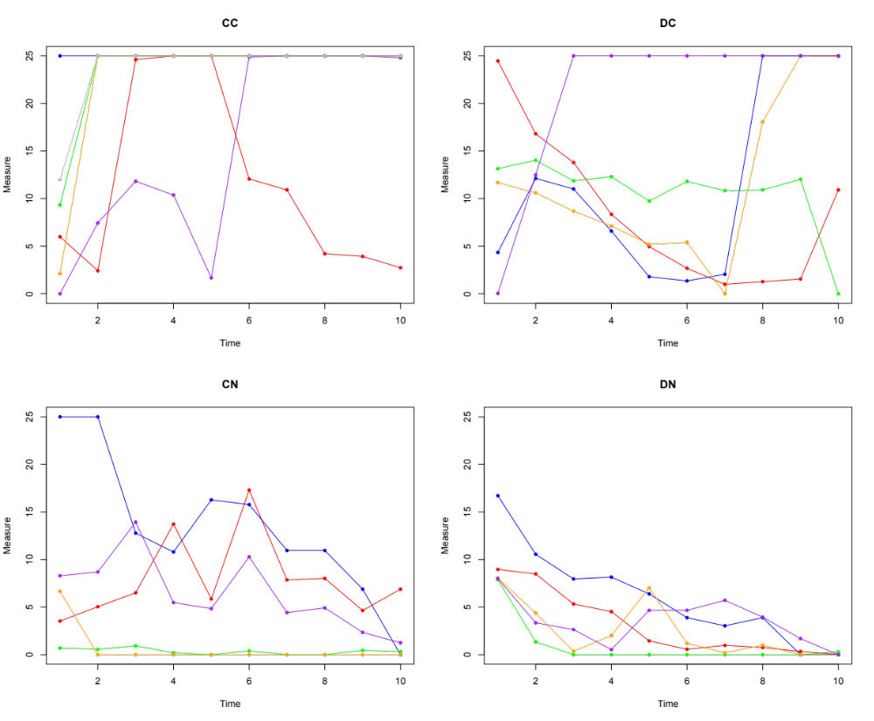
Figure II.1: Median contribution over time, by group
Note: In panel CC, one group -- plotted in gray -- nearly perfect overlaps other groups
and is therefore difficult to distinguish. This group achieves 100% cooperation by the
second bin and experiences a slight reduction in cooperation at the very end.

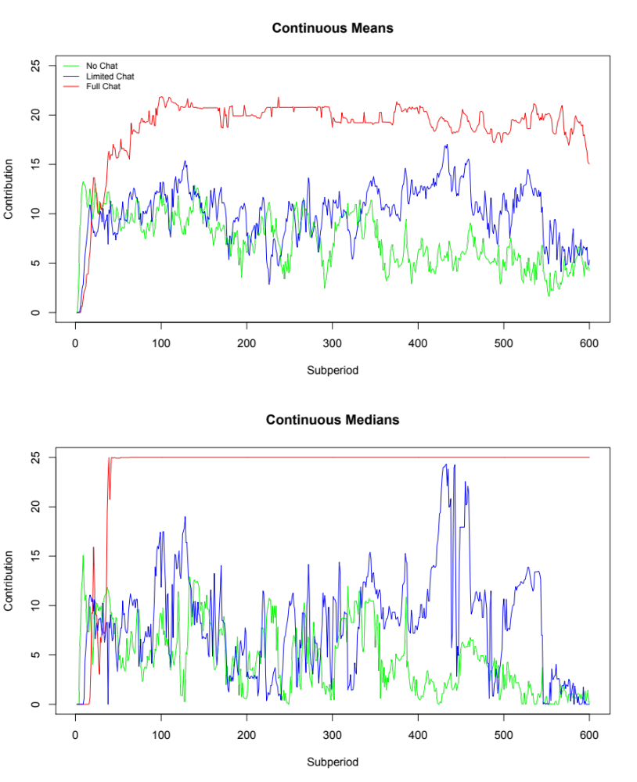

Figure II.2: Mean and Median contributions for continuous treatments aggregated by second.

Appendix III: Discussion and Analysis of Chat Data
Groups in the continuous-time treatment
We first examine the six CC groups, cross-referencing the summary statistics from Appendix I and the time series graphed in Figure 4 of Appendix I. Below, we provide summaries of the behavior and the communication for each group.

- CC Group 1 had the lowest mean contribution rate (10.496/25 = 41.98 percent) and the highest total variation. Here there was an agreement at about minute 2.5 to allow one person at a time to not contribute. This worked for a while and another agreement was proposed (to contribute half); however, this one was only kept by three people and lasted only briefly. This then broke down almost completely.
- Group 2 had an extremely high mean contribution rate (97.17 percent) and the lowest total variation. People started contributing 25 from the beginning, with no agreements made. Communication consisted of words of encouragement, such as “Good job team”, “Team players”, and “Haha yeah glad we got a good team tho”.
- Group 3 had a moderately high contribution rate (79.85 percent) and an intermediate level of total variation. There was an initial agreement to all contribute 25, which was kept for about 2.5 minutes. A new agreement was then made to alternate one person out from contributing; this was kept until near the end, when everyone contributed 25.
- Group 4 had a high mean contribution rate (92.24 percent) and an intermediate level of total variation. There was an early agreement to contribute 25, which was kept by all except for a brief deviation at the end of the third minute (from which the deviating party was cajoled) and a small deviation at the very end. One of the players wanted to deviate in the middle of the game, but was talked out of it.
- Group 5 had a relatively low mean contribution rate (48.05 percent) and considerable total variation. There was a three-party agreement early on, but it was only kept briefly (probably because two people made no contributions). After minute 1.5, only two players communicated (and frequently), keeping an agreement to contribute 25 for the rest of the game, despite the others’ behavior.
- Group 6 had a very high contribution rate (93.47 percent) and a low level of total variation. Here there was an early agreement to contribute 25, which was maintained until the end, except for some brief deviations by two of the players near the end. Severe admonishments by the others stopped these deviations.

Groups in the discrete-time treatment
- Group 1 had an intermediate mean contribution rate (41.20 percent) and a moderate level of total variation. There were no full agreements, but there was an early 3-person one. When the other didn’t cooperate at t= 60 seconds (and was excoriated), cooperation broke down. Two people tried to get it going later, but failed.
- Group 2 had an intermediate mean contribution rate (40.37 percent) and a moderate level of total variation. There was an early agreement on contributing half, but only three people did so; people complied with a new agreement for one period, then it decayed. New agreement for 25 at t=480; an excuse at 480, a defection (followed by chastisement) at 540, and full contribution at the end.
- Group 3 had an intermediate mean contribution rate (40.35 percent) and a low or moderate level of total variation. There were no real agreements, just some partial ones that weren’t honored. Strong words and complaints in the middle, with some people displaying considerable annoyance until the end. Some people doing half and some people did very little; these were not always the same people.
- Group 4 had an intermediate mean contribution rate (46.82 percent) and a low level of total variation. An early agreement to contribute half was violated, with an apology. It was then kept once and slipped away, with more violations. They agreed to be selfish at 360, and then were able to agree to contribute 25 at the end.
- Group 5 had a relatively high mean contribution rate (70.01 percent), as well as a high level of total variation. There was an early agreement to rotate one person out, but there was some confusion. But the alternation was successful from period 3 to the end, except that everyone contributed 25 at the very end.

Continuous-time groups (CC)

Group 1 (Red line)

- Agreement at 110 by all to alternate one person to the left every 30 seconds. Kept until around 255, when another agreement was proposed
- Agreement to go halfway at around 255. Worked for 3 people, but only briefly. It broke down into intermittent behavior after that. No later agreements made.

Group 2 (Blue line)

- No agreements at all. All started contributing from the beginning.

Group 3 (Green line)

- Agreement to all contribute 25 at 21.
- At around 167, then there was an agreement for one person at a time to contribute 0, with red going first. Red then went for about the agreed time. Then Green did so, and then Blue did so. And then Gray did so briefly, and then all contributed 25 for the last 100 seconds or so.

Group 4 (Orange line)

- Agreement at around 70 to all contribute 25. Three people deviated briefly at around 170 and then went back after some cajoling at around 180-190. Then people all contributed 25 until the end. Red wanted to deviate throughout the 200’s, but was talked out of it.

Group 5 (Purple line)

- Agreement by 3 people at around 84, but not Gray. Then not much happened until around 300, when both Red and Green started contributing 25 (until the end), apparently not minding that Blue and Gray weren’t helping. And only Red and Green communicated after 98.

Group 6 (Gray)

- Agreement at about 30 to contribute 25. Maintained until the end, except for some brief deviations by Gray and Blue near the end. These deviations were stopped by severe admonishments by Red and Green at 562-565.

Discrete-time groups (DC)

Group 1 (Red line)

- Three people agreed at 45 to put all in, but Green didn’t communicate. Green then contributed a little at 60, while everyone else contributed 25.
- Green was excoriated at 67-68 and 88. At 120, Red and Blue contributed little, while Green and Gray contributed a lot.
- Blue promised to go to the right at 143, and did so. But Green did not and Red lost faith. Green resisted public and got harangued throughout the 200’s and did cooperate at 180 and 240. But by then none of the other 3 were contributing much.
- Intermittent attempts at cooperation later, but without much success. No agreements.

Group 2 (Blue line)

- Agreement on halfway before 60. Complaint about Green at 80.
- New agreement at 99. Everyone complied at half.
- Decay at 180. Stayed low until new agreement at 471.
- 3 people went right at 480, but not Red, who made an excuse.
- Agreed again, but this time Green defected. Complaint. New agreement, and this time they all did 25 at 600.

Group 3 (Green line)
- Discussion early on about efficiency vs. greed, but no agreement. An attempt at agreement to go half at 180, but not everyone agreed, and Green defected.
- Some partial agreement to go half at 240, but not honored by 2 people. Lots of complaints/strong words between 240 and 300. And they stayed aggravated until the end, with some people doing half and some doing very little.

Group 4 (Orange line)

- Agreed early on middle, but Blue defected at 60. Blue “apologized” and agreed on middle for 120. Kept agreement, some slippage at 180.
- Some discussion about doing 25 at 240, but no agreement. Green was selfish again.
- Agreed on left at 360 and followed through.
- Agreed to go more to the right for 480 and they did. Then agreed on all the way right at around 500 and did so at 540 and 600.

Group 5 (Purple line)

- No solid agreement before 60; Green was the only one to contribute. Agreement at 90 for 3 people to contribute at 120, with rotation to private for one. But it didn’t get implemented for 120 (Green defected), but there was some confusion. Worked at 180, rotated successfully at 240. Agreement for Blue to go left at 300, all followed it. Successful alternation all the way until the end, when everyone contributed 25. There was a lot of discussion about how to choreograph this.

Of course, both one-shot and discrete time provision and consumption are idealizations of reality, as is our continuous time setup.
We discuss this issue in greater detail in section 5.1.
We also conduct sessions where there is only a limited message space in order to see whether full free-form communication was needed to generate a high level of contribution. We report the design and results in section 4.4.
For a review and a discussion of policy implications regarding conditional cooperation, see Gächter (2007).
A number of studies have considered this approach. See, for example, Sonnemans, Schram, and Offerman (1999), Keser and van Winden (2000), Fischbacher, Gächter, and Fehr (2001), Brandts and Schram (2001), and Fischbacher and Gächter (2009, 2010). Cinyabuguma, Page, and Putterman (2005) and Charness and Yang (2014) find that groups that can expel individuals achieve higher contribution levels. See also Page, Putterman, and Unel (2005) and Ahn, Isaac, and Salmon (2009).
Duffy, Ochs, and Vesterlund (2007) find a related result in a discrete time public goods game with a threshold component.
Bigoni et al (2013) confirm these results, and investigate the impact of alternative termination rules.
Throughout this article, we conduct tests using group-level data (5-6 groups per treatment) to ensure the independence of each observation.
To maintain comparability with the Discrete treatments, the Continuous data are aggregated over 60-second intervals in this Figure. The full detail for the Continuous treatments can be seen in Appendix II.
It is not clear whether the late movement to full contribution is a long-run trajectory for some groups or whether this is an entirely artifactual end-game effect. One group with this pattern mentioned the notion of “let’s get there at least at the end” before achieving full contribution, while the other group with this pattern did not. Our suspicion is that some groups will indeed eventually converge to full contribution in DC, while others will converge to little or no contribution. But of course this is an empirical question requiring more evidence.
As Appendix II shows, these aggregates mask considerable heterogeneity in the communication treatments. In the CC treatment, five of the six groups converged on full contribution while one other group seems to be drifting down to the zero-contribution level. The panel for the DC treatment indicates even more of a split, with three groups making full contributions at the end (with only two of these groups ramping up these contributions in the final three periods as in the aggregate plot) and two other groups having very low contributions at the end.
We observe similar patterns using means instead of medians, but the patterns are more compressed. This compression arises from the fact that much of observed behavior is bunched up at boundary points of the action space, e.g., near 25 in the CC treatment and near 0 in the DN treatment. Errors near boundary points are, of course, asymmetrically distributed, which mechanically pushes the mean into the interior. The upshot is that, in this environment, the mean can be quite misleading as a measure of central tendency.
Familiar dispersion measures such as variance fail to capture variability over time. For example, a variance of 100 in a discrete time setting could arise either from a single change of the contribution rate from 24 in periods 1-5 to 0 in periods 6-10, or else from violent fluctuations each period, e.g., 24 in odd periods and 0 in even periods.
Most of these results do not change if we omit the first 60 seconds (to allow time for communication to get under way) before calculating by-session medians. The only exception is that the difference between CL and CC strengthens (p = 0.041), further supporting our hypothesis that richness of protocol is important.
Some readers may be curious about the marginal effect of communication. The communication effect is 50% larger at the mean and 200% larger at the median in continuous than in discrete time. The difference is statistically significant using OLS and quantile regressions that control for subject-wise heterogeneity. However with the most conservative clustering, the statistical significance fades, due in large part to group-to-group heterogeneity.
Hoggatt, Friedman and Gill (1976) document pulsing behavior in an early near-continuous time oligopoly game with a similar action space; they observed considerable heterogeneity and variability. One of the co-authors participated in these experiments as a student in the Berkeley MBA program.
Note that a sense of group membership might affect behavior in our experimental environment (as in Charness, Rigotti, and Rustichini, 2007), given endogenous sorting. It may make it more costly to violate promises or agreements, as one may well feel worse when one has acted selfishly towards group members or close friends or kin than when the victim is a stranger/adversary. For example, there may be some sense of guilt or shame. There may well be other emotions that come into play and the level of tolerance may vary across continuous and discrete time.
As, of course, they should, given our challenging MCPR. With even just one free rider, the gain to contributing another unit is -1 + MCPR*(4-1) = -1 + 0.3*3 = -0.1 < 0.
Another possible factor involves the frequency of mention of how to make the most money, and the relative benefits of the private and group accounts. On average, this was mentioned more than twice as often in the continuous-time sessions as in the discrete-time sessions.

