Problem Set #2
You are encouraged to discuss all problems with other members of your group, and other class members. Please turn in your own individual writeup of problems in Parts I and II. For Part III, please turn in only one copy for the entire group, with all members’ names written down.
Due in class Tuesday October 15.

Part I. Word Problems.
1. Consider the following Extensive Form Games:
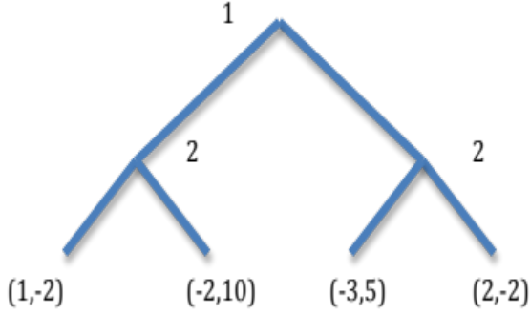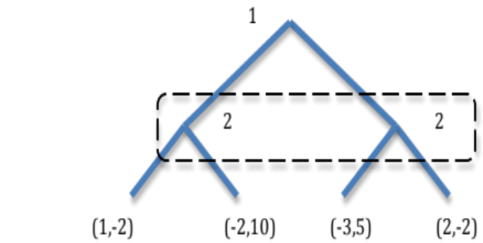
(a) For the game on the left, write out the strategic form. First list the players, then the strategy set of each, then the payoff function (as a bimatrix).
(b) do the same for the game on the right.

2. Which of the two games in the previous problem (if either) has a IDSDS solution? Which has a Nash equilibrium (in pure strategies)? Compute all such equilibria.

3. Recall the Motivation game played on the first day of class.
a. Write out the strategy sets for each player, and the game’s payoff function.
b. Write down the best response function for each player.
c. Does the game have any IDSDS solutions? Nash equilibria? If so, compute them.
d. Use simple statistical tools to analyze the data (posted on the class website). How good was the prediction you computed in part c?

4. Recall the QuadA and QuadB games played in class October 3.
a. Write out the strategy set for each player, and the payoff function (as a bimatrix) for each game.
b. Write down the best response function (or correspondence) for each player in each game.
c. Do the games have any IDSDS solutions? Any Nash equilibria? If so, compute them all.
d. Use simple statistical tools to analyze the data (posted on the class website). How good were the prediction you computed in part c?

5. You and four of your friends (players 1 thru 5) like the Zbox videogame console better than the Vii, but 5 of your other friends (players 6 thru 10) like the Vii better. Since you share games with your friends, you are better off the more friends choose the same console. For players i=1, ...,5 the payoff function is u_{i} = 10 1[x_{i}=Z] + 3n_{xi}, while for players i=6, ...,10 it is u_{i} = 7 1[x_{i}=V] + 3n_{xi}

where 1[x_{i}=Z] = 1 if player i buys the Zbox and zero otherwise (and similarly with V for the Vii instead of Z), while n_{xi} is the number of players buying the same console (Z or V) as player i.
- Find all Nash equilibria (in pure strategies) for this game.
- Are any of them payoff dominant?
- Is there “tipping” or congestion (or both or neither) in this game? Explain briefly.

6. (Extra credit) The professor of a MWF class announces that she will give a quiz some day next week, but the particular day (M, W, or F) will be a surprise. A student argues that surprise is impossible: if the quiz is on Friday, it will not be a surprise since no other options remain. So it can’t be Friday. But in that case, it can’t be on Wednesday because that wouldn’t be a surprise given that it can’t be Friday. But now Monday won’t be a surprise either, since Friday and Wednesday have been ruled out. The student concludes that there will be no exam and doesn’t study. [Here’s what actually happened. The professor gave the quiz on Wednesday and the student was unpleasantly surprised!]
Philosophers and logicians have puzzled over this apparent paradox. Resolve the paradox by
- writing out in Extensive Form a two player, zero sum game in which player #1, the Professor, chooses the day in advance, and player #2, the Student, guesses each day before class whether or not the exam is today (T) or later (L). Say the payoff is +1 to the Student and -1 to the Professor each time the student guesses correctly, and the opposite each time the Student guesses incorrectly.
- Find the strategic form corresponding to the Extensive Form as a bimatrix.
- For even more extra credit, actually solve this game.

Part II. Problems from Harrington.
Write out your solutions to the following chapter-end exercises in your textbook.
Chapter 3: #7, 10
Chapter 4: #2, 5.

Part III. Team Games.
1. What is the name of your team, and what is its number? Who are the members, and what are their majors?
2. What term project ideas are currently under consideration by your team?
3. Please attach your record sheets for the Motivation Game played the first day in class, and the Quadruped Games played in class Thursday, October 3. You will earn bonus points according to your total payoff on the sheets. If you turned these in last week, skip this part.

