Problem Set #6

Due in class Tuesday March 12.

Part 1: Look over all the questions and problems in Perloff Chapter 15. Write out and turn in your solutions to:
Problems 23, 25, and 48 of Chapter 15 (plus 47 for extra credit).

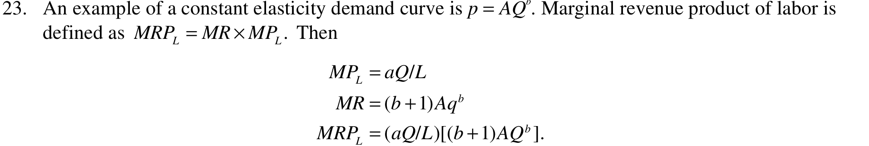

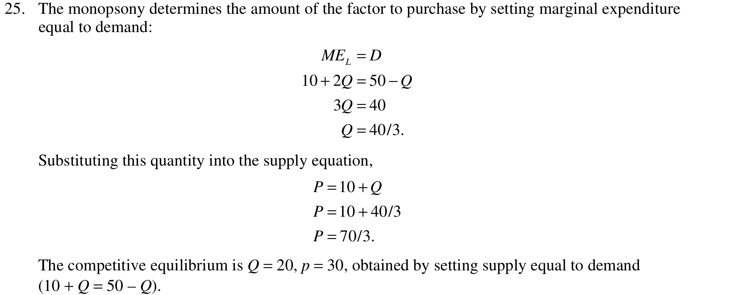
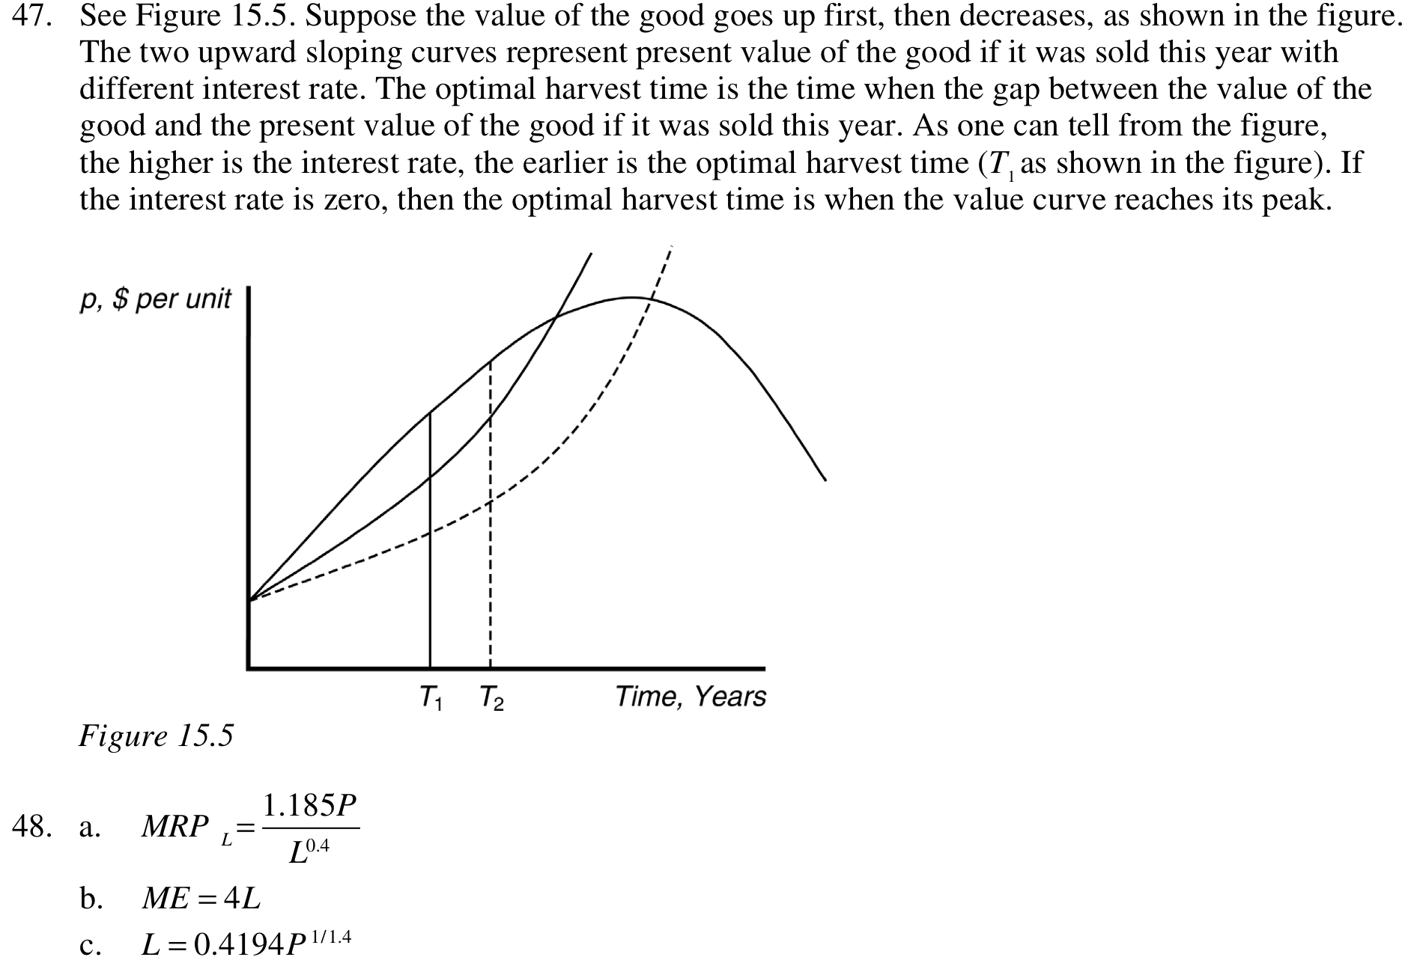

Part 2:
- Suppose that the PPF for per-capita Costanoan production of acorn cakes (a) and balled salmon jerky (b) is described by a² + 4b² = 64. Find an algebraic expression for the MRT. Then find the autarky optimum if each individual’s preferences are represented by U(a,b) = a³b².
A: Set F(a,b) = a² + 4b² . Then MRT = -F_{a} / F_{b} = -2a/8b = -a/(4b). Of course,
MRS = -MU_{a}/MU_{b} = -3a²b²/ 2a³b = -3b/(2a).
At autarky optimum, MRS = MRT ➔ 3b/(2a)=a/(4b) ➔ 2a² = 12b² ➔
a² = 6b² (*).
To find the optimum point, substitute the tangency condition (*) into the PPF eq F(a,b) =64 to get 6b² + 4b² = 64 ➔ b² = 6.4, and by (*) again, a² = 6(6.4) = 38.4. Taking square roots, we obtain (a*, b*) = (6.20, 2.53), approximately. Corresponding utility is approx
U* = U(a*, b*) = 1523.7.

- Find optimum production, consumption and trade when Costanoans in the previous problem can trade with another tribe at price p = p_{a} / p_{b} = 0.1. Compare the utility level of this optimum to the autarky optimum in the previous problem. (For extra credit, compute the entire Costanoan offer curve as a function of price p.)
A. Optimal production is at the point on PPF where -MRT = p ➔ a/(4b) = 0.1 ➔ a=0.4b.
Here a² = 0.16b² so the point on the PPF satisfies 4.16b² = 64 ➔ b= Sqrt(64/4.16)= 3.92 and a = 0.4(3.92) = 1.57 (approx). That is, (a**,b**) = (1.57, 3.92) is optimal production.
The income at this point (measured in units of a, so we set p_{a} =1 and thus p_{b} = 10)
is I = a + 10b = 1.57 + 39.2 = 40.8 (approx). The usual utility-max calculation for Cobb-Douglas preferences with relative weights (3/5, 2/5) tells us that optimal consumption is (a***, b***) = (24.5, 1.63), yielding utility U*** = 39,073 >> 1523.7 = U*.
Optimal trade is export b** - b*** = 3.92 – 1.63 = 2.29 (with value 22.9) and import
a***-a** = 24.5-1.6 = 22.9 (value 22.9, so trade balances, as it must!)

3.With the advent of the first transcontinental telegraph and railway lines, about 135 years ago, California’s financial market (Cal) joined the main US financial market (US). Compared to US at that time, Cal had more productive investment opportunities per capita and a younger (and less patient) population.
  - Use Fisher theory to predict (or would it be postdict?) the impact of market unification on interest rates, saving and investment in Cal and US. Mention the direction of net lending.
A: “Polonius” interest rate (at which local borrowing = local lending) is higher in California (r_{Cal}) than in US (r_{US}) because of Cal’s lesser thrift (steeper ICs for marginal financial market participant) and greater productivity (MROI higher at the margin than in the US). Therefore, as shown in Figure I below, unification leads to an equilibrium real interest rate r* between the two Polonius rates, determined by the intersection of net US lending and net Cal borrowing. So US is the net lender, Cal the net borrower. At the higher interest rate r*, the standard diagram (not included here) shows that investment in US decreases slightly, while investment in Cal increases substantially when r_{Cal} drops to r*. (Saving was not discussed in class; it is defined in this context as the t=0 endowment less consumption; it should decrease in Cal since present consumption will increase at when the real interest rate decreases. The reverse would be true in the US, but to a lesser degree.)

  - What were the impacts on consumption and wealth in Cal and US?
A: Wealth in Cal clearly increases at the lower real interest rate, since even at the old production point Qº, the horizontal intercept (w-tilde) is beyond the old wealth level wº and the new wealth level w^{n}, the present value of the new production point Q^{n}, is yet further beyond. The impact on t=0 consumption is clearly positive, due to income and substitution effect, assuming that we aren’t in the mythical Giffen case. The impact on t=1 consumption is ambiguous, since the income effect (due to higher w) here opposes the substitution effect (due to higher r). See Figure II below.
