Practice Problems for Final Exam

Draft Instructions. In class, closed book, three hours, one double-sided page of notes allowed. When insufficient information is provided, please write down a plausible specific assumption and proceed to the solution. A numerical solution will be considered complete when it is ready to be entered into a calculator, e.g., (3/17)*20^{0.5} gets as much credit as 0.79. Partial credit will be awarded for partial solutions and for brief, relevant remarks, but not for rambling. Points (pts) are marked and total 100.
Note: The practice problems below will not all have points marked, and probably will take more than 3 hours to complete. The actual exam will be about 2/3 as long.
Part I. Short answers. 50 word maximum. Diagrams may help.
- As the quantity produced of a good increases, the social value (SV) generated by that good increases. TFU? Explain.
- Explain how it is possible for one of two people in a two-good economy to have an absolute advantage in producing both goods, but trade can still benefit both people.
- If the government attempts to force a natural monopoly to charge a price equal to marginal cost, then the natural monopoly will shut down. TFU? E.
- An increase in the minimum wage can actually increase the level of employment if monopsony power is present.
- Suppose twenty neighbors share a park. One of the neighbors, Al, leaves trash in the park. This bothers the other neighbors. According to Coase's theorem, assigning the property rights to the park to Al will achieve the socially optimal quantity of trash. TFU?E

Part II. Problems.
1. Supply is approximated by S(p) = 3p – 20 and demand by D(p) = 80 - 7p. Derive formulas for the equilibrium quantity Q*(t), gross price p*(t), tax revenue R(t) and deadweight loss L(t) as functions of the excise tax rate t. What fraction of R(t) is borne by consumers?

2. Ed’s gardening service finds that demand is approximated by q = 24 + P – 2p, where P is the typical price charged by competitors, p is the hourly price Ed charges per crew member, and q is the monthly demand in hundreds of crew-hours. Ed’s cost is approximately 30 + 2q + ½ q². Recently the typical competitor price has been P = 12.
- Compute Ed’s profit maximizing output and price, and economic profit. (8 pts)
- Find Ed’s efficient scale and minimum average cost. (4)

3. The inverse supply curve in a market is given by Q = 3p2. What is the producer surplus when the market price is $6? Illustrate using a graph.

4. Suppose anyone with a driver's license is capable of supplying one trip from the airport to the downtown business center on any given day. The long-run supply curve of such trips is horizontal at p = $50, which is the average cost of such trips. Suppose daily demand is Q = 1000 - 10p. Calculate the change in consumer surplus, producer surplus and social welfare if the city government requires those people supplying such trips to possess a special license, and the government will issue only 300 licenses.
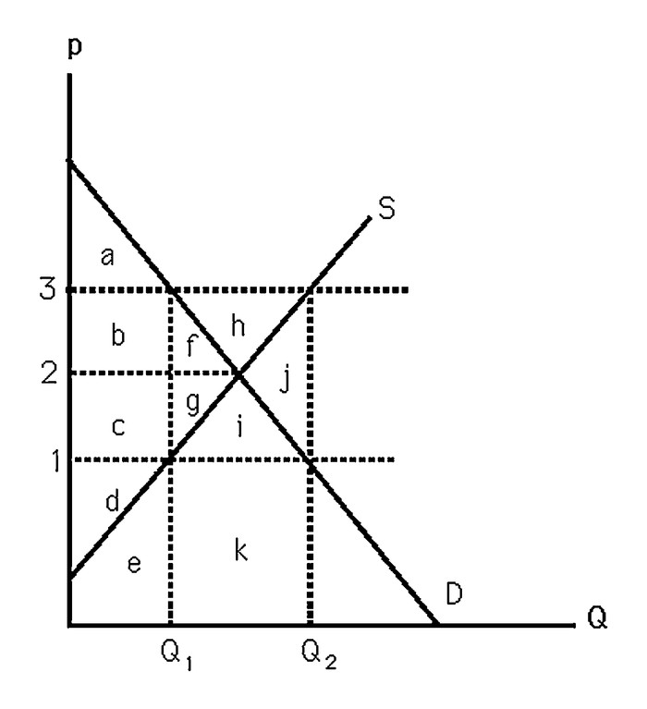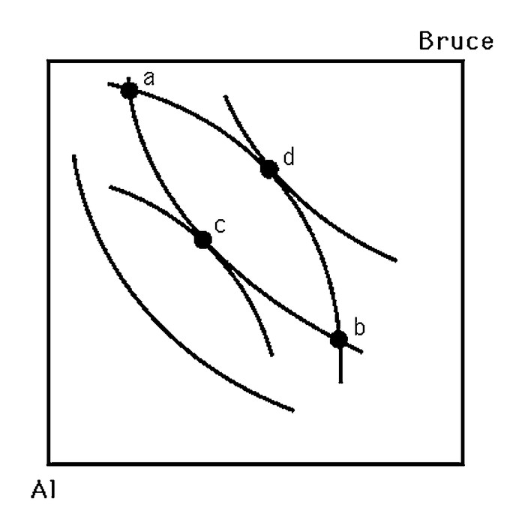
5. The left panel above shows supply and demand curves for milk. In an effort to help farmers, the government passes a law that establishes a $3 per gallon price support. Which of the areas labeled by letters a thru k represent
a. government expenditures to maintain the price support?
b. change in CS relative to CE?
c. change in PS relative to CE?
d. DWL?

6. The right panel above shows indifference curves in an Edgeworth box representing a pure exchange economy with two traders, Al and Bruce. Which points are Pareto superior to the endowment point (a)? Sketch and label the contract curve (CC) and a competitive equilibrium (CE).

7. Consider a society consisting of just a farmer and a tailor. The farmer has 10 units of food but no clothing. The tailor has 20 units of clothing but no food. Suppose each has the utility function U = F ∗ C. The price of clothing is always $1. If the price of food is $3, does a competitive equilibrium exist? If not, what will happen to the price of food?

8. A monopolist faces the (inverse) demand for its product: p = 50- 2Q. The monopolist has a marginal cost of 10/unit and a fixed cost given by F.
a. Assume that F is sufficiently small such that the monopolist produces a strictly positive level of output. What is the profit-maximizing price and quantity.
b. Compute the maximum profit for the monopolist in terms of F.
c. For what values of F will the monopolist’s profit be negative?

9. Suppose the government wishes to regulate mercury emissions of factories in a specific industry by either setting an emissions standard or imposing an emissions fee (per ton of mercury). The government is uncertain as to the marginal abatement costs, which may be high (MC1) or low (MC2).
MC1 = 15M + 500
MC2 = 15M – 500
where M is the units of mercury abated. The government believes there is a 50% chance of each of the marginal abatement costs. The marginal benefit of abatement is known to be:
MB = 1500 – 10M
a. What is the optimal level of emissions for each of the cost curves above?
b. What is the expected marginal abatement cost (equation)?
c. What is the optimal emissions standard according to the expected abatement costs?
d. What is the optimal abatement fee according to the expected abatement costs?
e. Which regulation will result in a lower DWL in the presence of the uncertainty? Explicitly compute the expected DWL arising from each proposal.

10. Suppose 100 citizens each derive marginal benefit from submarines according to the function MB = 10 - Q. If subs cost $100 each to produce, what is the efficient quantity of submarines?

