(Out of 100 points)
- Player 1 and 2 are colleagues at a company. They have an issue to discuss, but each would prefer the other initiate the conversation. Player 1 has to decide whether to (G)o to Player 2’s office to have a conversation or (N)ot. If he choses not to go, player 1 and 2 will simultaneously decide whether to (C)all on the phone or (W)ait. If one player calls and the other waits, the phone call goes through. The calling player gets a lower payoff than the waiting player (2 vs. 3), since the calling player is seen to be more anxious than the other. If the phone call fails (both players call or both wait) then both players get 0. Finally, player 1 gets a lower payoff for going to P2s office compared to what he gets from a successful phone call since going to the P2’s office makes him look even more anxious. The game tree is as follows:

Derive all Subgame Perfect Nash Equilibria. (Please make player 1 the row player of any game matrices you use in your analysis.) [15 points]

To find equilibria we first analyze the subgame on the right of the tree. This is a NFG
P2
 | Call | Wait
Call | 0,0 | 3,2
Wait | 2,3 | 0,0

It is easy to see that (Call,Wait) and (Wait, Call) are pure NE of the subgame. Now consider mixed strategies. Suppose P1 calls with probability p and P2 calls with probability q. Then P1 is indifferent between his actions if
2q = 3(1-q)
thus he is indifferent if q = 3/5. Similar analysis shows p=3/5 is required for P2 to be indifferent. These probabilities make each action have an expected payoff of 6/5 to each player.

To find all SPE, we insert each of these 3 subgame equilibria into the game tree and backward induct. When player 1 Waits, and player 2 calls, the payoff profile is (2,3). Player 1 gets to chose between this by choosing N or he can make the payoffs (1.5,3) by choosing G. Thus he chooses N. Thus this SPE is:

P1: N | W
P2: C

Next we insert the subgame equilibrium with player 1 calling and P2 waiting. By similar reasoning, P1 will want to pick N as his first move thus the SPE is:

P1: N | C
P2: W

Finally, we insert the mixed subgame equilibrium when each player calls with chance 3/5. This gives a payoff profile of (6/5,6/5). In this case, the payoff profile (1.5,3) is more attractive to player 1. Thus he chooses G as his first action. The resulting SPE is:

P1: G | (C w.p. 3/5, W w.p. 2/5)
P2: C w.p. 3/5, W w.p. 2/5

- Consider the interaction between a used car buyer and potential seller. Nature chooses whether the used car seller has a (H)igh quality car or a (L)ow quality car. The probability of a (H)igh quality car is q. The potential seller knows the actual quality of their car, but the buyer only knows that initially the potential seller has a (H)igh quality car with chance q. The value of the car to the potential seller and buyer are as follows:
Quality | Seller | Buyer
Low | 6000 | 7000
High | 10000 | 12000
The seller decides first on a price P to ask for the car. The buyer then decides whether to accept or reject. The buyer payoff for buying is:
Quality | Buyer
Low | 7000 - P
High | 12000 - P
And the buyer gets a payoff of 0 if he doesn’t buy.

The seller payoff for a completed sale is:
Quality | Seller
Low | P-6000
High | P-10000
The seller’s payoff for not selling is 0. [20 points total]

- Does there exist a separating Perfect Bayesian Equilibrium in which sellers of low quality cars ask for a lower price than sellers of high quality cars, and buyers buy cars of both types? In other words P^{l} < P^{h} where P^{l} and P^{h} are the prices for low and high quality cars respectively. Either give a succinct argument why such an equilibrium doesn’t exist, or derive such an equilibrium. [10 points]

There does not exist such a PBE. If the buyers bought cars of both prices, owners of low quality cars would want to post the higher price that high quality cars are being sold for.

- For what values of q does there exist a pooling equilibrium in which all sellers sell at some common price P* and buyers do the following
  - Believe the car is high quality with chance q if the price P ≤ P*
  - Believe the car is low quality with chance 1 if the price is P > P*
  - Buy the car if P ≤ P*, otherwise don’t buy the car? [10 points]

Buyers are willing to buy if the expected payoff of buying equals or exceeds 0. This requires
q(12000 – P) + (1-q)( 7000 – P) ≥ 0
5000q – P + 7000≥ 0
P≤5000q + 7000
Owners of high quality cars are only willing to sell if P≥ 10000, while owners of low quality cars require P≥ 6000. Combining all constraints we have
10000 ≤ P≤ 5000q + 7000
This is only possible if the right expression is greater or equal to 10000, which requires q ≥ 3/5.

- Consider the following symmetric matrix game:
Player 2
 | W | X | Y
W | 3,3 | 2,5 | 2,2
X | 5,2 | 1,1 | 0,0
Y | 2,2 | 0,0 | 1,1

Find all ESS’s. [20 points]

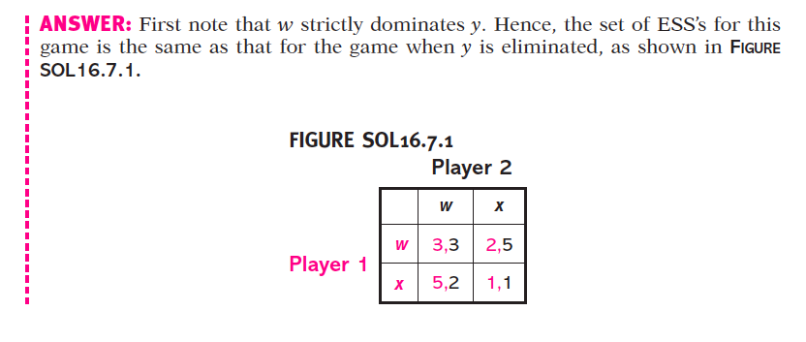
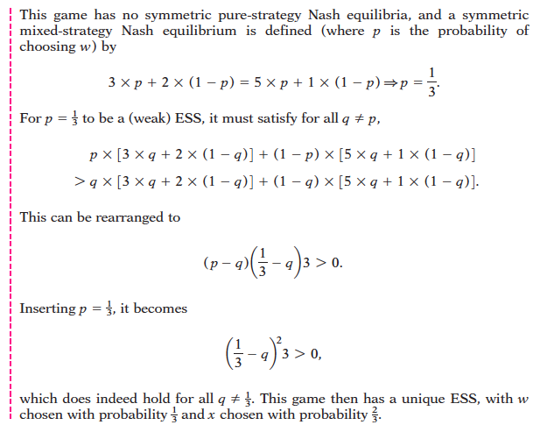

- Suppose company 1 and 2 are the only companies in the market for widgets. Each company decides how many widgets to make, Q₁ and Q₂ respectively. The price of a widget falls with the total quantity produced and follows the formula:
P = 10 – Q₁ – Q₂
where the units are dollars. It costs each company $1 to make a widget, thus the profit of each company i is
(P - 1)Q_{i}.
[30 points total]
- Derive a symmetric pure strategy Nash equilibrium for this game. Call the level of production of each player in this equilibrium Q_{N} . What profit does each company make in the equilibrium? [10 points]

Player 1’s payoff is
(9 – Q₁ – Q₂)Q₁
Differentiating w.r.t. Q₁ and setting it to 0 gives
9 – 2Q_{1N} – Q_{2N} = 0
Q_{N} = (9-Q₂ _{N})/2.
Let Q₂^{N} = Q₁ ^{N}.
Solving gives Q_{N} = Q_{1N} = Q_{2N} = 3.
The profit of each player is (9-6)x3 = 9.

- Suppose that the two companies could coordinate their production and each produce the same amount Q* such that their combined profits are maximized. What value of Q*, the amount each company produces, achieves this? What profit does each company make if they each produce Q*. [5 points]

The joint profits are
2(9-2Q)Q
Differentiating and setting to zero gives
2(9-2Q*) – 4Q* =0
Q* = 9/4
The profit each company makes is (9-9/4 – 9/4)*9/4 = 81/8 = 10.125

- Suppose that company 1 produces the Q* as described in B, but company 2 decides to maximize his own profit rather than maximizing the joint profits. What value of Q is 2’s best response to Q*. Call this value (Q_{D}). What profit would company 2 make? [5 points]

From part a, the best response function is (9-Q)/2. Plugging in Q=9/4 gives Q_{D} = 27/8 = 3.375. The profit for the deviating player in this scenario is (9 – Q_{D} – Q) Q_{D} = (27/8)²= 729/64 = 11.39

- Now suppose that the game we have described thus far is repeated every year. The overall payoff of each player is the discounted sum of the payoffs they get in each stage game. For what values of δ, the discount factor, is it a subgame perfect equilibrium for each player to play the following strategy
  - Produce Q* (from part b) until any player is seen to not produce Q*, after a player plays something other than Q*, “punish” them by producing Q_{N} forever.
[10 points]

A player who deviates increases his payoff in the deviating period from 81/8 to 729/64. In subsequent periods, his payoff falls from 81/8 to 9. His discounted net payoff is

( 729/64 – 81/8 ) + (δ/(1- δ)) (9 – 81/8) ≤ 0
(81/64) ≤ (δ/(1- δ)) (9/8)
(81/64) (1- δ) ≤ (9/8) δ
(81/64) ≤ (153/64) δ
(81/153) ≤ δ

