I. Short case study problems
Problem 1

To graph the budget constraint, start with p1*x1 + p2*x2 = m. We know that p1 = 1, p2 = 1, and m = 1*12 + 1*36 = 48. Therefore, we can re-arrange the budget constraint to get an equation in slope/y-intercept form: x2 = 48 – x1.

A
10 12 48 58 x₁
12 48 58 x₁
X₂
X₂
48
48
58
X1 is an inferior good
X1 is a normal good
1) Restricted Grant g=10 (graph in the left)
If x₁ is a normal good:
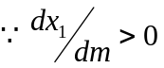, 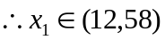 and x2 = 58 – x1
If we assume that x2 is also a normal good, then the new demand for x2 cannot fall below the initial demand. This implies that the new demand for x1 has to fall between 12 and 22. The new demand for x2 is still given by 58 - x1.
If x₁ is an inferior good:
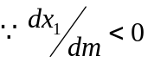, 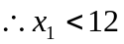
But x₁ can not be smaller than 10 given the terms of the grant. So if (as shown in the top IC in the figure) good 1 is so inferior that there is no tangency on the line with x₁>10, then the bundle (10, 48), at the kink, is chosen since it maximizes utility.

An unrestricted lump sum of 10 has a very similar to the restricted grant. The only difference is that there is no longer a “kink” in the budget constraint at (10, 48). This is shown in the graph on the right side. The only difference is that the inferior good case, a choice x₁ < 10 is now possible.

2) Grant g =15
With the larger restricted grant, the budget constraint is now shifted to the right by 15 units, giving us a kink at (15, 48). Now, if x1 is an inferior good, we will always maximize utility at the kink. Furthermore, we may end up choosing to consume at the kink even if x1 is a normal good.

b) A 1:1 matching plan is equivalent to decreasing p₁ by 50% while holding p₂ and m constant. Since the new price for x1 is p1 = 0.5, the new budget constraint can be graphed as: x2 = 48 – 0.5x1.
X₂
X₁
48 96
48
Label as U’ the utility obtained at the new consumption bundle. Since we do not know the form of the utility function, we cannot know for sure where on the budget constraint the new consumption bundle lies. But if we assume that preferences are homothetic, then the IEP is a ray going from the origin through the point (12, 36). From the Slutsky decomposition, we know that the final effect of the price change is made up of an income effect and a substitution effect. First, we consider the income effect. This must take us from the original bundle to a bundle on the IEP which also gives utility U’. Now we apply the substitution effect to end up at our new consumption bundle. From the diagram, it should be clear that this must lie below and to the right of the point where the IEP crosses the new budget constraint, (13.7, 41.15).

Problem 2

Given: 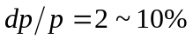

- Linear demand function: 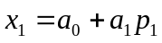 (for simplicity suppress other terms in m, p₂ etc)
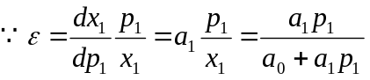
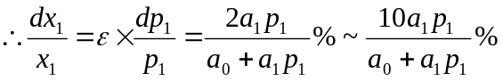 (you can also leave x₁ as is.)
Choke point: when x₁=0, then p₁= -a₀/a₁
Saturation point: when p₁=0, then 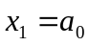
2. Log linear demand function: 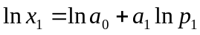
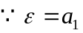
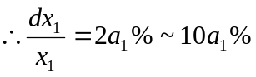
There is no choke point or saturation point (as neither x₁ nor p₁ can be zero in log form).
3. Semi-log demand function: 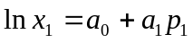
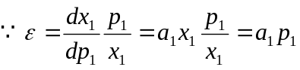
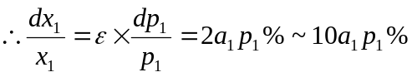
There is no choke point (as x₁ should not be zero in log form).
Saturation point: when p₁=0, then 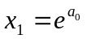

Problem 3

For middle-income teenagers:
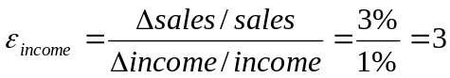;
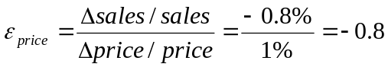

From Slutsky function:
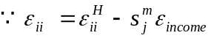 → 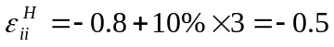

For high-income teenagers, assume they have the same income elasticity and price elasticity as middle-level income teenagers have:
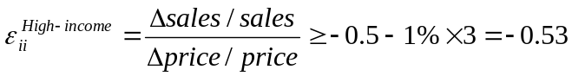
When price decreases by 1%, the sales in high-income teenagers will rise by less than 0.53%.

Essay 1
Some students seem unfamiliar with the format of a memo. Here is a sample.

Memo

Date: October 9, 2005
From: Yirui Peng, Economics Department, UCSC
To: F. Scott Page, TAPS, UCSC
------------------------------------------------------------------------------------------------------------
To predict the future demand of campus parking space, I will proceed as follows.

Step1. Demand analysis
The demand curve is the relationship between quantity of parking space and price, other factors held constant. However, I do need to take these other factors into consideration. The demand for parking space is derived from the demand for transportation, i.e., cars. The factors that will affect the demand curve are population, income, people’s preferences, and buses and other substitute forms of transportation.

In the absence of other information, I will suppose that the number of parking spaces available is the number of demanded. Please let me know if in some years either customers tried to purchase parking permits but were turned away, or there were significant numbers of unsold permits relative to available space.

The demand function will take a form like:
Demand for parking space = f(price of parking permits, campus population, income, the number of buses, gas prices, etc)

Step 2: Collect annual (or quarterly) historical data for regression.
The historical data we need are:
- Total number of parking spaces (dependent variable)
- Price schedule of parking permits;
- Population of students, faculty and staff;
- The average number of buses on campus on weekdays;
- Gas prices
- The number of dorms on campus
- Average level of parents’ income of students and income of faculties and staffs, respectively.

Step 3: Do regressions.
I will expect the price of permission and gas will have negative effect on demand, while population and income will have positive effect. I will consider different functional forms, such as linear, log, semi-log, etc. I will first apply OLS to do the regressions. I will break down the demand for parking space into sub-groups and try to get separate demand functions for students, faculty and staff.

Step 4: Make prediction and analysis
Once get the fitted demand functions, I can predict how changing permit prices will change in the demand of parking space, and help analysis of other parking policies.

I hope to meet with you soon to address any concerns, and to get your help in collecting data. I will be able to deliver a written report within three weeks of obtaining all data.

----------------------------------------------------

Essay 2

An advantage of the dual approach over the direct approach is that expenditure, unlike utility, is observable. The dual approach is also quite useful in applied work when costs (or revenues for the supply side) are better measured than quantities.

