INSTRUCTIONS

Quadruped Games

Rules: 2 students volunteer to monitor. The others join with their established teams. Two teams are matched to play the extensive form games shown below. Every player on each team gets the indicated payoffs, e.g., in QuadrupedA, the payoff to (RD, rr) is 1 point to players in team 1 and 3 points to players in team 2. Each team can discuss strategy privately, and conveys its choice to the monitor. The conductor will announce the games and the team matchings each period.

QuadrupedA
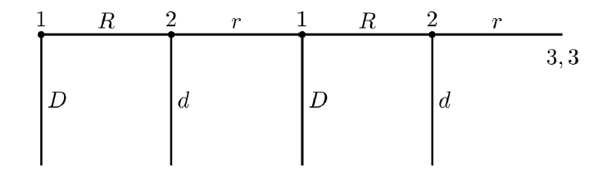
0, 1 2, 0 1, 3 4, 2

QuadrupedB
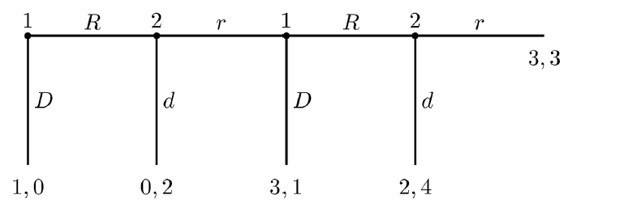

My Name:___________________ My Team’s Name:_______________________

Record Sheet
Quadruped Games

Period | Game:  A or B? | My team’s moves | Other Team’s moves | Other Team’s payoff |  | My Payoff
0 | A | RD | rr | 3 |  | 1
1
2
3
4
5
6
7
8
9
10
11
12
 |  |  |  |  |  | Total Payoff

