Practice Problems for Final Exam

Part I. Short answers. 50 word maximum. Diagrams may help.
- As the quantity produced of a good increases, the social value (SV) generated by that good increases. TFU? Explain.
A. U (or T or F) Only up to the point that MC(q) = MB(q), where MB is the inverse demand function. Past that point, SV diminishes.

- Explain how it is possible for one of two people in a two-good economy to have an absolute advantage in producing both goods, but trade can still benefit both people.
A. As long as the MRT differs for the two people, they can both benefit from specialization and trade. The one with lowest opportunity cost for the first good produces more of it (do-able except in odd corner cases) while the other produces more of the second good, resulting in greater total output of both goods. Then they trade at a price between the two MRT’s, and both come out ahead.

- If the government attempts to force a natural monopoly to charge a price equal to marginal cost, then the natural monopoly will shut down. TFU? E.
A. True. For a natural monopoly, AC is decreasing over the usual range, so MC is below AC. Hence setting p=MC(q) guarantees a profit of q[p-AC]<0 (i.e., a loss), so the firm is better off shutting down.

- An increase in the minimum wage can actually increase the level of employment if monopsony power is present. TFU? E.
A. True. This was a standard class exercise. A monopsonist maximizes profit by restricting employment to drive down the wage, and (for the right position of labor supply and MPL) removing the pricing power can increase both w and employment.

- Suppose twenty neighbors share a park. One of the neighbors, Al, leaves trash in the park. This bothers the other neighbors. According to Coase's theorem, assigning the property rights to the park to Al will achieve the socially optimal quantity of trash. TFU?E
A. U (or T or F)/ The Coase Theorem guarantees that optimum only if transaction (or bargaining) costs are negligible; they probably aren’t for 20 neighbors. Unless Al is a born diplomat or an altruist, he is unlikely to be able to get all 19 neighbors to pay their marginal benefit for the park.

Part II. Problems.
1. Supply is approximated by S(p) = 3p – 20 and demand by D(p) = 80 - 7p. Derive formulas for the equilibrium quantity Q*(t), gross price p*(t), tax revenue R(t) and deadweight loss L(t) as functions of the excise tax rate t. What fraction of R(t) is borne by consumers?
A. S(p) = D(p+t) ➔ 3p – 20 = 80 – 7(p+t) ➔ 10p = 100 -7t ➔
p(t) = 10 – 0.7t (net price) so p*(t) = p(t)+t = 10 + 0.3t (gross price),
➔ consumer burden is 0.3 or 30%.
Q*(t) = D(p*) = 80 – 7p* = 10 – 2.1t
R(t) = tQ* = 10t – 2.1t².
L(t) = ½ base*height of triangle = ½ (Q*(0) – Q*(t))*t = ½ 2.1t *t = 1.05t².

2. Ed’s gardening service finds that demand is approximated by q = 24 + P – 2p, where P is the typical price charged by competitors, p is the hourly price Ed charges per crew member, and q is the monthly demand in hundreds of crew-hours. Ed’s cost is approximately 30 + 2q + ½ q². Recently the typical competitor price has been P = 12.
- Compute Ed’s profit maximizing output and price, and economic profit.
MC = d/dq (30 + 2q + ½ q²) = 2+q. To find MR, first get inverse demand by solving the first expression for p = (24 + P – q)/2 = 18 - q/2 at the given P. Now it is easy to see that MR = 18 – q. Equating this to MC above, we get 18 – q = 2+q ➔ 2q = 16 ➔ q* = 8 at profit max, so p* = 18 – q*/2 = $14. Here R=p*q* = 14*8 = 112 while
C= 30 +2*8 + ½ 8²= 78, so max profit is 112-78 = 34.

- Find Ed’s efficient scale and minimum average cost.
Efficient scale is the point q that minimizes AC.
Taking the FOC on AC = (30 + 2q + ½ q²)/q, or just setting AC=MC, yields the equation 30/q = q/2 ➔ q²=60 → q .= 7.75 = efficient scale.
Here AC=MC(q) = 2+7.75 = 9.75 = minimum AC.

3. The inverse supply curve in a market is given by Q = 3p2. What is the producer surplus when the market price is $6? Illustrate using a graph.
Answer:
PS = 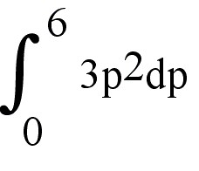 = (6)³ = 216. Graph omitted here to save space…

4. Suppose anyone with a driver's license is capable of supplying one trip from the airport to the downtown business center on any given day. The long-run supply curve of such trips is horizontal at p = $50, which is the average cost of such trips. Suppose daily demand is Q = 1000 - 10p. Calculate the change in consumer surplus, producer surplus and social welfare if the city government requires those people supplying such trips to possess a special license, and the government will issue only 300 licenses.
Answer: The competitive equilibrium is Q = 1000 - (10 * 50) = 500. With the supply restriction of 300, price becomes $70. The loss in social welfare is [(70 - 50) * (500 - 300)]/2 = $2,000. Producers gain (70 - 50) * 300 = $6,000. Consumers lose $6,000 + $2,000 = $8,000.
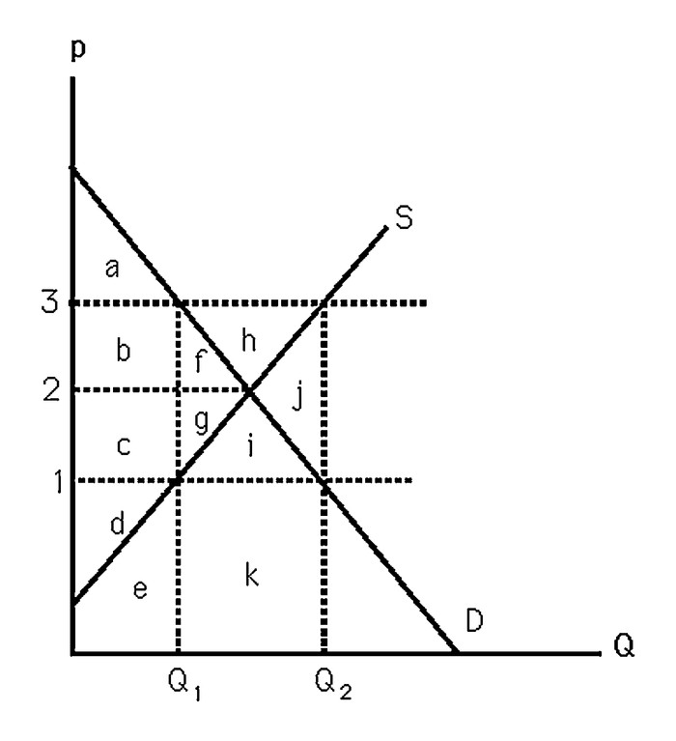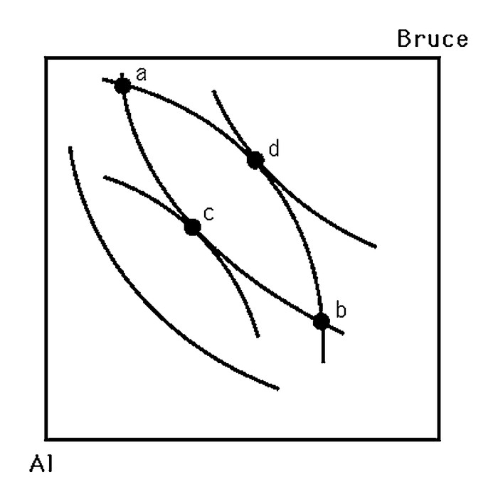
5. The left panel above shows supply and demand curves for milk. In an effort to help farmers, the government passes a law that establishes a $3 per gallon price support. Which of the areas labeled by letters a thru k represent
a. government expenditures to maintain the price support?
A: f+g+h+i+j+k
b. change in CS relative to CE?
A: b+f is reduction in CS
c. change in PS relative to CE?
A: b+f+h is increase in PS
d. DWL?
A: j plus the DWL (not shown in this diagram) associated with financing the government expenditure, e.g., from taxes on other goods.

6. The right panel above shows indifference curves in an Edgeworth box representing a pure exchange economy with two traders, Al and Bruce. Which points are Pareto superior to the endowment point (a)?
A. Everything in the lens shaped region bounded by the curves acb and adb.
Sketch and label the contract curve (CC) and a competitive equilibrium (CE).
A. Sketch suppressed to save space. The CC curve connects points c and d. The CE is a point on the CC such that the mutually tangent ICs have a tangent line that goes thru the endowment point a.

7. Consider a society consisting of just a farmer and a tailor. The farmer has 10 units of food but no clothing. The tailor has 20 units of clothing but no food. Suppose each has the utility function U = FC. The price of clothing is always $1. If the price of food is $3, does a competitive equilibrium exist? If not, what will happen to the price of food?
Answer: The farmer will have $30. His budget line is 30 = 3F + C. His budget line is tangent to an indifference curve when C/F = 3. Substituting yields 30 = 6F or F = 5 and C = 15. The tailor's budget line is 20 = 3F + C. His budget line is tangent to an indifference curve when C/F = 3. Substituting yields 20 = 6F or F = 3.33 and C = 10. In total 8.33 units of food and 25 units of clothing are demanded. There is excess demand for clothing and excess supply of food. The price of food will fall. When the price of food is $2, both markets clear.

8. A monopolist faces the (inverse) demand for its product: p = 50- 2Q. The monopolist has a marginal cost of 10/unit and a fixed cost given by F.
a. Assume that F is sufficiently small such that the monopolist produces a strictly positive level of output. What is the profit-maximizing price and quantity?
Answer: The monopolist will choose p=MR (or derive from first order condition of profit function). So 50 - 4Q = 10, so Q* = 10
The price follows from plugging the optimal output into the demand: p* = 30

- Compute the maximum profit for the monopolist in terms of F.
The profit comes from plugging the price and quantity into the profit equation:
Pi* =200 - F
c. For what values of F will the monopolist’s profit be negative?
Find F* such that Pi* = 0:
F* = 200
For F>200, profits will be negative.

9. Suppose the government wishes to regulate mercury emissions of factories in a specific industry by either setting an emissions standard or imposing an emissions fee (per ton of mercury). The government is uncertain as to the marginal abatement costs, which may be high (MC1) or low (MC2).
MC1 = 15M + 500
MC2 = 15M – 500
where M is the units of mercury abated. The government believes there is a 50% chance of each of the marginal abatement costs. The marginal benefit of abatement is known to be:
MB = 1500 – 10M
a. What is the optimal level of emissions for each of the cost curves above?
b. What is the expected marginal abatement cost (equation)?
c. What is the optimal emissions standard according to the expected abatement costs?
d. What is the optimal abatement fee according to the expected abatement costs?
e. Which regulation will result in a lower DWL in the presence of the uncertainty? Explicitly compute the expected DWL arising from each proposal.
Answer:
a. For each marginal cost curve, determine the level of M where MB=MC. If the costs are high:
15M + 500 = 1500 – 10M
Solving yields M=40. If the costs are low, M=80.
b. The expected abatement cost is:
E(MC) = .5 (15M + 500) + .5 (15M – 500) = 15M
c. The optimal level of abatement (standard) is where E(MC) = MB, or M = 60.
d. The optimal fee is found by substituting M = 60 into the MB or E(MC)
fee = 15 (60) = $900
e. We need to estimate the DWL arising from each regulation.
When a standard is imposed of M=60:
If costs are high, the standard is too high and the DWL is 5000
If costs are low, the standard is too low and the DWL is 5000
So the expected DWL from the standard is 5000.
When the fee is imposed of $900:
If costs are high, the DWL is 2214.45
If costs are low, the DWL is 2214.45
So the expected DWL is 2214.45.
The DWL from a fee in this case is lower

10. Suppose 100 citizens each derive marginal benefit from submarines according to the function MB = 10 - Q. If subs cost $100 each to produce, what is the efficient quantity of submarines?
Answer: The market demand is SMB = 1000 - 100Q. Setting this equal to the MC of 100 yields a quantity of 9. If the cost is shared equally, each citizen pays $1 for the ninth submarine, which they each value at $1.

