Final Exam

Instructions. In class, no communications devices, closed book, three hours, only the official double-sided page of notes allowed. Points (pts) are marked and total 100.
Part I. Short answers. 50 word maximum. Diagrams may help.
- Any competitive equilibrium is Pareto efficient because at that allocation the marginal rates of substitution are equal for all consumers. TFU? Explain. (6pts)
Answer: It is true that in an Edgeworth box economy (pure exchange) that at an interior CE, each trader’s MRS is equal to the CE price ratio. However, in a production economy, Pareto efficiency also requires MRT=p* at interior production points. Of course, externalities also cause inefficiency even when MRS’s are equal.

- It is a conventional practice to set the retail price of clothing at twice the cost paid to the manufacturer. What demand elasticity (if any) makes this practice consistent with retailers maximizing profit? (6pts)
Profit maximization ➔ MC = MR = p(1+ 1/E) = 0.5p ➔ (1+ 1/E) = 0.5 ➔E = -2.0. So if almost all MC is the cost paid to the manufacturer, then the elasticity is about -2.

- Which (if any) of the following total cost functions suggests the presence of a natural monopoly? Explain very briefly. a) TC = 2Q ; b) TC = 100 + 2Q; c) TC = 100 +2Q². (6pts)
AC functions are a) 2 ; b) 100/Q + 2; c) 100/Q +2Q . Only b) is decreasing in Q for large Q, so only b) clearly suggests a natural monopoly.

- Universities are monopsonists in the market for professors because professors usually have to move to a different city to work for a different university. TFU? E. (6pts)
It is true that once a professor accepts a job and settles down, then the U has some monopsony power (except in a few cities like Boston where there are lots of U’s.) However, U’s have to compete for initial hires, and will be at a severe disadvantage if they have the reputation of ruthlessly exploiting monopsony power.

- NPR broadcasts (usually) commercial-free programs. Do they supply a public good in the technical sense? What does Coase's theorem have to say about how to cover the cost of NPR programming? (Remember that you only have 50 words! 6pts)
Yes, NPR broadcasts are non-excludable (to anyone with within reception zone) and non-rival (my listening doesn’t preclude others’ tuning in). Coase’s Theorem here says that asking listeners to cover cost is efficient IF the costs are negligible of negotiating and enforcing payments that reflect the listeners’ marginal benefit. Of course, those transactions costs are prohibitive, so listeners face very inefficient and annoying pledge drives twice a year.

Part II. Problems. When insufficient information is provided, please write down a plausible specific assumption and proceed to the solution. A numerical solution will be considered complete when it is ready to be entered into a calculator, e.g., (3/17)*20^{0.5} gets as much credit as 0.79. Partial credit will be awarded for partial solutions and for brief, relevant remarks, but not for rambling.

1. Consider a monopolist with linear (inverse) demand p = a - bQ and constant average and marginal cost c, with a>c>b>0. Derive the monopolist's profit and the deadweight loss generated as functions of the parameters a, b and c. In particular, show that the deadweight loss is 50% of the monopolist's surplus. [Note: you can get partial credit if you pick numerical values for a, b and c, and solve the problem just for those numerical values.] (10 pts)
Profit = (a-bQ)Q – cQ ➔ dProfit/dQ = a - 2bQ - c = 0, so Q = (a - c)/2b and p = (a + c)/2.
Plugging back in and simplifying, we get Profit = (a - c)2/4b. Calculating the area of the triangle we get DWL = (a - c)2/8b = ½ Profit.

2. Demand for your hot lunch service is approximated by q = 10 – p + aP, where your price is denoted p and your rival’s price is P. Your marginal cost is 2 and your fixed costs are negligible.
- Classify your rival’s product as complement, perfect substitute, imperfect substitute or unrelated for when the coefficient a is 1, ½, 0, and –1. (4 pts)
Perfect substitutes can’t be captured in this simple continuous linear demand function, but we have imperfect subs with a = 1, ½. Of course a = 0 indicates unrelated goods, and a = -1 indicates complements.
- Now assume a = ½. Write down your profit maximizing price as a function of your rival’s price P. (8 pts)
Now q = 10 – p + ½ P ➔ p = 10 – q + ½ P ➔MR = 10 – 2q + ½ P, so setting MR=MC=2, we get 2=10 – 2q + ½ P ➔ q = 4 + 1/4 P ➔
p = 10 – (4 + 1/4 P) + ½ P ➔ p = 6 + 0.25P.

3. XYZ Co. operates in a competitive market. Its marginal product of labor is 1/L, and it takes the wage and price as given. Derive the firm's short-run demand for labor as a function of w and p. How much labor will the firm hire if w = 2 and p = 10? (10 pts)

A: Setting w = p*MPL yields w = p/L or L = p/w. At w = 2 and p = 10, the firm hires 5 units of labor.

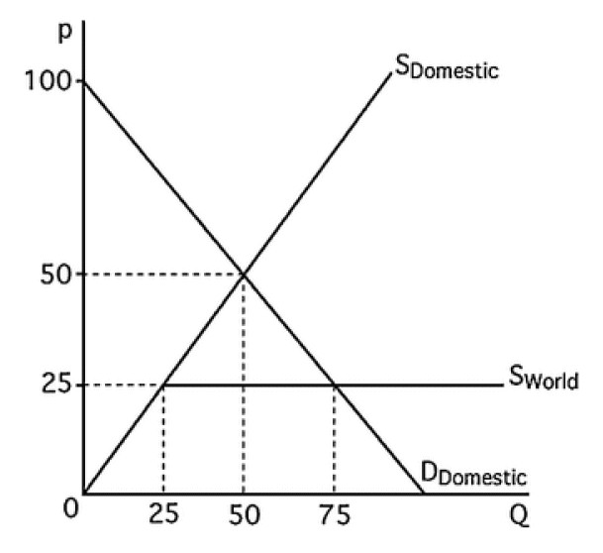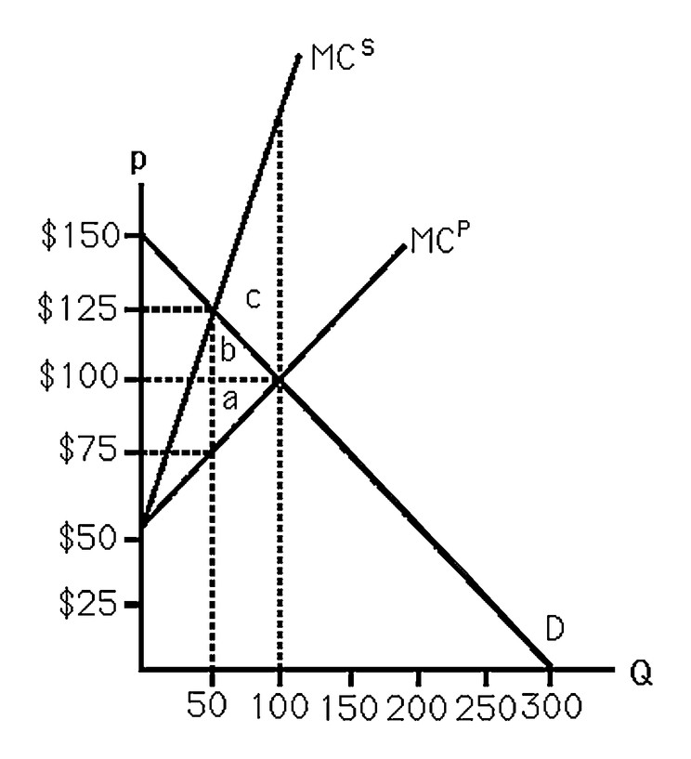
4. The left panel above shows the domestic demand curve, domestic supply curve, and world supply curves for a good. All the curves are linear. Initially, the country allows imports. Then imports are banned. Calculate numerically how consumer and producer surplus, and social value, change because of the ban. (10 pts)

Answer: CS decreases by the area of the trapezoid under the D line between the p=50 and the p=25 lines. That area is 25*(50+75)/2 = 1562.5.
PS increases by the area of the smaller trapezoid above the domestic supply line between the p=50 and the p=25 lines. That area is 25*(50+25)/2 = 937.5.
The loss of (domestic SV) is the difference between those two numbers, the area of the triangle above the p=25 line and below the D and domestic supply lines. That area is 25*50/2 = 625.

5. The right panel above shows the demand curve D for steel ingots, along with the private MC and the social MC, which includes the cost of pollution to society. What is the socially optimal level of production? What level of Pigouvian tax will lead to that outcome if the industry is competitive? Relative to the no-tax competitive equilibrium, what are the changes to CS, PS, and SV? Also, what are the tax revenues? (12 pts)

Answer: Social optimum where is MSC=MSB = D-curve, at the point Q=50, p=$125.At this optimal output A, the MPC is $75, so the required Pigouvian tax is $125-$75 = $50.
CE with no tax will be at p* = 100, Q* = 100, so routine calculations show that internal CS decreases by the area of the triangle labeled b plus the rectangle to its left (= 625+1250=1875), and decreases internal PS by the area of the triangle labeled a plus the rectangle to its left (also = 625+1250=1875). Tax revenues are the areas of those two rectangles (=2500).
Social Value must also reflect the external cost of pollution. At the social optimum, this cost is the area between the MPC and MSC lines to the left of the Q=50 line. In CE that cost also includes the areas labeled a+b+c. Hence the Pigouvinan tax increases SV by the area c, reflecting the decrease in pollution costs. It also transfers areas a and b from CS and PS to reductions in pollution costs, and transfers the two rectangles from CS and PS to tax revenue. The area of c can be obtained from a little geometry: the intersection with the Q=100 line must be at p=250, so the triangle has area (250-100)(100-50)/2 = 3750, so this is the net increase in SV.

6. Elbonia, a small isolated country has a PPF for food (F) and clothing (C) that can be described by 25 = F²+C². All residents have the same endowment and preferences that can be represented by the same utility function Ui = Fi^{0.64} Ci^{0.36}.
a. Compute Elbonia’s autarky prices, MRT and MRS. (6 pts)

(dropping the negative sign on MRT, MRS and price ratios, since they all cancel out)
MRT = ratio of partial derivatives of PPF equation = 2F/2C = F/C.
MRS = MUF / MUC = [0.64 U/F]/ [0.36 U/C] = [0.64 C]/ [0.36 F] = 16C/[9F].
At autarky MRT=MRS ➔ F/C = 16C/[9F]➔9F² = 16C² (#).
Plugging (#) into the PPF equation, you get 25 = F²+ (9/16)F² = (25/16) F²
➔ 16= F² ➔ F=4. From (#) we see 12 = 3F = 4C, so C = 3.
The autarky price is MRT(4,3) = MRS(4,3) = 4/3.

b. Suppose trade opens to the outside world, where the price of food pF = 3 and the price of clothing pC = 4. Compute Elbonia’s production, consumption and trade of food and clothing in the new equilibrium. (8 pts)
The world price ratio is 3/4, which is less than the Autarky price, so we expect Elbonia to increase production of clothing and decrease food production. Setting MRT=world price yields F/C = ¾ ➔ 4F = 3C. Substitute into PPF equation, so 25 = F²+(16/9) F² = (25/9) F² hence F² = 9 and F=3 at optimal production, where C = (4/3)F = 4.

Income at this point is I = F pF+ C pC= 3*3 + 4*4 = 25. Then the usual consumption optimization, using I = 3F + 4C and MRS=world price ratio ➔ 16C/[9F] = ¾,
yields 27F = 64C and 25 = 3F + 4C, whose simultaneous solution (e.g., from
27F = 9(25-4C) = 64C ➔ 100C = 225) is C= 9/4, F = 16/3.
Thus trade is C export of 4 – 9/4 = 7/4 and F import of 16/3 – 3 = 7/3.

