Answer Key for Midterm Exam
- Short answers. 50 word maximum for each question. 5 points each.
- Which is more important in achieving cooperation through repeated interaction: a long history together or the expectation of a long future together? Why?
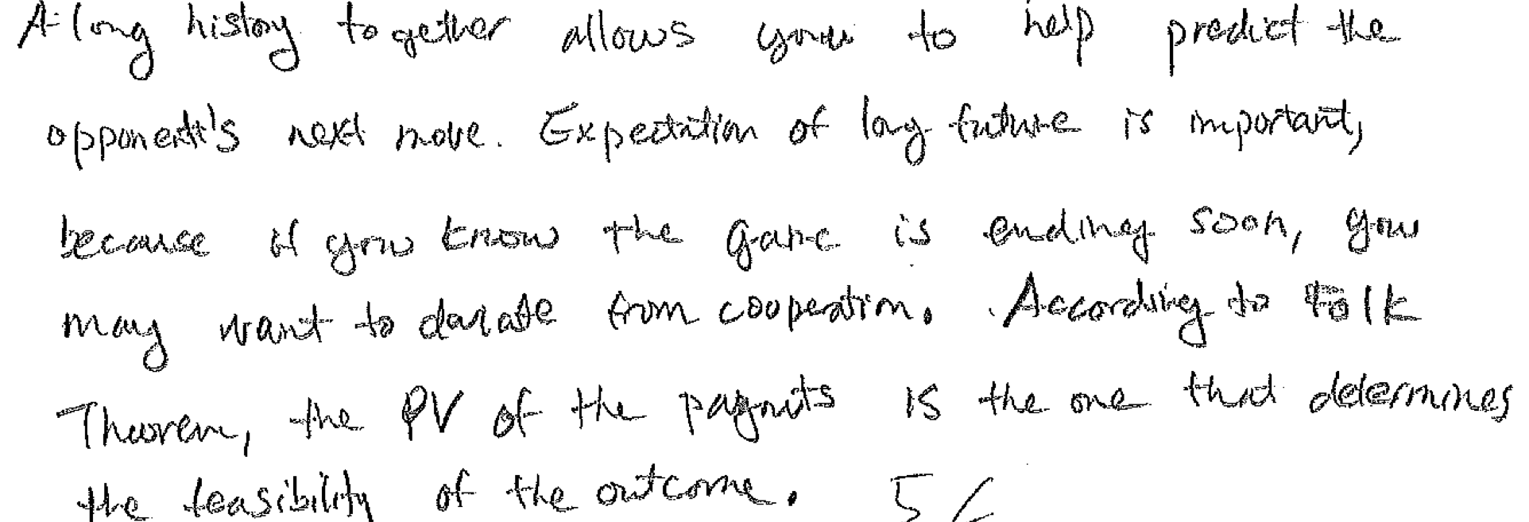
- When is backward induction a reliable technique for predicting the outcome of strategic interaction? When might it be misleading?
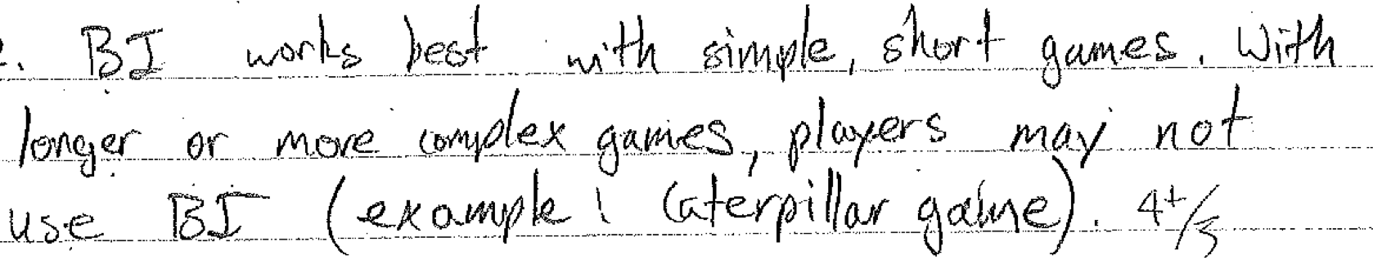
DF comment: generalized BI works for games of incomplete information, and finds all SPNE. When there are many such SPNE, the problem is usually not that it is misleading but rather that it is not very useful in predicting behavior.

Part II. Problems. Points as indicated.
- Player #1 first chooses whether to trust (T) or not (N). If he chooses N then both players get payoff 0. Otherwise, player #2 then chooses whether to cooperate (C) or to Defect (D). If she chooses C then each of the players gets payoff 1. Otherwise, #1 has the final move, and chooses either accept (A) in which case the payoffs are -1 to #1 and 2 to #2, or else chooses punish (P) in which case the payoffs are -2 to #1 and 0 to #2.
  - Draw the extensive form game for this situation. (4 pts) 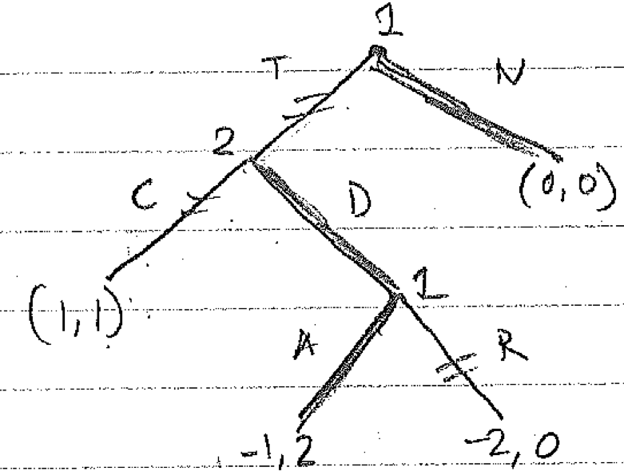

  - Find the subgame perfect Nash equilibrium. (4 pts)
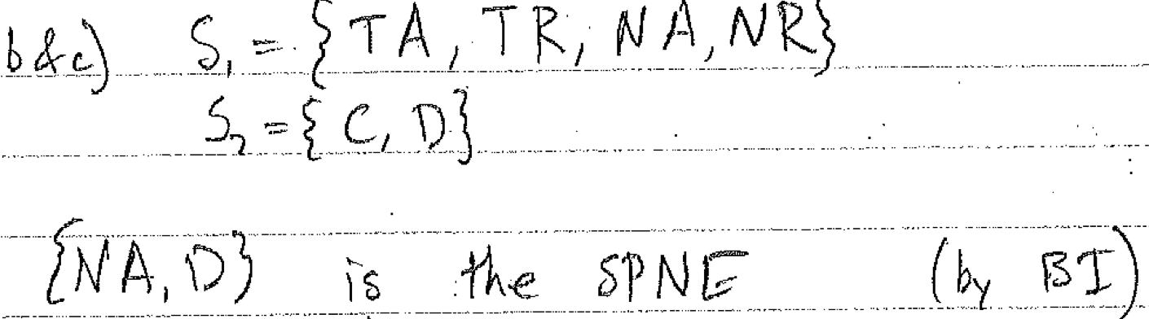
  - Find all other Nash equilibria in pure strategies. (4 pts)
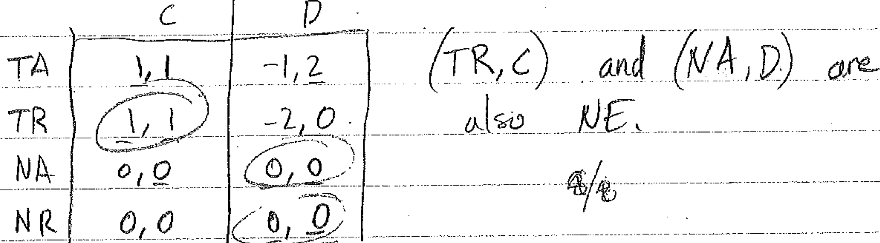
  - Now consider a different type of player #1 whose vengeful preferences give him payoff 0 (instead of -2) following P. If the game is otherwise unchanged, what is the SGPNE? (4 pts)
A: Replacing the payoff in the tree shown for part a. above, it is easy to verify by BI that the SPNE is (TR, C) with payoff (1,1). That is, the threat of vengeance supports the Pareto dominant NE as SGP.

- Initially you believe that the probability of passing an exam is 0.6, while the probability of flunking is 0.3, with the residual probability 0.1 representing postponement or cancellation. Following Bayes’ theorem, you revise your beliefs of these three outcomes to 0.8, 0.2 and 0 after showing up and discovering on first reading that the exam seems easy.
  - What are the likelihood ratios for the message you received on first reading the exam? (4 pts)
A: using the table below, the pass/flunk likelihood ratio given the message is 0.2/0.1 = 2, and the cancel/flunk l.r. is 0/0.1 = 0.
  - Write down the likelihood functions and the joint probabilities of outcomes and messages. {Hint: You may assume that the likelihood of the message you received given that you will flunk is 0.10; for extra credit, find the range of possible likelihoods.} (4 pts)
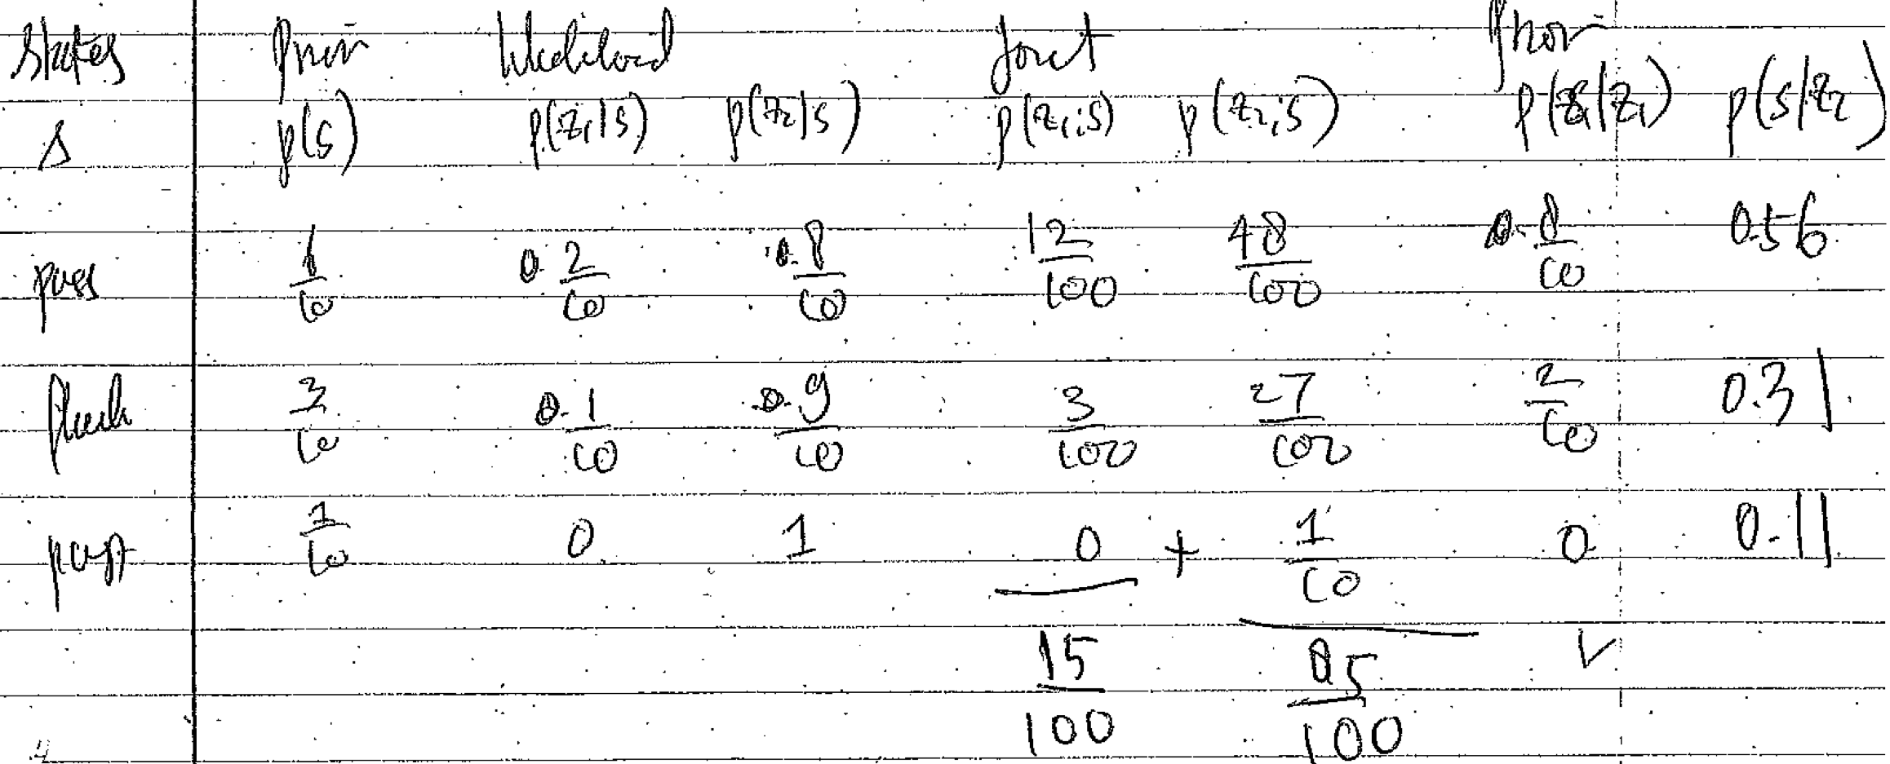

  - What was the economic value of the message received? Use the 0-1utility normalization and/or any other reasonable assumption you need. (2pts)
A: Recall that the messy formula says simply that the economic value of information is the (money equivalent) of the optimal informed decision minus that of the optimal uninformed decision. Since no decision was changed relative to the no-message case (you already decided to show up, and probably were not considering walking out without completing the exam), the economic value is zero. The fact that the message increased your expected utility does not imply that the information had economic value.

- Consider the following game, where player 2 might be either of two types, I or II.
Type I Type II
 | L | R |  | L | R
U | 0, 0 | -1, 2 |  | 0, 0 | -1, 2
D | 1,-2 | -5,-5 |  | 1,-3 | -5,-2
  - Find all NE if player 2 is known to be of type I. (4 pts)
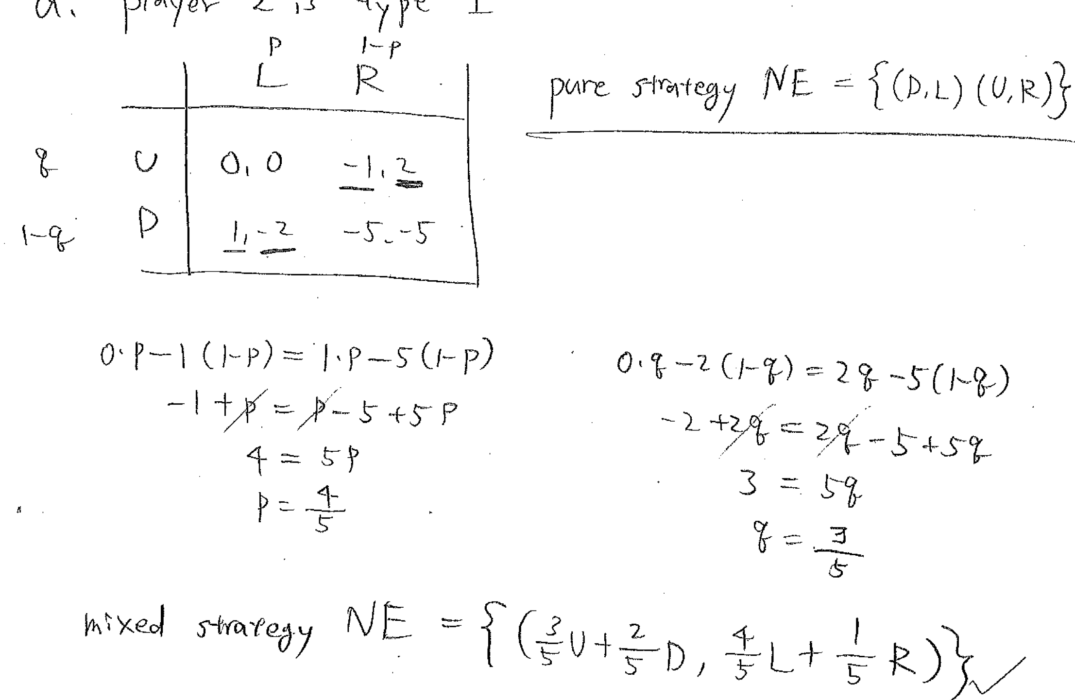
  - Find all NE if player 2 is known to be of type II. (4 pts)
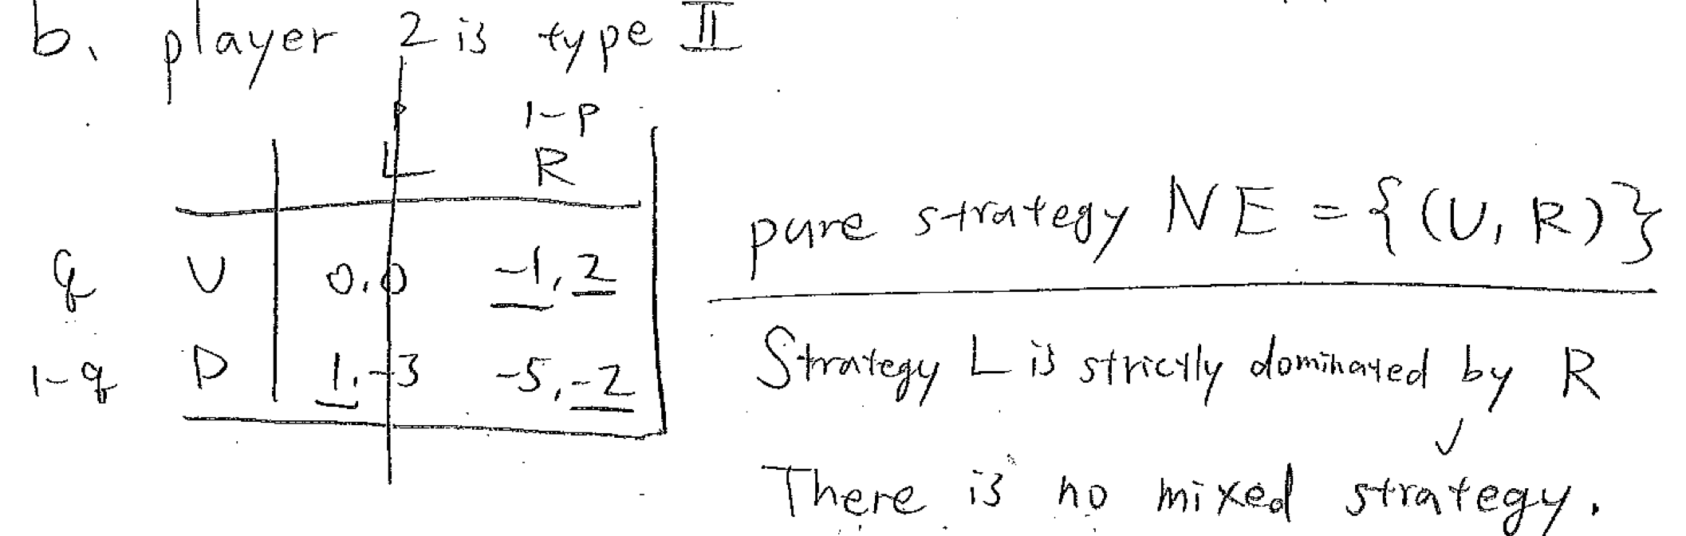

- Find all BNE if player 2 knows that player 1 assigns probability μ=0.6 to the event that player 2 is of type I. (Hint: you might want to write out the Harsanyi extensive form and then re-do the normal form.) (6 pts)
