Answer Key for Problem Set #4
Part I. Problems.
1. There are two risk neutral players, A and B. Nature chooses an amount of money, x, from a uniform distribution over [0, 1000], and places it in an envelope for A. Nature then tosses a fair coin. If it is heads, Nature places y = 2x in an envelope for B. If it’s tails, Nature places y = x/2 in an envelope for B. The players (who know Nature’s process but do not observe the results directly) look at their envelopes in private, and then announce “trade” or “no trade” simultaneously. Trade occurs if and only if both announce “trade”.
a. Is there an equilibrium in which trade occurs with positive probability? [Hint: to get started, think about whether there are high values of x or y that preclude trade. You might want to use the logic of iterated dominance.]
Answer: Player B will lose money for sure if he trades when his envelope has more than $1000. Therefore in equilibrium we can rule out a(y) =”Trade” when y>1000.
Knowing that, A will lose money for sure if he says Trade when x> 500, since B will never agree to trade when y=2x. But knowing that, B will never trade when y>250, and further iterations rule out trade for x>125, y>62.5, … . So trade is possible in equilibrium only when x=y=0.

b. A philosophy student tells you that he has heard of this problem, and insists that trade will occur with probability 1. His reasoning is that either player will look at the amount z in her envelope, compute her post-trade value as 0.5(z/2) + 0.5(2z) = 1.25z > z, and so regard trade as personally beneficial; indeed, ex ante, the trading opportunity is mutually beneficial, which any economist should understand. What, if anything, is wrong with the philosophy student’s reasoning?
A: The philosophy student doesn’t understand Bayes theorem or iterated dominance. He is using prior probabilities to compute z, but he should definitely use posteriors that take into account the uniform distribution over [0, 1000] and (if he believes that players are rational and think the other players are rations) also take account of the other player’s equilibrium strategy.

2. An uninformed player U possesses an object that is either type a (and worth $120 to him) or else type b (and worth $60 to him). U doesn’t know the true type and regards them as equally likely. By contrast, the other player I does know the true type but values type a at $100 and type b at $200. Consider a one shot game in which I makes an offer to U to buy the object, and U either accepts or rejects the offer. Then the true type is revealed to U and the players receive their final payoffs.
- Find all the PBE outcomes in which x_{a} = x_{b} . Explain why you think you have found all the pooling PBE outcomes.

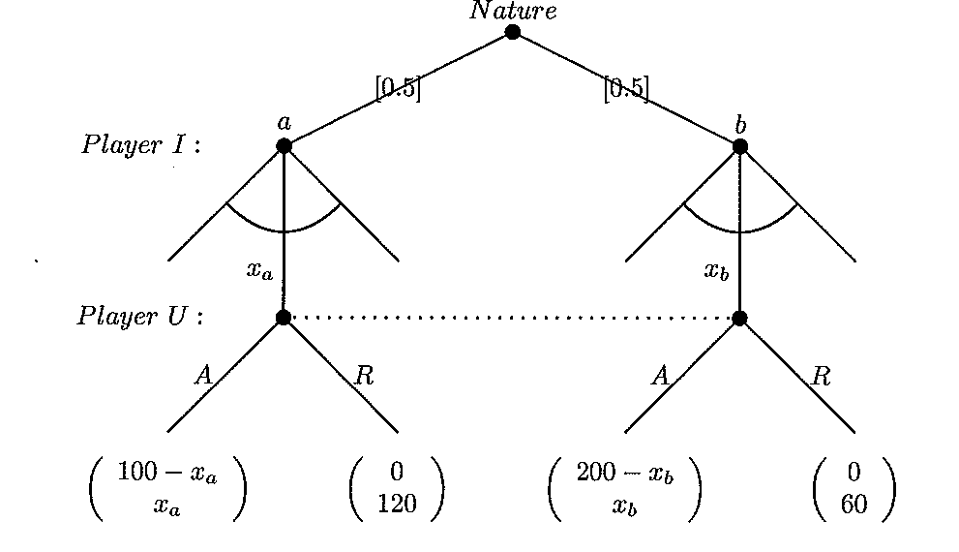

There are trivial no-trade PBE as well as a narrower set of PBE which do support trade. For completeness, the PBE has to include U’s posterior beliefs after every possible signal, not just those seen in PBE. Of course, in pooling equilibrium, the signal is uninformative, so posteriors = priors after the equilibrium signal is observed. Here is an analysis (thanks to Wei!):
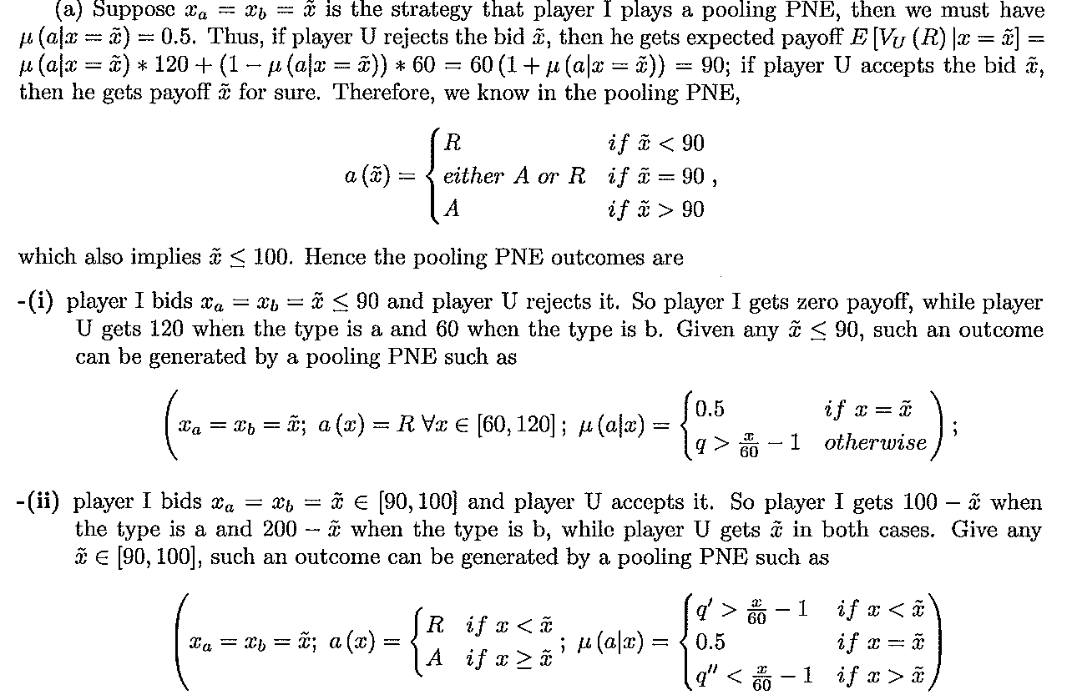
- Find all the PBE outcomes in which x_{a} ≠ x_{b} and x_{a} is rejected and x_{b} is accepted. Again, explain why you have found all separating PBE outcomes. Are there any PBE in which x_{a} is accepted and x_{b} is rejected? 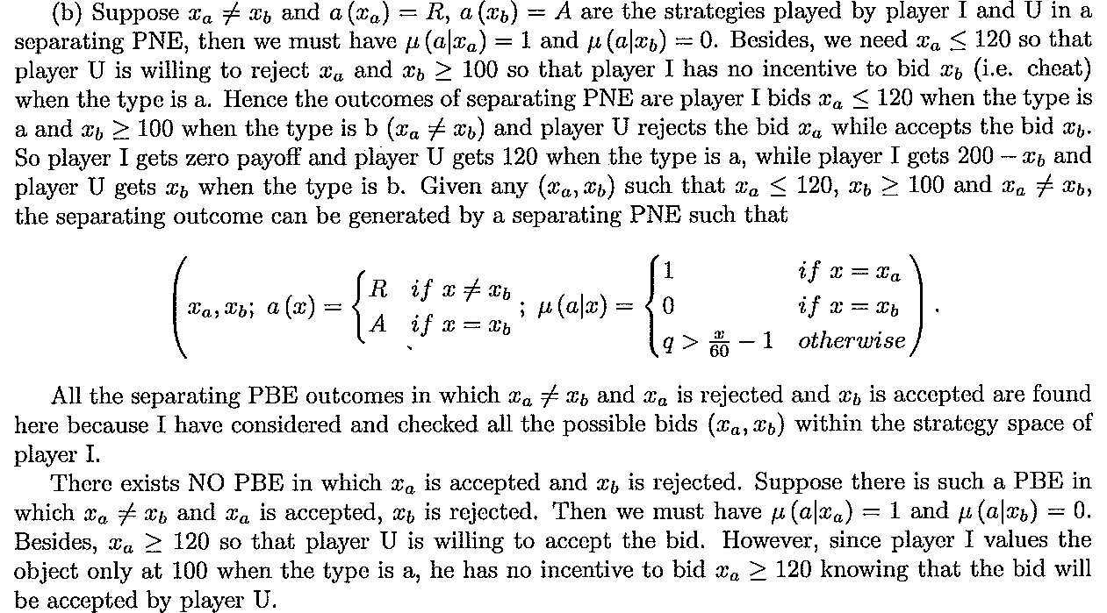

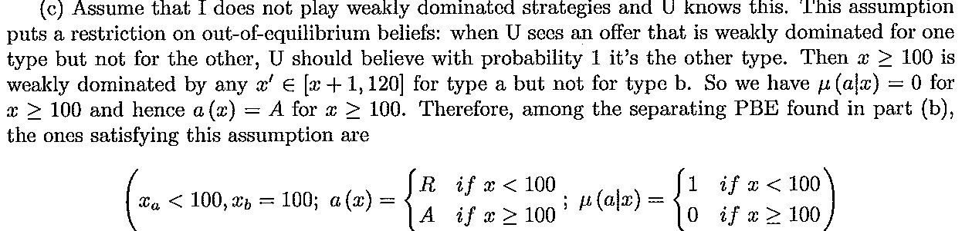

3. Slug Insurance (SI) is planning to sell policies to 20,000 UCSC and Cabrillo students. 80% of the students are low risk with average health costs (measured in thousands of dollars per year) C_{L} = 1 and standard deviation = 1. The other 20% are high risk with average health costs C_{H} = 2 and standard deviation = 4. All students have risk aversion coefficient r = 0.2 in utility function u(X) = EX – ½ r Var X. SI is a risk-neutral for-profit company with negligible overhead costs. It can't identify the risk type of individual students but does know the 20%-80% breakdown.
a. Compute the willingness to pay for health insurance by each type of student, L and H.
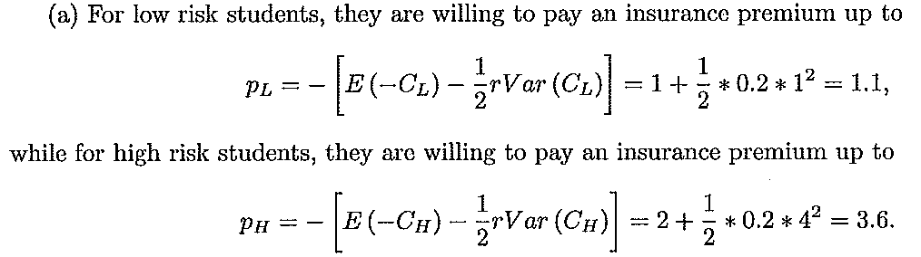
b.What annual premium (P*) would allow SI to break even if all students joined?
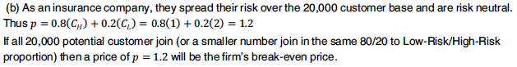
- SI charges 0.4 (or $400) above the break-even point. At that premium, which students would find it worthwhile to join SI?
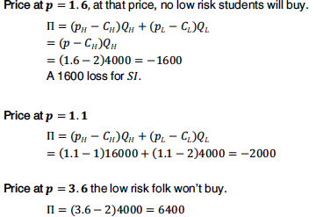
d. What are SI's profits in case c above? How can SI adjust their strategy to increase profits? How much could they make? 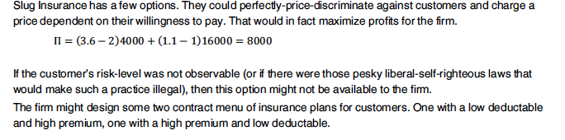

4. Professor P is hiring a teaching assistant, Mr A. Professor P’s payoff function is x-s, where x is the number of hours A works and s is the amount she pays A. Mr A’s payoff function is s – x²/2; he gets payoff 0 if he doesn’t work for P.
a. What choices of x and s will maximize P’s utility (subject, of course, to the constraint that A is willing to work for her)?
b. Suppose that P offers a wage schedule s(x) = ax + b, where A picks x. What choices of a and b will now maximize her utility?
c. Could P obtain higher utility using a non-linear wage schedule?
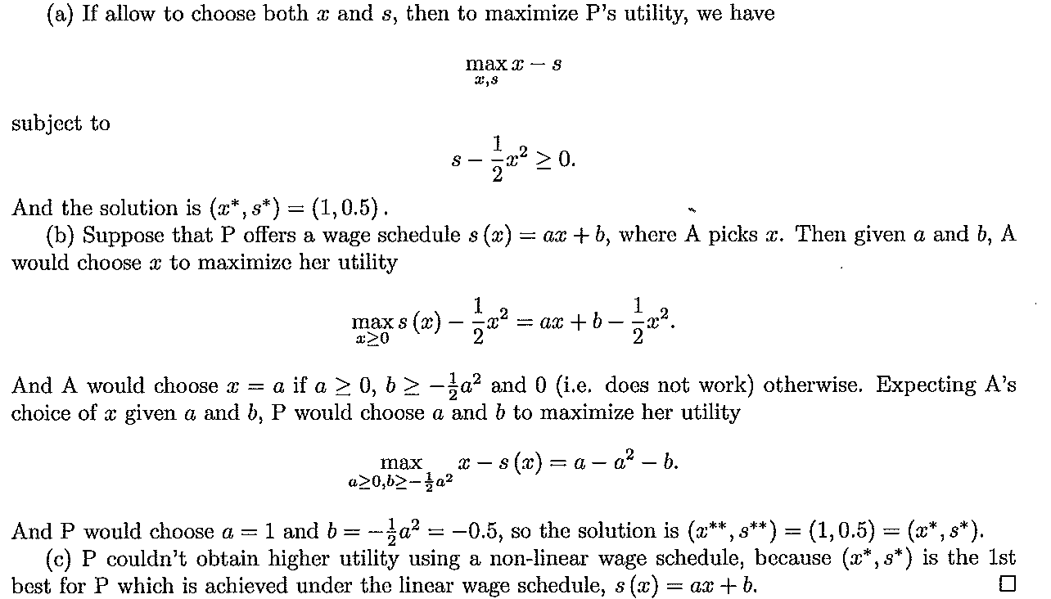

II. Textbook problems. Skim all the problems in MCWG Chapter 13-14. Write up and turn in solutions to 13.B.3, 13.C.4, and 14.B.3; for extra credit do 14.C.8.

