# Hindu

Edition: 2  
Date: July 06, 2024

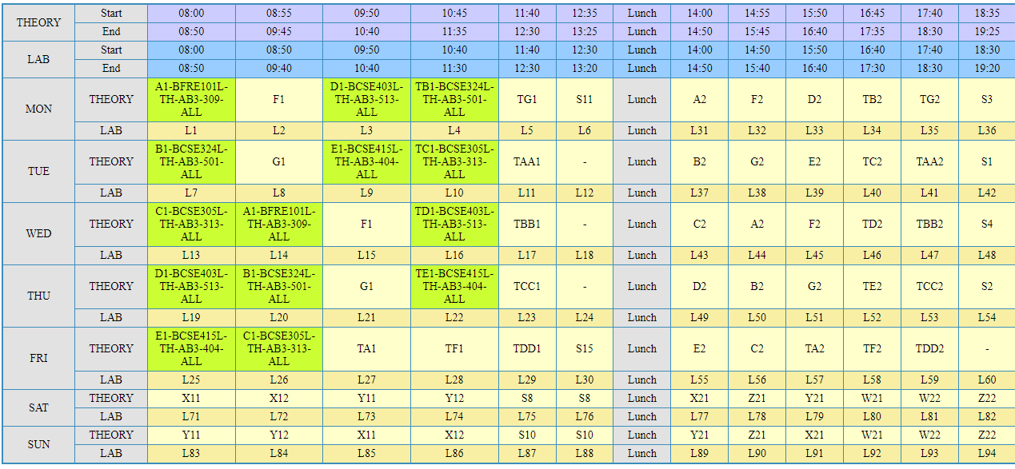

## Translated Text:

5… Rana 08 55 09 5௭…: 45 11 40 12 35 b …… 14 00 14 55 15 5௭ 16 45 17:4௭ 18:35  
௩15௦…  
Pa  
Mana  
ா  
Yo  
N.   
…  
5… gesture?)…}……!1112 58 58! Ya!… 221!… Come on!Ink 222  
Um !.