# Hindu

Edition: 2  
Date: July 06, 2024

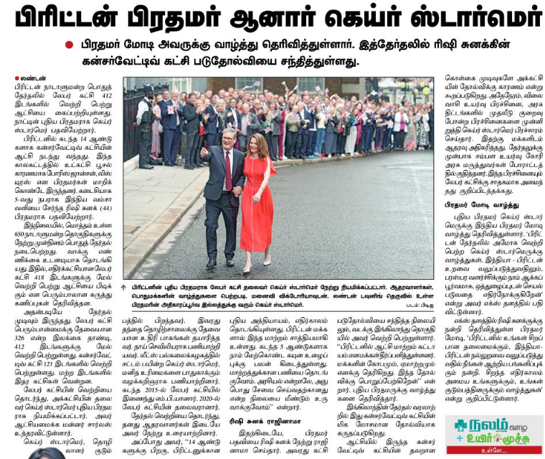

## Translated Text:

British Prime Minister Esuir Star  
Ander May »Lao Nidulnang. Hatirta-Kai Rishi Kasi  
Contemporary Gada Baduhonya Naina ».