MweziCare AI — Technical Architecture
Oct 19, 2026 · @Leon

Overview
MweziCare AI should be built as one mobile-first Progressive Web App (PWA) on Next.js, with React + TypeScript on the client, Next.js route handlers and server actions as the backend, and PostgreSQL (with PostGIS and pgvector) as the single data store. This keeps the MVP to one codebase, one deployable and one database, which a small team can ship and a funder can audit.
The architecture covers the five MVP modules in the proposal: menstrual profile and symptom logging, symptom assessment (triage), care navigation, a shareable clinical summary, and an impact dashboard — plus the conversational assistant.
Architectural principles
- Safety before intelligence. Triage runs on deterministic, versioned, clinician-signed rules. AI is used for education and pattern explanation, never for diagnosis or to override an urgent-care rule.
- Explainable by design. Every recommendation stores the rule set version and the reasons that fired, so the app can tell the user why and clinicians can audit it.
- Privacy by default. Collect the minimum, pseudonymise everything, encrypt sensitive fields, and keep identifiable data out of analytics and out of LLM prompts.
- Built for low connectivity. Installable PWA, small JS bundles, offline symptom logging, and urgent-symptom warnings that work without a network.
- Open-source ready. Clean module boundaries so the rules engine, facility importer and UI can be published without exposing user data or secrets.
- Portable hosting. Containerised Next.js and standard Postgres, so the system can move to a Kenyan or regional data centre if data-protection review requires it.

System architecture
Three kinds of client talk over HTTPS to a single Next.js application, which owns all business logic and is the only component that touches PostgreSQL.
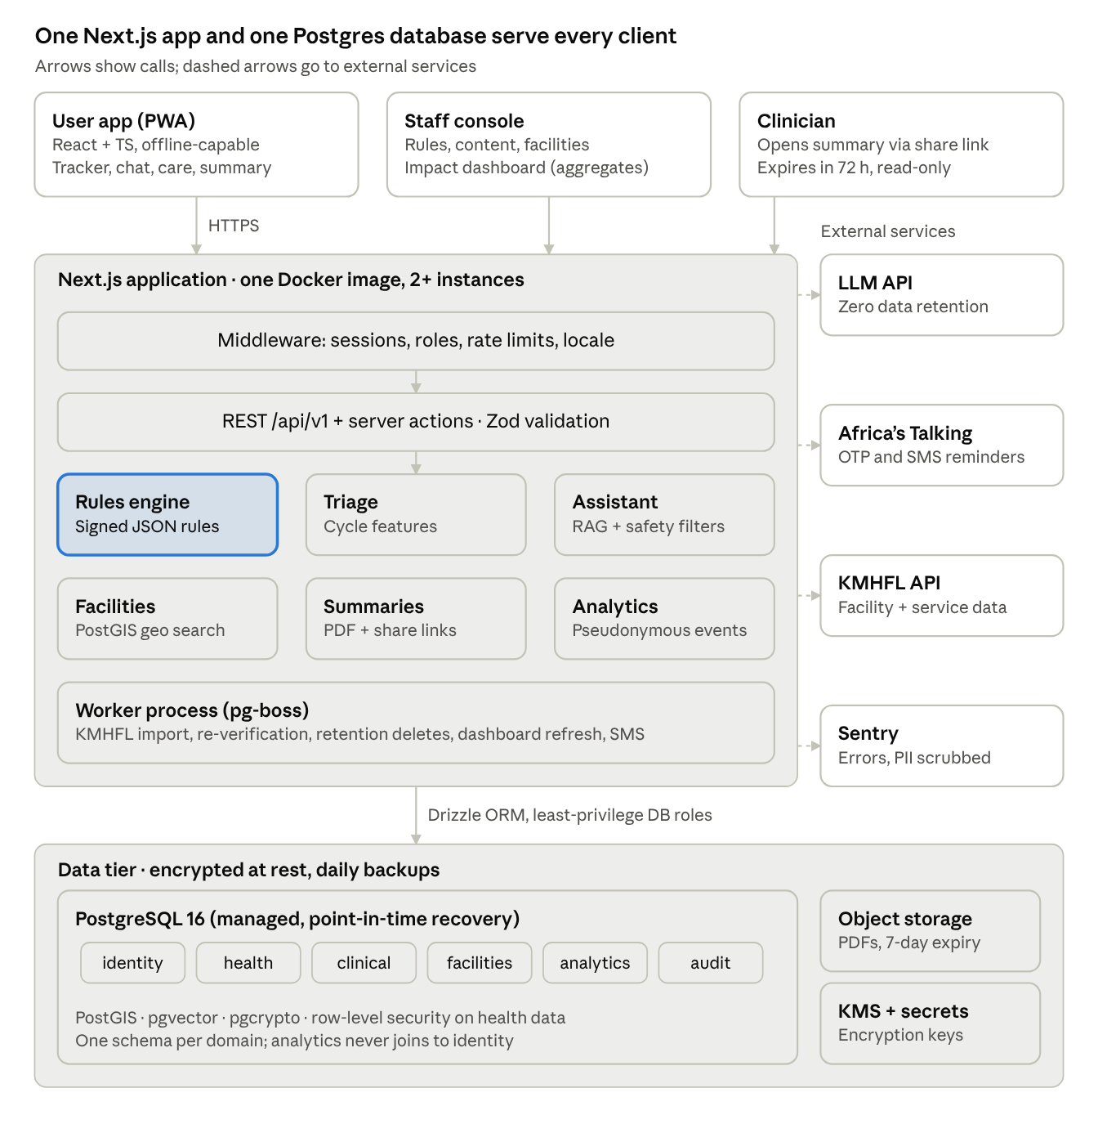
system architecture · clients, Next.js app, data tier, external services
Every request passes middleware and the validated API layer before reaching a domain module; the rules engine is highlighted because triage and the assistant's urgent-symptom checks both defer to it. The worker runs from the same image as a separate process, and only the app and worker call external services.

Technology stack
The core is fixed (React, TypeScript, Next.js, PostgreSQL); everything else is chosen to stay inside that stack, avoid extra servers, and be open-source friendly.
Layer | Choice | Why
Frontend framework | React 19 + TypeScript (strict) via Next.js App Router | Agreed stack; server components keep client bundles small on low-end phones
UI | Tailwind CSS + shadcn/ui (Radix primitives) | Accessible components, no heavy UI runtime
Forms & validation | React Hook Form + Zod | One Zod schema validates on client and server
Client data | TanStack Query | Caching, retries and optimistic updates on flaky networks
Offline | Serwist (service worker) + Dexie (IndexedDB) | Installable PWA, offline symptom logs and sync queue
Internationalisation | next-intl | English and Kiswahili, locale-aware dates
Backend | Next.js route handlers (REST) + server actions | Single deployable; REST endpoints reusable by a future native app or USSD gateway
Database | PostgreSQL 16+ | Agreed stack
DB extensions | PostGIS, pgvector, pgcrypto | Facility distance search, assistant knowledge retrieval, field-level encryption
ORM & migrations | Drizzle ORM + drizzle-kit | TypeScript-first, SQL-transparent, handles PostGIS and pgvector types cleanly (Prisma is the alternative)
Authentication | Better Auth (phone OTP + email, sessions in Postgres) | Self-hosted, TypeScript-native, no user data sent to a third-party identity provider
SMS / OTP | Africa's Talking | Kenyan carrier coverage for OTP and reminders
Background jobs | pg-boss (Postgres-backed queue) | Reminders, re-verification alerts, retention deletes — no Redis needed
Conversational AI | Vercel AI SDK + an LLM API (provider under a zero-data-retention agreement) | Streaming chat, provider-agnostic
Rules engine | Custom TypeScript evaluator over versioned JSON rules (json-rules-engine as a shortcut) | Deterministic, testable, runs on server and offline on the device
Maps | MapLibre GL + OpenStreetMap tiles; directions via deep link to Google Maps / OSM | No per-request map fees; works with any tile host
PDF summary | @react-pdf/renderer | Server-side clinician summary from React components
Charts (dashboard) | Recharts | Lightweight, React-native charts
Observability | Sentry (PII scrubbing on) + OpenTelemetry logs | Errors and traces without health data in logs
Testing | Vitest, Testing Library, Playwright | Unit, component and end-to-end
CI/CD | GitHub Actions + Docker | Lint, type-check, test, migrate, deploy

Application structure
Use a pnpm + Turborepo monorepo with one Next.js app and shared packages. The domain logic (rules, triage, facility import) lives in plain TypeScript packages so it can be unit-tested, run offline in the browser, and open-sourced separately.
mwezicare/
├─ apps/
│ └─ web/ # Next.js app (PWA + API + admin)
│ ├─ app/
│ │ ├─ [locale]/
│ │ │ ├─ (public)/ # landing, learn, privacy, sign-in
│ │ │ ├─ (user)/ # tracker, insights, assistant, care, summary
│ │ │ └─ (staff)/ # clinician review, facility verification, dashboard
│ │ ├─ api/v1/ # REST route handlers
│ │ └─ s/[token]/ # clinician summary share link
│ ├─ components/
│ ├─ lib/ # auth, db client, i18n, logging
│ └─ worker/ # pg-boss job handlers (same image, separate process)
├─ packages/
│ ├─ db/ # Drizzle schema, migrations, seed
│ ├─ rules-engine/ # rule DSL, evaluator, rule tests
│ ├─ triage/ # pattern features over cycles + symptoms
│ ├─ assistant/ # RAG retrieval, prompts, safety filters
│ ├─ facilities/ # KMHFL importer, geo search
│ ├─ validation/ # shared Zod schemas
│ └─ ui/ # shared components
└─ content/ # clinician-approved articles (EN/SW, Markdown)
Roles and route protection
Role | Can access
User | Own profile, logs, assessments, chat, summaries
Clinician reviewer | Rule sets, knowledge-base content, de-identified flagged-case samples
Facility verifier | Facility and service records, verification workflow
Programme admin | Aggregated impact dashboard only (no row-level user data)
System admin | Infrastructure and user support; health fields stay encrypted
Role checks run in Next.js middleware for routing and again inside every route handler and server action, so the UI is never the only gate.

Data model
One PostgreSQL database with six schemas separates identity, health data, clinical content, the facility directory, analytics and audit, so access can be granted per schema and analytics never joins back to identity.
Schema | Table | Key columns | Notes
identity | users | id (UUID), phone_hash, email_hash, role, locale, created_at | Phone and email stored encrypted plus a hash for lookup
identity | profiles | user_id, age_band, county, consent_version, guardian_consent_ref | Age band, not date of birth (data minimisation)
identity | consents | user_id, purpose, version, granted_at, withdrawn_at | One row per purpose: tracking, location, research, sharing
identity | sessions, accounts, verifications | managed by Better Auth | OTP codes expire in 5 minutes
health | cycles | id, user_id, start_date, end_date, predicted | Derived from period-day logs
health | symptom_logs | id, user_id, log_date, bleeding_level, pain_score (0–10), pain_locations[], symptoms jsonb, impact jsonb, client_id, synced_at | client_id makes offline sync idempotent
health | assessments | id, user_id, ruleset_version, outcome (routine / assess_soon / urgent), reasons jsonb, created_at | Immutable audit record of every recommendation
health | chat_sessions, chat_messages | id, user_id, role, content_enc, safety_flags, sources[] | Content encrypted; auto-deleted per retention policy
health | summaries | id, user_id, period, pdf_key, share_token_hash, expires_at, revoked_at, view_count | Share link expires in 72 hours by default
clinical | rulesets, rules | version, status (draft / approved / retired), approved_by, approved_at, definition jsonb | Only one approved version is live
clinical | kb_documents, kb_chunks | id, locale, title, body, reviewed_by, review_due, embedding vector(1536) | pgvector HNSW index for retrieval
facilities | facilities | id, kmhfl_code, name, county, sub_county, geom geography(Point), phone, keph_level, ownership | GiST index on geom
facilities | facility_services | facility_id, service_code, status (listed / verified / unavailable), verified_by, last_verified_at, source | Separates "listed in KMHFL" from "confirmed gynaecology"
facilities | referrals | id, user_id, facility_id, created_at, follow_up_status, follow_up_consent | Used for referral-completion indicators
analytics | events | id, pseudo_id, event_type, county, age_band, props jsonb, occurred_at | pseudo_id is a keyed hash; no join key to identity
analytics | mv_* materialised views | weekly aggregates by county and age band | Small cells (< 10 users) suppressed
audit | access_log | actor_id, action, entity, entity_id, at, ip_hash | Append-only; every staff read of user data is logged
Example DDL for the facility search path
CREATE EXTENSION IF NOT EXISTS postgis;
CREATE TABLE facilities.facilities (
id uuid PRIMARY KEY DEFAULT gen_random_uuid(),
kmhfl_code text UNIQUE NOT NULL,
name text NOT NULL,
county text NOT NULL,
sub_county text,
geom geography(Point, 4326),
phone text,
updated_at timestamptz NOT NULL DEFAULT now()
);
CREATE INDEX facilities_geom_idx ON facilities.facilities USING gist (geom);
-- nearest verified gynaecology services within 25 km
SELECT f.id, f.name, fs.last_verified_at,
ST_Distance(f.geom, ST_MakePoint($lng, $lat)::geography) AS metres
FROM facilities.facilities f
JOIN facilities.facility_services fs ON fs.facility_id = f.id
WHERE fs.service_code = 'GYN' AND fs.status = 'verified'
AND ST_DWithin(f.geom, ST_MakePoint($lng, $lat)::geography, 25000)
ORDER BY metres
LIMIT 20;

Core modules
Each MVP module maps to one package and one set of routes; the triage rules engine is the safety-critical centre and everything else defers to it.

1. Symptom tracking
- Daily log form: period day, bleeding level, pain score 0–10, pain locations, fatigue, nausea, bowel and urinary pain, pain with sex (age-gated), and impact on school, work, sleep and activities.
- Logs save to IndexedDB first, then sync to POST /api/v1/logs in batches; client_id + upsert prevents duplicates.
- Cycles and predictions are recomputed server-side after each sync.

2. Triage rules engine (symptom assessment)
- Urgent screen first. A small set of red-flag rules (sudden severe pelvic pain, fainting, severe pain with possible pregnancy) runs on every log, on the device and the server. A hit shows urgent-care guidance immediately, even offline, and never waits for more data.
- Feature extraction. The triage package turns the last 3–6 cycles into features: count of cycles with pain ≥ 7, days of activity missed, pain between periods, pain with bowel movements or urination, heavy or prolonged bleeding, trend in pain score.
- Rule evaluation. The approved ruleset maps features to an outcome: routine tracking, assess soon, or urgent — mirroring the guidance table in the proposal.
- Explanation. Each fired rule carries a clinician-written reason in English and Kiswahili ("Pain stopped you from going to school in 3 of your last 4 periods"). No diagnostic labels or unvalidated probabilities.
- Audit. The outcome, reasons and ruleset version are written to assessments.
Rules are JSON documents edited in the staff area, tested against a fixture library of synthetic cases, and go live only after a named clinician approves the version. Machine-learning models are out of scope for the MVP; the feature pipeline is designed so a validated model could later sit beside the rules, never above them.

3. Conversational assistant
- Pre-filter: the message is checked against the same red-flag rules plus a classifier prompt; urgent content returns a fixed, clinician-written response with care guidance.
- Retrieval: the question is embedded and matched against approved kb_chunks in the user's language (pgvector, top 5).
- Constrained generation: the LLM answers only from retrieved content, at a reading level for 15–24-year-olds, and cites the article.
- Post-filter: output is checked for diagnostic claims, medication dosing and out-of-scope advice; failures fall back to "I can't answer that — here's how to reach a clinician".
- Privacy: prompts carry no name, phone or location; the provider is contracted for zero data retention; transcripts are encrypted and auto-deleted after a set period (proposed 90 days).

4. Care navigation (facility locator)
- A weekly job imports facilities, coordinates and the service catalogue from the Kenya Master Health Facility List API into facilities.
- Imported services are marked listed; a facility verifier phones the facility and marks gynaecology verified with a date. The UI shows "Gynaecology confirmed on …" or "General outpatient — gynaecology not confirmed".
- Location is requested only after a consent screen; coordinates are used for the query and not stored. Manual county / town search is always available.
- Records older than 6 months since verification raise a re-verification task and show a "may be out of date" label.
- No verified facility within range → safe fallback guidance to the nearest appropriate public facility.

5. Clinical summary
- The user picks a period (e.g. last 3 or 6 cycles); the server renders a 1–2 page PDF: cycle lengths, pain scores over time, symptom frequency, days of activity missed, triage outcomes and reasons.
- Shared by a time-limited link (/s/[token], default 72 hours, revocable, view count shown) or as a downloaded PDF / QR code. Only a hash of the token is stored.

6. Impact dashboard
- Built only on analytics tables and materialised views refreshed nightly by pg-boss.
- Indicators: active users, logs per user, assessment outcomes, referrals made, referral follow-up (where consented), knowledge quiz scores, language split, by county and age band.
- Cells under 10 users are suppressed; export is CSV of aggregates only.

API design
Expose a versioned REST API under /api/v1 so the PWA, a future native app, and a possible USSD/SMS channel all use the same contracts; server actions are used only for in-app forms that call the same service functions.
Conventions
- JSON over HTTPS; request and response bodies validated with shared Zod schemas; OpenAPI spec generated from them (zod-to-openapi).
- Auth via secure, HTTP-only session cookie; staff routes also require a role claim.
- Errors follow RFC 9457 problem details; IDs are UUIDs; timestamps are ISO 8601 UTC.
- Writes from offline clients carry client_id and are idempotent; list endpoints use cursor pagination.
- Rate limits per user and per IP (Postgres-backed token bucket) on OTP, chat and share-link routes.
Method | Endpoint | Purpose
POST | /auth/otp/request, /auth/otp/verify | Phone sign-in (Better Auth)
GET / PATCH | /me, /me/profile | Profile, language, age band
POST / DELETE | /me/consents/{purpose} | Grant or withdraw consent
DELETE | /me | Delete account and all health data
GET | /me/export | Download own data (JSON)
POST | /logs/batch | Sync offline symptom logs
GET | /logs?from=&to= | Logs for a date range
GET | /cycles | Cycles and next-period estimate
POST | /assessments | Run triage on current data
GET | /assessments/latest | Latest outcome with reasons
POST | /chat | Stream an assistant answer (SSE)
GET | /facilities/search?lat=&lng=&radius=&service= | Nearby facilities
GET | /facilities/search?county=&q= | Manual area search
GET | /facilities/{id} | Facility detail and verification date
POST | /referrals | Record "I contacted this facility"
POST | /summaries | Generate clinician summary PDF
POST | /summaries/{id}/revoke | Revoke share link
GET | /content?locale= | Approved education articles
— staff — | /admin/rulesets, /admin/kb, /admin/facilities, /admin/metrics | Rule approval, content review, verification, dashboard

Security, privacy and compliance
Menstrual and reproductive health data is sensitive personal data under Kenya's Data Protection Act 2019, and many target users are minors, so privacy controls are part of the MVP scope, not a later hardening step.
Technical controls
Area | Control
Transport | TLS 1.2+ everywhere, HSTS, strict Content-Security-Policy
At rest | Encrypted disks and backups (managed Postgres); field-level encryption (AES-256-GCM, envelope keys in a cloud KMS) for phone, email, chat content and free-text notes
Identity | Phone OTP; no real name required; optional app PIN on shared phones; sessions expire after 30 days idle
Access | Least-privilege Postgres roles per schema; row-level security on health tables keyed to the session user; staff access logged to audit.access_log
Analytics | Keyed-hash pseudonyms, age bands not dates of birth, county not GPS, small-cell suppression
Location | Used per query, never stored or sent to analytics
LLM | No identifiers in prompts; provider under a data-processing agreement with zero retention
Logs | Sentry and app logs scrub request bodies and health fields
Retention | Scheduled jobs delete chat after 90 days, expired share links after 7 days, and all data 30 days after account deletion (proposed values for legal sign-off)
App security | OWASP ASVS Level 2 as the checklist; dependency scanning (Dependabot), secret scanning, pre-pilot penetration test
Shared-phone discretion | Neutral app name and icon option, no health content in notifications or SMS
Compliance items to confirm with counsel before the pilot
- Register with the Office of the Data Protection Commissioner (ODPC); organisations processing health data fall under mandatory registration (Afriwise summary).
- Complete a Data Protection Impact Assessment (DPIA) — expected for high-risk processing of health data and children's data.
- Children's data: the Act requires parental or guardian consent for users under 18; decide the minimum age and the consent flow (e.g. guardian OTP confirmation, or limiting the pilot to 18–24).
- Cross-border transfer and localisation: confirm whether hosting outside Kenya is acceptable with safeguards, or whether a serving copy must sit in a Kenyan data centre (ODPC General Regulations 2021).
- Research ethics approval for the pilot from an accredited Kenyan ethics committee, and clarify whether the triage feature counts as regulated software-as-a-medical-device.

Low connectivity, offline and localisation
The app must work on entry-level Android phones on 3G and intermittent data, so performance budgets are acceptance criteria, not goals.
- PWA first. Installable from the browser, no app-store download; a native wrapper (Capacitor or Trusted Web Activity) can follow for Play Store presence.
- Performance budget. Under 170 KB of compressed JavaScript on first load; Largest Contentful Paint under 3 s on a throttled 3G profile; images in WebP/AVIF; system fonts.
- Offline features. Symptom logging, cycle calendar, saved education articles, the urgent red-flag check and the last viewed facility list all work offline. Chat, new facility searches and summaries need a connection.
- Sync. A background sync queue in IndexedDB retries with exponential back-off; last-write-wins per log date, with the server timestamp as tie-breaker.
- Data-light. Map tiles load only on request; a list view with distance and phone number is the default.
- Languages. English and Kiswahili from day one with next-intl; every clinical string (rule reasons, urgent messages, articles) is translated and clinician-reviewed in both languages before release. Sheng and other local languages can be added through the same message files.
- Accessibility. WCAG 2.2 AA, large touch targets, readable at 200 % zoom, plain-language copy tested with users.
- Future channels. The REST API keeps a USSD/SMS channel (via Africa's Talking) open for feature-phone users after the MVP.

Infrastructure, DevOps and environments
Host the funding prototype on a managed platform with synthetic data only, then move to residency-reviewed infrastructure before any real user data is collected.
Stage | App hosting | Database | Data allowed
Prototype (for the application) | Vercel or any Docker host | Neon or Supabase Postgres (PostGIS + pgvector) | Synthetic and test data only
Pilot and production | Docker container on AWS ECS Fargate in af-south-1 (Cape Town), or a Kenyan cloud / data centre if counsel requires localisation | Amazon RDS for PostgreSQL (Multi-AZ) or equivalent managed Postgres with PostGIS + pgvector | Real users, after DPIA, ODPC registration and ethics approval
Runtime components (pilot)
- web container: Next.js in standalone output mode, 2+ instances behind a load balancer, CDN in front for static assets.
- worker container: same image, runs pg-boss jobs (KMHFL import, re-verification alerts, retention deletes, materialised-view refresh, reminder SMS).
- Managed Postgres with automated daily backups, point-in-time recovery (7–35 days), encrypted snapshots.
- Object storage (S3-compatible) for generated PDFs, with 7-day lifecycle expiry.
- KMS for encryption keys; secrets in a secrets manager, never in the repo.
Environments and pipeline
- dev (local Docker Compose with Postgres + PostGIS + pgvector), staging (production-like, synthetic data), production.
- GitHub Actions on every pull request: lint, type-check, unit and rule tests, Playwright smoke tests, Lighthouse budget check, dependency and secret scans.
- Merge to main → build image → run Drizzle migrations → deploy to staging; production deploys by tagged release with manual approval.
- A ruleset or knowledge-base change is a content release with its own clinician approval, separate from code deploys.
- Monitoring: uptime checks, Sentry alerts, Postgres slow-query logs, a weekly KMHFL import report.

Testing and clinical safety assurance
The release gate is clinical safety: no build ships if any urgent-case fixture is missed by the rules engine or the assistant.
Test layer | What it covers | Gate
Rule fixtures | 100+ synthetic patient histories written with the clinical lead, each with the expected outcome | 100 % of urgent fixtures escalate; any change to expected outcomes needs clinician sign-off
Unit tests (Vitest) | Feature extraction, cycle maths, sync merge, encryption helpers | 80 %+ coverage on rules-engine and triage
Assistant red-team set | Questions on urgent symptoms, diagnosis requests, medication dosing, self-harm, pregnancy, in EN and SW | Zero unsafe answers; urgent prompts always get the fixed safety response
API and integration | Route handlers against a real Postgres in CI (Testcontainers) | All pass
End-to-end (Playwright) | Sign-up, log offline, sync, assessment, facility search, share summary, delete account | All pass on a mobile viewport
Performance and accessibility | Lighthouse CI on 3G profile; axe accessibility checks | Within budget; no critical a11y issues
Security | Dependency and secret scans each PR; penetration test before pilot | No high or critical findings open
Usability | Moderated sessions with girls and young women, in both languages | Recommendations understood correctly by most participants
A hazard log (based on ISO 14971 / DCB0129-style clinical risk management) records each safety risk from the proposal — false reassurance, false alarms, outdated facility data, data exposure, biased AI — with its control and the test that proves it.

Delivery roadmap and open decisions
With the application due 4 November 2026, the next two weeks should produce a clickable, working prototype on synthetic data; the full MVP and pilot follow funding.
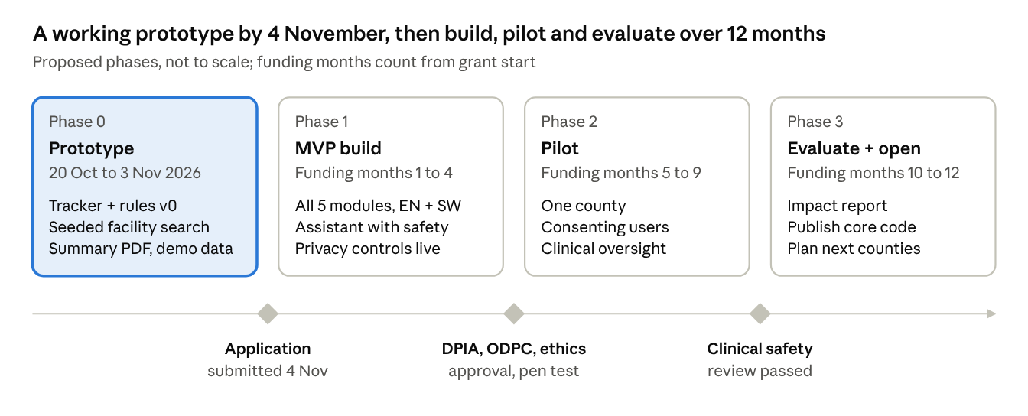
delivery roadmap · 4 phases, 3 gates
Phase 0 is the only phase that touches the deadline; no real user data is collected until the Phase 1 gate (DPIA, ODPC registration, ethics approval and a penetration test) is passed.
Prototype scope for the application (Phase 0)
- Sign-up, daily symptom log and cycle calendar (EN + SW strings scaffolded)
- Rules engine v0 with 10–15 draft rules and the urgent red-flag screen, plus explanations
- Facility search for one pilot county from a KMHFL extract, with a few manually verified entries
- Clinician summary PDF and share link
- Dashboard page on seeded synthetic events
- Assistant demo over 5–10 draft articles, clearly labelled as not clinically reviewed
Open decisions
- ☐ Minimum user age and guardian-consent flow (or 18–24 only for the pilot)
- ☐ Pilot county and the facilities to verify there
- ☐ Hosting region after legal advice on cross-border transfer and localisation
- ☐ LLM provider and data-processing terms (zero retention, no training on data)
- ☐ Clinical advisory group: named gynaecologist to approve rulesets and content
- ☐ Retention periods for chat, logs and summaries
- ☐ Open-source licence (e.g. Apache-2.0 for code, CC BY 4.0 for content) and which packages to publish
- ☐ Whether a native app wrapper is needed for the pilot or the PWA is enough

