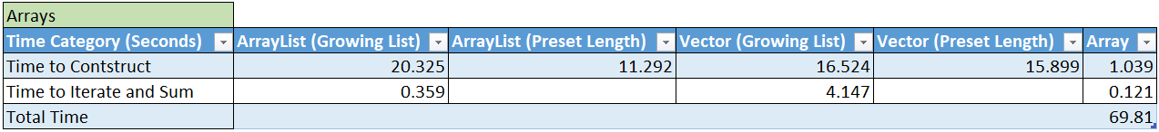

The Array in this use case is superior in terms of its time to construct, and its time to sum. Obviously the advantages that Vectors and Array Lists have over arrays is their capacity to grow, as the array must be created with a set size.

When comparing the ArrayList and Vector classes’ performance, it is interesting to note that the vector was slightly faster when growing, compared to the growing Arraylist, but was slower when both were created at a preset length. However, the Vector class was more than 10x slower than the ArrayList when summing the elements, which is a substantial difference.

In conclusion, if the number of elements are known, an Array will be most efficient. If the number of elements are not known, either Vector or ArrayList should be used, but if one is going to iterate over the list in any capacity, ArrayList is far superior.