**Test 1:**

Run GUI.java

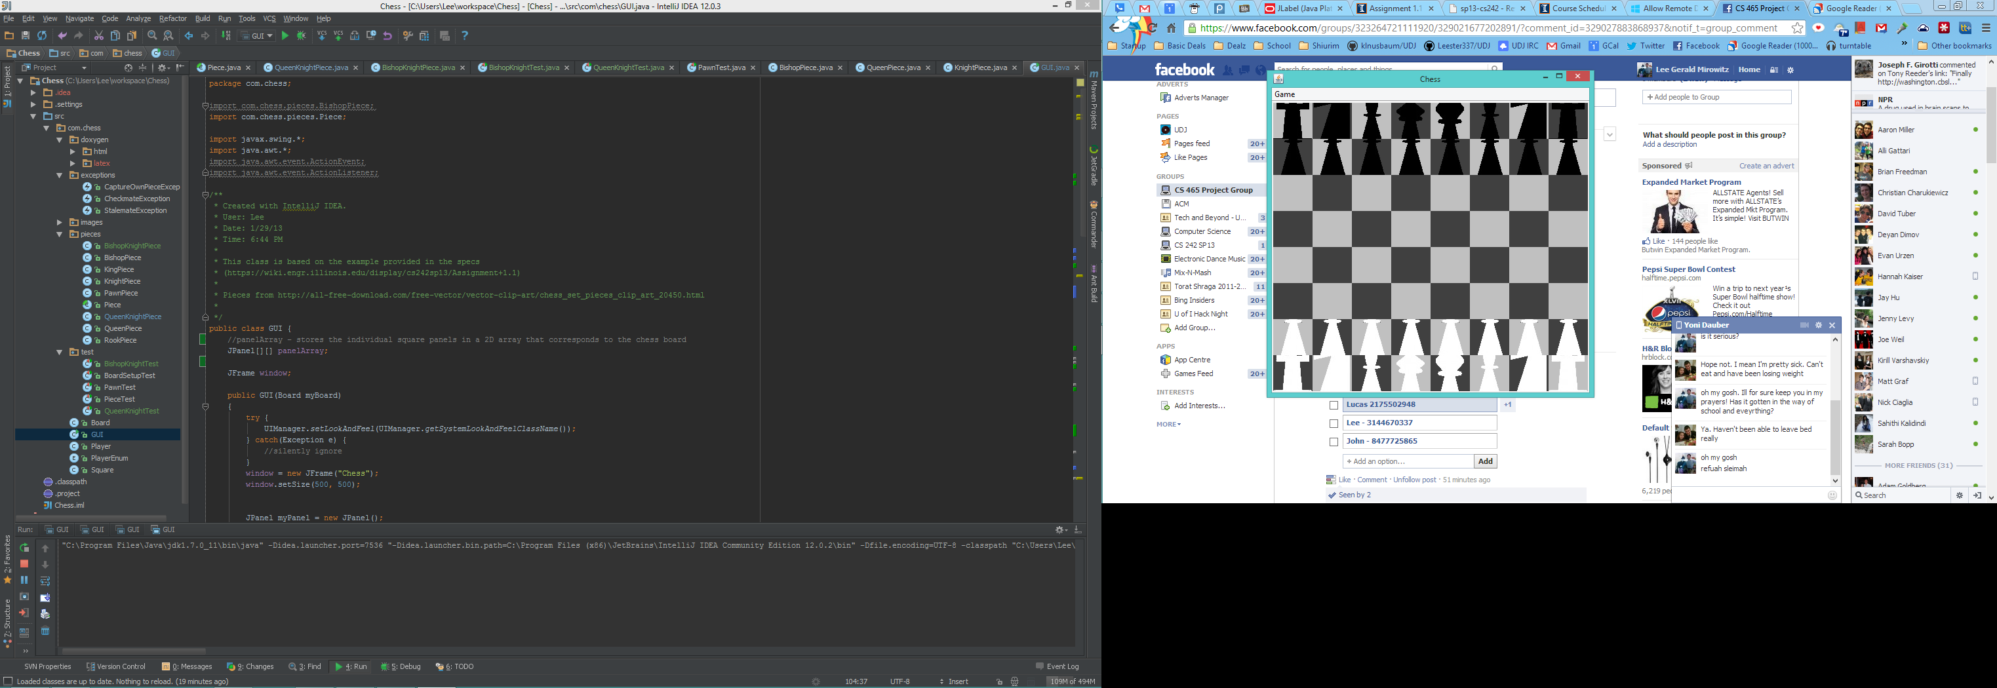That will initialize your chess board to look like this:

Anything other than this will be incorrect output.