Kirsten Lunzer – her number is 54092; she also has 51120 – which is the bldg. access number.

Inactivating 54092 for Advantus and putting her under Corp Security

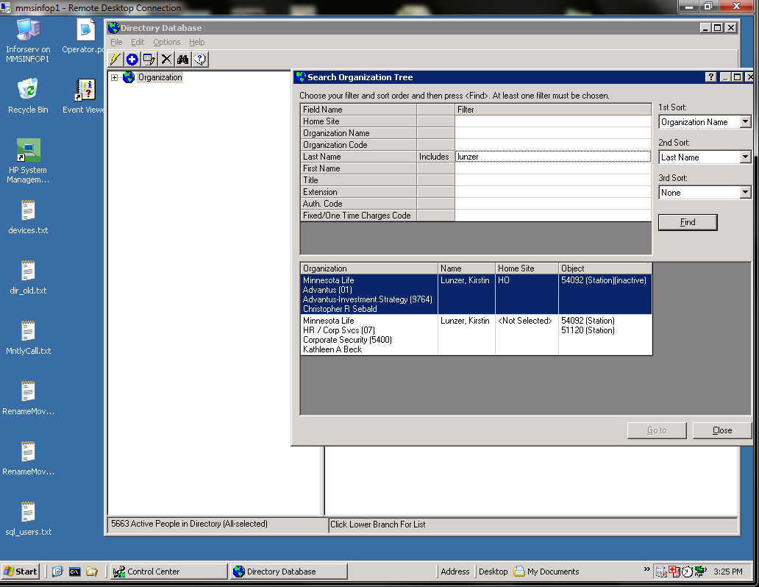

Inactive profile is inactive as of 2/22/13:

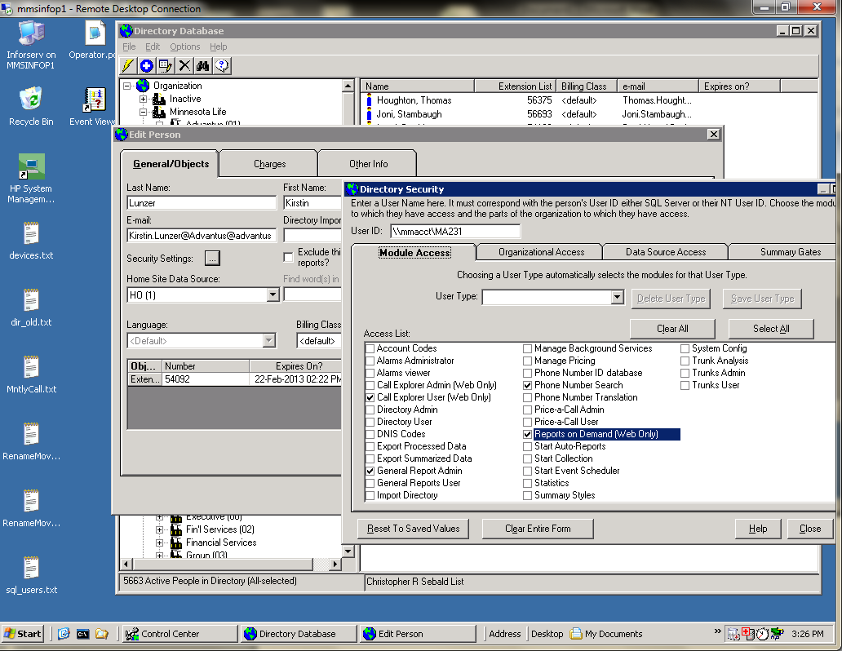

Kirsten has 2 active numbers and blank User ID:

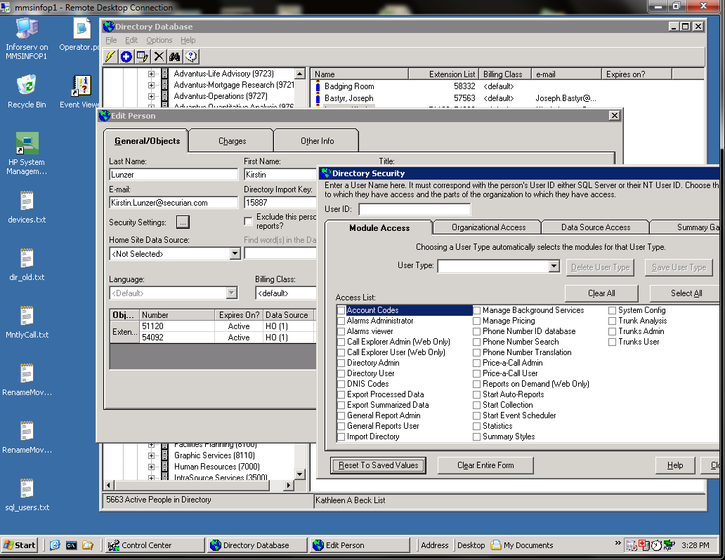

If you search on the extension, you get:

