
KENYA METHODIST UNIVERSITY

END OF 3RD TRIMESTER 2016 (FT) EXAMINATION

SCHOOL : SCIENCE AND TECHNOLOGY
DEPARTMENT : COMPUTING AND INFORMATION SCIENCE
UNIT CODE : BBIT 231/CISY 222/DCIS 104/DBIT 124
UNIT TITLE : SYSTEMS ANALYSIS & DESIGN
TIME : 2 HOURS

INSTRUCTIONS
Answer all questions in section A and any 2 questions from section B:
SECTION A (COMPULSORY):
Question One
- Describe a deterministic system and give an example of one such system. (3 marks)
- List three analytical skills that a systems analyst should have. (3 marks)
- List three weaknesses of the traditional SDLC. (3 marks)
- Name the two main activities involved in project identification and selection; hence describe the purpose of project identification and selection. (3 marks)
- Differentiate between operational feasibility and technical feasibility. (3 marks)
- Differentiate between the traditional approach and the object oriented approach to system analysis. (3 marks)
- Briefly describe the following DFD elements: (3 Marks)
- Process
- Data flow
- Data store.
- Define three business rules in the logical data model. (3 marks)
- Outline three constraints to system development. (3 marks)
- List three important factors to consider when measuring the effectiveness of a system in the maintenance phase of the SDLC. (3 marks)

SECTION B (CHOOSE ANY TWO QUESTIONS FROM THIS SECTION)
Question Two
- Consider the following scenario for a food ordering system: a customer places an order through the system. The system will send the order to the kitchen and issue a receipt to the customer. The system also produces management reports which are read by the restaurant manager. Draw a context diagram representing the above scenario. (6 marks)
- The food ordering system above can be further decomposed as follows: when the customer order is received the system receives and transforms the customer food order and updates the goods sold file as well as updates the inventory file. The formatted goods sold data is then stored in the goods sold datastore. The formatted inventory data is stored in the inventory file datastore. The daily goods sold amounts and the daily inventory depletion amounts are then used to produce management reports which are accessed by the restaurant manager. Draw a level 0 DFD capturing the above information. (14 marks)
Question Three
A company is deciding whether to develop and launch a new product. Research and development costs are expected to be $400,000 and there is a 70% chance that the product launch will be successful, and a 30% chance that it will fail. If it is successful, the levels of expected profits and the probability of each occurring have been estimated as follows, depending on whether the product’s popularity is high, medium or low:

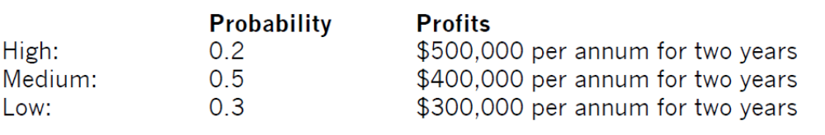

If it is a failure, there is a 0.6 probability that the research and development work can be sold for $50,000 and a 0.4 probability that it will be worth nothing at all. Draw a decision tree for the above. (20 marks)
Question Four
- Compare the process-oriented approach and the data-oriented approach to systems development by outlining three key characteristics of each approach. (12 marks)
- Explain four criteria you would use in making a decision as to whether to purchase COTS (Commercial Off The Shelf) software versus customized software. (8 marks)

