**Spring 2019 CSCI Ethics Paper**

**Due: April 24, 2019 by 11:59PM**

This ethics paper will consider the issue of memes and their affect on society.

The poster child of this issue is the “Star Wars Kid” [1]. Sadly, after the meme went viral the actor, Ghyslain Raza, entered psychiatric institution for severe depression because of the affect of the meme in his school. Namely Mr. Raza complained of mockery of his (amazing) dance moves and his stature. He reports students informing his to commit suicide.

Not all memes lead to depression. Kyle Craven [2] made $15,000-$20,000 from his “Bad Luck Brian” meme. You know, merchandising [3]. Also, Laina Morris launched her acting career in from the “Overly attached Girlfriend” meme.

One of the first questions that comes to mind is the role laws may play in memes. Should laws exist to prevent somebody’s image from be used as a meme? While currently no law exists, some song writers (like Weird Al [4]) ask for permission before deriving work from another. Should laws exist protecting a person’s personal content?

Even if the law decides one way or another there is the question of the meme creator interest. Does it matter if the meme creator know the person in the image? Can memes be used for slander? Can any of these have/should have legal or moral ramifications?

Lastly, should any meme creating guidelines be created and followed for meme creators? If so, what should they be? For example some people may want their permission before using their images. Others, and want some type of monetary compensation.

You are free to give *your* opinion on what you think is right or wrong regarding the way this technology has impacted society and the moral obligations of a computer professional. However, you must provide a balanced discussion of it utilizing other sources to create a logical argument for your opinion. Good sources include the **Bible**, ACM Code of Ethics and Professional Conduct, the IEEE Code of Ethics, and other sources from the library or respectable sites on the Internet. I am looking for your ability to create a logical argument including 3 or more sources in the confines of 2 pages, 12 pt font, double spaced.

Proverbs 17:5

He who mocks the poor taunts his Maker; He who rejoices at calamity will not go unpunished.

Zechariah 7:10

and do not oppress the widow or the orphan, the stranger or the poor; and do not devise evil in your hearts against one another.'

Deuteronomy 22:8 When you build a new house, make a parapet around your roof so that you may not bring the guilt of bloodshed on your house if someone falls from the roof.

Luke 6:31: Do to others as you would have them do to you.

Ephesians 4: 29: Do not let any unwholesome talk come out of your mouths, but only what is helpful for building others up according to their needs, that it may benefit those who listen.

1 Corinthians 10: 23-24: “Everything is permissible” – but not everything is beneficial. “Everything is permissible” – but not everything is constructive. Nobody should seek his own good, but the good of others. (NIV)

1: https://www.youtube.com/watch?v=kR3PT5E0XDo

2:

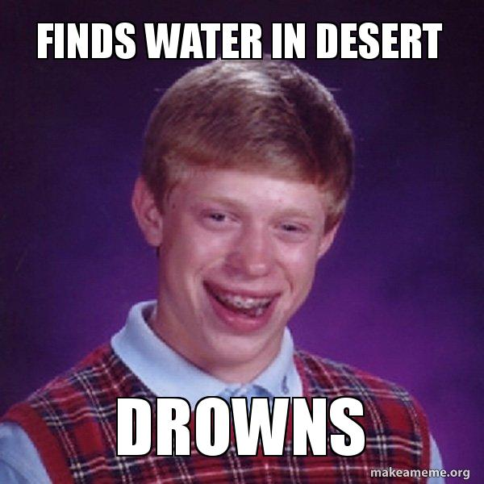

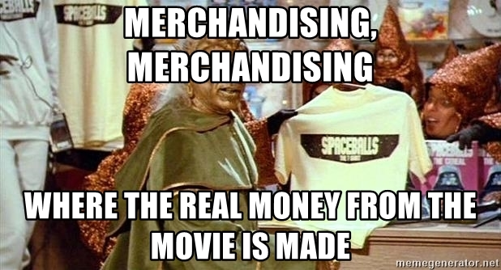3:

4: http://weirdal.com/archives/faq/