SECTION A ERD

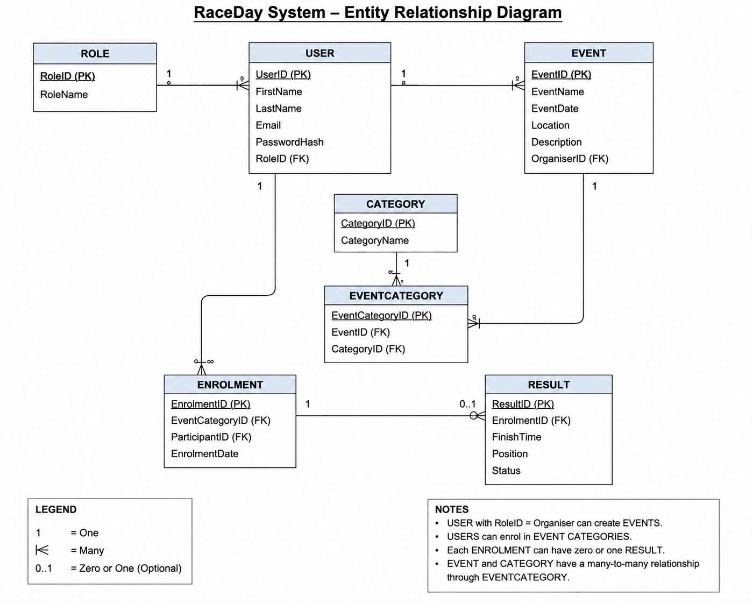

ERD Notes
- Each Role can be assigned to many Users, while each User has one Role.
- A User with the Organiser role can create many Events, while each Event has one Organiser.
- An Event can have many Event Categories.
- A Category can be used for many Event Categories.
- Therefore, Event and Category have a many-to-many relationship through the EventCategory entity.
- A User with the Participant role can have many Enrolments.
- Each Enrolment belongs to one EventCategory.
- An Enrolment can have zero or one Result, because a participant may be enrolled before the race has been completed.
- PK means Primary Key and uniquely identifies each record.
- FK means Foreign Key and links related entities.

