????????? ?????????? ?????? ???????
?????? ????????????????? ???????? ?? ??????? ?????. ????????? ???????????? ???? ? ???????, ????????????? ?????, ????? ???????, ?????? ? ????????, ????? ?????????????? ? ???????? ????????? ????????.

01 auth
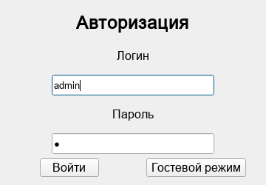

02 admin products
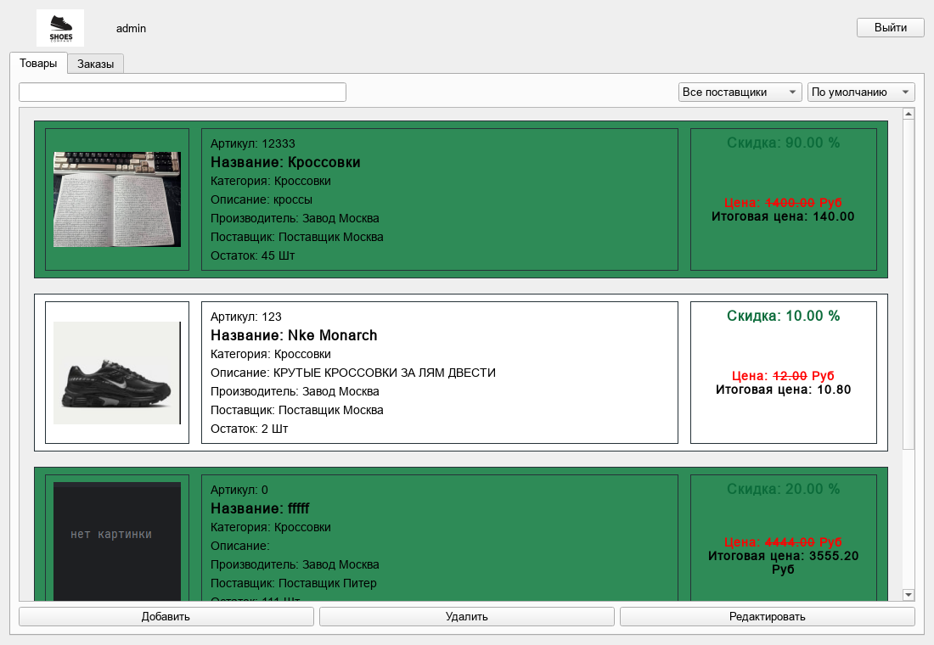

03 manager orders
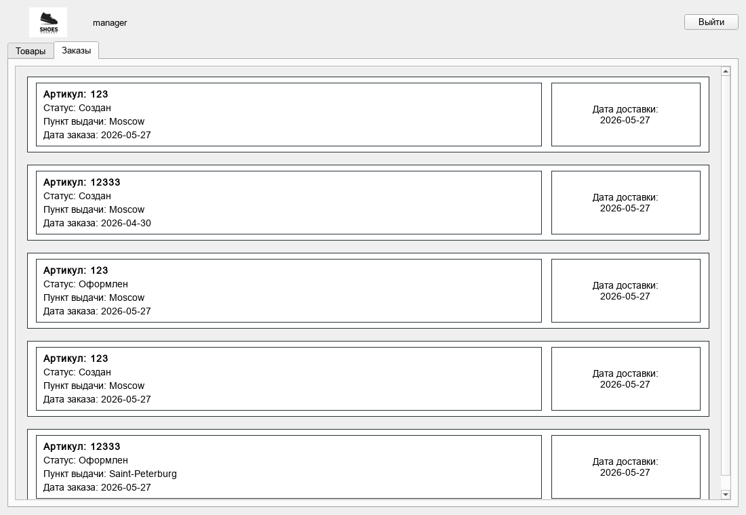

04 product edit dialog
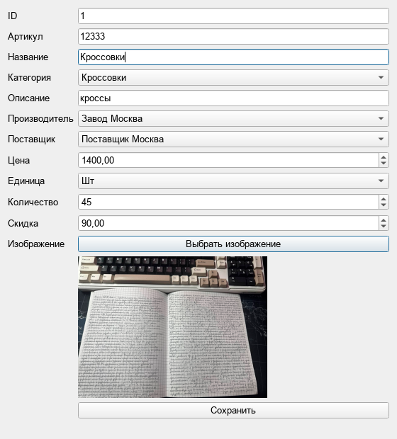

05 order edit dialog
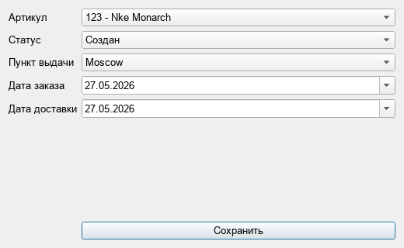

06 no stock card
